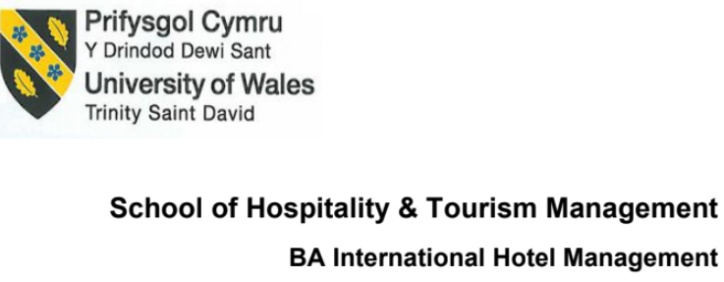
BMIH5003
Foreign Languages and Cultural Awareness
Claudia Diana Balta
Rodrigo Aguilera
STUDENT ID 2118842:
Table of Contents
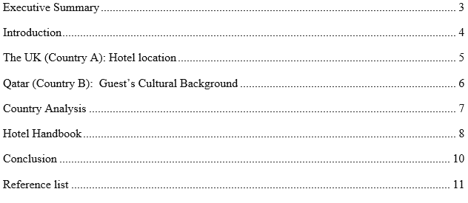

Executive Summary
This report compares and contrasts the cultural differences UK and Qatar to support hotel employees in the possible way to service the different guests from both countries. Hofstede's six cultural dimensions are studied in the two countries. The paper emphasises the need to recognise cultural differences to manage a lucrative hotel business by giving unique experience. This helps to ensure a pleasing and unforgettable holiday at the institution.

Introduction
Culture is a complicated factor as it can influences people's beliefs, views as well as their actions. Proper and suffficient understanding of cultural differences is essential so that organisation can deliver high-quality serivce and avoid misinterpretations. The Hofstede model by Dutch social psychologist Geert Hofstede, is one of the best recognized and normally utilized models till now for analysing cultural differences to gain a richer understanding of the tourists' expectations and preferences, including the hospitality industry (Eilers, 2021). This paper will employ the Hofstede model to assess the cultural differences between the UK and Qatar for hotel service performance so that hotel staff can modify their service to each country's needs and expectations for the experience.

The UK (Country A): Hotel location
By analysing the UK’s culture with Hofstede's six dimensions model, an individual can advance a better understanding of the cultural norms and practises that are noteworthy in order to serve the customers (Ertl and Graburn, 2022).
The United Kingdom is one of the most identified nations to have a low Power Distance score representing the people’s appreciatiation for equality and expectation to be provided with fairness irrespective of rank or position (Samovar, Porter and Roy, 2013). Here both employees and guests expect to have a flat and open organisational configuration lines to be maintained.
The culture of the UK is famous for standing individualistic and have a drive to emphasise to the personal and individual purposes and necessities over the needs of the shared or collective goals (Hofstede, 2022). So, in the UK, people trend to demand individualised responsiveness at hotels.
Due to low in masculinity manifestation, the United Kingdom do not bother with any gender roles for management and room service activities.
The United Kingdom counted in the midpoint of the dimension index for the willingness to embrace uncertainty and change (Huggan, 2019). As a result, hotel guests are more open to attempting new stuffs and have higher expectations for hotels’ response regarding unstable preferences and demands.
But the UK has an average score when it comes to long-term orientation of the customers as clients give importance to the short term work towards a better future.
The population has a tendency to put importance to the pleasure and enjoyment due to high indulgence scores ahead of self-control and discipline (Page, 2021). A hotel's guests demand a variety of leisure activities from the organization.
The United Kingdom values freedom of expression and mutual respect. In the hospitality business, this demonstrates that customers are considering those hotels prioritise both customers’ requirements and care about other stakeholders ethically and morally (Samovar, Porter and Roy, 2013).

Qatar (Country B): Guest’s Cultural Background
Qatar is a small but well-off nation. Hofstede's cultural dimensions approach can be used to comprehend Qatari culture from a guest's perspective.
Qatari people have a bias to give respect to the organised authority and hierarchies which makes it one of the most power distance nation on the scale. As a result, customers want to be pampered like royalty and additionally, they appreciate the extra efforts from the high-end establishment (McFarland and Harris, 2016).
Due to low individualism score, Qatari people tend to put the needs of the over all group ahead of the personal objective (Stoffelen and Ioannides, 2022). Because of this, they want a strong sense of community and shared culture while staying at the hotel.
However, due to cultural gender norms and values, Masculinity Index is high like in other middle east countries (Page, 2021). So, hotel guests would demand a more long-established gender role in service sectors.
Qatar always avoid uncertainty as individuals residing there are inclined to organize stable environments and demand clear and consistent communication from the hotel personnel.
Qatar places excessive significance on tradition and looks forward to future outcomes in its action. As result, clienteles expect an organisation to be forward-thinking and dedicated for procedures (Huggan, 2019).
Qatari people are highly regulated and self-control and have a low value on indulging in their passions, as a country with a low indulgence score. Guests may come to expect hotels to offer facilities and services for wellbeing.

Country Analysis
Several substantial distinctions must be taken into concern when comparing the UK as the home country (A) for hotel service to Qatar as the host country (B) of the client to deliver a satisfactory level of service to clients. Just like other industries, the cultural differentiations between Qatar and the United Kingdom affect the guest experience regarding customised service and social interaction (Ertl and Graburn, 2022). For example, If an employee does have enough awareness about minimum cultural differences and respect for a visitor from Qatar, this could be interpreted as a failure as a service provider.

Hotel Handbook
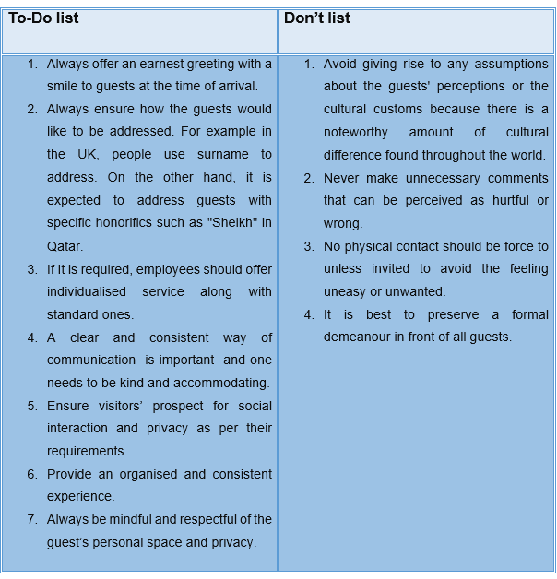
At the moment of dealings with customers from the United Kingdom and Qatar, the following list of things should be obeyed by hotel staff. This list is set to support personnel in acquiring an understanding of different cultural norms to serve guests from a variety of countries. Among the countless cultural practices in the UK and Qatar, hotel workforce should be mindful. A firm handshake is normal acknowledgment between male and females in Britain but women in Qatar generally avoid physical contact. So, hotel staff needs to recognise these distinctions and tailor the service accordingly (Page, 2021). Some Qataris sometimes follow strict mealtime. The staff of the hotel necessities to be aware of these differences to match the needs of the guests.

Conclusion
The Hofstede model can be a significant instrument for hotel workers to understand and grip cultural differences as it helps to increase cross-cultural understanding and aid positive relations.

Reference list
Desmond, J.C. (2020). Embodying Difference: Issues in Dance and Cultural Studies. Cultural Critique, 2(26), p.33. doi:https://doi.org/10.2307/1354455.
Eilers, F.-J. (2021). Communicating between cultures : an introduction to intercultural communication. Manila: Logos (Divine Word) Publications.
Ertl, J. and Graburn, N. (2022). Multiculturalism in the new nation : crossing the boundaries within. New York: Berghahn.
Hofstede, G. (2022). Dimensionalizing Cultures: The Hofstede Model in Context. Online Readings in Psychology and Culture, 2(1), pp.1–26. doi:https://doi.org/10.9707/2307-0919.1014.
Huggan, G. (2019). Extreme pursuits : travel/writing in an age of globalization. Ann Arbor: University Of Michigan Press.
McFarland, D.E. and Harris, P.R. (2016). Managing Cultural Differences (2nd Ed.). The Academy of Management Review, 13(1), p.147. doi:https://doi.org/10.2307/258365.
Page, S. (2021). Tourism Management. Oghiro, UK: Routledge.
Salah Wahab and Cooper, C. (2021). Tourism in the age of globalisation. London ; New York: Routledge.
Samovar, L.A., Porter, R.E. and Roy, C.S. (2013). COMMUNICATION BETWEEN CULTURES. 9th ed. Boston, Mass.: Wadsworth/Cengage Learning.
Stoffelen, A. and Ioannides, D. (2022). Handbook of tourism impacts : social and environmental perspectives. Cheltenham, UK: Edward Elgar Publishing.
Wu, S. (2023). Beyond Hofstede Dimension Model: A New Cultural Dimension of Context Culture. International Journal of Languages, Literature and Linguistics, 9(1), pp.90–93. doi:https://doi.org/10.18178/ijlll.2023.9.1.386.

