University of Wales Trinity Saint David

E-Portfolio Link: https://hifzanasir9.wixsite.com/my-site-1

Module Name: Learning In the Digital Era
Module Code: ACCA 4025

Student Name: Hifza Nasir
Student ID: 2524550
Group: 1

Lecturer’s Name: Suresh Shanmugasundaram

Table of Contents
Task 1: Essential Academic and Employment Skills for the future career Path 2
Task 1 (a): Report on Essential Academic and Employment Skills 2
Task 1 (b): Evaluation of Task 1 (a) based on Similarity report 2
Task 2: Collaborative Mind Map and Individual Poster 2
Mind Map (Collaborative) 2
Poster (Individual) 2
Task 3: Virtual Collaboration and RefWorks 2
Report on Virtual Collaboration 2
Step-by-step process of using RefWorks with visuals 2
Task 4: E-Portfolio Creation and Evaluation 2
Task 4 (a): E-Portfolio Creation 2
Task 4 (b): Illustrative Review of E-Portfolio tool Selection 2
Conclusion 2
References 2
Task 1 References: 2
Task 3 References: 2

Task – 1
Essential Skills for Study and Employment Skills for the Future Career Path
A: Report on Essential Academic and Employment Skills
Introduction to Academic Skills
Academic skills are a primary requirement for a student to successfully tackle a challenging course in computer science. Academic skills will enable a student to effectively process and present complex information in a manner that meets high standards set by a university [1].
- Time Management: The deadlines for coding and theory assignments sometimes overlap, and students need to manage their time in such a manner that they complete all tasks on time without compromising the quality.
- Critical Thinking: This is the capacity of a student to evaluate the technical issues in an unbiased manner. Rather than using the first available solution on the internet, the student needs to evaluate the algorithms and determine the best solution.
- Academic Integrity: The need for honesty in the research process is paramount, and students can use tools that help in the proper referencing of the content, thus protecting their reputation as professionals [2].
Employment Skills in Computing
To be successful in a professional technology industry, technical skills must be combined with "soft skills" that allow for effective teamwork within a corporate structure [3].
- Teamwork: Software development is a team effort in most cases. Good listening and communication skills are required for effective team coding and the use of tools such as GitHub.
- Digital Skills: This requires one to be updated with the latest technologies, for example, cloud computing and cybersecurity. To be a professional, one must be digitally skilled in order to respond to a dynamic market.
- Problem Solving: This is what computing is all about. Being able to divide a large complex problem into manageable problems is a skill that is highly prized by employers.
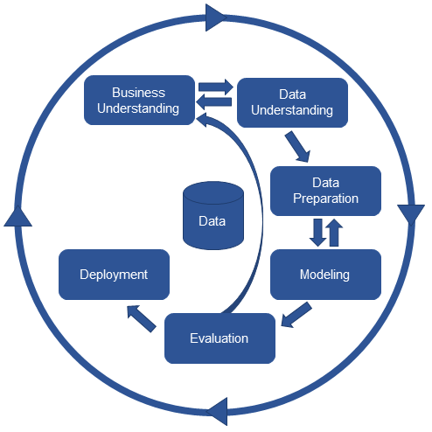
Career Impact and Importance
The technology sector is dynamic and such skills are needed to survive in the long run in my profession. The foundations of learning how to learn are based on academic skills and ensuring that technical solutions achieve the business goals are based on employment skills. Being employable according to Bennett [3] is a factor concerning the extent that a student is able to apply and transfer what he has learnt in an academic setting to a professional environment. Being precise in my technical skills and trustworthy in my professionalism will allow me to make my contribution to the world that is efficient and ethical.
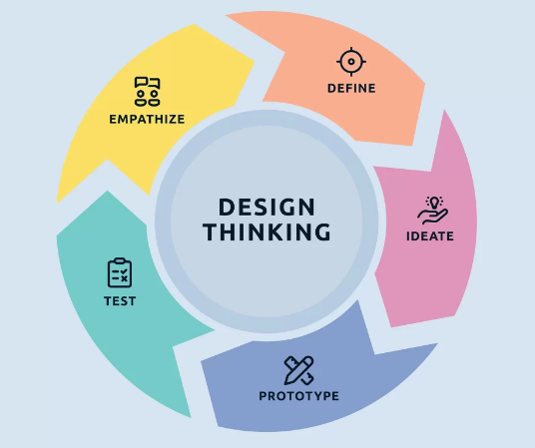
Conclusion
To sum up, it is crucial that an individual learns the academic and employment skills to succeed in his or her career in the computer world. This will ascertain that the projects are not only undertaken technically, but also through an integrity and communication perspective. Academic and job skills can be well learned and the future career in the international workforce in the field of technology is sustainable and successful.

B: Evaluation of (A) Based on Similarity Report
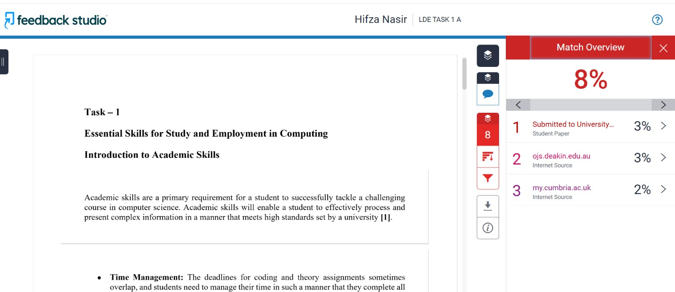
The similarity score of my turnitin is within the acceptable academic limit, which is around 8%. According to the report, a few parts of my work correspond with online sources, mainly university articles and websites. This is due to the use of common academic terms and definitions. For the improvement of similarity score, I can rephrase more carefully to avoid similar sentence structures. Moreover, I assure that I effectively understand the core idea of content and can express it in my own words. Furthermore, I can strengthen in text citations to present referenced ideas more effectively. On the Generic Assessment Criteria, I stand at 70 to 75%. This is rating is entirely based on my work, which is well structured, topic relevant and strong referenced. Yet it can be improved with further explanation, more critical thinking and strong personal connection to my computing career.
What do I need to improve?
I need to improve my paraphrasing skills, use of original wording, and ability to conduct deeper critical analysis.
What did I do to improve?
I thoroughly evaluated my work, minimized the repetition of words, ensured proper IEEE referencing and incorporated more authentic explanations, which made my work clearer and personal.

Task 1 References

[1] | Coursera, "10 Essential IT Skills for Your Career," 2024. [Online]. Available: https://www.coursera.org/articles/key-it-skills-for-your-career. [Accessed 17 March 2026].
[2] | S. Cottrell, The Study Skills Handbook, 5th ed., London, UK: Red Globe Press, 2019.
[3] | D. Bennett, "Student equity and employability in higher education," Journal of Teaching and Learning for Graduate Employability, vol. 7, no. 1," 2016.
[4] | Gemini, "Assistance in structuring academic and employment skills summary," 2026.

Task – 2
Collaborative Mind-Map and Individual Poster
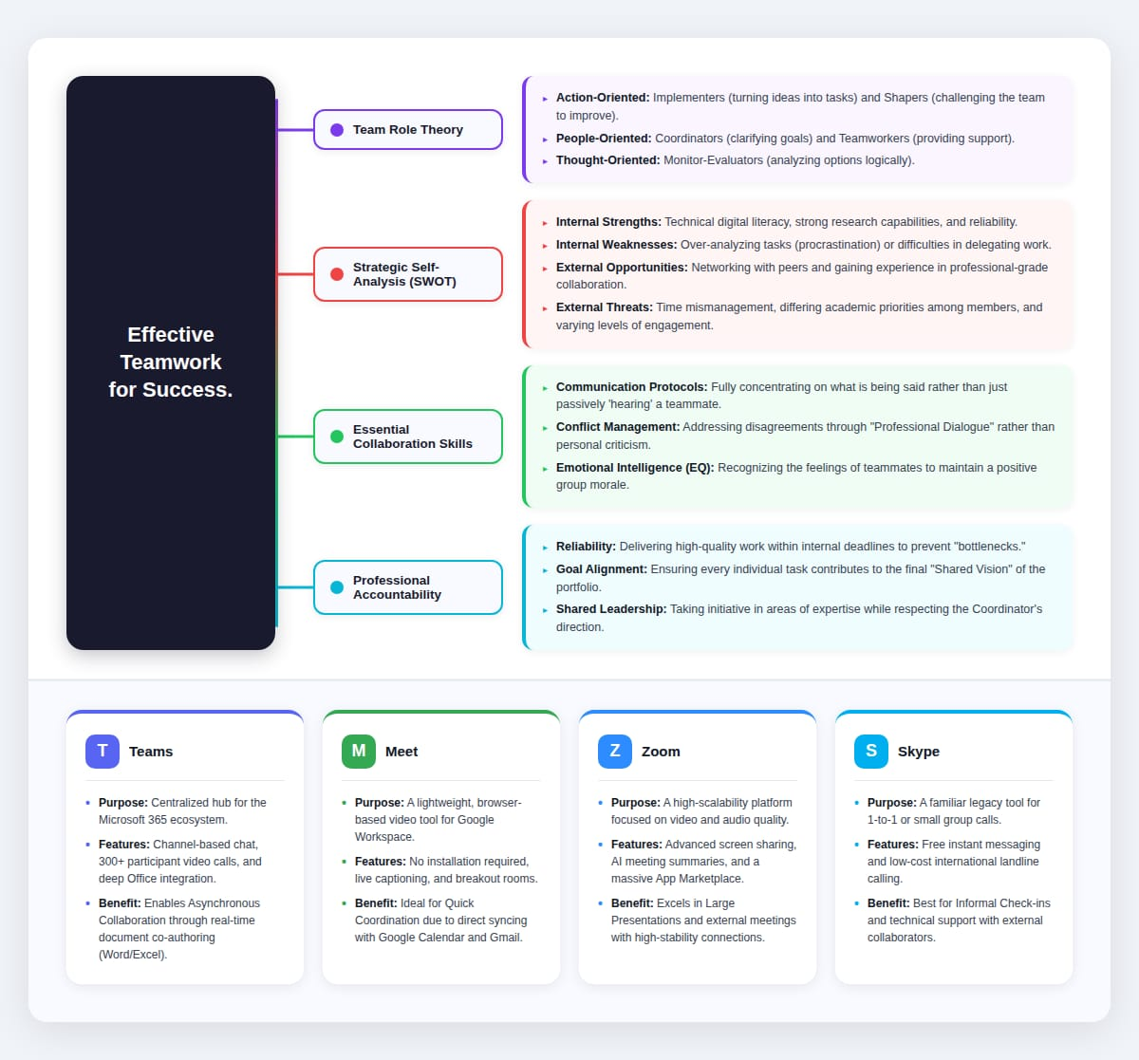
Mind-Map (Collaborative)
In the digital era effective collaboration is defined by coordination between individual roles and shared goals. In our group, we utilized Belbin’s team roles to ensure functional balance. Aranzabel et al. highlights that forming teams based on specified roles boosts accountability of individual and positive interdependence [4].
Furthermore, conducting SWOT analysis was the key for navigating a virtual environment. Our primary strengths lay in high digital literacy, but we had to actively address weaknesses such as asynchronous communication gaps. Studies shows that virtual teams face unique threats like “digital fatigue” and communication barriers that must be reduced through clear cultural alignment [5]. By identified these factors early, we transformed threats into opportunities for developing professional grade project management skills ensuring our teamwork was grounded in critical reflection rather than just task completion.
Poster (Individual)
The shift to digital-first learning environments has required proficiency among various communication platforms. In contrast to traditional face-to-face meetings, digital era requires “Tool Agility” - which is the ability to switch between platforms depending on projects specific needs. Microsoft Teams was our main place to work together, allowing us to edit documents at the same time and keep messages in order. A study shows that using digital communication tools can boost teamwork effectiveness by up to 92% in the IT field [6].
Alternatively, tools like Google Meet and Zoom provided the infrastructure for agile coordination and high-stakes presentations. Additionally, Skype remained a reliable for informal technical help. According to recent studies, the success of these tools is directly linked to “digital literacy” of team members [7]. Together these platforms prove that successful learning in the digital era relies on building cohesive ecosystem that supports transparency, accountability, and global connectivity.

Task 2 References

[4] | E. E. a. M. A. A. Aranzabal, "Team Formation on the Basis of Belbin's Roles to Enhance Students' Performance in Project Based Learning,"  https://www.sciencedirect.com/science/article/pii/S1749772821000452
[5] | M. T. P. a. M. Franco, "Contrasting Traditional and Virtual Teams within the Context of COVID-19 Pandemic," 2022.  https://www.mdpi.com/2071-1050/14/8
[6] | J. L. a. A. Jaizul, "The Role of Digital Communication in Enhancing Collaboration in the Information Technology Industry," p. 2024.
[7] | S. Research, "Analysis of Virtual Collaboration Tools in Higher Education," ProQuest Dissertations," 2022.  https://www.researchgate.net/publication/391144437_The_Impact_of_Virtual_Reality_on_Collaborative_Learning_in_Higher_Education

Task – 3
Virtual Collaboration and RefWorks
A: Report on Virtual Collaboration
- The Determinants of Virtual Performance
In recent studies on the software engineering industry, it has been suggested that virtual performance is a function of communication and trust. In analyzing this concept, Garro-Abarca et al. showed that virtual teams (VT) generally perform better than face-to-face teams by adopting a structured model of Input-Process-Output (IPO). In most cases, the emphasis is on "task cohesion" rather than "social bonding." This academic model ensures that leadership, empowerment, and cohesion are embedded in the "latent trust" of the team, which is critical for high-quality technical performance.[1]
- Reflective Practice and Pedagogical Transformation
However, moving beyond cooperative learning, learning in the digital era necessitates "Reflective Practice." According to a study by Mao et al., "the integration of digital technology in higher education requires students to critically think about the educational implications of digital tools they use". By diversifying earning material, such as using AI tools for brainstorming and creating interactive mind maps, people can move from being "passive users" to "transformative learners" who are capable of adapting to "new technological architectures."[2]
- Strategic Individual Evolution (SWOT Framework)
According to Mind Tools, "the SWOT framework is a powerful tool for discovering dangerous blind spots in our group's performance". By conducting a personal SWOT analysis, individuals are able to identify how my internal environment, such as their internal strength of "technical agility," could be utilized to take advantage of external opportunities, such as "new software in the industry."
Internal Alignment: Realizing how internal strengths, such as "low overheads" and "quick response times," are critical in a competitive digital environment.
Risk Mitigation: Realizing how risks, such as "technology" and "deadline pressures," need to be mitigated through a proactive rather than reactive strategy.[3]
B: References Through RefWorks
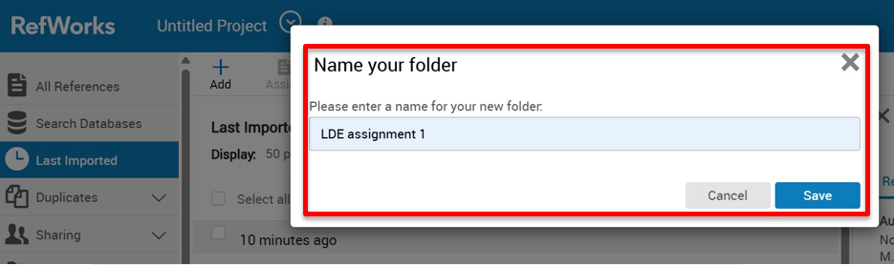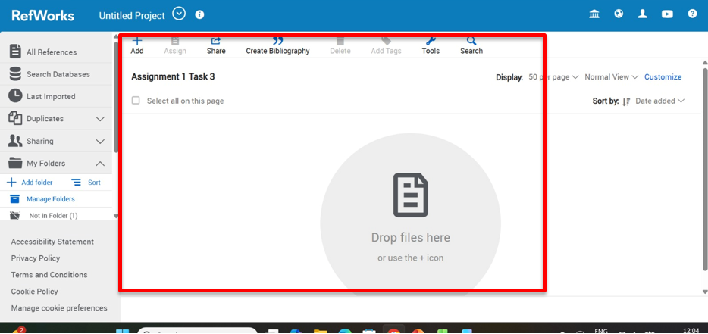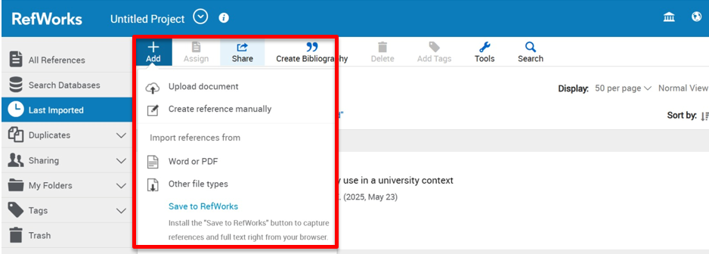
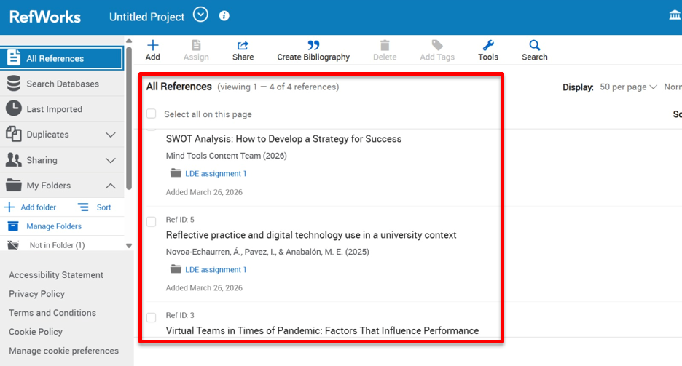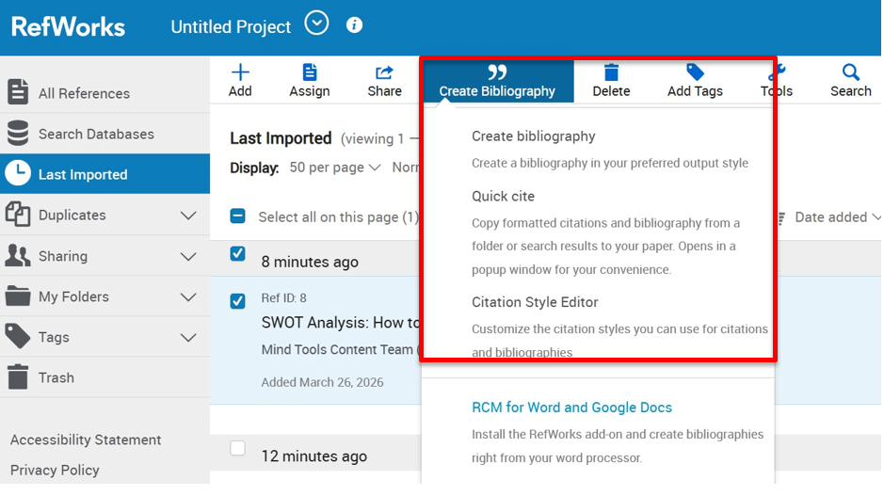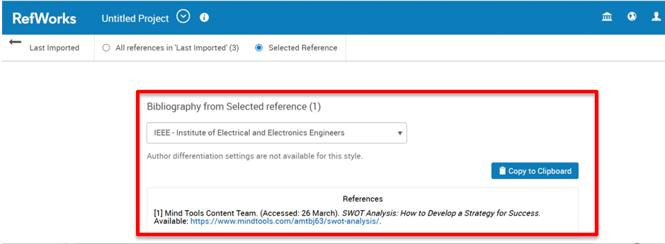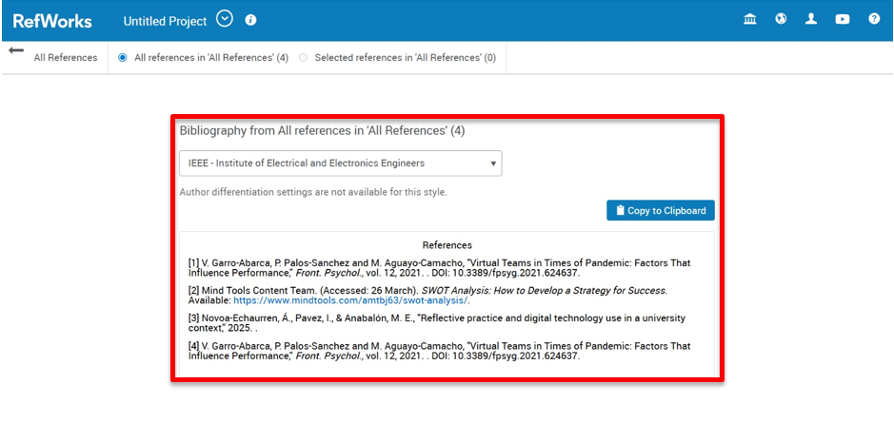
Through my student ID, I logged into RefWorks and accessed my personal library. Firstly, I created new folder and organized my work. Then, I added sources of my work by uploading documents and importing references in the new folder. After, I selected IEEE referencing required for my work. In Word, I used RefWorks tool to insert in-text citations from my saved sources. Finally, I generated automated bibliography ensuring all references were correctly formatted according to the IEEE standard. Overall, this task demonstrates my ability to effectively use RefWorks as an automatic referencing tool, apply correct IEEE citation style, and organize references accurately within my academic work.

Task 3 References
[1] V. Garro-Abarca, P. Palos-Sanchez and M. Aguayo-Camacho, "Virtual Teams in Times of Pandemic: Factors That Influence Performance," Front. Psychol., vol. 12, 2021. . DOI: 10.3389/fpsyg.2021.624637.
[2] Mind Tools Content Team. (Accessed: 26 March). SWOT Analysis: How to Develop a Strategy for Success. Available: https://www.mindtools.com/amtbj63/swot-analysis/.
[3] Novoa-Echaurren, Á., Pavez, I., & Anabalón, M. E., "Reflective practice and digital technology use in a university context," 2025. .
[4] V. Garro-Abarca, P. Palos-Sanchez and M. Aguayo-Camacho, "Virtual Teams in Times of Pandemic: Factors That Influence Performance," Front. Psychol., vol. 12, 2021. . DOI: 10.3389/fpsyg.2021.624637.

Task – 4
E-Portfolio Creation and Evaluation
E-Portfolio Link:
https://hifzanasir9.wixsite.com/my-site-1
A: E-Portfolio Creation
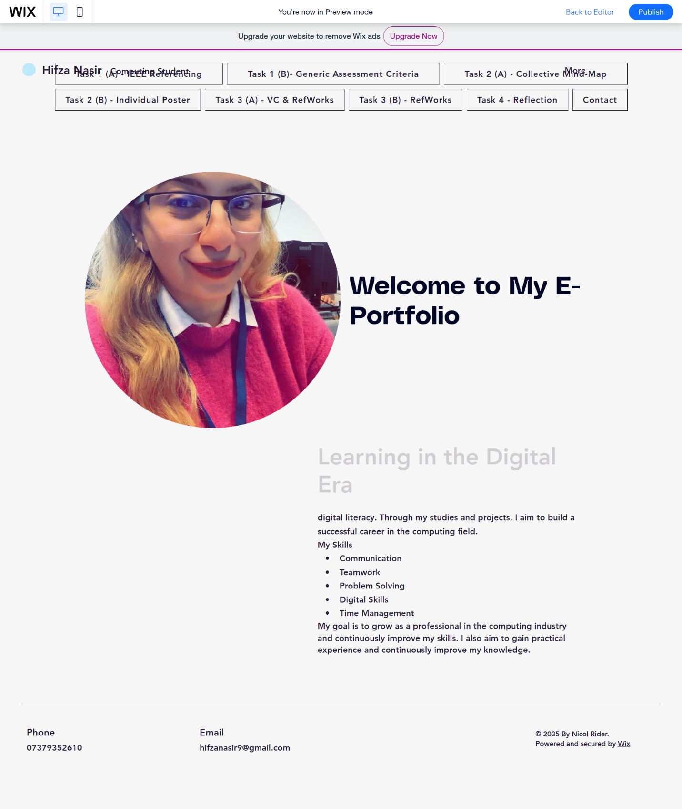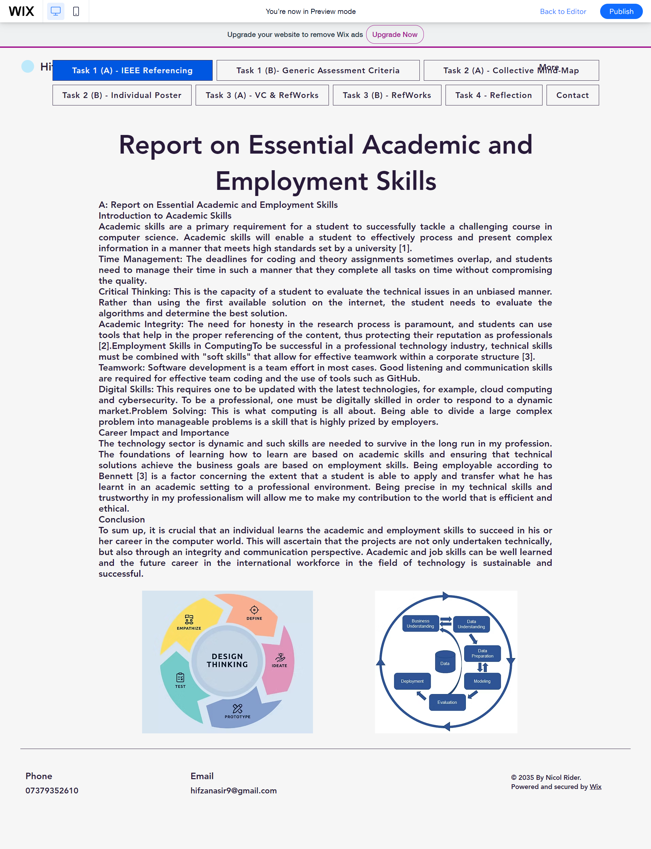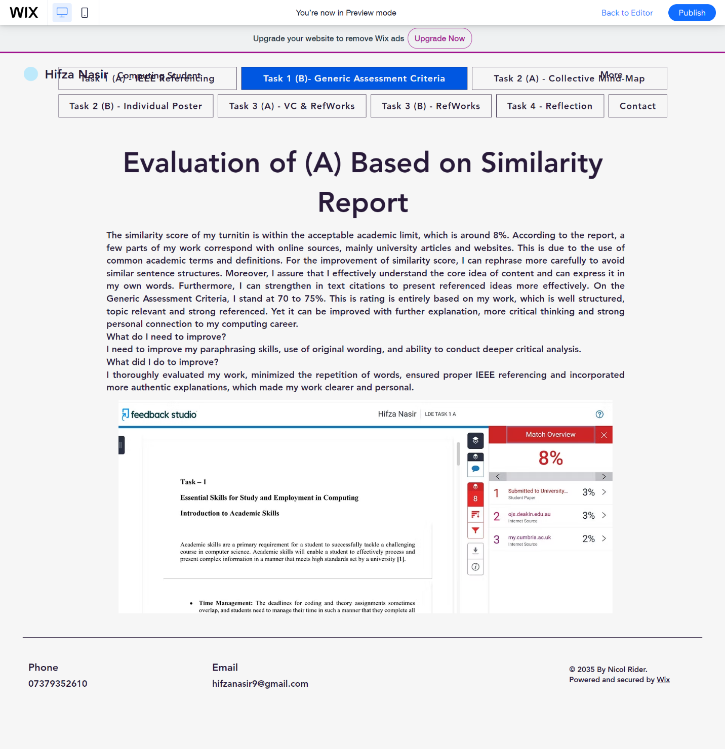
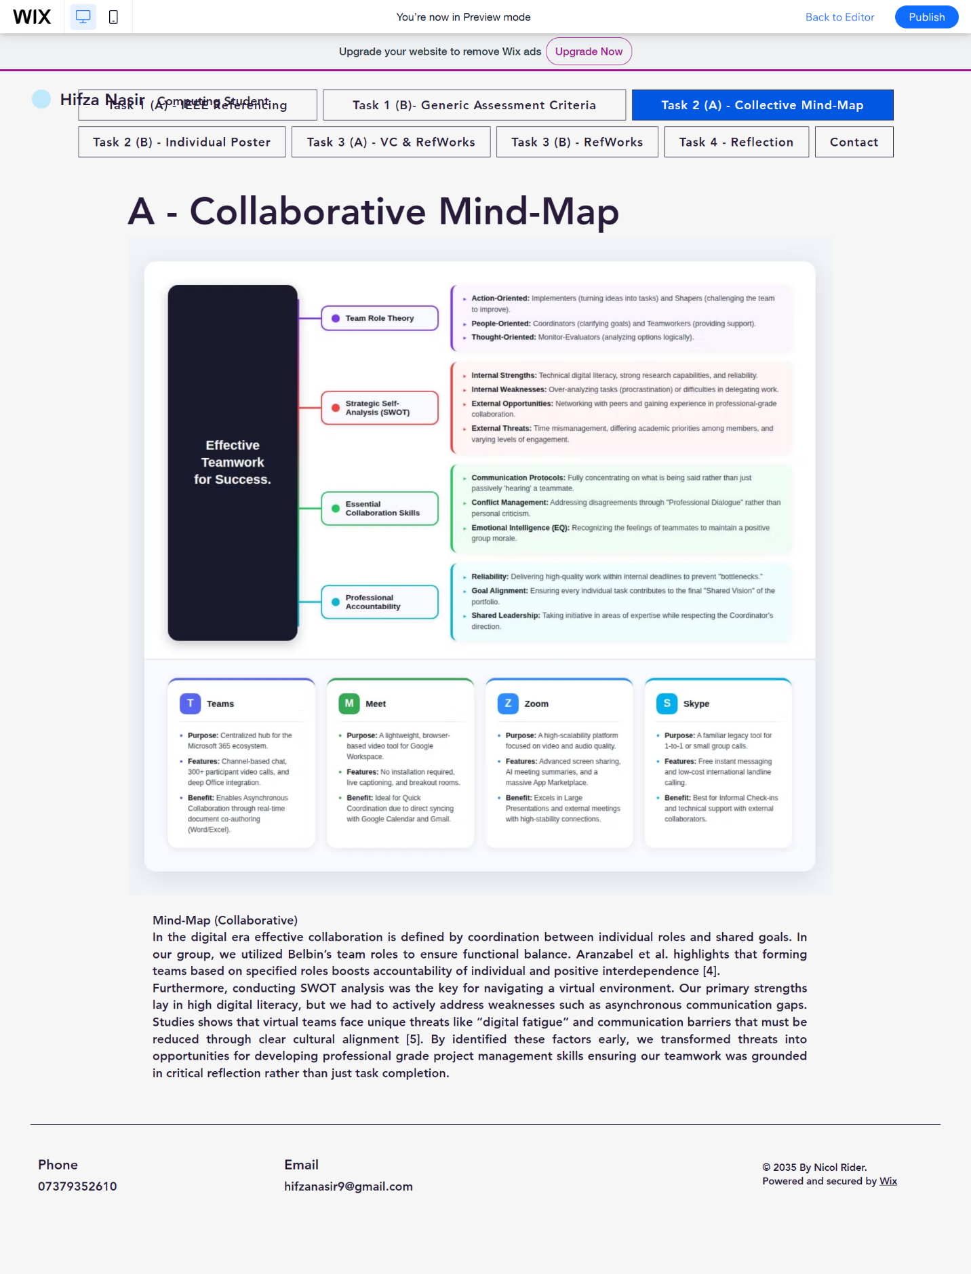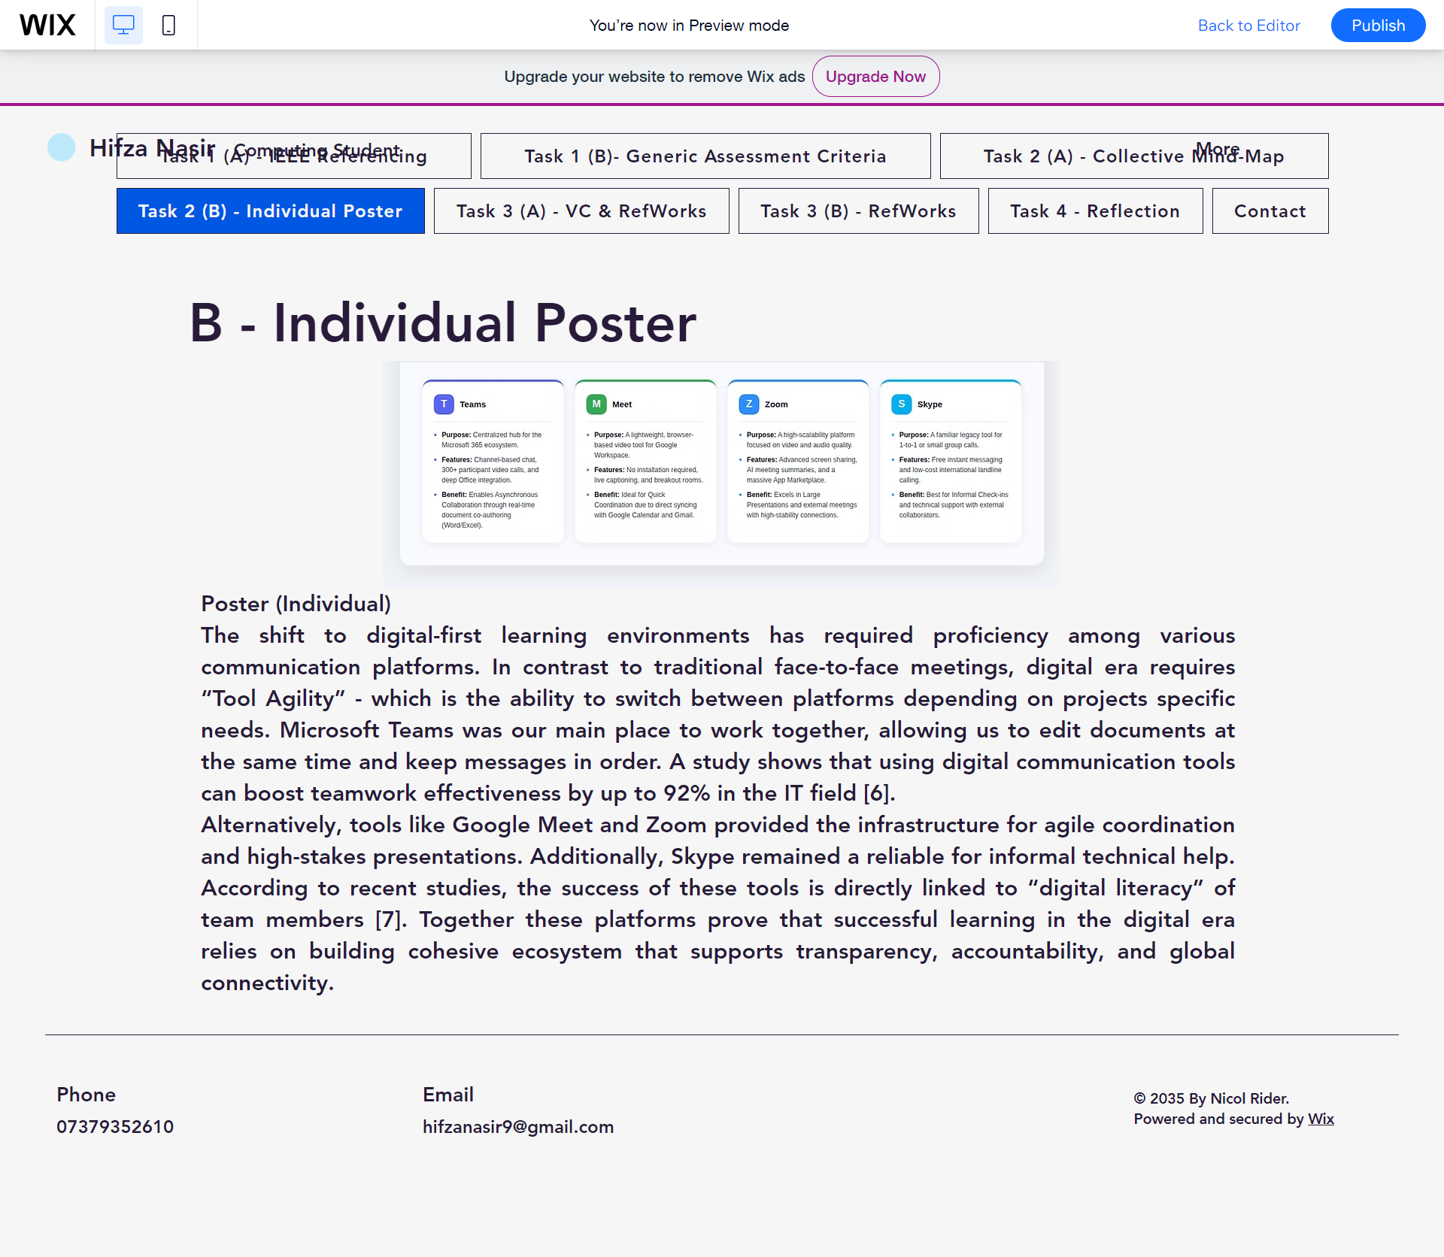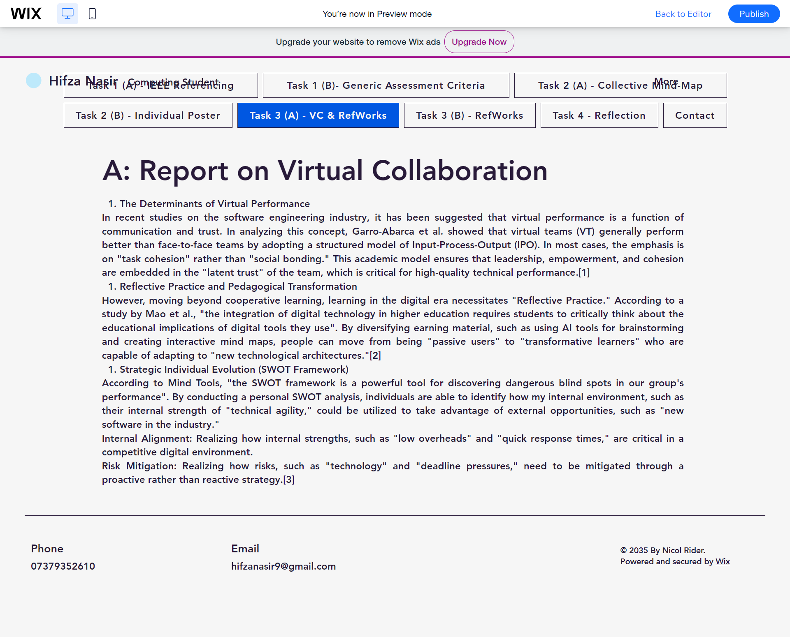
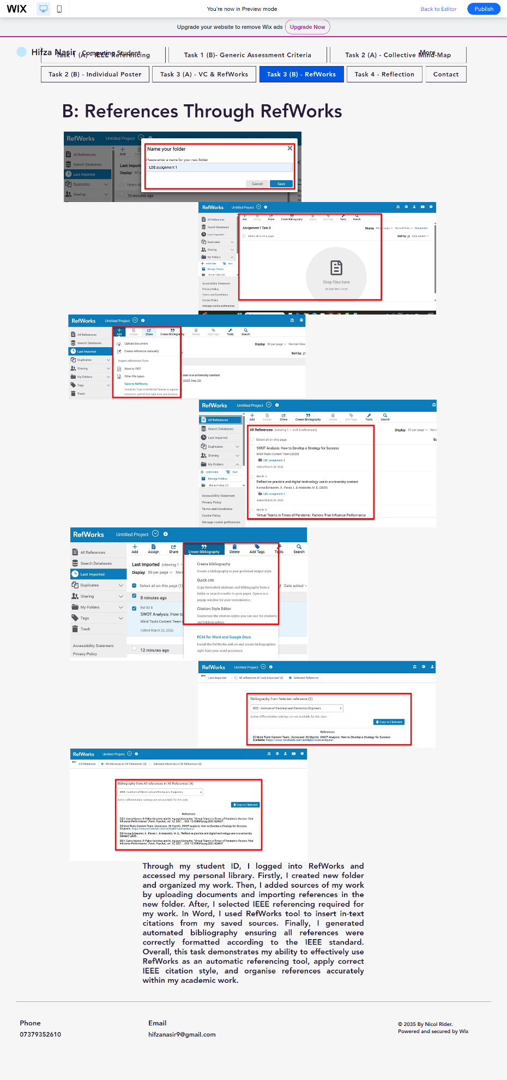
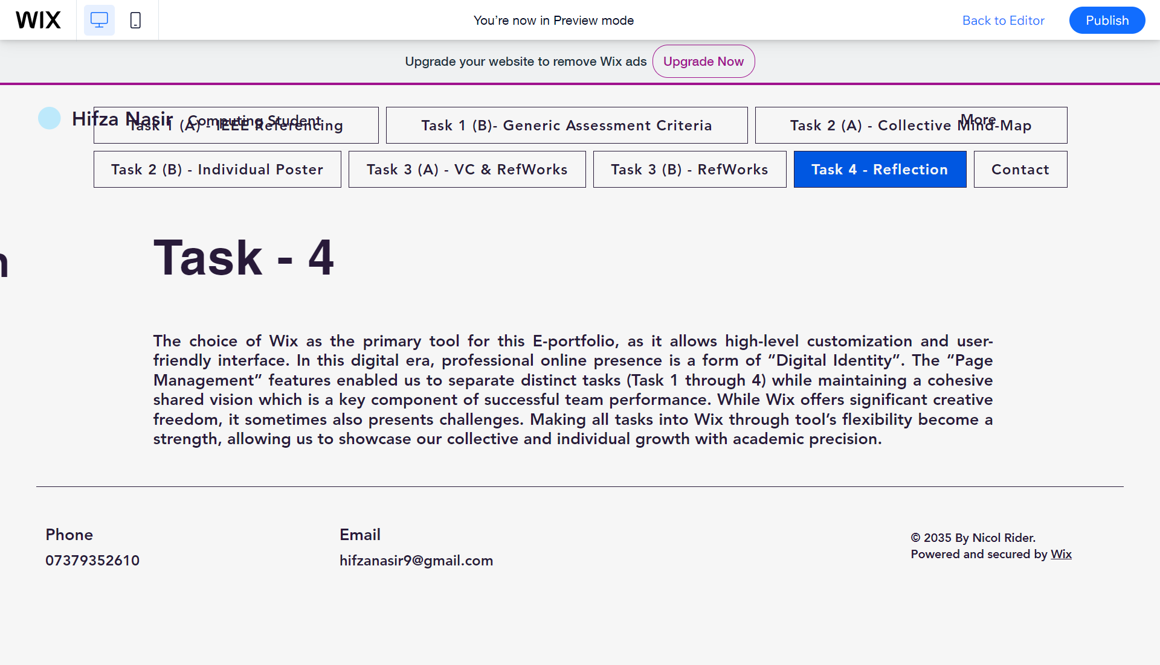
B: Reflection
The choice of Wix as the primary tool for this E-portfolio, as it allows high-level customization and user-friendly interface. In this digital era, professional online presence is a form of “Digital Identity”. The “Page Management” features enabled us to separate distinct tasks (Task 1 through 4) while maintaining a cohesive shared vision which is a key component of successful team performance. While Wix offers significant creative freedom, it sometimes also presents challenges. Making all tasks into Wix through tool’s flexibility become a strength, allowing us to showcase our collective and individual growth with academic precision.

Appendix
Evidence of AI as research assistance:


