SYNTHESIZE A SOLUTION TO A POTENTIAL REAL-LIFE SCENARIO
Name: Said Ahmed, ID Number: P150856, Programme: BSc (Hons) Computing Portfolio,
Lecturer: Dr Carlene Campbell, Module: Computer Forensics, Submission Deadline: 4th April 2019
Contents
1 INTRODUCTION 2
2 COMPUTER FORENSIC TOOLS 2
2.1 FTK IMAGER 2
2.2 AUTOPSY 3
2.3 VOLATILITY FRAMEWORK 4
2.4 CAINE 4
2.5 SIFT WORKSTATION 4
2.6 XPLICO 5
2.7 PRODISCOVER FORENSIC 5
2.8 BULK EXTRACTOR 5
2.9 REDLINE 6
2.10 X-WAYS FORENSICS 6
2.11 MALTEGO 7
2.12 OXYGEN FORENSIC 7
2.13 MAILXAMINER 7
2.14 WIRESHARK 8
2.15 EnCase 9
3 TOOLS CATEGORIES TABLE 9
I. CASE SUMMARY 10
II. CASE ASSESMENT 10
III. CASE ANALYSIS 11
IV. CONCLUSION 13
V. APPENDICES 13
4 REFERENCES 14

Table
Table 2 Tools Categories 10

Figures
Figure 2 Single Evidence Form 11
Figure 3 Chain of Custody Form 11
Figure 4 FTK shows File category 12
Figure 5 FTK shows Index search 12
Figure 6 FTK shows Bank details for Excel protected 13
Figure 7 Autopsy shows Bank details 13

ABSTRACT
This report presents the basic understand and appropriate computer forensic tools that used now days. Also, to categories and analyses those tools mentioned, it identifies each tool and the usage forensic investigation process. It provides a case study report for a terrorist attack, documents step by step investigation details taken for the case best achievement by summaries the main case, asses, analysis it and produce the complete investigation report.

INTRODUCTION
The aim of this report is to research the computer forensic tools for the needed in to different technology sector and understand the basics of computer forensic. These tools can be analysis and categories in to many ways such as for malware and monitor the system if attacked or not, to investigates smart device system, to do a recover of any deleted files. Also, the other aim is to provide the proper report of the terrorist attack case by document the steps taken, analysis and process of investigation to the final case report and based for an Incident Handler.

COMPUTER FORENSIC TOOLS
This is the tools used for investigating any unsolicited things appeared in digital data by collecting, reporting and analyzing evidence. The computer forensic investigator it can used these techniques for preventing any crimes detect in a computer system where evidence digitally stored. By following step by step of recording data bit by bit and to make sure not losing the original one for a better evidence report to present in a court. [1]

Computers system sometimes may find a deep crime that destroy everything, such as inner system service attack, hacking personal staff and even the government top secrets and the evidence they will have in a form of emails, documents, internet history or other files related to crimes for example drug trafficking, kidnap, fraud and murder. So, by using proper tools that will help to overcome the investigation of the all attacking happens and come out with the solution on what kind of unwanted activity occurred. [2]
Below are the most useful forensic tools used now days for a better system security:

FTK IMAGER
This tool used for a data imaging and preview to obtain data evidence by generating copies of the main data without lost or doing any changes from the evidence of the original. So, when done generate data of an image by using FTK tool will help to perform a forensic investigation and produce a report of the findings. [3] The FTK Imager will include the following: [4]
- Create hash reports for disk images that included files inside the disk images and regular files that can use for later as a “benchmark” to verify an integrity evidence of the case. Once imaged a full drive, a hash created through FTK Imager will use to confirm that an image hash and the hash drive match after created the image, that an image has continued not changed since the time of an acquisition.
- Screening contents that target the forensic images stored on the local system or on to drive through network
- Recover and review files that already deleted from the Recycle-Bin, but that file not yet overwritten on the system drive.
- FTK can build message digest 5 (MD5) or Secure Hash Algorithm (SHA1) hashes of files [5].
- Mount an image for a read-only view that influences Windows of Internet Explorer to view the content of an image as same as the one who use saw it on the original system drive.
- Screening folders and files on network drives, local system hard drive CDs and DVDs or even USB devices.
- Creating forensics images of CDs and DVDs, sometimes of USB device, local system hard drives, individual files or full folders.
- Export folders and files from forensic images to disk.
- Browse of the file contents also can perform by keyword searches [6]
Each tool has the useful of using it and the other side of disadvantage, so FTK Imager hasn’t got a progress bar, hasn’t got a multi-tasking, there is no time line but only for sorting column, doesn’t fit picture for windows on gallery view, doesn’t support HFS, AVI or even PSD also no scripting support [7].

AUTOPSY
This is GUI-based forensic tool to examine smart phones and hard drives system capably [8]. This program is most popular tool for forensic and in a worldwide has a lot of users for the purpose of investigation the things occurred in a computer. The end-to-end platform is why an Autopsy designed for, with available of third-parties and some from out-of-the-box [9].

Autopsy has the following features: [2]
- Cases for Multi-user for cooperate for a larger case with other examiners.
- Analysis for the timeline to help activity identify, that will display in to graphical interface with the system event.
- Search of the Keyword to help easily find the files that explain exact terms.
- Web activity extract to help of identify the user activity.
- Reg Ripper for registry analysis and identify the recent accesses USB devices and document viewed.
- Analysis LNK File is to classifies shortcuts and retrieved documents
- Email Analysis is to Analyses MBOX setup messages, for example Thunderbird.
- EXIF is to Extracts camera information and geolocation of JPEG files.
- File Type Sorting for Assembly files through their type to look the all documents or images.
- Media Playback to see images and videos inside application and doesn’t need the outside viewer.
- Thumbnail Viewer shows thumbnail of pictures to help fast pictures view.

VOLATILITY FRAMEWORK
Is the forensic tool software for analyzing malware and this used to identify of either the system is infected or no. Volatility can analysis crash dumps, virtual box dumps, VMware dumps, raw dumps and so many that performed on windows platform [10].
This runs on Linux, Mac and windows as well that is written in Python programming language, is an efficient and fast algorithm, is the type of forensic focus on malware and cohesive framework as well. So, this a some of features this volatility framework has. Also, this tool the information can extract through network sockets, connection and network process [10].

CAINE
Is stand for Computer Aided Investigative Environment and is the tool for data recovery, mobile forensic, network forensic and many more. The pack come in to Linux that built in Ubuntu, MATE and LightDM [11]. Below is the main feature for this tool [12]:
- A graphic user interface design that directs digital detectives throughout acquisition and examining of the evidence in electronic.
- Semi-automatic report creator
- Improved and updated environment to perform a forensic analysis

SIFT WORKSTATION
The capability of this tool is to examine byte level of the data available straight from hard disk drive system or to the any devices storage, evidence formats and multiple file systems. This tool of forensic investigation run through ubuntu system. It supports everything reaching from Advanced Forensic Format (AFF) in to RAW (dd) formats of evidence or more [2].
It included better of the memory utilization, option of install via Workstation /VMware Player or stand-alone via (.iso), cross compatibility among Windows and Linux, support of file system expanded, ReadTheDocs for the online documentation project, Auto DFIR bundle bring up to date and customizations. Also, it supports the evidence image of single raw file, advanced forensic format, all AFFLIB image formats, split raw files, affuse, ewfmount, analysis of E01- Expert Witness Format [13].
The tool of creating log2timeline for the purpose of generating for the timeline from the system log, Rifiuti for investigative the recycle bin, Scalpel for the data file carving, and many more is included to the SIFT [3].

XPLICO
Is the network forensic analysis tool for Open Source Network which can recreate any content of acquisitions achieved by the packet sniffer like as Ettercap and Wireshark. Xplico can function for extract and recreate the content from any source. The main function is to extract any application data from the internet traffic [2] [14].
Included the following structures [15]:
- Xplico data reassembled is related to the XML file, that exceptionally classifies the flow and pcap covering the data collected
- Multithreading;
- The Modularity of each Xplico factor is modular.
- Each application protocol got Port Independent Protocol Identification (PIPI)
- The information and data produce put in to Mysql or SQLite database.
- The supported protocols are UDP, SIP, SMTP, IMAP, POP, SIP, TCP, UDP, HTTP
- Hasn’t got any limit size of number on data entry or in the numbers of file entrance
- It supports IPv4 and IPv6

PRODISCOVER FORENSIC
This tool helps to make recover any deleted files and works as the powerful tool for computer security, examine slack space and access Windows Alternate Data Streams. ProDiscover Forensic animatedly to allows a search, preview, and capture the image of Hardware Protected Area-HPA for the disk and supports locate entire data on computer disk, protect the evidence and generating complete reports. So, provide general information reporting with 110 seconds processing time, required minimum training and run in to MS Windows operating system [16] [17].
The general key features for this tool are [17]:
- The ways search files are to the entire disk; this included “Windows NT/2000/XP
- Observes data at the cluster level or file.
- Alternate Data Streams, HPA section and slack space.”
- Bit-Stream of the disk copy created that include the HPA section to analysis.
- Is not changing data on disk that including the file Metadata for the file previews.

BULK EXTRACTOR
Is a computer system forensics tool used to scans a directory of files, disk image and file the information to extract such as Zip files, email address, URLs, domains and credit card numbers [18].The information extracted is come out to a sequence of text files that can be manually reviewed or analyzed by using different tools forensic or scripts [3].
Bulk extractor is designed in a GUI or command-line tool. It can access different features such as [19]:
- It will carve and sense encoded RAR files, it can cut office documents and JPEGs away of compressed data fragments.
- The all words found on data will It builds a word lists, even the files that are out of located space. And that word can be very useful for cracking password.
- Multi-threaded for bulk extractor that running within the computer for the twice of the number and makes to complete to run a half of the time.
- It generates histograms displaying the most common information on to the drive
This also included a graphical user interface, a Bulk Extractor Viewer that for surfing different features kept in a file and for a starting of scans of bulk extractor. Also has a small number of python language program for functional any additional features in file and for analysis [19].

REDLINE
Is a forensic computer security tool that used to find any malicious things that attack in to the system to provides host investigative capabilities. This can help to collect registry data, network information, web history, event logs, file system metadata, drivers from the memory and help to audit, also the ability to screen results around timeframe given for analyses and view the imported audit data [20].
Some of the features this tool support as follow [21]:
- Graphic user interface (GUI)
- support all windows operating system
- Raw image format
- Intelx86 and AMDx64 can run to this architecture of CPU
- Has MRI stands for Malware Risk Index to detects any processes of malicious

X-WAYS FORENSICS
Is the advanced tool for computer forensics investigation. It supports and runs on all windows version system. Although this Forensics tool is not resource hungry, faster and it can find any deleted files [22].
Come together with the key tool features as follow [22]:
- Knowledge to know and read the structures of system file internal various files images
- It detects automatic of any lost hard disk partition or deleted files
- Several powerful carving and techniques of data recovery
- Editing and seeing the structure of binary data by using templates
- The calculation done by bulk hash
- Disk cloning and imaging
- Easy access of NTFS ADS and detection
- Perfect file header maintained
- The activity is automated logging
- Data validity
- Complete most case management
- The analysis of RAM and Memory
- See gallery for pictures
- Most of the file system supported such as, CDFS/ISO9660/Joliet, FAT16, FAT32, exFAT, NTFS, TFAT, Next3®, Ext3, Ext2, Ext4, UDF, FAT12
- To every available email client this tool got power to extract emails.
- Report registry automated
- Inside viewer for Windows system registry file
- From various types of file, it extracts metadata

MALTEGO
This is the tool function based to analysis the relationship of the world among internet structure, social media platforms such as Facebook, Instagram and twitter, websites, people, and internet domains. Maltego has categories in two investigation options, infrastructural and personal [23]. Infrastructural investigation focuses on to domains and DNS covering information for example; DNS to IP plotting and transfer zone tables, servers, name and mail exchangers though Personal investigation contains personal data such as profiles of social networking, email address details, phone numbers and many more [23].
Seed servers is used to ends users’ information in the format of XML by a protected HTTPS connection [23]. After the data pass through the server side, the Maltego user gave back the results. For this tool is automates gathering the data to a great extent, so it is saving a lot time for the user, so play a huge different with the other manual search engine techniques. It can run in to many operating system such Windows, Mac and Linux

OXYGEN FORENSIC
This tool focus on mobile phones and cloud service to collect any digital evidence that used by the phones. Oxygen Forensic can investigate data records and call, bypass screen lock of android, have location history, combine any data from cloud storages, search data keywords and can recover the deleted information and transfer information to many file formats. It supports many systems of mobile such as, iPhone and Android. And the ways it is, the report can be easier to understand the report created [24].
This tool works as the other forensic tool but focus on preventing of any attack that comes to a mobile network and to provide the best evidence for the mobile crimes to make the world safer. As know each tool has the main key features that makes that tool more beneficial to the user, below is the features with its advantages [25]:
- In a WhatsApp messenger is extract messages over the WhatsApp server by using code of QR
- Investigate the IoT device that connected at home using Google Assistant and Amazon Alexa
- Decrypt physical extractions of LG devices with brute force
- By using MediaTek chipset can extract a lot of different smartwatches
- By using Keyscout can find additional verification token on desktop
- Has the access to the SkyPixel and for the new device it updated to DJI drone
- Attain the logical features of phones by using MediaTek chipset

MAILXAMINER
This is an email analysis forensic tool, it can investigate an email from either mail client application or web. Will be easier for forensic investigator to search email by using advanced service such as Regex and It helps to collects email evidence, arranging the evidence. By using Skintone can analysis for report and detect obscene attachment of image. Mailxaminer can support a lot of email format and can create the proper evidence format. Can help the court for presenting the perfect case file [24].
This tool has many useful in the world of mail hacking or attacking crime, such as [26]:
- Generate Case Source to be able to complete case and investigate clean evidence
- Go with Optical Character Recognition (OCR) Procedure to search in the Images
- Works for analysis Email Forensic of an Outlook, IMAP, Google Apps, O365, iCloud, Exchange Server
- Superb mechanism link analysis to follow the trail of connection among suspects
- Having the ability for the Hash values provided such as; MD5 for emails, SHA256, SHA1
- Ability to examine and analyse, Zip Archived file, DD file data, E01, DMG, and LEF
- Available for search in to different language such as; Spanish, English, Korean, Chinese, Japanese, French
- Has the power to recover any deleted email information and to be saved evidence for the format to present to the court
- Examine and analysis Skype Messaging Application details such as calls, SMS and chats.
- Can use analyse offensive images for the skin Tone Analysis procedures
- By using logs management can view the complete activities during mail investigation
- Create a final Export Report for the all details in PDF formats, CSV and HTML

WIRESHARK
This tool used to analyse and capture network traffic. LibPcap and WinPcap is used for the captures of the network packet., that network packets used to examined malicious movement. String presence and protocols is the among of the filters used to filter the traffic for this tool [24].
The common difficulties the Wireshark can support the troubleshoot like as malicious action on the network, latency problems and packets dropped [27]. Works as a microscope for zooming in on the main root of the problem caused for the network traffic and delivers tool for filter and for drill deep in that traffic [27]. The purpose for this tool for Administrators is to use for classifying any problem in a network application for the dropping packets, latency problems produced by a computer system routing the traffic midway around world and information exfiltration or sometime the attempts of hacking in to the company [27].

Wireshark interrupts traffic and changes the traffic of the binary into the format of the human can read. Can finds easy to classify how much traffic crossing in to the network, how often, how much the latency has there among hops and what traffic crossing in to that network [27].
Although this supports a lot of protocols in a network, a lot are esoteric, old or unusual, the advanced security will look for the examined IP packets of greatest instant usefulness. Most of the packets within the network has a chance to be a UDP, ICMP and UDP [27].

EnCase
This tool can do a most all types of matters, such as the internal case inquires and government investigations as well and in digital media as well [28]. Act as quickly search tool and gather across different several data bases without secret information of the integrity data. Moreover, pre-collection skills make the users to increase invaluable insight straight to the data during the process workflow [29].
The advantages it got [7]:
- Have a timeline
- Got a full ability of scripting to allow the report carving and decryption in automation
- Any complex structure of the file has capability for examination, such as registery file, thumbs db, pst files and dbx
Below is some of disadvantages [7]:
- The ways of search only can be in live search
- On the drive hasn’t have full indexing
- Report looking rough
- Doesn’t have internal mail viewer
- Doesn’t support 2003 outlook
- Index needs a lot of work
- Always corrupt images crash on to gallery view
- The case once can be hashed because of not have re-index order for applying hash list

TOOLS CATEGORIES TABLE
Tools | Operating System Support | Tools purpose
FTK Imager | Windows | Data imaging and preview
Autopsy | Both Windows and Linux | Smart phones and hard drive forensic [8]
Volatility Framework | Linux and Windows | Memory forensic
Caine | Linux, Ubuntu | Mobile, Network, Data recovery forensics
Sift Workstation | Ubuntu | Imaging tool
Xplico | Kali Linux | Network forensic
Prodiscover Forensic | Windows | Recovery for deleted files
Bulk Extractor | Kali Linux | Disk scans image, files and information extractor [18]
Redline | Windows | File and memory analysis
X-Ways forensic | All Windows versions | Disk imaging and cloning
Maltego | Windows, Mac and Linux | Network analysis through internet in to social media platform
Oxygen forensic | iOS and Android | Mobile analysis
MailXaminer | Mac and Windows | Email analysis tool
Wireshark | Linux and Windows | Capture and analysis network traffic
EnCase | Windows | All the task forensic
Table 2 Tools Categories
TASK TWO: CASE STUDY
THE TERRORIST ATTACK INVESTIGATION REPORT
To: Mr. Mark Wales
From: Said Ahmed
Re: Terrorist Attack: Examination for bomb planning to the Mason International Airport at Fiji

CASE SUMMARY
This case report was about the terrorist attacker who shot down at the Heathrow International airport in the United Kingdom, his face was familiar with the list of wanted terrorist. When the time police shot him was tried to escape and the police did their job in the right time. This man was planned to bomb the Mason International airport at Fiji. Mr. Mark Wales is the Heathrow Police department Chief Investigator contacted Mr. John a detective professional investigation service and handed him a brief case that was found from the terrorist when the time seized him by the police for the purpose of examines each item within.
Below is the process done by Mr. John for the investigation process step by step and the explanation of the proper ways of analysis performed during the entire procedure

CASE ASSESMENT
Mr. Mark Wales is an investigator for this case, gave bag with Dell Laptop, some of the crime scene’s photographs and fingerprints matched the terrorist. Should require taking notes from the crime scene as an evidence of everything happened also as an evidence of each things handed to Mr. John.
Mr. John and Mr. Mark with the witness should sign the Single evidence form as a proof of accepting and receiving the case also to mention all the details John performed.
John noticed the laptop was in Stand By mode, took photographs of the laptop screen and the model with physical appearance of the laptop and all the evidence received from Mr. Mark by using Cannon Digital camera for the evidence while continue with the examination. John found the laptop use Microsoft Windows XP Professional Service Pack 2 for the operating system, John used Volatility tool for extract images of volatile data that stored in a RAM-random access memory and used Autopsy and FTK Imager tool for non-volatile data stored on HDD-hard disk drive for a logical drives Images bit by bit for the aim of making a copy without loosing or changing the original evidence from a hard disk drive of the terrorist’s laptop and to do the investigation process through the copy created. John performed a hash value calculator for a bit to bit images and the other file founded, this helped the good reference for an evidence if any things changed in the future.
Those software tools the court of law recognized for provide a lawful truthful report results by analyzing and scanning a system.
When John finished a bit streaming imaging, prepared the Chain of custody form for an evidence of the case completed together with Single evidence form, from the time received examination case from Mr. Mark until when done the all final details.
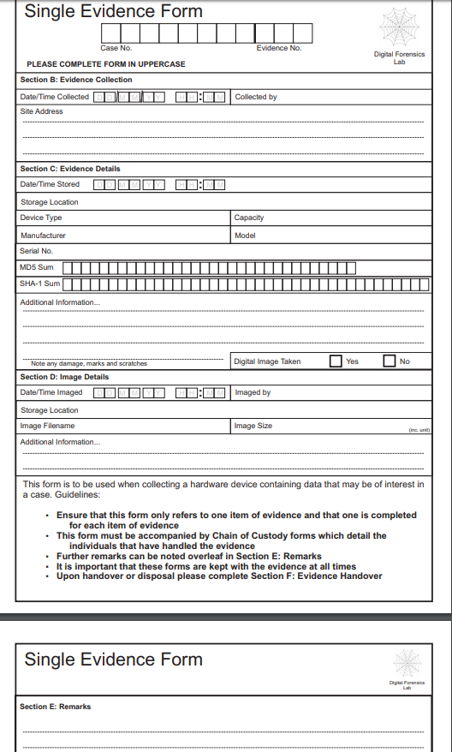
Figure 2 Single Evidence Form
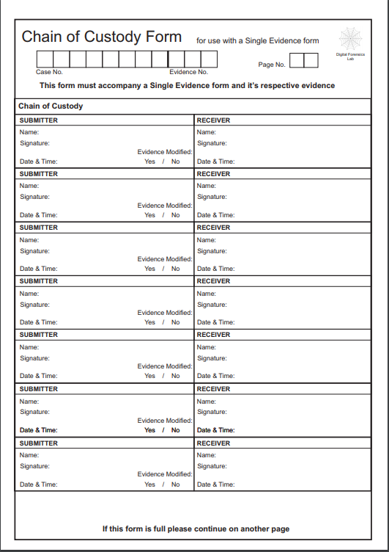
Figure 3 Chain of Custody Form

CASE ANALYSIS
Mr. John analysis the case file through FTK Imaging, PRTK password recovery, MailXaminer and Autopsy tool for the purpose of providing the better evidence from the suspect terrorist’s laptop, was asked to retrieve some of the following:
- Any Microsoft words
- Excel and PDF file
- Images files such as jpeg, giff, bmp, tiff
- Video files such as avi, mpeg, dat, mov and audio files (mp3, wav and rm) all from this case
- Microsoft Outlook contacts, messenger chat history, email messages, cache files and email messages.
Mr. John went through to the case overview from FTK Imager and retrieved each file that requested, as a detective investigator should have a good understanding of each file name and looks more on category column from the file list because sometimes the suspect change the file name and put the wrong file for hidden the important evidence as a part of tricky and even could encrypted the files for only password access to be open. John went through step by step to provide the good evidence requested
For the quick search John went to the file extension key word search and searched for the keyword requested to retrieve, such as .pdf for PDF file, .jpeg for images file and so on.
Some of the file John needed to change the format by right click the file and went to export/explore and straight exported to the desktop. Managed to change the file format to the really one by rename and found the exact thing hidden from these files. Also, John used PRTK tool for password recovery from FTK to have access with the encrypted files.
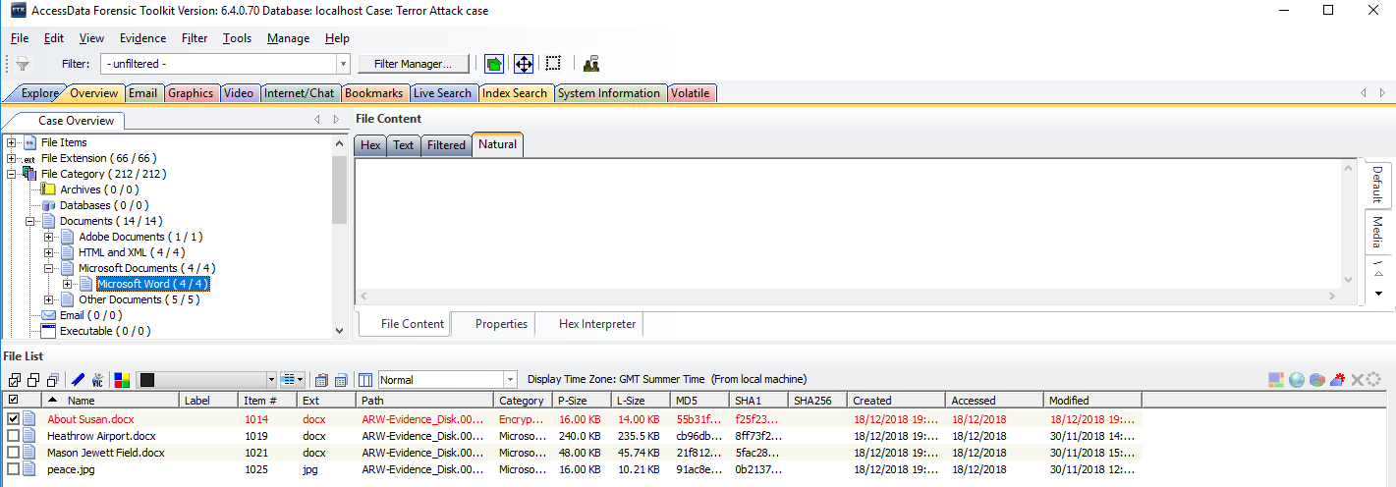
Figure 4 FTK shows File category
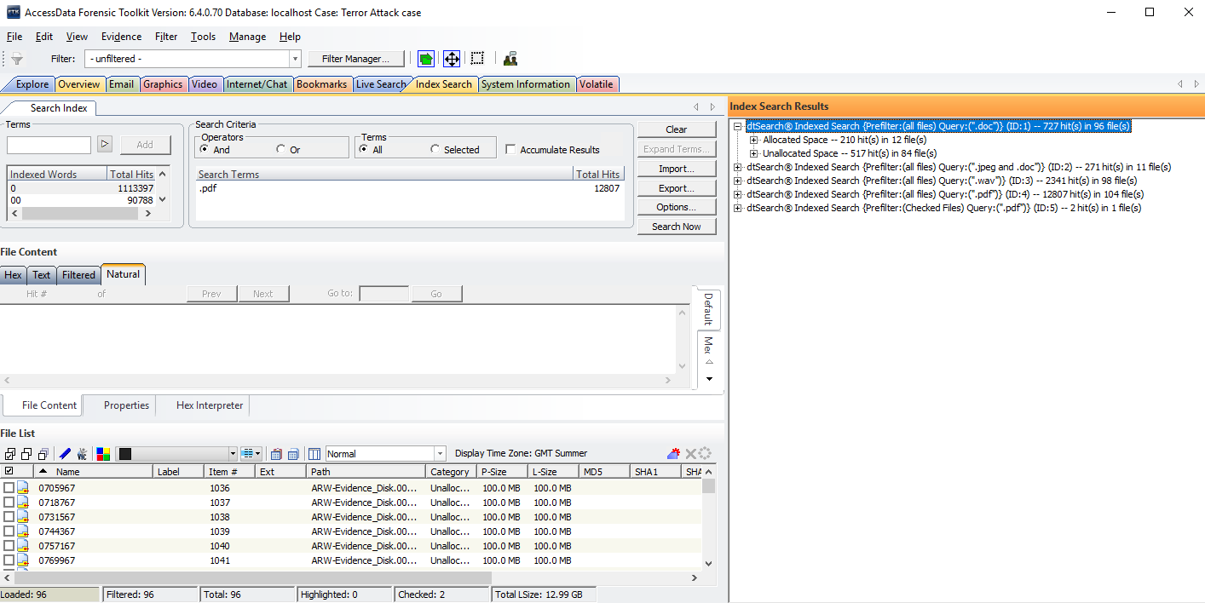
Figure 5 FTK shows Index search
Apart from this, John noticed some of the video files is related to the different terrorist attack details according from the video descriptions even when opened the video itself such the one of 9/11 Bombings the terrorist saved as 9_11~September 11th 2001-Attack on the World __ Trade Center. John made clear details list for each video found, that for the better report reference and for the easy brief of each videos founded attached with document of explanation of what each video included inside, so when the time to present to the court will be easier to be identified of each video content.

Mr. John also discovered the terrorist had some of the terrorist logos that present association group, how to bomb the Mason Airport, also mentioned important document related to the case such as how to make chemical bomb, how to prepare for jihad and put picture of Heathrow and Mason Airport as the part of the terrorist bombing plan.

John used MailXaminer forensic tool for getting the contacts list of the terrorist’s Microsoft Outlook because John knew this software is the best for quick analyzing email data in forensic.

John found the excel sheets and was encrypted by the terrorist, when decrypted by using PRTK tool found details of the bank account, also used the Autopsy John found all the bank details from the credit files.

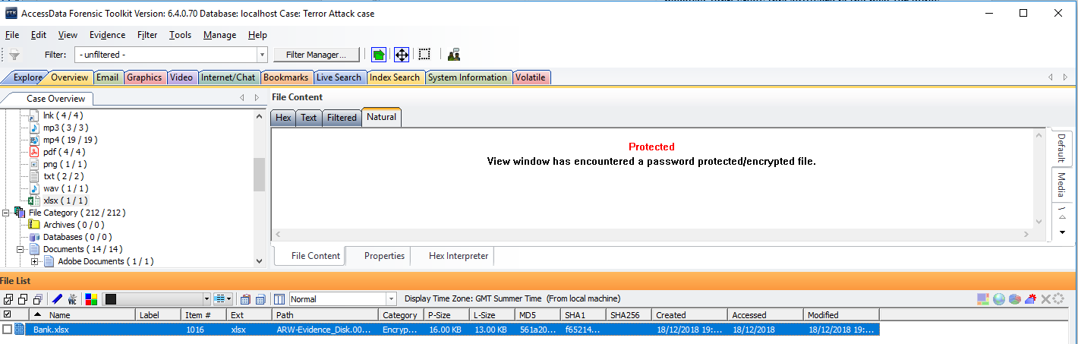
Figure 6 FTK shows Bank details for Excel protected

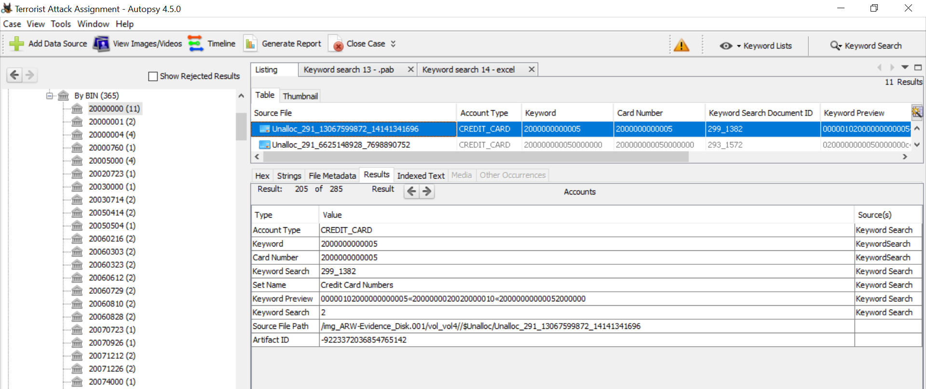
Figure 7 Autopsy shows Bank details
As part of the investigation, found the few documents with immigration visa details, also found some pictures of Heathrow and Fiji airport, two passports one was British by the name of Saajid Muhammad Badat and other terrorist saved by changed format to mp3 instead of jpeg and is an Indian passport that proved the link to the terrorist organizations.

CONCLUSION
This report has divided into two part, the first part explained about the research forensic tools, how the forensic tools used in different needed sector, some of the area mentioned is in email forensic, hard disk imaging, network and android forensic tool.
The next part is case study of terror attack case, the case Mr. John received to do the investigation of terrorist attack and to examine the all items founded from the terrorist. Mr. John acted as an Incident handler, mentioned the analysis techniques on how achieved to bring the best evidence without changed the original data collected. Also explained how John retrieved the details included images files, video files, audio files, email messages and the contacts from MS Outlook. Mr. John outlined process by process until reached the case conclusion for the final report to Mr. Mark.

APPENDICES
Below is the John invoice for the service of professional to Mr. Mark Wales.
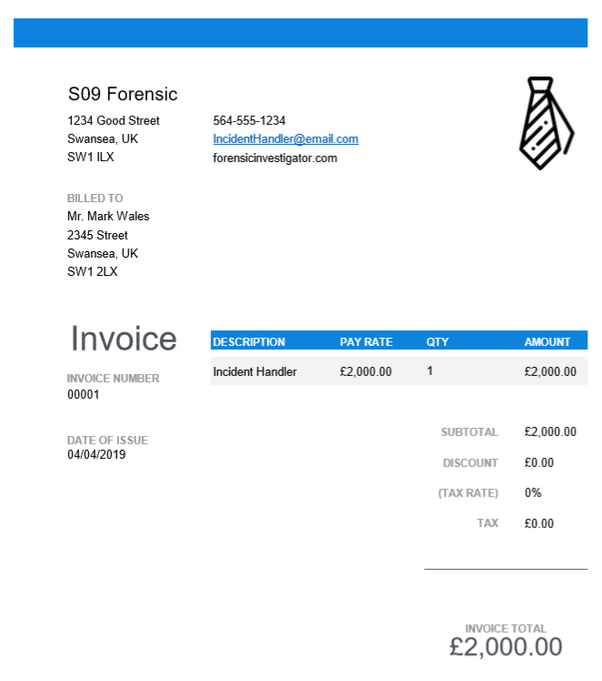

REFERENCES

[1] | "Introduction to computer forensics," [Online]. Available: https://forensiccontrol.com/resources/beginners-guide-computer-forensics/.
[2] | M. Thomas, "Top 7 Most Popular and Best Cyber Forensics Tools," 4th July 2018. [Online]. Available: https://www.hackread.com/top-7-cyber-forensic-tools/.
[3] | A. Tabona, "Top 20 Free Digital Forensic Investigation Tools for SysAdmins," 10 July 2018. [Online]. Available: https://techtalk.gfi.com/top-20-free-digital-forensic-investigation-tools-for-sysadmins/.
[4] | "FTK® Imager 4.2.0," [Online]. Available: https://marketing.accessdata.com/ftkimager4.2.0.
[5] | H. C. Cory Altheide, "HASING," in DIGITAL FORENSICS WITH OPEN SOURCE TOOLS, Waltham, Elsevier, 2011, pp. 56-57.
[6] | D. Ayers, "A second generation computer analysis," Digital Investigation, vol. 6, pp. s34-s42, 2009.
[7] | "Advantages and Disadvantages of FTK and EnCase," 7 April 2017. [Online]. Available: http://acid-burninfo.blogspot.com/2011/04/sadvantages-and-disadvantages-of-ftk.html.
[8] | H. W. R. J. H. Majeed Raji, "Analyzing Data from an Android Smartphone while Comparing between Two Forensic Tools," in IEEE, St. Petersburg, FL, USA, 2018.
[9] | J. Aguilan, "Top 10 free tools for digital forensic investigation," 19 June 2018. [Online]. Available: https://www.qa.com/blogs/cyber-digital-forensic-investigation.
[10] | "Memory Forensics and Analysis Using Volatility," 19 May 2018. [Online]. Available: https://resources.infosecinstitute.com/memory-forensics-and-analysis-using-volatility/#gref.
[11] | C. Easttom, in System Forensics, Investigation and Response, , p. Paperback 400 pages .
[12] | "Digital Forensics Review and Tutorial Project (Caine)," [Online]. Available: https://danoataylor.wordpress.com/digital-forensics-review-and-tutorial-project-caine/.
[13] | A. Fortuna, "What is SIFT Workstation and how install it on my Linux (or Windows) system?," 14 March 2018. [Online]. Available: https://www.andreafortuna.org/2018/03/14/what-is-sift-workstation-and-how-install-it-on-my-linux-or-windows-system/.
[14] | d. son, "Xplico: network traffic monitoring tools," 22 September 2017. [Online]. Available: https://securityonline.info/xplico-network-traffic-monitoring-tools/.
[15] | Riccardo, "Xplico a network forensic analysis tool," 27 October 2017. [Online]. Available: https://linuxaria.com/article/xplico-a-network-forensic-analysis-tool.
[16] | C. V. ,. L. C. Leonardo Carvajal, "Tools for Collecting Volatile Data: A Survey Study," IEEE, Konya, Turkey, 2013.
[17] | B. w. Guest, "6 Best Computer Forensic Analysis Tools," 16 October 2018. [Online]. Available: https://www.valuewalk.com/2018/10/6-best-computer-forensic-analysis-tools/.
[18] | I. B. F. B. Kevin Conlan, "Anti-forensics: Furthering digital forensic science through a new extended, granular taxonomy," Digital Investigation, vol. 18, pp. s66-s75, 2016.
[19] | S. L. G. Jessica R. Bradley, "bulk extractor 1.4," 2013.
[20] | "Introduction to Redline," 9 October 2017. [Online]. Available: https://cyberforensicator.com/2017/10/09/introduction-to-redline/.
[21] | Mr.J, "Comparison of Memory Forensic Tools," 18 08 2011. [Online]. Available: http://jay-fva.blogspot.com/2011/08/comparison-of-memory-forensic-tools.html.
[22] | P. Shankdhar, "Popular Computer Forensics Top 21 Tools [Updated for 2019]," 17 February 2019. [Online]. Available: https://resources.infosecinstitute.com/computer-forensics-tools/#gref.
[23] | H. Dalziel, "DIGITAL FORENSIC TOOLS & SOFTWARE," 13 December 2018. [Online]. Available: https://www.concise-courses.com/hacking-tools/forensics/.
[24] | H. Passi, "Top 20 Trending Computer Forensics Tools of 2018," 23 May 2018. [Online]. Available: https://www.greycampus.com/blog/information-security/top-twenty-trending-computer-forensics-tools.
[25] | Alexandria, "OXYGEN FORENSICS ENHANCES CLOUD AND DECRYPTION CAPABILITIES," 11 October 2018. [Online]. Available: https://www.oxygen-forensic.com/en/press-19.
[26] | SYTOOLSGROUP, "EMAIL FORENSICS," [Online]. Available: https://www.systoolsgroup.com/email-forensics.html#.
[27] | J.M.Porup, "What is Wireshark? What this essential troubleshooting tool does and how to use it," 17 September 2018. [Online]. Available: https://www.csoonline.com/article/3305805/what-is-wireshark-what-this-essential-troubleshooting-tool-does-and-how-to-use-it.html.
[28] | L. G. M. Ankita M. Ghate, "Survey on designing framework for analyzing twitter spammers using forensic method," in IEEE, Pune, India, 2015.
[29] | Relativity, [Online]. Available: https://www.relativity.com/ediscovery-software/app-hub/guidance-software/.

