
Investigating the Implementation of Split Stack Web Application Architecture
Written by Joseph Evans, Mentored by Dr Kemi Ademoye
April 6, 2019
University OF WALES TRINITY SAINT DAVID



Contents
Introduction 2
Research Methodology 4
Hypothesis 4
Aims & Objectives 4
Main Body 5
Security 5
Performance 5
Resource Consumption 7
Popularity 9
Limitations of This Investigation 9
Conclusion 10
Evaluation 10
References 12

Introduction
Currently, web architecture is often implemented in a relatively tried & tested fashion, this architecture is often referred to as MVC. MVC simply stands for ‘Model’, ‘View’, & ‘Controller’, this is often referred to as a standard & easy way to write the code powering the relevant web application(s) [1, p.1]. This architecture simply states how you can split your code into different components, thus the views being what the user will see & interact with, the controller(s) being referred to as “the unity of the MVC architecture” [1, p.3], furthermore the model being known for storing data about the user(s) & relevant resources.

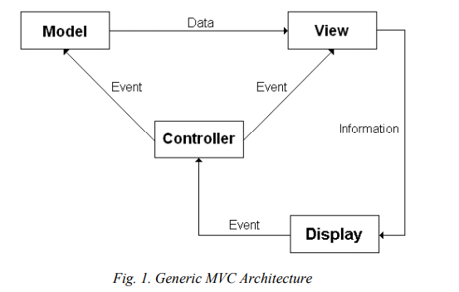
[1, p.2]

It is stated that a problem that may be found with applying a traditional MVC design to web applications is how the MVC design pattern states that the implementation should be “partition-independent” [2, p.2]. Seeing as the native architecture of the web is based on location dependency, natively partition-independence can be somewhat challenging. Hence why a RESTful API for the back end makes more sense in a lot of scenarios, as the common implementation of REST is in fact location dependent.
An example being how the partitioning proportion of the project must be done early on within the phase of development. Furthermore, such a decision can be hard to apply & cater for future changes, it’s considered to be an impossible task to achieve early in the design phase [2, p.2]. As stated, such a statement is reasonable, due to the ever-mutating requirements of a project throughout its life. It is a near impossible task to ensure that such problems never arise during the design phase of a project.
Alternatively, a lot of web applications may also make use of clients beyond the web browser, although these thick or heavy clients often make use of a very similar architecture of the MVC architecture. Often, client applications will typically make use of what is often known as a MVVM style architecture. 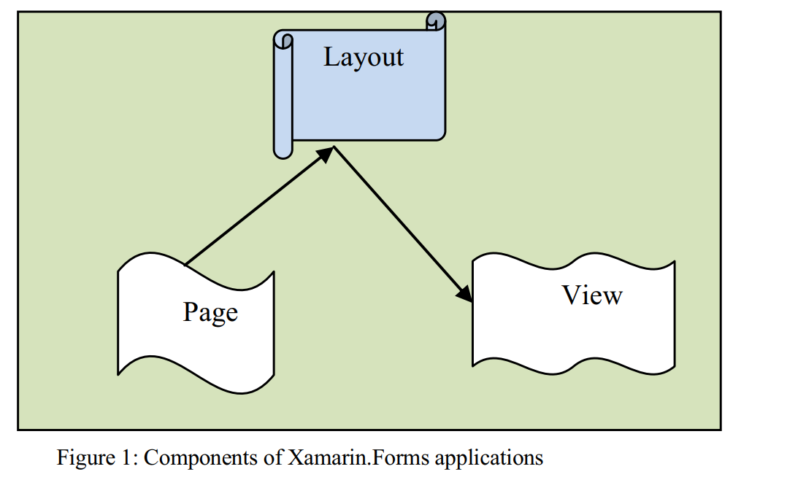
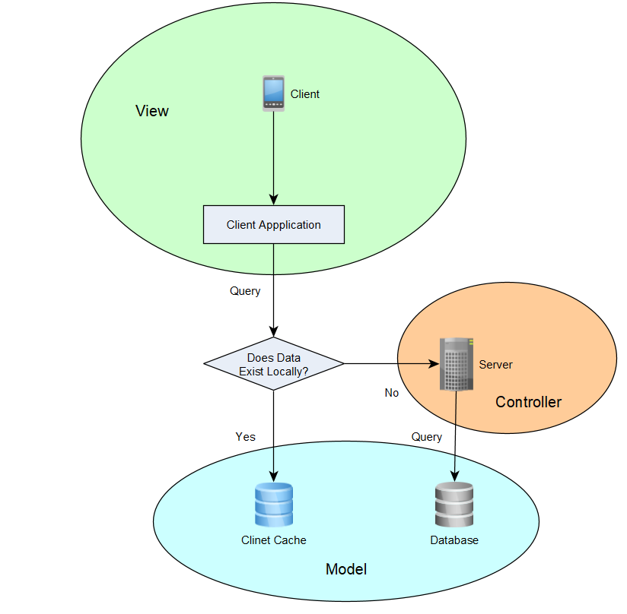
[10, p115]
Within this document, it is proposed that the web application architecture is to change, applying the same, or similar flow diagrams as illustrated above, only applying the programming rule of separation of concerns to a more in-depth extent. As an example, here’s an illustration to demonstrate the separation of concern within the stated application architecture, of-course the illustration is rather vague, it’s merely provided as a minor demonstration.

Research Methodology
For the stated research, it appears only suitable to conduct primary research, gathering a collection of both quantitative & qualitative data, as there is a requirement for statistics, such as performance analysis, however there’s also a need for more soft data as a lot of the content covered within this topic may contains some content which may appear to be somewhat opinionated. Furthermore, as it’s such a new area of research & the specific topic(s) covered do not have an immense amount of published research, hence the need for qualitive data.
Since this research is specifically covering a specific area of software development, it’s clear to state that this research will consist of more Phenomenology philosophy, a deductive approach & a mixture of document review(s) & software development strategies. The data that’s required for this document consists of opinions & statistics revolving around the many variables that come into play when determining the most effective web application architecture.
For the software development side of things, for the purpose of this research, I will focus mostly on two concepts, including the KISS programming principle & a separation of concern(s). To aid the research within this document, there will be a need for some degree of prototyping. To ensure that the conclusion is accurate, it is reasonable to presume that an evaluation considering a mixture of opinions & facts, including the current web development trend(s), performance, security, etc.
With regards to prototyping, it is necessary to conduct some experiment(s) revolving around performance. One potential performance experiment could contain analysing the performance benefits of a full stack architecture vs a split stack architecture while handling an unrealistic number of DOM elements.

Hypothesis
Web application architecture will mutate & change over the course of time, in such a shift that web applications will begin to make use of a split stack style architecture compared to current & previous architectures. It is believed that split stack web application architecture is more beneficial for an array of reasons, potentially the main reason being how it may allow companies & businesses to provide the best possible user experience when interacting with the relevant web application(s). Though, to ensure that user experience is kept to a maximum, it goes without stating that companies will have to implement their client-side applications using a progressive web application approach, or something of a very similar nature. To cater for such front-end applications, it is assumed that a backend architecture such as RESTful API’s may be come more & more common as web technologies continue evolve.
Provided the research conducted supports the statement, how split stack web architecture is more beneficial, then it is reasonable to conclude that split stack web architecture may be the future standard of web application architecture.

Aims & Objectives
The aim of this document is to conduct thorough research into concluding if split stack web application architecture may become the standard for web application architecture. Of course, the requirements of specific applications will change on a wide array of variables, including both technical & business requirements. A simple example being how an eCommerce company may care more so about SEO (Search Engine Optimisation) over UX (User Experience) due to the business requirements.
Furthermore, a distinctive aim is to provide some degree of documentation providing evidence how the stated architecture could withstand the test of time & how it can be flexible to cater for an array of requirements. Much like existing architectures, the split stack approach isn’t perfect, but this document seeks to provide clarification.

Main Body
One issue that is immediately recognised with the proposed architecture is how it may impact SEO for the worse as stated, “The content build by SPA’s is dynamic & search engines have a difficult time processing them, this can result into poor page rank” [3, p.2]. One may argue how this statement, while true, may or may not be relevant in so many years times. Due to the rise of occurrence of single page applications over the past ten or so years [4]. This leads to the argument of how search engines may be re-engineered to process such web applications in a more effective & efficient manner than present.
On the other hand, the proposed architecture may also provide benefits, such as how a single page application approach can potentially improve performance, as stated “save bandwith as well as time required for this client-server request-response cycle” [3 p.4]. Thus, if one’s aim is to provide as good of a user experience as possible, then perhaps this may be a more enticing architecture to apply to one’s web application. Furthermore, if one were to prioritise user experience to the extent where one’s web application can be considered & categorised as a PWA(Progressive Web Application), then this in turn will actually improve the SEO performance of the given web page due to the nature of the fact that PWA’s provide what’s considered to be “the best web experiences” [5].

Security
One large topic that is required to be covered with any web application is security, this is an interesting topic considering how this architecture may fix some security issues, but potentially present new ones. One example being how if implemented correctly, the client side will make use of MET’s (Mutation Event Transforms) to allow for a server to essentially monitor client-side behaviour [6, p2 - 3]. Furthermore, traditional web application architecture(s) rely on state & often application state is managed in memory, aka held within a session object, as opposed to other potential solutions for storing & managing application state, such as utilisation of a database [8, p1].
While HTTPS is not a new technology by any means necessary, however, in order to develop a progressive web application, developers must implement their application to make use of HTTPS [11]. Unlike traditional web-based applications, where one can use either HTTP or HTTPS, progressive web applications instantly enforce the application to at least implement this basic level of security.

Performance
One incredible advantage of making use of the stated application architecture is the added performance & the best part is that this applies to either side of the web application, both the back end & the front end. Looking at things from a client-side perspective, thanks to the implementation of a modern web architecture, a client device can make use of parallel computation, with little-to-no complexity through the utilisation of what is commonly known as a “Web Worker” [9, 105].
It goes without stating that the use of multiple threads compared to a single thread can often increase the overall performance of some application, although this is not always the case.
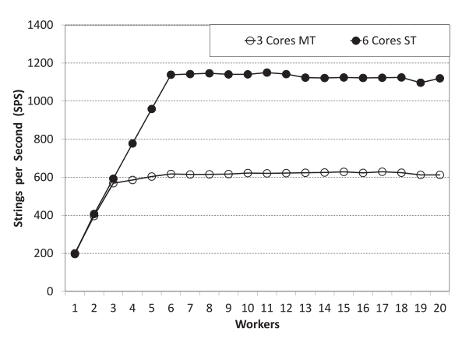
[9, p106]
As illustrated above, there are such scenarios where an application may benefit from the utilisation of a web worker. However, as this source also states, for a device to truly benefit from web workers, a variation of other variables come into play, such as the underlying hardware of the user’s devices & the underlying architecture & algorithms that are being applied within the web browser [9, p108].
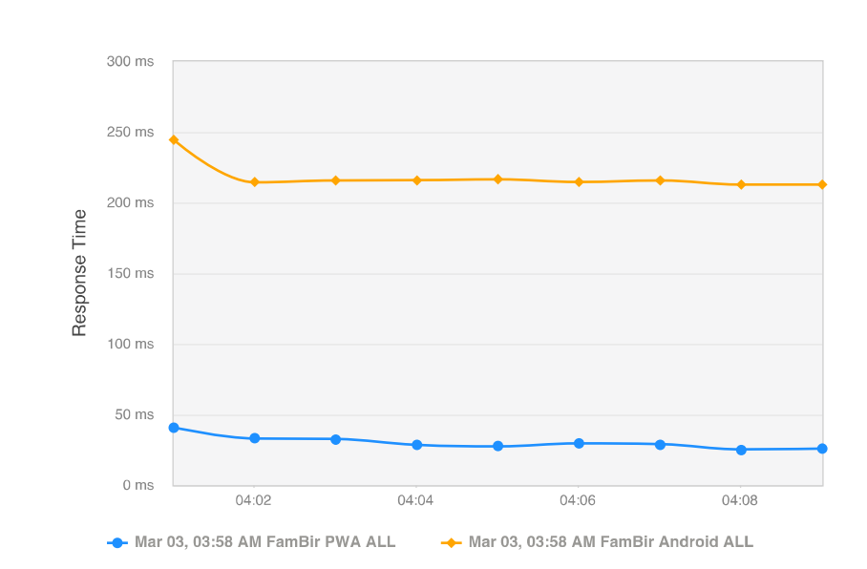
2[13, p297]
Furthermore, due to the nature of progressive web applications making use of cache, it’s natural to assume that this is an instant performance enhancer for the client application. As a result, this holds to be true, as can be seen in the illustration above. Not to mention that due to the observation that as the more often a user interacts with a progressive web application, the response time decreases at a rather drastic rate as time goes on, i.e. load time [13, p297].
As stated by Philip Walton & Shubhie Panicker, engineers at Google, one core focus of performance is user perceived performance. That’s one thing that makes this web application architecture so excellent is that due to the nature of progressive web applications, it almost makes the back-end performance irrelevant, to a certain extent of course [14]. Due to the nature of JavaScript behaving in an asynchronous fashion by default, as clearly stated with the Node programming model. “Node’s I/O approach is strict: asynchronous interactions aren’t the exception; they’re the rule” [15, p81]. This is essentially a part of how one can implement the theory that’s stated in Philip & Shubhie’s documentation, for long running tasks, rather than block the main execution thread, simply run it in an asynchronous style manner, this may simulate to the user that the application is more performance optimised than what it really is.

Resource Consumption
From a client-side application perspective, one added benefit to the user of the application(s) in question is that via the use of a progressive web application implementation, this will enhance the general user experience & reduce the amount of resources required for the user to compute & execute the application.

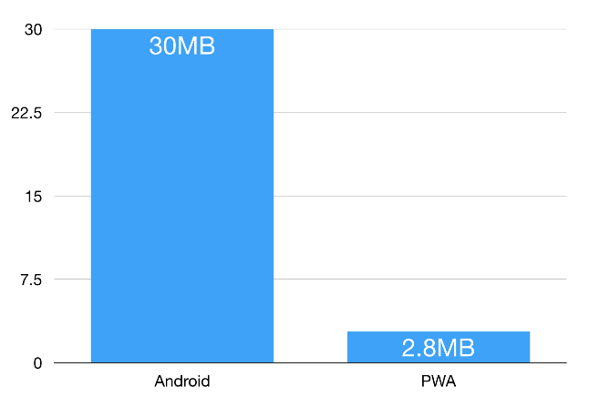
[7]
The above chart is an illustration the comparison of size with regards to what is often referred to as a native application & a progressive web application. It is regarded as common knowledge how a lot of mobile devices have limitations with regards to the amount of storage, they have available, as it is clear, via the implementation of a progressive web application it reduces the amount of resources required for the application. Considering that other sources, support this claim that progressive web applications are substantially smaller than native applications, it is reasonable to state that this is a reliable source, as seen in the other illustration below.
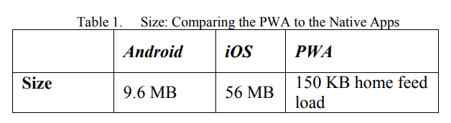
3[13, p295]
One excellent feature of having a stateless backend web application in place is that they typically tend to be more resource friendly, thus potentially reducing the cost of running the server. An example of how back end architectures such as a RESTful API may operate without the overhead in creating & maintaining a session [16]. Though, there are scenarios where one may wish to have some degree of state within an application to some extent or another. An example of when it may be important to maintain state is a shopping cart, to deny that such a feature is not stateful by design is fundamentally incorrect, potentially even counterproductive.

Popularity
When looking at the popularity of the search terms “MVC”, compared to “SPA”, over the past five years, it’s clear to see that the rise in popularity of single page applications has overtaken MVC. It’s also clear to conclude that the term progressive web app is on the rise & provided that the stated hypothesis holds to be true, then the term “PWA” will only continue to rise. Furthermore, as technologies become more & more popular, it’s a natural pattern to see that more & more support, investigation, research, etc. goes into the stated technology, thus rendering the technology more stable, supported & powerful all round, take social media as a prime example of such statement.
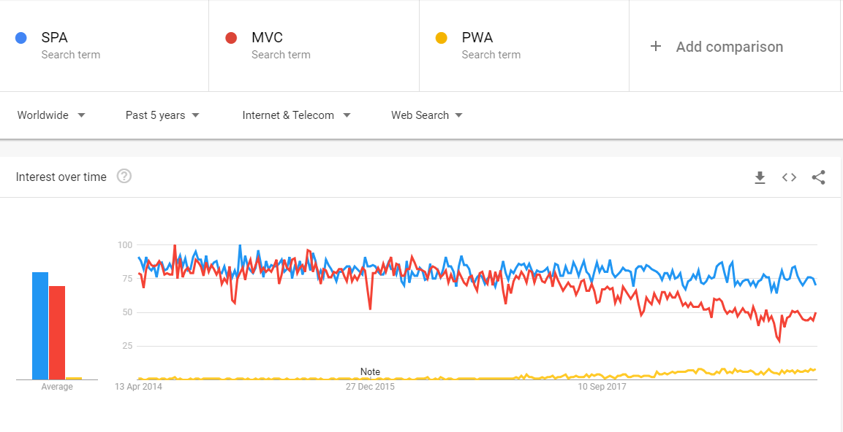
[12]

Limitations of This Investigation
While this investigation aims to cover the main subjects of focus regarding which architecture may be suitable for a web-based application. It’s logical to state that this document has not covered all possible evaluation metrics, including the cost of upgrading the architecture, including the time it would take to upgrade such architecture. One may argue how the stated hypothesis may be somewhat invalid for individuals with legacy devices or those whom utilise systems with very little computational power to make use of. Some may also argue that in order to implement such web application architecture, it requires more skilled & educated engineers than the average, etc.

Conclusion
Analysing the research provided from both academic sources & non academic sources, it’s reasonable to conclude that there are many advantages to implementing a web-based application via the utilisation of a split stack architecture. Such architecture goes as far as supporting many programming concepts & principles, including KISS as back end developers do not need worry about the view, they only need worry about more pressing matters like validations, verification, security, etc. Then of course the other end of the spectrum applies to front end engineers whom have a different skillset all together, such individuals will of course be concerned with the user experience, the design of the interface & as stated, user centric performance.
An issue with traditional web application architecture is that if a user of a system performs some action that requires some time for the back end application to operate, then this renders the overall application to appear slow to the user, as the user may have to wait for the back end application to finish the last operation before the user is able to interact with the application again. The beauty of a split stack application architecture is that this problem is immediately resolved. A prime example could be how the user needs to run some task which may appear trivial to the user, but for x number of reasons is substantially more complex than what one may expect. A real-world example may be how one may need to run some automated task, such as a system relying on some other system for information to verify the information provided to the initial system. In such a scenario, the back-end performance is inheriting any performance issues that may occur with an external system, even though it may not necessarily be doing anything except for waiting for a response from such external system(s).
With the rise of companies migrating from internal infrastructure to IaaS platforms such as Azure or AWS [18]. It seems highly cost efficient for such companies to take advantage of such an architecture as the more client-side processing that can be done on trivial tasks, it could reduce the cost(s) of running their web application greatly. Of course, this could potentially save certain companies more than others, as some companies may have incredibly dynamic data sets where the user will need to continuously query the back end. As opposed to other companies which may have very stagnant data sets, where the user may only need to update the cached data source(s) once every month, these companies would financially gain the most from such architecture being deployed within their web application.

Evaluation
As stated within the main body, there are limitations to this investigation, to elaborate upon what’s previously been stated, it’s reasonable to state that in order for such a web application architecture to take place, it requires either skilled front end developers & back end developers to be able to work on separate systems to function in parallel, or highly skilled full stack developers. A scenario of when a highly skilled front-end developer is needed is to prevent session hijacking or cookie theft, with very basic & minimal security implementations, this is simply not enough. In theory, due to a split stack application architecture, it can make security flaws such as session hijacking more prone, compared to an alternative solution such as JSF where such a framework relies on array of different states to be in synchronisation for the application to operate & work as expected. With such technologies as JSF which is an MVC based framework which typically makes use of a very stateful back end application.
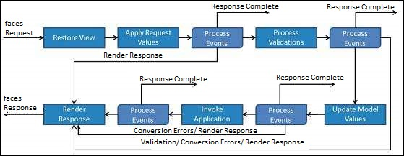
[17] – JSF Life Cycle
Another area that this document may appear to lack in is content revolving around demographics, one may be able to argue or imply that progressive web applications may confuse certain groups of people. Of course, this partially depends on how one implements the progressive web application, however if one were to implement a web application such as Tinder, as an example, one cannot simply use such application while in the web browser, one must download the application on a mobile device from the relevant app store. However, if one were to implement a progressive web application such as Squoosh, where one can use it within the web browser, this may render such confusion to be distinguished.
Furthermore, one may also argue that such an architecture is so immature that it lacks support, documentation, formal specification, thus such architectures being experimental for the time being, it is possible that during the time where such architecture is considered as experimental, perhaps an entirely new architecture may emerge. While it’s unlikely, it is possible that within this time frame web technologies may seize to exist, the internet as we know is my possibly revolutionise & the HTTP protocol could possibly all together diminish into an outdated technology. As stated, while this is very unlikely to happen within the foreseeable future, it’s far from impossible as there may emerge a way to communicate information in a much more efficient, secure & reliable fashion.
Yet another valid argument against implementing a web application to make use of a service worker is that the underlying browsers may have yet to discover bugs, furthermore, or potentially worse yet, the target browsers may not support such technologies. An example being how still, 2.37% [19] of the world still makes use of Internet Explorer 11 to some extent or another, yet this browser does not support the implementation or use of a service worker which is a fundamental component in implementing a progressive web application.

References
- D.M.K Kristály, A.V.C Craciun, A.P Pelcz & I.T Truican, “MVC Architecture In Web Applications Development” [Online], September 21 2005, Available: https://bit.ly/2JgYoSo
- A.L Leff & J.T.R Rayfield, “Web Application Using the Model/View/Controller Design Pattern” [Online], IBM T.J Watson Research Centre, 2001, Available: https://bit.ly/2FhUOmW
- M.A.J Jadhav, B.R.S Sawant, A.D Deshmukh, “Single Page Application using AngularJS” [Online], 2015, Available: https://bit.ly/2FjohgA
- Google Trends, “Single-page application” [Online], 2019, Available: https://bit.ly/2OencJK
- C.L Love, “Do Progressive Web Apps Help Organic Search Engine Optimization?” [Online], 15/03/2019, Available: https://bit.ly/2Tcx7jU
- U.e Erlingsson, B.L Livshits, Y.X Xie, “End-to-end Web Application Security” [Online], Microsoft Research, 2007, Available: https://bit.ly/2udJ52y
- A. Osmani, “A Tinder Progressive Web App Performance Case Study” [Online], 24 December 2017, Available: https://bit.ly/2pTSw7R
- S. Hadjiefthymiades, D. Martakos, C. Petrou , “State Management in WWW Database Appplications”, University of Athens, 21 August 1998
- IEEE, “Performance Scalability Analysis of JavaScript Applications with Web Workers”, 26 October 2015
- K. Vishal, A.S. Kushwaha, “Mobile Application Development Research Based on Xamarin Platform”, Lovely Professional University, 31 August 2018
- Google Developers, “Progressive Web App Checklist” [Online], 12 February 2019, Available: https://bit.ly/2qvK6Tq
- Google Trends, a comparison of the terms “SPA”, “MVC” & “PWA” [Online], 13 April 2019 Available: https://bit.ly/2Is4D3K
- A. Gambhir, G. Raj, “Analysis of Cache in Service Worker and Performance Scoring of Progressive Web Application”, Amity University Uttar Pradesh, 23 June 2018
- P. Walton, S. Panicker, “User-centric Performance Metrics” [Online], Google Web Fundamentals, 12 February 2019, Available: https://bit.ly/2HVcwvP
- S. Tilkov, S. Vinoski, “Node.js: Using JavaScript to Build High-Performance Network Programs”, volume 14, issue 6, 1 November 2010
- Xeonstack, “Sateful and Stateless Applications Best Practices and Advantages” [Online], 11 December 2018, Available: https://bit.ly/2SIQWPq
- Tutorials Point, “JSF – Life Cycle” [Online], 15 December, 2012, Available: https://bit.ly/2VMzsnO
- O. Kiddell, “Why IaaS Is Becoming A Popular Alternative To On-Premise IT” [Online], 21 July 2016, Available: https://bit.ly/2P7Uzyc
- W3Counter, “Browser & Platform Market Share” [Online], March 2019, Available: https://bit.ly/2KvBJ5o

