Financial Management for the Hotel Industry

Business Report:
Comparison of Corinthia Hotels and Ibis Hotels

Student name: Ana Maria Stoica
Student id: 2210328
Module Code: BMIH5007, BMIH5002
Lecturer’s Name: Tristan Hawkins
Word count: 2715

Executive summary
The report has included the study of two hotels, Corinthia Hotel Group and Ibis Hotels where it has described their source of revenue and revenue generated by them. The report has explored the market share of both hotels along with customer demographics and brand perception across the nation and the globe. The report has also described their expansion strategies and upcoming market opportunities and threats which hinder the performance of each hotel within the competitive market. The corporate social responsibilities of each firm have been highlighted to reflect the ethical and sustainable practices.

Table of Contents
Introduction 4
Presenting total revenue, sources of revenue, revenue trends and the elements which influencing the growth of revenue of Corinthia hotel group and ibis hotels 5
Assessing the market positioning of the given hotel groups 8
Evaluation of the growth potential of each organization 11
Explaining the financial commitment to CSR of Corinthia Hotels 13
Explaining the financial commitment to CSR of Ibis Hotels 14
Recommendations 15
Conclusion 16
References 17

Introduction
The business report will highlight the aspects of the financial management practices and strategies of the two hotels. The source and trend of the revenue of Corinthia Hotel Group and Ibis Hotels will be explored to critically analyses the areas and factors that have driven the growth or decline of the two hotels. The report will also assess the positioning of both hotels in the market along with their customer demographics and the precipitation of the brand image among the customers. The report will also explore the potential growth for both hotels by examining their strategies, market opportunities and potential barriers to the business. The report will also cover the aspects of corporate social responsibility of both firms to encompass their sustainable practices, community engagement and ethical practices included within the business.

Presenting total revenue, sources of revenue, revenue trends and the elements which influencing the growth of revenue of Corinthia hotel group and ibis hotels
Corinthia hotel group
Sources of revenue
Corinthia hotel group is the parent group of the hotel Corinthia and this business group is expanding its hotels as well as resorts in Africa and Europe. Each and every hotel is earning its profit by selling the services to its customers and guests (Ivanov et al., 2021). It can be said that the source of revenue of this hotel is its tourists or the customers.
Revenue trends
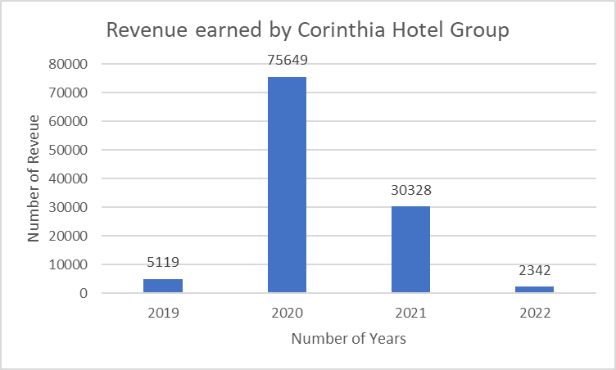
Figure: Corinthia hotel’s Revenue trend
Source: (Corinthia, 2024)
According to this graphical chart the revenue trend of “Corinthia hotel” can be understood. The graphical illustration has shown the total revenue of 2019 which is much lower than the revenue of 2020. On the other hand, even during the time of pandemic this respective hotel has earned a lot of revenue. Next year the revenue of Corinthia has decreased compared to the previous years, however it was more than the revenue of 2019 (Corinthia, 2024). Although, the company could not make a good revenue in the year 2022, which was even less than 2019 and its numerical amount was 2342 British Pound. It can be stated that the revenue trend of this respective hotel was fluctuating time after time.
Elements which have accelerated the revenue of Corinthia hotel
The wage rate, inflation and expansion initiatives can be considered as elements which have accelerated the growth of revenue. The inflation rate and wage rate are indirectly related to each other, it means whenever the rate of inflation has enhanced the company has to pay a high wage to its employees. This respective thing has enhanced the working capital of the hotel, and it could not expand its business as well. As the company could not expand its business the growth of the revenue of the respective hotel also became affected.
Ibis hotel
Sources of revenue
Similarly, Corinthia hotel group the Ibis hotel also earns its revenue from its guests and customers. The respective hotel is providing room, food and other facilities to its customers and in exchange for that service the customers are paying the remuneration to the hotel (Ivanov et al., 2021). The hotel is also providing an event area as well as community halls to its guests which is also a source revenue of this business.
Revenue trends
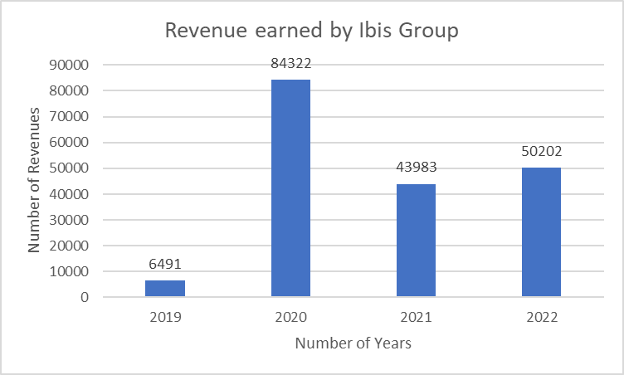
Figure: Exploring the revenue trends of Ibis Hotels
Source: (accor, 2024)
The revenue was very low in the year 2019 of ibis hotel and it was 6491 British pounds however, due to various good business performances the turnover enhances a lot in the year 2020. The revenue of the hotel declined a lot in the year 2021 compared to 2020. Again, when the hotel copes with the pandemic situation in the year 2022 the turnover improves a little compared to the previous years (accor, 2024).
Elements which have accelerated the revenue of Ibis hotels.
The numerous economic factors or elements have influenced the revenue of the Ibis hotel. The rate of unemployment, GDP and the choices of the clients has influenced the growth as well as contraction of the revenue of Ibis hotel.

Assessing the market positioning of the given hotel groups
Market share
Corinthia Hotels
Corinthia Hotels serves wealthy travelers looking for five-name reports with a significant market proportion in the elite hospitality area. Corinthia Hotels continues to have a vast presence in crucial worldwide places like London, Budapest, and St. Petersburg, however unique numbers might also differ utilizing area and lodge. Corinthia Hotels effectively competes with rival luxurious hotel chains by means of importing unmatched providers and luxurious resorts, solidifying its position as the choice of discerning travelers.
Ibis Hotels
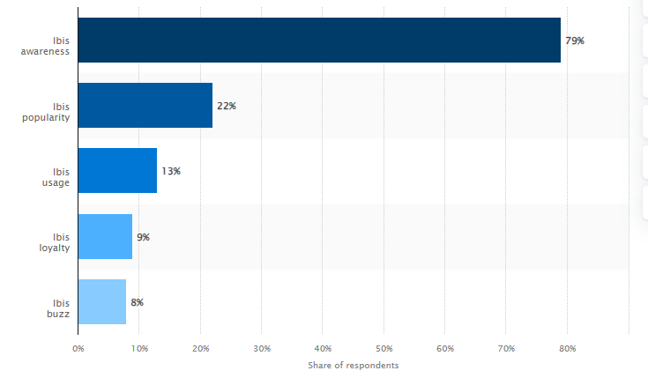
Figure: Awareness of Ibis Hotel
Source: (Statista , 2023)
The market share of Ibis hotels reflects 13% of customer occupancy in its accommodation channels within the UK while 79% of the accommodation users have an insight into the brand image and are aware of the existence of the brand due to the premium services offered to the customers (Statista , 2023). The premium and comfortable services attract 9% of loyal customers. Around 9% of its customers are ready to avail the offered services by the Ibis Hotel.
Customer demographics
Corinthia Hotels
Audiences from different demographics are interested in Corinthia Hotels with the aid of their shared appreciation of exclusivity and elegance. Rich commercial enterprise travelers looking for upscale accommodations and individualised interest while journeying crucial business centres are among its clientele. In addition, Corinthia Hotels' high priced services and best places in well-known cities entice entertainment visitors, consisting of celebrities and excessive net real worth people. Additionally, millennials who are lured to the extraordinary studies and immersive environment that Corinthia Hotels' accommodations provide are also attracted to the brand.
Ibis Hotels
The customer segmentation of Ibis Hotel covers the premium customers who love to afford luxurious products and services offered by the hotels. The indulgence of the premium customers can upscale and midscale the economy of the firm. The high-end amenities and personalised customer services increase the buzz of customers for the company and helps in maintaining loyalty among its customers. The firm also includes the segment of hosting wedding ceremonies and meeting events which results in an increase in its customer base.
Brand perception
Corinthia Hotels
Corinthia Hotels is typically acknowledged as a mark of luxury, sophistication, and elegance. The organisation has won recognition for being pleasant among travellers all around the world thanks to its rigorous interest in detail and determination to go above and past for guests. Because of its outstanding interiors, world-legance offerings, and striking architecture, Corinthia Hotels is acknowledged for its extravagance amongst visitors. In addition, the emblem's attention to social responsibility and sustainability makes it more appealing to eco-conscious vacationers searching out high-priced experiences that uphold moral standards. All matters taken into consideration, Corinthia Hotels has an effective logo picture because of its chronic commitment to providing unrivalled luxury and great service to its affluent clients.
Ibis Hotels
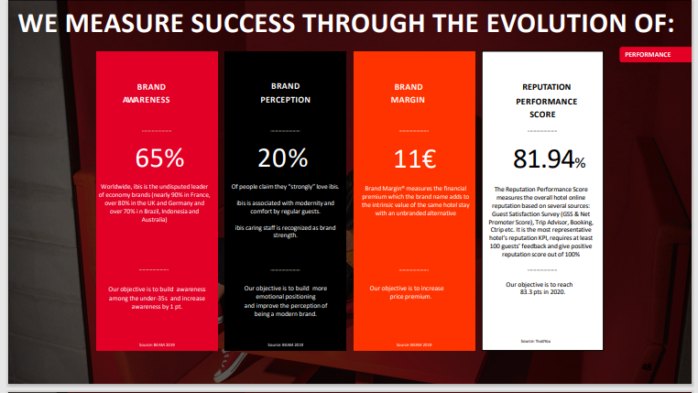
Figure: Brand perception of Ibis Hotels
Sources: (Jellesmark et al., 2023)
The firm has 20% brand perception as people strongly love the services provided by Ibis Hotels. The firm is associated with comfortable services along with the use of modernity to make its guests feel comfortable. The caring staff members help the customers recognise the strength of its brand image among them (Jellesmark et al., 2023). The main objective of this brand perception is to create emotions among the customers and enhance perception among the leading customers.

Evaluation of the growth potential of each organization
Corinthia Hotels
Examination of expansion strategies
Corinthia Hotels has indulged in a new management system within its firm to explore new ways for the expansion of the firm. The firm has also included training facilities for its employees to deliver standard services to its customers (Balinado et al., 2021). The firm is also using privacy engine facilities which can help the firm to reciprocate the behavior of the customers
Market Opportunities
The demand for premium facilities by customers has created market opportunities for the company. The shift in the interest of the customers for better beds and family rooms can help the firm acquire market share. The firm can also take advantage of hosting weddings and events ceremonies which can help it to acquire the market.
Potential barriers to growth
The change in market trends can create potential barriers to Corinthia Hotels as it can change the expectations of the customers after the impact of pandemic (Madeira et al., 2020). The trend of seasonal tourism has increased nowadays which can create barriers to the growth of the firm. The hiring and retention of staff members can create problems for the company to provide standard services.
Ibis Hotels
Examination of expansion strategies
The expansion strategy of Ibis Hotels includes the maintenance of international standards of quality services for its customers. The firm has also maintained an economical pricing policy to sustain in the competitive market and sector of hospitality. This strategy has helped the firm to operate its business in 64 different countries which has resulted in the increase in revenue after the severe hit of the pandemic.
Market Opportunities
The premium services offered by the firm can assist it to enter into new markets and operate its business. The alliance with the local level competitors can aid the firm in creating brand awareness among its new and targeted customers. The firm can create integration with the suppliers to acquire the further opportunities of the market.
Potential barriers to growth
The barriers such as low economic budgeted hotels can create a shift in demand among the customers which can be challenging for premium hotels like Ibis. After the impact of the pandemic, the issue of global competition and sustainability could hinder the growth of Ibis Hotels operating in different countries (Meager et al., 2020). The majority targeted customers of Ibis Hotels are people who look for luxurious services, thus, it can hinder the growth as well. However, Ibis Hotels should include different segments of customers to maintain its sustainability in the competitive market.

Explaining the financial commitment to CSR of Corinthia Hotels
Sustainability practices
Sustainability practices refer to the actions that fulfil sustainable activities according to the targeted measures by organisations. The Corinthia Hotels has taken sustainable measures such as making eco-garden and green roofs (Rhou et al. 2020). The sustainability practices indicate the use of greens as much as possible to reduce pollution and keep up with the environment.
Community engagement
Another important factor of CSR is community engagement defines the process of operating the working management collaboratively. Corinthia Hotels provides hotels and residential services to consumers which are based on consumer preferences. The consumers will be satisfied only when they are provided as per their preferences, so Corinthia Hotels focuses on working together as per their consumer preferences.
Ethical business practices
Ethical practices refer to the process of making decisions to build a sustainable business (Aagaard and A., 2022). Corinthia Hotels manages its operational activities by contributing to sustainable development by safeguarding the well-being of the individuals related to their community.

Explaining the financial commitment to CSR of Ibis Hotels
Sustainability practices
To reduce its influence on the surroundings, Ibis Hotels makes use of a number of sustainability measures. These encompass trash minimisation tasks like recycling programs, water conservation strategies like low-float furniture, and strength-efficient lighting and home equipment. Furthermore, Ibis endeavours the business to purchase things made in the location and presents backing for community outreach tasks (Bacari et al., 2021). Ibis Hotel suggests its determination to encourage eco-friendly journeys and sustainable tourism practices through those tasks.
Community engagement
Via a number of programmes, the Ibis Hotel places an excessive precedence on guest engagement. These encompass tailored traveller studies, loyalty plans with special blessings, and brief response customer support channels for questions and feedback from site visitors . In order to create a sense of network and loyalty among its guests, Ibis additionally uses email newsletters and social media web sites to educate visitors about specials and events.
Ethical business practices
Fair labour requirements and encouraging range and inclusion in the body of workers are methods that the Ibis Hotel helps moral practices. It also highlights moral sourcing of merchandise, supporting nearby vendors and communities (Yuan et al., 2020). Ibis is likewise dedicated to upholding human rights and putting anti-discrimination legal guidelines into impact (Aagaard and A., 2022). By making these efforts, the Ibis Hotel guarantees an ethical and socially conscious approach to its enterprise practices, constructing guest and stakeholder acceptance as true with and loyal.

Recommendations
Recommendation for Corinthia Hotels
Corinthia Hotels has been doing a great, for further development they should improve their organisational strategies such as implementing more sustainable practices to gather more customer attraction.
Recommendation for Ibis Hotels
Ibis Hotels are recommended to continue their organisational management, still, betterment in community engagements is preferred for the organisation.

Conclusion
The report concludes that Corinthia Hotels and Ibis Hotels operate an identifiable financial management. It has elaborated on the critical factors such as the total revenue of the two organisations, their market positions, and also their growth potential. The factors influence the financial performance and sustainability of the organisations. The report has also discussed the impacts of the factors on the financial activity of the organisation. Apart from this, the report also has elaborated the financial commitment of the two organisation to CSR including some recommendations.

References
Aagaard, A., (2022). Sustainable business: Integrating CSR in business and functions. CRC Press.
accor, (2024). VIBRANT HOTELS, CARING PEOPLE.. [Online] Available at: https://all.accor.com/brands/ibis.en.shtml [Accessed 19 January 2024].
Bacari, C., Séraphin, H. and Gowreesunkar, V.G., (2021). Sustainable development goals and the hotel sector: Case examples and implications. Worldwide Hospitality and Tourism Themes, 13(1), pp.9-21.
Balinado, J.R., Prasetyo, Y.T., Young, M.N., Persada, S.F., Miraja, B.A. and Redi, A.A.N.P., (2021). The effect of service quality on customer satisfaction in an automotive after-sales service. Journal of Open Innovation: Technology, Market, and Complexity, 7(2), p.116.
corinthia, (2024). CORINTHIA DISCOVERY. [Online] Available at: https://www.corinthia.com/ [Accessed 19 January 2024].
Ivanov, S., Del Chiappa, G. and Heyes, A., (2021). The research-practice gap in hotel revenue management: Insights from Italy. International Journal of Hospitality Management, 95, p.102924.
Jellesmark, S., Ausden, M., Blackburn, T.M., Hoffmann, M., McRae, L., Visconti, P. and Gregory, R.D., (2023). The effect of conservation interventions on the abundance of breeding waders within nature reserves in the United Kingdom. Ibis, 165(1), pp.69-81.
Madeira, A., Palrão, T. and Mendes, A.S., (2020). The impact of pandemic crisis on the restaurant business. Sustainability, 13(1), p.40.
Meager, S., Kumar, V., Ekren, B. and Paddeu, D., (2020). Exploring the drivers and barriers to green supply chain management implementation: A study of independent UK restaurants. Procedia Manufacturing, 51, pp.1642-1649.
Rhou, Y. and Singal, M., (2020). A review of the business case for CSR in the hospitality industry. International Journal of Hospitality Management, 84, p.102330.
Statista , (2023). Ibis brand awareness, usage, popularity, loyalty, and buzz among hotel customers in the UK in 2022. [Online] Available at: https://www.statista.com/forecasts/1335566/ibis-hotels-brand-profile-in-the-uk#:~:text=All%20in%20all%2C%2013%25%20of,brand%2C%2016%25%20use%20them. [Accessed 19 January 2024].
Yuan, Y., Lu, L.Y., Tian, G. and Yu, Y., (2020). Business strategy and corporate social responsibility. Journal of Business Ethics, 162, pp.359-377.

