MENU ENGINEERING
by Mihaela Robutu

Food & Beverage Operations
Antoinette Milne, Ka Po Chong, Philippa Fitzgerald
University of Trinity Saint David
10-11-2023

MENU ENGINEERING
PART 1: Restaurant Concept: The British Paradise Bistro
The restaurant concept involves introducing an innovative and fresh dining idea that we envision to bring outdoor beauty into a comfortable and elegant dining area British Paradise Bistro. The idea also capsulises a charming essence of the English garden and involves the traditional English garden serenity. The aim is to offer excellent cuisine to a 4-star hotel with a delicious, immersive, and visually stunning dining experience.
We aim to attract an appealing broad spectrum and diverse gain considering a few significant demographics of tourists, business travellers, and residents, as Cousins (2020) recommends. Hotel Trinity attracts visitors worldwide due to its central location in the city. The British Paradise Bistro is therefore alluring for promoting deal-making and networking for corporate meetings and a serene and calm environment for residents who value excellent dining and want relaxation from their everyday hustle and city bustle.
We have designed our menu to reflect the dynamic seasons in a local English garden. The menu will be developed regularly throughout the year to guarantee visitors homegrown and fresh ingredients at their service (Cousins et al.,2019). The menu will include afternoon tea, seasonal garden salads, roasts and grills, English garden desserts, vegetarian and vegan options, and local beverages. We will provide various salad varieties that alter with seasons, are locally sourced from gardeners and farmers, and offer guests organic, fresh, vibrant salads. The afternoon Tea will add a nostalgic touch to the experience for the tourists (Lin and Chang, 2020) while Roasts and Grills, such as beef, will be included to cater to seafood and meat lovers. Additionally, vegan and vegetarian dishes will showcase the adaptability of plan-based cookery as we adopt current dining trends. We will also have delightful desserts influenced by a gardening theme and will encompass traditional British puddings, fruit tarts, and floral-infused pastries to give visitors a nostalgic feeling. Furthermore, curated British ciders, beers, and substantial wine varieties, including UK produce, will be offered to complement the menu.
We emphaisise on this menu to guarantee our guests a memorable and engaging dining event by enjoying flavourous and natural produce that supports local gardeners and farmers while upholding sustainability, as recommended by Johnston (2012). Traditional Tea is significant in celebrating traditional British culture for visitors appreciating a heritage touch. The vegan and vegetarian options are also significant for inclusivity and aligning with current plant-based and healthier cuisine trends. It also broadens the restaurant's audience base. Additionally, we prioritise sourcing locally to support the local people and encourage sustainability measures while providing guests with high-quality and authentic British ingredients.

PART 2: MENU
Crafting a Memorable Dining Experience Menu in Keeping with the Concept
Conceptualisation
The British Paradise Bistro's concept encompasses more than just its food; it also includes the unique components, ambience, and service that immerse customers in the dreamlike setting of an English garden. Each dish on the menu has been thoughtfully selected to convey the idea of an English garden. Nature's beauty and the seasons ' passing influence each dish's components, taste profiles, and aesthetic presentation. For instance, the "British Paradise Risotto" highlights the garden's vitality with beets and peas, while the "Wild Mushroom Velouté" pays homage to the foraging customs in English woodlands. Every meal will convey a story of the British countryside courtesy of this alignment.
The British Paradise Bistro offers à la carte service and a set-course tasting menu for those looking to take a culinary adventure. This is consistent with our idea of crafting a customised eating experience comparable to meandering through a garden and picking out the flowers that pique your interest. The best of each season is showcased in a carefully planned experience: the tasting menu. The à la carte service provides the flexibility to select dishes that suit their dietary needs and preferences.
We will also include special components that fully immerse visitors in the English garden concept to improve the entire experience, including garden seating, live garden music, seasonal garden displays, garden-themed table settings, and a chef's garden table. Our outdoor garden seating area is a real-life illustration of the idea in the summertime. Diners can enjoy their meal amid potted herbs, blooming flowers, and the calming sound of a soft water feature. Fairy lights create a magical nighttime environment in the dining area. We feature acoustic and classical musicians who perform live, fostering a calm atmosphere reminiscent of a garden.
We provide a Chef's Garden Table so customers can eat right next to the kitchen for a private experience. They can engage with the chefs here, discover more about the cooking process, and enjoy expertly prepared foods not on the standard menu. To help diners relate to the concept even more, we have included seasonal garden displays with fresh vegetables and potted plants across the restaurant. To further engross guests in the experience, our table arrangements feature elements like floral centerpieces, beautiful dinnerware inspired by gardens, and serviette rings with botanical designs.
Menu Items
The menu items will comprise appetisers, main dishes, side dishes and desserts. Menu items are chosen with freshness, sustainability, and classic British flavours in mind to complement the concept. For those who choose the tasting menu, the service strategy gives a customized experience in addition to flexibility through à la carte service. This combination guarantees that diners can customise their dining experience to suit their tastes while taking pleasure in a seamless and unforgettable gastronomic journey through The British Paradise Bistro's menu. A list of the menu items is provided in the table below.
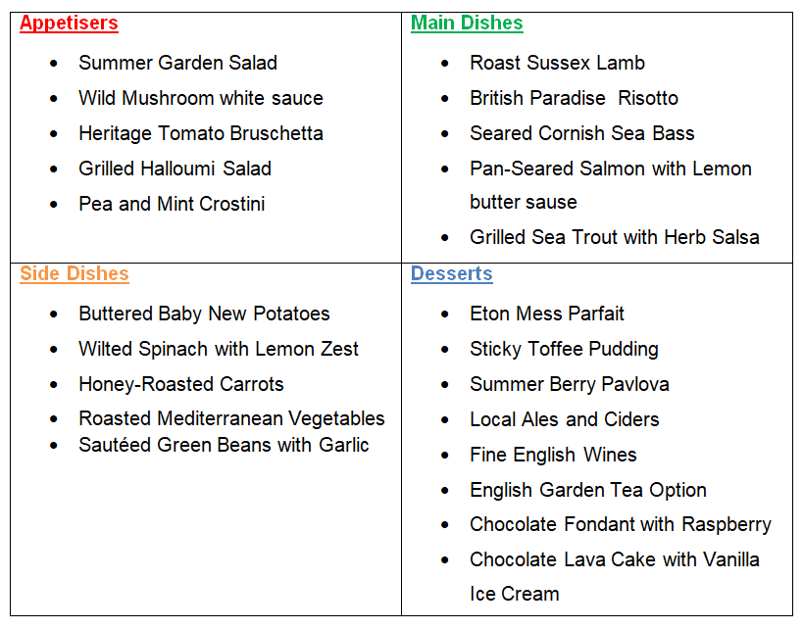

Pricing Strategy
Price is crucial when offering a product or service (Sudari et al., 2019). We aim to offer a reasonable and competitive pricing structure that accurately represents the calibre of our food and the outstanding dining experience we deliver by considering several variables, such as the cost of ingredients, labour, overhead, and industry norms, to establish the price for each menu item.
Since these ingredients are seasonal, their prices change throughout the year. For instance, fresh strawberries in the summer will cost more than imported strawberries in the winter. Each menu item's price will also include the labour costs for cooking and serving the food and the overhead associated with operating the restaurant. Additionally, we consider our restaurant's positioning to fit into the 4-star hotel dining market. The standard of service, culinary experience, and ambiance we offer will be reflected in our prices.
As indicated in our restaurant idea, we consider the diverse consumer base as Jeong and Lee (2021) recommend. The prices of various menu categories may also differ. For example, a sophisticated dish made using fine components and sophisticated cooking methods could cost more than an ordinary salad. Moreover, we will regularly evaluate our rivals in the 4-star hotel dining market to guarantee our prices are competitive.
Appetisers
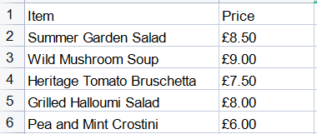
Main Dishes
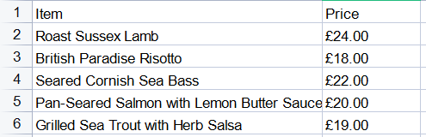
Side Dishes
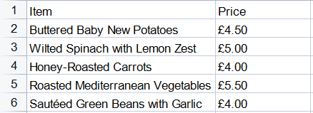
Desserts
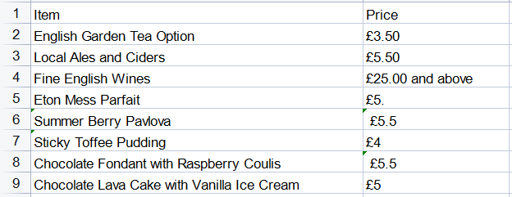
Menu Design
The British Paradise Bistro menu will showcase the traditional English Garden's tranquil and enchanting concept. We will design the menu as a visually appealing and elegant booklet textured and created with an earthly cover of botanical images (SAHIN and YAZICIOGLU, 2020). We will also enhance the pages with watercolour illustrations of flowers, vegetables, and seasonal fruits. Additionally, we will divide the menu categories with breakable nature-inspired borderlines to establish a mesmerising event. Furthermore, we will utilise easily readable and classic fonts, developing a sense of lasting elegance.
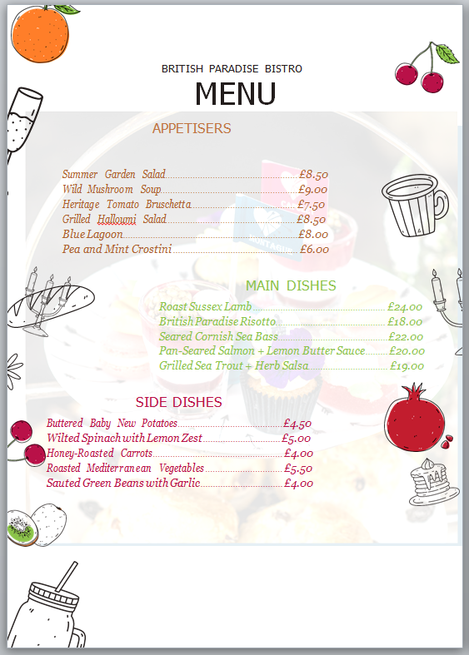

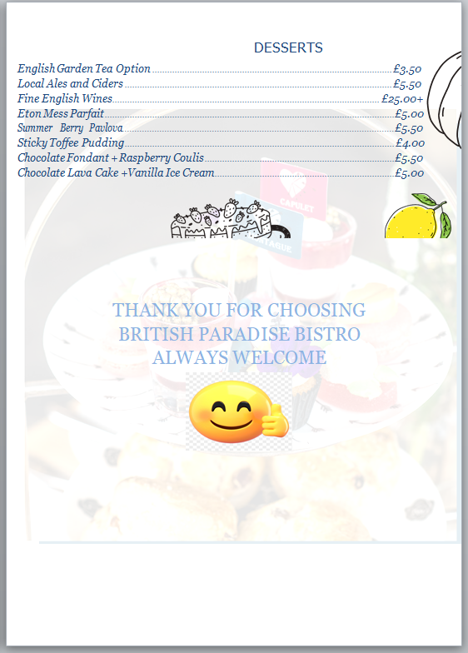
Menu Description
The menu description establishes an inviting and engaging attraction that sparks anticipation and curiosity as Davis et al. (2018) higlhight. We aim to ensure the menu description is created in a way that sparks curiosity, inviting anticipation and engagement.We aim to get our visitors to envision the exciting journey they are about to experience by providing them with concise but expressive descriptions.
The Menu description is provided below

Appetisers
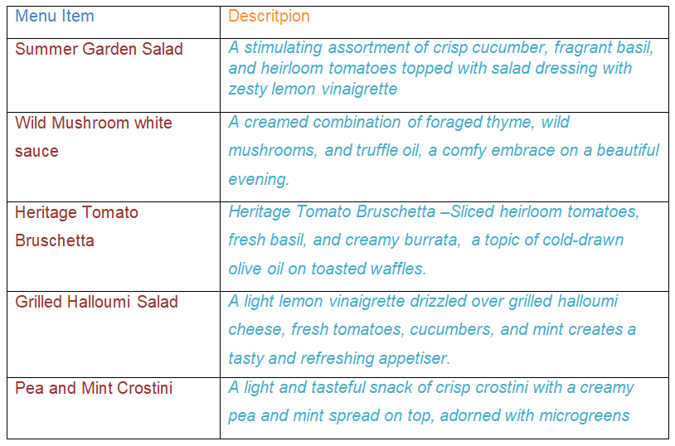

Desserts
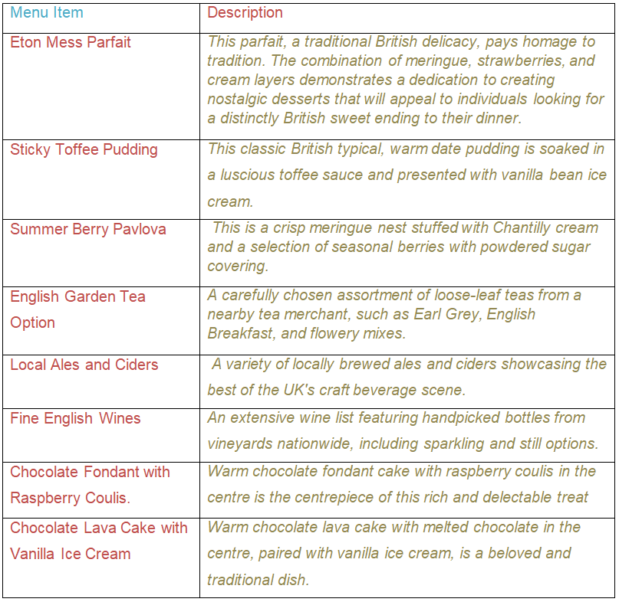

Main Dishes
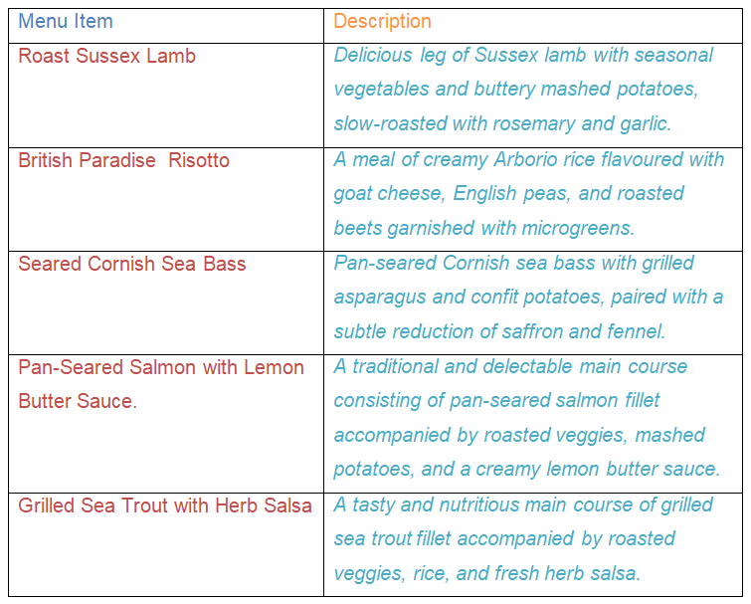

Side Dishes
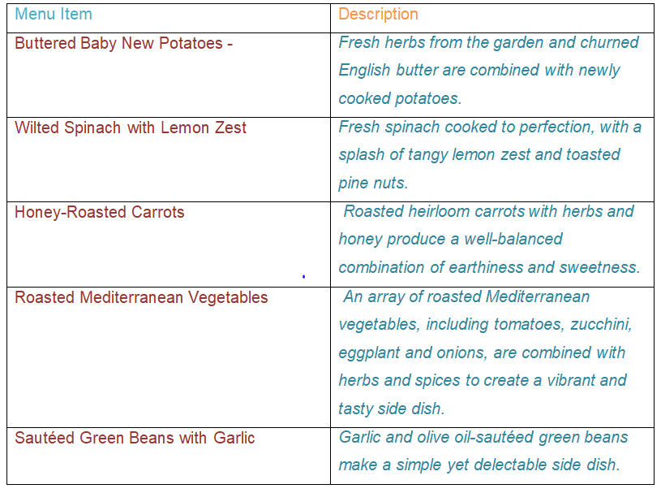

Sustainability and Seasonality:
According to Motarjemi and Lelieveld (2014 ), supporting environmental trends and regulations, reducing food miles, and improving the dining experience, sustainability, and seasonality are essential. We source our ingredients locally and in-season whenever possible since we are dedicated to sustainability and seasonality. Our collaborations with nearby farmers and gardeners provide the freshest, greenest produce possible. We will also integrate energy-efficient practises, waste reduction strategies, and ethical seafood purchasing to complement current environmental trends and requirements as adviced bt Belyaeva, Rudawska and Lopatkova, ( 2020). In keeping with our dedication to sustainability, we lower food miles and boost the local economy by regularly adjusting our menu to reflect the changing seasons.

References Lists
Belyaeva, Z., Rudawska, E.D. and Lopatkova, Y. (2020). Sustainable business model in food and beverage industry–a case of Western and Central and Eastern European countries. British Food Journal, 122(5), pp.1573-1592. https://www.emerald.com/insight/content/doi/10.1108/BFJ-08-2019-0660/full/html
Cousins, J. (2020) Food and beverage service. 9th ed. London: Hodder Education Group.**
Cousins, J., Foskett, D., Graham, D. and Hollier, A., 2019. Food and beverage management: for the hospitality, tourism and event industries. Goodfellow Publishers Ltd. https://www.goodfellowpublishers.com/free_files/Contents-37f090977c7c27f39d275780dca86f64.pdf
Davis, B et al. (2018) Food and Beverage Management. 6 edn London: Routledge.**
Jeong, S. and Lee, J.( 2021) Effects of cultural background on consumer perception and acceptability of foods and drinks: A review of latest cross-cultural studies. Current Opinion in Food Science, 42, pp.248-256. https://www.sciencedirect.com/science/article/pii/S2214799321001119
Johnston, R. (2012) Service operations management : improving service delivery. 4th ed. Harlow, England: Pearson.*
Lin, S.Y. and Chang, C.C. ( 2020)Tea for well-being: restaurant atmosphere and repurchase intention for hotel afternoon tea services. Sustainability, 12(3), p.778. https://www.mdpi.com/2071-1050/12/3/778
Motarjemi, Y and Lelieveld, H (2014) Food safety management : a practical guide for the food industry. Illustrated edition. Amsterdam: Academic Press.*
SAHIN, E. and YAZICIOGLU, I., 2020, December. Menu Design Strategies: An Experimental Research Using Neuromarketing. In The 2nd International Conference on Tourism and Entrepreneurship (ICTE) 2020 (p. 997). https://www.academia.edu/download/68029507/PROCEEDINGS_ICTE_2020_1_.pdf#page=498
Sudari, S., Tarofder, A., Khatibi, A. and Tham, J. (2019) Measuring the critical effect of marketing mix on customer loyalty through customer satisfaction in food and beverage products. Management Science Letters, 9(9), pp.1385-1396. http://m.growingscience.com/beta/msl/3217-measuring-the-critical-effect-of-marketing-mix-on-customer-loyalty-through-customer-satisfaction-in-food-and-beverage-products.html

