

Certificate of Higher Education in Skills for the Workplace

Task 2
Professional career development report

Student name: Ionut Cojan
Student ID: 2109652

Module name: Professional Career Development
Module code: BMSW4005
Lecturer name: Lizeta Demetriou

Table of Contents
Introduction 3
• Personal reflection on the role play: Recruitment and Selection - Applying Gibb’s learning cycle. 3
• Skills and knowledge which contribute toward working effectively 7
• My personal strengths and areas for further development 7
SWOT ANALYSIS 8
PERSONAL DEVELOPMENT PLAN 9
My short - medium – long term targets for the development of my own professional career plan (using Specific, Measurable, Agreed, Realistic, Time-bound –SMART targets) 11
Conclusion 13
References: 13
Appendix A: 15
Appendix B 19

Introduction

This study's objective is to evaluate my perspective, skills, and personality attributes that are crucial to attaining my ambition and assisting me in accepting a position I want. I shall adopt Gibbs' Reflective Cycle methodology for this introspective research. The objective of this paradigm is to categorise and arrange observations. The several phases normally help to slow down our brain procedures to avoid making hasty decisions. This approach will allow me to demonstrate my capabilities, providing me with a competitive edge for an employment offer. My shortcomings and the aspects I ought to strengthen will be highlighted for a better future direction in my career.

• Personal reflection on the role play: Recruitment and Selection - Applying Gibb’s learning cycle.

In week 10, I took part in a role-play as part of my assessment of the module Professional Career Development. Here I provide a reflective account of the role-play using Gibb’s learning cycle. Gibb’s learning cycle is composed of 6 reflective steps.
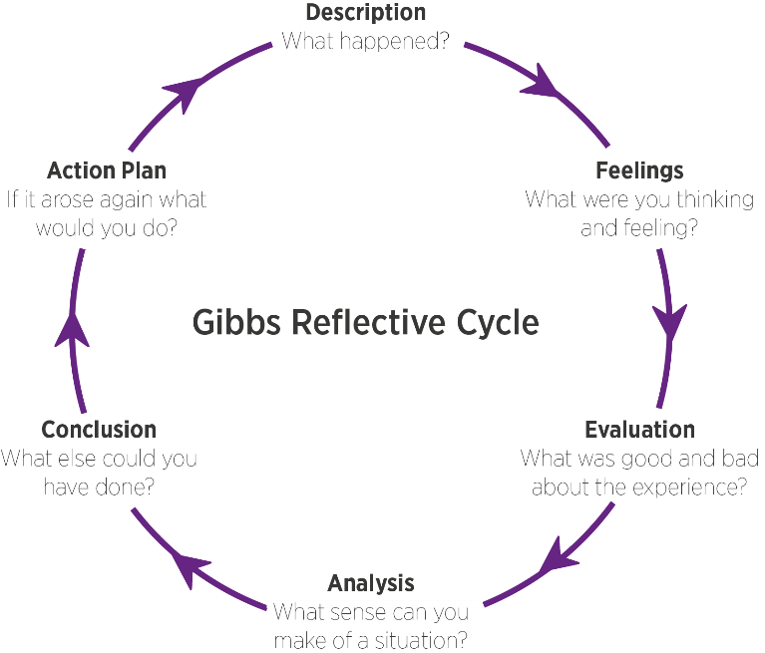

1 step: description. What is the event? What happened?
I was initially unsure about my career and always reacted to such uncertainty with dread and nervousness. But I now understand that it is much less threatening when I view this problem on a lesser scale. After all, I do intend to realise my brief goals and aspirations. Therefore, for week 10, I chose to have an interview related to the quantity surveyor position. I can say that it was an interesting and emotional interview. The questions I choose for the interview were kind of hard questions, so I can say that I had put myself into a real challenge. Those questions were:
- Could you tell me a little more about yourself than what is on your resume?
- What function do quantity surveyors, in your opinion, serve in the construction sector?
- What approach do you take while working on a project with suppliers and contractors?
- How will you keep up a strong subcontractor network?
- How do you plan to model financial management as a quantity surveyor?
Knowingly or unknowingly, I have improved in my capability to reason analytically and with attention to detail. For my prospects as a quantity surveyor in the future, both of these talents are essential. It goes without saying that a quantity surveyor needs to be proficient in a number of key skills in order to work effectively in the building business (Yusop et al., 2018)
Such characteristics have a significant impact on the real world. They support my ability to compete when I am searching for employment or overcoming some other career challenge. I now have a deeper grasp of networking, dispute resolution, efficient meetings, effective communication, and personal branding. These abilities are now applicable to my job path.
I learned from the role-playing game several things I should remember while I prepare for the interviews. I may increase my job prospects by performing well enough in interviews because they are such an important part of the hiring process. I have to adopt certain changes and start picking up certain abilities in my job position, like those linked to collaboration, interaction, having a solid working understanding of technology, and financial education skills.

2 step: Feelings in the event
I gave free rein to my emotions so that I could be as natural as possible and prove how I really am. The experience I lived cannot be suppressed or ignored, it serves as a personal impulse in my development.
I discovered how crucial it is to stand out in a crowd by utilising both my attitude and my expertise. I must take the time to learn about the organisation's goals, core beliefs, and latest events before my appointment. This knowledge will enable me in responding to questions about the company or the grounds I want to work there, as well as demonstrate that I have taken the time to research the company.
But I find that my timidity holds me back. Being an introvert, I prefer to exist in my own universe. Introverts are people who prefer not to interact with others and to stay away from circumstances that require them to speak. Introverts find it difficult to interact with others and prefer to be by themselves (Zainudin et al., 2019). As a quantity surveyor, paying attention to detail is a crucial ability that aids in preventing mistakes and advancing accuracy.

3 step: evaluation positive and negative
Since quantity surveyors are frequently involved in talks with business clients throughout the tendering stage as they seek projects for their companies, I have a great gift for negotiation abilities, which can benefit me in both my future work as a quantity surveyor and in the interview. Important soft skills like negotiating to remain instructional and difficult (McGuire et al., 2020).
In order to persuade clients to award them projects, strong negotiation abilities are also necessary. I came to the realisation that I still had a lot of flaws, such as a lack of strength, a tendency to get scared easily, and an unhealthy level of competition. I can then concentrate on strengthening my areas of weakness to increase my negotiation skills.

4 step: analysis: make sense of the situation/ most relevant things
Personal development is the process of discovering new things, conquering challenges, and benefiting from them. And this is how I continually search for ways to advance my life with a more sophisticated approach. My attention to detail, ability to negotiate and teamwork abilities are traits of my personality that will be very helpful to me in my future position as a quantity surveyor. However, I might find it difficult to answer the interviewer's questions due to my shyness, which can be a communication obstacle. Although I might be able to respond to their inquiries, I would lack the confidence necessary to converse with them. People will believe me if I am confident; it also makes me seem good, leads to success, fosters strong relationships with others, and makes me happier overall (Mbsfestival, 2022). I can wind up losing my professional prospects even if I am well qualified as a consequence of this. I know that once I acquire the necessary skills, I will be able to defend myself against any adverse situation.

5 Conclusion: What else could I have done? What could I have done differently?
During the interview I had relaxed myself, I knew what to talk as I have a real interest for a quantity surveyor position. An individual's optimal growth follows a specific course that distributes assets, capacities, capabilities, skills, possibilities, and preferences, amongst many other things, in a manner that is intended to lead to accomplishment. Career advancement and strategy make it clear how organisational goals and individual employee goals align (Berkeley, 2022). I will invest additional time there polishing the lacked talents and strong ones but could use some more polish. I will be extremely confident that I can showcase my potential to prospective employers if I am able to get all of these. Additionally, I will gain from this because I can simply complete my task and manage problems once I get to work. As a result, I have developed a strategy and set of strategies to aid in my skill development.

6 step: Action plan: behaviour/action I will take in a similar situation in the future.

Skills | How to Develop | Time Span
Patience | This can be cultivated through regularly practising mindfulness, accepting of one's existing situation, and developing a tolerance for mild discomfort. | About 8 months
Organising | This can be achieved by prioritising what matters most, creating daily, weekly, and monthly to-do lists of crucial chores, utilising planners and calendars and assigning tasks. | About 6 months
Analytical Thinking | Participating in analysis-based projects, beginning with a defined framework, consistently practising analytical abilities, and recognising analytical tools that can be beneficial are all ways to develop this. | About 10 Months

1 step: description: The event is the role play that I have done in week 10 as part of my assignment

• Skills and knowledge which contribute toward working effectively
Attention to Detail
To thrive as a quantity surveyor, I place a strong emphasis on being detail-oriented and taking a thorough approach to my work. I must have my work carefully examined for the position to ensure that it complies with the law, is lawful, and follows the terms of the contract. The ability to pay great attention to the details of the work allows one to discover flaws and strengthen them while also producing a nearly flawless final product (Successatschool, 2022)
Success and failure can be determined by one's ability to pay attention to details and have the patience to scroll through the paperwork.
Negotiation
A vital talent for a quantity surveyor is the capacity for negotiation. It might help to offer a better result by saving the business or the client time, money, or materials.
I can help my client receive the greatest deal because I am well-informed.
Critical analysis
I ought to be capable of thinking, making calculations, and understanding what is expected of me. I can visualise the project in my head and consider what it will take to finish it by thinking about it.

• My personal strengths and areas for further development
Write paragraph/s about strengths and areas for further development
Strength
I am a dedicated individual, a creative thinker, and a kind personality. When something does not turn out, I seek solutions rather than getting frustrated.
I can speak several languages. Technical topics are simple for me to grasp and comprehend.
Weaknesses
I must exercise more restraint, specifically when it comes to completing tasks that are imperative, like creating a budget or tidying up after myself. I am sometimes irritable and grumpy. My relatives think I am messy.
Opportunities
I hope to be able to discover client demands and develop a plan to meet them thanks to a sizable market opportunity. I can demonstrate my potential to improve a company's financial line by cultivating personal ties with developers, real estate brokers, and institutions. My capacity to view things from a different angle aid in my ability to comprehend them in a different light and clears the way for much more tolerance and understanding.
Threats
I occasionally get discouraged by my inadequacy of motivation. I feel tempted to splurge more while I am around my acquaintances. My impatience frequently causes issues with other people.

SWOT ANALYSIS

SWOT ANALYSIS

STRENGHTS  Solution-focused  Creativity  Organized  Optimism | WEAKNESSES  Budgeting  A better brainstormer than an operator  Technical expertise
OPPORTUNITIES  The capacity to approach situations with a fresh viewpoint  A big market with lots of possibilities  Great opportunity for networking | THREATS  A lack of drive  Irritability  Overspending

PERSONAL DEVELOPMENT PLAN
Goal | Action | Support/ Resources | Target date
- Hire more staff and learn to better manage a team in my company  - Get to know more about Quantity Surveyor position | - Add more adverts for recruiting  - Searching about the job role  - Applying for a Quantity Surveyor position to get experience | - Recruiting Agency  - Different websites | By the end of next year

What Skills do I need to achieve my goal?

Skills | How will I get them | What resources or support will I need | What can prevent me from achieving  my goals:  (Unemployment,  illness) | How long should it  take
Financial Management | This can be achieved by keeping an eye on my financial situation, being aware of my daily expenses, enrolling in training or a course, and experimenting with fictitious datasets. | Online or Offline course on financial plan | Being afraid of numbers | 2-3 Months
Networking | By establishing my networking goals, I can achieve this. It is crucial to set goals, develop my general verbal and nonverbal communication abilities, and go to social events to make sure I am making the most use of my time and resources to build a strong network. | Public events, conferences, and seminars | Shyness | 4-5 Months
Self-confidence | This can be accomplished through recognising my strengths, developing wholesome connections, being kind to myself, and developing assertiveness. | Getting feedback from others | Poor communication skills | 6-8 Months
Motivation | This may be achieved by setting new objectives, keeping track of my previous ones, surrounding myself with positive people, and making exercise a daily priority to enhance my mental health. | Online assessment on motivation and checking up on my mental health regularly | Lack of self-confidence and unemployment | 3-5 Months

My short - medium – long term targets for the development of my own professional career plan (using Specific, Measurable, Agreed, Realistic, Time-bound –SMART targets)

Short-term plan (3 -6 months)
Specific | Look for work that does not seem like just a job by pursuing the profession of my aspirations.
Measurable | Within the next six months, I will submit applications to at least 12 jobs.
Agreed | I am a pretty decent employee thanks to my skills.
Realistic | I want to work with fascinating individuals, contribute to something ground-breaking, and join a business that will allow me to develop.
Time-Bound | 15/10/2022
Medium-term plan (1-2 years)
Specific | I wish to start a profession as a quantity surveyor in the next 12 months.
Measurable | I will read articles and/or watch videos to learn what abilities, characteristics, and credentials are necessary to function as a quantity surveyor and take a note on a weekly basis.
Agreed | I will watch interviews with genuine administrators, instructors, learners, and quantity surveyors to learn about their accomplishments and what it is really like to work in this field.
Realistic | To make sure I am educated and competent to work in this industry, I will enrol in a training programme.
Time-Bound | 10/10/2024
Long-term plan (2-5 years)
Specific | I am hoping to land a job with a reputable organisation supervising a team of quantity surveyors.
Agreed | I will submit applications for any open manager positions at reputable businesses.
Measurable | In order to apply for managerial opportunities, I will update my résumé with the appropriate qualifications.
Realistic | I will actively seek out opportunities to take on informal leadership responsibilities in the workplace.
Time-Bound | 10/10/2025

Conclusion
Finally, good career growth necessitates self-improvement. I can achieve more in life if I work hard at conquering my weaknesses. My capacity to develop my talents and perform because of gaining the required abilities will have a big impact on my chosen profession. A professional development plan helps me to be more ambitious, dedicated, and productive because it helps me create short-term, attainable goals that will boost my self-confidence and motivation.

References:
Gibbs, G. (1988) Learning by Doing: A guide to teaching and learning methods. Further Education Unit. Oxford Polytechnic: Oxford.
Berkeley. (2022). Career Development. Available at. https://hr.berkeley.edu/hr-network/central-guide-managing-hr/managing-hr/managing-successfully/development/career (Assessed on 29 July 2020)
Mbsfestival. (2022). Importance of Confidence. Available at. https://www.mbsfestival.com.au/healthy-living-hub/confidence-importance/ (Assessed on 29 July 2020)
McGuire, S.J., Reilly, P., Zhang, Y., Mahdavian, B. and Prabhu, V., 2020. Teaching win-win negotiation skills to MBAs: A quasi-experimental examination of a social-exchange based pedagogical approach. Journal of Organizational Behavior Education, 13, pp.21-15.
Successatschool. (2022). Attention to Details. Available at. https://successatschool.org/advicedetails/1289/attention-to-detail-skills-examples (Assessed on 29 July 2020)
Yusop, N., Derus, M.M., Bakar, N.A., Saberi, M.H. and Abdullah, M.A., 2018. Technical skills in quantity surveying and relevant practices: Discipline standards. International Journal of Academic Research in Business and Social Sciences, 8(9).
Zainudin, Z.N., Yusop, Y.M., Hassan, S.A. and Alias, B.S., 2019. The effectiveness of cybertherapy for the introvert and extrovert personality traits. Malaysian Journal of Medicine and Health Sciences, 15(SUPP1), pp.105-109.

Appendix A :
Job application form

Application for [job title] - Quantity Surveyor
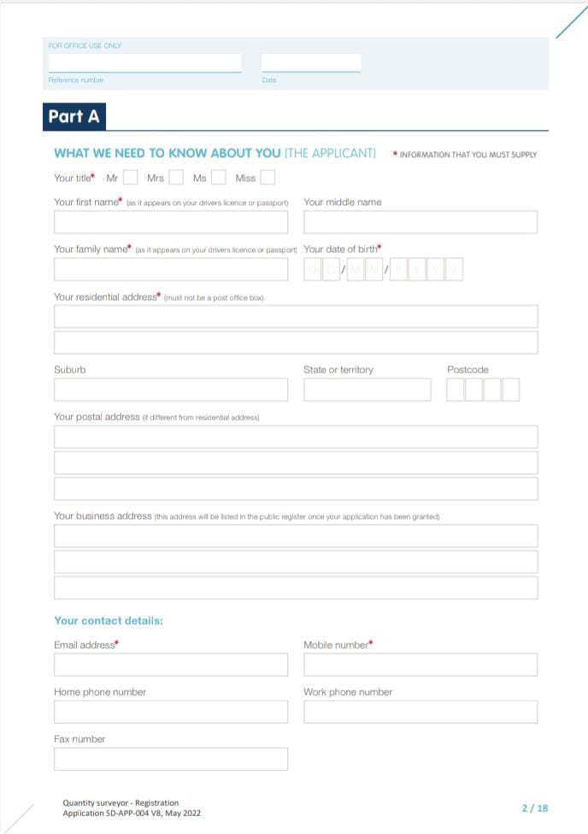
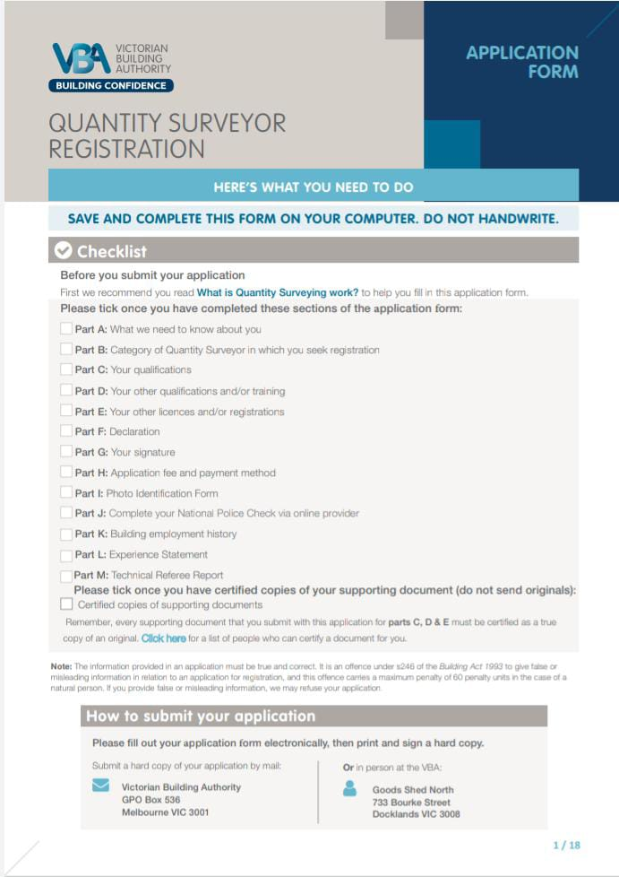
Your details

Name: Ionut Cojan

Education and training
Please give details:

- 2021-2022 Certificate of Higher Education Skills for the workplace
- 2006 – 2010 Technical College Anghel Saligny

Qualifications
Please give details:

- NVQ level 3
- 6 Years’ Experience on running a company

Employment history
Your current or most recent employer

Name of employer: ICD INTERIORS LTD

Job title: DIRECTOR

Length of time with employer: 6 YEARS

Reason for leaving: CURENTLY WORKING

Duties:

- Accounting
- Managing
- Representing the company at public events and attending conferences
- Preparing business plans, budgets, and schedules
- Recruiting and training new people

Previous employers
Please tell us about other jobs you have done and about the skills you used or learned in those jobs.

2014-2015 Sales Assistant
At this job I built my persuasion and negotiation skills. Being very ambitious by nature, I enjoyed upselling and make profit. Also, at this job I improved my communication skills, I was in a foreign country, and I had to manage by speaking a language that until then I had only practiced at a low level.
From this job it started my pleasure to make profit and to analyse everything related to a business, from the opening to the stage of success.

Supporting statement
Please tell us why you applied for this job and why you think you are the best person for the job.

I have applied for this job role as a Quantity Surveyor as I know your company has a great reputation that I have admired for long time, it is fitting my values and makes me excited to help with the company’s missions. As a director of a company, I had the opportunity to observe how important a quantity surveyor is in a job. I've always liked working with numbers, amounts and especially negotiating, that's why from the first months of construction I started documenting and analysing everything related to a quantity surveyor. I do have interest and knowledge in a variety of construction tools and technology, and I strongly believe that I can fit myself in all the requirements of your company. In the current company that I own, around 20 people are employed, so I can say about myself that I am a good leader, and that teamwork defines me. I am used to prepare labour and supplier account. The ability to negotiate contracts has always helped me and I can say that it has never happened that I leave a negotiation without real success. I am used to writing reports detailing costs and progress for clients, so this is another point why I think I am the right candidate for this position. I characterize myself as a person who pays attention to details, who follows every step, but above all a person who does not like to lose, and for this reason I calculate the cost of a project very meticulously.
So, I believe I am perfectly fitting to your company needs.

Right to work in the UK
Do you need a work permit to work in the UK? Yes / No
I have Indefinite Leave to remain in UK
References
Please give the names and contact details of 2 people who we can ask to give you a reference. We may ask them before an employment offer is made. We will not ask your current employer until we get your permission.
- Crina Ijac – ACCOUNTANT AT ICD INTERIORS LTD
crina@lilyaccount.co.uk
- Mark Bellchambers - Director of BELLWOOD
Contact number : 07793750676

Declaration
I confirm that to the best of my knowledge the information I have provided on this form is correct and I accept that providing deliberately false information could result in my dismissal.

Name: Ionut Cojan

Signature: Ionut Cojan

Date:

Appendix B

The questions asked as the interviewer in the role play (A1)
- Could you tell me a little more about yourself than what is on your CV?
- What function do quantity surveyors, in your opinion, serve in the construction sector?
- What approach do you take while working on a project with suppliers and contractors?
- How will you keep up a strong subcontractor network?
- How do you plan to model financial management as a quantity surveyor?

