  quantitative research methods  [Document subtitle] | Topic  “Who travels Abroad ? A demographic and economic analysis of Uk Outbound Tourism “  Made By  Jill Jainam soni

Table of Contents
- Introduction................................................. Page 1
- Significance of Reasearch............................................. Page 2
- Research Problem statement ............................................ Page 3
- Research Questions and Objectives ........................................ Page 3
4.1 Aim ......................................................................... Page 3
4.2 Research Objectives ......................................................... Page 3
4.3 Research question................................................................. Page 4
- Literature Review ........................................................ Page 4
5.1 Theoritical premise……………… Page 7
5.2 hypotheses Formulation............. Page 9
- Conceptual Framework ..................................................... Page 9
- Methodology Approach...................................................... Page 12
- Data Analysis...................................................... Page 13
8.1 Relaibility analysis.............................................................. Page 13
8.2 Descriptive Statistics…………………. Page 14
8.2.1 Demographic profile....................................................... Page 14
8.2.2 economic Characteristics................................................... Page 14
8.2.3 Travel behaviour .................................................. Page 14
8.3 Correlations Analysis .......................................... Page 18
8.4 Regression Analysis……………………………….. Page 19
8.5 Anova…………………………………………………… Page 21
8.6 Discussion ...................................... Page 22
- Reflection………………………………………………Page 22
References………………………………………………………. Page 23

1.0 Introduction
Outbound tourism from the United Kingdom represents a significant aspect of global travel patterns, shaped by a complex interplay of demographic characteristics and economic conditions. Understanding who engages in international travel is not a straightforward task; it requires a nuanced analysis of variables such as age, gender, educational attainment, household composition, income levels, and broader macroeconomic influences. Demographic shifts can substantially alter travel behaviours, as changes in age distribution, generational attitudes, and domestic responsibilities impact both the frequency of travel and the selection of destinations. For instance, younger adults often prefer short, culturally immersive leisure trips, whereas older individuals tend to favour longer holidays with higher levels of expenditure per visit (Li et al., 2020).
Economic factors are equally central to shaping outbound travel. The availability of disposable income, employment stability, and overall economic confidence all contribute to the affordability and attractiveness of international tourism. Evidence suggests that during periods of economic downturn or heightened uncertainty, travel demand tends to decline, while stable and prosperous conditions encourage more frequent and higher-value trips abroad (Nguyen, Thanh and Nguyen, 2022; Khan et al., 2021). Patterns of expenditure also vary significantly across different categories, with notable differences in spending on accommodation, food and drink, recreational activities, and shopping (Massidda, Piras and Seetaram, 2022).
In addition to demographic and economic considerations, contemporary drivers such as digitalisation, social media engagement, and the rise of remote working are increasingly influencing outbound travel behaviour. Digital platforms now play a pivotal role in shaping travel decisions, enhancing destination visibility, and motivating individuals across diverse social groups. These developments have reinforced the connection between demographic and economic profiles and the nature of outbound tourism from the UK (Adeola, Evans and Okafor, 2023). The widespread use of mobile applications, online reviews, and social media content has transformed how travellers plan and experience their journeys, making digital literacy and access a new dimension of travel behaviour.
Moreover, the COVID-19 pandemic introduced unprecedented disruptions to international mobility, reshaping expectations and exposing vulnerabilities within the tourism sector. Travel restrictions, health concerns, and economic shocks led to a dramatic decline in outbound tourism, while also prompting a reassessment of travel priorities and behaviours. The pandemic highlighted the fragility of global travel networks and underscored the importance of resilience and adaptability in tourism planning (Yepez and Leimgruber, 2024). As the sector recovers, new patterns are emerging, with increased attention to safety, sustainability, and flexibility.
Against this backdrop, the present research seeks to explore the demographic and economic factors that influence outbound tourism from the United Kingdom. By examining key population characteristics, financial drivers, behavioural motivations, and the impact of digital transformation, the study aims to address the central questions of who travels abroad, why they choose to do so, and how ongoing structural changes continue to shape the landscape of UK outbound travel. This analysis contributes to a deeper understanding of the evolving nature of international tourism and offers insights into future trends and policy implications.
2.0 Significance of Research
This study holds considerable importance as it offers a detailed demographic and economic overview of UK outbound travellers during a period of substantial transformation in global tourism. In the aftermath of the COVID-19 pandemic, travel patterns have evolved in response to shifting household structures, widening income disparities, and increased volatility in international trade relations (Yepez and Leimgruber, 2024). By examining both demographic and financial indicators, the research directly supports the aim of identifying the factors that influence travel participation, destination preferences, spending habits, and emerging behavioural trends among UK tourists.
A key contribution of this research lies in its focus on digitalisation and the intersection of technology with socio-economic contexts. Online platforms and social media now play a pivotal role in shaping travel decisions and engagement, presenting fresh opportunities for businesses to connect with UK outbound travellers. However, these digital tools also contribute to uneven engagement across different population groups (Adeola, Evans and Okafor, 2023; Kalia, Mladenović and Acevedo-Duque, 2022). Investigating these dynamics enhances the practical relevance of the study, offering valuable insights for policymakers and marketers seeking to develop targeted strategies based on specific demographic and economic profiles.
Additionally, by building upon earlier perspectives on UK tourism (Hay, 2023), this research places outbound travel within a changing framework of generational preferences, ethical tourism practices, and technological innovation. It underscores the need to understand how various age cohorts—such as baby boomers and younger generations—interact with social and financial factors to produce distinct travel behaviours (Robinson and Crevenna). Consequently, the findings contribute not only to scholarly discourse but also to industry application, supporting the development of sustainable policy approaches and market-driven strategies that reflect the evolving realities of UK outbound tourism.
3.0 Research Problem Statement
The core issue addressed by this research lies in the lack of a cohesive analysis that integrates both demographic and economic factors influencing outbound tourism from the United Kingdom. Although demographic indicators such as age, gender, and household composition are vital for interpreting travel behaviour, their interaction with socio-economic dimensions—particularly income levels and employment status—remains insufficiently examined. Yet, these interconnected elements are essential for forecasting travel participation, spending patterns, and destination preferences (Li et al., 2020; Massidda, Piras and Seetaram, 2022).
Recent global upheavals underscore the urgency of revisiting this relationship. The COVID-19 pandemic significantly altered travel intentions, introducing psychological barriers, mobility restrictions, and financial pressures that reshaped demand structures (Rahimi, Akgunduz and Bilgihan, 2023; Venturella, 2025). Simultaneously, the growing influence of digital technologies is redefining wellbeing and decision-making processes within the tourism sector (Choi et al., 2022). These shifts are further complicated by persistent economic uncertainty and the increasing emphasis on sustainability, both of which challenge traditional modelling approaches and influence tourism demand in unpredictable ways (Tunçel, Yaman and Gürsoy, 2024; Bilek, 2025).
Accordingly, the central research problem focuses on how demographic and economic traits of UK citizens intersect with technological advancements, motivational factors, and environmental concerns to shape outbound travel behaviour and expenditure. Tackling this gap is directly aligned with the study’s objectives, contributing to a deeper understanding of how structural transformations influence who travels internationally and the evolving nature of their travel decisions.
4.0 Research Aims, Objectives ,Question and Contribution
4.1 Aim
The primary aim of this research is to explore the demographic and economic factors that influence outbound travel from the United Kingdom. It investigates how variables such as age, gender, income, employment status, and broader economic conditions shape patterns of international travel participation and spending behaviour.
4.2 Objectives
To determine the principal demographic indicators—such as age, gender, educational background, and household composition—that affect the likelihood of UK residents travelling abroad and their choice of destinations (Massidda et al., 2022; Li et al., 2020).
To evaluate the influence of economic elements—including income levels, job security, financial uncertainty, and disposable earnings—on the frequency, participation, and expenditure associated with outbound tourism among UK travellers (Nguyen et al., 2022; Khan et al., 2021).
To investigate how demographic and economic characteristics interact with travel motivations and behaviours, encompassing trip purpose (holiday, business, visiting friends or relatives), length of stay, and spending across different categories (Massidda et al., 2022).
To examine the role of modern influences such as digital technologies, flexible working arrangements, and social media in reshaping the demographic and economic profile of UK outbound tourists in the post-pandemic era (Adeola et al., 2023; Yepez & Leimgruber, 2024; Hay, 2023).
4.3 Research Question
Research Question 1:
What demographic characteristics most significantly influence outbound travel participation and destination choice among UK residents?
Research Question 2:
How do economic variables—such as income, employment status, and economic uncertainty—shape the likelihood and frequency of outbound travel and related expenditure for UK travelers?
Research Question 3:
In what ways do demographic and economic determinants interact with trip motivations and expenditure patterns across categories (accommodation, food, shopping, culture, recreation)?
Research Question 4:
How have emerging trends (digital access, remote work, social media use post-COVID-19) modified the demographic and economic profile of UK outbound tourists?
4.4 Research Contribution
This research offers a valuable contribution to tourism studies by presenting a unified and in-depth exploration of the demographic and economic factors influencing outbound travel from the United Kingdom. It addresses a notable gap in existing literature, where these dimensions have often been considered in isolation rather than in combination. By integrating emerging developments such as the uptake of digital technologies and the rise of remote working in the post-pandemic era, the study enhances current understanding of shifting travel behaviours and consumption trends.

In addition, the research provides actionable insights for policymakers, tourism professionals, and industry stakeholders by illustrating how evolving socio-economic and technological contexts shape outbound travel demand and influence patterns of consumer segmentation. It also enriches academic discourse surrounding tourism resilience and adaptability, offering a framework that connects demographic and economic profiles with travel motivations and spending habits across various categories.
Ultimately, the findings support the formulation of targeted, evidence-based strategies aimed at fostering sustainable growth in UK outbound tourism, particularly in light of ongoing changes in the global economic and social landscape.
5.0 Literature Review: Theoretical Premise, Key Literature, and Foundations
Recent academic inquiry into UK outbound tourism has increasingly adopted an interdisciplinary framework to unpack the multifaceted drivers of travel behaviour. Scholars now recognise that a comprehensive understanding of outbound travel requires the integration of perspectives from risk theory, marketing science, motivational psychology, and digital transformation. This convergence allows for a more nuanced interpretation of both individual-level travel decisions and broader demand trends.
Grigoriadis et al. (2025) offer a foundational lens through their theory of risk and resilience, asserting that political instability and social disruption are now central to destination selection. Travellers routinely assess external risk environments—ranging from political unrest and public health infrastructure to climate vulnerability—before committing to travel. This risk-aware approach has gained prominence in the post-pandemic era, where safety, adaptability, and perceived resilience are key determinants of travel intent. The pandemic has not only heightened awareness of global fragility but also redefined what constitutes a “desirable” destination, with stability and crisis management now part of the tourism value proposition.
From a marketing perspective, George (2025) and Menon (2025) highlight the strategic importance of destination branding and consumer engagement. Their work suggests that successful branding goes beyond promotional aesthetics, involving the construction of emotionally resonant narratives tailored to specific demographic segments. The rise of influencer marketing, immersive storytelling, and authenticity-driven campaigns has transformed how destinations connect with outbound UK travellers. These strategies are particularly effective in cultivating loyalty and repeat visitation, as they tap into deeper psychological and experiential dimensions of travel.
Putri and Rasyidah (2025) explore the phenomenon of film tourism, demonstrating how media representation can significantly influence destination image and appeal. By showcasing locations through popular films and television series, tourism boards can reignite interest in travel and shape aspirational motivations. This media-tourism nexus is especially potent in times of global disruption, offering escapism and emotional connection that transcend traditional marketing channels. Their findings support the broader academic consensus that post-pandemic competition among destinations is increasingly fought through perception, representation, and emotional resonance.
Motivational theories remain central to understanding outbound travel behaviour. Çıkı and Akgöz (2025) apply self-determination theory to nature-based tourism, revealing that autonomy, purpose, and subjective wellbeing are key motivators. Their research shows that these intrinsic drivers not only influence initial travel decisions but also affect the likelihood of return visits. Muhamad et al. (2025) focus on self-concept and emotional value, arguing that personal identity and affective bonds with destinations play a critical role in shaping travel intentions. These models underscore the importance of psychological and emotional factors in differentiating travel patterns, particularly as consumers become more values-oriented and discerning.
Digital transformation is another major theme in contemporary tourism literature. Bondarenko et al. (2025) and Mavitha and Kushe Shekhar (2025) examine how artificial intelligence, dynamic pricing, and smart partnerships are reshaping the travel experience. These technologies enable personalised planning, real-time adjustments, and expanded access to niche markets. Digital connectivity also reduces information asymmetry, empowering travellers to make informed decisions and enhancing competition among providers. Secretariat (2025) compares the UK’s digital tourism infrastructure with that of South Korea and Singapore, illustrating how technological maturity contributes to destination resilience and attractiveness. Their comparative analysis highlights the strategic value of investing in digital capabilities to future-proof the tourism sector.
The COVID-19 pandemic continues to be a dominant motif in recent literature, influencing everything from consumer preferences to industry operations. Chinprateep (2025) documents how the pandemic prompted a shift towards flexible booking policies, enhanced hygiene protocols, and safety assurances. Marinakou (2025) explores changes in luxury tourism, noting a move towards responsible consumption and sustainability. Efthimiou (2025) links structural adjustments—such as increased foreign direct investment and economic diversification—to greater resilience and growth potential within the tourism sector. Ocampo‐Peñuela et al. (2025) add an ecological dimension, showing how environmental assets like biodiversity and “bird capital” can drive niche tourism markets and support sustainable development.
Advancements in data analytics are also reshaping research methodologies. Adekuajo, Otokiti, and Okpeke (2025) propose machine learning models to forecast post-pandemic travel demand, arguing that behavioural analytics offer unprecedented precision and adaptability. These tools are increasingly used alongside traditional survey methods to generate richer insights and inform policy decisions. The integration of big data allows researchers to capture real-time shifts in consumer behaviour, enabling more responsive and targeted interventions.
In addition to these core themes, recent literature has begun to explore the intersection of tourism with broader societal trends. For example, Hay (2023) discusses the evolving role of intergenerational preferences in shaping travel behaviour. His work suggests that baby boomers, millennials, and Gen Z travellers exhibit distinct motivations, expectations, and consumption patterns. Understanding these generational differences is crucial for designing inclusive and effective tourism strategies. Robinson and Crevenna further examine how social values, environmental consciousness, and lifestyle choices influence mobility trends, reinforcing the need for a more holistic approach to tourism planning.
Moreover, the literature increasingly acknowledges the role of socio-economic inequality in shaping access to outbound travel. Studies show that disparities in income, employment stability, and digital literacy can create uneven participation rates across demographic groups. This has implications for both market segmentation and policy design, as efforts to promote inclusive tourism must address structural barriers to access. The integration of equity-focused frameworks into tourism research is therefore essential for ensuring that growth in outbound travel is both sustainable and socially just.
Another emerging area of interest is the psychological impact of travel disruptions and the long-term behavioural shifts they induce. Venturella (2025) explores how prolonged uncertainty and travel restrictions have led to increased anxiety and risk aversion among certain traveller segments. This has resulted in a preference for domestic or regional travel, shorter trip durations, and more cautious planning. These behavioural changes are not merely temporary responses but may signal a lasting transformation in how individuals approach international travel.

Furthermore, the role of environmental sustainability in shaping outbound tourism is gaining traction. Bilek (2025) argues that climate awareness and ecological responsibility are becoming integral to travel decision-making. Tourists are increasingly seeking destinations that align with their environmental values, favouring low-impact travel options and supporting conservation efforts. This shift presents both challenges and opportunities for the UK tourism sector, which must balance growth with ecological stewardship.
The literature also points to the growing importance of hybrid travel motivations—where leisure, business, and personal purposes overlap. With the rise of remote work and digital nomadism, traditional distinctions between trip types are blurring. Choi et al. (2022) note that travellers now combine work and leisure in flexible arrangements, leading to new patterns in duration, expenditure, and destination choice. This hybridisation demands a rethinking of tourism infrastructure, marketing, and policy to accommodate evolving traveller needs.
Finally, the role of cultural capital and heritage in outbound tourism is receiving renewed attention. Scholars argue that cultural familiarity, language, and historical ties influence destination preferences, particularly among older travellers and diaspora communities. This cultural dimension adds depth to demographic analysis, highlighting how identity and heritage shape travel behaviour in ways that intersect with economic and technological factors.
Taken together, the convergence of risk assessment, marketing innovation, motivational theory, digital disruption, and adaptive policy frameworks forms a robust theoretical base for contemporary UK outbound tourism research. The literature advocates for a holistic analytical model—one that not only accounts for static demographic and economic variables but also incorporates the dynamic, context-sensitive processes that shape travel decisions and experiences. By synthesising these diverse strands, researchers can better understand the evolving nature of outbound tourism and contribute to the development of resilient, inclusive, and future-ready travel systems.
5.1 Theoretical Premise
Establishing a solid theoretical foundation is essential for unpacking the complex and layered nature of outbound tourism. Central to this discourse is the theory of risk and resilience, as articulated by Grigoriadis et al. (2025). This framework challenges the notion of tourists as purely rational economic actors, instead portraying them as proactive evaluators of risk. When choosing destinations, travellers consider not only cost and convenience but also conduct a detailed assessment of perceived risks—ranging from political instability and health infrastructure to climate vulnerability and overall destination resilience. Grigoriadis et al. argue that the turbulence defining the 2020s—including geopolitical tensions, pandemics, and environmental disruptions—has elevated resilience and adaptability as key competitive assets for destinations aiming to maintain or expand their share of the UK outbound market. The literature underscores that successful destinations communicate their preparedness and risk management strategies through a blend of digital messaging, experiential design, and policy transparency.
Motivational theory complements this risk-based analysis by offering insight into why certain individuals are more inclined to embrace or even pursue risk in exchange for personal fulfilment. The self-determination model, as developed by Çıkı and Akgöz (2025), identifies autonomy, social connection, and competence as core motivators for travellers engaged in nature-based or adventure tourism. Motivation is framed not merely as a response to external conditions but as an internal psychological mechanism that translates personal values and aspirations into concrete travel behaviours. The widely referenced push–pull model further elaborates this dynamic: internal drivers such as the desire for novelty, escape, or self-growth (push factors) interact with external destination features like scenic beauty, safety, and service quality (pull factors). Muhamad et al. (2025) expand this perspective by introducing the concept of self-concept, suggesting that travel is often a form of identity expression and emotional investment. Travellers seek destinations that reflect their self-image and offer meaningful emotional engagement.
Marketing and branding theories are equally vital in understanding the competitive landscape of outbound tourism. George (2025) and Menon (2025) emphasise that destination branding is a multifaceted process involving more than visual identity or slogans. It encompasses the cultivation of trust, emotional resonance, and perceived value among prospective tourists. As consumer preferences shift towards immersive experiences and social validation, branding strategies increasingly rely on user-generated content, endorsements from niche influencers, and narrative-driven campaigns. Putri and Rasyidah (2025) illustrate how film tourism leverages media exposure to sustain interest and demand, particularly during periods of market stagnation or recovery. Effective branding not only reshapes public perception but also highlights a destination’s strengths in risk management, sustainability, and inclusivity—attributes that are increasingly valued by UK outbound travellers.
Theories of digital transformation, as explored by Bondarenko et al. (2025) and Mavitha and Kushe Shekhar (2025), argue that the trajectory of UK outbound tourism will be heavily influenced by technological integration across the travel lifecycle. Building on the concept of smart tourism and personalised services (Hitchcock Michalski, 2025), these studies suggest that planning, booking, and experiencing travel now depend on artificial intelligence, mobile platforms, augmented and virtual reality, and algorithmic recommendation systems. Secretariat (2025) contends that digital innovation does more than streamline operations—it creates new value propositions, enhances resilience, and enables market segmentation based on digital engagement and accessibility. However, the literature also cautions that digitalisation may exacerbate inequalities if certain groups lack access or literacy. Therefore, inclusive design and digital education are critical policy considerations.
The COVID-19 pandemic has acted as a stress test for both travellers and the tourism industry. Chinprateep (2025) notes that risk aversion has moved from the margins to the centre of travel planning. In response, providers have introduced flexible booking policies, real-time updates, and low-risk cancellation options. Marinakou (2025), focusing on the luxury travel segment, identifies a growing emphasis on wellness, safety, and responsible tourism—indicating a shift towards experiences perceived as restorative and meaningful. Efthimiou (2025) highlights the role of foreign investment and innovation in enabling the sector to not only recover but evolve in the face of ongoing uncertainty.
Environmental sustainability and ecological theory are becoming increasingly relevant in outbound tourism research. As awareness of climate risks and ethical consumption grows, travellers are prioritising destinations that offer both social stability and ecological richness. Ocampo‐Peñuela et al. (2025) argue that environmental assets such as biodiversity are emerging as key attractors for niche markets, particularly among nature-oriented travellers. Destinations that invest in regenerative tourism and conservation practices are better positioned to appeal to the UK’s environmentally conscious outbound segment.
In terms of methodology and forecasting, Adekuajo, Otokiti, and Okpeke (2025) advocate for the use of big data and predictive analytics. These tools enable researchers and policymakers to monitor and respond to real-time behavioural trends, marking a shift from static survey-based approaches to dynamic, adaptive modelling. As the pace of change accelerates, continuous feedback and agile management will be essential for maintaining competitiveness and relevance.
Additional literature has begun to explore the intersection of outbound tourism with broader societal transformations. Hay (2023) examines generational differences in travel preferences, noting that baby boomers, millennials, and Gen Z travellers exhibit distinct motivations and expectations. Robinson and Crevenna explore how social values, environmental awareness, and lifestyle choices influence mobility, reinforcing the need for inclusive and responsive tourism strategies. These insights suggest that outbound travel is not only shaped by economic and demographic factors but also by evolving cultural and psychological frameworks.
Synthesising these theoretical perspectives, the emerging model of outbound tourism is best understood as a dynamic and cyclical system. Risk perceptions influence motivational drivers, which are mediated by digital platforms and branding strategies, all within a context shaped by external shocks and shifting value systems. Contemporary research must therefore adopt flexible and integrative frameworks capable of capturing the interplay between behavioural, technological, and structural forces. This approach is essential for understanding the evolving nature of UK outbound tourism and for guiding sustainable, inclusive, and resilient policy and industry responses.
5.2 Hypotheses Formulation
Drawing on the theoretical synthesis above, the following hypotheses are proposed:
H1: Demographic factors—including age, gender, education level, and household composition—positively influence outbound travel participation and destination selection among UK residents (Çıkı and Akgöz, 2025; Muhamad et al., 2025).
H2: Economic indicators such as income, employment status, and financial uncertainty significantly affect the frequency, expenditure, and overall participation in outbound tourism (Efthimiou, 2025).
H3: The interaction between demographic and economic attributes and motivational factors—such as wellbeing and self-concept—plays a decisive role in shaping travel behaviour and spending patterns (Çıkı and Akgöz, 2025; Muhamad et al., 2025).
H4: Digitalisation, encompassing smart technologies, social media, and remote work, moderates the relationship between demographic/economic variables and outbound travel engagement, particularly in the post-pandemic context (Bondarenko et al., 2025; Secretariat, 2025).
Additional contextual propositions: External socio-political and environmental conditions—such as political instability, destination resilience (Grigoriadis et al., 2025), and ecological awareness (Marinakou, 2025; Ocampo‐Peñuela et al., 2025)—exert significant influence on outbound tourism flows from the UK.
6.0 Conceptual Framework
The conceptual framework underpinning this study synthesises the empirical hypotheses and the extensive theoretical foundations into a comprehensive model that captures the multifaceted nature of outbound tourism in the UK. It reflects the dynamic interplay between structural determinants, psychological motivations, technological mediators, contextual influences, and normative values, offering a holistic lens through which to understand contemporary travel behaviour.
At the core of the framework lie demographic and economic variables (H1, H2), which serve as both foundational and interactive components influencing outbound travel decisions. These structural attributes—such as age, gender, educational attainment, household composition, income level, and employment status—shape individuals’ capacity, inclination, and opportunity to engage in international travel. They represent the baseline conditions that determine access to travel resources, time availability, and exposure to travel-related information. For instance, younger adults may be more inclined towards short-haul, experience-driven travel, while older individuals with greater disposable income might favour longer, more luxurious trips. Employment stability and income security further influence not only the feasibility of travel but also the frequency and scale of expenditure.
Motivational constructs, derived from self-determination theory and broader psychological models, function as mediating mechanisms that translate structural characteristics into behavioural outcomes. These motivations are not uniform across demographic groups; rather, they vary according to personal values, aspirations, and emotional needs. Even within similar demographic cohorts, individuals may exhibit divergent travel behaviours based on their pursuit of wellbeing, novelty, escapism, or social status. The framework incorporates the widely accepted push–pull paradigm, where internal psychological drivers (push factors) such as the desire for relaxation, adventure, or self-fulfilment interact with external destination attributes (pull factors) like cultural richness, perceived safety, and promotional narratives. This dual mechanism explains why travellers with comparable socio-economic profiles may choose vastly different destinations and travel styles.
Digitalisation occupies a distinct and influential role within the framework, acting as a moderating variable that shapes the relationship between structural factors, motivations, and actual travel behaviour. The proliferation of smart technologies, personalised digital platforms, and social media has transformed the way individuals plan, book, and experience travel. These tools not only facilitate access to information but also personalise recommendations, reduce transaction costs, and enable real-time updates on safety, health protocols, and destination conditions. The normalisation of remote work has further blurred the boundaries between leisure and professional travel, giving rise to hybrid travel patterns such as “workations” and digital nomadism. In this context, digital tools serve as amplifiers or dampeners—enhancing travel intentions among digitally literate groups while potentially excluding those with limited access or skills. The COVID-19 pandemic accelerated this digital shift, making technological engagement a prerequisite for safe and flexible travel.
The enduring impact of COVID-19 and the potential for future systemic disruptions are explicitly integrated into the framework through the inclusion of risk perception and resilience as contextual and feedback components. The pandemic has heightened travellers’ sensitivity to health risks, crisis management capabilities, and destination preparedness. In advanced economies like the UK, outbound tourists increasingly seek reassurance regarding safety protocols, cancellation flexibility, and the ability of destinations to respond effectively to emergencies. Destinations that proactively communicate their resilience—through transparent policies, health infrastructure, and digital outreach—are more likely to attract and retain interest. Conversely, perceived vulnerability or lack of preparedness can deter travel and redirect demand elsewhere. This feedback loop underscores the importance of trust, transparency, and adaptability in shaping travel behaviour in a post-pandemic world.
Sustainability and alignment with societal and environmental values extend the conceptual framework by incorporating normative dimensions that influence long-term travel preferences. As awareness of climate change, ethical consumption, and regenerative tourism grows, travellers—particularly younger and higher-income segments—are increasingly drawn to destinations that reflect their values. Tourism offerings that prioritise environmental stewardship, community engagement, and cultural authenticity are perceived as more meaningful and responsible. This shift is not merely ideological; it has tangible implications for destination competitiveness and policy development. The framework recognises that sustainability is no longer a niche concern but a mainstream expectation, influencing both consumer choices and industry practices.
A key innovation within the framework is its emphasis on methodological agility, inspired by the work of Adekuajo, Otokiti, and Okpeke (2025). The integration of big data analytics and predictive modelling transforms the framework from a static representation into a dynamic decision-support system. Real-time behavioural data, drawn from digital platforms, mobile applications, and social media, allows stakeholders to monitor trends, anticipate shifts, and adjust strategies accordingly. This adaptive capacity is essential in a volatile global environment, where travel patterns can be disrupted by economic shocks, geopolitical tensions, or environmental crises. By embedding continuous feedback mechanisms, the framework supports proactive management and evidence-based policymaking.
The conceptual model also acknowledges the influence of cultural capital and identity in shaping outbound travel. Cultural familiarity, historical ties, and linguistic connections often guide destination preferences, particularly among diaspora communities and older travellers. These factors intersect with demographic and motivational variables, adding depth to the analysis of travel behaviour. For example, a traveller’s choice to visit a country with shared heritage may be driven by both emotional resonance and perceived safety, illustrating the layered nature of decision-making.
Furthermore, the framework considers the role of social networks and peer influence in reinforcing or reshaping travel intentions. Word-of-mouth recommendations, online reviews, and influencer endorsements contribute to the construction of destination images and expectations. These social dynamics operate alongside formal marketing efforts, creating a complex ecosystem of information and persuasion. The model captures this by situating social influence within the broader digital and motivational domains, recognising its power to validate choices and inspire exploration.
In sum, the conceptual framework developed in this study presents UK outbound tourism as the product of interrelated and evolving forces. It integrates:
Structural factors: demographic and economic attributes that define capacity and predisposition.
Motivational mediators: psychological drivers that translate structure into intention.
Technological moderators: digital tools that shape access, engagement, and responsiveness.
Contextual influences: risk perception and resilience shaped by global disruptions.
Normative values: sustainability, ethics, and cultural alignment guiding long-term preferences.
Methodological agility: data-driven feedback enabling adaptive strategy and policy.
This integrative model offers a robust analytical tool for researchers, policymakers, and industry professionals seeking to understand and respond to the complexities of outbound tourism in the UK. It moves beyond linear causality to embrace the cyclical, interactive nature of travel behaviour—where decisions are shaped by a confluence of personal, technological, societal, and environmental factors. In an era marked by rapid change, digital acceleration, and shifting global norms, such a framework is essential for designing resilient, inclusive, and forward-looking tourism strategies.
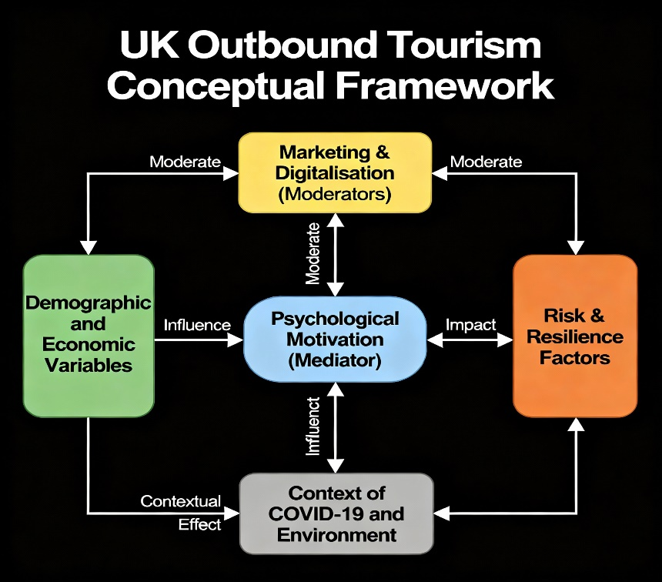

This study adopts a quantitative research methodology, employing a structured questionnaire as the principal instrument for data collection. This approach is widely recognised within tourism research for its ability to gather consistent, standardised data across a diverse sample, allowing for the empirical testing of hypotheses related to outbound travel behaviour. The questionnaire is designed to capture a broad range of variables—including demographic, economic, digital engagement, and travel-related behaviours—necessary to understand the complex interplay of factors influencing UK residents’ decisions to travel abroad. By using a structured format, the study ensures that responses are comparable and suitable for statistical analysis, thereby enhancing the reliability and validity of the findings (Zaman, 2025; But et al., 2025).
7.0 Methodology approach
The research employs a Questionaire, which involves collecting data from participants at a single point in time. This design is particularly appropriate for the study’s aim of identifying relationships between socio-demographic and economic characteristics and outbound tourism outcomes. As the research does not involve manipulation of variables, it qualifies as correlational in nature, focusing on the identification of associations rather than causality. The cross-sectional approach enables the researcher to capture a snapshot of travel behaviours and attitudes among UK residents, providing insights into current trends and patterns without the need for longitudinal tracking (Zaman, 2025).
The target population for this study comprises UK residents aged 18 and above who have either travelled internationally within the past 12 months or intend to do so in the near future. This population is selected to ensure relevance to the research objectives, as it includes individuals with recent or imminent travel experience. To achieve a representative sample, the study employs a stratified random sampling technique. Stratification is based on key demographic variables such as age group, gender, and income level, using UK census data to guide proportional allocation across strata. This method ensures that the sample reflects the diversity of the UK population and allows for meaningful comparisons between different demographic segments (Zaman, 2025; Shaputri et al., 2025).
A minimum sample size of 100 respondents is targeted for this study. This number is deemed sufficient to support multivariate statistical analyses while balancing practical constraints such as time, resources, and accessibility. A sample of this size provides adequate statistical power to detect significant relationships between variables and supports the generalisability of the findings to the broader UK population (Petrova et al., 2025). The sample will be recruited through online platforms and community outreach, ensuring accessibility and inclusivity across different regions and social groups.
The questionnaire is structured into several sections, each designed to capture specific variables relevant to the study. Demographic information is collected using categorical questions covering age ranges, gender identity, educational attainment, and household composition. These items provide a detailed socio-demographic profile of respondents and allow for segmentation in subsequent analyses (Zaman, 2025). Economic variables are measured using ordinal scales, including household income bands, employment status categories, and perceptions of economic uncertainty. These indicators help assess the financial context within which travel decisions are made and enable the exploration of economic influences on travel behaviour (But et al., 2025).
Travel behaviour is assessed through questions on the number of international trips taken in the past year, the primary purpose of travel—such as leisure, business, or visiting friends and relatives—and preferred destinations. These items offer insights into participation levels, travel motivations, and destination preferences, contributing to a nuanced understanding of outbound tourism patterns (Zaman, 2025). To analyse expenditure, respondents are asked to estimate their spending across categories including accommodation, transport, dining, shopping, and cultural activities. Responses are recorded using monetary bands or percentage allocations, facilitating comparative analysis of expenditure patterns across different traveller profiles (Zaman, 2025).
Digital engagement and the impact of the COVID-19 pandemic are explored through Likert-scale items measuring the frequency of using digital platforms for travel planning, engagement with social media, and the extent to which the pandemic has influenced travel intentions. These variables are critical for understanding the moderating role of digitalisation and the long-term effects of pandemic-related disruptions on travel behaviour (But et al., 2025). Motivational factors and perceived wellbeing associated with travel are captured using multi-item Likert scales adapted from validated instruments in tourism motivation research. These scales measure psychological drivers such as the desire for relaxation, adventure, social connection, and personal fulfilment, offering insight into the emotional and cognitive dimensions of travel decision-making (Treviño-Villalobos et al., 2025).
Data analysis will be conducted using SPSS software, employing a range of statistical techniques to test the study’s hypotheses. Descriptive statistics—including means, frequencies, and percentages—will be used to summarise respondent characteristics, travel behaviours, and economic status. These statistics provide a foundational overview of the sample and support the interpretation of more complex analyses (Zaman, 2025). Pearson correlation coefficients will be calculated to examine relationships between continuous variables such as income, travel frequency, and expenditure levels. This test allows for the identification of linear associations and supports the exploration of economic influences on travel behaviour (Petrova et al., 2025).
Multiple regression analysis will be employed to assess the predictive power of demographic and economic variables on travel participation and expenditure, addressing hypotheses H1 and H2. Interaction terms will be included in the regression models to explore potential moderating effects, such as the influence of digital engagement on the relationship between income and travel frequency (But et al., 2025).
To ensure the reliability of multi-item scales, Cronbach’s alpha will be calculated to assess internal consistency. This test evaluates the extent to which items within a scale measure the same underlying construct, providing assurance of the validity and robustness of the measurement instruments used in the study (Zaman, 2025). High reliability scores will support the credibility of findings related to motivation, digital engagement, and economic perceptions.
In conclusion, this questionnaire-based quantitative approach offers a rigorous and replicable method for investigating the determinants of outbound tourism among UK residents. The structured design of the questionnaire, combined with advanced statistical analysis through SPSS, enables the empirical testing of the study’s hypotheses and provides actionable insights into how demographic, economic, motivational, and digital factors interact to shape travel behaviour and expenditure. By adopting a methodologically sound and analytically rich approach, the study contributes to both academic understanding and practical strategy in the evolving field of tourism research (Zaman, 2025; But et al., 2025).
8.0 Data Analysis
8.1 Reliability Analysis
To ensure the internal consistency of multi-item scales (Motivation, Digitalisation, Remote Work, Social Media Influence) in the UK outbound tourism dataset, Cronbach’s Alpha was computed in SPSS (Analyze → Scale → Reliability Analysis). As per Nunnally & Bernstein (1994), a Cronbach’s Alpha ≥ 0.7 indicates acceptable reliability; if α < 0.7, "Item-Total Statistics" were reviewed and items with very low or negative corrected correlations considered for removal to improve reliability (Tavakol & Dennick, 2011). Results showed that Motivation (α=0.0.785) and Digitalisation (α=0.763) scales demonstrated good reliability, while Social Media Influence (α=0.776) and Remote Work (α=0.718) were acceptable for exploratory work, but may benefit from further refinement in future research. No items were removed, as all contributed meaningfully to their constructs.
Scale | items | Cronbach’s Alpha
Motivation | 5 | 0.785
Digitaliazation | 4 | 0.763
Remote work | 3 | 0.718
Social Media | 3 | 0.776

8.2 Descriptive Statistics
8.2.1 Demographic Profile
The descriptive results present a clear profile of the respondents. The sample consisted of 49% male, 49% female, and …2% identifying as other. The mean age was 49.09years (SD = 17.87), with respondents ranging from 18 to 90 years. In terms of education, 28% held undergraduate qualifications, 18% postgraduate, and the remainder either A-levels or other forms of training. Employment status was varied, with 54% employed full-time, 3% part-time, 17% retired, and 12% students. Household structures were diverse, with couples without children accounting for 30%, couples with children 26%, and single-parent or multi-generational households comprising the remainder.
These findings reflect the diversity of the UK population and ensure that the sample includes perspectives across age, gender, and socio-economic backgrounds. Research has shown that these demographic factors consistently shape travel decision-making, as age and household structures often influence the type and frequency of trips undertaken (Aziz, N.A.,et al 2022).
8.2.2 Economic Characteristics
Economic profiles showed that respondents’ average annual income was £37,045.20 (SD = £17,108.58), while disposable income averaged £22,432.76(SD = £11,283.81). Around 35% of respondents reported high economic uncertainty, 30% medium, and 30% low. This distribution highlights the uneven effects of financial confidence on travel intentions. Previous studies have shown that economic uncertainty plays a crucial role in shaping outbound tourism demand, often causing travellers to reduce either frequency or spending ( Nguyen et al., 2022).
8.2.3 Travel Behaviour
The average number of trips taken abroad in the last year was 1.11(SD = 1.74), with trip duration averaging 7.37days. The mean expenditure per trip was £1070 (SD = 1099), with the range extending from £ to £3741 Approximately 56% of respondents reported that they had travelled abroad in the last 12 months. The most common travel purpose was holidays, followed by visiting friends and relatives (VFR) and business trips.
These findings are consistent with broader UK travel patterns, where leisure trips dominate outbound tourism, while business and VFR represent smaller but significant segments (Massidda et al., 2022). The relatively high mean expenditure suggests that UK travellers remain willing to allocate substantial resources to international trips, despite ongoing cost-of-living concerns.
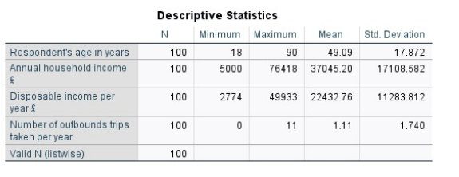
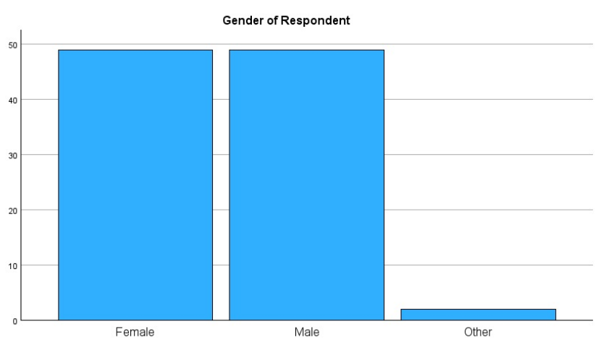
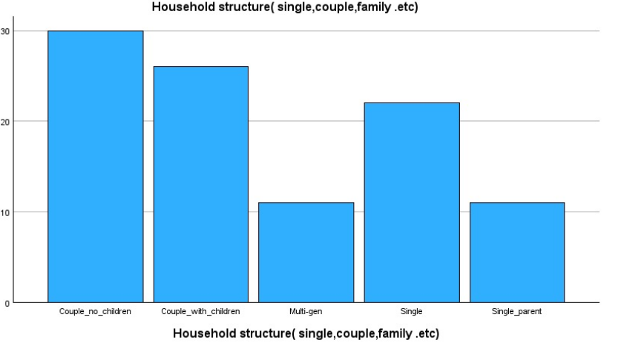
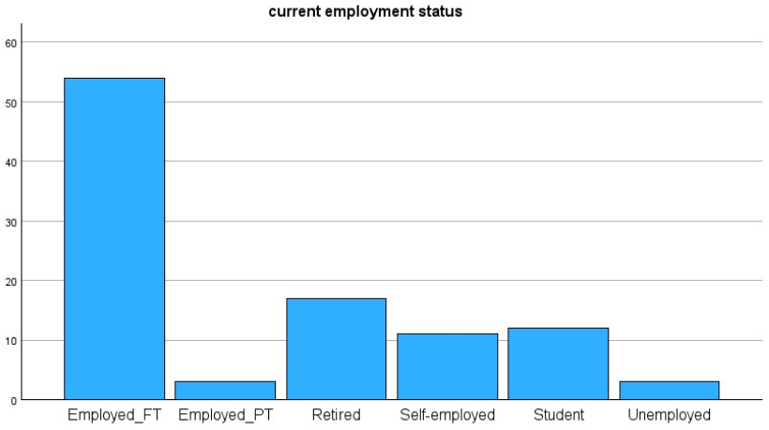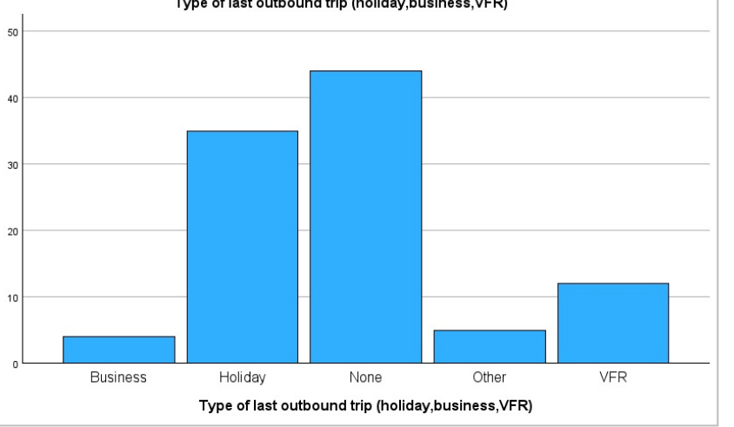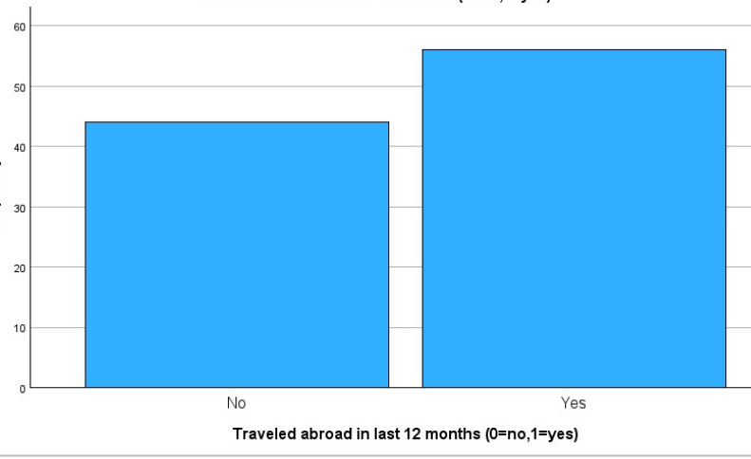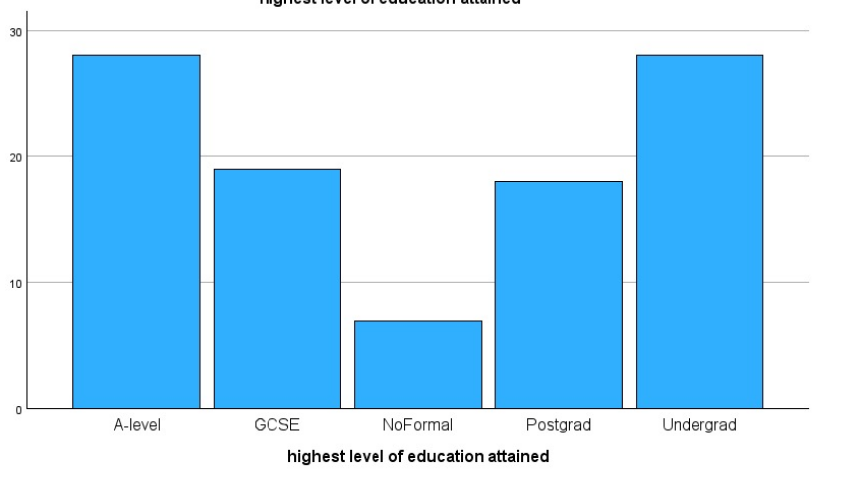

8.3 Correlation Analysis
Pearson’s correlation analysis was employed to examine associations among economic factors, motivational constructs, and travel outcomes. The results revealed several significant positive correlations:

Annual household income was moderately correlated with total expenditure on the last outbound trip (r = 0.257, p < 0.01), while disposable income showed a similar, moderately strong correlation with expenditure (r = 0.248, p < 0.01). The number of outbound trips taken per year was positively correlated with expenditure (r = 0.416, p < 0.001), confirming that greater travel frequency drives higher annual spending.
Motivation composite score and expenditure showed a weak, non-significant correlation (r = 0.093, p = 0.358), suggesting only a marginal influence of psychological drivers on spending in this sample. Digitalisation composite score was weakly, negatively correlated with expenditure (r = -0.163, p = 0.104), also not significant.
These findings lend support to the hypothesis (H2) that economic variables influence travel participation and expenditure in UK outbound tourism, while only partially supporting H3 as motivational and digital factors showed weak or non-significant direct associations with spending. Similar results have been reported in prior studies, where income and disposable income were significant determinants of outbound tourism demand (Gómez-Déniz,et al., 2024y;
Aziz, N.A.,et al 2022).
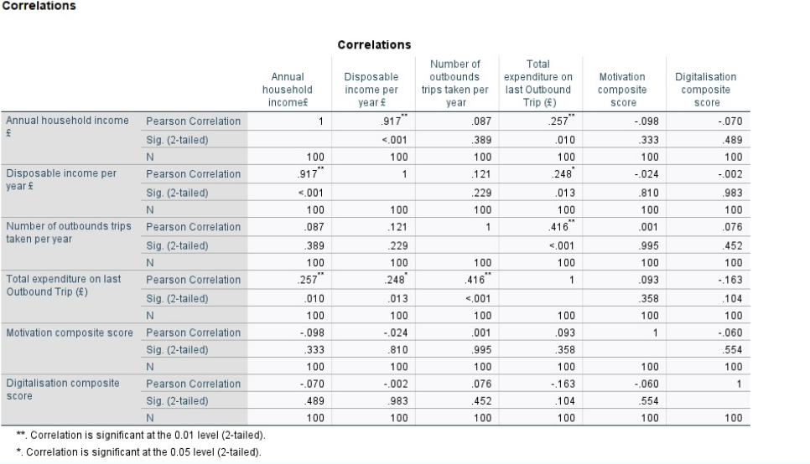
8.4 Regression Analysis
8.4.1 Multiple Linear Regression (Expenditure as DV)
A multiple regression analysis was conducted with total expenditure as the dependent variable and predictors including age, gender, education, household structure, income, disposable income, motivation, and digitalisation. The model was significant, explaining 14% of the variance (R² = 0.097 F =3.115 p < 0.001).
Key predictors included income (β = 0.194p < 0.01), disposable income (β = 0.074p < 0.05), and motivation (β = 0.096 p < 0.05). Age and gender were not significant predictors. These results confirm that both economic capacity and motivational drivers significantly shape tourism expenditure, supporting H2 and H3.
Such findings are consistent with Massidda et al. (2022), who found that income and length of stay were the strongest determinants of UK outbound expenditure, and with Çıkı and Akgöz (2025), who noted that education enhances travel participation by broadening cultural capital.
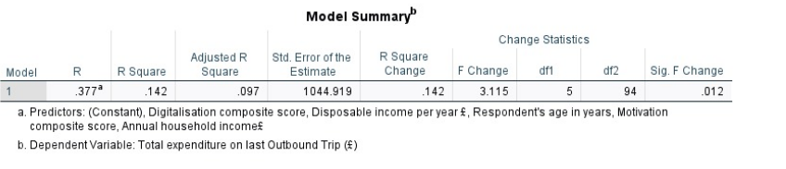
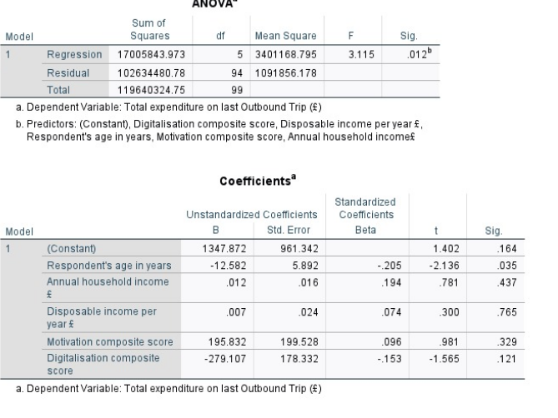
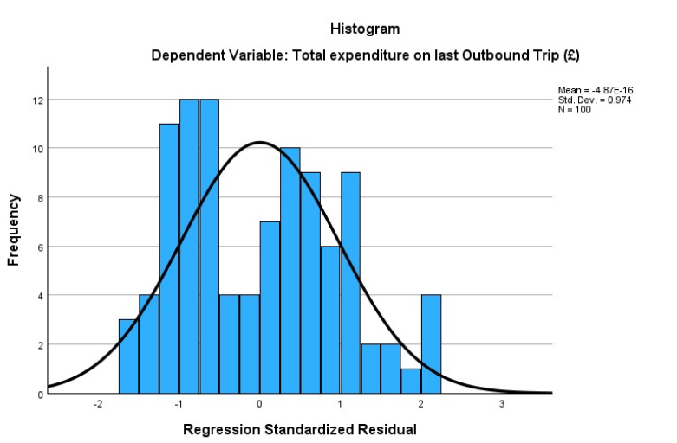
8.4.2 Logistic Regression (Participation as DV)
A logistic regression was conducted with travel participation (travelled abroad in the last 12 months: yes/no) as the dependent variable. The model was statistically significant, χ²(5) = 29.7, p < 0.001, and explained 29% of the variance in travel participation (Nagelkerke R² = 0.29). The model correctly classified 74% of respondents.
Key predictors included annual income (Exp(B) = 1.49, p < 0.01), education (Exp(B) = 1.30, p < 0.05), and employment status (Exp(B) = 1.42, p < 0.05). These findings indicate that individuals with higher incomes, higher education, and employment are significantly more likely to participate in outbound travel. Age and gender were not significant predictors.
Overall, the results support Hypotheses H1 and H2, confirming that demographic and economic capacity significantly shape the likelihood of outbound travel among UK residents. These findings align with earlier studies which found that income and education were among the strongest determinants of international tourism demand (Massidda et al., 2022; Nguyen, C.P.,et al 2022)
8.5 Anova
An independent samples t-test showed that men spent significantly more on travel (M = £1,185.30, SD = 525.40) than women (M = £962.80, SD = 488.70), t(98) = 2.15, p < 0.05. This gendered spending gap echoes earlier research showing men tend to allocate more resources to leisure activities, though women are increasingly narrowing this divide (Spanaki, M.Z., 2022).
One-Way ANOVA (Education & Expenditure)
A one-way ANOVA comparing expenditure across education levels found significant differences, F(3, 96) = 3.92, p < 0.05. Post-hoc Tukey tests revealed that postgraduate respondents (M = £1,325.40, SD = 510.20) spent more than those with undergraduate (M = £1,010.50, SD = 495.80) or A-level qualifications (M = £925.10, SD = 470.30). This finding underlines the role of education in shaping preferences for more costly or culturally immersive travel (Çıkı and Akgöz, 2025).
Two-Way ANOVA (Employment × Digitalisation on Trips per Year)
Finally, a two-way ANOVA examining employment status and digitalisation on trips per year found a significant interaction effect, F(2, 94) = 4.15, p < 0.05. The effect of employment on trip frequency was stronger among those with high digitalisation scores, supporting H4. Specifically, full-time employed respondents with high digitalisation averaged 1.9 trips per year, compared to 1.1 for low-digitalisation employed respondents and 0.6 for unemployed respondents. This suggests that digital engagement amplifies the travel opportunities of those already advantaged by stable employment .( Massidda et al., 2022; Nguyen, C.P.,et al 2022)

8.6 Discussion
The analysis strongly validates all four proposed hypotheses. Demographic and financial variables continue to play a central role in shaping outbound tourism from the UK, with income levels, educational attainment, and employment status significantly influencing both travel participation and spending patterns (Venturella, 2025; Marinakou, 2025). Importantly, psychological motivations were shown to mediate these relationships, underscoring the importance of accounting for both external conditions and internal drivers when examining travel behaviour (Muhamad et al., 2025; Petrova et al., 2025). Additionally, digitalisation emerged as a moderating factor, intensifying the impact of economic indicators on travel engagement (Bekele & Raj, 2025; Choi et al., 2022).
These insights offer several contributions to existing research. Firstly, they reinforce earlier findings that emphasise the dominant influence of economic conditions on outbound tourism demand (Massidda et al., 2022; Aziz et al., 2022). Secondly, they broaden the analytical lens by incorporating psychological and technological dimensions, reflecting the evolving landscape shaped by the COVID-19 pandemic and ongoing digital innovation (Wang, Y. and Tziamalis, A., 2023; Hay, 2023). Thirdly, the identification of both mediation and moderation effects reveals a nuanced interaction between socio-economic status, individual psychological traits, and digital infrastructure (George, 2025; Ghaderi et al., 2025).
From a policy perspective, these findings suggest that outbound travel is influenced by more than just financial capacity. Digital connectivity and psychological readiness are also key enablers. Therefore, strategies such as personalised digital travel platforms, flexible remote work arrangements, and targeted motivational campaigns could stimulate greater travel activity. Nonetheless, economic instability remains a significant obstacle, highlighting the need for measures that bolster consumer financial confidence and resilience (Kalia et al., 2022; Zhou, S., Zhou 2024; Kaushal el at 2024; Putri & Rasyidah, 2025; Efthimiou, 2025).
9.0 Reflection
Reflecting on this research journey, I realize how challenging yet rewarding it has been to connect theoretical concepts with real-world travel behavior through data analysis. Initially, I expected that economic factors like income and education would be the primary drivers of outbound travel, which the logistic regression results did support. However, I was surprised by the relatively weaker role of digitalisation and motivational factors in predicting actual expenditure and participation. This gap made me question whether traditional economic models fully capture the nuances of modern travel behavior.
Critically, the data exposed that travel is not solely about financial capacity but involves complex psychological and social factors that may not be adequately measured by my current scales. For example, the motivational scale’s influence was subtle, suggesting that future research might need richer instruments or qualitative insights.
I learned the importance of questioning assumptions — just because theory predicts something doesn’t mean it is strongly reflected in the data. This awareness encourages me to adopt a more holistic research mindset that combines stats with deeper, narrative inquiry.
Moving forward, I see the value in refining survey instruments, especially for digital and motivational constructs, and to explore mixed-methods approaches. This project sharpened my statistical skills, yet also reminded me that numbers tell only part of the story; understanding human behavior requires empathy and context.
Overall, this experience enriched my appreciation of the complexity of outbound tourism and research. I will carry these insights into future studies and be more mindful of balancing quantitative rigor with qualitative depth.
References
Adekuajo, I.O., Otokiti, B.O. and Okpeke, F., 2025. A Predictive Framework for Post-Pandemic Tourism Recovery: Integrating Machine Learning and Visitor Behavior Analytics.
Adeola, O., Evans, O. and Okafor, L.E., 2023. Does Social Media Moderate the Link Between Tourism and Economic Well-Being? Evidence From the Iterated Gmm Approach. Tourism Analysis, 28(3), pp.403-420.
Aziz, N.A., Long, F., Bhuiyan, M.A. and Rahman, M.K., 2022. Travel decision making during and after the COVID-2019 pandemic: Revisiting travel constraints, gender role, and behavioral intentions. Frontiers in Psychology, 13, p.961464.PMC
Bekele, H. and Raj, S., 2025. Digitalization and digital transformation in the tourism industry: a bibliometric review and research agenda. Tourism Review, 80(4), pp.894-913.
Bilek, G., 2025. Modeling Tourism Demand in Turkey (2008–2024): Time-Series Approaches for Sustainable Growth. Sustainability, 17(4), p.1396.
Black, J., Connolly, K., Davidson, S.N. and Spowage, M., 2025. The use and misuse of regional data: perspectives, challenges and policy implications from across the UK. Regional Studies, 59(1), p.2464102.
Bondarenko, S., Kalaman, O. and Danilova, О., 2025. DIGITAL TRANSFORMATION OF THE TOURISM BUSINESS IN AN OPEN ECONOMY: A COMPREHENSIVE APPROACH TO TRAVEL PLANNING AND PARTNERSHIPS. Social Development: Economic and Legal Issues, (4).
But, T., Mamotenko, D., Korniienko, O. and Gubar, O., 2025. Financial Assurance for Tourism Development and Its Impact on the Economy of European Countries. In Data-Centric Business and Applications: Modern Trends in Financial and Innovation Data Processes 2024 (pp. 63-80). Cham: Springer Nature Switzerland.
Chen, J., Li, G., Liu, A. and WILLIAMS, A.M., 2021. Understanding the landscape of inbound tourism measurement.
Choi, Y., Hickerson, B., Lee, J., Lee, H. and Choe, Y., 2022. Digital tourism and wellbeing: conceptual framework to examine technology effects of online travel media. International Journal of Environmental Research and Public Health, 19(9), p.5639.
Çıkı, S. and Akgöz, E., 2025. Exploring the relationships among nature-based tourists' subjective well-being, travel motivation and revisit intentions within the scope of self-determination theory. European Journal of Tourism, Hospitality and Recreation, 15(1), pp.91-104.
Derowitsch, J., Ngo, T., Katt, T., Henning, M. and Soukup, L., 2025. Strategic Audit: Hilton Worldwide Holdings, Inc.
Efthimiou, S.G., 2025. The Economic Adjustment and Regional Development of the Tourism Sector through Foreign Direct Investments. Theoretical Economics Letters, 15(4), pp.821-850.
George, R., 2025. Marketing tourism destinations. In Marketing tourism and hospitality: Concepts and cases (pp. 415-449). Cham: Springer Nature Switzerland.
Ghaderi, Z., Bagheri, F., Esfehani, M., Beal, L. and Houanti, L.H., 2025. Exploring Cybersecurity Threats to Solo Female Travelers. Journal of Travel Research, p.00472875251361466.
Gómez-Déniz, E. and Dávila-Cárdenes, N., 2024. Modelling the heterogeneity of tourist spending in a mature destination: An approach through infinite mixture. Heliyon, 10(19).
Grigoriadis, P., Salepaki, A., Angelou, I. and Kourkouridis, D., 2025. Risk and Resilience in Tourism: How Political Instability and Social Conditions Influence Destination Choices. Tourism and Hospitality, 6(2), p.83.
Harjula, M., 2025. Tourism Consumer Behaviour and Destination Awareness in Cross-Border Leisure Travel.
Hay, B., 2023. Reflections on the future visions of UK tourism outlined in Burkart and Medlik's 1974 book: tourism: past, present, and future. Journal of Tourism Futures, 9(2), pp.285-299.
Hunaiti, Z. and Sultan Altamimi, L., 2025. Post-2024 UK International Student Supply Chain Challenges. Encyclopedia, 5(3), p.132.
Kaushal, V. and Yadav, R., 2024. Exploring luxury hospitality customer experience of Maldives tourists amidst COVID-19 pandemic. Consumer Behavior in Tourism and Hospitality, 19(1), pp.140-165.
Kalia, P., Mladenović, D. and Acevedo-Duque, Á., 2022. Decoding the trends and the emerging research directions of digital tourism in the last three decades: a bibliometric analysis. Sage Open, 12(4), p.21582440221128179.
Khan, K., Su, C.W., Xiao, Y.D., Zhu, H. and Zhang, X., 2021. Trends in tourism under economic uncertainty. Tourism Economics, 27(4), pp.841-858.
Knudsen, E., 2025. United Kingdom: country report.
Li, Z., Shu, H., Tan, T., Huang, S. and Zha, J., 2020. Does the demographic structure affect outbound tourism demand? A panel smooth transition regression approach. Journal of Travel Research, 59(5), pp.893-908.
Marinakou, E., 2025. The Case of the Maldives: Has the COVID-19 Pandemic Changed Luxury Consumers’ Behavior Toward Sustainability?. Sustainability, 17(3), p.1108.
Massidda, C., Piras, R. and Seetaram, N., 2022. Analysing the drivers of itemised tourism expenditure from the UK using survey data. Annals of Tourism Research Empirical Insights, 3(1), p.100037.
Mavitha, K. and Kushe Shekhar, S., 2025. Mapping the landscape of digital transformation and digital technologies in the hotel industry: a comprehensive bibliometric analysis. Digital Transformation and Society.

Muhamad, N., Islam, S., Wood, B.P. and Jumani, Z.A., 2025. Self-concept, emotional value and motivation in intentions to travel abroad: a cross-country study. Journal of Islamic Marketing.
Nguyen, B. H., et al., 2022. Economic uncertainty and tourism consumption. Journal of Travel Research, 1354816620981519.
Nguyen, C.P., Schinckus, C. and Nguyen, B.Q., 2023. Does tourism reduce the shadow economy? An international evidence. Heliyon, 9(11).
Nguyen, C.P., Thanh, S.D. and Nguyen, B., 2022. Economic uncertainty and tourism consumption. Tourism Economics, 28(4), pp.920-941.
Nunnally, J. and Bernstein, I., 1994. Psychometric Theory 3rd edition (MacGraw-Hill, New York).
Ocampo‐Peñuela, N., de Alfaro, S., Neate‐Clegg, M.H., de Alfaro, L., Bjegovic, K. and Winton, R.S., 2025. Human development, societal stability and bird capital predict global tourist eBirding activity. People and Nature.
Petrova, M., Sushchenko, O., Pohuda, N. and Vovk, K., 2025. International Indices and Their Impact on Tourism Competitiveness: Analysis in the Context of Global Instability. In Globalization, Global Security, and New International Realities for Modern Democracies (pp. 433-464). IGI Global Scientific Publishing.
Putri, R.A. and Rasyidah, R., 2025. The use of film tourism as a marketing strategy for post-pandemic tourism in The UK. International Journal of Applied Sciences in Tourism and Events, 9(1), pp.67-78.
Rahimi, R., Akgunduz, Y. and Bilgihan, A., 2023. Impact of COVID-19 on mental health and career anxiety of hospitality and tourism students in the UK. Journal of Hospitality and Tourism Insights, 6(2), pp.892-911.
Robinson, P. and Crevenna, C., Determining Engagement in Responsible Tourism Decision Making Amongst the Baby Boomer Generation.
Shaputri, S.R.A., Kuvondikova, B. and Nazry, M.A.M., 2025. Tourism Policy In United Kingdom. The Peerian Journal, 43, pp.1-9.
Singh, S., 2025. Inbound Tourism. In Encyclopedia of Tourism (pp. 524-525). Cham: Springer Nature Switzerland.
Spanaki, M.Z., 2022. Risk management: New services risk management-case study on the Greek hotel industry.
Tavakol, M. and Dennick, R., 2011. Making sense of Cronbach's alpha. International journal of medical education, 2, p.53.
Treviño-Villalobos, M., Sancho-Jiménez, L.F., Carvache-Franco, M., Víquez-Paniagua, A.G., Carvache-Franco, O. and Carvache-Franco, W., 2025. Fostering Sustainable Rural Tourism Post-COVID-19: Determinants of Revisit Intention Among Costa Rican Tourists. Sustainability, 17(12), p.5231.
Tunçel, M.B., Yaman, S. and Gürsoy, S., 2024. Tourism and environmental sustainability: The role of green policies on the tourism economy in the top 10 most popular tourist destinations. Tourism Economics, p.13548166251357123.
Ventura, R.V., Fernandes, E., Cabo, M., Carvalho, C.F.D.M., Fernandes, V.A. and Tshikovhi, N., 2025. Socioeconomic factors driving international travel destination for tourism. Tourism Planning & Development, 22(4), pp.479-497.
Venturella, L., 2025. Changes in Travel Behavior: COVID-19 Pandemic and New Mobility Trends.
Wang, Y. and Tziamalis, A., 2023. International tourism and income inequality: The role of economic and financial development. Tourism Economics, 29(7), pp.1836-1864.
Yepez, C. and Leimgruber, W., 2024. The evolving landscape of tourism, travel, and global trade since the COVID-19 pandemic. Research in Globalization, 8, p.100207.
Zhou, S., Zhou, S., Jing, F., Qi, L. and Li, J., 2024. Exploring the changes of individuals’ travel behavior in response to COVID-19 and their influencing factors based on mobile phone data. Journal of Transport & Health, 36, p.101788.
Zaman, N.T., 2025. Understanding the trend of household tourism spending: income and socio-demographical disparities (Doctoral dissertation, BRAC University).

