

Module Title: MBA Dissertation
Module Code: LCMB7020
Course: MBA Marketing
Lecturer: Tushara Balandran

Dissertation Topic:
Understanding the Influence of digital marketing strategies on buying behaviour of Consumers: A Case of Netflix UK

Master’s Degrees by Examination and Dissertation
Declaration Form.
1. This work has not previously been accepted in substance for any degree and is not being concurrently submitted in candidature for any degree.
Signed – Ashok Gorana
Date – 15/06/2023

2. This dissertation is being submitted in partial fulfilment of the requirements for the degree of Master in Business Administration.
Signed – Ashok Gorana
Date – 15/06/2023
3. This dissertation is the result of my own independent work/investigation, except where otherwise stated.
Other sources are acknowledged by footnotes giving explicit references.
A bibliography is appended.
Signed candidate: Ashok Gorana
Date: 15/06/2023

4. I hereby give consent for my dissertation, if accepted, to be available for photocopying, inter- library loan, and for deposit in the University’s digital repository
Signed (candidate) – Ashok Gorana
Date – 15/06/2023
Supervisor’s Declaration.
I am satisfied that this work is the result of the student’s own efforts.
Signed: Tushara Balendran
Date: 15/06/2023

University of Wales: Trinity Saint David

E-Thesis Deposit Agreement

Details of the Work
I would like to deposit the following item in the digital repository maintained by the University, and/or in any other repository authorized for use by the University:

Title - Understanding the Influence of digital marketing strategies on buying behaviour of Consumers: A Case of Netflix UK

This item is a product of my own research endeavours and is covered by the agreement below in which the item is referred to as “the Work”. It is identical in content to that deposited in the Learning Resources Centre, subject to point 4 below.

I agree that the University of Wales: Trinity Saint David may electronically store, copy or translate the Work to any approved medium or format for the purpose of future preservation and accessibility. The University is not under any obligation to reproduce or display the Work in the same formats or resolutions in which it was originally deposited.

UW: TSD Digital Repository
I understand that work deposited in the digital repository will be accessible to a wide variety of people and institutions, including automated agents and search engines via the World Wide Web.

I understand that once the Work is deposited, the item and its metadata may be incorporated into public access catalogues or services, such as national databases of electronic theses.

I agree as follows:
- That I am the author or have the authority of the author/s to make this agreement and do hereby give the University of Wales: Trinity Saint David the right to make available the Work in the way described above.
- That the electronic copy of the Work deposited in the digital repository and covered by this agreement, is identical in content to the paper copy of the Work.
- That I have exercised reasonable care to ensure that the Work is original, and to the best of my knowledge, does not breach any laws including those relating to defamation, libel and copyright.
- That I have, in instances where the intellectual property of other authors or copyright holders is included in the Work, gained explicit permission for the inclusion of that material in the Work, and in the electronic form of the Work as accessed through the open access digital repository, or that I have identified and removed that material for which adequate permission has not been obtained and which will be inaccessible via the digital repository
- That University of Wales: Trinity Saint David does not hold any obligation to take legal action on behalf of the Depositor, or other rights holders, in the event of a breach of intellectual property rights, or any other right, in the material deposited.
- That I undertake to indemnify the University of Wales: Trinity Saint David against all actions, suits, proceedings, claims, demands and costs occasioned by the University in consequence of any breach of this agreement

Signature – Ashok Gorana

Date – 15/06/2023



MBA DISSERTATION LCMB7020
Topic: Understanding the Influence of digital marketing strategies on buying behaviour of Consumers: A Case of Netflix UK
ABSTRACT
In the present business environment, implementation of appropriate digital marketing strategies has become a priority for all organisations to gain deeper insights into understanding the client requirements and desires. This aligns with the organisation’s objective to attract customer engagement and loyalty by customising the products and services, based on the consumer’s taste and preferences, as well as ensure that the brand awareness strengthens across different modes and channels of digital marketing. In the context of Netflix UK, the study has conducted an in-depth investigation on the role and effect of digital marketing strategies on the customer’s buying behaviour, using suitable theories. The formulation of specific aims and objectives ensures conclusive justifications of the research questions with the assistance of the primary quantitative data process used in the study. The study utilises correlation and regression analysis to evaluate the responses of 75 UK-based respondents through a survey. The findings reveal a positive relationship between “the “dependent variable” of “changing nature of purchasing” and the “independent variable” of “online marketing benefits”, “reliable online purchase” and “provide appropriate content”. Recommendations to mitigate the literature gaps have been provided to enhance the future scope of the study.

Acknowledgement

I am very grateful to my professors for helping me in organising and analysing the collected data for enhancing the scope for the research study. Additionally, I want to thank my supervisors who were gracious enough to support my hard work with relevant notes and material sources for an in-depth study on the research topic and building my knowledge for the upcoming stages of the research. I am indebted to my parents and fellow colleagues for having encouraged me throughout the research process by presenting me with the required details for the study and motivating me to perform productively.

Table of Contents
Chapter 1: Introduction 8
1.1 Background of Study 8
1.2 Significance of Study 9
1.3 Research Rationale 9
1.5 Research Questions 10
1.6 Chapter overview 10
Chapter 2: Literature Review 13
2.1 Introduction 13
2.2 Different types of digital marketing adopted by organizations 13
2.3 Importance of understanding the consumer buying behaviour of digital consumers Maslow’s hierarchy of needs 15
2.4 Relating 5 stage model of consumer buying behaviour with Netflix: Kotler's model 17
2.5 Digital marketing strategies used by Netflix 19
2.6 Honeycomb model and RACE model 22
2.7 Similarities and differences between Honeycomb MODEL and RACE Model 26
2.8 Literature Gap 27
2.9 Conclusion 27
Chapter 3: Research Methodology 29
3.1 Introduction 29
3.2 Research Onion 29
3.3 Research Philosophy 30
3.4 Research Approach 30
3.5 Research Strategy 31
3.6 Type of investigation 31
3.7 Research choices 32
3.8 Time horizon 33
3.9 Sampling Technique 33
3.10 Data Collection Method 34
3. 11 Data Analysis 35
3.12 Research Ethics 35
Chapter 4: Findings and Analysis 37
4.1 Introduction 37
4.2 Findings 37
4.2.1 Specification of Variables 37
4.2.2 Specification of Hypotheses 37
4.2.3 Descriptive Statistics 38
4.2.4 Graphical Representation 40
4.2.5 Correlation Analysis 53
4.2.6 Regression 54
4.3 Discussion 55
4.3.1 Discussion on graph 55
4.3.2 Discussion on the correlation analysis 57
4.3.3 Discussion on the regression 57
4.3.4 Comparative analysis 58
4.4 Conclusion 59
Chapter 5: Conclusion and Recommendation 60
5.1 Conclusion 60
5.2 Limitations 62
5.3 Recommendation 62
5.4 Further research 63
References 64
Appendices 77
Appendix 1: Survey questionnaire 77

Chapter 1: Introduction

1.1 Background of Study
The use of digital platforms is widely considered the most effective method of attracting a substantial customer base nowadays considering how many people use them on a daily basis. Moreover, digital marketing provides the opportunity for business organisations to reach out to a diverse group of customers internationally, and that too within a short span of time. Also, the approach to digital marketing helps the company to emphasise the distinctive qualities of its goods or services to clients, which can considerably impact their purchasing behaviour.(Habib et al. 2022). Thus, the percentage of sales as well as the earnings % are heavily dependent on the effectiveness of the online advertising approach in capturing the interest of the customers. In this research, a detailed analysis of the influence of digital marketing strategy on customers’ buying behaviour will be depicted with special emphasis on the renowned subscription-based online streaming platform, Netflix of the UK. From the study, different modes of digital marketing strategy used by Netflix can be obtained along with the determination of the connection between digital marketing and customer buying behaviour of the service provided by Netflix.

1.2 Significance of Study
The effort on analysing the impact of digital advertising strategies on customer purchasing behaviour is notable for a number of reasons, most notably in the context of Netflix UK. Considering the increased usage of digital media, internet marketing has grown into an important aspect of a company's advertising approach. This project traces how digital marketing strategies fuel the buying habit of consumers and help Netflix with its advertisement strategy. It also investigates the impact of developing effective digital marketing strategies for Netflix. The report also performs research on the impact of online advertising methods on client purchase behaviour. In today's digitalization, consumer behaviour has undergone a drastic change, this project will provide insights into purchasing behaviour and the things that motivate the purchasing behaviours of customers. Netflix might gain a competitive advantage by understanding the impact of digital marketing strategies. This might help the company to make efficient digital marketing strategies. The study is extremely significant as it might help to provide insights into the connections between digital marketing strategies and online buying behaviour. The case study of Netflix adds an important point to the study making the project relevant for other businesses as well that function in the digital media space.

1.3 Research Rationale
According to Rashi, (2021), the goal of the research is to gain knowledge and investigate digital marketing's impact on the buying behaviour of customers online. Companies are adopting these marketing strategies due to the demand of digital channels and social media platforms. Marketing researchers have had a debate regarding the effectiveness of these strategies and their impact on the behaviour of consumers. The study is significant because it offered information about the successful efficacy of strategies for digital advertising as well as their effects on customer behaviour in the highly aggressive digital marketplace. Customer management of the company is also enhanced using this research. The data on the recent strategy says that more than half of the UK population has a Netflix subscription, which makes it a relevant topic for this research. The characteristics that shape the buying patterns of Netflix customers in the United Kingdom helps businesses who compete in identical markets in improving their marketing tactics.(SAPUTRA et al. 2022). This research adds to the body of knowledge on the interaction between buying habits and the use of digital marketing. The target of this research is to analyse the effect of digital advertising methods based on client behaviour and to provide useful suggestions for organisations that operate in comparable industries.

1.4 Research Aim and Objectives

Research Aim: The primary intention of the research to explore and understand the concept of digital marketing strategy in influencing the consumer purchasing behaviour. For in-depth knowledge, Netflix Company will be taken into account as an example.

Research Objectives
● To determine Netflix’s current digital marketing strategy
● To examine the prospects and difficulties of Netflix’s digital marketing strategy implementation.
●To comprehend the impact of digital marketing methods on consumer buying behaviours.

1.5 Research Questions
● What are the most recent digital marketing strategy implemented by Netflix?
● What are the advantages and disadvantages of implementing a digital marketing strategy at Netflix?
● What impact do digital marketing methods have on customer purchasing Behaviour?

Hypotheses
H0- Digital marketing strategies of Netflix do not have any influence on buying behaviour of customers.
H1- Digital marketing strategies of Netflix have significant influence on buying behaviour of customers.

1.6 Chapter overview
Introduction
According to Amoroso, (2021), the research provides an overview of the background information relevant to the topic. This includes the reason why the research is important and necessary, the aims and objectives of the study, the research questions that will guide the investigation, and the rationale behind the study. The introduction serves as a map for the reader that is outlining the purpose and scope of the research and is providing a proper knowledge of the aim of the study that is required to achieve. The stage is set for the remaining paper by providing context and information on the background which helps the reader to get proving understanding of the importance of the research.

Literature Review
The following section implies the literature portion that will include an in-depth discussion of research objectives. Every component of the study topic concerns will be thoroughly explored. For example, the adequate model will be employed regarding digital marketing in this section. Owing to this study, its purpose is to provide a scene of latest findings concerning to digital market and consumer behaviour and debate pertaining to particular area and convey the knowledge accordingly. However, to ensure that all elements of research topic have been addressed, various journals and authentic articles will be taken into account for research purpose (Bernacki et al. 2021). The most important objective of this following section aimed at providing a clear concept and understanding about choose context. Most significantly, the study will make sure of including critical evaluation in this portion.

Research Methodology
This section of the research outlines the process that is used to conduct this study. Various components are included in this section like research philosophy, research design, research strategy, research approach, research ethics, data analysis, and data collection tactics. Secondary sources of information were used by the researchers to rely on to guide the activities of the research (da Silva Wegner et al. 2023). Here, a comprehensive description of every segment of the research process including how was the collection of data carried out, what methods were used for data analyzation, and ethical considerations were taken into account. This is a crucial part of the research paper as this helps to guarantee the accuracy and dependability of the results of the research.

Data Findings and Analysis
This section of the research paper concentrates on presenting the data derived from the study. The findings obtained that are used to interpret the perceptions related to the topic of the research are mainly described in this section. Results are presented using tables, graphs, or charts in a clear and precise manner that makes it easier to understand (Florido-Benítez et al.2022). The summary of the data provided in this section during the research highlights any patterns or trends that were observed. The research objectives and hypothesis is supported by the result section and also help to validate the outcomes of the study.

Recommendations and conclusion
This section of the research concentrates on providing a detailed description of the study and recommendations are offered for mitigating any identified problems. This section carefully analyses the findings, interpreting and explaining their significance in relation to the objectives of the research (Meyer et al. 2023). This section offers insights into the implications, limitations, and future directions for research. Recommendations for addressing any issues or challenges that occurred during the research and practical solutions are suggested that requires to improve the effectiveness of research endeavours of the future.

Chapter 2: Literature Review

2.1 Introduction
Marketing employing digital platform allow business to draw attention to their offerings in the best possible moments along with at right spot when customers are most likely to take decision regarding purchasing (Dwivedi et al. 2023). Based on this, the particular brand undertakes discounts and promotions so as to attract people. Therefore, further, the study will focus on Netflix Company and will further explore various hypotheses. In addition to this, multiple relevant models will be implemented to understand the buying pattern of customers. Moreover, the section will also focus on presenting Netflix’s digital marketing strategy along with the recommendation concerning motivating customers through effective models.

2.2 Different types of digital marketing adopted by organizations
Definition of Digital Market
With the advancement of technology, the modern world has become extremely dependent on the digital platform. In this era of digitalization, most of companies prefer to attract customers through digital platforms as most of people use the internet nowadays. It has become easier for a business organization to advertise their products through social media because most of modern people have social media accounts and they are able to view the products of a particular company by viewing their social media pages. According to Desai et al. (2019), the process of marketing through the Internet and digital platforms is called digital marketing.

Definition of Consumer Behaviour
According to the point of view of Han et al. (2021), consumer behaviour is considered as one of the most common aspects a business organization focuses on. Consumer behaviour is known as the individuals’ choice and decision for purchasing any product. It is one of the responsibilities of a business organization to understand consumer behaviour.
According to Desai and Vidyapeeth, (2019), the basic dissimilarity between digital marketing and internet marketing is that the former golds a broader meaning for a marketing strategy that gives leverage to the digital channels to make promotions regarding the product and services. The promotion can be done through TV ads, social media platforms, billboards, and campaigns like pay-per-click, which shows that digital marketing in the present time is just not limited to the internet but beyond it. On the other hand, Herhausen et al. (2020), says that internet marketing means the set of different strategies of marketing which are carried out through the internet. There are mainly seven types of Internet marketing that utilize numerous strategies and tactics. All these marketing types complete each other and are sometimes used together.
Using a variety of social media platforms to acquire and increase customer attention, such as Instagram, Facebook, and Twitter, social media marketing can be referred to as - an approach used to gain customer attention and increase sales. Social media marketing is further divided into sub-parts those are “organic social media marketing” and “paid social media marketing”. As per Krizanova et al. (2019), Search engine optimization (SEO) is another digital media marketing strategy whereby websites and digital content are optimized for enhancing the ranking of search engines which further increases the number of visitors to a specific webpage. As stated by Olson et al. (2021), Content marketing is another strategy that is being used by companies in which the process of continuous creation, distribution, and promotion of relevant online materials is being done. It is designed in a strategic manner in order to attract, engage and transform the segmented targeted market into loyal costumes. There are various form of content that businesses could use which includes blog posts, videos, podcasts, emails, and many more. Content marketing mainly works with social media marketing and search engine optimization. Founded on the preceding discussion, it can be said that social media s one of the most popular channels which are being used by businesses in distributing and promoting their products and services.
As per Saura, (2021), in influences marketing influences works together for promoting a product or service to attract online followers. Prior to internet marketing, only renowned brands were able to have influencer marketing as they were able to afford to work with famous celebrities. But, in the present time, everyone can benefit from influencer marketing. Many businesses tend to pay a part of their revenue or sales which is known as affiliate marketing. According to Lee and Cho (2020), Affiliate marketing is a process whereby businesses sets up a program in order to give commissions to external websites or individuals in return for the traffic or sales generated by them. This strategy mainly helps influences and internet marketers to gain money by promoting the product and services of different brands.
As stated by Ritz et al. (2019), email marketing is a process whereby an email is sent directly to the customer holding a marketing message in an effort to attract new customers and retail the existing ones. According to Vieira et al. (2019), paid advertisement is such digital marketing strategy in which advertisers are being paid to showcase the adverts of the companies on search engines and different online platforms. The most popular of them are Facebook, Instagram, YouTube, etc.

2.3 Importance of understanding the consumer buying behaviour of digital consumers Maslow’s hierarchy of needs
According to Abbas, (2020), consumers are the main backbone of every business organisation so it is essential for every company to evaluate and comprehend the behavioural patterns of the potential customers appropriately and accordingly, the company can include essential measures and products into the business model. This assists in boosting the satisfaction as well as retention of the audience. This initiative further influences the volume of sales which is associated with the profitability as well as revenue of a company. According to the viewpoint of Hopper, (2020), a strong financial statement can help a business enterprise to manage all its operations and maintain its reputation in the competitive business market adequately in this modern era. Maslow’s Hierarchy of Needs is one of the most important theories that explain efficiently the needs of a person in five pyramidal stages. Physiological needs, needs for security, affection and community requirements, self-esteem needs, and self-actualization needs are the five stages. Basic essential items suggest medicine and staples are considered as a basic requirement for all human needs that are reflected in the psychological needs of the pyramid. Insurances, retirement policies, alarm systems and investment coverings constitute the safety needs of the pyramid (Guo et al. 2019). Other products such as the clotting dreams club pass- all these are aligned with the self-belonging needs of the pyramid. Self-esteem needs of the hierarchy pyramid model include certain products or services such as credit cards, cars, furniture, properties and other products that reflect the social and living standards of a person. Self-actualization needs are those needs that involve tourism and education.
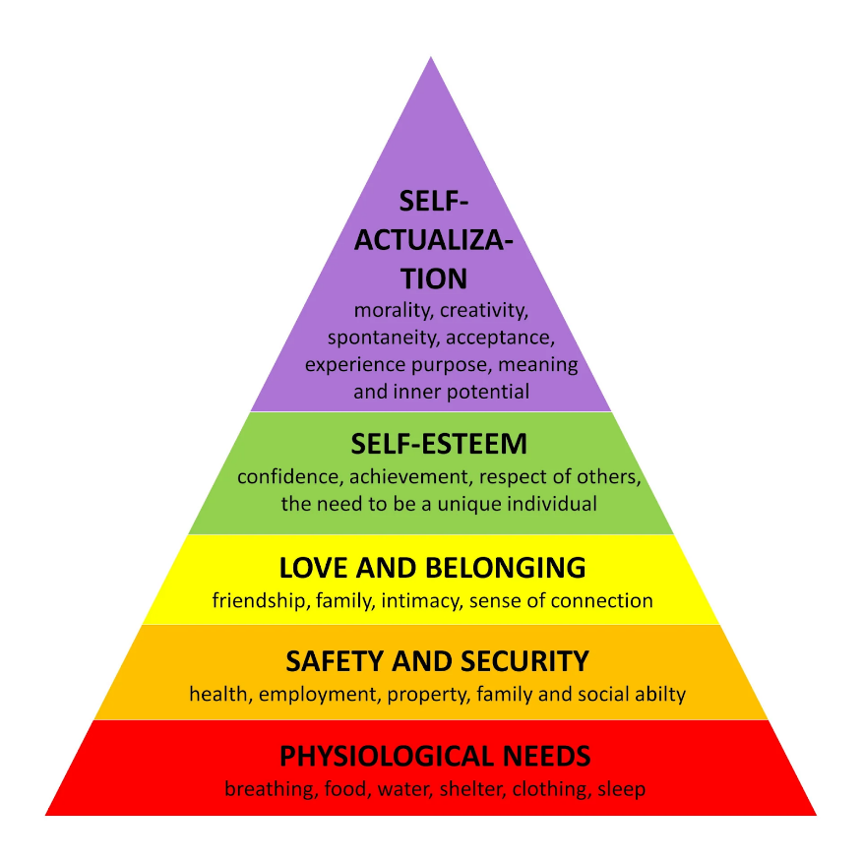
Figure 1: Maslow’s Hierarchy of Needs
(Source: simplypsychology, 2023)
Considering the globally reputed OTT platform, this model is significantly utilized by Netflix to target particular segments of online subscribers and potential buyers by significant utilization of various social media portals, communities, or groups for promoting their manufactured products and services. As per Trivedi and Mehta, (2019), by effective utilization of Maslow's hierarchy of needs, Netflix gains a significant perception of the customer's needs and preferences and produces their content accordingly. In this way, through a customer-centric data-driven marketing strategy, Netflix provides optimum satisfaction to its online global subscribers. Maslow’s hierarchy of needs model has also been significantly utilized by Netflix to formulate a significant marketing strategy that inverses the incorporation and implementation of various innovative measures and modern-day technological aspects for producing effective content (Altymurat et al. 2021). The advertisement strategy of Netflix is based on “agility, data-collection, data-analysis, user-centricity, personalization and dedication". Netflix creates its content based on these features, effective information of which is significantly provided by Maslow's hierarchy of needs model.
Maslow's hierarchy of needs also facilitates the organization in the effective production of personalised and customized content that can effectively enhance the level of user satisfaction. By analysing and evaluating the needs and preferences of the target customers, Netflix utilizes this information to create content and customize recommendations as per the needs and preferences of potential global subscribers. This facilitates global subscribers to find specific content according to their taste without searching or surfing through numerous lists. As a result of this, Netflix is able to meet the “self-actualization” aspect of the customers which is associated with creativity.
To enhance the self-esteem of the customers Netflix conducts various events as well as advertisements that talk about the elimination of discrimination regarding genders, religion as well as various ineffective elements. In addition to this, there are various series as well as movies that are available on Netflix which are originally produced by the organization to spread the word against discrimination as well as harassment and child labour (seventeen.com, 2020). Moreover, to motivate customers for purchasing subscription packages, Netflix provides various discounts and offers during Friendship Day, Father's Day, Mother's Day, and so on. According to Maslow's hierarchy of needs, the “love and belonging” aspect heavily influence the purchasing decision as well as buying patterns of the potential individuals to a certain extent.

2.4 Relating 5 stage model of consumer buying behaviour with Netflix: Kotler's model
The consumer behaviour can be regarded as the kind of customer’s demeanour before, during, and after making purchases of the products and services. Ljepava (2022) state, in order to effectively satisfy the expectations of customers, businesses operating in different markets around the globe require to have a full understanding of the behaviours consumers engage in when making purchases. Gaining an understanding of the behaviour of customers is critical to the success of a company's existing products as well as the launching of any new items. There is a wide variety of thought processes and attitudes present among buyers when it comes to the act of purchasing certain goods. If a company is unable to accurately form an understanding of how consumers will respond to the products it offers, the company may observe a significant number of losses in the sales of its products or services (Ghazali and Suhaimi, 2022). A range of variables that impact modifications to buying habits, includes but not confined to developments in technology, fashion, lifestyle, financial resources, and other comparable factors.
Digital marketing can be regarded as an extensive term that refers to all different kinds of Internet marketing endeavours. As per Ahmad et al. (2022), when it comes to communicating with existing customers as well as those potential customers, the majority of businesses rely on a wide range of digital mediums. These channels include social media, search engines, email, and other websites. Transference of information using media formats and text messages are both examples of different modes of communication.
Consumers go through a series of attributes that collectively make up the consumer purchasing process before settle self-actualizations on purchasing of a product (Ostonakulova, 2022). The Kotler 5 stages model consists of five steps to attain this goal, and each stage shows a different phase of the customer purchasing cycle as mentioned below:
Problem Identification: In the first stage recognizing the requirements of the customers that aren't being met is a common way of referring to this process. The need is the driving force behind every action taken by a consumer. The occurrence of a purchasing difficulty can be attributed to giving rise to an unmet necessity and hence leading to dissatisfaction among the customers. Nworgu (2022) state, an individual is majorly motivated to take action or make a purchase as a result of a rising necessity. Netflix places a high emphasis on comprehending the reasons that lie behind a requirement. The company does this by gathering information from customers regarding the characteristics of particular products that attract their interest. Furthermore, it develops marketing techniques to stimulate the interest of customers by using the data they have collected.
Information Search: This stage is considered to be the second as the customers who are interested in a certain product or service are inclined towards getting information about it. Therefore, they look into areas where they can gather information such as media, newspapers, a relative or a shop etc (Azizah et al. 2022). Netflix has been promoting itself both in the digital as well as the traditional platform. It has significantly paved the way in creating its presence online and has also partnered up with traditional media channels to present proper information about the kind of services they sell to customers.
Evaluation of Alternatives: The third stage can be regarded as the stage of the evaluation carried out by the customers to understand the right kind of products or services. Kurashov (2022) states, it aids in the determination of the brand which interests the customer to purchase the product or service. The customers specifically look into benefits, quality, affordability and so on for the selection of the brand and the kind of product or service. To remain competitive and at the top of its game in the market, Netflix significantly places its focus on providing its customers with attractive subscription-based offers. It furthermore more produces quality content that attracts consumers around the world which increases its value as a brand.
Purchase Decision: Purchase decision is all about the personal choice and decision making ability of an individual customer. According to the point of view of the famous researchers Hanaysha et al. (2021), the purchasing decision heavily depends on the brand name, product quality as well as the price. If a particular brand offers several benefits such as discounts and buy one get one free, then the customers get easily attracted to the offers and it makes them want to buy the products.

Post-purchase Decisions: As per the statement of Azizah et al. (2022), customers buy the products with some minimum expectations and the post purchase decision is considered as the final step of the customer purchasing process. Post-purchase decisions are the decisions made by the customers after purchase. This process includes whether the customers would repurchase the particular product again or not.
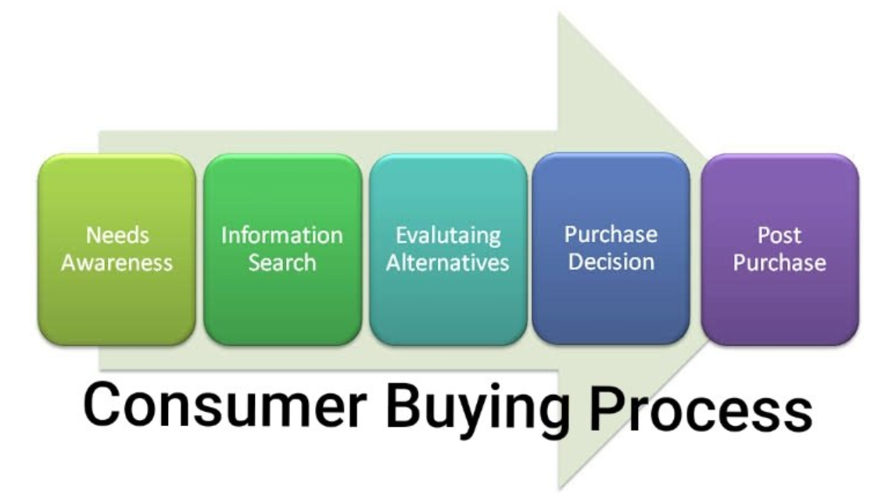
Figure 2: Kotler’s 5 stages Model of Consumer Buying Behaviour
[Source: linkedin, 2023]

2.5 Digital marketing strategies used by Netflix
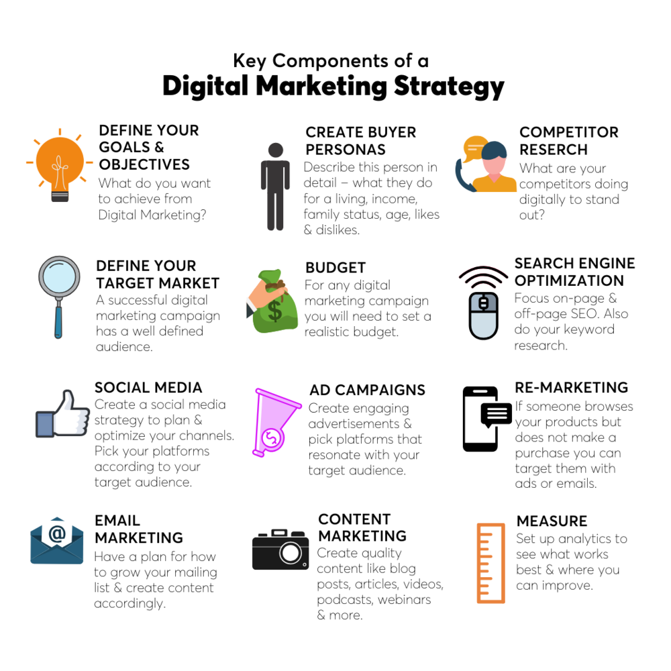
Figure 3: Digital marketing strategies
(Source: boldxcollective.com, 2023)
Promotion of any particular product or service is one of the most essential requirements of an organization in order to sustain its business. If an organization uses different digital technologies or the internet for getting the opportunity to better connect with a diverse base of customers, then the promotional strategy can be known as the digital marketing strategy (Burroughs, 2019). This strategy is highly employed by organizations all over the world for the expansion of respective businesses and in this respect, Netflix is not an exception.
Despite the different kinds of digital marketing methods available, the well-known OTT platform in order Netflix, makes heavy use of social media advertising. Because the use of multiple social media platforms such as YouTube, Facebook, Twitter, Instagram, and a number of others is fast rising around the world, this form of digital marketing approach is the most appropriate for the organisation for reaching the attention of a wide range of clients. In the year 2022, an increase of 6.5% in the social media utilization rate increased globally (oberlo.com, 2023). According to Nafees et al. (2021), this can enable the organization to get a better opportunity to make clients all over the world conscious of the new web series or other innovative content coming up next in the OTT platform quite rapidly. The marketing team of the multinational firm is quite potent and utilizes the tactic of posting upcoming content on the OTT platform regularly on various social media platforms. As a result of this, the company is able to retain the interest among the clients about the upcoming websites or entertainment programs which is a quintessential requirement for the optimum growth and development of the business. Thus, it can be said that with the proper utilization of this specific digital marketing strategy, the company is able to flourish its prospect better in the harsh business market. As per Hendrikx and Castro, (2022), the organization also employs sharing of memes as well as the preparation of snippets based on movies or web series which can help it to remain in the limelight giving it a competitive advantage compared to other rivals.
Along with this, the organization also employs a targeted advertising form of marketing approach which enables the firm to produce personalized advertising content which can efferent grab the attention of a particular customer segment. Budzinski et al. (2021), claims that the organization can be able to better connect with the clients by employing this personalized advertising approach. Hence, with the application of this personalized advertising process, the company can trigger the interest of the customers regarding their content offered by it efficiently. As a result of this, the organization is able to enhance the customer engagement rate which is a key necessity for achieving success in the global business market.
Presentation of marketing content based on data driven by customers is also an effective way to enhance the promotion of any particular brand. In accordance with Maddodi, (2019), it is seen Netflix uses this marketing strategy for making the advertising content more attractive as well as more acceptable to potential clients. This is possible for the firm as the proper implementation of this procedure provides the opportunity for Netflix to know about the demands of the customer’s better which in turn resulted in the modification of the content of the advertisement with time as per the requirement. Thus, the organization is able to keep proper pace with the changing requirements of the customers which enhanced the chance of survival of the firm in the highly dynamic competitive environment. As per Au-Yong-Oliveira et al. (2020), this particular marketing strategy encourages the firm to understand the changing consumer behaviour with market trends which enhances its productivity. Consumer behaviour determines the direction or approach of change in the requirements of customers. The data-driven marketing approach provides the necessary data to keep Netflix aware of the shifting inters of its clients.
Due to the efficient implementation of the marketing plan along with the choice of appropriate strategies for reaching out to a large customer base, Netflix is able to make a strong business reputation or recognition in the international market. In 2022, the organization also reported an annual gross profit of $12.447 billion which further strengthened the position of the firm in the international market (macrotrends.net, 2023).

2.6 Honeycomb model and RACE model
Honeycomb Model
The honeycomb model is an extensive structure that offers understanding of the fundamental characteristics of social networking sites and its impact on customer behaviour. This framework is extremely useful for assessing the impact of online advertising techniques on customer purchasing behaviour in the environment of Netflix UK. Identity, Sharing, Conversation, Presence, Relationships, Reputation, and Groups are the seven dimensions of the Honeycomb Model.
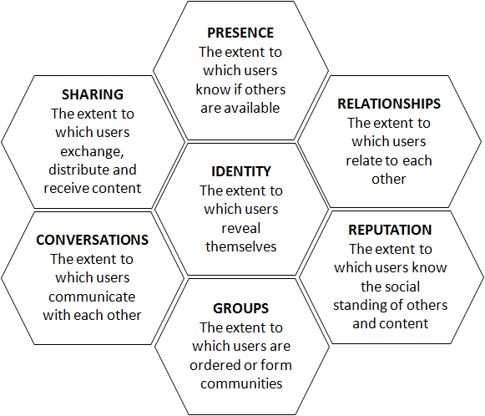
Figure 4: Honeycomb Model
(Source: smartinsights, 2023)

Identity
The Honeycomb Model's Identity component concentrates on how customers demonstrate themselves via the internet and interact with digital mediums. According to Kim, (2020), identifying the preferences of customers can help Netflix UK adjust its promotional strategies to specific audience segments. Netflix offers personalised content and builds focused marketing initiatives that correspond with the personalities of its consumers by analysing user data and preferences.

Sharing
The Sharing component focuses on individuals disseminating material across social media sites. From the viewpoint of Thomas and Tiwari (2019), Netflix can capitalise on this aspect by encouraging viewers to discuss their viewing interactions, favourite episodes, or suggestions for movies on social media networks like as Facebook, Twitter, and Instagram. Netflix can promote easy content sharing by putting social sharing buttons across its platform, improving visibility for the company and drawing new prospective consumers.

Conversation
The Conversation element encompasses online user discussions and exchanges. Netflix may actively interact with with its clients by getting involved in social media interactions, reacting to feedback, and resolving consumer issues or queries. Talwar et al. (2020), stated that as consumers are acknowledged and valued by the company, this reciprocal interaction develops a feeling of community and devotion to the company.

Presence
The Presence dimension is concerned with a brand's presence on the internet and accessibility. As per Pietikäinen (2020), Netflix UK can preserve an impressive online presence through keeping engaged Facebook and Twitter accounts, providing entertaining material on a regular basis, and leveraging appropriate hashtags to reach a wider audience. Netflix can boost its exposure and acquire prospective consumers who take an active role in online debates by getting involved in social networking trends and events.

Relationships
The relationship factor emphasises the necessity of developing and fostering client connections. Netflix may build powerful connections by delivering personalised suggestions, distinctive material or price reductions to devoted customers, and recognising and honouring user interaction. Khan and Jan (2019), points out that Netflix can improve client satisfaction, retention, and engagement by concentrating on developing positive relationships with its consumers.

Reputation
The Reputation facet emphasises a brand's digital image and reputation. Netflix UK can proactively handle its online image through tracking social media mentions, reacting to consumer input quickly, and reacting to any unfavourable opinions or reviews. As per Iftikhar et al. (2022), Netflix can significantly affect consumer purchasing behaviour by keeping a positive image and efficiently resolving customer issues.

Groups
The Groups dimension is concerned with the establishment of web-based networks or interest groups. Netflix may capitalise on this aspect by building and marketing communities of users based on particular genres, series, or movie franchises. As per the opinion of Baj-Rogowska and Sikorski (2023), Netflix can promote a feeling of community and improve consumer loyalty by promoting exchanges of ideas between like-minded viewers.

RACE model
The RACE model is often used by the company to identify and set up its objectives, approach, and procedure while enabling the definition of suitable metrics at all phases.

Reach
This stage refers to brand awareness where Netflix focuses on various activities associated with handling social media pages and others so as to attract the target audience and thereby increase the evictors in the websites.

Act
When customers reach social media pages, or respond to email marketing, the brand’s responsibility is to undertake initiative and act fast as a result (Arya et al. 2019). Opening a conversation through sharing details about the company or the offerings will lead to the conversion phase. Beside ethos, as people are more interested in personalized result, Netflix digital marketing team can conduct quiz concerning the offerings.
Convert
As Netflix possesses multiple payment settings along with an easy navigation system and multiple contents, its possibility is high when converting prospective customers to actual pay customers. The company can implement a unique featuring of offline plan. In this way, wider customer can easily turn as the core customer of the company.

Engage
The KPI metric refers to customer loyalty satisfaction, advocacy level and repeat purchasing (Fombelle et al. 2020). To maintain this aspect Netflix can build long term relation with continuous improvement and engagement as a result.
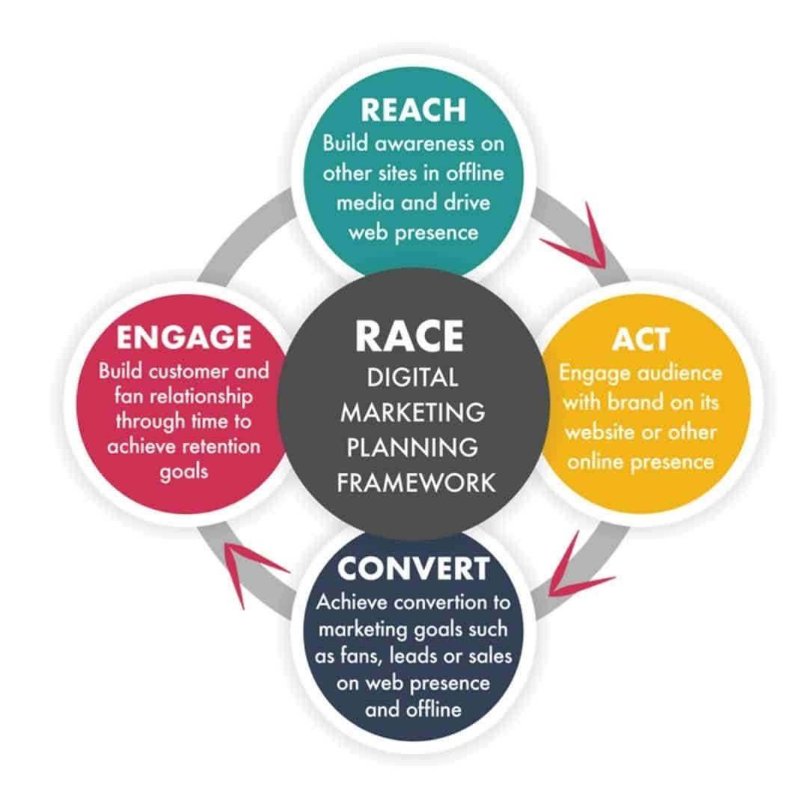
Figure 5: RACE model
(Source: Ytimg, 2022)
As Desai and Vidyapeeth, (2019) underline the fact that digital marketing strategies and omnichannel communication plans can be designed based on the “RACE model”. The four stages of the model are designed to target the needs of customers at different stages of their lifecycle with a view to building relationships with them and increasing their loyalty. Furthermore, as per Rautela (2021), “RACE” is a framework that can be applied across a variety of levels within a digital marketing strategy. Using this model, Netflix can define objectives, strategies, and tactics, as well as set KPIs at each stage of their customer lifecycle. As a result of this streamlining, Netflix will be able to identify strengths and weaknesses in its strategy with ease, allowing them to make changes and improve their overall strategy more quickly.

2.7 Similarities and differences between Honeycomb MODEL and RACE Model
In the area of digital marketing, there is a constant need to identify the preferences and motivation of customers. In the opinion of Wijenayake et al. (2020), identifying the factors that lead to a purchase decision is an essential part of creating a customized marketing strategy for any online business. The “Honeycomb model of marketing” and the “RACE model” are two effective digital marketing frameworks that are customer-centric. Both the models emphasise on the importance of understanding, engaging and interacting with customers across the digital realm while recognising the need to realise the "consumer purchase intentions" and signifying relationship-building with customers at different channel touchpoints that influence the marketing strategy of the business.
According to Hussain (2019), businesses can learn a lot about factors influencing customer buying decisions using both these models. The Honeycomb model's facets like Reputation and Group largely complement the RACES model's focus on customer engagement with the market economy, through their wants and preferences that is crucial for the success of organizations. As stated by Fortenberry, and McGoldrick, (2020), having a positive customer experience is an important component of both the respective models. The “RACE Model’s” focus is primarily on creating a perfect and ideal customer journey while the "Honeycomb model" examines the various dimensions of human behaviour and provides insights into their preferences and buying intentions through "Identity", "Conversation", "Sharing", "Reputation", "Groups" and "Location".
However, there are points of differences between the two models as well as. The “Honeycomb model” highlights the interconnectivity of the customer interaction with the digital networks while fostering online communities for building strong relationships, while the “RACE model” optimizes campaigns and improves customer engagement. As Siebert et al. (2020) points out, in the “RACE Model”, the focus is on the customer journey, from the first point of awareness to the final point of loyalty. On the other hand, the “Honeycomb model” understands the importance of multi-directional communication that influences online relationships as well as brings changes in customer engagement with digital marketing strategies. As compared to the “Honeycomb Model” that establishes credibility in terms of creating a strong online presence from better outreach to potential customers, the “RACE model” examines the steps involved in getting customers to make a purchase.

2.8 Literature Gap
A literature gap mainly takes place due to incomplete information that prohibits the researchers to investigate any context which is not good for meeting the objectives related to the investigation (Loveday et al. 2022). This is the approach that is not good for operating the research activities conveniently which can lead to the creation of negative externalities (Malazdrewicz et al. 2022). In the specific context of the effect related to the influence of the digital strategy, the researchers have not mentioned the negative effects associated with the tactics of digital planning that can hamper Netflix. Moreover, the investigators have not indicated the demerit related to the digital strategy that are not good for the development as well as the success of the company.
The lack of details regarding the shortcomings associated with the content is the main cause owing to which, the investigators have failed to continue the investigation on the above-mentioned issue. On the other hand, the insufficient amount of time is regarded as another factor that has prevented the researchers to collect adequate information about the problem which has been mentioned above. Therefore these are the causes that have prevented the investigators to explore the certain content associated with the context that has been given.

2.9 Conclusion
Based on the above information, it has been understood that Netflix has utilized various digital strategic planning to attain a wide number of customers. Based on this, it has been identified that Netflix employs social media as its core marketing strategy. Moreover, data-driven marketing along with advertising based on demographic are two main components used by Netflix. However, the study has also presented various models that include Maslow’s hierarchy of need, Kotler's model, the Honeycomb model, and, the RACE model. Some model refers to customer motivation towards favourable buying decisions and others lead to understanding the pattern of customers. Maslow’s hierarchy of needs, Kotler's model, the 6Cs of the customer motivation model.

Chapter 3: Research Methodology

3.1 Introduction
The essential aspect of this part is to evaluate the provided topic area by using the appropriate investigational procedures. This will be addressed by using the “research onion framework” to bring out the crucial stages in the study’s execution.

3.2 Research Onion
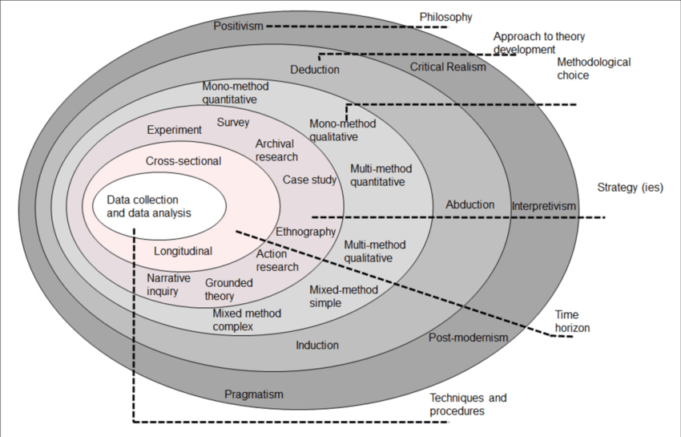
Figure 1: Research Onion
(Source: Saunders et al. 2019)
The “research onion” paradigm can be successfully utilized to organize each element of the study. Various elements are included in it, such as a research philosophy, a research strategy, a research design, a research technique, a data gathering method, and a data analysis method. By emphasizing the relevance of the research topic and connecting it with relevant methods and procedures, this framework assists researchers in attaining their research objectives. Researchers use the research onion paradigm to guarantee that their study follows known practices, enables a methodical inquiry, and improves the validity and reliability of what they discover. It is the most crucial tool for presenting and carrying out research studies, allowing researchers to effectively navigate through the numerous levels and aspects that constitute the research process. (Saunders et al. 2019).

3.3 Research Philosophy
With the aim to offer the framework essential to the effective execution of the research endeavour, the research statement is put together in conjunction with the research philosophy. The three principles that are commonly applied to outline research philosophy are “positivism”, “interpretivism”, and along with “realism” (Ikram and Kenayathulla, 2022). The “positivism research philosophy” that the investigator has used for this investigation has been addressed.
Positivism has been selected as the research framework for examining the effects of online marketing methods on consumer purchasing activity in the Netflix UK context. Positivism places a premium on objectivity, concrete evidence, and the application of scientific techniques to the investigation of social phenomena. In this research subject, positivism enables for the collection of measurable data using questionnaires, experiments, and data processing to investigate the link between Netflix UK's digital marketing methods and customer purchasing behaviour. The research uses positivism to give real and statistical data regarding the success of digital marketing initiatives, contributing to an expanded awareness of how they influence customer behaviour in the context of Netflix UK.

3.4 Research Approach
Considering the approach of investigation is regarded as essential to an investigator in that it assists in developing the outcomes of an assessment by applying an array of regulations and steps, in accordance with the procedures pertaining to the research. For the purpose of this study, it is essential to highlight that the investigator constructed an approach for acquiring credible sources of information and successfully implemented the research process for gathering trustworthy information (Rakhmatova and Kh, 2022).
The “deductive approach” has been considered as the appropriate tool to carry out the necessary research. The deductive approaches are essential in a research to derive specific conclusions from generalized hypotheses. As such, this approach is beneficial in comprehending the specific inferences drawn from the research (Azkarai et al. 2022). This can be incorporated in the following research to interpret the responses of participants in understanding the influential practice of digital marketing to enhance the buying behaviour of consumers. This especially helps in verifying the reliability of the gathered information by comparing it with the responses of the participants. Moreover, this approach was chosen for the following research since it helps bring more inclusivity of chosen hypotheses for the research. As the deductive approach analyses and tests the hypothesis, it ultimately proves the validity and credibility of the incorporated ideologies in the research (Fox et al. 2022). Therefore, the selection of the deductive approach would influence in achieving the validity of the interpreted data.

3.5 Research Strategy
In order to guarantee reliable information presentation and a cohesive inquiry investigation, the researcher has been equipped to keep a record of the research’s strategy execution procedure. As a consequence, the researcher’s evaluation has been contingent upon the manner in which the researcher deploys the “quantitative research strategy” when dealing with the reliable practice of interpreting the information (Vijayendra et al. 2023). The quantitative method has been deployed in the form of a survey to collect necessary information from the participants. In addition to that, the research has incorporated a mono method for collecting quantitative data from the survey results. Therefore, using the mono method, the research has interpreted quantitative and numerical data from individual responses of the participants.

3.6 Type of investigation
Methodologies in dissertation incorporate two distinct types of investigation processes which includes primary and secondary investigation. Primary research investigation is incorporated in the following research, allowing researchers to conduct the analysis themselves in the firm of surveys and interviews and interpret the responses accordingly rather than relying on pre-existing information. Primary research is also considered as survey-based research since it allows researchers to directly aim for the source rather than obtaining information from existing sources (Pandey and Pandey, 2021). Secondary research information, on the other hand, is derived from existing hypotheses, which enables the research to collect information from reliable and authentic sources. Therefore, secondary research is considered literature review-based research.
Primary and secondary research advantages and disadvantages
Benefit of primary research is that it ensures that the collected information is reliable and updated, however, one key disadvantage is that the primary research is cost-ineffective and time-consuming. On the other hand, secondary research is much more cost-effective since information is mainly collected from existing sources, nonetheless, this decreases the reliability and relevance of the collected data concerning the research topic (Mukherjee, 2019).

3.7 Research choices
Qualitative research is a strategy for gaining a comprehensive knowledge of people experiences, attitudes, and behaviours. It relies on subjective information collecting methods such as discussions, observations, and text analysis. It delivers profound understanding, investigates context, and unearths subtleties, making it useful in social sciences and exploratory research.
Quantitative research is the collection and analysis of numerical information in order to arrive at unbiased findings and establish broad assumptions. It uses quantitative techniques and instruments to measure, determine, and analyse data from investigations, polls, and previously collected datasets. Its goal is to find patterns, create links, and give numerical proof to support or disprove theories in a variety of domains, including science and economics.
As a process of collecting and analysing both qualitative and quantitative data, mixed methods is described as an approach to research.
Advantages
According to Dawadi et al. (2021), as a major advantage of this scope, the combination of both the qualitative and quantitative methods for data interpretation allows a comprehensive understanding of the research topic by integrating the strengths of both the approaches for enhancing the validity and reliability of the study. Furthermore, this method manages to capture the breadth and width of the databases in conjugation with a flexible research design.
Disadvantages
However, Palinkas et al. (2019), argue that the mixed method engages in conflicting results with increasing need for extensive time and resources as well as the challenging aspects of integrating different data types that might alter the route towards achieving the desired results.

3.8 Time horizon
The time horizon creates a schedule of project tasks for every task included in a project while also ensuring that every task event is completed within the time limit specified. The time horizon chosen for this research is a cross-sectional time horizon. This is a consequence of the fact that the data is gathered from the overall population at an identifiable point in time. A study with a cross-sectional design, unlike a longitudinal study, occurs at a single point in time and does not manipulate factors (Wang and Cheng, 2020). In this way, research can look at multiple characteristics at a time and describe what is taking place at the moment. The project activities are organized into 10 distinct stages, beginning with project selection and ending with project acceptance. Over the course of 16 weeks, the full project was completed. The topic was chosen and introduced in the first eight weeks, followed by the creation of the simulations and objectives, as well as the main deliverables, in the following four weeks.

3.9 Sampling Technique
Sample size: Necessary information and data were collected from 75 UK-based consumers to retrieve appropriate evidence on the effect of the strategies of Netflix UK on the buying tendencies of consumers.
Sample type: The sample mainly contributes to the primary type of data, which is collected quantitatively. Further, statistical analysis has been conducted to interpret the participant responses (Brown, 2023).
Sampling method: For the intent of acquiring participant responses, the research method has incorporated a survey method to analyse the responses of the participants, using a questionnaire technique (Mukherjee, 2019). The research has also implemented a convenience sampling method to address the participant responses and also deliver useful insights from the individual data.
Advantages and disadvantages of convenience sampling
Convenience sampling technique is a useful data interpretation tool used for non-probability test samplings. This method selects distinct units based on the inclusion criteria of the research, thereby enabling the investigators to assess the proximity and accuracy of the collected data in easy processes (Campbell et al. 2020).
Advantage: Unlike the random sampling technique, this method is much easier to implement and modify in the data sampling processes as this process indulges in faster data collection in a typically smaller pool of participants (Stratton, 2021). Based on the above research, the participant pool is comparatively lower which increases the integrity of the data collection process through this method.
Disadvantage: As this method is best suited for smaller pool data samplings, it doesn't work best in larger quantity data. There is a slight chance of data being skewed if the quantity of the information increases, thereby decreasing the symmetry of the data (Etikan and Babtope, 2019). This method also has a possibility of producing biased data.

3.10 Data Collection Method
“Data gathering procedures” represent one of the most useful way of the research procedure since they contribute to helping the researcher obtain accurate information that corresponds to the study’s topic or renders it easier to determine the validity of an assumption or hypothesis. The process of collecting information applied has been determined by the type of study matter, objectives, and investigation, as well as the form of data required to be gained (Qiu et al. 2022). The notion of “data gathering methods” is utilized for defining two distinct groups: “primary data gathering”, and “secondary data gathering method”. The “primary data gathering” procedure was chosen for the purpose of the study since it allows the researcher to collect relevant data by incorporating participants in the investigation process.
The viewpoints and responses of those surveyed offer essential background information for the research issue and direct the researcher to multiple objectives for the study to aid in coming up with a hypothesis or outlining a way forward. Coupled with the exploratory tactics performed throughout the research procedure, the primary data, which becomes more demonstrating, is beneficial for getting a comprehensive grasp of the respondent’s perceptions or opinions. Since it is contradictory to the purposes of the study, the “secondary gathering method” was disregarded. To acquire the essential primary information for the current investigation, a survey of 40 customers in the UK has been undertaken.
Moreover, upon collecting data based on the primary-strategy, individual responses from the participants are keenly analysed using necessary statistical methods. To assess the data statistically, the use of “MS-Excel 2013” software has been used to formally record the observations collected from participant responses. The analysis of the retrieved data was based upon statistical learning via utilising different mathematical parameters and discussing their relevant findings to gain necessary insights on the selected topic. Since the research primarily relied on the analysis of factual data, the Excel software proved to be a strategic tool in storing all the necessary information and records for future use.

3. 11 Data Analysis
The researcher can make conclusions from the content that has been evaluated for the objective of validating the hypotheses by carefully analysing the information gained that has relevance to the research’s objectives utilizing statistical or thematic-based assessment techniques (Hou et al. 2022).
The research study has employed “statistical data analysis” which is beneficial for accumulating reliable data and statistical information from participants to confirm the objectives of the research (Bąk and Cheba, 2022). Moreover, to analyse the statistical data, analysis tools like “MS Excel 2013” are utilized to interpret the quantitative data retrieved from primary sources. In addition to that, the research has mainly focused upon surveys as the main data collecting tool, wherein the responses from significant participants are measured to gain knowledge about the influence of digital marketing strategies. The use of the statistical method is also useful in eradicating collection of superfluous data that doesn't adhere to the stated objectives of the research.

3.12 Research Ethics
The analysis and assessment of information collected by participants administers the lawful guidelines of the GDPR principles to acknowledge the privacy and security concerns of collected data. Further, to achieve that, the implementation of useful principles of the “Data Protection Act” has been issued in the research process to deliver authentic results from credible sources (Brown, 2023). Moreover, since the research has incorporated primary and quantitative research strategy with the help of survey procedure, it is therefore essential to acknowledge the safety and security of the participants. To ensure the same, the research has implemented “voluntary participation” of the contestants, wherein they were asked to fill a form for their “informed consent” (Normand and Donohue, 2023). Furthermore, the research has also made sure to acknowledge the “anonymity and confidentiality” of the participants to protect them from possible harm. Moreover, compliance protocols are also ensured in the research to acknowledge proper data assessment.

Chapter 4: Findings and Analysis

4.1 Introduction
The data evaluation and discussion part provides an extensive examination of the acquired data as well as a description of how digital advertising techniques impact customer purchasing behaviour. In this section, the data gathered has been analysed using proper data analysis techniques. Furthermore, the hypothesis is specified, and potential variables are considered. The responses of the participants were analysed and interpreted properly using SPSS software. Additionally, graphical representations of the participants' responses have been provided and analysed. A variety of analytical models are also examined in this section, such as descriptive statistics and regressions matrix to facilitate evaluation of data and formulate conclusions.

4.2 Findings

4.2.1 Specification of Variables
Variables are specified in the primary research to understand the measurability of the content data and information. The independent variables are determined as non-measurable quantities, used for comparison purposes in a dissertation (Washington et al. 2020). Whereas the dependent variables are measurable quantities, which are compared based on the usefulness of the independent variables.
Dependent variable | Changed nature of purchasing
Independent variables | Online marketing benefits, reliable online purchase, and provides appropriate content
Table 1: specification of variables
(Source: Self-created)
In the above-mentioned table, the dependent variable is stated to be “changed nature of purchasing” which is measured after thorough analysis and comparison of the independent variables, which are “online marketing benefits”, “reliable online purchase”, and “provides appropriate content”.

4.2.2 Specification of Hypotheses
Hypotheses are structured in a primary research to aid in the understanding of the selected topic using various theoretical approaches and ideas (Meeker et al. 2022). However, in the context of this research, hypotheses are designed to help in the understanding of the mathematical parameters, signifying the acceptance of the alternate variable (H1).
Hypothesis | Statement | P-value | Result
H0 | Digital marketing strategies of Netflix do not have any influence on buying behaviour of customers. | 0.00 | Rejected
H1 | Digital marketing strategies of Netflix have significant influence on buying behaviour of customers. | 0.00 | Accepted
Table 2: specification of hypothesis
(Source: Self-created)
Based on the above table, for the null hypothesis (H0), if the p-value is less than 0.05, then the statement is rejected, whereas, on the other hand, for the alternate variable (H1), if the p-value is less than 0.05, the statement is accepted.

4.2.3 Descriptive Statistics
Descriptive statistics is the primary form of statistical analysis of data, which contains a detailed interpretation of statistical data, required to keenly understand the relation between dependent as well as independent factors. As per the analysis of Pallant (2020), descriptive statistical data comprises the following mathematical parameters including the mean and median values, standard deviation, variance, skewness, as well as kurtosis. Interpreting the results of the following data, a thorough understanding is achieved for the association between the variables as well as gaining necessary insights from the data information. In the following table, the statistical assessment will be performed for the dependent variable, “transformed nature of purchasing” and the independent variables, “Online marketing benefits”, “reliable online purchase”, and “provides appropriate content”.

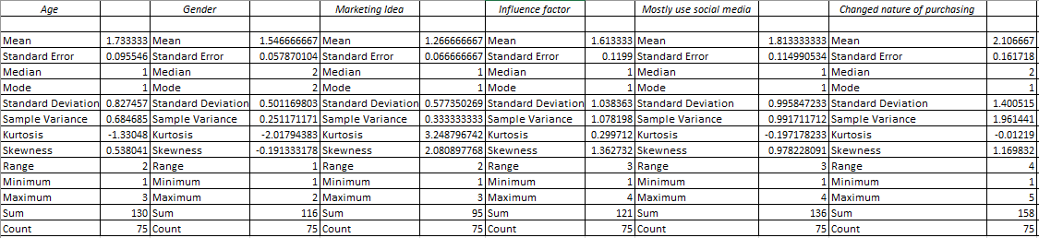
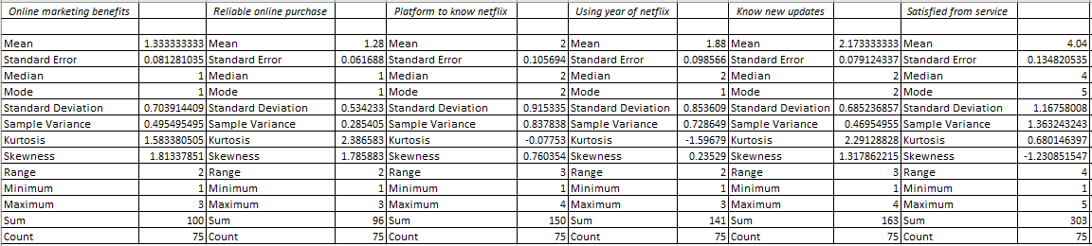
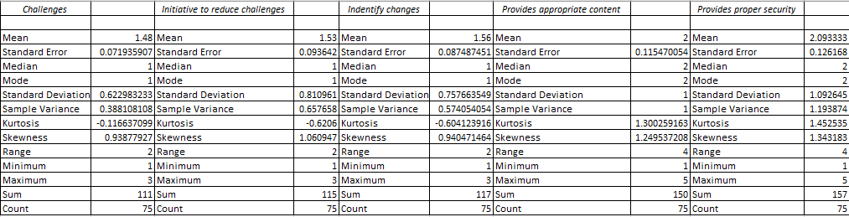
Table 3: Descriptive statistics
(Source: Self-created)
From the above table, the mean value of the dependent variable is observed to be 2.106, whereas the median value is 0.161. In addition to that, the standard deviation is calculated to be 1.400, whereas the variance of the sample is measured as 1.961. Moreover, it is also seen that the skewness of the variable is 1.169, whereas the kurtosis value is (-0.012). On the other hand, for the variable “online marketing benefits”, the observed mean is 1.333, followed by a median value of 1.000. Apart from that, the standard deviation of the similar value is observed to be 0.703 with a variance of 0.495. Moreover, the skewness and kurtosis of the above variable is calculated as 1.813 and 1.513. From the above interpretation, it is learnt that both the standard deviation values of the variables are either more than 1 or closer to 1. This further suggests that the values are scattered around the mean and are highly associated with each other. In addition to that, the skewness values of both the variables are positive and more than 1, which depicts that the values are appreciably symmetrical and linear in association with each other.
Furthermore, for the variable “reliable online purchase”, the observed mean, median, standard deviation, variance, skewness, and kurtosis values are 1.28, 1.00, 0.534, 0.285, 1.785, and 2.386 respectively. Whereas for “provides appropriate content”, the values are 2.00, 2.00, 1.00, 1.00, 1.249, and 1.3002. Therefore, with the evaluation of the above data, it is understood that the standard deviation values are vastly scattered around the mean values which makes it independent and linear. Moreover, the positive skewness data confirms the linearity and symmetry of the associated variables.

4.2.4 Graphical Representation
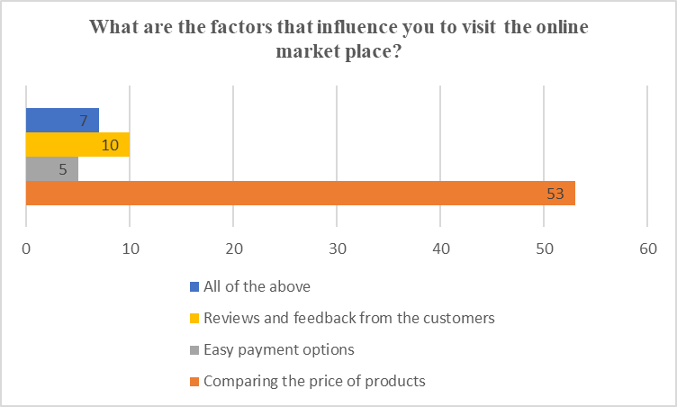
Graph 1: Factors that influence to visit the online marketplace
(Source: Self-created)
According to the graph, which depicts the opinions of 75 participants on the elements that impact their trips to online marketplaces, evaluating product prices was an important factor for 53 people. Furthermore, 5 individuals stated that quick payment alternatives were significant, while 10 participants stated that customer evaluations and feedback influenced the choices they made. Furthermore, all of the abovementioned viewpoints were shared by 7 individuals. According to Rita et al. (2019), price comparison is the most influential factor in motivating visitors to marketplaces on the internet, followed by quick payment choices and user reviews.
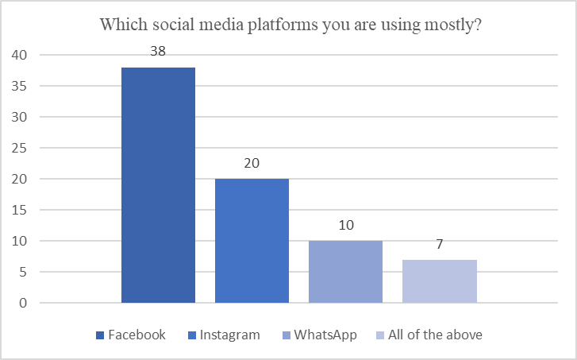
Graph 2: Mostly used social media platforms
(Source: Self-created)
According to the graph, 38 participants all agreed that Facebook is the most widely used social networking site. Additionally, it is clear that almost 20 people favour Instagram over all other social media sites, ranking it as their top option. Furthermore, 10 interviewees said they primarily use WhatsApp. It's interesting that 7 people said they would use all the social networking sites mentioned actively. This view implies that, in terms of overall usage, Facebook continues to be the most popular platform. As noted by Arora et al. (2019), Facebook has been around longer than other networks, building up a sizable user base and familiarity.

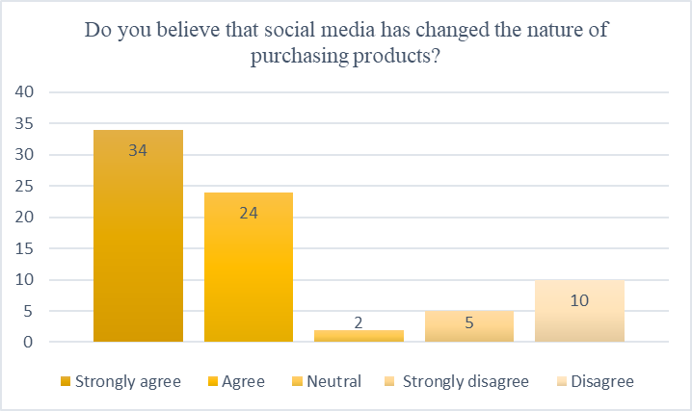
Graph 3: Concept about the social media has changed the nature of purchasing products
(Source: Self-created)
The graph illustrates that a large majority of the 34 participants agree completely that social media has completely changed how people shop for items. However, it is noteworthy that nearly 10 participants hold a contrasting viewpoint, disagreeing with the notion that social media has changed the purchasing landscape. Additionally, 5 individuals, emphasising their opposing viewpoint, strongly disagree with this perspective. Furthermore, 2 participants remain neutral, neither fully embracing nor rejecting the idea. Depending on the interpretation it must be said that, social media has unquestionably revolutionised how customers approach goods purchases. From the viewpoint of Maria et al. (2019), customers are now acquainted with a wide range of goods and services catered to their interests and choices because to the growth of social networking advertising, focused advertising campaigns, and influencer sponsorships.
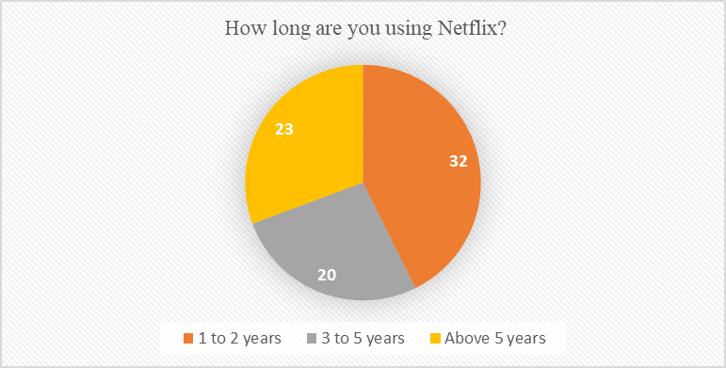

Graph 4: Netflix Use
(Source: Self-created)
The different durations of time that people have spent using the well-known streaming platform are illustrated in this pie graph. The fact that 32 participants fell into the 1-2 year category shows that Netflix is becoming more and more popular as an alternative form of entertainment. The 20 participants who have used Netflix for three to five years demonstrate a sense of contentment and ongoing involvement with the service. The fact that 23 of the participants have used Netflix for more than five years also highlights the platform's substantial client base, which can be due to the platform's high-quality content, simple-to-use interface and ongoing improvements that take customer needs into account. Auditya and Hidayat (2021), suggest in their research that Netflix has effectively built up and preserved its customer base over time, with a sizable portion of users sticking with the service for several years.

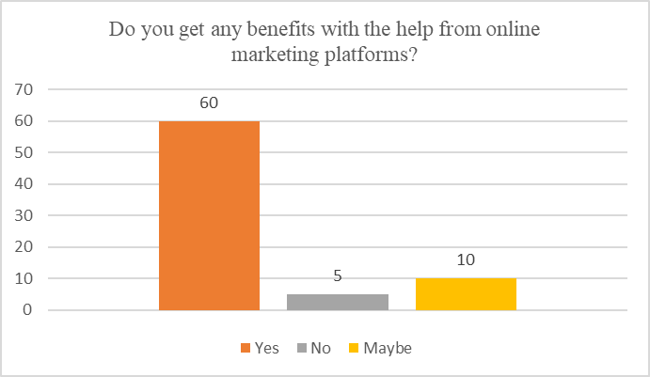
Graph 5: Benefits with the help from online marketing platforms
(Source: Self-created)
Based to the graph, which represents the views of 75 participants on the advantages they acquired from internet marketing platforms, 60 people believed that they did. 5 people, on the other hand, saw no benefits, and 10 responded in a neutral manner. According to this view, more than half of participants recognised the benefits of internet marketing platforms. Herhausen et al. (2020) opined that there are numerous advantages, such as better awareness of the brand, targeted marketing, greater rate of conversion, and better consumer interaction and analytics.
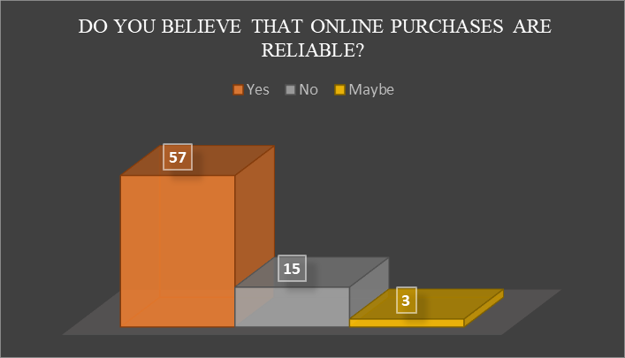
Graph 6: Reliability of Online Purchase
(Source: Self-created through MS-Excel)
In accordance to the visualisation, 57 out of 75 participants believe in the dependability of online purchases. In contrast, 15th participant agreed that person did not trust internet purchases, while 3 people were neutral for the responses. Several variables contribute to the dependability of online purchasing. Online markets frequently use secure payment methods to ensure transaction security. Second, user reviews and ratings provide information about the product's quality and validity. Furthermore, Wai et al. (2019), highlight that dependable return and refund policies provide buyers with peace of mind. These variables all contribute to consumers' impression of internet shopping as a trustworthy alternative.
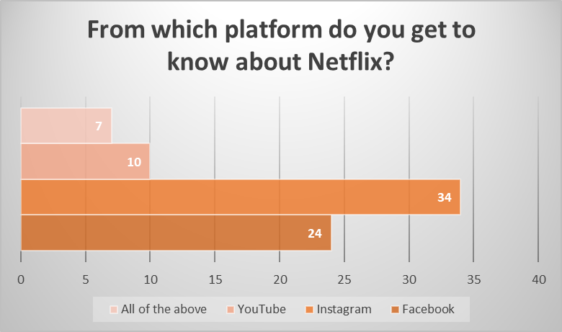
Graph 7: Platforms
(Source: Self-created)

As to the graph, 24 of the 75 participants found Netflix through Facebook, while 34 found it through Instagram. Furthermore, 10 participants learnt about Netflix through YouTube, and 7 people concurred with all of these possibilities. According to this explanation, Instagram is the leading site via which people learned about Netflix, followed by Facebook and YouTube. From the standpoint of Kurniati et al. (2021), online social networks are crucial for raising awareness of and interest in video streaming services like Netflix.
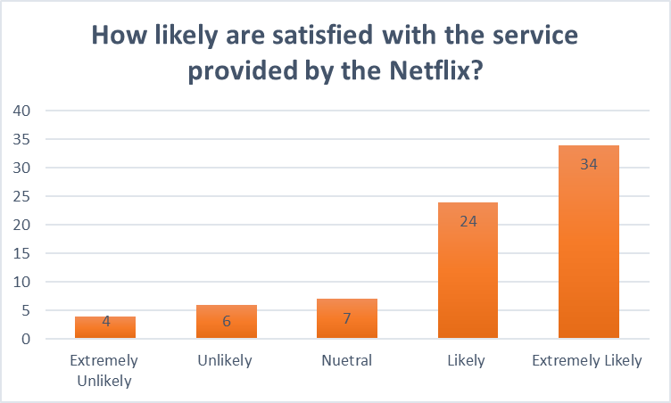
Graph 8: Satisfaction with the service provided by the Netflix
(Source: Self-created)
According to the graph, 34 out of the total respondents are wholly happy with the service offered by Netflix. In addition, while not to the same extent as the previous group, 24 people report satisfaction with the service. However, 4 people are completely unsatisfied with Netflix's service, while 6 people are only partially happy. The key finding from this interpretation is that while a significant percentage of respondents express a high level of happiness with Netflix, a small minority of respondents express varying levels of discontent with the service. As per Tanuwijaya et al. (2021), Netflix offers a remarkable entertainment experience with its easy-to-use design, individualised suggestions, and excellent streaming quality. There is something for all audiences because of its wide variety of genres and ongoing upgrades.
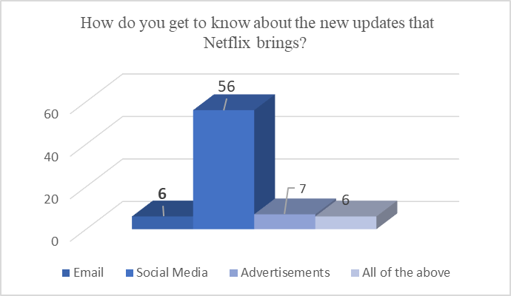
Graph 9: The new updates that Netflix brings
(Source: Self-created)
According to the graph, 6 of the participants completely accept that they get notifications about new Netflix upgrades via email. Conversely, a significant proportion of 56 participants depend on social media channels to remain up to date on the most recent Netflix news. In addition, 7 individuals said they learned about the upgrades from marketing. 6 participants stated that they are aware of the updates via all of the platforms indicated. In the opinion of Onyusheva and Baker (2021), Netflix's dependence on social networking sites as the primary source indicates the efficacy of the business's presence on platforms such as Facebook, Twitter, and Instagram for offering messages, trailers, and teasers.

Challenges faced while operating Netflix
Operating Netflix presents its own set of difficulties. The 6th participant agreed that licencing agreements and content procurement can be complicated and costly. On the other hand, the 20th participant stated that as acquiring the rights to famous series and films can be competitive and pricey. Furthermore, 10 th participant opined that keeping a large collection of information necessitates continual discussions and administration. Whereas from the viewpoint of 15th participants delivering a pleasant streaming service to millions of viewers around the world presents technical obstacles such as handling heavy traffic, optimising bandwidth, and avoiding buffering difficulties. According to the 25th participant, preventing piracy and unauthorised sharing of Netflix material is an ongoing battle that necessitates ongoing surveillance and regulatory actions. Despite these obstacles, As per Steck et al. (2021), Netflix manages to develop and evolve in order to give exceptional programming to its worldwide viewers.
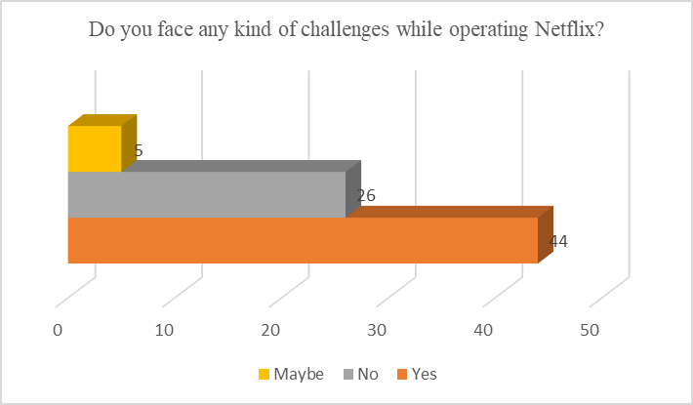
Graph 10: Challenges
(Source: Self-created)
According to the graph, 44 of the 75 participants reported having difficulties while using Netflix, while 26 said they had no difficulties. In addition, 5 people offered a neutral answer to this question. The challenges encountered while using Netflix might range from problems with technology such as broadcasting or connectivity issues to problems browsing the user interface or locating specific content. These difficulties may develop as a result of issues such as speed of the internet, compatible devices, or platform unfamiliarity. As per Wayne and Uribe Sandoval (2023), Netflix must address the improvement of user experience by continuously refining its interface, providing assistance to customers, and optimising its streaming infrastructure in order to retain seamless and reliable service for consumers.

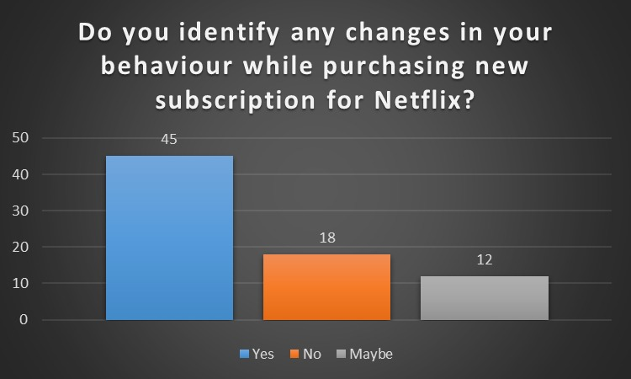
Graph 11: Behaviour changes while purchasing new subscription for Netflix
(Source: Self-created through MS-Excel)
The graph shows that 44 of the 75 participants stated they experienced changes in behaviour after getting a new Netflix subscription. In contrast, 18 participants stated they had experienced no changes, while 12 others responded neutrally. The primary finding from this interpretation is that when it comes to getting a new Netflix subscription, a sizeable percentage of individuals modify their behaviour. Sharma and Gandhi (2023) highlight that this implies that using streaming services like Netflix can affect user behaviour, possibly affecting their viewing choices and habits. To pinpoint particular changes in behaviour and the reasons behind them, more investigation would be necessary.

Changes identified after using Netflix
After using Netflix, several changes can be identified in the way people consume and engage with media. One noteworthy change, according to 1st participant there is a migration away from conventional television networks to streaming services. Whereas 7th participant opined that Netflix has popularised the idea of binge-watching, in which users consume many episodes or a whole season in one sitting, due to its large library of shows and films. On the other side 30th participant stated that this has resulted in a decrease in commitment to viewing and the flexibility of watching shows. Furthermore, according to 45th participant, Netflix's broadcasting approach has transformed the film and television sector, influencing how consumers access and enjoy the content.
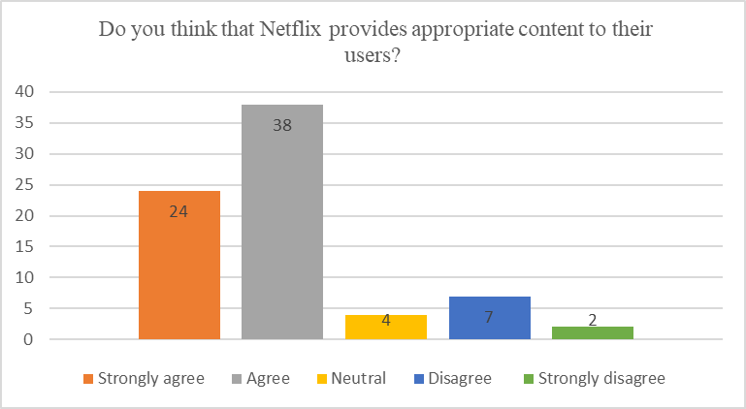
Graph 12: Appropriate Content
(Source: Self-created through MS-Excel)
According to the graph, 24 out of the total participants absolutely believe that Netflix gives appropriate content to its viewers. In contrast, around 7 persons disagree with this fact, with 2 strongly opposing. In addition, four individuals provided an unbiased response to this issue. The important takeaway from the research of Sadana and Sharma (2021), Netflix provides appropriate content. However, quite a few of the participants have opposing views, demonstrating that individuals may have different tastes or interpretations of the content offered by Netflix.
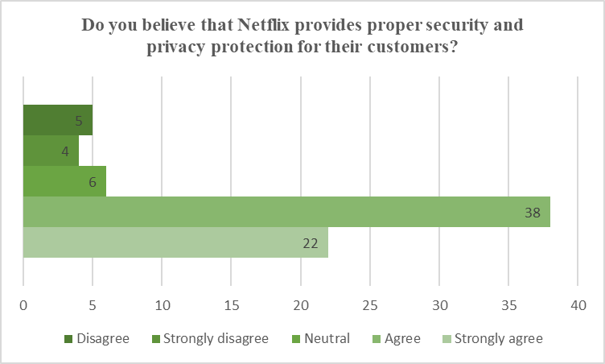
Graph 13: Privacy Protection
(Source: Self-created through MS-Excel)
In regard to the graph, 38 of the total participants concur with the assumption that Netflix provides enough privacy and security safeguards for its consumers. In contrast, it is noticed that roughly 5 people disagree, with 4 of them strongly disagreeing. In addition, 6 people gave a neutral answer to this question. Limov (2020), believe Netflix provides acceptable security and privacy protections. However, a significant number of people either disagree with or are unsure about this claim.

Recommendations on improving the digital marketing operations
After using Netflix, various recommendation for improving their digital marketing processes can be recognised. According to the fifth participant, one important idea is to employ data analytics and consumer insights to give personalised content and recommendations to Netflix UK users. In accordance to the 35th participant, team up with prominent influencers and content creators who connect with the Netflix brand and target demographic. On the other hand, the 30th participant answered that it is important to spend money on social media management equipment and techniques in order to continuously monitor and communicate with users across many platforms. Furthermore, in accordance to the 45th participant, user-generated content campaigns are needed to motivate consumers to contribute their experiences and thoughts about Netflix UK content. Generate contests, hashtags, and challenges to encourage people to create and circulate their own material linked to their favourite shows, enhancing brand visibility and cultivating an emotion of community among users (Desai and Vidyapeeth, 2019).

4.2.5 Correlation Analysis
The correlation analysis in a statistical data interpretation is crucial to highlight the link between the specified variables, especially the dependent and independent factors. These mathematical parameters compare the relation of the dependent factors with the independent ones through simple factual data (Mishra et al. 2019). Through this analysis, investigators highly acknowledge the prevalence of linearity within the stated variables to deepen the learning aspect on the prospective outcome. A perfect correlation between both the variables delivers a result of “1”. Therefore, the obtained data in the following table would be compared based on their proximity to 1. The correlation values which are closer to 1 are deemed as “highly correlated” and “interdependent”.
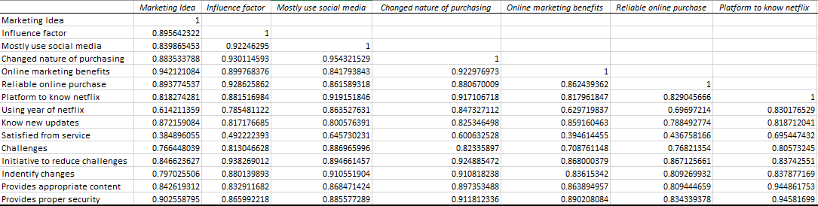
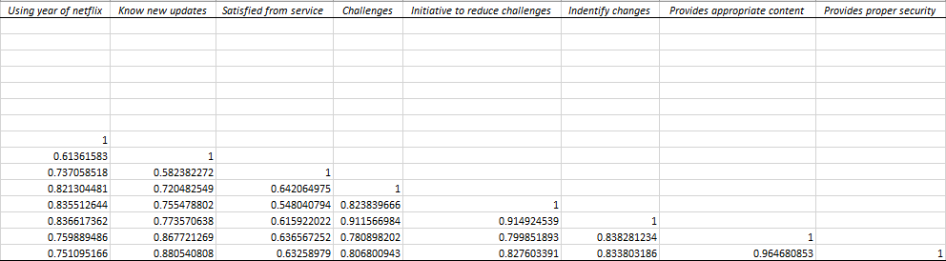
Table 4: Correlation analysis
(Self-created through MS-Excel)
In the context of the following research, the dependent variable is selected as the “changed nature of purchases”, whereas the independent variables are “Online marketing benefits”, “reliable online purchase”, and “provides appropriate content”. Therefore, the correlation analysis is conducted based on the results of these variables. From the table, the correlation value between the dependent factor and “online marketing benefits” variable is observed to be 0.9229, whereas the correlation value between the dependent factor and “reliable market purchase” variable is 0.880. On the other hand, the correlation value between the dependent factor, “changed nature of purchases” and “provides appropriate content” variable is calculated as 0.897.
From the analysis of the above table, it is therefore understood that all the correlation values between independent and dependent factors are closer to 1, which substantiates the positive correlation between both the variables. However, on individual classification, the correlation of the changing purchasing nature is highly correlated with the benefits of online marketing, as the obtained value is 0.9229. This means that with increasing benefits of digital marketing, the purchasing nature of customers would change. Furthermore, the association between the changes in purchase nature with the proper content development is observed as 0.897, which means that with the right content development by digital marketers, it can subsequently increase the purchasing behaviour of the customer. In addition to that, the correlation between reliable market purchases and changes in purchasing behaviour of customers is also observed to be closer to 1 (0.880). This further elaborated the fact that the purchasing intensity of customer increases with reliable and transparent market purchases.

4.2.6 Regression
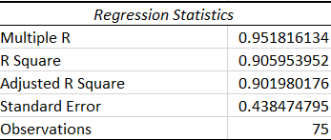
Table 5: Regression Data
(Source: Self-created)
Regression analysis results in important conclusions. The alternative hypothesis is accepted due to the R-value of 0.951, which shows a significant positive relationship between the variables that are independent of "online marketing benefits," "reliable online purchase," and "provides appropriate content" and the dependent variable, "changed nature of purchasing." Furthermore, the model of regression effectively accounts for the predicted variation in the variable that is dependent based on the independent factors, as shown by the high R-square value of 0.905. The adjusted R-square value of 0.901, which is close to the R-square value, indicates that when the variation among the variables that are dependent and independent reduces, a regression analysis becomes more accurate.
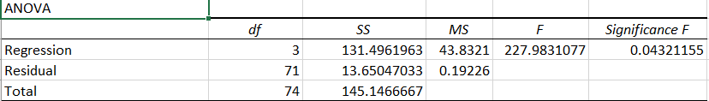
Table 6: ANOVA Table
(Source: Self-created)

The ANOVA analysis evaluates the regression model's validity and its ability to produce a significant association among the dependent variable and the predictors (Connelly, 2021). The regression data in the presented table reveals a significant value of 0.04. Because a p-value of less than 0.05 is required to accept the alternate hypothesis (H1), it concludes that the alternate hypothesis is accepted. This research demonstrates that Netflix's digital marketing methods have a significant impact on users' purchasing behaviour. The regression study supports the impact of Netflix's internet marketing activities on the buying choices of consumers.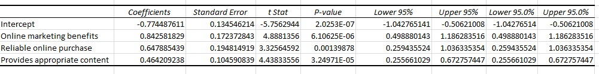
Table 7: Coefficients data
(Source: Self-created through MS-Excel)
The relevance of the "dependent variable" in relation to the "independent variables" is highlighted by the coefficients in the table. Specifically, the "Reliable online purchase" variable stands out with a p-value of 0.001, which is less than the critical threshold of 0.05. This suggests that Netflix's digital marketing tactics have a considerable and statistically significant impact on consumers' purchasing decisions. The significant p-value of 0.001 supports the idea that a trustworthy online shopping experience, made possible by Netflix's marketing initiatives, is essential for influencing consumer behaviour and motivating purchases.

4.3 Discussion

4.3.1 Discussion on graph
Throughout the research study, significant efforts have been made to achieve the research goals and queries. Data and statistics are discussed in an appropriate manner in order to ascertain the progress made towards achieving the goals set before the study. According to Mbete and Tanamal, (2020), when making a purchase decision, consumers take into consideration a variety of factors, and product price has an important part in it. As per the findings of the study, 53 % of the total population consider the factor of comparing the product price before making a purchase decision. Price is often associated with product quality by consumers, such that a perceived high price implies a high level of quality and vice versa. In accordance with the data collected, 60% people believe that there are a number of advantages associated with online marketing platforms. As per Saura et al. (2019), digital marketing benefits organisations of all sizes since it allows them to reach a large number of people at a low cost. Customer loyalty and online sales are also rising as a consequence of digital advertising. Furthermore, 57% participants believe that online purchases are reliable as they have not experienced any issues in buying products online. Moreover, as per the findings, social media and online interaction networks significantly increase the awareness of video streaming platforms like Netflix. As per the data, the most popular medium by which people learn about Netflix is through Instagram.Netflix's services were rated as satisfactory by 34% of respondents. 56% participants rely on social media to stay up to date on the latest Netflix news. Despite this, a minority of this population also expresses dissatisfaction with the service to varying degrees. Thus, as Prentice et al. (2020), points out the satisfaction of customers and the quality of services are both considered as crucial elements in business, as the success of a company highly depends on how well it maintains its customers.
Additionally, it has been observed in the study graphical findings that 44% of participants face difficulty in using Netflix. According to Lobato and Lotz, (2020), issues such as slower internet speeds, incompatibilities with devices, or unfamiliarity with platforms may contribute to these difficulties. Furthermore, as per the data, 44% of participants have experienced changes in their behaviour post a new Netflix subscription. Thus, it is observed that streaming services such as Netflix have an impact on viewers’ behaviour and potentially influence their viewing habits and choices. A further 24% of participants strongly agreed and 38% agreed that Netflix provides its users with appropriate content. As observed by Verganti et al. (2020), Netflix uses modern technologies such as artificial intelligence (AI) and machine learning (ML) to give relevant and customised material to its users. Furthermore, when it comes to security and confidentiality, 22% completely concur and 38% agree that Netflix offers sufficient safety for its users. As observed by Finck and Moscon, (2019), for encrypting its content and preventing unauthorised access, Netflix uses a technology called “digital rights management” (DRM).

4.3.2 Discussion on the correlation analysis
In order to draw a reliable connectivity between the “dependent variable” and its “independent variables”, the analysis performed through “correlation” assists in deducing the development of close linkage between the “associated variables” that enhance the scope of the research study in an effective manner. With respect to the research topic, digital marketing provides significant opportunities to amply its reach among its potential customer segment while enabling the organisation to highlight unique products and services in connection with the “digital developments” that help in influencing the purchase intentions of the relevant customers as evaluated in the case of subscription-based online streaming giant, Netflix (Ziyadin et al. 2019). This statement is confirmed through a “high correlation value” of “0.89” detected in the relationship between the “dependent variable” of “changing nature of purchasing” and the “independent variable” of “provide appropriate content”. The other “independent variables” of “online marketing benefits”, at “0.922”, and “reliable online purchase”, at “0.88”, depict a positive interconnectivity and dependency with the “dependent variable” for the study’s enhancement. Therefore, the analysis signifies that “online marketing benefits” stands more positively correlated to “changing nature of purchasing”, followed by “provide appropriate content” and “reliable online purchase” This reveals that using specific digital marketing strategy has assisted Netflix to develop online marketing strategies through the personalised advertising approach to enhance customer engagement and loyalty. Additionally, through the customisation of content, Netflix has engaged in analysing the preferences and needs of the consumers that dictates on the current market trend and helps in making the purchase of relevant OTT content more reliable and transparent (Al-Azzam and Al-Mizeed, 2021).

4.3.3 Discussion on the regression
Based on the “regression analysis” conducted on the “primary data” for determining the accuracy of the formulated hypothesis, this research study stipulates on the intercreativity of the “primary findings” with the “secondary data” used in the literature in a feasible manner. With respect to the “P-Value” being “0.00” and lesser than the standard value of “0.05”, a positive connection between the “dependent variable” and the “independent variable” attests that the “null hypothesis” stands rejected while the “alternative hypothesis” is accepted, that is, ““Digital marketing strategies of Netflix have significant influence on buying behaviour of customers”, in relevance with the research topic. The declining variance between the “dependent variable” and the “independent variable” signifies the increasing effectiveness of the regression analysis and therefore, with the R-value being closer to 1, the association between the “dependent variable” of “changing nature of purchasing” and the “independent variable” of “online marketing benefits”, “reliable online purchase” and “provide appropriate content” is deemed to be positive and linear with the presentation of symmetrical data. Furthermore, these “associated variables” are more linearly organised due to the positive relationship diagnosed through the “regression analysis” and therefore, with the accepted hypothesis, it can be observed that the incorporation of appropriate digital marketing strategies by Netflix is linearly associated with “online marketing benefits”, “reliable online purchase” and “provide appropriate content” in cognizance with the customer’s buying behaviour.

4.3.4 Comparative analysis
This section has emphasised on the close relationship between the “secondary data” implemented in the Literature and the “primary findings” with respect to a survey conducted with 75 UK-based consumers on retrieving responses on the impact of digital marketing strategies of Netflix UK on the buying nature of the customers for a conclusive outcome of the research study. According to Munsch, (2021), “digital marketing” has enveloped the organisational infrastructure with advanced digitalisation being incorporated in the business operations for synthesising the product and services offering with the “brand awareness” for better outreach among customers. Ioanas, (2020), states that the global integration of “digital marketing” with the prevailing market trends has also assisted several organisations to understand the taste and preferences of the consumers as well as aligning their organisational values to customise the products as per the consumer’s demands. Surge in sales and revenue generation are two major effects seen upon incorporating the appropriate digital marketing strategies that coincide with the business model which has been witnessed in the case of Netflix UK, a subscription-based online streaming company (El Junusi, 2020).
In accordance with the graphical representations, 60 out of the 75 participants reveal that online marketing benefits, such as brand awareness, targeted marketing, higher conversion rates and customer satisfaction, are critical outcomes when businesses utilise internet-based marketing platforms. Such factors further attest the reliability of the online purchases of the content marketed by Netflix UK for its customers, as agreed upon by 57 respondents. Since Netflix UK has now engaged its digital marketing tactics through “social media marketing”, display of relevant content is assured through Facebook and Instagram, as stated by 24 and 34 participants, respectively (Chopra et al. 2021). In addition to the above, this strategy has increased the effectiveness of digital marketing for Netflix through credible service provision of the company has helped customers attain great satisfaction, thus harbouring more loyalty among its targeted customer segment (Pandey et al. 2020).
However, lingering challenges faced by customers while streaming Netflix content online in the form of broadcasting or connectivity issues as well as problems related to the browser unable to locate specific content for the customers can be detrimental for the company’s digital infrastructure over loss of profitability and customer loyalty (di Silva Wgener et al. 2023). In association with the above response, changes have been witnessed in the buying behaviour of the customer while purchasing an online subscription of Netflix, as agreed by 45 individuals, thus implying that “self-actualisation” of the viewer’s choices and habits are affected by Netflix’s streaming services. Furthermore, the user’s perceptions are influenced by Netflix with appropriate content provision as well as the scope of security that protects confidential data of the subscribed consumers, analysed by 38 participants in each element. Such initiatives have proved to be advantageous for Netflix UK while also improving its scope in the competitive market towards higher earnings and better performance. Thus, the analysis of the findings performed through “correlation” and “regression” have proved such facets true while pointing towards the acceptance of the alternative hypothesis that “Digital marketing strategies of Netflix have significant influence on buying behaviour of customers”.

4.4 Conclusion
Based on the above analysis chapter, it is evident that the use of statistical analysis is an effective means of obtaining relevant information and results. As can be seen in the chapter, various statistical parameters have been used in this study, including “descriptive analysis”, “regression”, “correlation matrix”, “collinearity diagnostics”, and “residual statistics” for defining the interconnection between “dependent and independent variables” in the study. All of the parameters were determined by focusing on the “alternate hypothesis”. Moreover, the proper interpretation of graphical representation was effective in obtaining relevant results. Furthermore, it was noted in the discussion section the manner in which these parameters are effective in optimizing the research questions.

Chapter 5: Conclusion and Recommendation

5.1 Conclusion
The section is focused to discuss the entire topic in a brief way by highlighting the major factors involved with the influences of the digital marketing tactics on the buying behaviour of the consumers. By representing the case of the business of Netflix operating in the UK, the section aims to analyse the suitable factors working for conducting the digital marketing interface by the thorough evaluation of the behaviour of the consumers. It also aims to analyse the major recommendations on the basis of the complications faced by the business of Netflix in the UK. The advantages as well as disadvantages are considered to be highlighted in the section to obtain the ideas related to the topic in a summarised way.
As Xhema (2019) mentions, digital marketing provides organisations with the ability to track consumer behaviour and determine what content is popular with their audience. The introduction section of the study analyses the research topic and evaluates the study background. To appreciate the importance of the study, the chapter also presents the rationale and significance of the study. The research has addressed the subject matter properly and has laid out proper aims and objectives to analyse the topic even more effectively. Moreover, the research questions are stated adequately in order to get desired outcomes effectively.
Through the literature review part of the study, the significance of the study has been further effectively evaluated by assessing past interpretations of the research and theories in connection with it. The literature section has evaluated the various types of digital marketing techniques that organizations are using. Furthermore, the chapter examines the importance of understanding the purchasing behaviour of digital consumers. By doing so, it has also highlighted the significance of “Maslow's Need Hierarchy Theory”, as understanding customer needs and preferences is essential to understanding digital marketing strategies (Dwivedi, 2021). Moreover, the chapter discusses consumer behaviour and illustrates the various phases of the customer purchase cycle with the help of the 5 stages model of Kotler. Additionally, the study evaluates the different digital marketing strategies Netflix uses in order to better connect with its diverse customer base. This way the chapter meets its first objective of determining the digital marketing strategies implemented by Netflix currently. As stated by Lu (2023), Netflix has been utilizing the online marketing strategy extensively for the expansion of its business prospects throughout the globe. According to Eklund (2022), by using personalized advertising, Netflix increases the interest of their customers in their content. By analysing the different aspects of digital marketing and its usage, the study has been able to meet its second objective of examining the prospects and difficulties associated with Netflix's implementation of its digital marketing strategy. For understanding the needs of different customers and identifying their preferences, literature related to the "Honey comb model" and the model of RACE has also been reviewed.
The quantitative strategy and primary data collection technique used by the investigator to get details and data utilising the survey approach were described in the methodology chapter. Data from 75 UK-based customers were gathered to offer data about the effect of Netflix's digital advertising tactics on consumers' spending habits with the goal to accomplish the third purpose of the study, which indicates a rough estimate of the consequences of computerised advertising techniques on customers' buying behaviours. The data was collected using the survey method through the distribution of the Google form. The data were gathered from the suitable participants that were recorded by using the “Microsoft Excel” (Rahman and Muktadir, 2021).
In the analysis and findings chapter, it has been critically observed that the study contains one dependency of the variable, which is varied nature of purchasing, as well as three “independent variables”, which are online benefits of marketing, reliable purchasing in online, and providing suitable content. A "correlation matrix" is used in the research process to evaluate the consistency and interdependence of the information and to establish the connection between the "dependent and the independent parameters."(Archakov and Hansen, 2021). Observations in the study indicate that the "dependent and independent variables" were positively correlated. Further, by using the approach of regression analysis and comparing “R values” and “R square values” that are closer to one, it is concluded that there is a significant relationship positively prevailing between the variables. Due to the interdependency among variables, the researcher's selected hypothesis in an alternative way has been accepted as technical strategies of marketing Netflix significantly influence the buying behaviour of customers (Al-Azzam and Al-Mizeed, 2021). As a result of the "comparative analysis" of the primary findings and the secondary dataset also, it can be seen that both of these categories of factors are closely related, and as a result, it can be inferred that Netflix, UK's digital marketing methods significantly affect its customers' purchase decisions.

5.2 Limitations
A “limitation in research” can be a constraint in research methodologies, design or even a researcher's own limitations that can affect and impact the interpretation of the final results of the research. Addressing study constraints, in the view of Akanle et al. (2020), enhances the study's validity and involves a careful review of the research's limitations to ensure that any potential weaknesses in the research are eliminated. The investigator has noted a few drawbacks to the current study on assessing the impact of "online marketing strategies" on customer buying behaviour in the environment of Netflix, UK. One of the major limitations is with regard to the sample size which is restricted to only “75 UK-based consumers”. A small sample size of this kind is not representative of an entire population of UK Netflix subscribers (Andrade, 2020). Moreover, the outcome of the research is also limited and narrowed to one country, the United Kingdom. Therefore, the outcome of the study is not applicable for other regions and countries of the world having Netflix subscribers who may not be influenced by digital marketing strategies of the brand. Furthermore, the “convenience sampling technique” is subjected to biases and lacks variety in the research sample.

5.3 Recommendation
The entire analysis of the subject matter has been observed to be presented from a quite narrow perspective. Conducting the research work on the basis of the collection of the primary data to gather the information and data has been critically associated with the major threats to the study. Since the primary data has been considered to be involving the time-oriented factors on a significant scale, the investigator must try to cut the duration of arranging the data while keeping the span shorter as much as possible. The longer duration of time requires the implementation of the huge sums in conducting the study effectively. Hence, the investigator is required to be highly involved with the incorporation of the essential tactics of analysing the subject matter by the implementation of the cost-effective strategies. In addition to this, the study has been observed to be lacking on the basis of the creation of the scopes of exploring the negative effects involved with the strategies incorporated on the basis of the technical planning involved with the business of Netflix. According to Ackrivo et al. (2019), the investigator is required to be associated with the creation of the broader perspectives involved with the study. It is highly required to be associated with the incorporation of the suitable tactics in terms of the creation of the potential chances involved with the development of the perspective of the researcher implemented in the investigation. According to Kiriakova et al. (2019), the development of the insufficiencies in terms of the management of the time are required to be minimised to terminate the negative impacts in terms of managing the insights of managing the perspectives of the study in a considerable way. Moreover, the indication of the major demerits involved with the businesses are required to be developed for the proper elaboration of the major aspects relevant to the topic.

5.4 Further research
While the present study has conducted a comprehensive analysis of the influence of "digital marketing" on consumer behaviour, further research is still needed. According to Anjum et al. (2020), providing personal attention to customers is one of the most effective ways to communicate empathically with them and tailor the business to their requirements. Therefore, the researcher can further investigate on “personalisation strategies” of Netflix and compare it with other competing streaming service providers for a more comprehensive understanding of digital marketing influence. The study can also investigate the effectiveness of these strategies for consumer engagement and retention along with revenue generation (Kingsnorth, 2022). Future research can also concentrate on the effectiveness of “influencer marketing” which is a popular “digital marketing strategy” that highly impacts consumer behaviour and purchase intention of customers. Moreover, the role of “data analytics” can also be examined to understand Netflix’s marketing strategies and customer engagement tactics.

References
Abbas, J., (2020). Service quality in higher education institutions: qualitative evidence from the students’ perspectives using Maslow hierarchy of needs. International Journal of Quality and Service Sciences, 12(3), pp.371-384.
Ackrivo, J., Hansen-Flaschen, J., Wileyto, E.P., Schwab, R.J., Elman, L. and Kawut, S.M., (2019). Development of a prognostic model of respiratory insufficiency or death in amyotrophic lateral sclerosis. European Respiratory Journal, 53(4).
Ahmad, P., Khalifa, H., Kulkarni, S., Omer, E., Ahmad, A.R., Sharif, S., Singh, S. and Bali, A.O., (2022). An Empirical Study on Consumer Buying Behaviour during COVID-19 Pandemic. Journal of Positive School Psychology, pp.7446-7465.
Akanle, O., Ademuson, A.O. and Shittu, O.S., (2020). Scope and limitation of study in social research. Contemporary Issues in Social Research, pp.105-114.
Al-Azzam, A.F. and Al-Mizeed, K., (2021). The effect of digital marketing on purchasing decisions: A case study in Jordan. The Journal of Asian Finance, Economics and Business, 8(5), pp.455-463.
Al-Azzam, A.F. and Al-Mizeed, K., (2021). The effect of digital marketing on purchasing decisions: A case study in Jordan. The Journal of Asian Finance, Economics and Business, 8(5), pp.455-463.
Ali, S.A.G., Al-Fayyadh, H.R.D., Mohammed, S.H. and Ahmed, S.R., (2022), June. A Descriptive Statistical Analysis of Overweight and Obesity Using Big Data. In 2022 International Congress on Human-Computer Interaction, Optimization and Robotic Applications (HORA) (pp. 1-6). IEEE.
Altymurat, A., Muhai, M. and Saparow, T., (2021). Human Behavior in Organizations Related to Abraham Maslow's Hierarchy of Needs Theory. Interdisciplinary Journal Papier Human Review, 2(1), pp.12-16.
Amoroso, S., Pattuglia, S. and Khan, I., (2021). Do Millennials share similar perceptions of brand experience? A clusterization based on brand experience and other brand-related constructs: the case of Netflix. Journal of Marketing Analytics, 9, pp.33-43.
Andrade, C., (2020). The limitations of online surveys. Indian journal of psychological medicine, 42(6), pp.575-576.
Anjum, A., Thomas, M.R. and Prakash, P.K., (2020). Digital Marketing Strategies: Effectiveness on Generation Z. SCMS Journal of Indian Management, 17(2).
Archakov, I. and Hansen, P.R., (2021). A new parametrization of correlation matrices. Econometrica, 89(4), pp.1699-1715.
Arora, A., Bansal, S., Kandpal, C., Aswani, R. and Dwivedi, Y., (2019). Measuring social media influencer index-insights from Facebook, Twitter and Instagram. Journal of retailing and consumer services, 49, pp.86-101.
Arya, V., Sethi, D. and Paul, J., (2019). Does digital footprint act as a digital asset?–Enhancing brand experience through remarketing. International Journal of Information Management, 49, pp.142-156.
Auditya, A. and Hidayat, Z., (2021). Netflix in Indonesia: Influential Factors on Customer Engagement among Millennials' Subscribers. Journal of Distribution Science, 19(1), pp.89-103.
Au-Yong-Oliveira, M., Marinheiro, M. and Costa Tavares, J.A., (2020). The power of digitalization: The Netflix story. In Trends and Innovations in Information Systems and Technologies: Volume 3 8 (pp. 590-599). Springer International Publishing.
Azizah, F.D., Nur, A.N. and Putra, A.H.P.K., (2022). Impulsive buying behavior: Implementation of IT on technology acceptance model on E-Commerce purchase decisions. Golden Ratio of Marketing and Applied Psychology of Business, 2(1), pp.58-72.
Azkarai, A., Oliver, R. and Gil‐Berrio, Y., (2022). Examining deductive versus guided instruction from an interactionist perspective. Language Learning, 72(S1), pp.125-164.
Baj-Rogowska, A. and Sikorski, M., (2023). Exploring the usability and user experience of social media apps through a text mining approach. Engineering Management in Production and Services, 15(1), pp.86-105.
Bąk, I. and Cheba, K., (2022). Green Transformation: Applying Statistical Data Analysis to a Systematic Literature Review. Energies, 16(1), p.253.
Bernacki, M.L., Greene, M.J. and Lobczowski, N.G., (2021). A systematic review of research on personalized learning: Personalized by whom, to what, how, and for what purpose (s)?. Educational Psychology Review, 33(4), pp.1675-1715.
boldxcollective.com, (2023), about marketing strategies. Available at: https://www.boldxcollective.com/insights-12-ways-to-optimize-your-digital-strategy-for-results. [Accessed on: 29.04.2023].
Brown, N., (2023). Research ethics in a changing social sciences landscape. Research Ethics, 19(2), pp.157-165.
Budzinski, O., Gaenssle, S. and Lindstädt-Dreusicke, N., (2021). The battle of YouTube, TV and Netflix: an empirical analysis of competition in audiovisual media markets. SN Business & Economics, 1(9), p.116.
Burroughs, B., (2019). House of Netflix: Streaming media and digital lore. Popular Communication, 17(1), pp.1-17.
Campbell, S., Greenwood, M., Prior, S., Shearer, T., Walkem, K., Young, S., Bywaters, D. and Walker, K., (2020). Purposive sampling: complex or simple? Research case examples. Journal of research in Nursing, 25(8), pp.652-661.
Chopra, A., Avhad, V. and Jaju, A.S., (2021). Influencer marketing: An exploratory study to identify antecedents of consumer behavior of millennial. Business Perspectives and Research, 9(1), pp.77-91.
Connelly, L.M., (2021). Introduction to analysis of variance (ANOVA). Medsurg Nursing, 30(3), pp.218-158.
da Silva Wegner, R., da Silva, D.J.C., da Veiga, C.P., de Fátima Barros Estivalete, V., Rossato, V.P. and Malheiros, M.B., (2023). Performance analysis of social media platforms: evidence of digital marketing. Journal of Marketing Analytics, pp.1-12.
Das, M., (2021). Influence of Customised Advertisements of High-End Smartphones in OTT Platforms on the Consumer Buying Intentions of Millennial & Generation Z. Ushus Journal of Business Management, 20(4), pp.63-95.
Dawadi, S., Shrestha, S. and Giri, R.A., (2021). Mixed-methods research: A discussion on its types, challenges, and criticisms. Journal of Practical Studies in Education, 2(2), pp.25-36.
Desai, V. and Vidyapeeth, B., (2019). Digital marketing: A review. International Journal of Trend in Scientific Research and Development, 5(5), pp.196-200.
Desai, V. and Vidyapeeth, B., (2019). Digital marketing: A review. International Journal of Trend in Scientific Research and Development, 5(5), pp.196-200.
Dwivedi, P., (2021). Maslow Theory Revisited-Covid-19-Lockdown Impact on Consumer Behaviour. Turkish Journal of Computer and Mathematics Education (TURCOMAT), 12(2), pp.2445-2450.
Dwivedi, Y.K., Hughes, L., Wang, Y., Alalwan, A.A., Ahn, S.J., Balakrishnan, J., Barta, S., Belk, R., Buhalis, D., Dutot, V. and Felix, R., (2023). Metaverse marketing: How the metaverse will shape the future of consumer research and practice. Psychology & Marketing, 40(4), pp.750-776.
Eklund, O., (2022). Custom thumbnails: The changing face of personalisation strategies on Netflix. Convergence, 28(3), pp.737-760.
El Junusi, R., (2020). Digital marketing during the pandemic period; A study of islamic perspective. Journal of Digital Marketing and Halal Industry, 2(1), pp.15-28.
Etikan, I. and Babtope, O., (2019). A basic approach in sampling methodology and sample size calculation. Med Life Clin, 1(2), p.1006.
Finck, M. and Moscon, V., (2019). Copyright law on blockchains: between new forms of rights administration and digital rights management 2.0. IIC-International Review of Intellectual Property and Competition Law, 50, pp.77-108.
Florido-Benítez, L., (2022). International mobile marketing: A satisfactory concept for companies and users in times of pandemic. Benchmarking: An International Journal, 29(6), pp.1826-1856.
Fombelle, P.W., Voorhees, C.M., Jenkins, M.R., Sidaoui, K., Benoit, S., Gruber, T., Gustafsson, A. and Abosag, I., (2020). Customer deviance: A framework, prevention strategies, and opportunities for future research. Journal of Business Research, 116, pp.387-400.
Fox, M.P., Murray, E.J., Lesko, C.R. and Sealy-Jefferson, S., (2022). On the need to revitalize descriptive epidemiology. American journal of epidemiology, 191(7), pp.1174-1179.
Ganti, A., (2020). Correlation coefficient. Corp. Financ. Account, 9, pp.145-152.
Ghazali, A.F. and Suhaimi, A., (2022). Data-driven Insights from Visualization of Bibliometric Analysis on Consumer Purchase Decision. Asian Journal of Research in Business and Management, 4(3), pp.619-631.
Guo, J., Weng, D., Zhang, Z., Jiang, H., Liu, Y., Wang, Y. and Duh, H.B.L., (2019), October. Mixed reality office system based on maslow’s hierarchy of needs: Towards the long-term immersion in virtual environments. In 2019 IEEE International Symposium on Mixed and Augmented Reality (ISMAR) (pp. 224-235). IEEE.
Habib, S., Hamadneh, N.N. and Hassan, A., (2022). The Relationship between Digital Marketing, Customer Engagement, and Purchase Intention via OTT Platforms. Journal of Mathematics, 2022.
Han. H., (2021). Consumer behavior and environmental sustainability in tourism and hospitality: A review of theories, concepts, and latest research. Journal of Sustainable Tourism, 29(7), pp.1021-1042.
Hanaysha, J.R., Al Shaikh, M.E. and Alzoubi, H.M., (2021). Importance of marketing mix elements in determining consumer purchase decision in the retail market. International Journal of Service Science, Management, Engineering, and Technology (IJSSMET), 12(6), pp.56-72.
Hendrikx, A. and Castro, D., (2022). Netflix’s community relationship management. An analysis of its Facebook-USA page. Journal of Media Business Studies, 19(2), pp.108-125.
Herhausen, D., Miočević, D., Morgan, R.E. and Kleijnen, M.H., (2020). The digital marketing capabilities gap. Industrial Marketing Management, 90, pp.276-290.
Herhausen, D., Miočević, D., Morgan, R.E. and Kleijnen, M.H., (2020). The digital marketing capabilities gap. Industrial Marketing Management, 90, pp.276-290.
Hopper, E., (2020). Maslow’s hierarchy of needs explained. ThoughtCo, ThoughtCo, 24, pp.1-3.
Hou, Y.F., Huang, C.Y. and Fang, C.C., (2022). Using the methods of statistical data analysis to improve the trustworthiness of software reliability modeling. IEEE Access, 10, pp.25358-25375.
Hussain, R.B.M., (2019). Influence of Social Media on Brand and Branding: A Sociological Review. Jurnal Pengajian Media Malaysia, 21(2), pp.89-101.
Iftikhar, I., Yasmeen, B. and Ahmad, N., (2022). Honeycomb Framework: Examining the Social and Personal Drivers of Fake News Sharing on Social Media Platforms. Journal of Development and Social Sciences, 3(3), pp.01-16.
Ikram, M. and Kenayathulla, H.B., (2022). Out of Touch: Comparing and Contrasting Positivism and Interpretivism in Social Science. Asian Journal of Research in Education and Social Sciences, 4(2), pp.39-49.
Ioanas, E., (2020). Social media and its impact on consumers behavior. Jurnal Analisa Kesehatan, 1(1), pp.1-1.
Junjie, M. and Yingxin, M., (2022). The Discussions of Positivism and Interpretivism. Online Submission, 4(1), pp.10-14.
Khan, M.F. and Jan, A., (2019). A measure of social media marketing: Scale development and validation. Jindal Journal of Business Research, 8(2), pp.158-168.
Kim, N.H., (2020). User Experience Validation Using the Honeycomb Model in the Requirements Development Stage. The International Journal of Advanced Smart Convergence, 9(3), pp.227-231.
Kingsnorth, S., (2022). Digital marketing strategy: an integrated approach to online marketing. Kogan Page Publishers.
Kiriakova, V., Cooray, S.D., Yeganeh, L., Somarajah, G., Milat, F. and Vincent, A.J., (2019). Management of bone health in women with premature ovarian insufficiency: systematic appraisal of clinical practice guidelines and algorithm development. Maturitas, 128, pp.70-80.
Krizanova, A., Lăzăroiu, G., Gajanova, L., Kliestikova, J., Nadanyiova, M. and Moravcikova, D., (2019). The effectiveness of marketing communication and importance of its evaluation in an online environment. Sustainability, 11(24), p.7016.
Kurashov, R., (2022). Customer decision-making process in the digital era: the models’ overview and its future development. Стратегии развития социальных общностей, институтов и территорий. Том 1.—Екатеринбург, 2022, pp.455-461.
Kurdi, B., Alshurideh, M., Akour, I., Alzoubi, H., Obeidat, B. and Alhamad, A., (2022). The role of digital marketing channels on consumer buying decisions through eWOM in the Jordanian markets. International Journal of Data and Network Science, 6(4), pp.1175-1186.
Kurniati, H., Prabumenang, A.K.R. and Aditya, S., (2021). The Effect of E-Service Quality and Brand Image Toward Netflix Customer Loyalty through Customer Satisfaction. Jurnal REKOMEN (Riset Ekonomi Manajemen), 5(1), pp.17-29.
Lee, H. and Cho, C.H., (2020). Digital advertising: present and future prospects. International Journal of Advertising, 39(3), pp.332-341.
Limov, B., (2020). Click it, binge it, get hooked: Netflix and the growing US audience for foreign content. International Journal of Communication, 14, p.20.
linkedin.com, (2023). Available at: https://www.linkedin.com/pulse/according-philip-kotler-typical-buying-process-involves-waed-salem/. [Accessed on: 30.04.2023]
Ljepava, N., (2022). AI-Enabled Marketing Solutions in Marketing Decision Making: AI Application in Different Stages of Marketing Process. TEM Journal, 11(3), pp.1308-1315.
Lobato, R. and Lotz, A.D., (2020). Imagining global video: The challenge of Netflix. JCMS: Journal of Cinema and Media Studies, 59(3), pp.132-136.
López García, J.J., Lizcano, D., Ramos, C.M. and Matos, N., (2019). Digital marketing actions that achieve a better attraction and loyalty of users: An analytical study. Future Internet, 11(6), p.130.
Loveday, J., Morrison, G.M. and Martin, D.A., (2022). Identifying knowledge and process gaps from a systematic literature review of net-zero definitions. Sustainability, 14(5), p.3057.
Lu, Z., (2023). An Exploratory Study on Netflix Inc. Current Strategy by Case Study Methods. Advances in Education, Humanities and Social Science Research, 5(1), pp.303-303.
macrotrends.net, (2023), about Netflix profit. Available at: https://www.macrotrends.net/stocks/charts/NFLX/netflix/gross-profit#:~:text=Netflix%20annual%20gross%20profit%20for,a%200.66%25%20increase%20from%202021. [Accessed on: 29.04.2023].
Maddodi, S., (2019). NETFLIX bigdata analytics-the emergence of data driven recommendation. Srivatsa Maddodi, & Krishna Prasad, K.(2019). Netflix Bigdata Analytics-The Emergence of Data Driven Recommendation. International Journal of Case Studies in Business, IT, and Education (IJCSBE), 3(2), pp.41-51.
Malazdrewicz, S., Ostrowski, K.A. and Sadowski, Ł., (2022). Large Panel System Technology in the Second Half of the Twentieth Century—Literature Review, Recycling Possibilities and Research Gaps. Buildings, 12(11), p.1822.
Maria, S., Pusriadi, T., Hakim, Y.P. and Darma, D.C., (2019). The effect of social media marketing, word of mouth, and effectiveness of advertising on brand awareness and intention to buy. Jurnal Manajemen Indonesia, 19(2), pp.107-122.
Mbete, G.S. and Tanamal, R., (2020). Effect of Easiness, Service Quality, Price, Trust of Quality of Information, and Brand Image of Consumer Purchase Decision on Shopee Online Purchase. Jurnal Informatika Universitas Pamulang, 5(2), p.100.
Meeker, W.Q., Escobar, L.A. and Pascual, F.G., (2022). Statistical methods for reliability data. John Wiley & Sons.
Meyer, K.E., Li, J., Brouthers, K.D. and Jean, R.J.B., (2023). International business in the digital age: Global strategies in a world of national institutions. Journal of International Business Studies, pp.1-22.
Mishra, P., Pandey, C.M., Singh, U., Gupta, A., Sahu, C. and Keshri, A., (2019). Descriptive statistics and normality tests for statistical data. Annals of cardiac anaesthesia, 22(1), p.67.
Mukherjee, S.P., (2019). A guide to research methodology: An overview of research problems, tasks and methods.
Mukherjee, S.P., (2019). A guide to research methodology: An overview of research problems, tasks and methods.
Munsch, A., (2021). Millennial and generation Z digital marketing communication and advertising effectiveness: A qualitative exploration. Journal of Global Scholars of Marketing Science, 31(1), pp.10-29.
Nafees, L., Mehdi, M., Gupta, R., Kalia, S., Banerjee, S. and Kapoor, S., (2021). Netflix in India: expanding to success. Emerald Emerging Markets Case Studies, 11(2), pp.1-31.
Nascimento, T.C.D., Campos, R.D. and Suarez, M., (2020). Experimenting, partnering and bonding: a framework for the digital influencer-brand endorsement relationship. Journal of Marketing Management, 36(11-12), pp.1009-1030.
Normand, M.P. and Donohue, H.E., (2023). Research ethics for behavior analysts in practice. Behavior Analysis in Practice, 16(1), pp.13-22.
Nworgu, K.O., (2022). The influence of beauty models on consumers’ product choice.
oberlo.com, (2023), about social media utilisation rate globally. Available at: https://www.oberlo.com/statistics/how-many-people-use-social-media#:~:text=The%20latest%20figures%20show%20that,jump%20in%20just%20five%20years. [Accessed on: 29.04.2023].
Olson, E.M., Olson, K.M., Czaplewski, A.J. and Key, T.M., (2021). Business strategy and the management of digital marketing. Business horizons, 64(2), pp.285-293.
Onyusheva, I. and Baker, A.S., (2021). Netflix: A Case Study on International Business Strategy Development. The EUrASEANs: journal on global socio-economic dynamics, 6(31), pp.40-52.
Ostonakulova, G., (2022). Features of Consumer Behavior on the Internet. American Journal of Economics and Business Management, 5(9), pp.138-145.
Palinkas, L.A., Mendon, S.J. and Hamilton, A.B., 2019. Innovations in mixed methods evaluations. Annual review of public health, 40, pp.423-442.
Pallant, J., (2020). SPSS survival manual: A step by step guide to data analysis using IBM SPSS. McGraw-hill education (UK).
Pandey, N., Nayal, P. and Rathore, A.S., (2020). Digital marketing for B2B organizations: structured literature review and future research directions. Journal of Business & Industrial Marketing.
Pandey, P. and Pandey, M.M., (2021). Research methodology tools and techniques. Bridge Center.
Pietikäinen, M.O., (2020). Social media marketing through influencers with a particular focus on Instagram and Honeycomb model.
Prentice, C., Dominique Lopes, S. and Wang, X., (2020). The impact of artificial intelligence and employee service quality on customer satisfaction and loyalty. Journal of Hospitality Marketing & Management, 29(7), pp.739-756.
Qiu, S., An, P., Kang, K., Hu, J., Han, T. and Rauterberg, M., (2022). A review of data gathering methods for evaluating socially assistive systems. Sensors, 22(1), p.82.
Rahman, A. and Muktadir, M.G., (2021). SPSS: an imperative quantitative data analysis tool for social science research. Int. J. Res. Innov. Soc. Sci, 5, pp.300-302.
Rakhmatova, M.S. and Kh, V.Z., (2022). Inductive and deductive approaches in teaching grammar. Web of Scientist: International Scientific Research Journal, 3(5), pp.1618-1623.
Rashi, P., Bist, A.S., Asmawati, A., Budiarto, M. and Prihastiwi, W.Y., (2021). Influence of post covid change in consumer behaviour of millennials on advertising techniques and practices. Aptisi Transactions on Technopreneurship (ATT), 3(2), pp.201-208.
Rautela, S., (2021). Social Media for New Product Launch: A Study of Social Media Platforms Across the RACE Planning Framework. International Journal of Interactive Mobile Technologies, 15(5).
Revechat.com, (2022), blog/buying-motivation/. [Available at:https://www.revechat.com/blog/buying-motivation/]. [Accessed on: 25.04.2023]
Rita, P., Oliveira, T. and Farisa, A., (2019). The impact of e-service quality and customer satisfaction on customer behavior in online shopping. Heliyon, 5(10), p.e02690.
Ritz, W., Wolf, M. and McQuitty, S., (2019). Digital marketing adoption and success for small businesses: The application of the do-it-yourself and technology acceptance models. Journal of Research in interactive Marketing, 13(2), pp.179-203.
Sadana, M. and Sharma, D., (2021). How over-the-top (OTT) platforms engage young consumers over traditional pay television service? An analysis of changing consumer preferences and gamification. Young Consumers.
SAPUTRA, I.W. and HIDAYAT, Z., (2022). NETWORKING AS A MARKETING STRATEGY: A CASE STUDY ON THE INDONESIAN NETFLIX SUBSCRIBER COMMUNITY. Journal of Theoretical and Applied Information Technology, 100(19)
Saunders, M.N.K., Lewis, P. and Thornhill, A. (2019). Research Methods for Business Students. 8th Edition, Pearson, New York.
Saura, J.R., (2021). Using data sciences in digital marketing: Framework, methods, and performance metrics. Journal of Innovation & Knowledge, 6(2), pp.92-102.
Saura, J.R., Palos-Sanchez, P.R. and Correia, M.B., (2019). Digital marketing strategies based on the e-business model: Literature review and future directions. Organizational transformation and managing innovation in the fourth industrial revolution, pp.86-103.
seventeen.com, (2020). [Available at: https://www.seventeen.com/celebrity/movies-tv/g32770452/netflix-shows-that-expertly-address-racism/] [Accessed on: 20.04.2023]
Sharma, A. and Gandhi, A.V., (2023). Consumer adoption study for innovative technology products and services in an emerging economy. International Journal of Innovation Science.
Siebert, A., Gopaldas, A., Lindridge, A. and Simões, C., (2020). Customer experience journeys: Loyalty loops versus involvement spirals. Journal of Marketing, 84(4), pp.45-66.
Sihombing, A.K., Permata, R.R. and Ramli, T.S., (2021). Comparison of Digital Copyright Protection on Over the Top (OTT) Streaming Content Media in Indonesia and the United States. PADJADJARAN JURNAL ILMU HUKUM (JOURNAL OF LAW), 8(2), pp.183-212.
simplypsychology.org, (2023). [Available at: https://www.simplypsychology.org/maslow] [Accessed on: 20.04.2023]
smartinsights (2023), [Avaliable at: https://www.smartinsights.com/social-media-marketing/social-media-strategy/digital-marketing-models-honeycomb-model/] [Accessed on: 25.5.2023]
Steck, H., Baltrunas, L., Elahi, E., Liang, D., Raimond, Y. and Basilico, J., (2021). Deep learning for recommender systems: A Netflix case study. AI Magazine, 42(3), pp.7-18.
Stratton, S.J., (2021). Population research: convenience sampling strategies. Prehospital and disaster Medicine, 36(4), pp.373-374.
Talwar, S., Dhir, A., Singh, D., Virk, G.S. and Salo, J., (2020). Sharing of fake news on social media: Application of the honeycomb framework and the third-person effect hypothesis. Journal of Retailing and Consumer Services, 57, p.102197.
Tanuwijaya, S., Alamsyah, A. and Ariyanti, M., (2021), August. Mobile customer behaviour predictive analysis for targeting Netflix potential customer. In 2021 9th International Conference on Information and Communication Technology (ICoICT) (pp. 348-352). IEEE.
Thomas, T. and Tiwari, G., (2019). Crushing behavior of honeycomb structure: a review. International journal of crashworthiness.
Trivedi, A.J. and Mehta, A., (2019). Maslow’s Hierarchy of Needs-Theory of Human Motivation. International Journal of Research in all Subjects in Multi Languages, 7(6), pp.38-41.
Verganti, R., Vendraminelli, L. and Iansiti, M., (2020). Innovation and design in the age of artificial intelligence. Journal of Product Innovation Management, 37(3), pp.212-227.
Vieira, V.A., de Almeida, M.I.S., Agnihotri, R., da Silva, N.S.D.A.C. and Arunachalam, S., (2019). In pursuit of an effective B2B digital marketing strategy in an emerging market. Journal of the Academy of Marketing Science, 47, pp.1085-1108.
Vijayendra, K., Fantone, A. and Shehryar, Z., (2023). Recent Trends of Quantitative Approaches in Different Sectors: A Concise Review. Asian Journal of Education and Social Studies, 41(2), pp.22-34.
Wai, K., Dastane, D.O., Johari, Z. and Ismail, N.B., (2019). Perceived risk factors affecting consumers’ online shopping behaviour. The Journal of Asian Finance, Economics and Business, 6(4), pp.246-260.
Wang, X. and Cheng, Z., (2020). Cross-sectional studies: strengths, weaknesses, and recommendations. Chest, 158(1), pp.S65-S71.
Washington, S., Karlaftis, M.G., Mannering, F. and Anastasopoulos, P., (2020). Statistical and econometric methods for transportation data analysis. CRC press.
Wayne, M.L. and Uribe Sandoval, A.C., (2023). Netflix original series, global audiences and discourses of streaming success. Critical Studies in Television, 18(1), pp.81-100.
Wijenayake, P., Silva, D.D., Alahakoon, D. and Kirigeeganage, S., (2020), January. Automated detection of social roles in online communities using deep learning. In Proceedings of the 3rd International Conference on Software Engineering and Information Management (pp. 63-68).
Xhema, J., (2019). Effect of social networks on consumer behaviour: complex buying. IFAC-PapersOnLine, 52(25), pp.504-508.
Ytimg.com, (2022), vi/Vsk6Bx3Erhw/maxresdefault.jpg. [Available at:https://i.ytimg.com/vi/Vsk6Bx3Erhw/maxresdefault.jpg]. [Accessed on: 25.04.2023]
Ziyadin, S., Doszhan, R., Borodin, A., Omarova, A. and Ilyas, A., (2019). The role of social media marketing in consumer behaviour. In E3S Web of Conferences (Vol. 135, p. 04022). EDP Sciences.

Appendices

Appendix 1: Survey questionnaire
- What is your age?
- 20 to 30
- 31 to 45
- 45 and above

- What is your gender?
- Female
- Male
- Others

- Do you have any idea about online marketing?
- Yes
- No
- Maybe

- What are the factors that influence you to visit the online market place?
- Comparing the price of products
- Easy payment options
- Reviews and feedback from the customers
- All of the above

- Which social media platforms you are using mostly?
- Facebook
- Instagram
- WhatsApp
- All of the above

- Do you believe that social media has changed the nature of purchasing products?
- Strongly agree
- Agree
- Neutral
- Strongly disagree
- Disagree

- Do you get any benefits with the help from online marketing platforms?
- Yes
- No
- Maybe
- Do you believe that online purchases are reliable?
- Yes
- No
- Maybe
- From which platform do you get to know about Netflix?
- Facebook
- Instagram
- YouTube
- All of the above

- How long are you using Netflix?
- 1 to 2 years
- 3 to 5 years
- Above 5 years

- How do you get to know about the new updates that Netflix brings?
- Email
- Social Media
- Advertisements
- All of the above

- How likely are satisfied with the service provided by the Netflix?
Mostly Unlikely | Unlikely | Neutral | Likely | Mostly Likely

- Do you face any kind of challenges while operating Netflix?
- Yes
- No
- May be

- What kind of challenges do you face while operating Netflix?
- Did the organisation taken any initiative to reduce the challenges?
- Yes
- No
- Maybe

- Do you identify any changes in your behaviour while purchasing new subscription for Netflix?
- Yes
- No
- Maybe

- What are the changes have you identified after using Netflix?

- Do you think that Netflix provides appropriate content to their users?
- Strongly agree
- Agree
- Neutral
- Disagree
- Strongly disagree

- Do you believe that Netflix provides proper security and privacy protection for their customers?
- Strongly agree
- Agree
- Neutral
- Strongly disagree
- Disagree

- Do have any recommendation to improve their digital marketing operations?

