Advanced Software Development (ACCB5011)
  - Maze pathfinding implementation
Sophie Meyrick-Vernon 2221762
BSc Applied Computing

Contents
Describing and Comparing Dijkstra's and A* Algorithms 3
Dijkstra’s Algorithm 3
A* Algorithm 3
Implementation 4
Performance 6

Describing and Comparing Dijkstra's and A* Algorithms

Dijkstra’s Algorithm
Dijkstra’s algorithm is a widely used method in computer science for determining the shortest path from a starting point to all other points in a weighted graph. Originally developed by Edsger Dijkstra in 1956, the algorithm works by systematically exploring the graph to find the most efficient routes [1]. It begins by assigning a distance of zero to the starting node and treating all other nodes as infinitely far away. Using a priority-based approach, it repeatedly selects the node with the smallest known distance, updates the distances of its neighbouring nodes if a shorter path is found, and continues this process until the shortest path to the destination is confirmed or all nodes have been considered [2].
One of the key advantages of Dijkstra’s algorithm is that it always finds the shortest possible path from the starting point to the destination, if all the edge weights in the graph are non-negative. This makes it a reliable and accurate method for pathfinding [3]. However, it can become quite slow and inefficient when working with large graphs, especially if the target is far away from the starting point. This is because the algorithm doesn’t focus its search in any particular direction it explores outward from the starting point, checking many nodes that don’t necessarily lead toward the goal. As a result, it may end up visiting a lot of unnecessary nodes and causing the processing time to increase before finding the shortest path [3].
Dijkstra’s algorithm follows a greedy approach, always picking the node with the smallest known distance. It uses a priority queue to keep track of which node to visit next, often implemented as a min-heap. When using a binary heap, the time complexity of Dijkstra’s algorithm is O((V + E) log V), where V stands for the number of or nodes, and E is the number of connections between nodes. While this performance is acceptable for smaller or moderately sized graphs, it can become a bottleneck in more complex scenarios.

A* Algorithm
The A* algorithm is an improvement upon Dijkstra’s algorithm. It also guarantees the shortest path but does so more efficiently by incorporating a heuristic function that estimates the cost from any node to the goal [3]. This means that, unlike Dijkstra’s approach which explores all paths equally, A* tries to guess which paths are most likely to lead to the goal and focuses on those first. This makes it faster and more efficient, especially when the goal is far away.
At the heart of A* is a formula that helps it decide which direction to go. This formula is written as f(n) = g(n) + h(n). Here, g(n) is the cost to move from the starting point to the current location. In a maze, this would simply be how many steps it took to get there. h(n) is the heuristic – this is the part that makes A* different. It is a rough estimate of how far the current position is from the goal. A* adds these two together to get f(n), which is its best guess of how good that path is [3].
A commonly used heuristic for grid-based problems like mazes is the Manhattan distance. This is because movement is limited to four directions: up, down, left, or right without allowing diagonal steps [4]. So, to estimate how far you are from the goal, A* simply adds up the number of horizontal and vertical steps it would take to get there in a straight line, ignoring any walls.
One of the biggest advantages of A* is that it usually finds the shortest path faster than Dijkstra’s algorithm. This is because A* uses a heuristic to focus its search on the goal, rather than exploring in all directions equally. This saves both time wasted and computing resources. However, how well A* performs depends a lot on the quality of the heuristic. If the heuristic is poor for example, if it always gives a bad guess about how far the goal is then A* might behave more like Dijkstra’s algorithm and check too many paths [5].
A* is a little more complex to set up compared to Dijkstra because it needs to keep track of both the real distance and the guessed distance. But once implemented correctly, it tends to be much more effective, especially in situations where you are just trying to find a single path from a starting point to a goal, like in a maze.
If we compare Dijkstra and A*, Dijkstra doesn’t use any guesswork and checks every possible route. It always finds the shortest path, but it might take a lot longer because it explores everything. A*, on the other hand, is more focused. It uses a distance estimate to avoid checking unnecessary directions, and if the estimate is reasonable, it will also find the shortest path, but in a more efficient way [6].

Implementation
The maze-solving program was built using a simple version of Dijkstra’s algorithm. The main aim was to make sure the player always reaches the target without hitting any walls, while also trying to keep the number of moves and grid checks as low as possible. The code was written to follow the rules exactly, using only the allowed functions and without changing anything in the original program files.
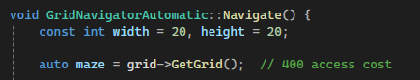

At the start, the program reads the full maze using grid->GetGrid(), which gives the layout of the entire 20x20 grid. This action only happens once, so it keeps the access count low at 400. The player and target positions are then found by scanning through the grid. Even though the player and target usually start in opposite corners, the program doesn’t assume this and checks every square to be sure.
To find a path from the player to the target, the program keeps track of the shortest number of steps needed to reach each square. It also remembers which square each step came from, so it can build the path backwards once the goal is reached. Another grid is used to keep track of which squares have already been visited, so they aren’t checked again.
The main part of the algorithm uses a list that always picks the square with the lowest number of steps so far. It looks at all the neighbouring squares up, down, left, and right and adds them to the list if they aren’t walls and haven’t already been visited. This repeats until the target is found.
After the target is reached, the program follows the path back to the start using the "came from" data. It figures out which directions to move by comparing each square to the one before it. For example, if the player moved from (3,4) to (3,3), that means the next move should be "up". These moves are saved in a list and then reversed so the player moves from the start to the goal in the correct order.

The following code shows how the directional movement was determined during path reconstruction:
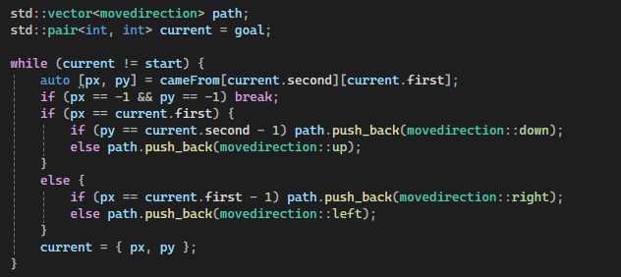

In performance testing, the implementation consistently completed the maze with zero wall collisions. The number of moves varied depending on the maze layout but typically ranged between 40 and 60. These results demonstrate that the solution is both efficient and accurate.

Performance
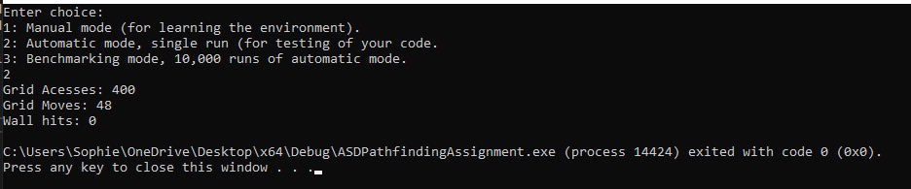
When option 2 is selected:

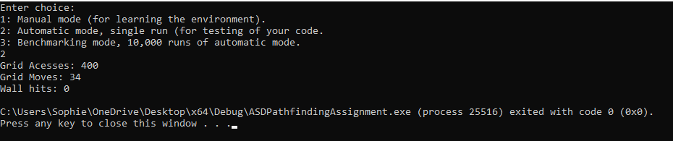
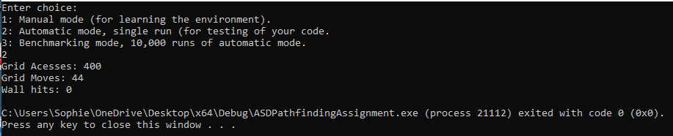

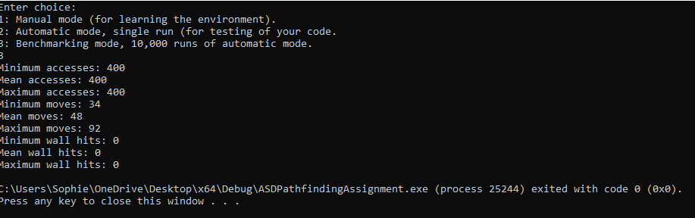
When option 3 is selected:
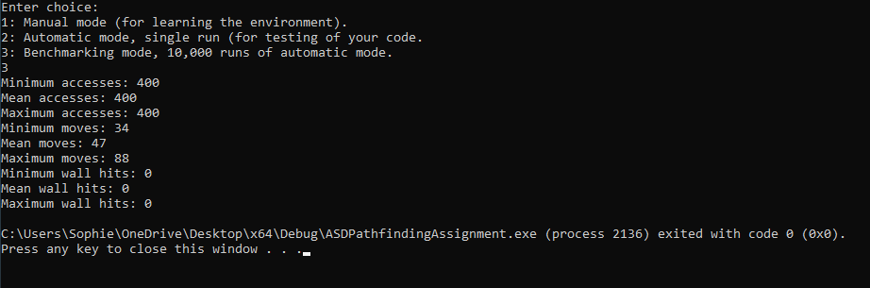
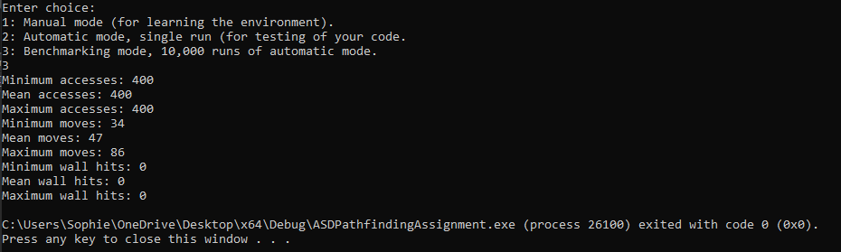

While the current implementation does not incorporate a heuristic, operating as a Dijkstra-based solution, it performs well under the given constraints. Incorporating an A* heuristic could improve performance further by reducing the number of expanded nodes. However, the existing solution satisfies the core requirements of the task, providing an optimal path with minimal overhead and reliable navigation across all randomly generated mazes.

References

[1] | w3schools, “DSA Dijkstra's Algorithm,” w3schools, [Online]. Available: https://www.w3schools.com/dsa/dsa_algo_graphs_dijkstra.php. [Accessed 9 July 2025].
[2] | geeksforgeeks, “Dijkstra's Algorithm to find Shortest Paths from a Source to all,” geeksforgeeks, 21 May 2025. [Online]. Available: https://www.geeksforgeeks.org/dsa/dijkstras-shortest-path-algorithm-greedy-algo-7/. [Accessed 9 July 2025].
[3] | R. Patel, “Understanding Dijkstra’s Algorithm – Comprehensive Guide,” upper, 18 November 2024. [Online]. Available: https://www.upperinc.com/glossary/route-optimization/dijkstras-algorithm/. [Accessed 15 July 2025].
[4] | “The A* Algorithm: A Complete Guide,” Data Champ, 7 November 2024. [Online]. Available: https://www.datacamp.com/tutorial/a-star-algorithm. [Accessed 9 July 2025].
[5] | “A* Search Algorithm,” GeeksForGeeks, 30 July 2024. [Online]. Available: https://www.geeksforgeeks.org/dsa/a-search-algorithm/. [Accessed 9 July 2025].
[6] | M. Simic, “Dijkstra vs. A* – Pathfinding,” Baeldung, 18 March 2024. [Online]. Available: https://www.baeldung.com/cs/dijkstra-vs-a-pathfinding. [Accessed 15 July 2025].

