

Improvement of an HR priority area

STUDENT NAME: Madalina Nagy
STUDENT NUMBER: 2019619
MODULE CODE: BMMB7025
MODULE NAME: Managing People in Organisations

Lecturer: James Moore
FCIPD, MSc

Executive summary
This report analyses the People Management strategies of Hilton Hotel and Marriott Hotel, which specialise in key regions, such as engagement, typical performance control, range, and the function of technological improvements, especially AI. Both businesses undertake specific strategies tailor-made to their length, attain, and place, emphasizing centralized regulations for Hilton and flexibility for Marriott. The file highlights the importance of aligning HR techniques with organisational desires and market dynamics, leveraging AI gear for recruitment, training, and general performance evaluation. Recommendations embody enhancing employee engagement, strengthening standard overall performance control systems, selling diversity and inclusion, and ensuring moral use of AI technology in People Management approaches.
Table of Contents

Executive summary 2
1. Introduction 4
2. Organisational overview 4
2.1.Hilton Hotel Cardiff/Wales/UK: 4
2.2.Marriott Hotel Cardiff/Wales/UK: 5
3. Main discussion 7
3.1. Influence of Internal and External Environmental Changes: 7
3.2. Approach to People Management Based on Size, Reach, and Sector: 8
3.3. Key People Management Concerns: 9
3.4. Role of Technological Advancements in People Management: 10
4. Conclusions 12
5. Recommendations 12
6. Reference list 14

Table of Figures

1. Figure 1: Organisational chart of Hilton Hotel 5
2. Figure 2: Organisational chart of Marriott Hotel 6

Introduction
The hotel industry is seeing rapid global growth. The hotel business contributes to the economic growth of multiple countries. This area of the business is distinguished by its provision of services such as shelter, food, and drinks to consumers. The success of hospitality companies is contingent upon their adeptness in managing their staff resources (Akbar, and Tracogna, 2018). The report will highlight people management at both Hilton Hotel and Marriott Hotel and the problem that is influencing the people management process. The report will also present several recommendations to address the identified problem.

In the dynamic environment of the hospitality industry, effective people management plays an important role in organisational growth, employee satisfaction and overall performance. This report comparatively examines the people management strategies of Hilton Hotel Cardiff/Wales/UK and Marriott Hotel Cardiff/ Wales/UK. The insights of this study will pave the way for potential practitioners ready to improve the HR practices of these companies. According to Armstrong (2020), strategic human resource management (HRM) is key to employee engagement, improving familiar performance and solving organisational challenge’s role. Furthermore, Henderson (2017) highlights the importance of aligning HR strategies with organisational desires to achieve sustainable competitive advantage. This record aims to offer a review of the People Management strategies of Hilton Hotel and Marriott Hotel, highlighting their strengths, weaknesses, and areas for development. Drawing insights from scholarly literature and industry first-class practices, this analysis will provide valuable suggestions to optimize HRM practices in each company, which will, in the long run, contribute to ideal worker pleasure, productivity, and organisational success.

2. Organisational overview

2.1. Hilton Hotel Cardiff/Wales/UK:

Hilton Hotel Cardiff/Wales/UK is part of a prominent hotel chain renowned for its luxurious accommodations and pinnacle-notch hospitality offerings. Catering to numerous purchasers, including commercial enterprise tourists, vacationers, and event attendees, Hilton maintains a strong presence in the hospitality enterprise. The HRM feature at Hilton Hotel Cardiff/Wales/UK operates with a devoted HR organisation overseeing all factors of human belongings control. This crew, which includes HR professionals, managers, and coordinators, is accountable for recruitment, education, everyday overall performance management, and worker members of the family. Notably, the HR department holds strategic importance inside the business enterprise, as evidenced by its instance on the director stage. This positioning lets Hilton simultaneously use its HR suggestions and practices with international necessities and address them efficaciously.
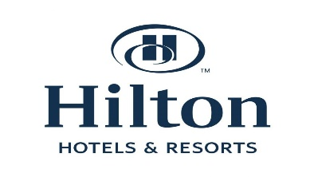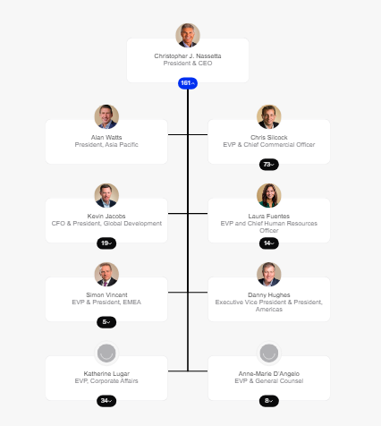
Figure 1: Organisational chart of Hilton hotel
(Source: Theorg, 2024)

2.2. Marriott Hotel Cardiff/Wales/UK:

With almost six hundred resorts and motels in over sixty-five nations and territories global, Marriott Hotels keeps elevating the artwork of hospitality – setting people first is the emblem's legacy – ensuring guests usually feel deeply cared for throughout their live. Marriott Hotels increases the bar by means of always turning in heartfelt service with present day, snug areas and by using providing reports elevated beyond the ordinary. As international travellers’ desires and expectations evolve, so do Marriott Hotels, main the enterprise with innovations, such as the Great room foyer and Mobile Guest Services that embody style, layout, and technology. This institution consists of HR professionals, managers, and administrators who oversee recruitment, education, preferred usual overall performance assessment, and employee engagement tasks. The HR branch's instance of the manipulated diploma underscores its strategic significance within the employer. Marriott aligns its HR hints and practices with worldwide requirements at the same time as tailoring them to fulfil close by requirements successfully.
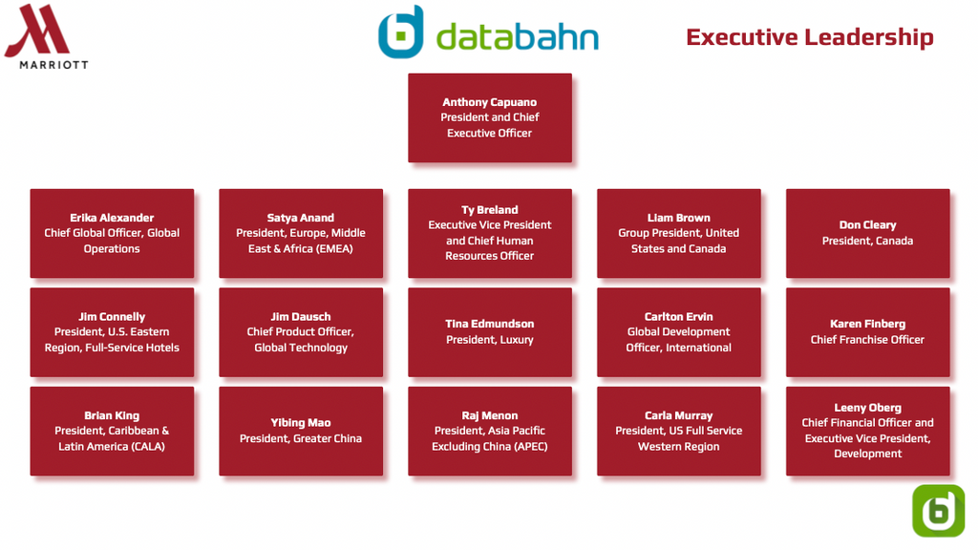
Figure 2: Organisational chart of Marriott Hotel
(Source: Databahn, 2023)

People management at Hilton and Marriott Hotel
People management helps business firms to create a positive and inclusive working environment that empowers employees. Marriott Hotel emphasizes prioritizing employees and their well-being which helps in career growth and advancement. Marriott fosters an environment that values diversity and inclusivity. Whereas Hilton Hotel also believes that employees are the heart of an organisation. Therefore, Hilton undertakes several initiatives to sustain the interest of employees including training, rewards, compensation, etc (Gajjar, and Okumus, 2018). Both Marriott and Hilton emphasise on empowering employees to enhance their job satisfaction. To ensure a collaborative working environment they ensure open communication and feedback at the workplace.

Main discussion

Influence of Internal and External Environmental Changes:

The consideration of the depth which exits between Hilton Hotels and Marriott Hotels and some of the factors that affect this depth, call for the evaluation of the human resources strategies that are employed within the two organisations. One of the most vital advantages on the side of Hilton is the organisation of its solid culture, management systems and the overall development of its' employees. As the employee-centric subculture of Hilton, creating a stimulating working environment is one of the main principles and offering the employees the opportunity for continuous learning is the other principle. Apart from this, it results in more engaged staff which gets translated into a good client experience and new product (Schaufeli and Bakker, 2004).

Opposite, Marriott concentrates its attention on methods that are mostly targeted to the realization of business objectives, within the company's organisational strategy, mostly optimization of operational process and customer experience. On the other hand, while the Marriott approach has an edge in focusing more on customer engagement the Hilton's culturally oriented employment may also be used in this regard to achieve employee engagement and more sustained consistency in service quality and innovation.

While externally impacts that may be created by market dynamics and regulatory stipulations influence those organisations, these factors apply to both Hilton and Marriott. Through adaptation to local conditions and cultural sensitivities, Hilton stresses diversity, inclusion, sustainability, and digitization, all taken together, following the market trends and cultural trends in the world they operate. Being able to do that, Hilton will set the pace to the industry-related changes and satisfy customers (Zhang, 2023).

On the other hand, Marriott's approach toward strategy is anchored on effectiveness with standardized HR practices across its market operations. This methodology undoubtedly brings operational uniformity, but simultaneously, it offers an opportunity to evict Hilton's agility to bolster responsiveness of the company to unpredictable market conditions and consumer demands.
The central thing to shed the light on, in this situation, is how Marriott will be influenced if it doesn't create solutions for the areas where Hilton succeeds. The use of a standardized HR approach by Marriott, however, could become a challenge if its transactions fail to adjust to the ever-changing trends of the market and cultural changes. A band of ignoring issues such as staff engagement and diversity just as shown by Hilton can lead to lack of competitiveness, restricted innovation, and lower staff satisfaction in Marriott (Michael and Fotiadis, 2022).

Approach to People Management Based on Size, Reach, and Sector:

Hilton Hotels and Marriott Hotels strategically tailor their People Management strategies according to their organisational length, worldwide attain, and quarter-specific wishes. As a larger entity with a massive worldwide footprint, Hilton adopts centralized HR recommendations and practices to ensure consistency and compliance in several regions (Armstrong, 2020). This centralized technique permits Hilton to correctly control HR methods, recruitment, education, and performance assessment while maintaining standardized practices globally (Engage for Success).

Despite having a worldwide logo in assessment, Marriott exhibits a more excellent and bendy HR method for relocating neighbourhood market dynamics and cultural variations (Covey, 2020). This flexibility allows Marriott to conform its HR techniques to meet the unique wishes of different regions and immediately reply to marketplace adjustments and purchaser expectancies (Stanford, 2018). By aligning HR practices with neighbourhood contexts, Marriott can beautify employee engagement and pleasure, ultimately contributing to stepped-forward consumer reviews.

Sector Influence on People Management:

Furthermore, the arena wherein every hotel operates appreciably affects their People Management strategies. With its attention to luxury and top-class services, Hilton emphasizes skills development and purchaser-centric training packages (Henderson, 2017). This investment in expertise improvement guarantees that Hilton's employees possess the capabilities and capabilities crucial to delivering brilliant careers and upholding the brand's popularity for luxury (Ulrich, 2010).

Conversely, catering to a broader market consisting of employer tourists and households prioritizes operational efficiency and issuer high quality. By focusing on operational excellence, Marriott can meet its client base's diverse desires and expectations while optimizing sources and maximizing productivity (Henderson, 2017).

Key People Management Concerns:

Employee engagement, overall performance management, and variety constitute vital additives of People Management for the Hilton Hotel and Marriott Hotel. These issues mirror the middle attention on nurturing a lovely painting environment, maximizing worker potential, and promoting inclusivity in the organisational subculture.

Employee Engagement:

Hilton Hotel strongly emphasises worker engagement tasks to foster a sense of belonging and commitment among its workforce (Engage for Success). This includes various applications, and career development opportunities that empower employees to develop and advance within the organisation (Armstrong, 2020). Prioritising the engagement of workers, Hilton enhances employee pleasure, increases morale, and improves retention expenses, ultimately contributing to an extra recommended and effective workforce.

Similarly, Marriott Hotel recognizes the significance of employee engagement and implements strategies to beautify worker motivation and task pleasure (Covey, 2020). This can also contain tasks encompassing normal feedback instructions, team-building sports, and leadership improvement applications to create a supportive and attractive painting environment (Stanford, 2018). By fostering a way of life of engagement, Marriott seeks to boost worker loyalty, reduce turnover, and stress organisational fulfilment.

Performance Management:

In terms of overall performance control, Hilton focuses on imposing sturdy systems that align employee and organisational goals (Armstrong, 2020). This includes setting clean standard performance expectations, imparting ordinary feedback and education, and providing opportunities for skills development and career development (Henderson, 2017). By aligning a person's overall performance with strategic dreams, Hilton's goals are to enhance regular organisational universal performance, force productivity, and benefit excellence in customer support transport.

Marriott Hotel adopts a comparable technique to usual performance management, emphasizing the importance of performance metrics, goal-setting, and overall performance appraisal strategies (Covey, 2020). This entails regular overall performance opinions, recognition of achievements, and improvement plans tailor-made to individual worker dreams (Ulrich, 2010). By specializing in performance excellence, Marriott Hotel desires to decorate worker accountability, pressure non-prevent improvement, and gain commercial organisation targets effectively.

Diversity and Inclusion:

Both Hilton and Marriott apprehend the crucial function of diversity and inclusion in fostering nice painting surroundings and using innovation (Engage for Success). Hilton implements a range of obligations across its recruitment methods, training packages, and place of work rules to sell variety and create a lifestyle of admiration and equality (Henderson, 2017). This consists of initiatives collectively with diversity schooling, mentoring programs, and range networks to applicable resource personnel from diverse backgrounds (Ulrich, 2010).

Similarly, Marriott prioritizes diversity and inclusion efforts via focused recruitment strategies, a variety of training, and inclusive workplace practices (Covey, 2020). By embracing range, Marriott's goals are to leverage the specific perspectives and capabilities of its diverse frame of employees, beautify creativity and innovation, and help worker engagement and retention (Stanford, 2018).

Role of Technological Advancements in People Management:

Technological upgrades, especially Artificial Intelligence (AI), have revolutionized People Management strategies at Hilton Hotel and Marriott Hotel, allowing those corporations to optimize HR techniques and beautify worker reviews.

Recruitment:

AI-powered equipment has extensively transformed the recruitment system for each Hilton and Marriott. Hilton uses AI algorithms to investigate vast numbers of candidate statistics, perceive pinnacle skills efficiently, and healthy applicants with appropriate roles based on their talents and experience. This streamlines the recruitment method, reduces time-to-hire, and improves the quality of hires (Pilbeam and Corbridge, 2010). Similarly, Marriott leverages AI in abilities acquisition, utilizing predictive analytics to forecast hiring needs, investigate candidate fit, and make data-pushed hiring picks (Morgan, 2014). This information-driven approach lets Marriott find candidates who align with the agency's way of life and business goals, which enhances recruitment effects in the long run.

Training and Development:

The AI-pushed era is critical to education and improvement tasks at Hilton and Marriott. Hilton uses AI-driven analytics to assess employee engagement stages, discover education wishes, and customize development plans (Cook, 2016). This statistics-driven method permits Hilton to deliver focused education programs that address precise skill gaps and beautify worker standard overall performance (Pilbeam and Corbridge, 2010). Similarly, Marriott leverages AI-powered studying structures to deliver customized educational content material cloth, track employee progress, and provide real-time feedback (Morgan, 2014). This allows Marriott to enhance learning effectiveness and worker talents and pressure non-prevent reading and improvement.

Performance Evaluation:

AI technology moreover decorates performance assessment procedures at Hilton and Marriott. Hilton uses AI-pushed analytics to display employee performance metrics, become privy to overall performance trends, and offer actionable insights to managers (Cook, 2016). This facts-pushed method permits Hilton to conduct extra correct typical overall performance reviews, become aware of immoderate-appearing personnel, and understand regions for improvement (Pilbeam and Corbridge, 2010). Similarly, Marriott leverages AI-powered equipment for usual overall performance comments and training, allowing managers to provide nicely timed remarks, set ordinary performance goals, and track development successfully (Morgan, 2014). This fosters a tradition of non-prevent feedback and improvement, improving fundamental overall performance control practices.

Challenges and Considerations:

While AI greatly benefits people's management, traumatic situations, and concerns must be recollected. These include the potential for bias in AI algorithms, records privateness and protection worries, and the want for ongoing schooling and upskilling of HR professionals to effectively leverage AI technology (Taylor, 2014). Ethical issues include transparency in AI choice-making strategies and ensuring fairness in AI-pushed HR practices (Truss et al., 2012).

Conclusions
The evaluation of well-known essential areas for development within the selected priority location of People Management at Hilton Hotel and Marriott Hotel. Every inn can enhance its techniques by addressing organisational way of existence, management styles, employee dynamics, marketplace dispositions, monetary situations, regulatory modifications, range and inclusion tasks, scalability, and standardized HR tactics. Specifically, measures targeting the body of worker turnover, recruitment desire strategies, and schooling deficiencies are recommended for immediate attention. This holistic method guarantees a far higher and more sustainable People Management framework, aligning with enterprise first-rate practices and organisational goals for prolonged-time period fulfilment.

Recommendations

The problem in the Marriot Hotel
Employee turnover is Marriott's liability that it both reduces its performance, employees' productivity, and profitability. The cost same is that rapid staff turnover leads to a loss of the invaluable resource - the assets and thus disturbs operational stability. Employee dissatisfaction happens when there is something lacking and is one of the drivers of staff turnover in the hospitality industry as it is influenced by how the manager relates to employees, conditions of work, task scheduling, working times, characteristics of work, compensation, and bonuses (Michael & Fotiadis, 2022). This is what makes Marriott's current system, where business efficiency is given credence over an employee-centred system such as that of Hilton, partly responsible for the poor frame of mind of their employees. Addressing these issues is critical for the organisation in order to avoid diminishing competitiveness, innovation, and quality of services provided at Marriott.

- Enhanced Recruitment and Selection Process: Implement a comprehensive recruitment method comprising rigorous screening approaches, competency-primarily based interviews, and assessment centres. This guarantees the selection of applicants who align with the organisational manner of lifestyles and possess the favoured abilities and talents. The disadvantage of this approach is the capacity boom in recruitment costs and time, but the lengthy-time period benefits of hiring the proper candidates outweigh the drawbacks.

- Investment in Training and Development: Develop tailored training applications that deal with potential gaps and sell continuous reading. Utilize e-getting-to-know systems and on-the-activity education techniques to beautify worker skills. While this may incur initial fees and require committed sources, the progressed performance and retention of skilled personnel justify the funding.

- Leadership Development Programs: Invest in management improvement tasks to cultivate influential leaders who can power employee engagement and overall performance. Offer management schooling, schooling, and mentorship applications to boom management talents. While this calls for financial investment and time willpower, it complements succession-making plans and organisational resilience.

Ethical Considerations: Ensure all HR practices adhere to moral and legal requirements. Avoid discrimination, bias, or unfair treatment in recruitment, merchandising, and typical overall performance evaluation approaches. Regular audits and training on ethical behaviour are essential to mitigate risks and uphold the organisation's popularity.

In conclusion, even though the guidelines require funding for property and addressing ability challenges, they'll be essential for improving People Management at the Hilton Hotel and Marriott Hotel. The blessings of more potent recruitment strategies, intense training and development programs, inclusive practices, effective control, and ethical behaviour outweigh the associated dangers and costs, contributing to prolonged-term organisational achievement and worker pleasure.

Word count: 2.507

Reference list
- Akbar, Y.H. and Tracogna, A., 2018. The sharing economy and the future of the hotel industry: Transaction cost theory and platform economics. International Journal of Hospitality Management, 71, pp.91-101.
- Armstrong, M. and Taylor, S. (2023). Armstrong’s Handbook of Human Resource Management Practice (9781398606630). [online] www.koganpage.com. Available at: https://www.koganpage.com/hr-learning-development/armstrong-s-handbook-of-human-resource-management-practice-9781398606630.
- Bakker, A. B. and Demerouti, E. (2007). The job demands-resources model: Review of its current state of knowledge. Journal of Vocational Behaviour, 71(1), 301-330. Available at: https://psycnet.apa.org/record/2007-03960-005 (Accessed: April 12, 2024).
- Beer, M., Boselie, P. and Rousseau, R. (2020). Human resource management: A global and critical perspective. Routledge.
- Bennett, C. and Daly, M. (2019). Bias in algorithmic hiring: An employer's guide to mitigation strategies. Business Horizons, 62(4), 563-572. Jobin, A., Ienca, M. and Vayena, E. (2019). The moral landscape of algorithmic fairness. Science, 366(6468), eaax6772. Available at: https://www.nature.com/articles/s42256-019-0088-2 (Accessed: April 12, 2024).
- Cascio, W. F. (2018). Managing human resources: Productivity, quality of work life, profits. Pearson Education Limited.
- Coyle-Shapiro, J., Hoque, K., Kessler, I., Pepper, A., Richardson, R. and Walker, L. (2013). Human resource management. [online] Available at: https://www.london.ac.uk/sites/default/files/uploads/mn3075-human-resource-management-study-guide.pdf.
- Cox, T. H. (1993). Cultural diversity in organisations: Theory, research, and practice. Sage Publications Limited.
- Cropanzano, R. and Wright, T. A. (2022). Employee engagement in a changing world: A review and future agenda. Journal of Management, 48(8), 2421-2454. Available at: https://www.researchgate.net/publication/211384078_Work_Engagement_A_Quantitative_Review_and_Test_of_Its_Relations_with_Task_and_Contextual_Performance (Accessed: April 12, 2024).
- Databahn, 2023.Marriott Org Chart in 2023. [Online][Accessed Through] https://www.databahn.com/pages/marriott-org-chart [11th April 2024]
- Deloitte. (2019). The future of work report: Jobs transformed by automation. Available at: https://www2.deloitte.com/us/en/insights/focus/technology-and-the-future-of-work.html (Accessed: April 12, 2024).
- DeLong, D. W., Beatty, R. W. and Sackett, P. R. (2020). Performance management: Current practices and future directions. Journal of Management, 46(2), 381-423. Available at: https://www.researchgate.net/publication/351516187_Performance_Management_Practices_A_Decisive_Approach_to_Improve_Employee_Productivity (Accessed: April 12, 2024).
- DeNisi, A. S. and Murphy, B. R. (1986). From expectancy to performance: The influence of feedback frequency and performance variability. Journal of Applied Psychology, 71(3), 546-557. Available at: http://t.johnsonresearchlab.com/publications/2019ParkJohnsonMoonLee_The%20Interaction%20Effects%20of%20Frequency%20and%20Specificity.pdf (Accessed: April 12, 2024).
- Edwards, T. and Rees, C. (2016). International Human Resource Management: globalization, national systems, and multinational companies. 3rd Ed. Essex: Palgrave
- Gajjar, T. and Okumus, F., 2018. Diversity management: what are the leading hospitality and tourism companies reporting? Journal of Hospitality Marketing & Management, 27(8), pp.905-925.
- Gold, J., Holden, R., Iles, P., Stewart, J. and Beardwell, J. (2013). Human Resource Development: Theory and Practice. 5th Ed. London: Palgrave Macmillan‌‌
- Jobin, A., Ienca, M. and Vayena, E. (2019). The moral landscape of algorithmic fairness. Science, 366(6468), eaax6772. Available at: https://www.ncbi.nlm.nih.gov/pmc/articles/PMC4479978/ (Accessed: April 12, 2024).
- Kuva, B. and Boxall, P. (2020). The Future of Performance Management: A Review and Framework. Human Resource Management Review, 30(4), 100683. Available at: https://www.linkedin.com/pulse/future-performance-management-nestorup-jimef?trk=public_post_main-feed-card_feed-article-content (Accessed: April 12, 2024).

- Marchington, Mick and Wilkinson, Adrian. (2002). People Management and Development: Human Resource Management at Work.
- Michael, N., and Fotiadis, A.K., 2022. Employee turnover: The hotel industry perspective. Journal of Tourism, Heritage & Services Marketing (JTHSM), 8(1), pp.38-4
- Page, K. (2018). CIPD Catalogue - HR and LandD Titles (GBP). [online] Issu. Available at: https://issuu.com/koganpagebooks/docs/cipd_catalogue_updated_nov_2018 [Accessed 9 April ,2024].
- Pfeffer, J. (1998). The human equation: Building profits by putting people first. Harvard Business School Press.
- PwC. (2022). Artificial intelligence in HR: How AI is transforming the world of work. Available at: https://www.pwc.com/gx/en/archive/about/analyst-relations/future-of-work.html (Accessed: April 12, 2024).
- Richard, O. C. and Grant-Mickens, L. (2023). Diversity, equity, and inclusion in the hospitality industry: A critical review of the literature. International Journal of Hospitality Management, 79, 102541. Available at: https://www.tandfonline.com/doi/full/10.1080/19368623.2023.2196282 (Accessed: April 12, 2024).
- Schaufeli, W. B. and Bakker, A. B. (2004). Utrecht Work Engagement Scale: Preliminary manual. Available at: https://www.scirp.org/reference/referencespapers?referenceid=1957564 (Accessed: April 12, 2024).
- Stanford, N. (2018). Organization Design: The Practitioner’s Guide. 3rd ed. [online] Perlego. Routledge. Available at: https://www.perlego.com/book/1574312/organization-design-the-practitioners-guide-pdf [Accessed 11 Apr. 2024].
- Theorg, 2024. Hilton. [Online] [Accessed Through] https://theorg.com/org/hilton [11th April 2024]
- Thomas, D. A. (1990). Beyond race and gender: Unleashing the potential of your workforce for competitive advantage. Harvard Business Review, 68(2), 71-81. Available at: https://onlinelibrary.wiley.com/doi/abs/10.1002/hrdq.3920030413 (Accessed: April 12, 2024).
- Truss, C., Mankin, D. and Kelliher, C. (2012). Strategic Human Resource Management. [online] Google Books. OUP Oxford. Available at: https://books.google.com/books/about/Strategic_Human_Resource_Management.html?id=pW2cAQAAQBAJ [Accessed 11 Apr. 2024].
- Ulrich, D., Ulrich, W. and Goldsmith, M. (2010). The Why of Work: How Great Leaders Build Abundant Organisations That Win. 1st edition ed. [online] Amazon. New York, NY: McGraw Hill. Available at: https://www.amazon.com/Why-Work-Leaders-Abundant-Organizations/dp/0071739351 [Accessed 11 Apr. 2024].
- Zhang, Y. (2023) Crisis Management Performance of Upscale Hotels in the Greater Bay Area, China: A Comparative Study in a Complex Institutional Situation. Sustainability, 15(6), p.5476.

