

Student Name: Buha Viraj Manishbhai
Student ID: 2506581

Module Name: Human Capital Management
Module Code: LCMB7023

Lecturer’s Name: Dr Gladius Kulothungan

Work Count: 2567

Term 1

Executive Summary
This study critically examines how global, technical, demographic, and geopolitical variables are transforming HRM and IHRM activities and labour markets. It examines how automation, AI, and digital platforms are creating specialist occupations that require more adaptability and learning. The paper suggests HR managers rethink talent acquisition, learning and development, and strategic workforce planning for full-time, freelance, and remote digital professionals. Ageing populations, migratory flows, and workforce diversity interact with geopolitical issues like trade conflicts, political instability, and health crises to generate a dynamic global employment picture, the research says. HR directors must improve compliance, risk management, and cultural integration for employee well-being and organisational resilience. To compete in fast-changing areas like technology, healthcare, and hospitality, companies must use a targeted combination of “Build, Buy, Borrow, and Bind” to fill talent gaps. Gibbs' Reflective Cycle assesses technology, communication, cooperation, leadership, and self-directed learning, indicating growth in digital competency, collaboration, and adaption and prospects for cross-cultural leadership and time management.

Table of Contents
Introduction 4
1.0 Question 1: Technology & Labour Markets 5
1.1 Cause-and-effect relationship between technology and HR strategy 5
1.1.1 The Reshaping of Labour Markets 5
1.1.2 Implications for HRM/IHRM Strategies 6
2.0 Question 2: Demographic & Geopolitical Factors 8
2.1 Key macro-environmental factors and analysing the specific challenges they pose for HR 8
2.1.1 Key Demographic Factors 8
2.1.2 Key Geopolitical Factors 8
2.1.3 Challenges for HR Professionals 9
3.0 Question 3: Skills Gaps & Strategic HRM 11
3.1 Strategic solutions driven by HRM 11
3.1.1 Understanding the Causes 11
3.1.2 Strategic HRM Approaches 11
3.1.3 Sector-Specific Examples 12
4.0 Question 4: Reflective Report on Capabilities 14
4.1 Self-assessment and a proactive plan for development 14
4.1.1 Introduction 14
4.1.2 Self-Assessment 14
4.1.3 SWOT Analysis 16
4.1.4 Development Plan 16
Conclusion 17
References 18

Introduction
Context of the Report
The study examines how global and technology variables are affecting labour markets and HRM and IHRM strategies, focussing on new challenges, skill transitions, and worker adaptation in a quickly changing environment.
Global and Technological forces on labour markets and HRM
Global Forces: Geopolitics, migration, and demographics affect global labour markets. In changing conditions, HRM must balance localisation and globalisation for agility, inclusiveness, and compliance.
Technological Forces: AI, automation, and digital platforms alter occupations and skills. HRM must promote adaptability, learning, and human-tech collaboration to compete in the digital age.

1.0 Question 1: Technology & Labour Markets

1.1 Cause-and-effect relationship between technology and HR strategy

1.1.1 The Reshaping of Labour Markets
Automation and AI: Job Displacement vs. Job Creation
Automation and AI swap has complicated tasks. Technology might create 170 million jobs by 2030, replacing 92 million. A poll indicated 40% of large corporations foresee AI-automated job cutbacks. HR strategy must anticipate attrition and change, identifying functions that will disappear, evolve, and create new roles like AI-ethicists and automation specialists (Brynjolfsson and McAfee, 2014). Replace cost-cutting with deliberate upskilling, transition paths, and ethical redeployment. Without this approach, HR may manage disruption instead of designing it.
The Gig Economy & Digital Platforms: The shift from traditional employment
Flexible, networked, and ad-hoc work is replacing long-term contracts in the gig economy and internet platforms. Digital markets help companies recruit talent across borders and time zones, and gig-work will dominate the global labour supply by 2025. HR and IHRM must rethink talent strategies for full-time, part-time, project-based, freelance, and remote workers. Worker classification, talent pooling, engagement, and social protections are HR methods. International businesses require HR to combine talent networks, technological platforms, and legal frameworks to handle contract status, taxation, worker rights, and culture.
Skills Churn: The accelerating half-life of skills
Rapid invention reduces “relevant skills”. In 2025–2030, the WEF estimates 39% of essential work skills to need updating. According to another report, most organisations are investing in AI, but only 1% are ready to use it. Change exceeds organisational preparation. HR strategy must change from one-time training to micro-learning, role-based career ladders to capability-based career fluidity, and reactive hiring to proactive reskilling. Talent acquisition must emphasise adaptability and learning agility, learning and development must be lifelong, tailored journeys, and workforce planning must prioritise skills over roles.

1.1.2 Implications for HRM/IHRM Strategies
Talent Acquisition
It is found that 68.1% of companies hire with AI. It is found that 73% of HR pros trust AI candidate recommendations. In HR strategy, AI-assisted sourcing, screening, and matching must replace posting opportunities and human screening. HR must emphasise adaptation and learning agility as technology changes quickly. HRM must evaluate technical fit and adoption of new digital technologies (CIPD, 2025). The IHRM approach must also address national legal/regulatory differences (e.g., AI transparency laws) and enable inclusive and fair cross-cultural recruitment. The global AI in HR market will grow 19% from $6.05 billion in 2024 to $14.03 billion in 2029.
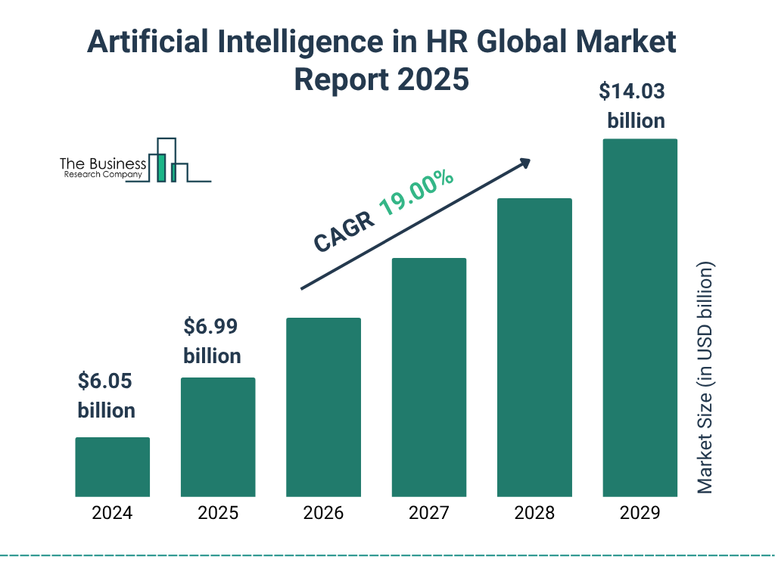
Fig 1: AI in HR Global Market
Source: (The Business Research Company, 2025)
Learning and Development (L&D)
Continuous upskilling and reskilling are needed since micro-learning modules increase retention by 80%. Digital badges for certified, modular learning are expected to expand from USD 264.8 million in 2024 to USD 969.7 million in 2032. Thus, HR strategy must transition from periodic training to continuous learning with personalised learning paths, digital badges/micro-credentials, AI-recommended learning, and embedded learning into daily work. L&D programs must be designed for international, remote, and global learning infrastructures and certifications by IHRM.
Strategic HR Planning
Companies use a mix of full-time, part-time, gig/freelance, and AI/digital labour. HR strategy should anticipate skill needs rather than headcount and be agile in recruiting, retention, redeployment, and learning (World Economic Forum 2025). Planning must include contingent workers, remote global teams, and human-machine interactions. International talent mobility, multi-jurisdictional compliance, and global talent framework harmonisation with local flexibility are added by IHRM.
IHRM Specifics
Global teams can collaborate on digital platforms, but HR must manage GDPR and gig-work. Strategies are emerging to uncover “hidden workforce capacity”—freelancers, contractors, AI-augmented workers. IHRM initiatives require global policy frameworks for worker classification, data governance, cultural integration, virtual-team standards, remote involvement, and inclusive talent development across national labour markets.

2.0 Question 2: Demographic & Geopolitical Factors

2.1 Key macro-environmental factors and analysing the specific challenges they pose for HR

2.1.1 Key Demographic Factors
Ageing Populations
65.3% of Euro area workers aged 55–64 were employed in 2023, up from 55% a decade earlier, indicating longer working lives and postponed retirement. The OECD expects the old-age reliance ratio (65+ per working-age individual) to rise from 31% in 2023 to 52% in 2060 (Deloitte, 2025). HR experts must create multi-generational workforce strategies to collect and transfer older workers' tacit knowledge, allow flexible retirement, reduce younger entrants, and boost older workers' responsibilities.
Changing Migration Patterns
Global migration changes jobs. Immigration is needed in health care and other talent-short industries, and OECD migration reached record highs in 2024. Tightening immigration laws causes 'brain-drain' in source countries. HR managers must manage complex personnel pipelines, deliver global mobility and integration initiatives, handle foreign credentials fairly, and balance ethical source country recruitment.
Increasing Workforce Diversity
60% of workers worldwide say diversity and inclusion influence their employer choice. Diversified enterprises earn 35% more than their sector median. HR must hire diverse individuals, create inclusive settings, fair career and leadership routes, and communicate across age, gender, ethnicity, and culture.

2.1.2 Key Geopolitical Factors
Trade Wars and Protectionism
Global trade conflicts increasingly affect corporate hiring and placement. In 2025, 40% of companies increased local sourcing due to tariff risk and supply-chain disruption. These policies force HR to rethink hiring geographies, cost models, and talent deployment: offshored functions may return home or require transfer to “safe” locations. HR must balance cost, risk, and flexibility as talent location, hiring markets, and job definitions evolve (Dowling et al., 2017).
Political Instability and Sanctions
International assignments and professional mobility are riskier. Over 70% of corporations handle risk after 2024 political-risk losses. Expatriate failure, repatriation, and operational disruptions cost more, thus HR and IHRM management, contingency planning, and local talent strategies are crucial. Conflict zones, sanctions, and weak governments hinder payroll, benefits, relocation, and local law compliance.
Pandemics and Global Health Crises
HR strategies need resilience and flexibility after the epidemic. By 2025, 48% of the global workforce may work remotely, a long-term shift. Strategic workforce planning by HR must address company continuity, hybrid-working, health-safety requirements, and dispersed team engagement platforms. After the pandemic, remote work rose from 30% to 48%, showing a long-term shift towards hybrid models.
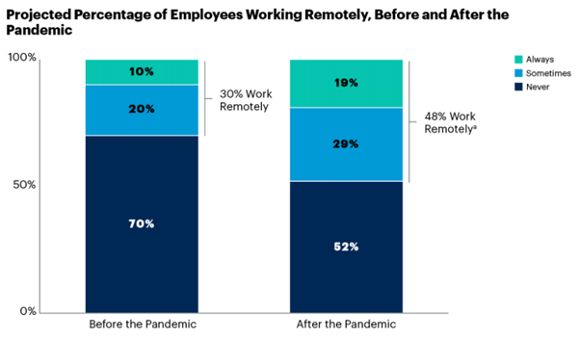
Fig 2: Employees Working Remotely
Source: (Intution, 2024)

2.1.3 Challenges for HR Professionals
Talent Mobility
Over half of companies plan to hire more overseas next year, making talent mobility a business issue rather than an HR function. HR professionals must navigate visa frameworks like US H-1B quotas, regional permit regimes, and geopolitical uncertainties when migrating staff. Although mobility alternatives make employees 53% more likely to stay, just one third of organisations have a comprehensive internal mobility program.
Risk Management
As companies send workers abroad, HR must address health hazards, travel delays, geopolitical uncertainties, and hybrid work issues. HR directors identified compliance and mobility challenges as operational risks in the 2025 global workforce report. Evacuation planning, remote-work cyber-risk management, and home-host insurance/benefit coverage are issues. Mishandling an expatriate assignment or remote-team issue can harm reputation, law, and finances.
Compliance
European GDPR, job classifications, cross-border tax, payroll, and benefits rules affect worldwide firms. A recent global HR compliance insight warns companies about employer misclassification, payroll issues, and local labour law changes. Compliance and trust are linked, with 97% of CHROs wanting to improve culture in 2025 and 69% of employees feeling appreciated (PwC, 2024). HR professionals now view compliance as a strategic enabler of employee experience, risk management, and global agility, not just an administrative burden.
Cultural Integration
Growing global, hybrid, and remote work requires cultural integration. Even as global talent acquisition grows, only 21% of workers are engaged. Dispersed teams typically have this gap due to weak belonging, misalignment across time-zones/cultures, and lack of cross-cultural leadership. HR professionals must evolve from global recruiting to inclusive, cohesive, high-performing virtual cultures.

3.0 Question 3: Skills Gaps & Strategic HRM

3.1 Strategic solutions driven by HRM

3.1.1 Understanding the Causes
Industry-wide skills shortages indicate a rising gap between technology, education, and worker adaption. Innovation in AI, data analytics, and robotics has overtaken training cycles, leaving many unprepared for new employment. Over 50% of employees have not been up-skilled in the past year, despite 39% of global skills changing by 2030. Universities often fail to educate business-relevant digital and soft skills due to syllabus misalignment with industrial needs. Many organisations spend less than 2% of payroll on reskilling despite digital expectations.

3.1.2 Strategic HRM Approaches
“Build” Strategies: Internal Development
“Build” develops internal talent for firm future proofing. To replenish skills as automation speeds obsolescence, corporations are investing in apprenticeships, in-house academies, and university or ed-tech linkages (Bahuguna et al., 2024). Upskilling 2025, Amazon's USD 1.2 billion program, trained 300,000 data science and cloud workers internally. From 2023, PwC Digital Fitness has trained 95% of staff in AI and analytics.
“Buy” Strategies: Strategic Recruitment
“Buy” tactics quickly fill skill gaps with external personnel employing strategic recruitment and data-driven workforce planning. In a tighter global labour market where 77% of businesses struggle to recruit talented workers, predictive analytics and AI-driven sourcing are helping companies uncover top talent. Unilever and IBM save 30% on time-to-hire by mapping new capabilities and rival recruiting trends using talent intelligence products. It is found that well-known organisations attract 50% more quality applicants and lower recruitment costs by 43%.
“Borrow” Strategies: Accessing External Talent
Organisations might “borrow” knowledge to fill short-term skill gaps without investing. For project-specific or seasonal work, freelancers, consultants, and gig workers are recruited online. The gig economy could reach $918 billion by 2030, up 16%. Microsoft and Google use up to 50% contingent labour, showing how flexible workforces boost agility and innovation (Cappelli, 2008). HR must maintain confidentiality, integrate borrowed people into business culture, and maintain quality and engagement despite minimal contractual standards.
“Bind” Strategies: Retention
With purpose, recognition, and promotion, “bind” tactics retain important people. Gallup predicts worldwide turnover will cost disengaged workers 9% of GDP by 2025. HR prioritises emotional and developmental retention over pay and benefits. Netflix's accountability and Salesforce's career pathing empower. It is discovered that continuous learning cuts turnover 47%.

3.1.3 Sector-Specific Examples
Tech Sector: Technology sector capability building is needed due to rapid digital disruption. Google and IBM employ Toptal and Upwork to hire AI and data professionals and internal coding bootcamps to “build” staff digital skills. Innovation and agility are achieved using dual methods (Chowdhury et al., 2024).
Healthcare Sector: Global healthcare personnel shortage to reach 10 million by 2030. The UK recruits nurses from Asia and Africa, while “bind” efforts like flexible schedule, mental health assistance, and career ladders help keep fatigued frontline personnel and decrease costly turnover. Healthcare has 15.7% of the AI technologies market, followed by finance and manufacturing at 13.65% each.
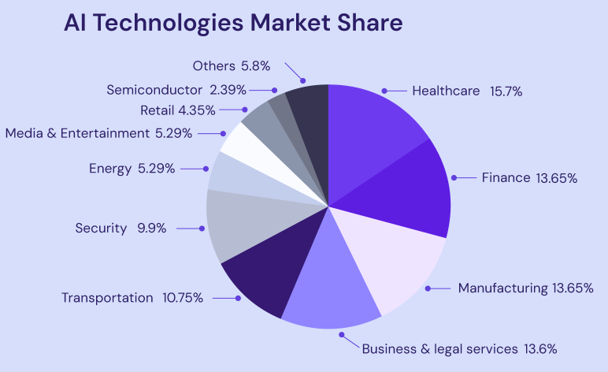
Fig 3: AI Tech Market Share
Source: (Hostinger, 2025)
Hospitality Sector: Global hospitality labour shortages reached 62% in 2024 (WTTC). Companies "build" internal pipelines for local talent through management trainee programs and leadership academies (Tahir et al., 2024). In a competitive environment, Marriott and Accor recruit younger, experienced staff with sustainability, professional progress, and inclusive workspaces.

4.0 Question 4: Reflective Report on Capabilities

4.1 Self-assessment and a proactive plan for development

4.1.1 Introduction
MBA graduates require global and flexible skills to succeed in today's corporate world. As organisations operate worldwide and technologies develop quickly, workers must be culturally sensitive, digitally savvy, and strategic. Leaders may create value by understanding uncertainty, collaborating with diverse teams, and inventing. Globally adaptable MBAs become forward-thinking leaders.

4.1.2 Self-Assessment
Description: MBA improved my technical, communication, teamwork, leadership, and self-learning skills. Course projects, cooperation, and global and digital learning develop each skill.
Feelings: First, advanced data and learning management systems worried me. My curiosity and tenacity led me to try ChatGPT and advanced Excel analytics. I gained confidence and saw technology as useful and innovative (UNESCO-UNEVOC, 2025).
Evaluation: Tech-savvy, I managed projects utilising MS Teams, Power BI, and the LMS. Clear, analytical reports improved academic and professional communication. Teamwork helped me resolve issues and distribute tasks in group initiatives (Gibbs, 1988). Offering to assemble essential pieces, setting deadlines, and pushing coworkers under pressure became leadership.
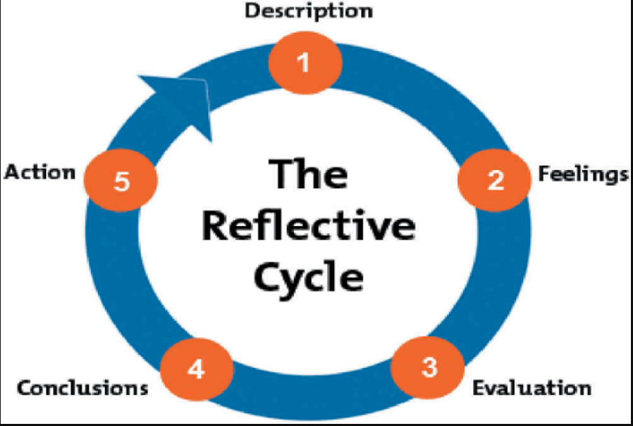
Fig 4: Gibbs Reflective Cycle
Source: (Gibss, 1988)
Analysis: These instances show introspection and adaptation's benefits. Tech skills helped me solve challenges and gain digital confidence, essential in data-driven fields. Like Hofstede's intercultural theory, effective communication and teamwork, especially in multicultural groups, boosted my interpersonal intelligence and resilience (Trilling and Fadel, 2009). Empathy and collaboration replaced authority in relational leadership.
Conclusion: Acquiring global competency is the entirety of my performance. There are strengths of digital adaptability, communication, and teamwork, and based on the reflection, time management and cross-cultural leadership should be developed.
Action Plan: I will also use Leading Global Teams of Coursera and establish micro-learning goals at the start of every week to reinforce the intercultural leadership and self-directed learning. I require Power BI and AI analytics certification to compete. To facilitate the objective of the MBA to produce adaptable and globally conscious leaders, I will keep a journal on the reflection of every major project to combine lessons and pursue adaptative learning.

4.1.3 SWOT Analysis
Strengths | Weaknesses
Strong digital proficiency with tools like MS Teams, Power BI, and AI platforms. | Limited experience in leading large, cross-cultural teams.
Effective communicator with proven written and presentation skills. | Time management challenges during multiple project deadlines.
Collaborative team player with conflict-resolution and problem-solving abilities. | Overreliance on digital tools may reduce face-to-face engagement skills.
Opportunities | Threats
Expanding global demand for digitally skilled and adaptive leaders. | Rapid technological changes requiring continuous upskilling.
Access to global online learning platforms for leadership and analytics. | Intense job market competition among MBA graduates.
Networking opportunities through MBA alumni and professional forums. | Evolving global HR trends may demand new cultural competencies.

4.1.4 Development Plan
Leveraging Strengths: My computer and communication skills will secure me employment. By rapidly integrating AI-based analytics and collaboration technologies, I will be able to enhance the efficiency of organisations and data-based decision-making. I have good communication skills, which will assist me to communicate complex concepts to diverse teams and stakeholders. I am up to date on technology, communicative, and able to combine technology and human in formulating global strategy in a company.
Addressing Weaknesses: I have no cross-cultural team leader skills and have difficulties with diversity. To address this, I will facilitate the next multicultural group project of my MBA students on inclusive decision-making and cross-cultural communication. I will also be taking the course Leading Global Teams provided by Coursera before February 2026 to enhance my intercultural leadership and conflict management. I would prefer feedback within my team and mentor to enhance my global, digital leadership.

Conclusion
This view demonstrates the role of adaptation, team work and learning in progressing careers. The world has become prepared to work professionally due to multicultural communication and leadership, as well as digital fluency. The advancements of cross-cultural leadership and time management involve self-discipline. I can contribute to changing the lives of various, innovative companies with my technical capabilities, emotional intelligence, and reflective practice.

References
Bahuguna, P.C., Srivastava, R. and Tiwari, S., (2024). Human resources analytics: where do we go from here?. Benchmarking: An International Journal, 31(2), pp.640-668.
Brynjolfsson, E. and McAfee, A. (2014). The Second Machine Age: Work, Progress, and Prosperity in a Time of Brilliant Technologies. New York: W. W. Norton & Company.
Cappelli, P. H. (2008). Talent on Demand: Managing Talent in an Age of Uncertainty. Harvard Business Press. (The Press. (The classic &quot;Make vs. Buy&quot; framework for talent management).
Chartered Institute of Personnel and Development (CIPD) (2025). ‘AI in the workplace’. London: Chartered Institute of Personnel and Development. Available at: https://www.cipd.org/en/topics/artificial-intelligence-workplace/
Chowdhury, S., Budhwar, P. and Wood, G., (2024). Generative artificial intelligence in business: towards a strategic human resource management framework. British Journal of Management, 35(4), pp.1680-1691.
Deloitte (2025) ‘Deloitte Global’s 2025 Gen Z and Millennial Survey: Growth, learning and well-being in a shifting world of work’, 14 May. Available at: https://www.deloitte.com/global/en/about/press-room/deloitte-2025-gen-z-and-millennial-survey.html
Dowling, P.J., Festing, M. and Engle, A.D. (2017) International Human Resource Management, 7th edn. Andover: Cengage Learning. Available at: https://www.scirp.org/reference/referencespapers?referenceid=3684050 (Accessed: 8 November 2025).
Gibbs, G. (1988) Learning by Doing: A guide to teaching and learning methods. Oxford: Further Education Unit, Oxford Polytechnic. Available at: https://reflection.ed.ac.uk/reflectors-toolkit/reflecting-on-experience/gibbs-reflective-cycle
PricewaterhouseCoopers (PwC) (2024) Global Workforce Hopes & Fears Survey 2024. Available at: https://www.pwc.com/gx/en/news-room/press-releases/2024/global-hopes-and-fears-survey.html (Accessed: 8 November 2025). PwC
Tahir, A.H., Umer, M., Nauman, S., Abbass, K. and Song, H., (2024). Sustainable development goals and green human resource management: A comprehensive review of environmental performance. Journal of environmental management, 370, p.122495.
Trilling, B. and Fadel, C. (2009) 21st Century Skills: Learning for Life in Our Times. San Francisco: Jossey-Bass. Available at: https://assets.publishing.service.gov.uk/media/5d71187ce5274a097c07b985/21st_century.pdf
UNESCO-UNEVOC (2025) ‘21st Century Skills’. Glossary TVETipedia. Available at: https://unevoc.unesco.org/home/TVETipedia%2Bglossary/lang%3Den/show%3Dterm/term%3D21st%2Bcentury%2Bskills
World Economic Forum (2025). The Future of Jobs Report 2025. Geneva: World Economic Forum. Available at: https://www.weforum.org/publications/series/future-of-jobs/
Image References
The Business Research Company (2025) Artificial Intelligence in HR Global Market Report. Available at: https://www.thebusinessresearchcompany.com/report/artificial-intelligence-in-hr-global-market-report
Intuition (2024) Remote Working Statistics You Need to Know in 2025. Available at: https://www.intuition.com/must-know-remote-working-statistics-for-2025/ (Accessed: 8 November 2025)
Hostinger (2025) AI statistics and trends: New research for 2025. Available at: https://www.hostinger.com/tutorials/ai-statistics
Gibbs, G. (1988) Learning by Doing: A Guide to Teaching and Learning Methods. Oxford: Further Education Unit, Oxford Polytechnic. Available at: https://reflection.ed.ac.uk/reflectors-toolkit/reflecting-on-experience/gibbs-reflective-cycle

