BMIH5005 Personnel Resourcing and Development
(Investigation of the impact of employee engagement over the performance of the Organisation: A case study of Premier Hotel Inn)

Lecturer: Kathryn Roberts, Emma Roberts.

Student Name: Syed Jahangir bakth
Student ID:2026520
Word Count: 2018

Table of Contents
Introduction and Background 3
Literature Review 5
Research Methodology 7
Evaluation and Conclusion 11
References 12

Introduction and Background
Employees are referred to as the driver of the production house of the company. When the employees lack dedication and concentration in their working environment, the organisation suffers heavily in managing productivity (Al Mehrzi and Singh, 2016). Again, despite having an abundance of resources such as land, property and pieces of machinery, etc., the organisation cannot transform its resources into finished products which position human resources as one of the most valuable resources for the organisation (Carasco-Saul et al., 2015). Since employees are valuable resources for the organisation, the company has to bear the high cost of attaining skilled employees which increases the importance of managing employees for ensuring operational efficiency and gaining a competitive advantage within their industry. Here, the report will be based on Premier Hotel Inn. Premier Inn is the largest brand of Hotel chain operating in the United Kingdom with more than 800 hotels and accommodation of 72,000 rooms. Since its establishment in 1987 by Whitbread, the company has been operating as one of the most desirable destinations and accommodation centres for tourists and guests visiting the United Kingdom (Chandani et al., 2016). Presently, Premier Inn has been providing its guest and tourist with their desired services with a workforce of 30,000 people. The workforce of the hotel chain has been deemed as the key success factor for successfully operating the organisation as the largest hotel chain brand in the United Kingdom. Since the Company-Premier Hotel Inn is operating in the service industry, the efficiency and quality of the services provided have a considerable impact on the success of the organisation. The company has to take effective steps in keeping its employees dedicated to the organisation as well as remain highly engaged within their working environment to generate higher revenue for the company. Currently, the company has been facing serious issues with their employees due to their behaviour of absenteeism and high turnover rate due to poor management of employees. The presence of absenteeism has been impacting productivity whereas the increasing turnover rate has significantly increased the cost of retaining employees (Eldor and Vigoda-Gadot, 2017). Here, the study will consider how the organisation-Premier Inn can increase employee engagement as well as reduce its employee turnover rate to improve employee retention in the company.
Research aims and objectives
The research study aims to investigate the impact of employee engagement and retention contributing to the performance of Premier Hotel Inn.
The subsequent section will demonstrate the key research objectives of the study:
- To identify key issues related to employee engagement and productivity of the premier Hotel Inn.
- To understand the challenges for Premier Inn in managing employee engagement, employee retention, and productivity impact of the organisation.
- To know how Premier inn will reduce its turnover rate and improve the overall performance of the company.
- To provide effective suggestions for the Company-Premier Inn on how the company can improve its employee engagement and contribute to the overall performance.
Research Questions
- What is the current level of employee engagement and key issues in employee engagement for Premier Hotel Inn?
- What are the key challenges of human resources management and performance management for Premier Hotel Inn?
- What are the steps that premier Inn should take in improving employee engagement in the company?
The rationale of the study
The research has been taken into consideration primarily due to self-interest. Again, the management of employees has become more important and valuable for supporting the corporate goals of the company. The hotel industry has been based upon the skills and expertise of Human resources which become highly pertinent for me to understand the importance of proper human engagement with the company to improve productivity.

Literature Review
Employee engagement has become a well-known topic of discussion due to its importance for companies operating in a highly competitive environment (Hoffman and Tadelis, 2021). Employee engagement does not only refer to how much work the employees are performing for the company rather, employee engagement is the measure of the level of dedication, passion and level of satisfaction of the employees toward their organisation.
According to Satata (2021), the level of engagement of employees determines the devotion of the employees working for the organisation to support the productivity goals and objectives of the company. When employees demonstrate a high level of engagement and supporting behaviour, this means that the employees are happy with the working environment and other factors which can motivate the performance of the employees. This directly supports their movements to higher productivity and supports them in attaining higher goals (Kaliannan and Adjovu, 2015). Again, when the employees are unsatisfied with their working arrangement, they tend to show absenteeism behaviour and lowers individual performance for the organisation.
According to Al-Suraihi et al., (2021), the acquisition of the employees has become costly for the organisation when they fail to retain them for a long period. Since employees represent the outlook and part of the competitive strategy, most organisations desire to hire the best talents available in the market. Moreover, the organisation has to undergo the long process of hiring, training, and preparing the employees for serving the company. When the organisation will have low employee engagement, the employees will ultimately leave the company. With a high turnover rate, the investment undertaken by the organisation for individual employees will likely go in vain (Kumar and Pansari, 2015). Eventually, the organisation will have to bear a high cost of managing employees due to a short retention period which will reduce the profitability of the company.
According to Kurniawan et al., (2021), Productivity has been directly linked with motivation and employee engagement. Usually, the organisation has to manage a large number of employees and the organisation cannot easily measure the level of motivation among the employees. Here, the level of employee engagement with organisational culture and activities help managers to measure how much employees are motivated at the individual level and what are the steps the organisation can pursue to increase their supportive attitude towards the organisation.
For measuring engagement level, the organisation has to establish clear employee engagement goals as well as develop strong communications and relationships with employees. Here, the managers of the company will have to monitor the behaviour and outlook of employees towards the organisation (Kurniawan et al., 2021). The organisation will also have to undergo analysis regarding how comfortable employees are working in their offices as well as their loyalty towards the organisation. The participation of employees in organisational programs has been a key indicator of employee engagement in the organisation. When employees will show high participation in the organisational program, this means the employees are having a high level of engagement with the company (Mone and London, 2018). Again, the managers of the company must increase their level of trust and confidence among their employees. This will support employees to express their opinion as well as inform the management of the company regarding the reasons for which the employees are feeling disconnected from their organisation as well as showing absenteeism behaviour in their workplaces.

Research Methodology
Research philosophy
Research philosophy reflects the belief of the researcher through which the researcher will gather, analyse and interpret information for the research project. The research philosophy controls the behaviour and impacts the practical implications of the research work (Osborne and Hammoud, 2017). There are mainly four research philosophies that researchers take into consideration which are positivism, realism, Interprevist, and pragmatist philosophy. The research project will follow a positivist research philosophy. Positivist research philosophy gathers factual information from the observation in an objective way. This helps the research project to maintain its accuracy as well as offset any subjective influence over the results of the study. On the other hand, Interpretivism has subjective influence over the research topic which decreased the credibility of the method. Again, the philosophy of pragmatism will require a high amount of resources and time to conduct any research work which increases complications for the researcher. Realism philosophy is particularly unsuitable for scientific observation and extracting factual information for the work.
Research Approach
The research approach is the comprehensive plan that guides the research work and its accomplishment over time. There are mainly two research approaches to conducting the work which are quantitative and qualitative approaches. Here, the research will take the help of both of the approach quantitative as well as qualitative approaches. Undergoing mixed research approach will help the research study to become comprehensive and accurate in generating results.
Research Method
Research methods are the ways by which the research will collect information as well as process them. Among the wide range of research methods, the use of questionnaires, interviews, observation, and experiments are the most prevalent (Satata, 2021). The research will undertake interviews and a survey questionnaire for completing this project. This will be more efficient in responding to the problems of the organisation. The responses of the employees of Premier Hotel inn will be taken through interviews as well as a survey questionnaire.
Time Horizon
The time horizon represents the timeframe for completing this work. The project will take around 10 weeks for completion where individual works have been presented along with different time allocations. The Gantt chart will represent the schedule of the project:
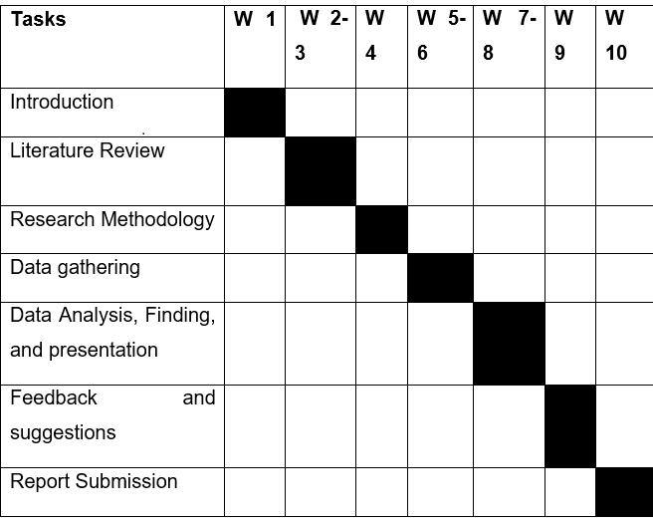
Figure 1: Time horizon of the work (Source: Self-created)

Work Breakdown Structure
Work break-down structure refers to breaking the task into smaller parts to efficiently complete them. Work breakdown structure helps the researcher to complete their tasks properly to avoid hesitation of miscalculation and arranging them together. Under the Work breakdown structure, the whole research project has been divided into small frameworks.
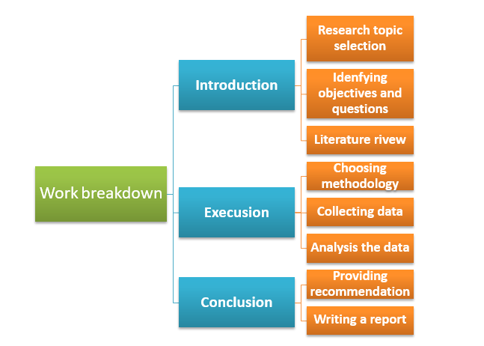
Figure 2: Work breakdown Structure (Source: Self-Created)

Data collection and Sampling
Data collection has been one of the key challenges of the project. The research will incorporate both primary and secondary sources of data. The secondary sources of data will be collected from articles, journals, books, online websites etc. In Contrast, the primary sources of the data will be gathered from interviews and survey questionnaires. The Survey will incorporate sampling methods of the larger population. Here, the research will incorporate a sample of 15 people on a random sampling basis and incorporate their responses through a survey questionnaire.
Ethical Considerations
Ethical consideration refers to the practices which will ensure the research will take care of the privacy of the participants of the project as well as follow the guidance provided by the University. Here, the research will carefully protect any private information and only use them for academic purposes. The data will be collected anonymously and follow the guidelines of the General data protection act 2016.

Evaluation and Conclusion
Human resource management has been becoming importantly and intertwining with the organisational performance and achievements of their desired goals (Sun and Bunchapattanasakda, 2019). The research has been a reflection of such interest and investigates the relationship between employee engagement and its impact, on organisational performance. Premier Hotel Inn is one of the most popular hotel brands in the country. The research will be based on the employee engagement of the hotel in exploring the performance impact of the company. The research project will follow a strict and useful methodology in exploring the level of employee engagement of Premier Hotel Inn and its impact on the performance of the company. Employees are valuable as well as expensive resources for which when employee engagement has been highly associated with the productivity and performance goals of the company. Here, the research will undertake a positivistic approach which will help the research project to gather useful and non-biased information, as well as the project, will use both quantitative and qualitative methods to explore the research topic properly. By using a mixed-method of data analysis, the organisation will be able to bring the whole picture of the working conditions, employee behaviour their current engagement level as well as its influence on the productivity of the company (Al Mehrzi and Singh, 2016). Further, the research will use interviews and a survey questionnaire for the research project where 15 employees will have selected as samples for conducting the project.

References
Al Mehrzi, N. and Singh, S.K., 2016. Competing through employee engagement: a proposed framework. International Journal of Productivity and Performance Management, 65(6), pp.831-843.
Al-Suraihi, W.A., Samikon, S.A., Al-Suraihi, A.H.A. and Ibrahim, I., 2021. Employee turnover: Causes, importance and retention strategies. European Journal of Business and Management Research, 6(3), pp.1-10.
Carasco-Saul, M., Kim, W. and Kim, T., 2015. Leadership and employee engagement: Proposing research agendas through a review of literature. Human Resource Development Review, 14(1), pp.38-63.
Chandani, A., Mehta, M., Mall, A. and Khokhar, V., 2016. Employee engagement: A review paper on factors affecting employee engagement. Indian Journal of Science and Technology, 9(15), pp.1-7.
Eldor, L. and Vigoda-Gadot, E., 2017. The nature of employee engagement: Rethinking the employee–organization relationship. The International Journal of Human Resource Management, 28(3), pp.526-552.
Hoffman, M. and Tadelis, S., 2021. People management skills, employee attrition, and manager rewards: An empirical analysis. Journal of Political Economy, 129(1), pp.243-285.
Kaliannan, M. and Adjovu, S.N., 2015. Effective employee engagement and organizational success: a case study. Procedia-Social and Behavioral Sciences, 172, pp.161-168.
Kumar, V. and Pansari, A., 2015. Measuring the benefits of employee engagement. MIT Sloan Management Review, 56(4), p.67.
Kurniawan, N., Yasin, M. and Hamidah, H., 2021. Pension and retirement intentions as determinants of employee engagement and productivity. Management Science Letters, 11(5), pp.1601-1606.
Mone, E.M. and London, M., 2018. Employee engagement through effective performance management: A practical guide for managers. Routledge.
Osborne, S. and Hammoud, M.S., 2017. Effective employee engagement in the workplace. International Journal of Applied Management and Technology, 16(1), p.4.
Satata, D.B.M., 2021. Employee engagement as an effort to improve work performance: a literature review. Ilomata International Journal of Social Science, 2(1), pp.41-49.
Sun, L. and Bunchapattanasakda, C., 2019. Employee engagement: A literature review. International Journal of Human Resource Studies, 9(1), pp.63-80.

