  Component One:  What are the key skills required when working in the housekeeping team? 750 words (+/- 10%)  Contribution to Overall Module Assessment: 25% | Student No:  Student name | 2133017  Eduard Popa
 | Module Title: | Operating Hotel Facilities
 | Module Code: | BMIH4006
 | Lecturer: | Laurence Blake
Housekeeping is an important department in the hospitality industry that plays a crucial role in providing a clean and comfortable environment for guests. Working in the housekeeping team requires specific skills that are crucial for successful job performance. In terms of the number of employees, housekeeping is the largest department. Housekeeping is an important department in the hotel industry. The responsible person is the executive housekeeper. His duties and responsibilities require exceptional leadership, organization, motivation, and commitment to maintaining high standards. Housekeeping staff must demonstrate concern for customers, which will motivate them to return, which is the primary element for increased occupancy and profitability in the hotel company. (Jones,2008)
The key skills required when working in the housekeeping team it is the attention to detail, the eye for the out of place, and the old or frayed that keeps it real for visitors. It is a physically intensive job that is critical to guest satisfaction. Most of your job is done behind the curtain, out of sight of the guests, but they will notice and appreciate it when they walk into a room with new towels, a made bed, and impeccable cleanliness. (Walker, J,2021)
Also, time management is crucial in ensuring that rooms are cleaned and prepared within a specific time frame (Mok & Sparks, 2013). Housekeepers are given a time limit in which to clean a particular number of rooms. They must accomplish the assignment within the time frame specified without sacrificing the quality of their work. This ability has proven to be particularly difficult for me while working on a tight timeline or with a large number of rooms to clean. Yet, through effort, I have learned to better manage my time and prioritize my duties to make the deadlines. Effective communication skills are essential when interacting with guests, colleagues, and other departments (Kasavana & Brooks, 2014). His or her principal objective is to manage and operate the communication link between the front desk, engineering, and any customer who needs cleaning assistance. (Rutherford and O’fallon,2006) They must have the ability to listen to requests and complaints from guests and act quickly in response. I have had to interact with guest who had requests or concerns in the past. These experiences have taught me the value of excellent communication and how it may affect the entire visitor experience. Big hotels require additional management skills. After all, housekeeping is the hotel's largest department.(Vallen and Vallen,2013) Problem-solving skills are required for housekeeping employees to deal with problems in the workplace, such as a shortage of cleaning materials or a difficult-to-clean space. According to a study conducted by Saranya and Srinivasan (2020), problem-solving abilities are essential for hotel cleaning employees to give a good level of service to guests. Excellent problem-solving abilities may assist workers in discovering innovative solutions to problems, such as finding alternate cleaning supplies or strategies to clean a difficult region. During my studies, I have learned different theoretical concepts that can be applied in industry. For instance, I have learned about time management, communication skills, and problem-solving, which are essential skills when working in the housekeeping department. I believe that applying theoretical knowledge in the industry can help in enhancing my performance and provide quality services to guests. The importance of these skills in the housekeeping industry cannot be emphasized. For example, a hotel that regularly provides high-quality cleaning services would attract and retain more customers, resulting in greater income. A hotel with bad cleaning services, on the other hand, is likely to earn negative reviews, which can affect its reputation and income of the hotel. As a result, housekeepers must have the necessary skills to constantly provide high-quality services. In conclusion, working in the housekeeping team requires specific skills that are crucial for successful job performance. The importance of this topic in the hospitality industry cannot be underestimated, and it is essential in ensuring guest satisfaction and the hotel's reputation. Applying theoretical knowledge in industry can help in problem-solving and enhancing job performance.
Reference list :
Jones, T.J.A. (2008). Professional management of housekeeping operations. Hoboken, N.J.: John Wiley & Sons.
Kasavana, M. L., & Brooks, R. M. (2014). Managing front office operations. Pearson.
Mok, C., & Sparks, B. (2013). Hospitality and tourism marketing: A global perspective. Sage.
Rutherford, D.G. and O’fallon, M.J. (2007). Hotel management and operations. Hoboken, N.J.: John Wiley.
Saranya, R., & Srinivasan, K. (2020). Employee Competency in Hospitality Industry: A Study on the Importance of Soft Skills for Hotel Housekeeping Staff. In Advances in Hospitality, Tourism, and the Services Industry (pp. 1-12). Springer, Cham.
Vallen, G.K. and Vallen, J.J. (2013). Check-in Check-Out: Managing Hotel Operations. Pearson Higher Ed.
Walker, J (2021), Introduction to Hospitality, Global Edition, Pearson Education, Limited, Harlow.

Word Count

Component Two:
Contribution to Overall Module Assessment: 25%
In this scenario – You have just been promoted to team leader for a floor within the hotel. A guest complains that on their arrival, their room had not been properly cleaned. Create an action plan and answer the following questions.

Problem | Why did it happen? | What are you going to do? | How will you prevent this from happening in the future? | What measures would you introduce to improve team effectiveness?
A guest complains that on their arrival, their room had not been properly cleaned. | The reason for the improperly cleaned room could be that the cleaning staff did not properly clean the room or that they missed some areas | Apologize to the guest for the inconvenience and tell them that such problems are taken seriously by the hotel. | Reinforce the importance of thorough cleaning and attention to detail during staff training | Set specific goals for the team, such as cleaning a certain number of rooms in a specified time. This action will provide the team with a clear objective to work towards, increasing their motivation and effectiveness.
 | It could also be due to inadequate training | Assign a staff member to immediately clean the room to the guest's satisfaction. | Conduct regular quality checks to ensure that rooms are cleaned to a high standard and that cleaning staff are meeting the required level of cleanliness | Establish clear communication channels among the team members, ensuring that each member understands their roles and responsibilities
 | It could be insufficient resources for the cleaning staff. | Offer compensation, such as a discount on the guest's stay or a complimentary meal or amenity, to address their inconvenience. | Ensure that the cleaning staff have the necessary resources to perform their duties effectively. This may include providing them with sufficient cleaning supplies, equipment, and time to complete their tasks. | Recognize and reward team members who perform well.
 | It could be short staff. | Investigate the root cause of the issue to prevent it from happening in the future. | Increase the number of housekeeping staff during high occupancy periods to ensure | Recruiting qualiﬁed people for each position.
 | It could be due to a lack of attention to detail | To prevent this from happening in the future, an investigation will be conducted to determine the root cause of the issue | Implement a room inspection checklist to ensure that all rooms are cleaned to the hotel's standards. | Making people proﬁcient through instruction and practice

Reference list:
Jones. (2008). Professional management of housekeeping operations (5th ed.). John Wiley & Sons.
Rutherford, DG, O'Fallon, MJ, & Rutherford, DG 2006, Hotel Management and Operations, John Wiley & Sons, Incorporated, New York
Kandampully, J., Zhang, T., & Bilgihan, A. (2015). Customer loyalty: a review and future directions with a special focus on the hospitality industry. International Journal of Contemporary Hospitality Management, 27(3), 379-414.
Carbone, V., & Sitzia, S. (2017). The role of human resource management in the performance of hospitality and tourism organizations. Journal of Hospitality and Tourism Research, 41(8), 975-1002.
Bakker, A. B., & Demerouti, E. (2014). Job demands-resources theory. Well-being: A Complete Reference Guide, 37-64.
Component Three:
Contribution to Overall Module Assessment: 50%
Your task is to create and prepare a presentation following the detailed scenario provided below.

As the floor housekeeping manager and given the recent guest complaints you need to put together a basic training presentation for your colleagues within the housekeeping team to get the best out of them, ensure that brand standard is being achieved and that Health and Safety procedures are also being followed.

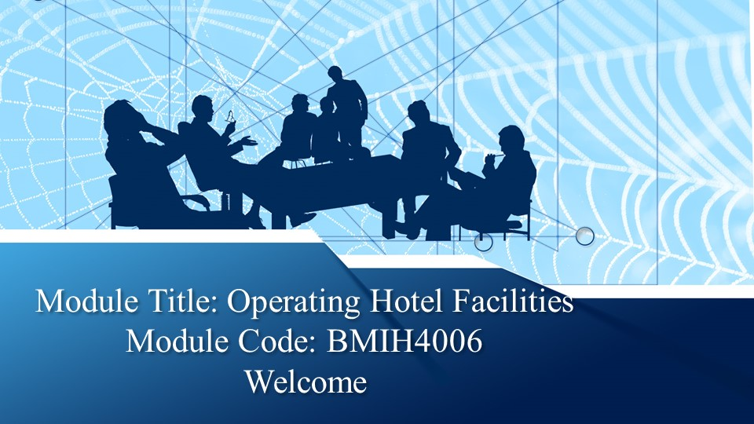
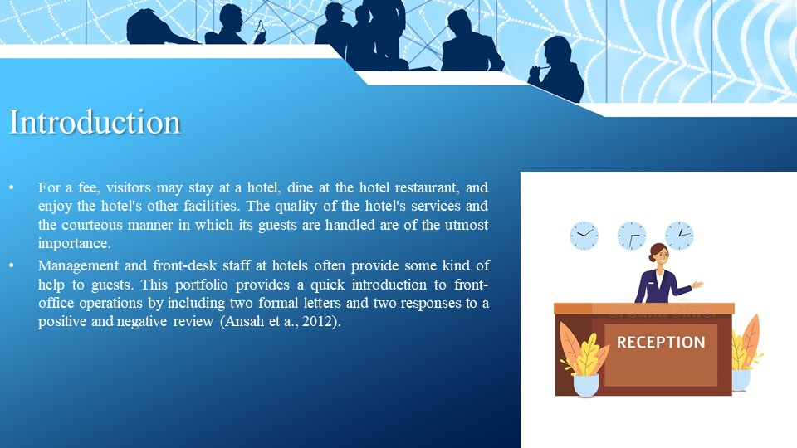

Training Notes: Introduction
For a fee, visitors may stay at a hotel, dine at the hotel restaurant, and enjoy the hotel's other facilities. The quality of the hotel's services and the courteous manner in which its guests are handled are of the utmost importance. Management and front-desk staff at hotels often provide some kind of help to guests. This portfolio provides a quick introduction to front-office operations by including two formal letters and two responses to a positive and negative review (Ansah et a, 2012).

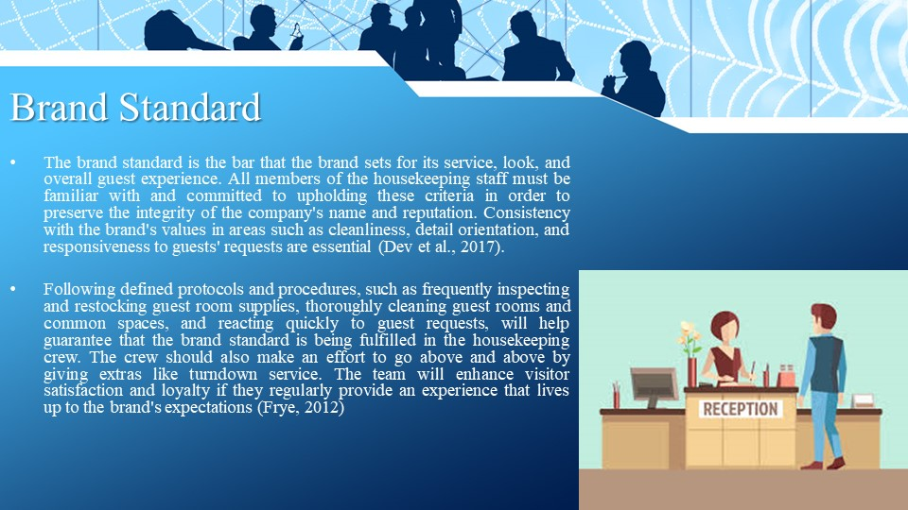

Training Notes: Brand Standard
The brand standard is the bar that the brand sets for its service, look, and overall guest experience. All members of the housekeeping staff must be familiar with and committed to upholding these criteria to preserve the integrity of the company's name and reputation. Consistency with the brand's values in areas such as cleanliness, detail orientation, and responsiveness to guests' requests is essential (Dev et al, 2017).
Following defined protocols and procedures, such as frequently inspecting and restocking guest room supplies, thoroughly cleaning guest rooms and common spaces, and reacting quickly to guest requests, will help guarantee that the brand standard is being fulfilled in the housekeeping crew. The crew should also make an effort to go above and above by giving extras like turndown service. The team will enhance visitor satisfaction and loyalty if they regularly provide an experience that lives up to the brand's expectations (Frye, 2012)

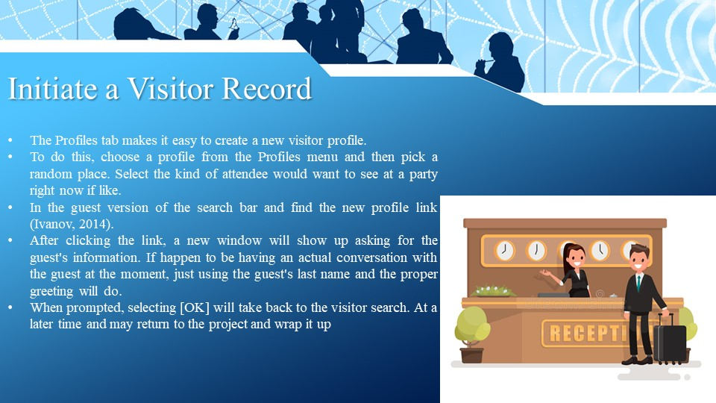

Training Notes: Initiate a Visitor Record
The Profiles tab makes it easy to create a new visitor profile.
To do this, choose a profile from the Profiles menu and then pick a random place. Select the kind of attendee you'd want to see at your party right now if you'd like.
In the guest version of the search bar, you'll find the new profile link (Ivanov, 2014).
After clicking the link, a new window will show up asking for the guest's information. If happen to be having an actual conversation with the guest at the moment, just using the guest's last name and the proper greeting will do.
When prompted, selecting [OK] will take back to the visitor search. At a later time, may return to the project and wrap it up

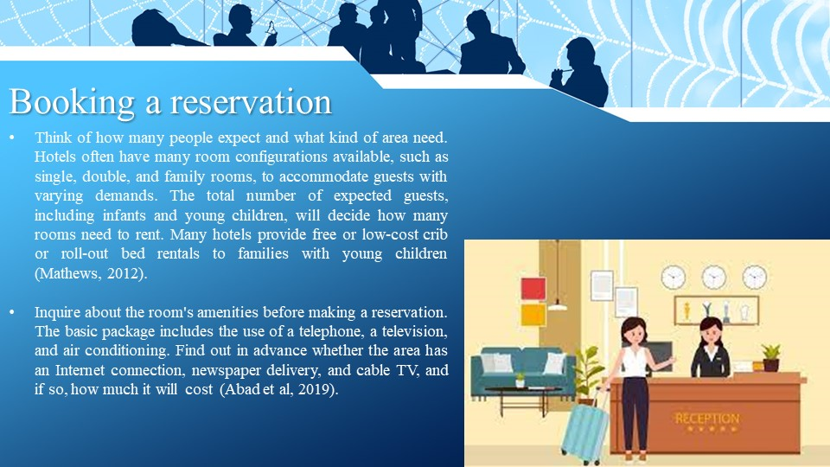
Training Notes: Booking a reservation
Think of how many people expect and what kind of area will need. Hotels often have many room configurations available, such as single, double, and family rooms, to accommodate guests with varying demands. The total number of expected guests, including infants and young children, will decide how many rooms a person needs to rent. Many hotels provide free or low-cost crib or roll-out bed rentals to families with young children (Mathews, 2012).
Inquire about the room's amenities before making your reservation. The basic package includes the use of a telephone, a television, and air conditioning. Find out in advance whether the area has an Internet connection, newspaper delivery, and cable TV, and if so, how much it will cost (Abad et al, 2019).

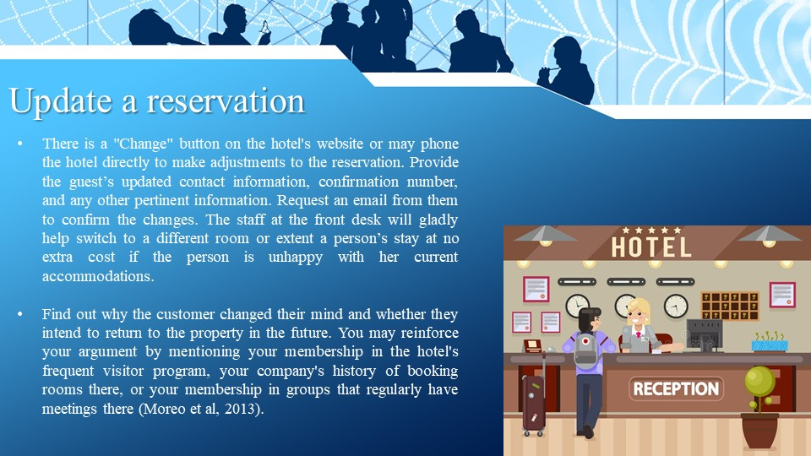

Training Notes: Update a reservation
There is a "Change" button on the hotel's website or may phone the hotel directly to make adjustments to your reservation. Provide the guest's updated contact information, confirmation number, and any other pertinent information. Request an email from them to confirm the changes. The staff at the front desk will gladly help switch to a different room or extend your stay at no extra cost if are unhappy with your current accommodations.
Find out why the customer changed their mind and whether they intend to return to the property in the future and may reinforce your argument by mentioning your membership in the hotel's frequent visitor program, your company's history of booking rooms there, or your membership in groups that regularly have meetings there (Moreo et al, 2013).

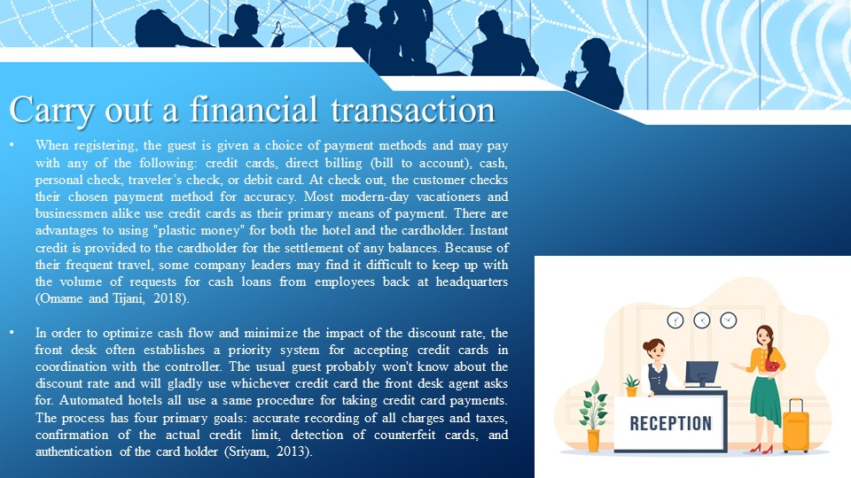

Training Notes: Carry out a financial transaction

When registering, the guest is given a choice of payment methods and may pay with any of the following: credit cards, direct billing (bill to account), cash, personal check, traveller’s check, or debit card. At check out, the customer checks their chosen payment method for accuracy. Most modern-day vacationers and businessmen alike use credit cards as their primary means of payment. There are advantages to using "plastic money" for both the hotel and the cardholder. Instant credit is provided to the cardholder for the settlement of any balances. Because of their frequent travel, some company leaders may find it difficult to keep up with the volume of requests for cash loans from employees back at headquarters (Omame and Tijani, 2018).
To optimize cash flow and minimize the impact of the discount rate, the front desk often establishes a priority system for accepting credit cards in coordination with the controller. The usual guest probably won't know about the discount rate and will gladly use whichever credit card the front desk agent asks for. Automated hotels all use the same procedure for taking credit card payments. The process has four primary goals: accurate recording of all charges and taxes, confirmation of the actual credit limit, detection of counterfeit cards, and authentication of the cardholder (Sriyam, 2013).

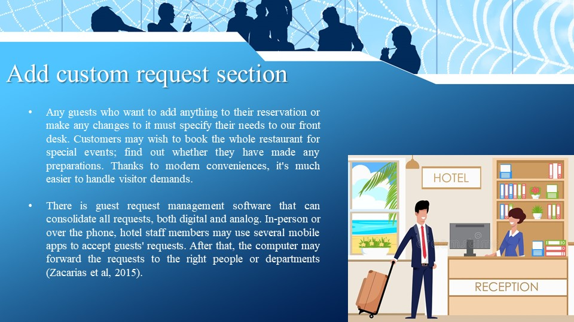

Training Notes: Add a custom request section
Any guests who want to add anything to their reservation or make any changes to it must specify their needs to our front desk. Customers may wish to book the whole restaurant for special events; find out whether they have made any preparations. Thanks to modern conveniences, it's much easier to handle visitor demands. There is guest request management software that can consolidate all requests, both digital and analogue. In-person or over the phone, hotel staff members may use several mobile apps to accept guests' requests. After that, the computer may forward the requests to the right people or departments (Zacarias et al, 2015).
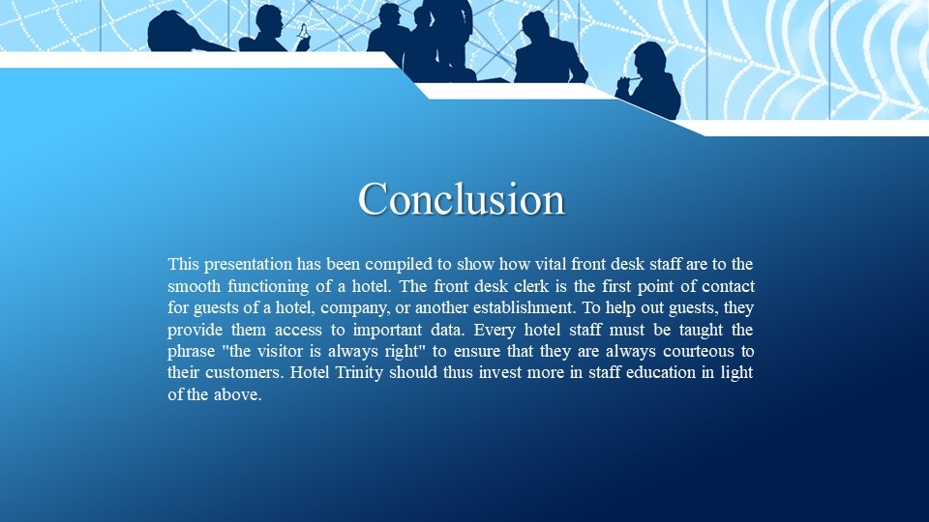

Training Notes: This presentation has been compiled to show how vital front desk staff are to the smooth functioning of a hotel. The front desk clerk is the first point of contact for guests of a hotel, company, or another establishment. To help out guests, they provide them access to important data. Every hotel staff must be taught the phrase "the visitor is always right" to ensure that they are always courteous to their customers. Hotel Trinity should thus invest more in staff education in light of the above.

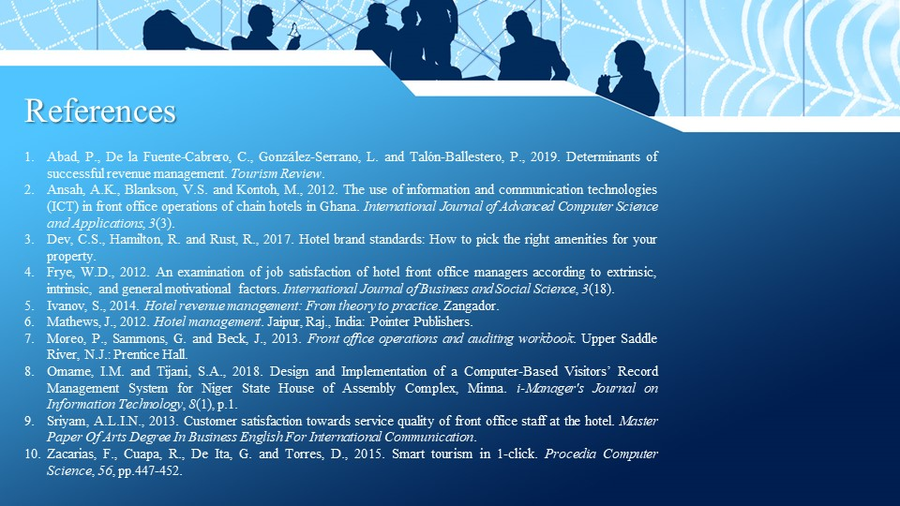

Training Notes:
Training Notes:

References
Abad, P., De la Fuente-Cabrero, C., González-Serrano, L. and Talón-Ballestero, P., 2019. Determinants of successful revenue management. Tourism Review.
Ansah, A.K., Blankson, V.S. and Kontoh, M., 2012. The use of information and communication technologies (ICT) in front office operations of chain hotels in Ghana. International Journal of Advanced Computer Science and Applications, 3(3).
Dev, C.S., Hamilton, R. and Rust, R., 2017. Hotel brand standards: How to pick the right amenities for your property.
Frye, W.D., 2012. An examination of job satisfaction of hotel front office managers according to extrinsic, intrinsic, and general motivational factors. International Journal of Business and Social Science, 3(18).
Ivanov, S., 2014. Hotel revenue management: From theory to practice. Zangador.
Mathews, J., 2012. Hotel management. Jaipur, Raj., India: Pointer Publishers.
Moreo, P., Sammons, G. and Beck, J., 2013. Front office operations and auditing workbook. Upper Saddle River, N.J.: Prentice Hall.
Omame, I.M. and Tijani, S.A., 2018. Design and Implementation of a Computer-Based Visitors’ Record Management System for Niger State House of Assembly Complex, Minna. i-Manager's Journal on Information Technology, 8(1), p.1.
Sriyam, A.L.I.N., 2013. Customer satisfaction towards service quality of front office staff at the hotel. Master Paper Of Arts Degree In Business English For International Communication.
Zacarias, F., Cuapa, R., De Ita, G. and Torres, D., 2015. Smart tourism in one 1-click. Procedia Computer Science, 56, pp.447-452.

