

Applied PLC control system
by
Nicholas Jones (P149676)
Lecturer: Dr Gary Jones
18th May 2020

Abstract
A PLC based sorting program has been created in ladder logic, a given specification was analysed which the program has been designed to, a HMI with various screens has been included which gives the operator control of the system as well as any feedback such as running status, warnings and errors.
A block diagram was drawn up showing the inputs and outputs to the Siemens S7-1200 PLC and a data connection for the HMI KTP700, Siemens TIA software was been used to write the ladder logic which includes multiple networks making it easier to follow and understand.
To aid the operator an operational flow chart has been created showing the intended flow of the system when stopped and running, accompanying this is an audit document explaining the warnings and errors in detail and procedures to rectify any that occur.
Suggested improvements included errors or warnings already listed but not implemented as well as others that could be included if more hardware was introduced, also mentioned is a dedicated engineers screen with features such as fault diagnosis down to individual component level and a configuration screen for the operator.
The current global crisis has meant that testing the system on hardware was reliant on a third party to be involved by running the program remotely and although the given specification has been fulfilled there is room for improvement which may have been implemented if time constraints had not forced otherwise.

Contents
Abstract i
1 Introduction 1
2 Design specification 1
3 System block diagram 3
4 HMI screens 3
4.1 Home screen 3
4.2 Warnings screen 4
4.3 Errors screen 5
5 Ladder logic & timing diagrams 6
5.1 Network 1 start stop and running status 6
5.1.1 Network 1 timing diagram 7
5.2 Network 2 optical beam latches 7
5.2.1 Network 2 timing diagram 8
5.3 Network 3 belt speed 8
5.3.1 Network 3 timing diagram 9
5.4 Network 4 optical 1 beam timer 10
5.4.1 Network 4 timing diagram 10
5.5 Network 5 checks puck diameter 10
5.5.1 Network 5 timing diagram 11
5.6 Network 6 tall puck check 11
5.6.1 Network 6 timing diagram 12
5.7 Network 7 puck confirmation 12
5.7.1 Network 7 timing diagram 12
5.8 Network 8 bin selection 13
5.8.1 Network 8 timing diagram 13
5.9 Network 9 bin 1 narrow tall & short pucks 14
5.9.1 Network 9 timing diagram 15
5.10 Network 10 bin 2 medium short pucks 16
5.10.1 Network 10 timing diagram 17
5.11 Network 11 bin 3 large short pucks 18
5.12 Network 12 bin 4 medium tall pucks 18
5.12.1 Network 12 timing diagram 19
5.13 Network 13 bin 5 large tall pucks 19
5.13.1 Network 13 timing diagram 19
5.14 Network 14 resets when a puck is sorted 20
5.14.1 Network 14 timing diagram 22
5.15 Network 15 error and warnings flags 22
5.15.1 Network 15 timing diagram 24
5.16 Network 16 hard reset 24
5.16.1 Network 16 timing diagram 25
6 Operational flow chart 26
7 Audit documentation. 27
8 Suggested improvements 27
9 Conclusion 28

Introduction
Design of a PLC program that determines diameter and height of pucks to enable them to be sorted into various bins is required, along with this a HMI is needed which can control the system and provide user with various features.

Design specification
Analysis of the given specification has extracted the following key information, in total there are five bins Table 1 shows which puck needs to be placed into which bin.
Table 1 Bin and puck sort
Bin number | Puck
1 | Narrow tall and short
2 | Medium short
3 | Large short
4 | Medium tall
5 | Large tall

The bin numbers in Table 1 correspond to each bin next to the conveyor where bin 1 is opposite piston 1, bin 2 is opposite piston 2, bin 3 is opposite piston 3, bin 4 is at the end of the belt and bin 5 is at the beginning, bin 5 requires the conveyor belt to reverse direction.
The HMI requires the main screen to have an emergency stop button, indicators to show the system is running, counters to show number of pucks sorted, speed of the conveyor belt and warnings / errors notification, the warnings / errors must be shown on a separate screen which is accessible from the main screen. Table 2 shows a list of intended warnings.

Table 2 Warnings list
Warnings | Description
Bin_x full | Initiates when a certain number of pucks have been placed into a bin, the operator is required to empty the bin and reset the counter. If this is not done after another ‘x’ number of counts an error will occur and stop the conveyor.
Low / High air pressure | This comes on when the air pressure is above or below the intended system pressure, adjust the pressure before resetting.
Conveyor belt under / over speed | If the conveyor belt is detected to be running to fast or to slow this warning will occur.

Table 2 shows a list of warnings for the system, each warning has a brief explanation which is expanded in the audit documentation chapter 7, warnings are designed to not stop the conveyor from running, a list of intended errors is in Table 3.

Table 3 Errors list
Errors | Description
Emergency stop | Emergency stop has been pressed on home screen, rectify situation and then release emergency stop button.
Foreign object detected | If an object larger than the large puck is detected then this error will occur, remove object and reset error.
Empty bins | This occurs when the ‘Bin_x full’ warning is not rectified, empty bins and reset warnings before resting this error.
Master reset | This comes on when any error from above has occurred and will not let the conveyor belt re-start, rectify other errors first before resetting this.

The errors in Table 3 are intended to stop the conveyor belt immediately, when an error occurs a master reset error comes on as well, this master reset is what stops the conveyor belt, it cannot be reset until the other errors have been rectified.

System block diagram
Figure 1 shows the system block diagram.
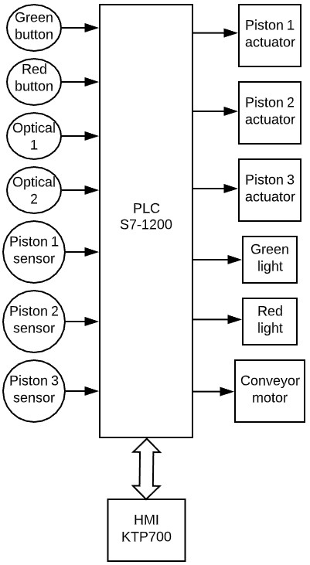
Figure 1 System block diagram
The block diagram in Figure 1 shows the inputs for the PLC on the left with outputs on the right, a HMI with a data link to the PLC is seen at the bottom.

HMI screens
A HMI KTP700 is used, three screens have been designed, these are main (home), warnings and errors.

Home screen
Figure 2 shows the home operators screen.
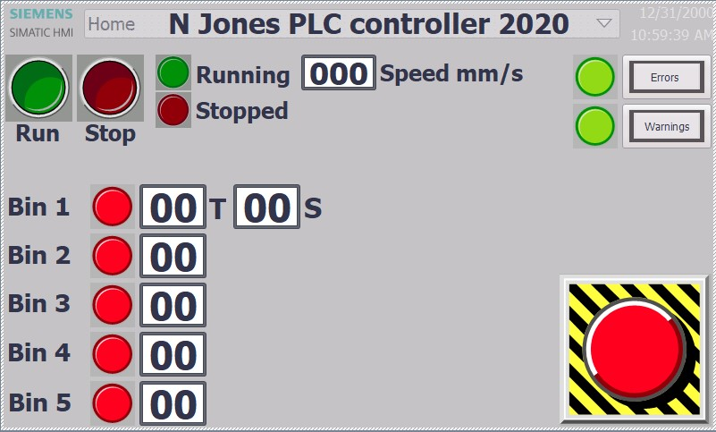
Figure 2 HMI home screen
The home screen in Figure 2 has a run and stop button, next to these are tell-tale lights, when the conveyor is running the Green light comes on, when the conveyor is stopped the red light comes on, a 3 digit display shows the speed of the conveyor in mm/s. Far right are two lights with buttons that take the operator the different screens, when the lights are Green there are no errors or warnings, if a light turns red it indicates either an error or warning and pressing the respective button activates the screen. On the left are indicators for each bin, when a light is red then no bin is selected and the operator may proceed to put a puck on to the conveyor, a green light indicates a bin has been selected and is waiting for the puck to be sorted into that bin, the counters show how many pucks are in the bin, bin 1 ‘T’ and ‘S’ stand for tall and short. Bottom right is the Emergency stop button where pressing this stops the conveyor belt.

Warnings screen
Figure 3 shows the warning screen.
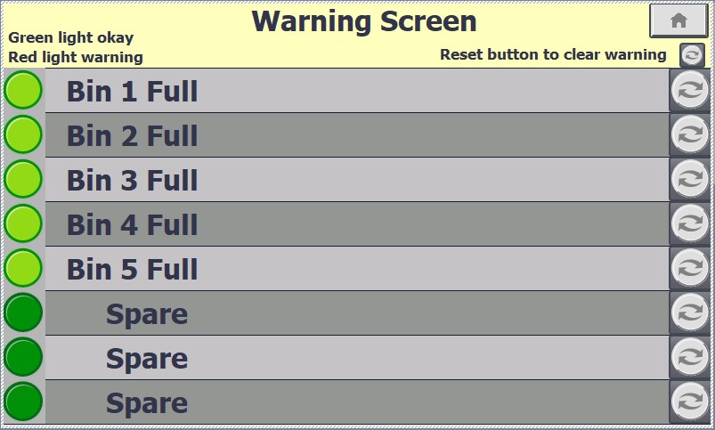
Figure 3 HMI warning screen
The warning screen in Figure 3 has a home button to the top right, pressing this takes the operator back to the main home screen, just below that is information to remind the user that pressing a refresh symbol will reset the warning once rectified, a green light indicates no warnings are present, a red light shows a warning has occurred, once the operator has rectified the warning the reset button to the right can be pressed and the light turns Green.

Errors screen
Figure 4 shows the error screen.
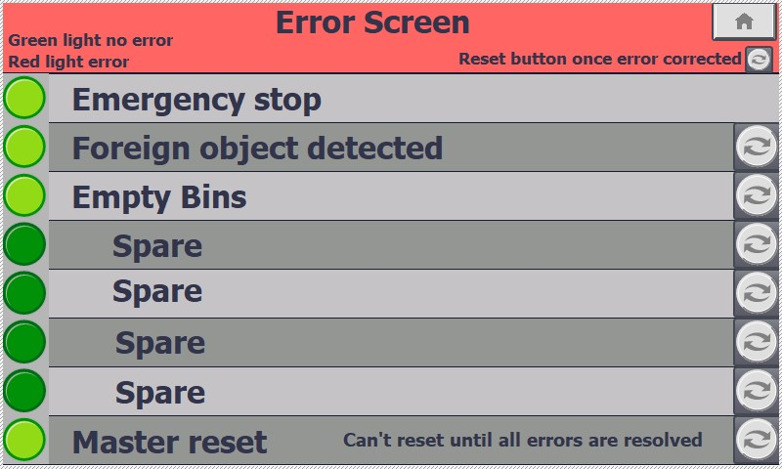
Figure 4 HMI Error screen
The layout of the errors screen in Figure 4 is similar to the warning screen where a green light indicates no error and a red light is an error, the master reset comes on when any error occurs and can only be reset once the other errors have been rectified, the emergency stop is rectified by releasing the button on the home screen the other errors can be reset using the adjacent buttons.

Ladder logic & timing diagrams
Siemens TIA V16 software was used to create the ladder logic.

Network 1 start stop and running status
Figure 5 shows the start, stop and running status.
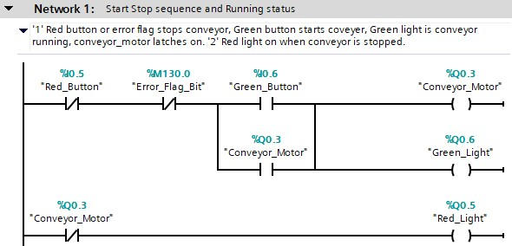
Figure 5 Network 1, start, stop and running
In Figure 5 rung 1 starts the conveyor belt and switches on the Green light when the red button is not pressed and no error is set and Green button is briefly pressed, the conveyor running keeps it latched on, rung 2 switches on red light when conveyor is not running.

Network 1 timing diagram
Timing diagram for network 1 is in Figure 6.
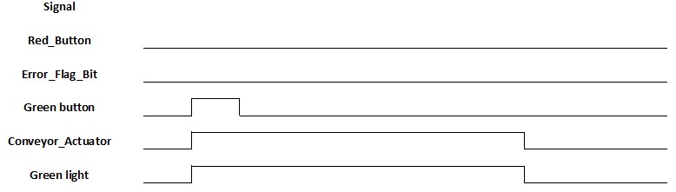
Figure 6 Network 1, timings
Figure 6 shows if the red button and error flag are not set pressing the green button switches on conveyor and green light.

Network 2 optical beam latches
Network 2 is seen in Figure 7.
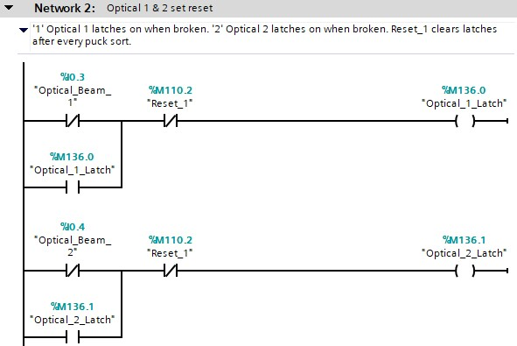
Figure 7 Network 2 optical beam latches
In Figure 7 when an optical beam is broken the respective latch flag gets set these are then used in other networks.

Network 2 timing diagram
Timings for network 2 in Figure 8.
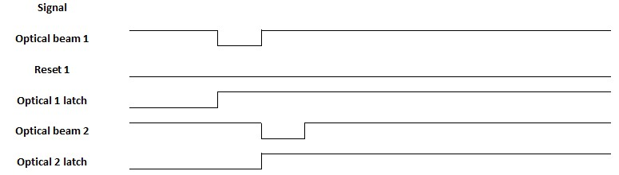
Figure 8 Network 2, timings normal
Figure 8 shows that whilst reset 1 is low then the latches will set when the respective optical beam is broken.

Network 3 belt speed
Belt speed code is shown in Figure 9.
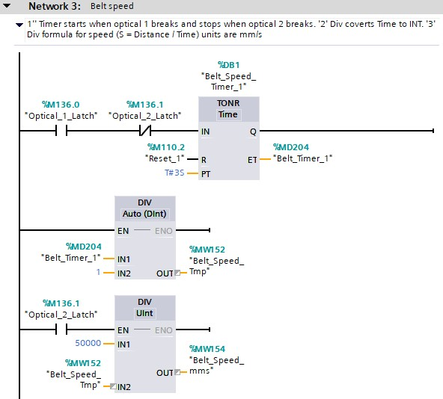
Figure 9 Network 3 belt speed
The timer in Figure 9 runs while optical beam 1 latches and stops when optical 2 latches, division blocks are used to calculate the speed, where speed = distance / time in mm/s, this is then displayed on the HMI home screen.

Network 3 timing diagram
Figure 10 shows timings for belt speed.
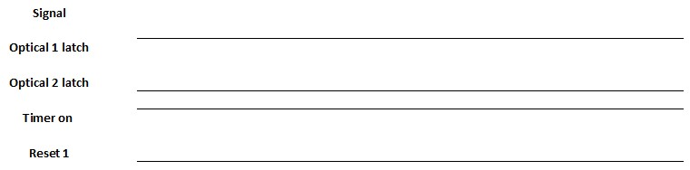
Figure 10 Network 3 timings belt speed
In Figure 10 the timer is running when optical 1 latch is high and optical 2 and reset 1 is low.

Network 4 optical 1 beam timer
Network 4 is shown in Figure 11.
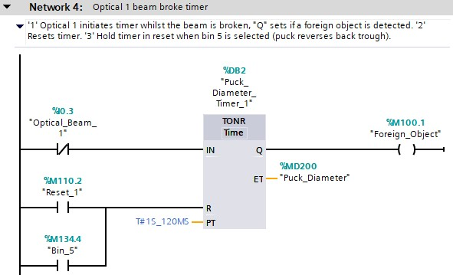
Figure 11 Network 4 optical 1 timer
Rung 1 In Figure 11 shows while optical 1 beam is broke a timer counts which is used to determine puck diameter, if a larger object is put through then the foreign object error is set, rung 2 ‘Reset_1’ resets the timer and ‘Bin_5’ holds the timer in reset state until the puck has been sorted.

Network 4 timing diagram
Network 4 timings in Figure 12.
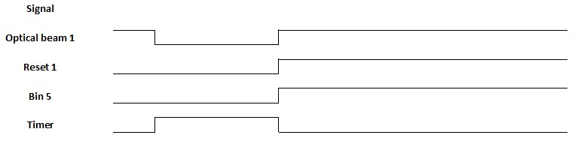
Figure 12 Network 4 timings
The timings in Figure 12 shows the timer only runs when optical beam 1 is broken and reset 1 and bin 5 are low.

Network 5 checks puck diameter
Puck diameter check code in Figure 13 was used.
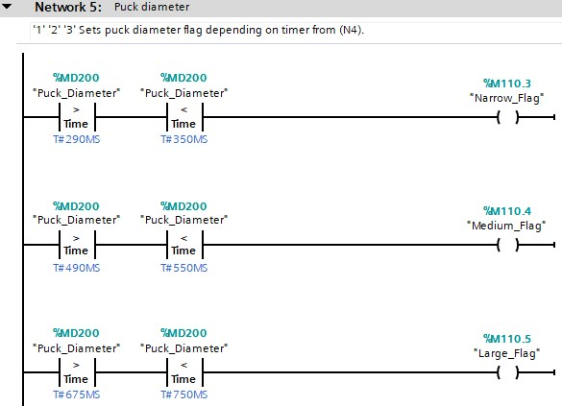
Figure 13 Network 5, puck diameter check
Figure 13 sets one of the puck diameters flags by using the timer from network 4.

Network 5 timing diagram
Timing for network 5 is in Figure 14.
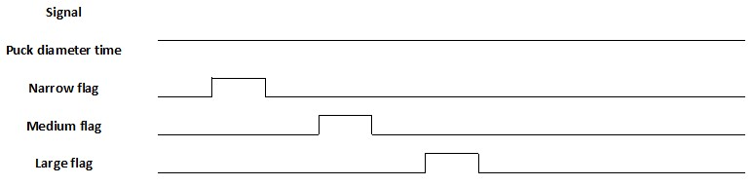
Figure 14 Network 5 timing
In Figure 14 while puck diameter is counting the necessary flag gets set.

Network 6 tall puck check
Figure 15 shows tall puck check.
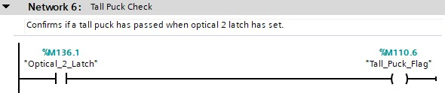
Figure 15 Network 6, tall puck check
In Figure 15 the tall puck flag is set if optical 2 is broken.

Network 6 timing diagram
Network 6 timing in Figure 16.
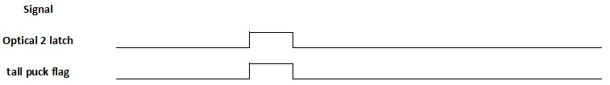
Figure 16 Network 6 timing
Optical 2 latch in Figure 16 sets the tall puck flag.

Network 7 puck confirmation
Figure 17 shows the code for puck confirmation.
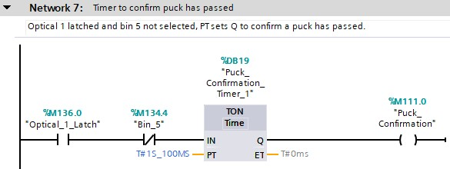
Figure 17 Network 7, puck confirmation
A pre-set time confirms that a puck has passed, this is then used in network 8.

Network 7 timing diagram
Timings for network 7 seen in Figure 18.
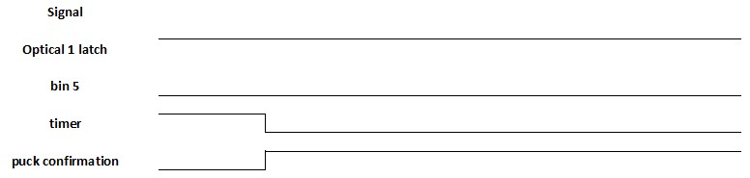
Figure 18 Network 7 timings
Optical 1 latch high and bin 5 low in Figure 18 allows the timer to run before setting puck confirmation high.

Network 8 bin selection
In Figure 19 are bin selection flags.
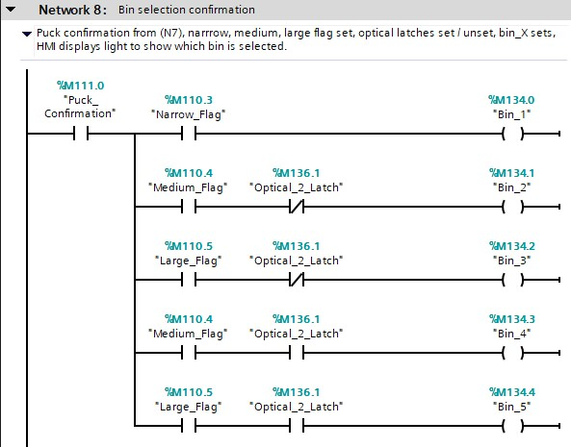
Figure 19 Network 8, bin selection
Bin selection code is seen in Figure 19, the flags are used to confirm what bin is selected and illuminates the ‘Bin x’ lights on the HMI home screen.

Network 8 timing diagram
Figure 20 shows network 8 timings.
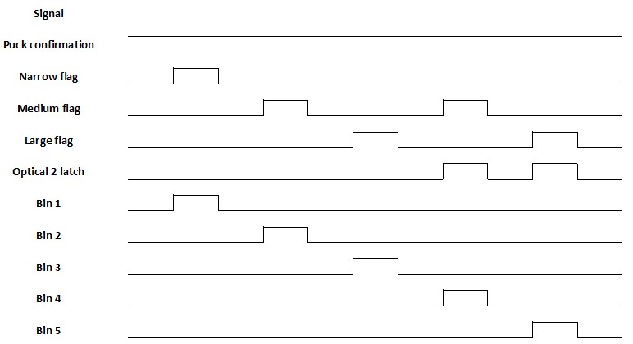
Figure 20 Network 8 timings
In Figure 20 puck confirmation being set allows bin 1 – 5 flags to get set providing other conditions are met. .

Network 9 bin 1 narrow tall & short pucks
Bin 1 is shown in Figure 21.
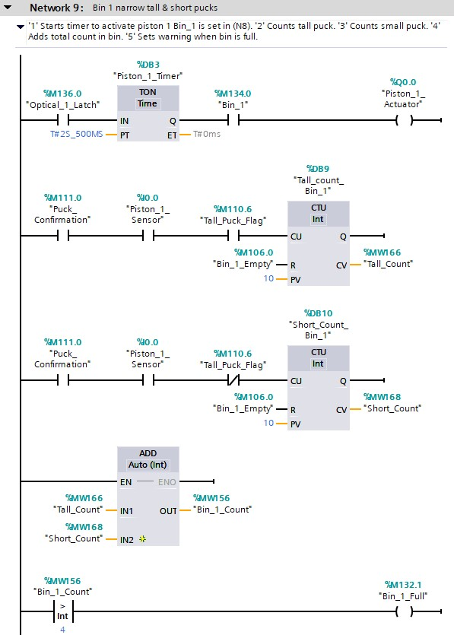
Figure 21 Network 9 bin 1
Rung 1 in Figure 21 starts timer for piston activation, this will only trigger if bin 1 flag is set from network 8, rung 2 & 3 increment timer based on either tall or short puck, rung 4 is total puck count for HMI home screen and rung 5 sets the bin full warning when 5 pucks has been sorted.

Network 9 timing diagram
Network 9 timings shown in Figure 22.
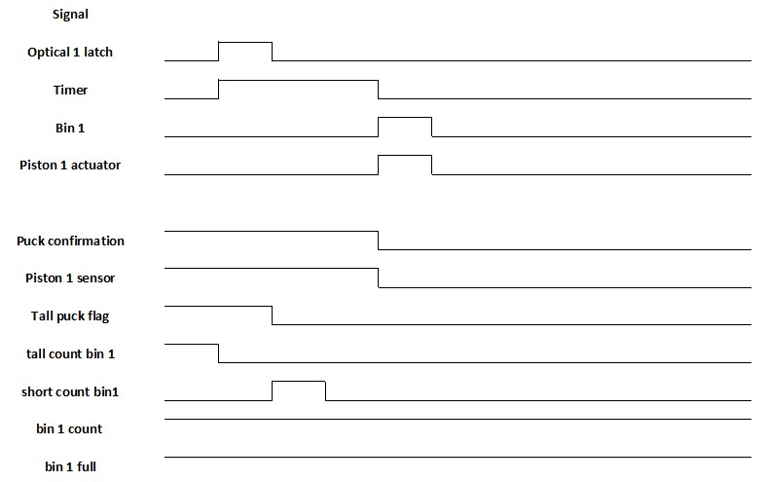
Figure 22 Network 9 timings
In Figure 22 piston 1 actuator triggers if bin 1 is set and the timer has expired which is started by optical 1 latch.
Puck confirmation and piston sensor being high causes the counters to increment depending on the state of tall puck flag, bin 1 count being true sets bin 1 full flag.

Network 10 bin 2 medium short pucks
Bin 2 code seen in Figure 23.
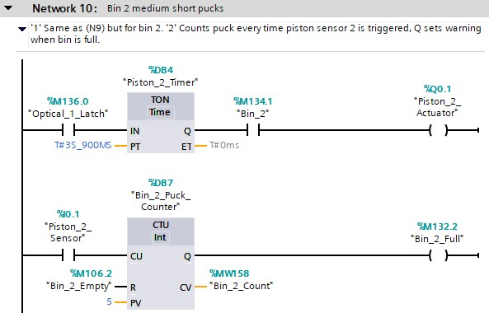
Figure 23 Network 10 bin 2
Rung 1 in Figure 23 sets timer to activate piston 2 when optical 1 is latched, bin 2 flag needs to be set for it to trigger, rung 2 increments puck counter when piston 2 sensor is triggered, bin full warning occurs when puck count of 5 is reached.

Network 10 timing diagram
In Figure 24 the timings for network 10 is shown.
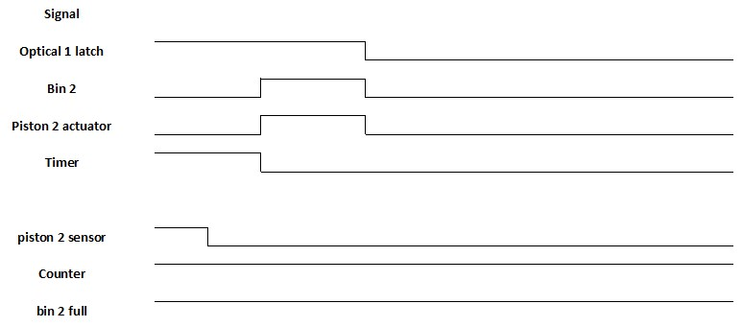
Figure 24 Network 10 timings
In Figure 24 when optical 1 latch is high the timer starts when it is finished piston 2 actuator fires if bin 2 is set.
Piston 2 sensor increments counter which sets bin 2 full when pre-set value of 5 has reached.

Network 11 bin 3 large short pucks
Network 11 for bin 3 seen in Figure 25.
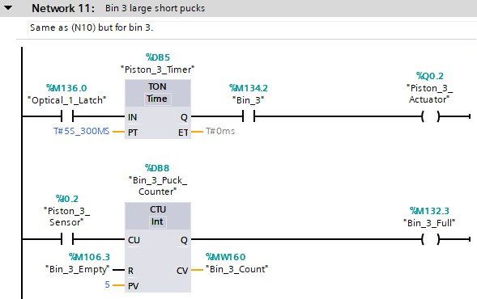
Figure 25 Network 11 bin 3
Network 11 in Figure 25 works the same as bin 2 network 10 except it is for bin 3.

Network 12 bin 4 medium tall pucks
Bin 4 code in Figure 26.
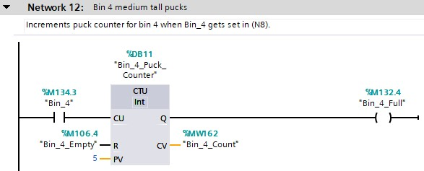
Figure 26 Network 12 bin 4
In Figure 26 puck count increments every time the bin 4 flag gets set the warning flag occurs when total puck count reaches 5.

Network 12 timing diagram
Figure 27 shows network 12 timings.
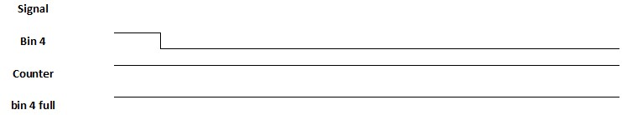
Figure 27 Network 12 timing diagram
Bin 4 in Figure 27 increments the counter which goes high when count reaches 5 and sets bin 5 full flag.

Network 13 bin 5 large tall pucks
Figure 28 shows bin 5 code.
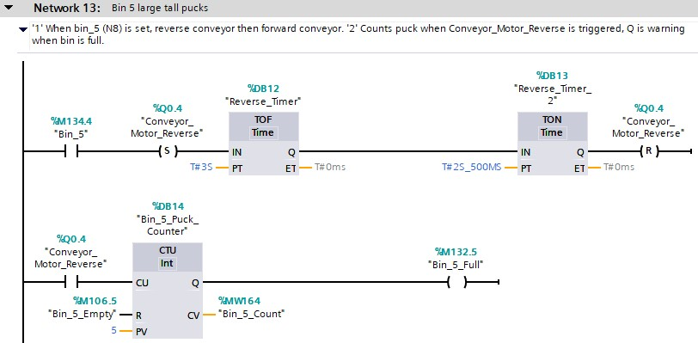
Figure 28 Network 13 bin 5
In Figure 28 rung 1 reverses the conveyor belt when bin 5 is selected, once the pre-set times have completed the conveyor is returned to forward running, rung 2 is the puck count code where bin full warning occurs at 5.

Network 13 timing diagram
Network 13 timings in Figure 29.
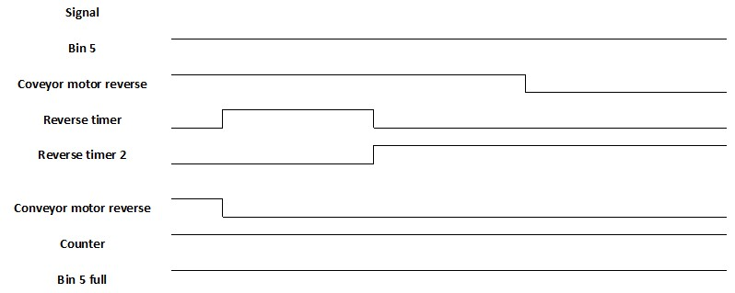
Figure 29 Network 13 timings
In Figure 29 bin 5 high sets conveyor motor reverse before being unset after the timers.
Conveyor motor reverse increments counter which sets bin 5 full once a count of 5 is reached.

Network 14 resets when a puck is sorted
Figure 30 shows network 14.
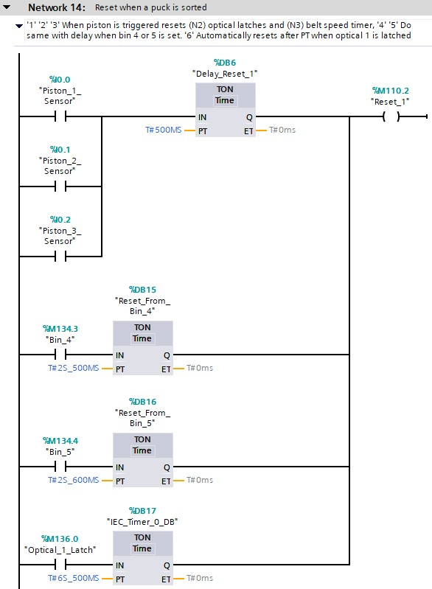
Figure 30 Network 14, resets when puck is sorted
In Figure 30 ‘Reset_1’ is triggered following delays from an on timer once a puck has been sorted, rung 6 is an auto reset, ‘Reset_1’ is used in networks 2 and 3.

Network 14 timing diagram
Network 14 timings in Figure 31.
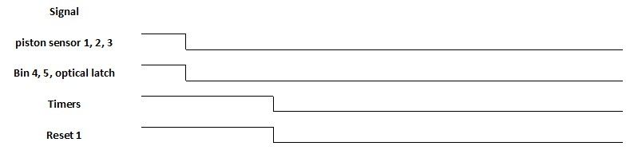
Figure 31 Network 14 timings
Piston sensor 1,2 or 3, or bin 4,5 or optical latch starts one of the timers before setting reset 1.

Network 15 error and warnings flags
Figure 32 shows errors and warnings being set.
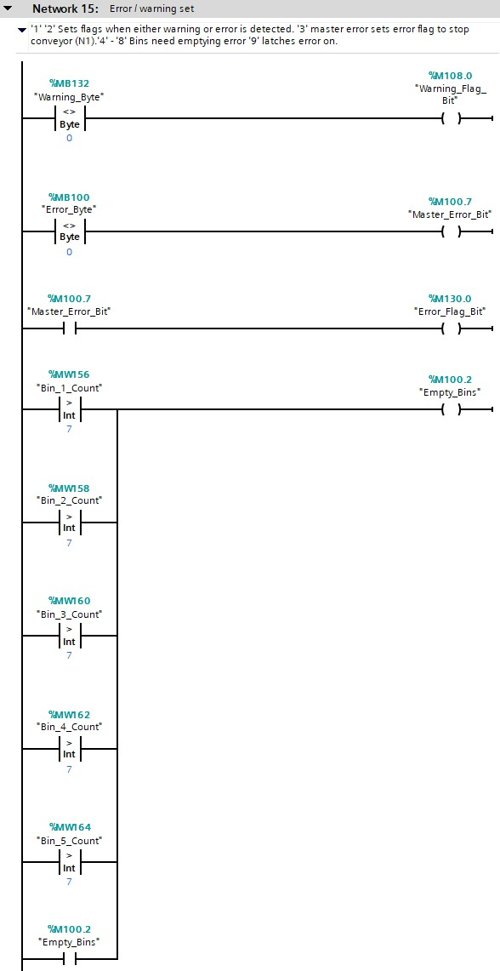
Figure 32 Network 15 errors and warnings
In Figure 32 rungs 1 & 2 checks the error and warning bytes and sets a relevant flag for the HMI home screen, rung 3 ‘Error_Flag_Bit’ is used in network 1 to stop the conveyor belt. Rungs 4 – 8 sets the error to empty bins once a bin count exceeds 7 and rung 9 latches this error on.

Network 15 timing diagram
Timings for network 15 in Figure 33.
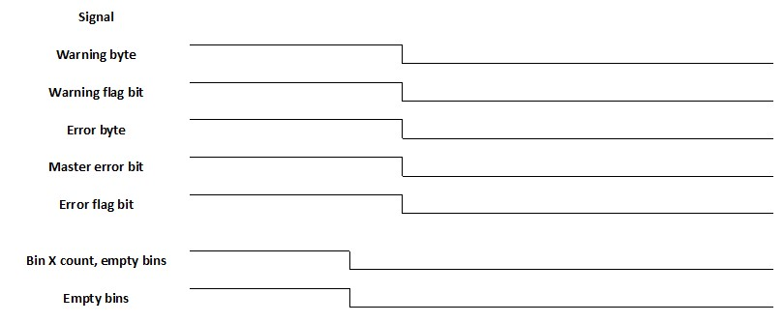
Figure 33 Network 15 timings
Figure 33 shows signals going high and setting the respective bits.

Network 16 hard reset
Hard reset code in Figure 34.
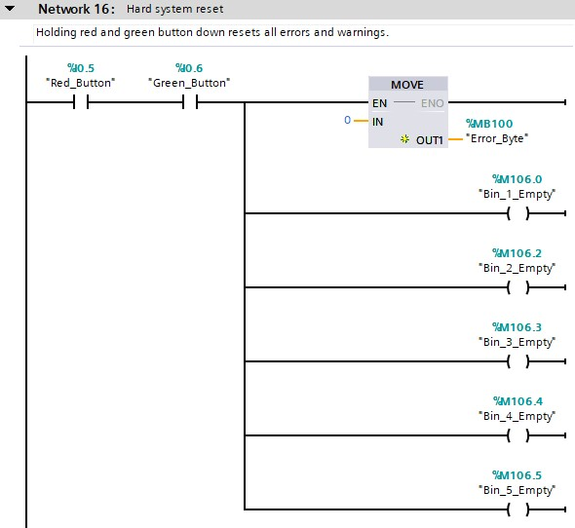
Figure 34 Network 16 hard reset
In Figure 34 when both red and green buttons are held down together all errors and warnings get reset.

Network 16 timing diagram
Figure 35 shows timings for network 16.
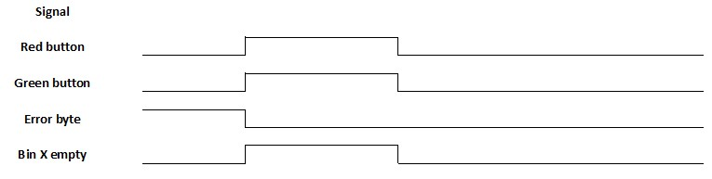
Figure 35 Network 16 timings
Red and Green button being high in Figure 35 sets error byte to 0 and bin x empty high.

Operational flow chart
Figure 36 shows the system operation.
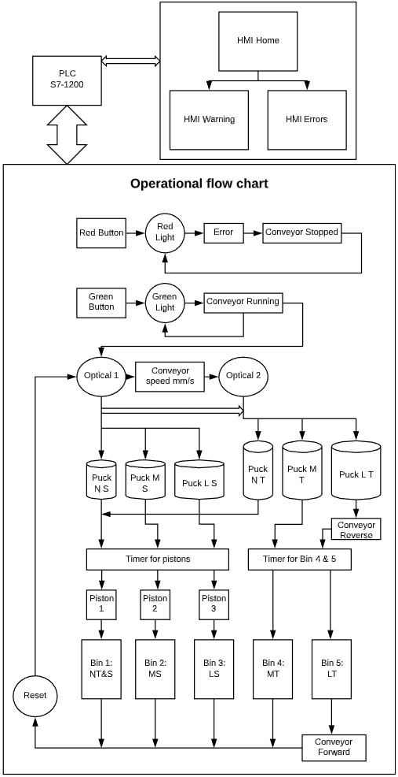
Figure 36 Operational flowchart
At the top of Figure 36 is the PLC, this has a data link to the HMI and controls the overall system. Red button, Red light or error stops the conveyor.
Green button starts the conveyor, optical 1 detects object first and if tall enough optical 2 will, once a puck has been chosen timers are activated before sorting them into the correct bin, various counters and timers are reset ready for next object.

Audit documentation.
Warnings: These do NOT stop the conveyor belt running.
- Bin x full warnings indicate that the respective bin is nearly full and should be emptied soon, once emptied the warning can be reset by pressing the refresh button at the end.
Errors: These DO stop the conveyor running.
- Emergency stop: should this error occur then the emergency stop has been initiated on the HMI home screen, once the emergency has been dealt with the button needs to be reset on the home screen.
- Foreign object detected: This error will occur when the optical 1 beam has been broken for at least 1120 ms, most likely to occur if a larger than expected diameter object has been placed on the belt, another cause could be a fault with optical 1 sensor, either remove object and reset on the error screen or notify an engineer.
- Empty bins: This occurs after the bin X full warning has not been rectified, empty the bin shown on the warning screen, then reset warning before resetting this error.
- Master reset: This comes on when any of the above errors occur and causes the conveyor to stop, it can NOT be reset until the other errors have been rectified.

Suggested improvements
- Implementing other errors or warnings: some errors and warnings mentioned in Table 2 and Table 3 have not yet been implemented such as belt speed under or over and air pressure to low or to high also an event timer could be used for if the belt has been running for x time with no object being detected then stopping the conveyor can conserve energy.
- Engineers screen for testing various components separately to aid with fault diagnosis.
- User configuration screen. Certain areas of the program involve setting values either for a counter like puck count or for timers to determine puck size, if bigger bins were used then they could hold more or if other puck sizes were introduced then extra timers would need to be added.

Conclusion
The design specification was analysed with key information extracted for building this system, a basic block diagram has been included to show the inputs and outputs for the PLC. The HMI included three screens for the operator to have control of and feedback from the system.
Multiple networks were used when writing the ladder logic making it easier to read and understand with each network having a suitable title and comments attached, where necessary timing diagrams have been included.
To visualise the operational flow a flow chart has been constructed showing the system when stopped and when running correctly, the audit document gives the operator information on the system such as error and warning descriptions.
Suggested improvements included areas that was planned to be implemented but was not able to down to technical issues as well as ideas such as engineers’ screens with fault diagnosis abilities.
Due to the current global crisis part of the technical issues was limited access time to some physical hardware whereby a third party was needed to test the program code from a remote location, all tests that were done concluded with positive results.

