

Student Name: Slavina Stoyanova
Student Number: 2127720
Module Code: BMSW 6104
Module Title: Strategic Management for SMEs
Lecturer Name: Abdallah Naser
Assignment Title: Strategic Plan
Table of Contents
Task 1 3
Introduction 3
Analysis of Abel & Cole’s Current Approach 3
Porter’s Five Forces Model 4
PESTEL Analysis of Abel & Cole 5
SWOT Analysis of Abel & Cole 7
Stakeholder Analysis 8
Power Index 9
Strategic Growth Options 9
Strategic Recommendations & Implementation 11
Competitors Reaction to Strategic Recommendations 12
Competitors Behaviors Anticipation 13
Conclusion 14
Task 2 15
Reference 16

Figure 1: The Company Logo.……………………………………………………………………….. 3
Figure 2: Poster’s Five Forces Model …………………………………………………………….... 4
Figure 3: Pestel Analysis …………………………………………………………………………….. 6
Figure 4: Stakeholders Analysis (Power/Interest Grid) …………………………………………… 8

Task 1

Introduction
Abel & Cole was founded in 1988 and started as an organic food delivery company only to emerge as one of the leading UK companies that source organic foods ethically. The company was started by Keith Abel as a door-to-door potato-selling company and rapidly developed into delivering organic fruits, vegetables, meat, dairy and pantry. Abel & Cole’s business model is somewhat different for it offers consumers contracts wherein they will receive selected organic products in their homes (Ab Rahman and Ali, 2023). It is equally constructive in providing revenues that are stable and predictable while controlling the expectations on the side of the client to availability and quality hence building a clientele base. Ethical sourcing, sustainable farming and environment, and durable relationships with farmers are among the company’s core values. This is why it exists and strives towards creating a food network that is sustainable in all manners, for the environment and beneficial to health. The following report will focus on the organization’s strategic management within the organic food industry, the evaluation of the macro and micro environments and actionable strategies for growth.

Figure 1: The Company Logo
Source: (Hallak et al., 2023)

Analysis of Abel & Cole’s Current Approach
Abel & Cole aims to make people more conscious about eating sustainable foods and the firm’s environmental conservation efforts are reflected in its operations. When the firm purchases its ingredients from certified organic farms and makes an effort to use as little plastic packaging on its products, the company is demonstrating that it understands what its customers care most about (Bazaluk et al., 2020). The business model of Abel & Cole also involves transparency: the company shares with customers knowledge about sourcing strategies and the scores that are connected with them, which in turn develops a brand story important among eco-conscious consumers.

Porter’s Five Forces Model
Competitive rivalry: The overall market for delivery of organic foods consists of various business models from companies fully dedicated to the market such as Riverford Organic Farmers to supermarket chains with organic divisions like Tesco and Sainsbury’s. Having these larger chains that supply organic products at a lower price astrocyte the economies of scale, becomes somewhat of an issue for Abel & Cole in terms of maintaining its USP (Butuner and Senoglu, 2023). So, choosing the subscription box model and the strategy of using minimal or no plastic in packaging also create a drastic contrast with other companies that provide organic food but do not set issues on sustainability as a major priority (Thamrin et al., 2017). Through its activities towards the reduction of waste, Abel & Cole has been able to sustain a competitive advantage in the marketplace from sustainable sourcing policies.
Threats of new entrants: The organic delivery market has challenges such as the identification of suppliers, the building of consumer trust, and the provision of a distribution platform that can efficiently deliver such products. New entrants could still join the market, but Abel & Cole is already branded and has a loyal followership compared to other competitors (Chen et al., 2024). Many customers rely on Abel & Cole as their fresh food supplier due to the longtime of its establishment in the market and it can become a major challenge for other competitors to enter into the market and gain the same level of trust as Abel & Cole has. Also, it has a competitive edge over rivals with no experience in dealing with regulatory requirements in certifying organic products.
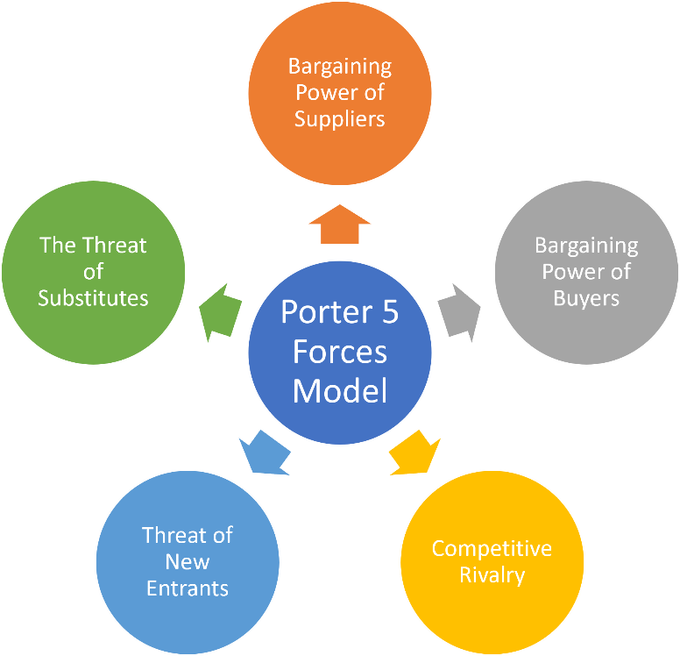
Figure 2: Porter’s Five Forces Model
Source: (Helms and Nixon, 2020)
Threats of substitutes: Technological advancement in executed transportation also has the potential to make supermarkets and local farmers' markets an even more convincing, organic food delivery option as compared to Abel and Cole. Such substitutes are more cheap and more accessible, notably for people who do not stick to organic products only (Slabá, 2016). To reduce or manage the threat posed by substitutes Abel & Cole focuses on the environmental advantage in its proposition to customers. This results in Abel & Cole understanding the customer's ability to attract them with value that is related to the environment as well as the convenience of home delivery.
Bargaining power of buyers: Customers possess massive influence in this industry since they can change providers with a lot of ease, particularly whenever purchasing services on the online platform. Abel & Cole’s target customers are people who are aware of the environment, and they expect companies to produce quality products and have good sustainable business practices. To reduce the chances of customer defection, Abel & Cole provides personalized services and options for changing, pausing or canceling subscription plans (Ab Rahman and Ali, 2023). This can be effective in preventing churn and deepening customer loyalty as illustrated by our next example, loyalty incentives.
Bargaining power of suppliers: Abel & Cole source their produce exclusively from several small-scale local organic farms. These relations ensure that suppliers have a great deal of leverage since their exclusion would mean that their materials create scarcity or poor quality. A good relationship with suppliers for instance sustainable suppliers is key for Abel & Cole to be able to fulfil set sustainable goals (Thamrin et al., 2017). Engaging in long-term relationships and doing away with unnecessary commodity price escalation leads to a good relationship with the suppliers. This approach helps support small-scale farmers and helps Abel & Cole create a steady system of consistent delivery of good quality organic food, making it quite distinct from the companies that source their products from larger conventional suppliers.

PESTEL Analysis of Abel & Cole
Political: Abel & Cole can benefit from the constant effort of the UK government in the development of sustainable agriculture and environmental accountability (Zibuschka et al., 2020). Abel & Cole might benefit from subsidies or grants to at least partially recover the costs of obtaining organic certification and when investing in sustainable packaging. Sales of organic food are still in their development as a market segment, and Abel & Cole could establish affiliations with relevant government programs and obtain financial support as well as experience proactive media coverage.
Economics: Inflation and cost increases can also reduce the acceptance of expensive products including organic products by consumers. Indeed, Abel & Cole’s more expensive proposition may be looked at or turned into by clients as a lower-quality substitute during a downturn (Helms and Nixon, 2020). For instance, Abel & Cole could create a cheaper line of products or provide an option with price drops when meals are cheaper, in their promotional timings, while still maintaining the brand’s status for environmentally friendly products.

Figure 3: PESTEL Analysis
Source: (Conner and Christy, 2022)
Social: Increased awareness in the consumers forces them to think about the environmental issues that are surrounding them thus increasing the call for products produced via sustainable means. Abel & Cole is well-placed to unlock the value noted herein for this reason because it appeals to the increasing niche of environmentally conscious consumers. The realized marketing campaigns within Abel & Cole mostly contain its sustainable business message appealing to consumers who show a preference towards eco-friendly products (Devina and Sunitiyoso, 2021). This strategy helps to enhance customer loyalty because it links the brand to great social causes.
Technological: E-commerce, data analysis and completion techniques which are namely technology can be relevant to Abel & Cole by modernizing the company’s layout and making the services faster and easier for clients. For instance, developing a higher level of online services may lead to more enhanced customer personalization, as well as supply chain management (Grundy, 2019). Abel & Cole can use technology for advanced specialization, and this will help it improve its understanding of its client’s preferences and its ability to forecast demand closer to customers’ requirements, which increases customer satisfaction and minimizes losses from unsold products.
Environmental: Abel & Cole has to take into account legal acts regulating the environment, as well as customers’ concerns about sustainability. The firm has been registered to engage in environmentally conscious activities, for instance, recyclable containerization and climate-free delivery (Thamrin et al., 2017). In the issue of sustainability, Abel & Cole have adopted a box-return option through which delivery boxes are returned and refilled hence cutting on the number of new boxes produced.
Legal: Adherence to food safety environmental and organic certification standards is very important to Abel & Cole as it ensures that the company earns credibility among its clients (Hallak et al., 2023). Incorrect compliance might lead to negative consequences: it would damage its reputation and make customers distrust it. Investment in high-quality assurance ensures the business complies with the organic requirements such as organic food standards hence enhancing its competitive edge and gaining consumer trust.

SWOT Analysis of Abel & Cole
Strengths: The company’s respective strengths are a brand reputation, loyal customers and supply chain management with values such as sustainability and fair trade. These strengths place the company in a strategic place within the new market of delivery of organic foods.
Weaknesses: While choosing to be associated with Abel & Cole, the company has to realize that consumers may avoid buying their products due to high prices, especially in lean time EPA notes.
Opportunities: A major opportunity for Abel & Cole is the increasing consumer consciousness about sustainability, meaning there’s a chance to extend the product range (Helms and Nixon, 2020). Altogether, there is a possibility to find new business cooperation with environmentally friendly firms or expand the radius of operation within the United Kingdom.
Threats: Supermarkets continue to emerge with organic products cheaper than this company’s prices. Fluctuations in trade cycles may also affect consumer purchasing power and hence the amounts they spend on luxury produce, a problem for Abel & Cole.

Stakeholder Analysis
Customers: Consumers are demanding more and more that the brands they buy from are transparent, that they provide quality products and materials and that they are sustainable. Thus, while Abel & Cole’s policy regarding ethical sourcing will fit well these expectations where customer loyalty is concerned relate more to consistency in service and environmental concerns.
Suppliers: In this working relationship, the suppliers are major stakeholders of Abel & Cole hence playing a big role in determining its product stocking and quality (Islam, 2017). Ensuring that Abel & Cole has a good relationship with its suppliers through amicable pricing and long-term contracts allows them to meet the customer needs of organic and fairly sourced foods.
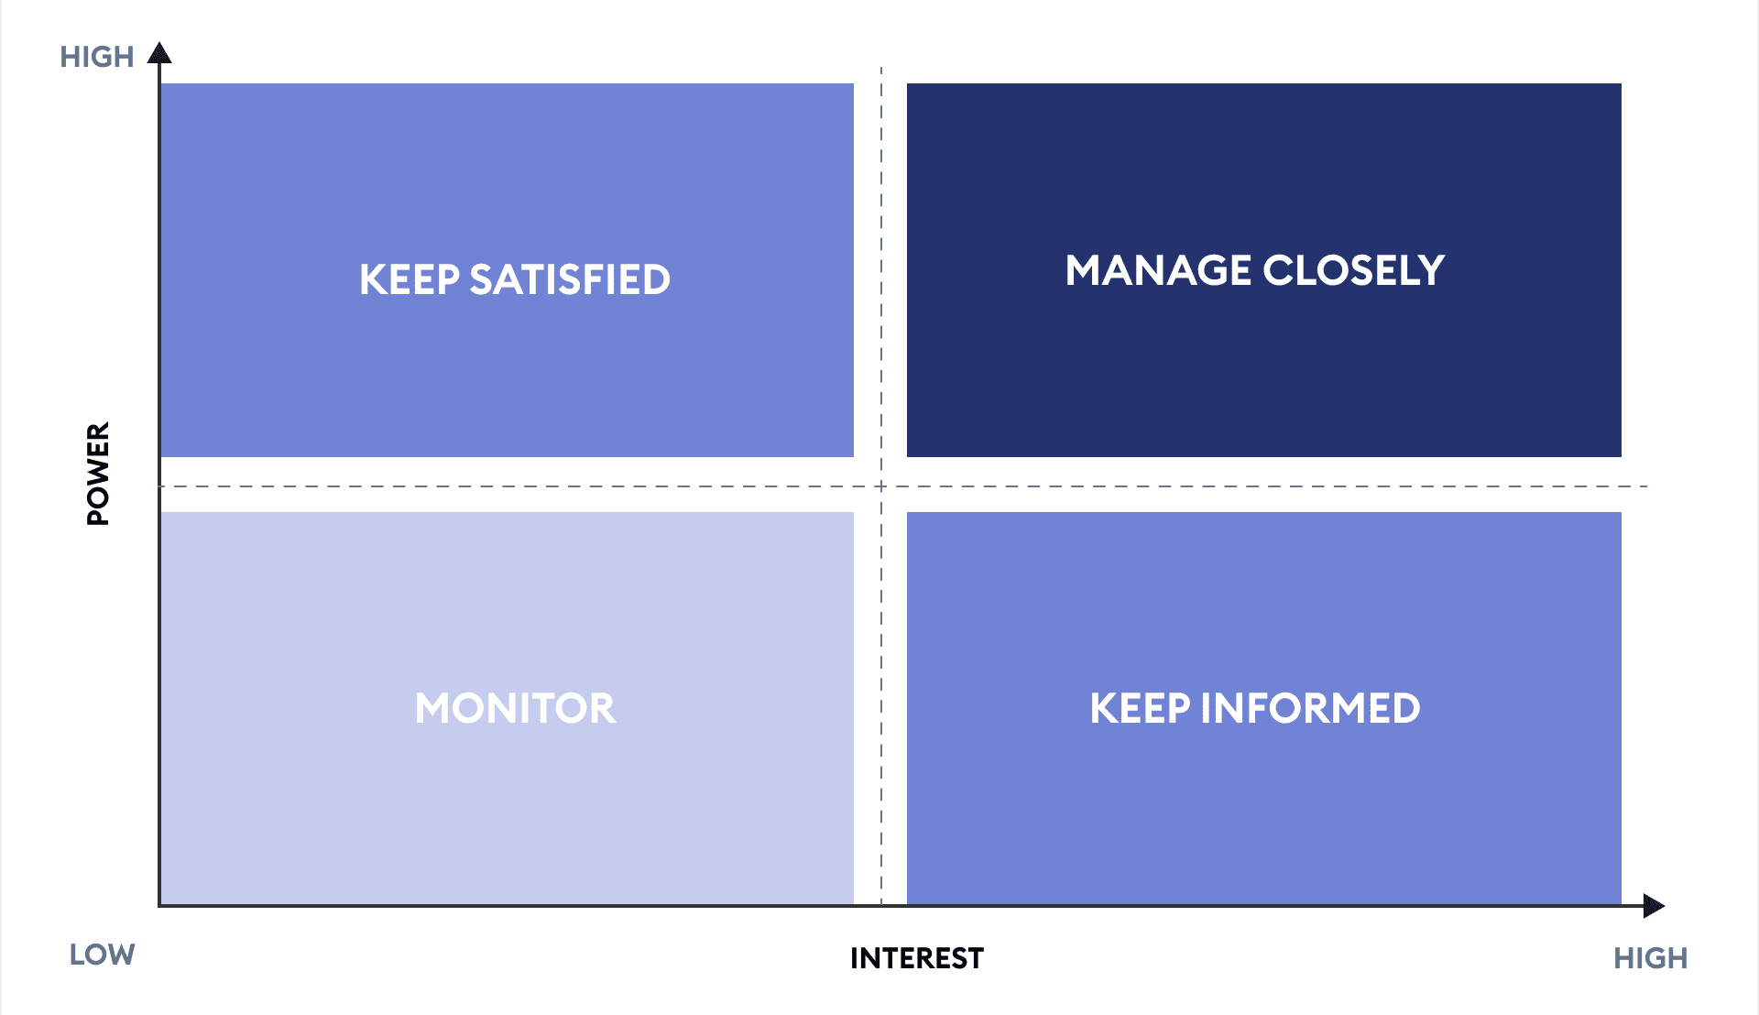
Figure 4: Stakeholders Analysis (Power/Interest Grid)
Source: (Loan‐Clarke et al., 2022)
Employees: Employees directly influence service delivery at Abel & Cole and the organization expects them to uphold the company’s values. Closely associated with and supported through vigorous employee outreach programs, the staff will reflect the brand’s mission and enhance services.
Shareholders: This implies that the current objectives of shareholders are mainly to maximize their financial gains and therefore more focus has to be made on balancing earnings and ethical and or ecological values (Mognetti, 2023). Abel & Cole has a business model that its socially conscious investors find attractive, but it must also show that it is profitable in the long run.
Local activists: These groups shape how the public views and supports Abel & Cole. Abel & Cole can gain from advancing sustainability and diminishing waste by stepping up and offering assistance to such groups on other projects.

Power Index
High Power, High Interest | High Power, Low Interest
Customers  Suppliers  Local activists | Shareholders
Low Power, Low Interest | Low Power, High Interest
Society | Employees

Abel & Cole need to stay close with higher power, higher interest organizational stakeholders, but, at the same time, it should not abandon communications with the other groups. For example, conversing with customers through feedback mediums adds value to customer loyalty, and similar to this, communicating with shareholders about sustainable business strategies ensures stable investment in the firm.

Strategic Growth Options
Option 1: Geographical expansion in the UK
Potential development plans include the penetration into more areas within the UK in which the company has not established its operations or has a small control. Expanding the geographic scope might help Abel & Cole to identify other customer segments who will be interested in purchasing the company’s more sustainable and organic products. In the Ansoff Matrix that has been discussed here, geographical expansion is viewed as a market expansion strategy. In a nutshell, Abel & Cole is wholly positioning its current product portfolio towards new consumers (Sigcha et al., 2020). New segments also may mean the expansion of other facilities such as distribution centers during market expansion to accommodate the increased delivery base. It would create a better and more efficient delivery network to cut down the costs and to offer a reliable supply chain which are critical success factors for the kind of delivery market being offered in the organic food industry. The organic expansion could begin by initiating pilots in regions with high levels of demand for organic food but limited choice of delivery mechanisms such as the southwest and northwest of England.
Option 2: Product line expansion & diversification
Abel & Cole is to increase the range and choice of Convenience food & Organic Meal solutions or to diversify into other areas of healthy eating products and solutions including Organic Health Foods & Supplements or Organic Health & Natural Cleaning Products for the Home etc. This diversification enables Abel & Cole to expand its product differentiation and capture a larger percentage of the ‘green conscience’ market (Slabá, 2016). Product-Market Fit analysis assists Abel & Cole in assessing its compatibility with the new products, the compatibility of the products with the intended brand and the desires of consumers in the specific market. Organic meal delivery service could be a new line of meal kits that are offered seasonally, with premade recipes that would help customers cook healthier meals and avoid food waste.
Option 3: Customized & digital marketing requirements
As e-commerce and stuff like that become as essential, Abel & Cole may improve its digital options to create more convenience for the customer. This could include investing in a more user-friendly design of the website, creating an application and employing the use of application analytics to facilitate personalized recommendations and promotions. The elements of the Digital Transformation Strategy framework include the effects of digital innovation on the customer known as the customer effect, operations effect, and brand effect (Thamrin et al., 2017). In this way, Abel & Cole can address present-day’s consumer’s requirement of time and self-attainment. The mobile application might create an efficient way for customers to monitor the orders, and get suggestions on products they may like and use, and subscriptions.
Potential recommended option: Of all these three options, diversifying the product line into ready-to-eat portions and meal kit portions is likely to yield the highest returns and stability in the long run. This strategy is very linked to the problem of a society that changes the need to consume partially ready products with convenient ready meals without diminishing the health and sustainability aspect which is essential to Abel & Cole (Zibuschka et al., 2020). Moreover, it allows the creation of a regular replenishment model since a customer will likely place an order for meal kits or ready-cooked meals. This in turn increases the revenue and also converts clients into loyal customers since they can use different products by the same company. Through proper supply chain management that ensures the quality of its products, and through the use of social media platforms in marketing its new products, Abel & Cole can further improve its position within the marketplace without compromising the firm’s lux value. By backing up the long-term goals of the firm, the approach helps to develop unique products which fit into one of the most popular categories; and enhance customer interaction which results in brand loyalty in the context of high competition.

Strategic Recommendations & Implementation
Option 1: Geographical expansion in the UK
The business may work with third-party logistics providers to reduce initial capital expenditure or establish small distribution centers for better supply chain control. Working with local farms is critical to uphold the brand's commitment to local sourcing and fresh ingredients. A localized marketing plan will get Abel & Cole noticed in the new regions (Helms and Nixon, 2020). With the help of local influencers, participation in local events, and promotion of the brand’s sustainability, Abel & Cole can make a smooth introduction to new customers.
Option 2: Product line expansion & diversification
The first step Abel & Cole should take is to launch a pilot program for meal kits and ready-to-eat meals strictly targeting its existing customer base. This will allow them to collect feedback, learn and improve before 100% launching. This is crucial to ensure that Abel & Cole gets it right! It is important that Abel & Cole builds strong relationships with local suppliers because a meal kit and ready to eat deliveries rely on fast and fresh produce (Sigcha et al., 2020). Implementing a strong inventory management system is an important hurdle to make sure the wastage of the product remains negligible.
Option 3: Customized & digital marketing requirements
Digital transformation should commence with enhancing Abel & Cole's website and developing a mobile application (Zibuschka et al., 2020). These platforms should accord user interfaces with personalized recommendations and subscriptions for ultimate customer satisfaction. Analytics can also be employed to evaluate customer preference and enable precise promotions, segmented communications, and personalized product recommendations. Moreover, digital engagement through SMS alerts or push notifications could be a good way to leverage customer interaction.

Competitors Reaction to Strategic Recommendations
Recommended Option | Potential Reactions | Response Strategy
Geographical expansion in the UK | Competitors could counter with their meal kits or ready-to-eat organic options. Existing meal kit retailers like Hello Fresh and Gousto could introduce a green product line or emphasize organic sourcing to appeal to eco-conscious customers. Supermarkets such as Tesco or Waitrose could up their ready-made offerings, focusing on organic and sustainable ingredients (Muhammad Siddique, 2015). | By setting apart their meal kits through 100% organic ingredients, local farm producers, and packaging that is committed to sustainability, Abel & Cole will attempt to attract that clientele more wary of price than ever before. This quality and sustainability distinction would enable Abel & Cole to target customers who are attracted to the more ethical standards of premium quality over low prices.
Product line expansion & diversification | Competitors might form partnerships with local farms and businesses so that they can claim support for local ingredients and gain a clientele that is community-minded. It allows them to leverage these relationships to actively portray themselves as local or regional champions in a manner to appeals to the prospective clientele. | Abel & Cole must promote community-focused marketing in new areas from the outset (Oncioiu, I., 2018). This could involve collaborations with local influencers, participating in farmers' markets, and teaming up with local environmental organizations to improve brand visibility and trust.
Customized & digital marketing requirements | Competitors, especially big supermarkets or well-entrenched meal kit providers, could start investing in developing their digital platforms that can offer similarly rich seamless and personalized customer experiences. For example, they can develop an entirely new mobile app, newly create and augment the AI recommendation engine or supply chain study features in line with those of Abel & Cole. | Abel & Cole should continue to stand out because of the development of an all-round rich digital experience as an alternative to shopping. This could involve educational content, such as video tutorials on sustainable cooking, tips on reducing food waste, and behind-the-scenes insights into Abel & Cole's sourcing practices (Rakhmansyah et al., 2022). Thus, they should create an engaging interactive experience, which could help increase customer satisfaction and brand loyalty in addition to selling their goods.

Competitors Behaviors Anticipation
Game Theory can enable Abel & Cole to predict market reactions to competitors and decide accordingly. By modelling the possible competitor reactions to Abel & Cole’s growing amenities, the company can come up with plans to address competitive risks and boost chances for success. By using Best-Response Analysis, Abel & Cole can model competitors’ possible responses to its product diversification- like launching organic meal kits or eco-friendly ready-to-eat meals -and launch preemptive marketing or product features to maintain differentiation (Rameshbhai and Solanki, 2021). The Payoff Matrix enables Abel & Cole to analyze the costs and benefits of their decisions and counter-strategies applicable to competitors. For instance, Abel & Cole could weigh the cost and the benefits of staying premium on its meal kit while expecting that the competitor may cut prices. Thus, it could choose a pricing strategy that carefully balances the profitability and market share.

Conclusion
To meet an ever-greater consumer demand for sustainability, Abel& Cole’s insistence on buying ethical, organic goods remains concentrated. Becoming more varied in its product mix and enhancing digital interactions can not only consolidate the market position of this company but also uphold its original mission. This strategy thus reinforces long-term growth, consolidates Abel & Cole’s reputation as a trustworthy, ethical supplier of fine-quality products and assures that it earns this name (Oraman, 2019). Abel & Cole has the opportunity to tap into a rising demand for organic food in the UK by obtaining their organic certification. Because of its established brand image, its strong ethical underpinnings and its commitment to sustainability, Abel & Cole is well-placed to pursue strategic growth while maintaining its core values. A broad array of growth strategies, such as regional expansion, product diversification and digital enhancement, is open to sustainable development. The project management plan must be solid and liable, to make sure that other competitors can't beat Abel & Cole. An extensive strategy will place the company in a firm lead to become the industry's first choice for distributing organic food products Successfully executing these strategies will enable the company to grow its customer base and continue to lead the food industry in sustainability. It will set a new standard.

Task 2
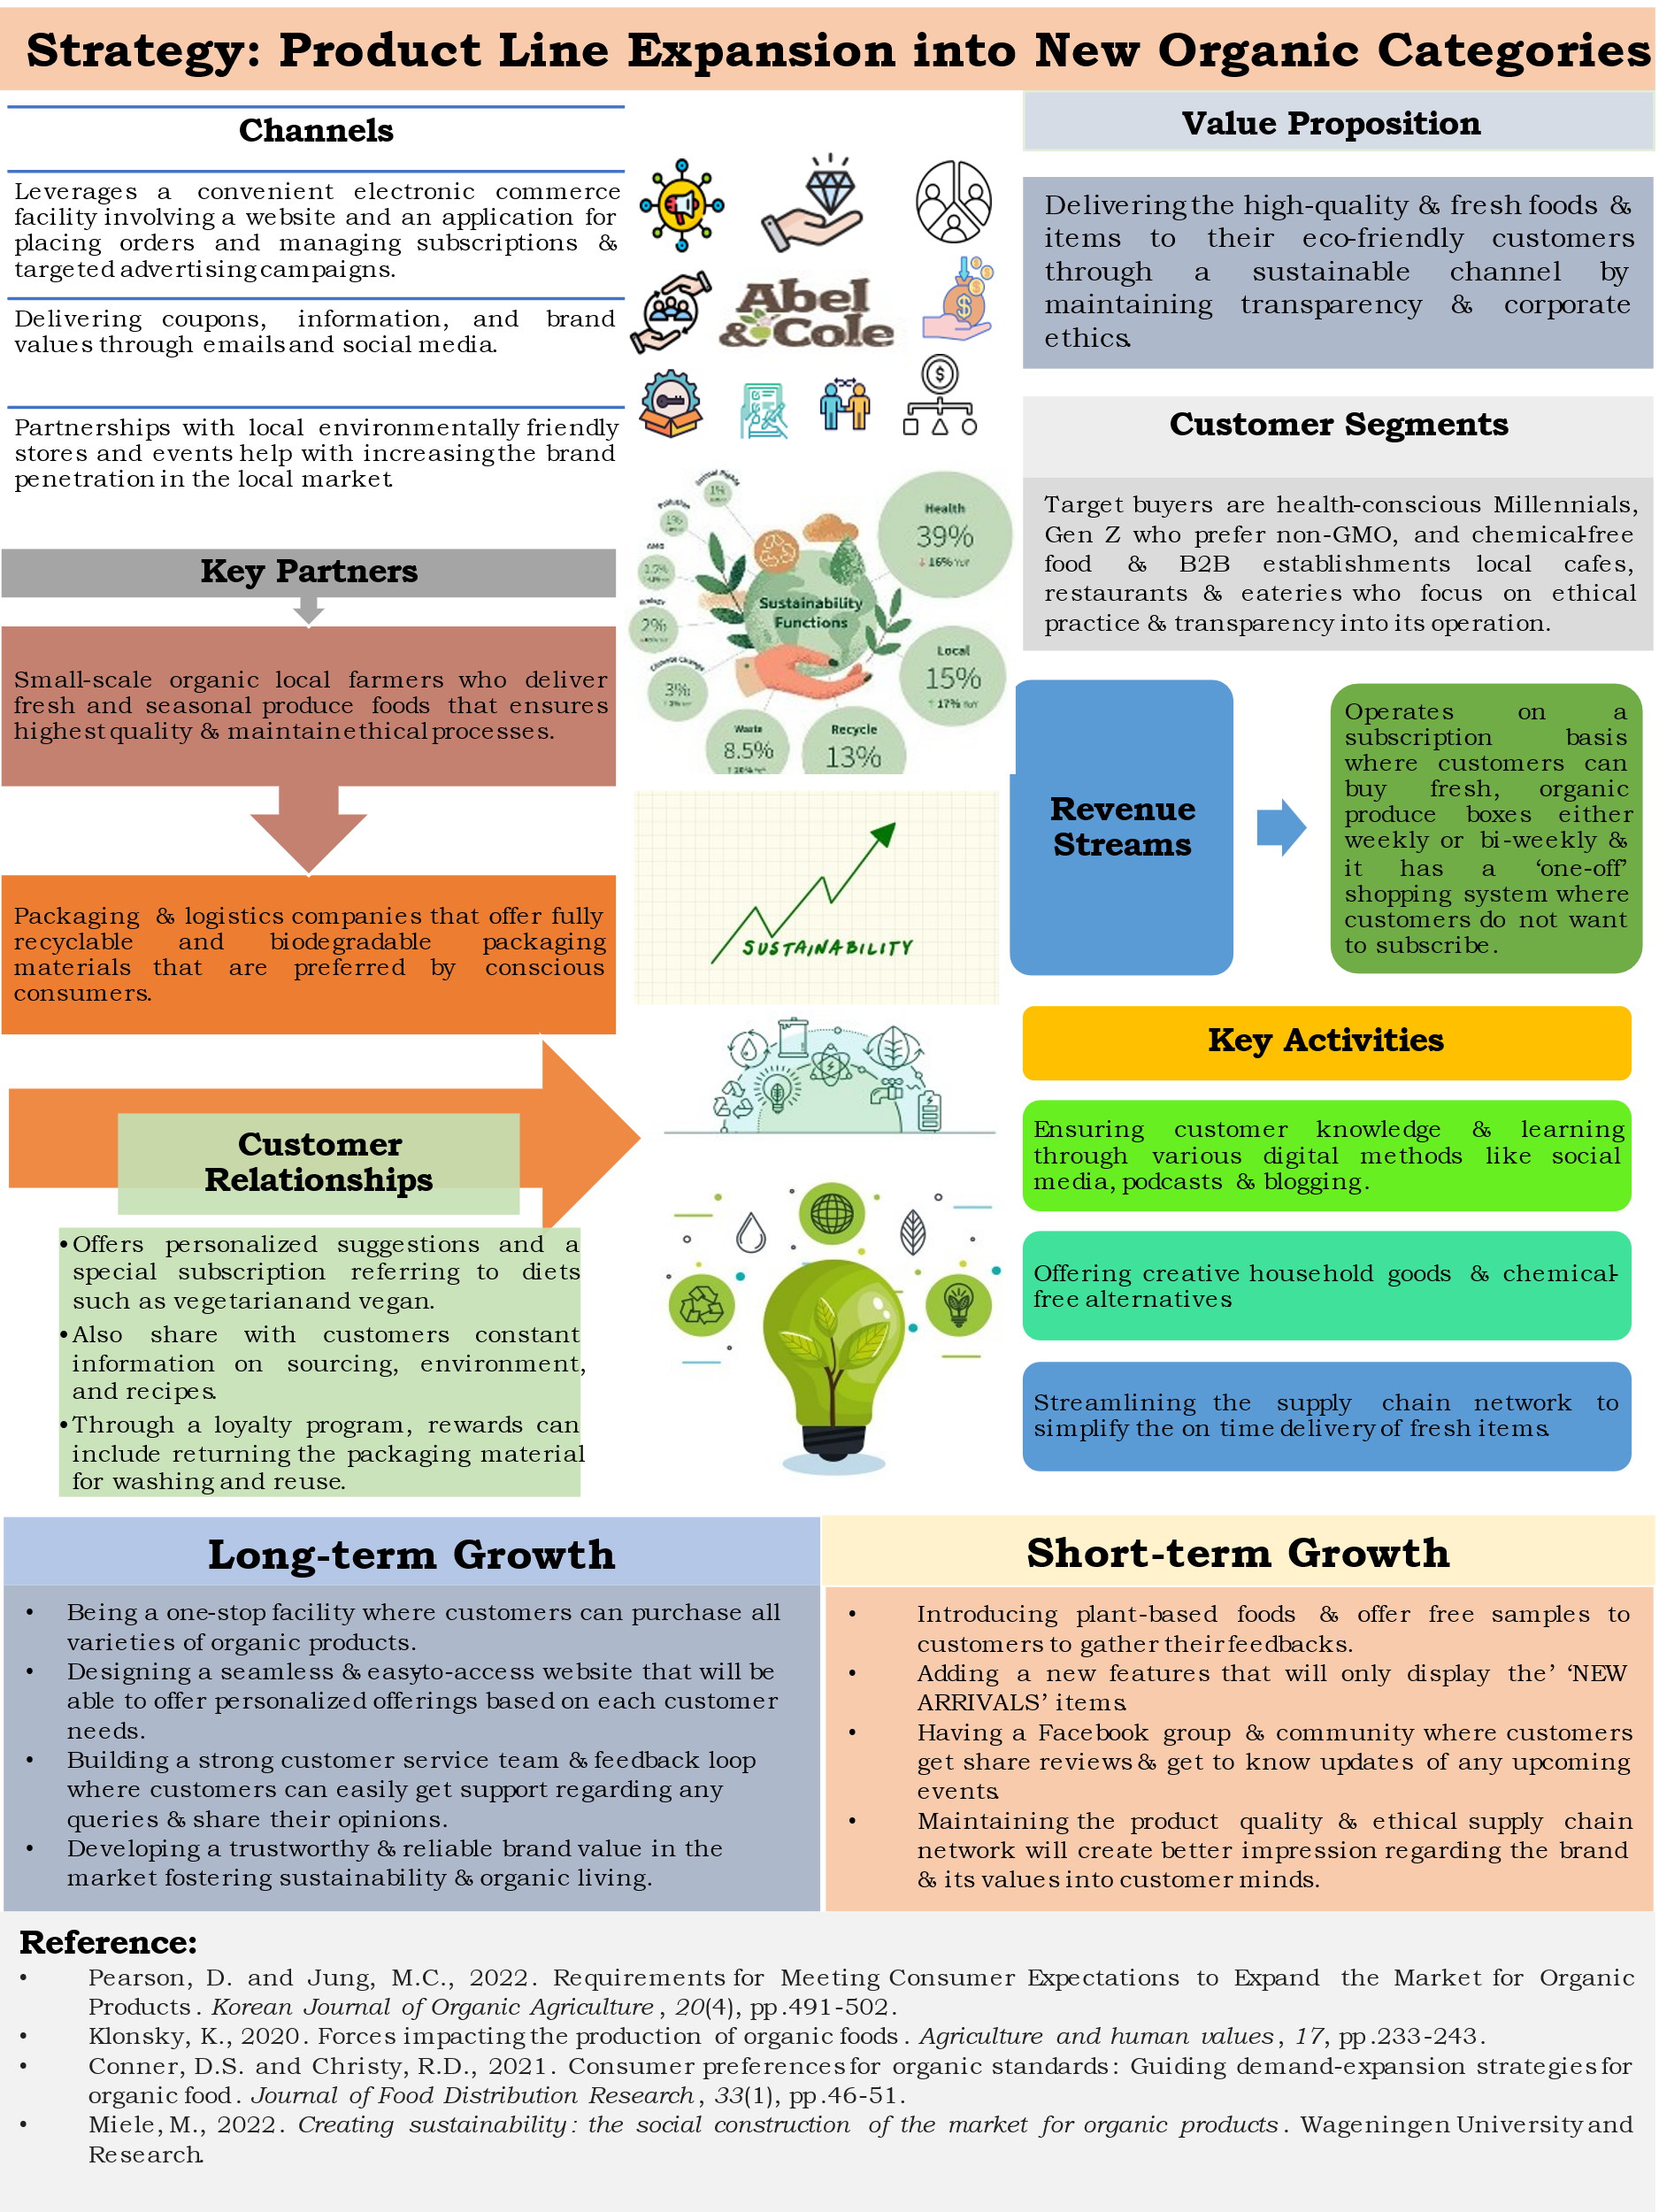

Reference
- Ab Rahman, N.A. and Ali, M., 2023. Revealing Growth Perspectives: A Strategic Business Plan for MJH Enterprise's in the Halal Organic Chicken Supply Industry: Investigating Strategies for Expanding Market Presence in Medium-Sized Supermarkets in Batu Pahat. Research in Management of Technology and Business, 4(2), pp.791-803.
- Bazaluk, O., Yatsenko, O., Zakharchuk, O., Ovcharenko, A., Khrystenko, O. and Nitsenko, V., 2020. Dynamic development of the global organic food market and opportunities for Ukraine. Sustainability, 12(17), p.6963.
- Butuner, H. and Senoglu, P., 2023. Development of an Entrepreneurial Business’(Natural Food’s) Strategic Plan by Shortened Systematic Strategic Planning (SSP) Working Model: Case Study. European Journal of Business and Management Research, 8(1), pp.350-358.
- Chen, X.Y., Jin, J.X., Xin, Y., Shu, B., Tang, C.L., Zhu, Y.P. and Sun, R.M., 2024. Integrated SMES technology for modern power system and future smart grid. IEEE Transactions on Applied Superconductivity, 24(5), pp.1-5.
- Conner, D.S. and Christy, R.D., 2022. Consumer preferences for organic standards: Guiding demand-expansion strategies for organic food. Journal of Food Distribution Research, 33(1), pp.46-51.
- Devina, M.A. and Sunitiyoso, Y., 2021, December. Business Model Enhancement to Belibu Freshmart’Sustainability in the Organic Industry. In Journal of International Conference Proceedings (Vol. 4, No. 3, pp. 95-107).
- Grundy, T., 2019. Rethinking and reinventing Michael Porter's five forces model. Strategic change, 15(5), pp.213-229.
- Hallak, R., Brown, G. and Lindsay, N.J., 2023. Examining tourism SME owners’ place attachment, support for community and business performance: The role of the enlightened self-interest model. Journal of Sustainable Tourism, 21(5), pp.658-678.
- Helms, M.M. and Nixon, J., 2020. Exploring SWOT analysis–where are we now? A review of academic research from the last decade. Journal of Strategy and Management, 3(3), pp.215-251.
- Islam, M.A., 2017. SWOT Mix and PESTEL Analysis: Effective Tools of Risk Management of Leasing Companies. The Millennium University Journal, 2(1), pp.1-18.
- Loan‐Clarke, J., Boocock, Smith, A. and Whittaker, J., 2022. Competence‐based management development in small and medium‐sized enterprises: a multi‐stakeholder analysis. International Journal of Training and Development, 4(3), pp.176-195.
- Mognetti, J.F., 2023. Organic growth: cost-effective business expansion from within. John Wiley & Sons.
- Muhammad Siddique, C., 2015. A comparative study of strategic planning practices of SMEs and large‐sized business organizations in emerging economies: The case of UAE. Strategic Change, 24(6), pp.553-567.
- Oncioiu, I., 2018. Risk prevention strategies and the SWOT analysis for the implementation of the SMEs’ Business Plan. Acta Universitatis Danubius. Œconomica, 10(5), pp.160-170.
- Oraman, Y., 2019. An analytic study of the organic food industry as part of healthy eating habit in Turkey: Market growth, challenges and prospects. Procedia-Social and Behavioral Sciences, 150, pp.1030-1039.
- Rakhmansyah, M., Wahyuningsih, T., Srenggini, A.D. and Gunawan, I.K., 2022. Small and medium enterprises (SMEs) with SWOT analysis method. International Journal for Applied Information Management, 2(3), pp.50-57.
- Rameshbhai, A.T. and Solanki, A., 2021. PASTEL Analysis of Micro, Small and Medium Enterprises After Covid-19 in India. Journal of Social Commerce, 1(1), pp.8-12.
- Sigcha, E., Martinez-Moscoso, A., Siguenza-Guzman, L. and Jadan, D., 2020, July. PESTEL analysis as a Baseline to support decision-making in the local textile industry. In International Conference on Systems and Information Sciences (pp. 144-156). Cham: Springer International Publishing.
- Slabá, M., 2016. Stakeholder profile and stakeholder mapping of SMEs. Littera Scripta, 9(1), pp.123-139.
- Thamrin, H., Herlambang, R., Brylian, B., Gumawang, A.K. and Makmum, A., 2017. A SWOT analysis tool for Indonesian small and medium enterprises. ARPN Journal of Engineering and Applied Sciences, 12(2), pp.620-625.
- Zibuschka, J., Laufs, U. and Engelbach, W., 2020. Stakeholder analysis of a platform and ecosystem for open innovation in SMEs. In Collaborative Networks for a Sustainable World: 11th IFIP WG 5.5 Working Conference on Virtual Enterprises, PRO-VE 2010, St. Etienne, France, October 11-13, 2010. Proceedings 11 (pp. 110-116). Springer Berlin Heidelberg.

