Computer Services
Gower College Swansea
Papi’s Pizzeria

Contents
Introduction 2
1.0 Analysis 3
2.0 Design Brief 4
2.1 Interview 4
2.2 About the business 5
2.3 Purpose of web app 5
2.4 Scope of project 6
2.5 Project Limitations/legal considerations 7
2.6 Specify solutions 8
Project Plan 0
3.0 Project Design 0
3.1 site map 0
3.2 Storyboards 1
3.3 ERD 8
3.6 SQL scripts 9
3.7 Evaluation criteria 11
Testing 12
Evaluation 13
Bibliography 15
Appendix A 16

Introduction

I have been given the task of implementing a web app based EPOS system for the small business “Papi’s Pizzeria Pontarddulais”. This report will consist of an analysis of what has been requested, the design of the project and how the project will be implemented.

Analysis

The old system is an outdated EPOS system which was not designed or made efficiently which leads to the system running rather slow and being clunky at times. Along with being an old system it is very limited to what can be changed/edited on it, this includes prices of items which have been hard coded and the products which are for sale, this is leaving little room for the business owners to adjust prices of items and even add items to the till.
Has it been done before?
Yes, many times which gives me a good head start on what to and not include in my project.
Open source?
Yes, there are multiple examples of an open source EPOS system.
https://unicenta.com/
Mediocre reviews, freezes and is slow difficult to move around for example trying to add inventory
http://chromis.co.uk/chromispos/
Very good reviews and has an active help forums page.

2.0 Design Brief

2.1 Interview
To get a rough idea of what the company is wanting me to do I first arranged a meeting with one of the managers at the shop, the following transcript is what was said.
HH- Hi Anni, thanks for meeting with me today I was just hoping that we could talk over what you think that you need to improve the work flow and efficiency of your front desk here at Papi’s pizzeria.
AM- Hi Harry, I appreciate you coming down and talking to me today. The first thing which comes to mind would be our electronic till that we use, this till gives us no end of problems and is probably the main cause of issues when it comes to the front desk.
HH- Would that be something that you would want me to look into upgrading with a better system and potentially upgrades?
AM- Yes that would be amazing.
HH- Could you possibly tell me some of the issues that you are currently having with the current system?
AM- The current system tends to freeze a lot and gives off error messages quite a bit, on top of this the functionality of the till is lacking and we would like to be able to do more on it.
HH- Ok those are some issues we can work on and look at solving, would you be ok with me designing a questionnaire to give to the employees who use the machine? Just to gauge a wider view on what issues are wrong with the current epos system and what we could do to improve on it?
AM – Yes certainly.
HH- Ok I will get to working on that and some design aspects of the new system, Thanks again Anni.
AM- No problems see you soon.

2.2 About the business
Papi’s pizzeria is a small family run pizzeria based in Pontarddulais, currently they have around 8 staff members and are open 11am-12pm doing both collections and deliveries.
Papi’s pizzeria is currently looking to expand their business down to the mumbles where they will be more of a restaurant instead of a take away like they currently are.
After being open for 3 years their current epos system is slowing down and almost becoming unusable for the traffic they are receiving and they worry that in an even busier atmosphere such as Mumbles that the system will not be able to keep up with demand.

2.3 Purpose of web app
The purpose of the web app is to be a low usage in terms of computer power EPOS system, to do this I have opted to design a web app based solution, this application will work alongside databases stored on the web server that will hold information such as items prices, items sold, staff clock in, staff clock out and potentially a staff pay calculator.
This proposed web app will hopefully cut down on many/all the current issues that are having and will allow for a much smoother customer service which also adding in more functionality where the users of the application see fit.
To keep in line with the data protection act I may not include a pay calculator in the final product.
The general purpose of this system is to act as a fast and easy way to take orders from customers in a face to face manner, this means that the staff member must be able to use and input data into the till just as fast as the customer is requesting the items, this is going to require a system that is built and designed in a simple way for ease of access and speed.

2.4 Scope of project
Papi’s Pizzeria
Prepared: May, 2018
Project Name Papi’s Pizzeria EPOS system
Project Manager Harry Hierons
Customer: Papi’s Pizzeria
Project Sponsor
Project Start/End: 01/01/2018 – 03/05/2018
Problems:
- Lack of functionality with current system
- Too slow and crashes
- Bad layout/difficult to use
Project objectives:
- Create more features as requested by staff members
- Reduce time spent taking orders by improving layout and speed of the application
Project scope:
- The scope of the system is to provide staff members an easy and fast way to take customer orders,
- This application must be able to expand in case of any improvements/updates need to be made in the future.
- Deadline for the application is 24th of May 2018.
- Application must be user friendly and easy to use as it has to be used by a wide range of people who need to preform actions on it as fast as possible.
- Owners of the shop must be able to edit food menus and prices.
Constraints:
- Time constraints – must be ready by 24th May 2016.
- Developers quality of work and knowledge of coding

Preliminary ideas:
- Simple ordering EPOS system that has a very simple but effective design

2.5 Project Limitations/legal considerations
Limitations
- Single developer with tight schedule
- No card payments
- Web app linking to a till draw/receipt machine
- Time constraints
With the limited amount of time that the system needs to be completed on there will be some features that I would like to include that I possibly might not be able to based purely on the amount of development time that I will have available to put into this project, these features can certainly be added in a future development of the project but may not make it into the first version.

legal considerations
- Data Protection act
- Labelling foods correctly
Since we might be working with staff information and payment plans we will need to stick in line with the DPA which we will need to take into consideration when adding security measures later in development.
We will also need to take care in labelling foods correctly with things such that include allergens.

2.6 Specify solutions
It will have these parameters:
> Are you sure you want to remove this item?
> Total order value too high
> are you sure you want to add x amount of product?
> Is it Tuesday? Buy one get one free
> Turn off at x time
>Vat
>add/edit item prices
>Delivery distance fee
The system will take inputs via buttons to decide what products and their price get added to the total sum of the sale. The system will take inputs that allow products to be added and removed from the till. The system will allow custom amounts to be added to the total sum of the sale.
The system will output a price for the cashier to view and pass onto the customer, when cash is received by the cashier the system will open the till draw and print a receipt for the customer. The system will out put an end of day receipt

Project Plan
For a project plan I will be basing my time frames off personal experiences and estimates.
Time | Task | Deadline
01.01.2018 – 20.01.2018 | Identify problems and requirements for the project | 20.01.2018
20.01.2018 – 20.02.2018 | Investigate the project - identify its purpose, restrictions, user requirements, create data flow diagrams, analyse existing system | 20.02.2018
20.02.2018– 20.04.2016 | Design the application based on the proposed project – Identify platform for the development, programming language and methods which will be used.  Define all parts of the system as well as its components, modules, security levels, interfaces, graphic designs, databases and any other parts of the application.  Create storyboards, colour schemes, pseudo code and algorithms. | 20.04.2016
20.04.2016– 30.04.2018 | Implement the application – based on the design, create the website, all code, graphics and finish the final product. | 30.04.2018
30.04.2018– 10.05.2018 | Test the application - test implemented application before it goes live, all different parts of the system need to be tested, all inputs, outputs, security, functions and other parts of the application. | 10.05.2018
10.05.2018– 13.05.2018 | Correct any errors found in the testing phase. | 13.05.2018
24.05.2018 | Hand over the final product to users. | 24.05.2018

Gantt
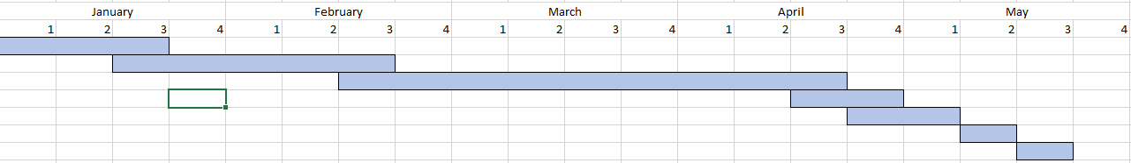

3.0 Project Design

3.1 site map
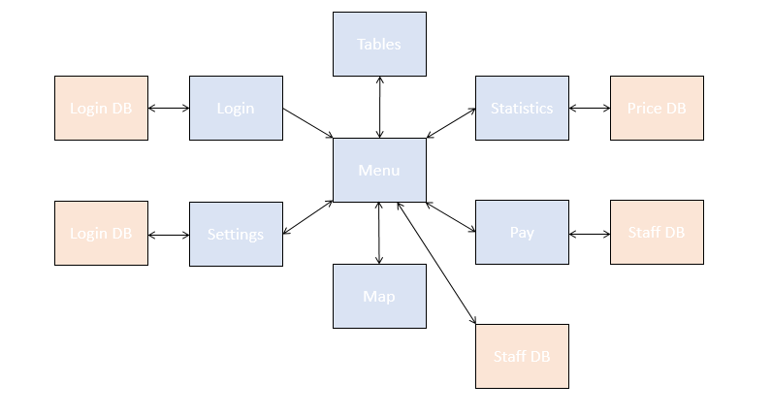

3.2 Storyboards
Page Title: Login

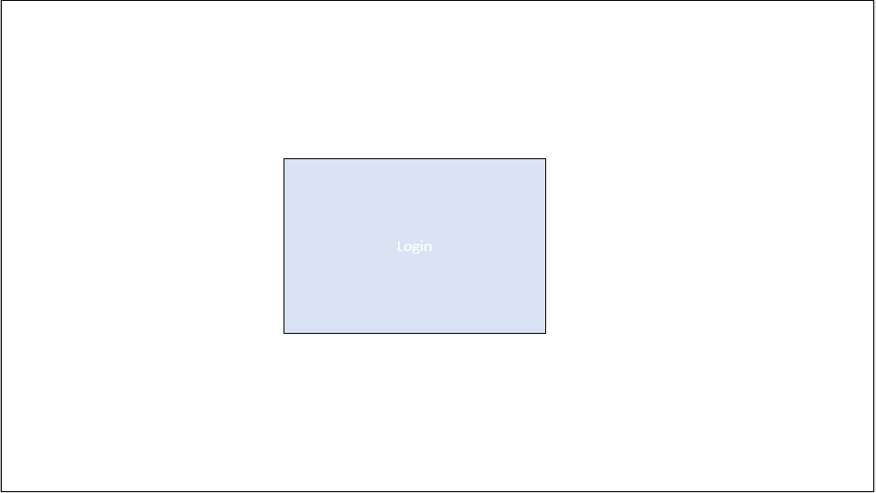
Background: White

CSS File: Login.CSS, bootstrap.CSS, vendors.CSS

Images: N/A

Sound: N/A

Videos: N/A

Interaction: Login/Cancel Buttons, 2 text inputs

Navigation: NA

Meta-Tagging: Papisweb, Login

Content Description:

Page Title: Main Menu

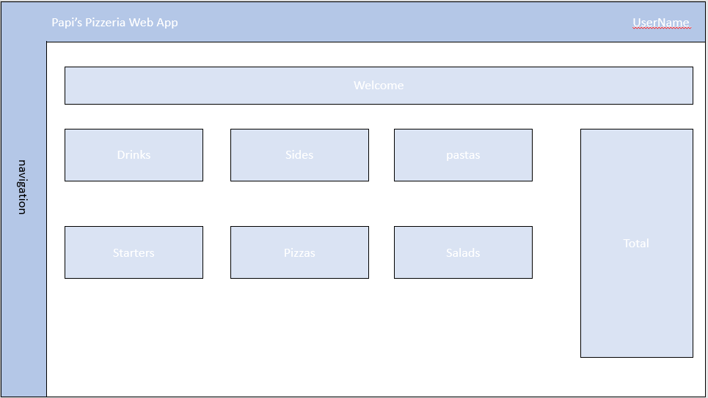
Background: White

CSS File: nav.CSS, bootstrap.CSS, vendors.CSS

Images: N/A

Sound: N/A

Videos: N/A

Interaction: 6 expanding classes, 28 Add buttons, 1 Checkout button, 1 Clear button
Navigation: Navigation to all other pages besides login
Meta-Tagging: Papisweb, Main Menu

Content Description:

Page Title: Tables

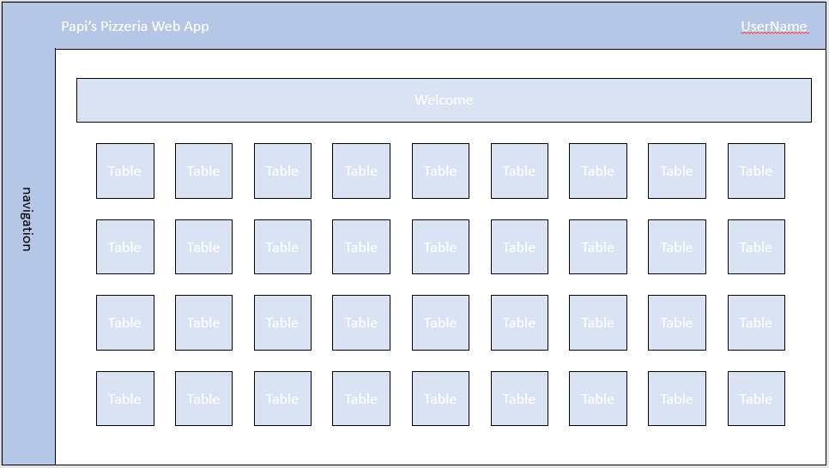
Background: White

CSS File: nav.CSS, bootstrap.CSS, vendors.CSS

Images: N/A

Sound: N/A

Videos: N/A

Interaction: a large selection of different tables that you can assign a bill too.
Navigation: Navigation to all other pages besides login
Meta-Tagging: Papisweb, tables

Content Description:

Page Title: Map

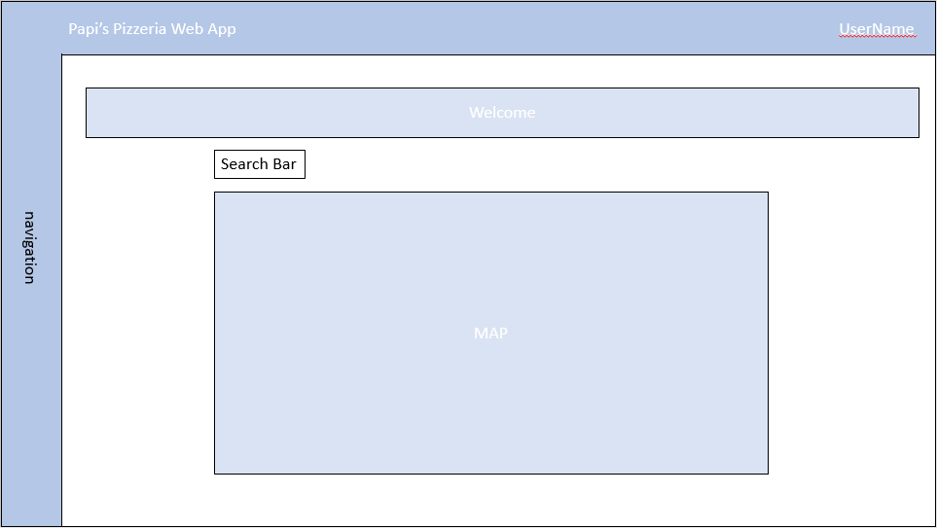
Background: White

CSS File: nav.CSS, bootstrap.CSS, vendors.CSS

Images: N/A

Sound: N/A

Videos: N/A

Interaction: search bar with a map that updates
Navigation: Navigation to all other pages besides login
Meta-Tagging: Papisweb, map

Content Description:

Page Title: Statistics

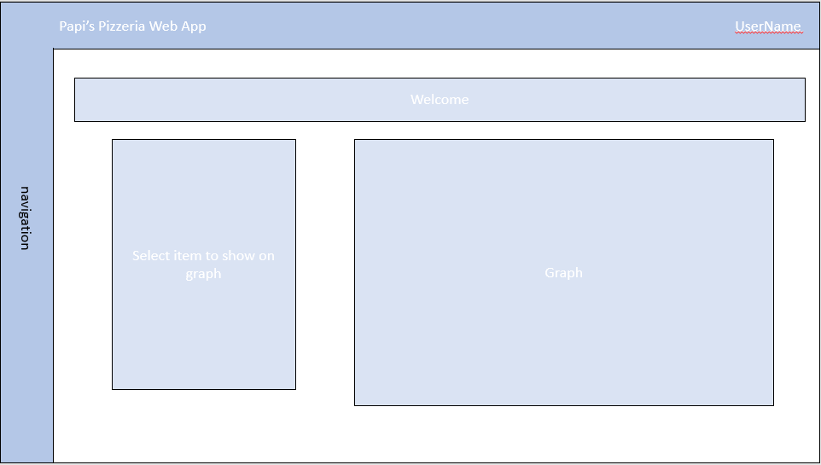
Background: White

CSS File: nav.CSS, bootstrap.CSS, vendors.CSS

Images: N/A

Sound: N/A

Videos: N/A

Interaction: select a statistic to see as a graph
Navigation: Navigation to all other pages besides login
Meta-Tagging: Papisweb, statistics

Content Description:

Page Title: Settings

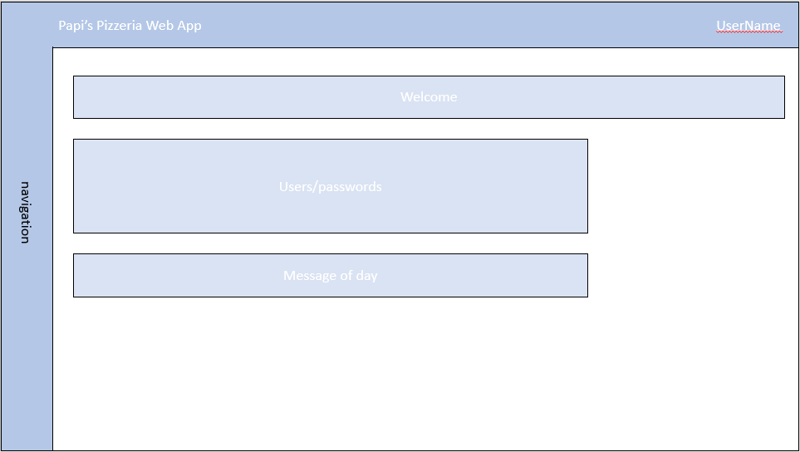
Background: White

CSS File: nav.CSS, bootstrap.CSS, vendors.CSS

Images: N/A

Sound: N/A

Videos: N/A

Interaction: N/A
Navigation: Navigation to all other pages besides login
Meta-Tagging: Papisweb, settings

Content Description:

Page Title: Payroll

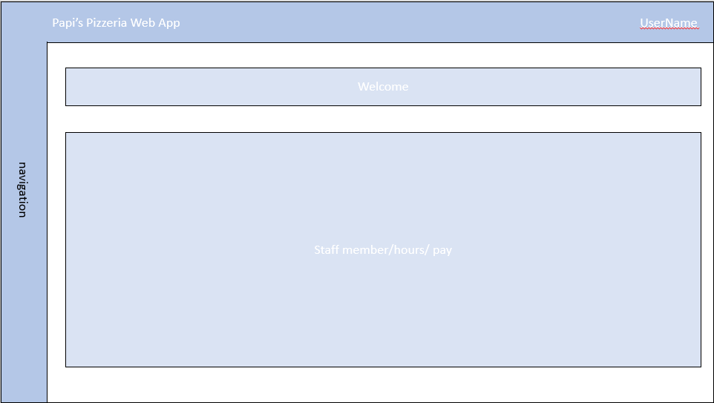
Background: White

CSS File: nav.CSS, bootstrap.CSS, vendors.CSS

Images: N/A

Sound: N/A

Videos: N/A

Interaction: N/A
Navigation: Navigation to all other pages besides login
Meta-Tagging: Papisweb, payroll

Content Description:

3.3 ERD
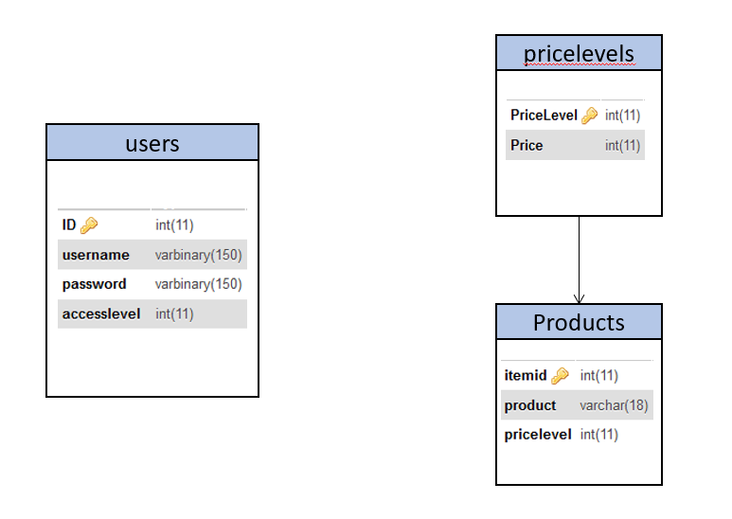

3.6 SQL scripts

Creating a login for the admin user:
INSERT INTO users (ID,username,password,accesslevel,lastupdated,loginname,jobrole,lastloggedin)
VALUES ('1', admin’, password’, '0', '2018-05-23 20:17:20', 'Administrator'.’ System Administrator’,’ 2018-05-23 20:17:20’);

Creating a list of price levels:
INSERT INTO pricelevels (PriceLevel,Price)
VALUES ('1', 0.90’);
VALUES ('2', 1.90’);
VALUES ('3', 4.90’);
VALUES ('4', 9.90’);
VALUES ('5', 11.90’);
VALUES ('6', 14.90’);

INSERT INTO products (itemid,product,pricelevel)
VALUES ('1', ‘Coca-Cola’, ‘1’);
VALUES ('2', ‘Diet Coca-Cola’, ‘1’);
VALUES ('3', ‘Salad’, ‘3’);
VALUES ('4', ‘Plain Pizza’, ‘4’);
VALUES ('5', ‘pepperoni pizza’, ‘5’);
VALUES ('6', ‘sausage calzone’, ‘6’);

3.7 Evaluation criteria

To test if the product that I have designed and implemented meets all of the criteria proposed I will be completing an in depth test plan that will help identify what criteria has been fulfilled/not fulfilled. I will not be the only user testing to system to try and avoid bias therefor another user will be brought in to test the project to ensure nothing is skipped over and overlooked.

4.0 Testing

Test No./page | Test | Expected result | Obtained result | Action taken
Login Page
- Login | Username entry | Username will be accepted along with the password | Username and password was successfully accepted. | N/A
- Login | Password entry | password will be accepted along with the username | Username and password was successfully accepted. | N/A
- Login | No username | Error message will show | Error message obtained | N/A
- Login | No password | Error message will show | Error message obtained | N/A
Dashboard
- Navigation | Test 7 of the buttons on the navigation bar and see if they take the user to the corresponding page | User will be taken to the correct pages | 5/7 Pages work correctly, other 2 pages are incomplete | Need to address the issue of 2 missing pages

5.0 Evaluation
I am disappointed in the outcome of this project, the application that I have created failed to meet the requirements that I set in the design phase and the whole project could be massively improved. This was down to both lack of available time and the lack of dedication that I as a developer put into making this project a reality. I failed to balance the amount of time spent designing and creating the project and therefor have ended up with a lacklustre product because of those actions.
With the current state of my project I have not met the project aims that I had originally set out to achieve, this is a large set back in terms of my development and designing of the system. The aims of this project were to Create more features as requested by staff members and to Reduce time spent taking orders by improving layout and speed of the application
Even though the outcome of this project was ultimately a failure on my part I found a large collection of resources to use that will help in the creation and development of projects in the future. Along with finding helpful resources I also learned a very valuable lesson on time management and that the ratio of effort in/final product is much larger than I anticipated.

If I was to do this project again I would manage my time much more productively to stop the main issue that I had during this project, I would efficiently use the resources at my disposal to speed up development times and I would try and stick to the design section much closer than I did this time around. I would also aim to add in more features to the web app, during this project I ran out of time and was very limited to what I could add into the final product which ultimately was a complete failure. This all ultimately came down to very poor time management on my part which would be the main focus of the next project I work on.

6.0 User Guide

Login page:
Both the username and password boxes both need to be filled before a user can login. If any box is empty an error box will be shown,
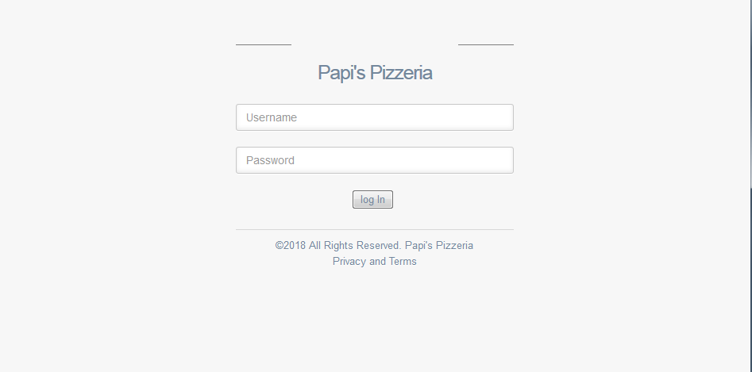

Dashboard:
Clicking add on one of the buttons should add the product to the total tab on the right hand side.
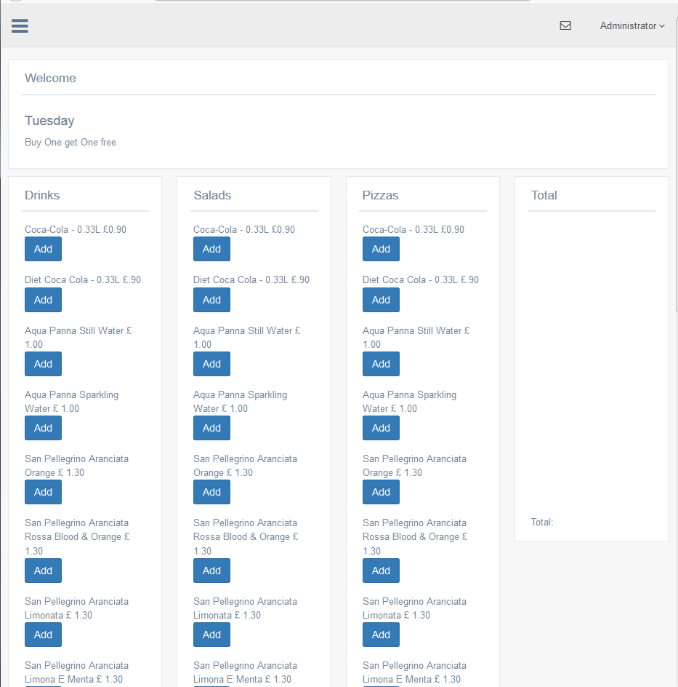
Tables:
Clicking add on one of the tables should assign the current total to the table.
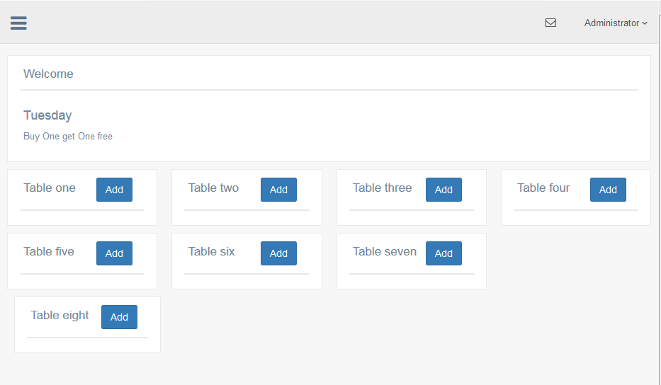

Map:
Entering an address into the search bar and hitting search should bring the address up on the google map.
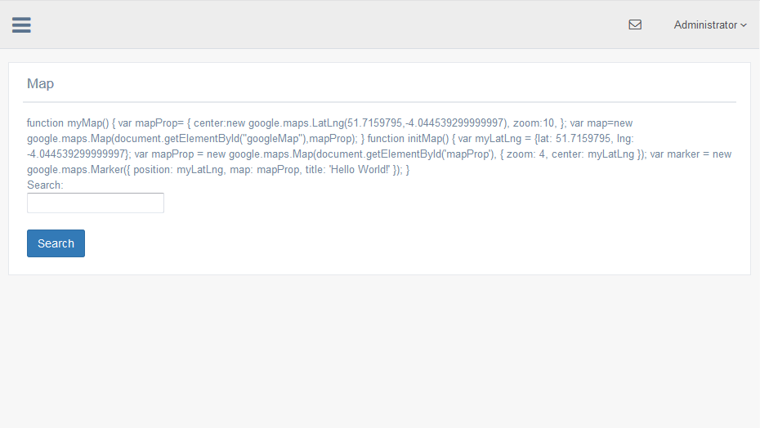

Payroll:
Payroll should be auto updated with clocked in hours.
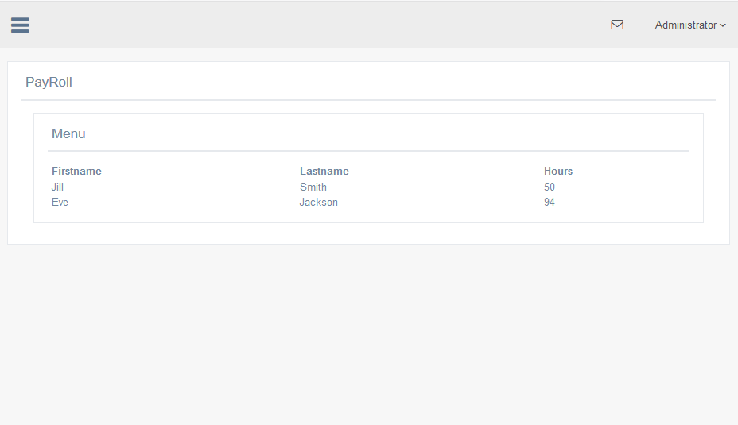

Statistics:
Selecting a statistic from the list should bring up a graph showing the selected statistic.
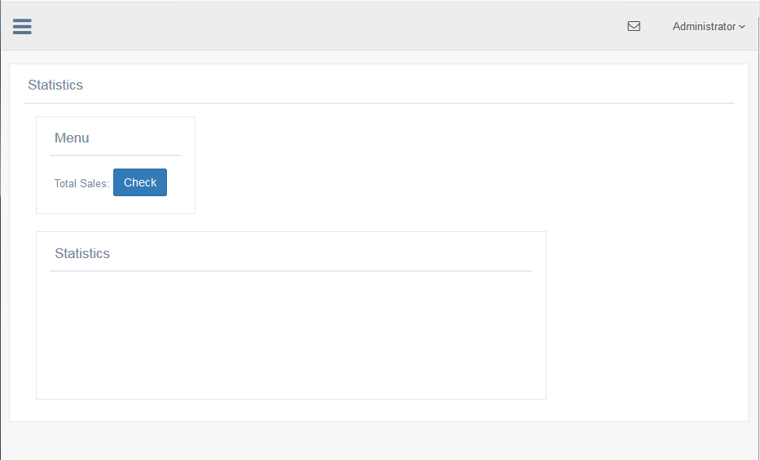

Settings:
Selecting the users tab will bring up the currently registered users allowing you to edit their details.
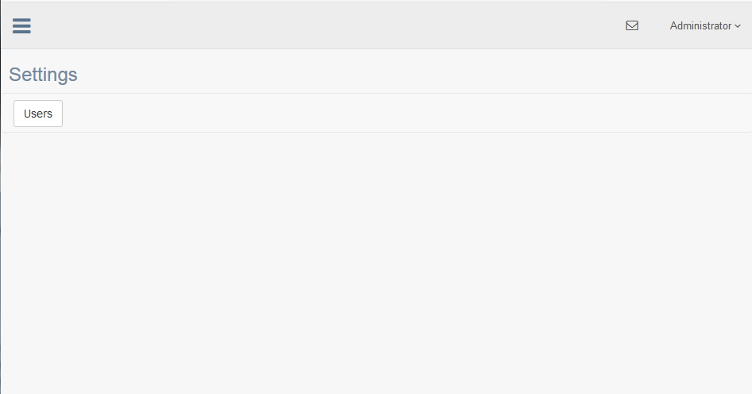

Bibliography

https://unicenta.com/

http://chromis.co.uk/chromispos/

Appendix A
This must be included if you have additional data that supports the content of your assignment. E.g. raw research data tables.
<?php
include "../scripts/sessionstart.php"; /*session starting*/
include "../scripts/config.php"; /*database shit*/
include "../scripts/sessionhandling.php"; /*session handling*/
?>
<!DOCTYPE html>
<html lang="en">
<head>
<meta http-equiv="Content-Type" content="text/html; charset=UTF-8">
<!-- Meta, title, CSS, favicons, etc. -->
<meta charset="utf-8">
<meta http-equiv="X-UA-Compatible" content="IE=edge">
<meta name="viewport" content="width=device-width, initial-scale=1">

<title>Home | </title>

<!-- css header includes -->
<?php include "..\scripts\cssheader.php" ?>

</head>

<body class="nav-md">
<div class="container body">
<div class="main_container">
<div class="col-md-3 left_col">
<div class="left_col scroll-view">

<div class="clearfix"></div>

<!-- menu profile quick info -->
<?php include "../scripts/userinfo.php" ?>
<!-- /menu profile quick info -->

<br />

<!-- sidebar menu -->
<?php include "../scripts/sidemenu.php" ?>
<!-- /sidebar menu -->
</div>
</div>

<!-- top navigation -->
<?php include "../scripts/navbar.php" ?>
<!-- /top navigation -->

<!-- page content -->
<div class="right_col" role="main">
<div class="">
<div class="page-title">
<div class="title_left">

</div>

</div>

<div class="clearfix"></div>

<div class="row">
<div class="col-md-12 col-sm-12 col-xs-12">
<div class="x_panel">
<div class="x_title">
<h2>Welcome</h2>

<div class="clearfix"></div>
</div>
<div class="x_content">
<h2>Tuesday</h2>
<p>Buy One get One free
</div>

</div>
</div>
</div>
<!-- @@@@@@@@@@@@@@@@@ -->
<div class="row">
<div class="col-md-3 col-sm-3 col-xs-3">
<div class="x_panel">
<div class="x_title">
<ul class="nav navbar-right panel_toolbox">
<li><a class="collapse collapse-link"><i class="fa fa-chevron-up"></i></a>
</li>
</ul>
<h2>Drinks</h2>

<div class="clearfix"></div>
</div>
<div class="x_content">
Coca-Cola - 0.33L £0.90<br>
<button type="button" class="btn btn-primary">Add</button>
</div>
<div class="x_content">
Diet Coca Cola - 0.33L £.90<br>
<button type="button" class="btn btn-primary">Add</button>
</div>
<div class="x_content">
Aqua Panna Still Water £ 1.00<br>
<button type="button" class="btn btn-primary">Add</button>
</div>
<div class="x_content">
Aqua Panna Sparkling Water £ 1.00<br>
<button type="button" class="btn btn-primary">Add</button>
</div>
<div class="x_content">
San Pellegrino Aranciata Orange £ 1.30<br>
<button type="button" class="btn btn-primary">Add</button>
</div>
<div class="x_content">
San Pellegrino Aranciata Rossa Blood & Orange £ 1.30<br>
<button type="button" class="btn btn-primary">Add</button>
</div>
<div class="x_content">
San Pellegrino Aranciata Limonata £ 1.30<br>
<button type="button" class="btn btn-primary">Add</button>
</div>
<div class="x_content">
San Pellegrino Aranciata Limona E Menta £ 1.30<br>
<button type="button" class="btn btn-primary">Add</button>
</div>
<div class="x_content">
San Pellegrino Aranciata Melograno E Arancia £ 1.30<br>
<button type="button" class="btn btn-primary">Add</button>
</div>
</div>
</div>

<!-- @@@@@@@@@@@@@@@@@ -->

<div class="col-md-3 col-sm-3 col-xs-3">
<div class="x_panel">
<div class="x_title">
<h2>Exercises</h2>

<div class="clearfix"></div>
</div>
<div class="x_content">
Back Extension
<br>
</div>
<div class="x_content">
Barbell Row
</div>

</div>
</div>

<!-- @@@@@@@@@@@@@@@@@ -->

<div class="col-md-3 col-sm-3 col-xs-3">
<div class="x_panel">
<div class="x_title">
<h2>Exercises</h2>

<div class="clearfix"></div>
</div>
<div class="x_content">
Back Extension
<br>
</div>
</div>
</div>
<!-- @@@@@@@@@@@@@@@@@ -->

<div class="col-md-3 col-sm-3 col-xs-3">
<div class="x_panel">
<div class="x_title">
<h2>Total</h2>

<div class="clearfix"></div>
</div>
<div class="x_content">

<br>
<br>
<br>
</div>
</div>
</div>
<div class="row">

</div>
<!-- @@@@@@@@@@@@@@@@@ -->
<div class="row">
<div class="col-md-3 col-sm-3 col-xs-3">
<div class="x_panel">
<div class="x_title">
<h2>Drinks</h2>

<div class="clearfix"></div>
</div>
<div class="x_content">
Back Extension
<br>
</div>
<div class="x_content">
Barbell Row
</div>

</div>
</div>

<!-- @@@@@@@@@@@@@@@@@ -->

<div class="col-md-3 col-sm-3 col-xs-3">
<div class="x_panel">
<div class="x_title">
<h2>Exercises</h2>

<div class="clearfix"></div>
</div>
<div class="x_content">
Back Extension
<br>
</div>
<div class="x_content">
Barbell Row
</div>

</div>
</div>

<!-- @@@@@@@@@@@@@@@@@ -->

<div class="col-md-3 col-sm-3 col-xs-3">
<div class="x_panel">
<div class="x_title">
<h2>Exercises</h2>

<div class="clearfix"></div>
</div>
<div class="x_content">
Back Extension
<br>
</div>
<div class="x_content">
Barbell Row
</div>

</div>
</div>
</div>
<!-- @@@@@@@@@@@@@@@@@ -->

</div>
</p>
</div>
</div>
</div>
</div>
</div>
</div>
<!-- /page content -->

<!-- footer content -->
<?php include "../scripts/pagefooter.php" ?>
<!-- /footer content -->
</div>
</div>

<!-- includes for various js plugins -->
<?php include "../scripts/appfooter.php" ?>
<!-- end includes -->
</body>
</html>

<?php
include "../scripts/sessionstart.php";

if (isset($_SESSION['errormessage']))
$errormsg = $_SESSION['errormessage'];
unset($_SESSION['errormessage']);
?>
<!DOCTYPE html>
<html lang="en">
<head>
<meta http-equiv="Content-Type" content="text/html; charset=UTF-8">
<!-- Meta, title, CSS, favicons, etc. -->
<meta charset="utf-8">
<meta http-equiv="X-UA-Compatible" content="IE=edge">
<meta name="viewport" content="width=device-width, initial-scale=1">

<title>Welcome!</title>

<!-- include relevant css files -->
<?php include "../scripts/cssheader.php" ?>
<!-- end include css -->

<!-- Bootstrap -->
<link href="../vendors/bootstrap/dist/css/bootstrap.min.css" rel="stylesheet">
<!-- Font Awesome -->
<link href="../vendors/font-awesome/css/font-awesome.min.css" rel="stylesheet">
<!-- NProgress -->
<link href="../vendors/nprogress/nprogress.css" rel="stylesheet">
<!-- Animate.css -->
<link href="../vendors/animate.css/animate.min.css" rel="stylesheet">

<!-- Custom Theme Style -->
<link href="../build/css/custom.min.css" rel="stylesheet">
</head>

<body class="login">
<div>
<a class="hiddenanchor" id="signup"></a>
<a class="hiddenanchor" id="signin"></a>

<div class="login_wrapper">
<div class="animate form login_form">
<section class="login_content">
<h1>Papi's Pizzeria</h1>

<form action="login.php" method="post">

<div>
<input type="text" name = "username" class="form-control" placeholder="Username" required="" />
</div>
<div>
<input type="password" name = "password" class="form-control" placeholder="Password" required="" />
</div>
<div>
<button type="submit"> log In</button>
</div>
<?php
/* display error if it exists */
if(isset($errormsg))
{
echo ("<p class='text-red text-center'><b>".$errormsg."</b></p>");
}
?>
<div class="clearfix"></div>

<div class="separator">
<div>

<p>
©2018 All Rights Reserved.
Papi's Pizzeria
<BR> Privacy and Terms
</p>
</div>
</div>
</form>
</section>
</div>

</div>
</div>
</body>
</html>

<?php
include "../scripts/sessionstart.php";
include "../scripts/config.php";
include "../scripts/dbconn.php";

/* get username/password from form */
$username = $_POST['username'];
$password = $_POST['password'];

/* now generate the query */
$sql = $dbconn->prepare("select id, loginname, AES_DECRYPT(username,'$key') as username, accesslevel, jobrole, lastloggedin from users where AES_DECRYPT(username,'$key') = ? and AES_DECRYPT(password,'$key') = ?");
$sql->bind_param('ss', $username, $password);

/* execute the query */
$sql->execute();

$sql->bind_result($id, $loginname, $username, $accesslevel, $jobrole, $lastloggedin);
$sql->store_result();
$sql->fetch();
if (!empty($sql->error))
{
echo "Error: " . $sql->error;
echo "Error No: " . $sql->errno;
die();
header("location: ../login");
exit();
}
// reset session variables
unset($_SESSION['errormessage']);
unset($_SESSION['login']);
unset($_SESSION['id']);
unset($_SESSION['loginname'] );
unset($_SESSION['uname']);
unset($_SESSION['accesslevel']);
unset($_SESSION['jobrole']);
unset($_SESSION['lastloggedin']);
unset($_SESSION['LAST_ACTIVITY']);

$_SESSION['errormessage'] = '';
$_SESSION['login'] = true;
$_SESSION['id'] = 0;
$_SESSION['loginname'] = '';
$_SESSION['uname'] = '';
$_SESSION['accesslevel'] = 0;
$_SESSION['jobrole'] = '';
/*sort out the date time format */

$_SESSION['lastloggedin'] = '';
$_SESSION['LAST_ACTIVITY'] = time();

/* launch dashboard if only 1 record */
if ($sql->num_rows == 1)
{
/* clear error and get user details data */
$_SESSION['errormessage'] = 'No Error';
$_SESSION['login'] = true;
$_SESSION['id'] = $id;
$_SESSION['loginname'] = $loginname;
$_SESSION['uname'] = $username;
$_SESSION['accesslevel'] = $accesslevel;
$_SESSION['jobrole'] = $jobrole;
/*sort out the date time format */
$date = strtotime($lastloggedin);
$_SESSION['lastloggedin'] = date("d-m-Y h:i a");
$_SESSION['LAST_ACTIVITY'] = time();
$_SESSION['errormessage'] = '';

/* update users account with new login time */
$sql = $dbconn->prepare("update users set lastloggedin = now() where id = ?");
$sql->bind_param('i', $id);
$sql->execute();

/* redirect to the dasboard */
$sql->close();
$dbconn->close();

header("location: ../dashboard");
exit();
}
else
{
$_SESSION['errormessage'] = 'Error 1: Invalid Login/Password Entered. Try Again';
$sql->close();
$dbconn->close();
echo "No Rows".$sql->num_rows;
die();
header("location: ../login");
exit();
}

?>
body {
background: white ;
color: gray

}
h3 {
color: white;
padding: 2px 6px;
font-family: "Lucida Console";

}

/* NAVIGATION BAR */
/* The navigation bar */
.navbar {
overflow: hidden;
background-color: #333;
position: fixed; /* Set the navbar to fixed position */
top: 0; /* Position the navbar at the top of the page */
width: 100%; /* Full width */
}

/* Links inside the navbar */
.navbar a {
float: left;
display: block;
color: #f2f2f2;
text-align: center;
padding: 14px 16px;
text-decoration: none;
}

/* Main content */
.main {
margin-top: 30px; /* Add a top margin to avoid content overlay */
}
/* LOGIN FORM */
/* Bordered form */
form {
border: 0px solid #f1f1f1;
}

/* Full-width inputs */
input[type=text], input[type=password] {
width: 100%;
padding: 12px 20px;
margin: 8px 0;
display: inline-block;
border: 1px solid #ccc;
box-sizing: border-box;
}

/* Set a style for all buttons */
button {
background-color: #4CAF50;
color: white;
padding: 14px 20px;
margin: 8px 0;
border: none;
cursor: pointer;
width: 100%;
}

/* Add a hover effect for buttons */
button:hover {
opacity: 0.8;
}

/* Extra style for the cancel button (red) */
.cancelbtn {
width: auto;
padding: 10px 18px;
background-color: #f44336;
}

/* Center the avatar image inside this container */
.imgcontainer {
text-align: center;
margin: 24px 0 12px 0;
}

/* Avatar image */
img.avatar {
width: 40%;
border-radius: 50%;
}

/* Add padding to containers */
.container {
padding: 16px;
}

/* The "Forgot password" text */
span.psw {
float: right;
padding-top: 16px;
}

/* Change styles for span and cancel button on extra small screens */
@media screen and (max-width: 300px) {
span.psw {
display: block;
float: none;
}
.cancelbtn {
width: 100%;
}
}

.topnav {
overflow: hidden;
background-color: #e9e9e9;
}

.topnav a {
float: right;
display: block;
color: black;
text-align: center;
padding: 14px 16px;
text-decoration: none;
font-size: 17px;
}

.topnav a:hover {
background-color: #ddd;
color: black;
}

.topnav a.active {
background-color: #2196F3;
color: white;
}

.topnav .search-container {
float: right;
}

.topnav input[type=text] {
padding: 6px;
margin-top: 8px;
font-size: 17px;
border: none;
}

.topnav .search-container button {
float: right;
padding: 6px 10px;
margin-top: 8px;
margin-right: 16px;
background: #ddd;
font-size: 17px;
border: none;
cursor: pointer;
}

.topnav .search-container button:hover {
background: #ccc;
}

@media screen and (max-width: 600px) {
.topnav .search-container {
float: none;
}
.topnav a, .topnav input[type=text], .topnav .search-container button {
float: none;
display: block;
text-align: left;
width: 100%;
margin: 0;
padding: 14px;
}
.topnav input[type=text] {
border: 1px solid #ccc;
}
<?php
include "../scripts/sessionstart.php"; /*session starting*/
include "../scripts/config.php"; /*database shit*/
include "../scripts/sessionhandling.php"; /*session handling*/
?>
<!DOCTYPE html>
<html lang="en">
<head>
<meta http-equiv="Content-Type" content="text/html; charset=UTF-8">
<!-- Meta, title, CSS, favicons, etc. -->
<meta charset="utf-8">
<meta http-equiv="X-UA-Compatible" content="IE=edge">
<meta name="viewport" content="width=device-width, initial-scale=1">

<title>Home | </title>

<!-- css header includes -->
<?php include "..\scripts\cssheader.php" ?>

</head>

<body class="nav-md">
<div class="container body">
<div class="main_container">
<div class="col-md-3 left_col">
<div class="left_col scroll-view">

<div class="clearfix"></div>

<!-- menu profile quick info -->
<?php include "../scripts/userinfo.php" ?>
<!-- /menu profile quick info -->

<br />

<!-- sidebar menu -->
<?php include "../scripts/sidemenu.php" ?>
<!-- /sidebar menu -->
</div>
</div>

<!-- top navigation -->
<?php include "../scripts/navbar.php" ?>
<!-- /top navigation -->

<!-- page content -->
<div class="right_col" role="main">
<div class="">
<div class="page-title">
<div class="title_left">

</div>

</div>

<div class="clearfix"></div>

<div class="row">
<div class="col-md-12 col-sm-12 col-xs-12">
<div class="x_panel">
<div class="x_title">
<h2>Map</h2>

<div class="clearfix"></div>
</div>
<div class="x_content">
<script>
function myMap() {
var mapProp= {
center:new google.maps.LatLng(51.7159795,-4.044539299999997),
zoom:10,
};
var map=new google.maps.Map(document.getElementById("googleMap"),mapProp);
}

function initMap() {
var myLatLng = {lat: 51.7159795, lng: -4.044539299999997};

var mapProp = new google.maps.Map(document.getElementById('mapProp'), {
zoom: 4,
center: myLatLng
});

var marker = new google.maps.Marker({
position: myLatLng,
map: mapProp,
title: 'Hello World!'
});
}
</script>

<script src="https://maps.googleapis.com/maps/api/js?key=AIzaSyDg7mNIQ9J9txx6ASh2oJux2snyVQV-C-8 &callback=myMap"></script>

</div>

</div>
</div>
</div>

</div>
</p>
</div>
</div>
</div>
</div>
</div>
</div>
<!-- /page content -->

<!-- footer content -->
<?php include "../scripts/pagefooter.php" ?>
<!-- /footer content -->
</div>
</div>

<!-- includes for various js plugins -->
<?php include "../scripts/appfooter.php" ?>
<!-- end includes -->
</body>
</html>
<!-- jQuery -->
<script src="../vendors/jquery/dist/jquery.min.js"></script>
<!-- Bootstrap -->
<script src="../vendors/bootstrap/dist/js/bootstrap.min.js"></script>
<!-- FastClick -->
<script src="../vendors/fastclick/lib/fastclick.js"></script>
<!-- NProgress -->
<script src="../vendors/nprogress/nprogress.js"></script>
<!-- Datatables -->
<script src="../vendors/datatables.net/js/jquery.dataTables.min.js"></script>
<script src="../vendors/datatables.net-bs/js/dataTables.bootstrap.min.js"></script>
<script src="../vendors/datatables.net-buttons/js/dataTables.buttons.min.js"></script>
<script src="../vendors/datatables.net-buttons-bs/js/buttons.bootstrap.min.js"></script>
<script src="../vendors/datatables.net-buttons/js/buttons.flash.min.js"></script>
<script src="../vendors/datatables.net-buttons/js/buttons.html5.min.js"></script>
<script src="../vendors/datatables.net-buttons/js/buttons.print.min.js"></script>
<script src="../vendors/datatables.net-fixedheader/js/dataTables.fixedHeader.min.js"></script>
<script src="../vendors/datatables.net-keytable/js/dataTables.keyTable.min.js"></script>
<script src="../vendors/datatables.net-responsive/js/dataTables.responsive.min.js"></script>
<script src="../vendors/datatables.net-responsive-bs/js/responsive.bootstrap.js"></script>
<script src="../vendors/datatables.net-scroller/js/dataTables.scroller.min.js"></script>

<!-- bootstrap-daterangepicker -->
<script src="../vendors/moment/min/moment.min.js"></script>
<script src="../vendors/bootstrap-daterangepicker/daterangepicker.js"></script>
<script src="../vendors/bootstrap-datetimepicker/build/js/bootstrap-datetimepicker.min.js"></script>

<!-- Custom Theme Scripts -->
<script src="../build/js/custom.min.js"></script>
<?php

// DB configuration
$dbhost = "localhost";
$dbname = "dvdrentals2017";
$dbuser = "root";
$dbpass = "password";
$key = "Pa55w0rd";

// admin/password
// session timers settings
$sessionexpiry = 2000; // 1800 sec = 30 mins

?>
<!-- Bootstrap -->
<link href="../vendors/bootstrap/dist/css/bootstrap.min.css" rel="stylesheet">
<!-- Font Awesome -->
<link href="../vendors/font-awesome/css/font-awesome.min.css" rel="stylesheet">
<!-- NProgress -->
<link href="../vendors/nprogress/nprogress.css" rel="stylesheet">
<!-- Animate.css -->
<link href="../vendors/animate.css/animate.min.css" rel="stylesheet">
<!-- Datatables -->
<link href="../vendors/datatables.net-bs/css/dataTables.bootstrap.min.css" rel="stylesheet">
<link href="../vendors/datatables.net-buttons-bs/css/buttons.bootstrap.min.css" rel="stylesheet">
<link href="../vendors/datatables.net-fixedheader-bs/css/fixedHeader.bootstrap.min.css" rel="stylesheet">
<link href="../vendors/datatables.net-responsive-bs/css/responsive.bootstrap.min.css" rel="stylesheet">
<link href="../vendors/datatables.net-scroller-bs/css/scroller.bootstrap.min.css" rel="stylesheet">
<!-- bootstrap-daterangepicker -->
<link href="../vendors/bootstrap-daterangepicker/daterangepicker.css" rel="stylesheet">
<!-- Custom Theme Style -->
<link href="../build/css/custom.min.css" rel="stylesheet">
<?php

/* get the data from the form and find a user */
$dbconn = new mysqli($dbhost, $dbuser, $dbpass, $dbname);

if($dbconn->connect_errno > 0)
{
die('Unable to connect to database [' . $dbconn->connect_error . ']');
}
?>
<?php
/* start to the session */
session_start();

/* remove all session variables */
session_unset();

/* destroy the session */
session_destroy();

/* redirect to the login */
header("location: ../login");
?>
<div class="top_nav">
<div class="nav_menu">
<nav>
<div class="nav toggle">
<a id="menu_toggle"><i class="fa fa-bars"></i></a>
</div>

<ul class="nav navbar-nav navbar-right">
<li class="">
<a href="javascript:;" class="user-profile dropdown-toggle" data-toggle="dropdown" aria-expanded="false">
<img src="images/img.jpg" alt=""><?php echo $_SESSION['loginname']; ?>
<span class=" fa fa-angle-down"></span>
</a>
<ul class="dropdown-menu dropdown-usermenu pull-right">
<li><a href="javascript:;"> Profile</a></li>
<li>
<a href="javascript:;">
<span class="badge bg-red pull-right">50%</span>
<span>Settings</span>
</a>
</li>
<li><a href="javascript:;">Help</a></li>
<li><a href="../scripts/logout.php"><i class="fa fa-sign-out pull-right"></i> Log Out</a></li>
</ul>
</li>

<li role="presentation" class="dropdown">
<a href="javascript:;" class="dropdown-toggle info-number" data-toggle="dropdown" aria-expanded="false">
<i class="fa fa-envelope-o"></i>

</a>
<ul id="menu1" class="dropdown-menu list-unstyled msg_list" role="menu">
<li>
<a>
<span class="image"><img src="images/img.jpg" alt="Profile Image" /></span>
<span>
<span>John Smith</span>
<span class="time">3 mins ago</span>
</span>
<span class="message">
Film festivals used to be do-or-die moments for movie makers. They were where...
</span>
</a>
</li>
<li>
<a>
<span class="image"><img src="images/img.jpg" alt="Profile Image" /></span>
<span>
<span>John Smith</span>
<span class="time">3 mins ago</span>
</span>
<span class="message">
Film festivals used to be do-or-die moments for movie makers. They were where...
</span>
</a>
</li>
<li>
<a>
<span class="image"><img src="images/img.jpg" alt="Profile Image" /></span>
<span>
<span>John Smith</span>
<span class="time">3 mins ago</span>
</span>
<span class="message">
Film festivals used to be do-or-die moments for movie makers. They were where...
</span>
</a>
</li>
<li>
<a>
<span class="image"><img src="images/img.jpg" alt="Profile Image" /></span>
<span>
<span>John Smith</span>
<span class="time">3 mins ago</span>
</span>
<span class="message">
Film festivals used to be do-or-die moments for movie makers. They were where...
</span>
</a>
</li>
<li>
<div class="text-center">
<a>
<strong>See All Alerts</strong>
<i class="fa fa-angle-right"></i>
</a>
</div>
</li>
</ul>
</li>
</ul>
</nav>
</div>
</div>
<footer>
<div class="pull-right">
Training Tracker (c) Bont Elim Community Church 2018
</div>
<div class="clearfix"></div>
</footer>
<?php
if (isset($_SESSION['LAST_ACTIVITY']) && (time() - $_SESSION['LAST_ACTIVITY'] > $sessionexpiry)) {
// last request was more than 30 minutes ago
session_unset(); // unset $_SESSION variable for the run-time
session_destroy(); // destroy session data in storage
session_start();
/* redirect to the login */
echo "died";
die();
header("location: ../login");
exit();
}

$_SESSION['LAST_ACTIVITY'] = time(); // update last activity time stamp
?>
<?php
session_start();
?>
<nav class="navbar navbar-default" role="navigation">
<!-- Collect the nav links, forms, and other content for toggling -->
<div class="collapse navbar-collapse" id="">
<a class="btn btn-default navbar-btn" href="userdetails.php" role="button">Users</a>
<a class="btn btn-default navbar-btn" href="welcomemessage.php" role="button">Dashboard Message</a>
</div>
</nav>
<div id="sidebar-menu" class="main_menu_side hidden-print main_menu">
<div class="menu_section">
<h3>System Menu</h3>
<ul class="nav side-menu">
<li>
<a href = "../dashboard"><i class="fa fa-home"></i> Dashboard </a>
</li>
<li>
<a href = "../Tables"><i class="fa fa-edit"></i> Tables</a>
</li>
<li>
<a href = "../Map"><i class="fa fa-map-o"></i> Map </a>
</li>
<li>
<a href = "../statistics"><i class="fa fa-area-chart"></i> Statistics </a>
</li>

<?php
/* check if admin has logged in */
if($_SESSION['accesslevel'] == 0)
{
echo "<li>";
echo "<a href='../settings'>";
echo "<i class='fa fa-cogs'></i> <span>Settings</span>";
echo "</a>";
echo "</li>";
echo "<li>";
echo "<a href='../Payroll'>";
echo "<i class=' fa fa-money'></i> <span>Payroll</span>";
echo "</a>";
echo "</li>";

}
?>
<li>
<a href = "../login"><i class="fa fa-close"></i> Logout </a>
</li>
</ul>
</div>
</div>

<!-- /sidebar menu -->
<div class="profile clearfix">

<div class="profile_info">
<span>Welcome,</span>
<h2><?php echo $_SESSION['loginname']; ?></h2>
</div>
<div class="clearfix"></div>
</div>
<nav class="navbar navbar-default" role="navigation">
<!-- Collect the nav links, forms, and other content for toggling -->
<div class="collapse navbar-collapse" id="">
<a class="btn btn-default navbar-btn" href="adduser.php" role="button">Add User</a>
</div>
</nav>
<?php
include "../scripts/sessionstart.php";
include "../scripts/config.php";
include "../scripts/dbconn.php";

/* variables for keeping hold of data */
$displayname = "";
$username = "";
$password1 = "";
$password2 = "";
$accesslevel = "";
$jobrole = "";
$accesslevel = 0;

/* start checking which button was pressed */
if (!empty($_POST['cancel']))
{
/* redirect to the login */
header("location: userdetails.php");
}

/* process the save */
if (isset($_POST['saveuser']))
{
$save = true;

$displayname = $_POST['displayname'];
$username = $_POST['username'];
$password1 = $_POST['password1'];
$password2 = $_POST['password2'];
$accesslevel = $_POST['accesslevel'];
$jobrole = $_POST['jobrole'];

/* checks are ok. Post the data - be careful of the prepare and brackets ??? */
$sql = $dbconn->prepare("insert into users(username, password, loginname, accesslevel, jobrole) values (AES_ENCRYPT(?,'$key'), AES_ENCRYPT(?,'$key'), ?, ?, ?)");

/* convert accesslevel to int and adjust as we start from 0 */
$myaccesslevel = intval($accesslevel) - 1;
$sql->bind_param('sssis', $username, $password1, $displayname, $myaccesslevel, $jobrole);

/* execute the query */
$sql->execute();

/*close the database */
$sql->close();
$dbconn->close();

/* redirect to userdetails */
header("location: userdetails.php");
}
?>
<!DOCTYPE html>
<html lang="en">
<head>
<meta http-equiv="Content-Type" content="text/html; charset=UTF-8">
<!-- Meta, title, CSS, favicons, etc. -->
<meta charset="utf-8">
<meta http-equiv="X-UA-Compatible" content="IE=edge">
<meta name="viewport" content="width=device-width, initial-scale=1">

<title>Gentelella Alela! | </title>

<!-- css header includes -->
<?php include "..\scripts\cssheader.php" ?>

</head>

<body class="nav-md">
<div class="container body">
<div class="main_container">
<div class="col-md-3 left_col">
<div class="left_col scroll-view">
<div class="navbar nav_title" style="border: 0;">
<a href="index.html" class="site_title"><i class="fa fa-paw"></i> <span>DVD App 2017</span></a>
</div>

<div class="clearfix"></div>

<!-- menu profile quick info -->
<?php include "../scripts/userinfo.php" ?>
<!-- /menu profile quick info -->

<br />

<!-- sidebar menu -->
<?php include "../scripts/sidemenu.php" ?>
<!-- /sidebar menu -->
</div>
</div>

<!-- top navigation -->
<?php include "../scripts/navbar.php" ?>
<!-- /top navigation -->

<!-- page content -->
<div class="right_col" role="main">
<div class="">
<div class="page-title">
<div class="title_left">
<h3>Add New User</h3>
</div>

<div class="clearfix"></div>

<div class="row">
<section>
<?php include "../scripts/settingsmenu.php" ?>
</section><!-- /.content -->
</div>
</div>
</div>
<!-- /page content -->

<div class="clearfix"></div>
<?php include "../scripts/settingsmenu.php" ?>
<div id="row">
<div class="col-xs-7">
<div class = "x_panel">
<form class="form-horizontal" method="post">
<!-- check displayname -->
<div class='form-group form-group-sm '>
<label for="" class="col-xs-3 control-label">Display Name</label>
<div class="col-xs-6">
<input type="text" class="form-control input-sm" name="displayname" id="displayname" placeholder="Display Name" value = "<?php echo $displayname ?>">
</div>
</div>

<!-- check jobrole -->
<div class='form-group form-group-sm '>
<label for="" class="col-xs-3 control-label">Job Role</label>
<div class="col-xs-6">
<input type="text" class="form-control input-sm" name="jobrole" id="jobrole" placeholder="Job Role" value = "<?php echo $jobrole ?>">
</div>
</div>

<!-- access levels -->
<div class='form-group form-group-sm '>
<label for="" class="col-xs-3 control-label">Access Level</label>
<div class="col-xs-6">
<select name="accesslevel" id="accesslevel" class="form-control input-sm" title="Access Level">
<option value="" disabled selected>Access Level</option>
<option <?php if ($accesslevel == 1) echo 'selected'; ?> value=1>Full Control</option>
<option <?php if ($accesslevel == 2) echo 'selected'; ?> value=2>Standard User</option>
<option <?php if ($accesslevel == 3) echo 'selected'; ?> value=3>Read Only</option>
<option <?php if ($accesslevel == 4) echo 'selected'; ?> value=4>Disabled</option>
</select>
</div>
</div>

<!-- username -->
<div class='form-group form-group-sm '>
<label for="" class="col-xs-3 control-label">User Name</label>
<div class="col-xs-6">
<input type="text" class="form-control input-sm" name="username" id="username" placeholder="User Name" value = "<?php echo $username ?>">
</div>

<!-- user for error checking -->
<div id = "status"></div>
</div>

<!-- password -->
<div class='form-group form-group-sm '>
<label for="" class="col-xs-3 control-label">Password</label>
<div class="col-xs-6">
<input type="password" class="form-control input-sm" name="password1" id="password1" placeholder="Password" value="<?php echo $password1 ?>">
</div>
<div id = "p1s"></div>
</div>

<!-- confirm password -->
<div class='form-group form-group-sm '>
<label for="" class="col-xs-3 control-label">Confirm Password</label>
<div class="col-xs-6">
<input type="password" class="form-control input-sm" name="password2" id="password2" placeholder="Confirm Password" value="<?php echo $password2 ?>">
</div>
<div id = "p2s"></div>
</div>

<!-- buttons for the form -->
<div class="action_bar_duplicate action_bar action_bar_center">
<span class="action">
<span class="action_element">
<input type="submit" name="saveuser" id="saveuser" value="Save and Return" class="submit_button btn btn-success"/>
</span>
</span>
<span class="action">
<span class="action_element">
<input type="submit" name="cancel" value="Cancel" class="submit_button submit_button btn btn-default"/>
</span>
</span>
</div>
</div>
</div>
</form>
</div>
</div>
<!-- footer content -->

<!-- /footer content -->
</div>
</div>

<!-- includes for various js plugins -->
<?php include "../scripts/appfooter.php" ?>
<!-- end includes -->
<SCRIPT type="text/javascript">
$(document).ready(function()
{
$("#username").change(function()
{
var username = $("#username").val();
var msgbox = $("#status");

if(username.length > 4)
{
$("#status").html('<img src="../images/loader.gif" align="absmiddle">&nbsp;Checking availability...');

$.ajax(
{
type: "POST",
url: "checkuser.php",
data: "username=" + username,
success: function(msg)
{
if(msg == 'OK')
{
msgbox.html('<img src="../images/available.png" align="absmiddle">');
}
else
{
msgbox.html(msg);
}
}
});
}
else
{
if (username.length == 0)
{
$("#status").html('');
}
else
{
$("#status").html('Please enter at least 5 chars');
}

}
return false;
});
});

// perform data validation
$(document).ready(function()
{

$("#saveuser").click(function()
{
var p1 = $("#password1").val();
var p2 = $("#password2").val();

// compare the passwords
if (p1 == p2)
{
$("#p1s").html("");
$("#p2s").html("");
return true;
}
else
{
$("#p1s").html("<b>Check Passwords</b>");
$("#p2s").html("<b>Check Passwords</b>");
return false;
}

});
});
</script>
</body>
</html>
<?php
session_start();
include "../scripts/config.php";
include "../scripts/dbconn.php";

/* get username/password from form */
if (isset($_POST['username']))
{
$username = $_POST['username'];
/* now generate the query */
$sql = $dbconn->prepare("select AES_DECRYPT(username, '$key') from users where AES_DECRYPT(username,'$key') = ?");
$sql->bind_param('s', $username);

/* execute the query */
$sql->execute();
$sql->bind_result($username);
$sql->store_result();
$sql->fetch();

/* process query and inform user of duplicate username */
if ($sql->num_rows > 0)
{
echo("Username already in use");
}
else
{
echo("OK");
}
}
/*close the database */
$sql->close();
$dbconn->close();
?>
<?php
include "../scripts/sessionstart.php";
?>
<!DOCTYPE html>
<html lang="en">
<head>
<meta http-equiv="Content-Type" content="text/html; charset=UTF-8">
<!-- Meta, title, CSS, favicons, etc. -->
<meta charset="utf-8">
<meta http-equiv="X-UA-Compatible" content="IE=edge">
<meta name="viewport" content="width=device-width, initial-scale=1">

<title>Settings | </title>

<!-- css header includes -->
<?php include "..\scripts\cssheader.php" ?>

</head>

<body class="nav-md">
<div class="container body">
<div class="main_container">
<div class="col-md-3 left_col">
<div class="left_col scroll-view">
<div class="navbar nav_title" style="border: 0;">
<a href="index.html" class="site_title"><i class="fa fa-paw"></i> <span>DVD App 2017</span></a>
</div>

<div class="clearfix"></div>

<!-- menu profile quick info -->
<?php include "../scripts/userinfo.php" ?>
<!-- /menu profile quick info -->

<br />

<!-- sidebar menu -->
<?php include "../scripts/sidemenu.php" ?>
<!-- /sidebar menu -->
</div>
</div>

<!-- top navigation -->
<?php include "../scripts/navbar.php" ?>
<!-- /top navigation -->

<!-- page content -->
<div class="right_col" role="main">
<div class="">
<div class="page-title">
<div class="title_left">
<h3>Settings</h3>
</div>

<div class="clearfix"></div>

<div class="row">
<section>
<?php include "../scripts/settingsmenu.php" ?>
</section><!-- /.content -->
</div>
</div>
</div>
<!-- /page content -->

<!-- footer content -->

<!-- /footer content -->
</div>
</div>

<!-- includes for various js plugins -->
<?php include "../scripts/appfooter.php" ?>
<!-- end includes -->
</body>
</html>
<?php
// put relevant include in - required for all pages
include "../scripts/sessionstart.php";
include "../scripts/config.php";
include "../scripts/dbconn.php";

// retrieve message from form
$message = $_POST["editor1"];

// prepare sql script to update messages
$sql = $dbconn->prepare("update settings set message = ? where settingsid = 1");
$sql->bind_param('s', $message);

// execute sql script and check for errors
$sql->execute();

// close connection to DB
$sql->close();
$dbconn->close();

// direct website back to welcomemessage
header("location: welcomemessage.php");
exit();
?>
<?php
include "../scripts/sessionstart.php";
include "../scripts/config.php";
include "../scripts/dbconn.php";

/* now generate the query */
$sql = $dbconn->prepare("select id, loginname, AES_DECRYPT(username,'Pa55w0rd'), accesslevel, jobrole, lastloggedin from users");

/* execute the query */
$sql->execute();
$sql->bind_result($id, $loginname, $username, $accesslevel, $jobrole, $lastloggedin);
$sql->store_result();
?>
<!DOCTYPE html>
<html lang="en">
<head>
<meta http-equiv="Content-Type" content="text/html; charset=UTF-8">
<!-- Meta, title, CSS, favicons, etc. -->
<meta charset="utf-8">
<meta http-equiv="X-UA-Compatible" content="IE=edge">
<meta name="viewport" content="width=device-width, initial-scale=1">

<title>My Demo Site</title>

<!-- css header includes -->
<?php include "..\scripts\cssheader.php" ?>

</head>

<body class="nav-md">
<div class="container body">
<div class="main_container">
<div class="col-md-3 left_col">
<div class="left_col scroll-view">
<div class="navbar nav_title" style="border: 0;">
<a href="index.html" class="site_title"><i class="fa fa-paw"></i> <span>DVD App 2017</span></a>
</div>

<div class="clearfix"></div>

<!-- menu profile quick info -->
<?php include "../scripts/userinfo.php" ?>
<!-- /menu profile quick info -->

<br />

<!-- sidebar menu -->
<?php include "../scripts/sidemenu.php" ?>
<!-- /sidebar menu -->
</div>
</div>

<!-- top navigation -->
<?php include "../scripts/navbar.php" ?>
<!-- /top navigation -->

<!-- page content -->
<div class="right_col" role="main">
<div class="">
<div class="page-title">
<div class="title_left">
<h3>User Accounts</h3>
</div>

<div class="clearfix"></div>

<div class="row">
<section>
<?php include "../scripts/settingsmenu.php" ?>
</section><!-- /.content -->
</div>
</div>
</div>
<!-- /page content -->

<div class="clearfix"></div>
<?php include "../scripts/usersmenu.php" ?>
<div class = "row">
<div class="col-md-12 col-sm-12 col-xs-12">
<div class = "x_panel">
<div class="box-body table-responsive">
<table id="users" class="table table-bordered table-striped">
<thead>
<tr>
<th>Login Name</th>
<th>User Name</th>
<th>Access Level</th>
<th>Job Role</th>
<th>Last Logged In</th>
<th></th>
</tr>
</thead>
<tbody>
<!-- display users here -->
<?php
while ($sql->fetch())
{
echo "<tr>";
/* stop the admin account being selected */
if ($username == "admin" or $username == $_SESSION['uname'])
echo "<td>".$loginname."</td>";
else
echo "<td><a href=edituser.php?id=".$id.">".$loginname."</a></td>";

echo "<td>".$username."</td>";
switch($accesslevel)
{
case 0:
echo "<td>Full Control</td>";
break;
case 1:
echo "<td>Standard User</td>";
break;
case 2:
echo "<td>Read Only</td>";
break;
case 3:
echo "<td>Disabled</td>";
break;
default:
echo "<td>Not Valid</td>";
break;
}

echo "<td>".$jobrole."</td>";
echo "<td>".$lastloggedin."</td>";
/* stop the admin account being deleted */
if ($username == "admin" or $username == $_SESSION['uname'])
echo "<td></td>";
else
echo "<td><a href=deleteuser.php?id=".$id.">Delete</a></td>";
echo "</tr>";
}
?>
</tbody>
</table>
</div>
</div>
</div>
</div>
<!-- footer content -->

<!-- /footer content -->
</div>
</div>

<!-- includes for various js plugins -->
<?php include "../scripts/appfooter.php" ?>
<!-- end includes -->
</body>
</html>
<?php
include "../scripts/sessionstart.php";
include "../scripts/config.php";
include "../scripts/dbconn.php";

/* now generate the query */
$sql = $dbconn->prepare("select message from settings");

/* execute the query */
$sql->execute();
$sql->bind_result($message);
$sql->store_result();
$sql->fetch();
?>

<!DOCTYPE html>
<html lang="en">
<head>
<meta http-equiv="Content-Type" content="text/html; charset=UTF-8">
<!-- Meta, title, CSS, favicons, etc. -->
<meta charset="utf-8">
<meta http-equiv="X-UA-Compatible" content="IE=edge">
<meta name="viewport" content="width=device-width, initial-scale=1">

<title>Gentelella Alela! | </title>

<!-- css header includes -->
<?php include "..\scripts\cssheader.php" ?>
<script src="../vendors/ckeditor/ckeditor.js"></script>

</head>

<body class="nav-md">
<div class="container body">
<div class="main_container">
<div class="col-md-3 left_col">
<div class="left_col scroll-view">
<div class="navbar nav_title" style="border: 0;">
<a href="index.html" class="site_title"><i class="fa fa-paw"></i> <span>DVD App 2017</span></a>
</div>

<div class="clearfix"></div>

<!-- menu profile quick info -->
<?php include "../scripts/userinfo.php" ?>
<!-- /menu profile quick info -->

<br />

<!-- sidebar menu -->
<?php include "../scripts/sidemenu.php" ?>
<!-- /sidebar menu -->
</div>
</div>

<!-- top navigation -->
<?php include "../scripts/navbar.php" ?>
<!-- /top navigation -->

<!-- page content -->
<div class="right_col" role="main">
<div class="">
<div class="page-title">
<div class="title_left">
<h3>Settings</h3>
</div>

<div class="clearfix"></div>

<div class="row">
<section>
<?php include "../scripts/settingsmenu.php" ?>
<form action="updatemessage.php" method="post">
<textarea name="editor1" id="editor1" rows="10" cols="80" >
<?php echo $message; ?>
</textarea>
<script>
// Replace the <textarea id="editor1"> with a CKEditor
// instance, using default configuration.
CKEDITOR.replace( 'editor1' );
</script>
<div>
<button type="submit">Update</button>
</div>
</form>
</section><!-- /.content -->
</div>
</div>
</div>
<!-- /page content -->

<!-- footer content -->

<!-- /footer content -->
</div>
</div>

<!-- includes for various js plugins -->
<?php include "../scripts/appfooter.php" ?>
<!-- end includes -->
</body>
</html>
<?php
include "../scripts/sessionstart.php"; /*session starting*/
include "../scripts/config.php"; /*database shit*/
include "../scripts/sessionhandling.php"; /*session handling*/
?>
<!DOCTYPE html>
<html lang="en">
<head>
<meta http-equiv="Content-Type" content="text/html; charset=UTF-8">
<!-- Meta, title, CSS, favicons, etc. -->
<meta charset="utf-8">
<meta http-equiv="X-UA-Compatible" content="IE=edge">
<meta name="viewport" content="width=device-width, initial-scale=1">

<title>Home | </title>

<!-- css header includes -->
<?php include "..\scripts\cssheader.php" ?>

</head>

<body class="nav-md">
<div class="container body">
<div class="main_container">
<div class="col-md-3 left_col">
<div class="left_col scroll-view">

<div class="clearfix"></div>

<!-- menu profile quick info -->
<?php include "../scripts/userinfo.php" ?>
<!-- /menu profile quick info -->

<br />

<!-- sidebar menu -->
<?php include "../scripts/sidemenu.php" ?>
<!-- /sidebar menu -->
</div>
</div>

<!-- top navigation -->
<?php include "../scripts/navbar.php" ?>
<!-- /top navigation -->

<!-- page content -->
<div class="right_col" role="main">
<div class="">
<div class="page-title">
<div class="title_left">

</div>

</div>

<div class="clearfix"></div>

<div class="row">
<div class="col-md-12 col-sm-12 col-xs-12">
<div class="x_panel">
<div class="x_title">
<h2>Welcome</h2>

<div class="clearfix"></div>
</div>
<div class="x_content">
<h2>Tuesday</h2>
<p>Buy One get One free
</div>

</div>
</div>
</div>
<!-- @@@@@@@@@@@@@@@@@ -->
<div class="row">
<div class="col-md-1 col-sm-3 col-xs-1">
<div class="x_panel">
<div class="x_title">
<ul class="nav navbar-right panel_toolbox">
</ul>
<h2>Table one</h2>
<button type="button" class="btn btn-primary">Add</button>
<div class="clearfix"></div>
</div>

</div>
</div>

<!-- @@@@@@@@@@@@@@@@@ -->

<div class="col-md-3 col-sm-3 col-xs-3">
<div class="x_panel">
<div class="x_title">
<h2>Exercises</h2>

<div class="clearfix"></div>
</div>
<div class="x_content">
Back Extension
<br>
</div>
<div class="x_content">
Barbell Row
</div>

</div>
</div>

<!-- @@@@@@@@@@@@@@@@@ -->

<div class="col-md-3 col-sm-3 col-xs-3">
<div class="x_panel">
<div class="x_title">
<h2>Exercises</h2>

<div class="clearfix"></div>
</div>
<div class="x_content">
Back Extension
<br>
</div>
</div>
</div>
<!-- @@@@@@@@@@@@@@@@@ -->

<div class="col-md-3 col-sm-3 col-xs-3">
<div class="x_panel">
<div class="x_title">
<h2>Total</h2>

<div class="clearfix"></div>
</div>
<div class="x_content">

<br>
<br>
<br>
</div>
</div>
</div>
<div class="row">

</div>
<!-- @@@@@@@@@@@@@@@@@ -->
<div class="row">
<div class="col-md-3 col-sm-3 col-xs-3">
<div class="x_panel">
<div class="x_title">
<h2>Drinks</h2>

<div class="clearfix"></div>
</div>
<div class="x_content">
Back Extension
<br>
</div>
<div class="x_content">
Barbell Row
</div>

</div>
</div>

<!-- @@@@@@@@@@@@@@@@@ -->

<div class="col-md-3 col-sm-3 col-xs-3">
<div class="x_panel">
<div class="x_title">
<h2>Exercises</h2>

<div class="clearfix"></div>
</div>
<div class="x_content">
Back Extension
<br>
</div>
<div class="x_content">
Barbell Row
</div>

</div>
</div>

<!-- @@@@@@@@@@@@@@@@@ -->

<div class="col-md-3 col-sm-3 col-xs-3">
<div class="x_panel">
<div class="x_title">
<h2>Exercises</h2>

<div class="clearfix"></div>
</div>
<div class="x_content">
Back Extension
<br>
</div>
<div class="x_content">
Barbell Row
</div>

</div>
</div>
</div>
<!-- @@@@@@@@@@@@@@@@@ -->

</div>
</p>
</div>
</div>
</div>
</div>
</div>
</div>
<!-- /page content -->

<!-- footer content -->
<?php include "../scripts/pagefooter.php" ?>
<!-- /footer content -->
</div>
</div>

<!-- includes for various js plugins -->
<?php include "../scripts/appfooter.php" ?>
<!-- end includes -->
</body>
</html>
<?php
include "../scripts/sessionstart.php";

header('Location: login/');
?>
<!DOCTYPE html>
<html lang="en">
<head>
<meta http-equiv="Content-Type" content="text/html; charset=UTF-8">
<!-- Meta, title, CSS, favicons, etc. -->
<meta charset="utf-8">
<meta http-equiv="X-UA-Compatible" content="IE=edge">
<meta name="viewport" content="width=device-width, initial-scale=1">

<title>Gentelella Alela! | </title>

<!-- Bootstrap -->
<link href="../vendors/bootstrap/dist/css/bootstrap.min.css" rel="stylesheet">
<!-- Font Awesome -->
<link href="../vendors/font-awesome/css/font-awesome.min.css" rel="stylesheet">
<!-- NProgress -->
<link href="../vendors/nprogress/nprogress.css" rel="stylesheet">
<!-- Animate.css -->
<link href="../vendors/animate.css/animate.min.css" rel="stylesheet">

<!-- Custom Theme Style -->
<link href="../build/css/custom.min.css" rel="stylesheet">
</head>

<body class="login">
<div>
<a class="hiddenanchor" id="signup"></a>
<a class="hiddenanchor" id="signin"></a>

<div class="login_wrapper">
<div class="animate form login_form">
<section class="login_content">
<form>
<h1>Login Form</h1>
<div>
<input type="text" class="form-control" placeholder="Username" required="" />
</div>
<div>
<input type="password" class="form-control" placeholder="Password" required="" />
</div>
<div>
<a class="btn btn-default submit" href="index.html">Log in</a>
<a class="reset_pass" href="#">Lost your password?</a>
</div>

<div class="clearfix"></div>

<div class="separator">
<p class="change_link">New to site?
<a href="#signup" class="to_register"> Create Account </a>
</p>

<div class="clearfix"></div>
<br />

<div>
<h1><i class="fa fa-paw"></i> Gentelella Alela!</h1>
<p>©2016 All Rights Reserved. Gentelella Alela! is a Bootstrap 3 template. Privacy and Terms</p>
</div>
</div>
</form>
</section>
</div>

<div id="register" class="animate form registration_form">
<section class="login_content">
<form>
<h1>Create Account</h1>
<div>
<input type="text" class="form-control" placeholder="Username" required="" />
</div>
<div>
<input type="email" class="form-control" placeholder="Email" required="" />
</div>
<div>
<input type="password" class="form-control" placeholder="Password" required="" />
</div>
<div>
<a class="btn btn-default submit" href="index.html">Submit</a>
</div>

<div class="clearfix"></div>

<div class="separator">
<p class="change_link">Already a member ?
<a href="#signin" class="to_register"> Log in </a>
</p>

<div class="clearfix"></div>
<br />

<div>
<h1><i class="fa fa-paw"></i> Gentelella Alela!</h1>
<p>©2016 All Rights Reserved. Gentelella Alela! is a Bootstrap 3 template. Privacy and Terms</p>
</div>
</div>
</form>
</section>
</div>
</div>
</div>
</body>
</html>

