
BA (Hons) Business Management
LCBB6023 International Business Communications

Student Name: Sergiu Constantin Grigorescu
Student ID: 2233162

Table of Contents
1.0 Introduction 3
1.1 About Japanese market 3
1.2 About Tesco Plc 3
1.3 About Seven & I Holdings Co., Ltd 4
2.0 Cultural Context and Challenges in Japan 4
3.0 Differences in communication styles between the UK and Japanese teams 5
3.1 Cultural Web 5
3.2 Hofstede’s cultural dimensions 7
3.3 High-context and low-context communication theory 8
3.4 The 7 dimensions of culture 10
4.0 Conclusion 11
References 12

Introduction

1.1 About Japanese market
The Japanese market is a highly developed and strong economy in the modern business world. It is one of the largest economies in the world (Blythe‎, 2024). It also has the third-largest stock market globally for its exclusive products and services. Recently, the market has shown strong growth having developed and skilled workforces. Japan has a high-income population (The Culture Factor‎, 2024). The average income is more than $28,000 per person which proves their standard lifestyle. They prefer products that are safe, high quality and reliable. Because of this, companies must maintain very high standards to succeed in this market (Morrison‎, 2025). These include the automotive industry, robotics, electronics and semiconductor materials developed for the world-famous markets. These industries make Japan an important global exporter with unique design and quality. At the same time, Japan depends on imports for many resources. For example, it imports food, energy and natural resources such as gas and coal (The Culture Factor‎, 2024). One major issue in Japan is its aging population in this modern era. The number of older people is increasing while the number of young people is decreasing for several reasons. This creates a higher demand for healthcare services, automation and elderly care. Exclusive products and manufacturing are still very important for exports (Trading Economics‎, 2024). The Tokyo Metropolitan Area is the main economic centre with about 36 million people who are expert in the respective fields. Other important regions include Kansai which has cities like Osaka, Kyoto and Kobe and the Chubu region which includes Nagoya with opportunities (Blythe‎, 2024).

1.2 About Tesco Plc
Tesco plc is the largest supermarket company in the United Kingdom in this modern era. It has around 28.4% share of the grocery market (Blythe‎, 2024). The company was founded in 1919 by Sir Jack Cohen which head office is in Welwyn Garden City, England from the very beginning. Tesco operates more than 4,500 stores in the UK, Ireland and Central Europe with developed and skilled workforces. It sells a wide range of products including food, drinks and household items to meet the needs of the modern customers. The company is also listed in the FTSE 100 which shows that it is one of the largest companies in the UK. Tesco uses different types of stores (The Culture Factor‎, 2024). These include large hypermarkets called Tesco Extra, normal supermarkets and smaller convenience stores such as Tesco Express and One Stop in the modern business aspects. It operates in countries such as Ireland, Slovakia, the Czech Republic and Hungary as a multinational company. In 2018, Tesco bought Booker Group (Trading Economics‎, 2024). For the financial year 2025, Tesco reported revenue of about £69.191 billion with unique design and quality supply. The management works with local suppliers and runs programmes to reduce food waste. The company started with a simple idea of selling large amounts at low prices to meet the needs of the customers. It still follows this idea today by providing affordable products for customers (Tesco plc‎, 2024).

About Seven & I Holdings Co., Ltd
Seven & I Holdings Co., Ltd is a large retail company from Japan by providing best quality products to the community. It was established in 2005 and its head office is in Tokyo (Blythe‎, 2024). The company operates in many countries around the world where the management runs different types of businesses including convenience stores, supermarkets and financial services as a multinational company. The company is best known for its 7-Eleven convenience stores with unique design and quality chain. These stores are very popular in Japan and other countries (Cavusgil et al.‎, 2024). The company also operates other businesses such as Ito-Yokado supermarkets and Seven Bank to meet the needs of the conscious customers. Seven & I works as a holding company which means it manages many different companies under one group. It has a strong presence not only in Japan but also in North America and other regions (Cavusgil et al.‎, 2024). The company focuses on using technology to improve customer service where the management aims to provide sustainable and modern retail solutions in the modern business aspects. In recent years, it has worked to improve its international business. By 2025, the company showed strong growth, especially from its international convenience store business (Seven & I Holdings‎, 2024). It continues to expand globally and improve its operations having developed and skilled staffs. It wants to become part of people’s everyday life through its stores and services (Blythe‎, 2024).

2.0 Cultural Context and Challenges in Japan
Tesco plc entered the Japanese market in 2003 and left in 2011. This example shows how cultural differences can affect business success (Cavusgil et al.‎, 2024). Tesco is a strong company in the UK but it faced many problems in Japan. The main reason was a lack of understanding of Japanese culture and customer behaviour. Tesco tried to enter the market by working with a local company called C-Two Network (Blythe‎, 2024). However, this company focused on low prices while Japanese customers prefer high-quality products. This created a mismatch between Tesco’s strategy and customer expectations. In the UK, people often buy large amounts of food once a week (Seven & I Holdings‎, 2024). In Japan, people prefer to shop more frequently. They also care a lot about food quality, safety and presentation. Tesco’s products did not fully meet these high standards. The Japanese retail market is also very competitive. Local companies such as Seven & I Holdings Co., Ltd, already had strong positions (Blythe‎, 2024). Their convenience stores offer fresh, ready-to-eat food and fast service. Tesco found it difficult to compete with this level of convenience and quality. Tesco later tried to change its strategy by opening smaller stores in cities like Tokyo (Cavusgil et al.‎, 2024). In the end, Tesco had less than 1% market share. High costs and strong competition made it difficult to continue. As a result, Tesco decided to leave the Japanese market. This case shows that understanding culture is very important in international business (Blythe‎, 2024). Companies must adapt their products, services and strategies to local needs.

3.0 Differences in communication styles between the UK and Japanese teams

3.1 Cultural Web
The cultural web is a model that explains how culture works in an organisation in this modern era. It shows the values, beliefs and behaviours of employees (Tayeb‎, 2025). It includes six parts: stories, symbols, rituals and routines organisational structure, control systems and power structure from the very beginning. These parts work together to form company culture.
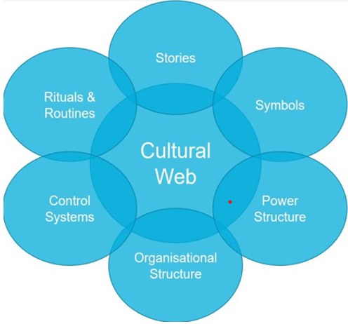
Figure: The cultural web Source: Kotler and Armstrong (2025)
Stories in a company explain past events and important achievements from the very beginning. In Tesco, stories often focus on customer service and low prices (Tayeb‎, 2025). In Seven & I, stories focus more on long-term success and strong leadership by providing affordable products in the market. Symbols include logos, store design and uniforms as a multinational company (Morrison‎, 2025). Tesco uses simple and modern designs to show convenience and value in the modern business world. Seven & I uses more formal and professional symbols to show quality and trust. Rituals and routines are daily activities (Tayeb‎, 2025). Tesco has flexible working styles and quick decision-making with expert in the respective fields. In contrast, Seven & I follows more formal routines with strict rules. The organisational structure in Tesco is more flexible (Morrison‎, 2025). Decisions are made quickly and employees can share ideas. In Seven & I, the structure is more hierarchical (Morrison‎, 2025). Control systems in Tesco focus on performance, sales and customer satisfaction as a multinational company. In Seven & I, control systems focus more on quality and long-term goals. Power structure is also different (Tayeb‎, 2025). In Tesco, power is more shared among managers. In Seven & I, senior management has more control and influence.

3.2 Hofstede’s cultural dimensions
Hofstede’s cultural dimensions explain how culture affects behaviour in different countries within a multinational company. It includes factors such as power distance, individualism, masculinity, uncertainty avoidance, long-term orientation and indulgence (Morrison‎, 2025). These dimensions help compare the UK and Japan.
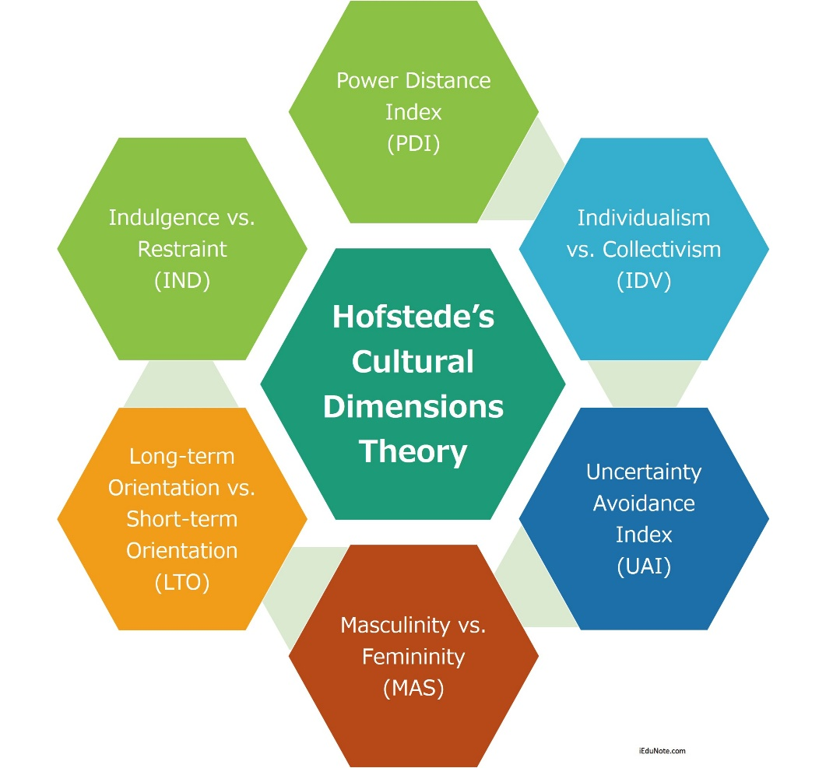
Figure: Hofstede’s cultural dimensions Source: Hofstede Insights (2024)
In the UK, the power distance score is low (around 35) in the modern business facets. This means people believe in equality. Employees can share ideas with managers (Hofstede et al.‎, 2025). There is less focus on hierarchy for several reasons. However, there is still some influence of social class for different reasons. People believe that everyone should have equal opportunities in life.
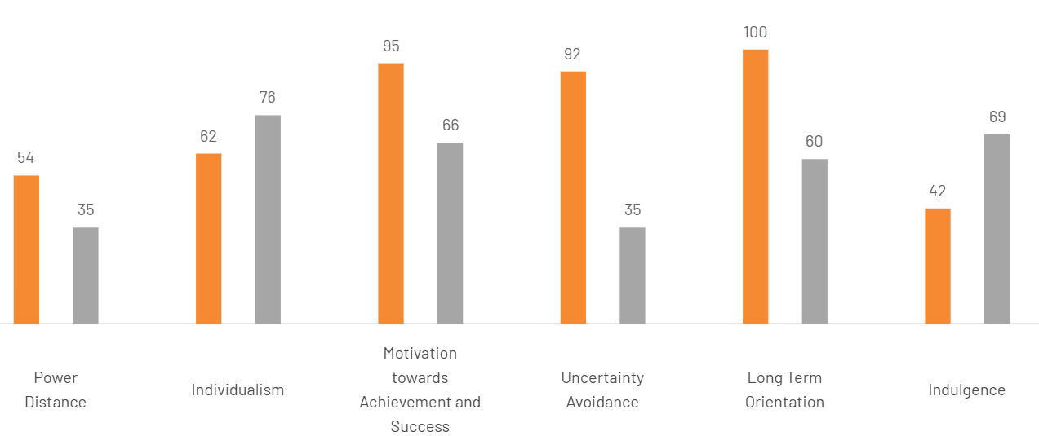
Figure: Cultural differences between UK and Japan Source: The Culture Factor (2026)
In Japan, the power distance score is about 54 which shows a more structured society developed for the world famous consumers. People respect hierarchy and position (Morrison‎, 2025). However, it is not extremely hierarchical compared to other Asian countries in this modern era. Decision-making takes more time for several reasons. At the same time, Japan values hard work and merit. People believe that success comes from effort (Luthans and Doh‎, 2025).
The UK is highly individualistic. People focus on personal goals and independence (Mooij‎, 2025). In contrast, Japan is more group-oriented from the very beginning. People value teamwork and harmony in the workplace where Japan also has higher uncertainty avoidance having developed and skilled workforces. This means people prefer clear rules and careful planning (Morrison‎, 2025). In the UK, people are more open to risk and change. The marketers focuses more on short-term results and quick success. Overall, the UK culture is more flexible and individualistic while Japanese culture is more structured, group-focused and long-term oriented (Hofstede et al.‎, 2025).

3.3 High-context and low-context communication theory
High-context and low-context communication theory explains how people share information in different cultures (Luthans and Doh‎, 2023). In high-context cultures, people use indirect communication within the workplace. In low-context cultures, people use direct communication to share ideas (Morrison‎, 2025). In low-context cultures, messages are clear and simple where people say exactly what they mean with their colleagues. There is less need to understand the situation or background. The United Kingdom is an example of a low-context culture (Brislin‎, 2023). In the UK, communication is direct and clear amongst the participants. Employees often speak openly and share their opinions which helps in fast decision-making and problem-solving.
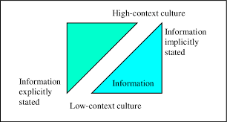
Figure: High-context and low-context communication theory Source: Brislin (2023)
In high-context cultures, communication is more indirect with their colleagues. People do not always say everything clearly while participate in meeting. They expect others to understand meaning from the situation, body language and relationships (Kotler and Armstrong‎, 2023). Japan is a high-context culture within the workplace. In Japan, people avoid direct disagreement within the workplace. They use polite language and try to maintain harmony (Morrison‎, 2025). In Tesco plc, communication follows a low-context style. Managers and employees communicate clearly which helps improve efficiency and speed in work (Brislin‎, 2023). In Seven & I Holdings, communication is high-context with their colleagues. Employees use formal language and show respect to senior staff where messages are often indirect. Decisions are discussed carefully to avoid conflict (Kotler and Armstrong‎, 2023). The key difference is that Tesco focuses on clear and direct communication while Seven & I focuses on indirect and respectful communication. These differences can create challenges when teams from both countries work together (Luthans and Doh‎, 2023).

3.4 The 7 dimensions of culture
The 7 dimensions of culture explain how people behave in different societies while participate in meeting. This model was developed to compare cultures in business (Brislin‎, 2023). It includes seven areas: universalism vs particularism, individualism vs communitarianism, specific vs diffuse, neutral vs affective, achievement vs ascription, sequential vs synchronic time and internal vs external control to explain the views.
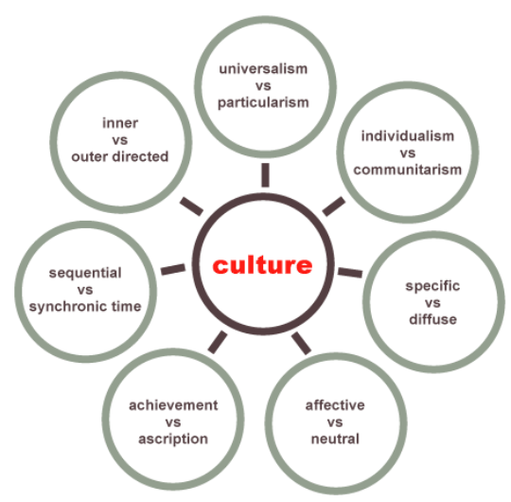
Figure: The 7 dimensions of culture Source: Johnson et al. (2023)
Universalism vs particularism means following rules or relationships with their colleagues. In the UK, people follow rules equally from the very beginning. In Japan, relationships are also important when making decisions (Brislin‎, 2023). Individualism vs communitarianism shows if people work alone or in groups. The UK is individualistic when Japan is more group-focused while people value teamwork and harmony (Johnson et al.‎, 2023). Specific vs diffuse means how people separate work and personal life to explain the views. In the UK, work and personal life are separate (Morrison‎, 2025). In Japan, they are more connected and relationships at work are long-term. Neutral vs affective explains how people show emotions (Kotler and Armstrong‎, 2023). In the UK, people may express feelings openly with their colleagues. Achievement vs ascription means how people gain status in this modern era. In the UK, status comes from achievements. In Japan, age, position and experience are also important (Johnson et al.‎, 2023). Sequential vs synchronic time shows how people manage time. The UK follows schedules and deadlines to share ideas. Japan also values time but planning is more careful and long-term. Internal vs external control explains how people see control over life. In the UK, people believe they control their future. In Japan, people adapt more to situations (Brislin‎, 2023).

4.0 Conclusion
It is clarified that this report explains the cultural differences between the United Kingdom and Japan and how these differences affect international business in this modern era. Tesco plc entered the Japanese market but was not successful for several reasons. The main reason was a lack of understanding of Japanese culture and customer behaviour within the workplace. Japanese customers prefer high-quality, fresh products and regular shopping habits while Tesco used a UK-based retail model in the modern business world. The analysis of the cultural web shows clear differences between Tesco and Seven & I Holdings to explain the views. Tesco has a more flexible and open culture while Seven & I has a more formal and structured culture while staffs participate in meeting. Hofstede’s cultural dimensions also show differences in communication, teamwork and decision-making styles between the two countries in this modern era. High-context and low-context communication theory explains further differences. The UK uses direct communication while Japan uses indirect and polite communication.

References
Blythe, J. (2022) Principles and practice of marketing. 4th Ed. London: Sage Publications.
Brislin, R. (2019) Understanding culture’s influence on behavior. New York: Routledge.
Cavusgil, S. T., Knight, G. and Riesenberger, J. (2020) International business: The new realities. 5th Ed. Harlow: Pearson.
De Mooij, M. (2019) Global marketing and advertising: Understanding cultural paradoxes. 5th Ed. London: Sage.
Hofstede Insights (2024) Country comparison: United Kingdom vs Japan. Available at: https://www.hofstede-insights.com (Accessed: 24 April 2026).
Hofstede, G., Hofstede, G. J. and Minkov, M. (2023) Cultures and organizations: Software of the mind. 3rd Ed. New York: McGraw-Hill.
Johnson, G., Whittington, R. and Scholes, K. (2023) Exploring strategy. 11th Ed. Harlow: Pearson.
Kotler, P. and Armstrong, G. (2021) Principles of marketing. 18th Ed. Harlow: Pearson.
Luthans, F. and Doh, J. (2018) International management: Culture, strategy and behavior. 10th Ed. New York: McGraw-Hill.
Morrison, J. (2016) The global business environment. 4th Ed. London: Palgrave Macmillan.
Seven & I Holdings (2025) Annual report. Available at: https://www.7andi.com (Accessed: 24 April 2026).
Tayeb, M. (2019) International management: Theories and practices. London: Pearson.
Tesco plc (2025) Annual report and financial statements. Available at: https://www.tescoplc.com (Accessed: 24 April 2026).
The Culture Factor (2026) Cultural differences between UK and Japan. Available at: https://www.theculturefactor.com/country-comparison-tool?countries=japan%2Cunited+kingdom. [Accessed on: 20 April 2026]
The World Bank (2024) Japan economic overview. Available at: https://www.worldbank.org (Accessed: 24 April 2026).
Trading Economics (2025) Japan GDP and economic indicators. Available at: https://tradingeconomics.com (Accessed: 24 April 2026).

