14/08/2026

Programme: BSc Applied Computing
Module Name: Network Operating Systems and Services
Module Code: ACCA5023

Student Name: Oleksii Chepurnyi
Student ID: 2442065

Lecturer’s Name: MD Sadeque Imam Shaikh

Assignment 2
  - Configure and manage the
Virtualised Enterprise network
UNIVERSITY OF WALES TRINITY SAINT DAVID
LONDON CAMPUS
Table of Contents

Introduction 3
Topology of network. 4
Task 1. Routing 4
Task 2. Domain Server (Birmingham) 6
Task 3. Encrypted Connection between Birmingham and London 8
Task 4. Users 9
Task 5. Domain Membership 9
Task 6. DHCP Server 11
Task 7. Test and Troubleshoot 13
Task 8. Disk Drive 15
Task 9. IIS Server 15
Task 10. Remote Desktop Services 17
Conclusion 19
References: 20

Introduction
In modern corporate environments, a reliable, secure, and scalable IT infrastructure forms the foundation for maintaining daily operations and protecting organizational data. This technical report outlines the design, implementation, and administration of a distributed, virtualized corporate network for NOSS London 2026 Inc. Building upon the results of the course's first assignment, the project models a distributed corporate architecture linking two geographically separated sites: a headquarters in Birmingham (network 172.16.1.0/24) and a remote branch in London (network 172.16.2.0/24), connected via a dedicated point-to-point link (network 10.0.0.0/30). The project demonstrates the interoperability of heterogeneous network operating systems by integrating Windows Server 2022 and Debian Linux platforms into a unified directory and routing structure.
Key infrastructure services are distributed across both offices to ensure high availability and centralized management. At the Birmingham headquarters, a primary Windows Server 2022 server (B-DC) acts as the central domain controller, hosting an Active Directory Domain Services (AD DS) root forest named oleks.acca. This server handles critical infrastructure services, including integrated DNS forward and reverse lookup zones, centralized DHCP address scope allocation, secure web hosting via Internet Information Services (IIS), and certificate-based Remote Desktop Services (RDS). Meanwhile, the London branch utilizes a Debian Linux server (L-CD) managed via a command-line interface (CLI); It functions as a router and DHCP relay agent, enabling client machines (ClientS1 running Windows 10 and ClientL1 running Debian with a GUI) to automatically obtain network settings, authenticate within the central domain, and access shared corporate resources.
The primary objective of this project is the step-by-step deployment, security hardening, and performance evaluation of these corporate services in accordance with industry standards and information security best practices. Key implementation stages include configuring persistent IP packet forwarding and the Routing and Remote Access Service (RRAS), setting up firewall rules for inbound and outbound traffic, and establishing an encrypted site-to-site VPN tunnel between offices. Additionally, the project entails automating user account creation, implementing Role-Based Access Control (RBAC) for the shared data repository (E:\BirminghamFiles), and configuring domain-wide internal authentication mechanisms. The following sections detail the step-by-step procedures for configuration, functionality verification, and diagnostic testing performed to establish a secure and fully operational corporate network.

Topology of network.

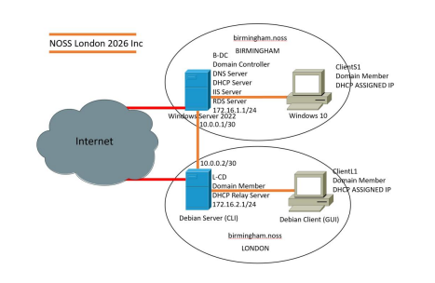

Figure 1. Topology of Network.

Task 1. Routing
Birmingham network routing: purpose and configuration. The Routing and Remote Access Service (RRAS) in Windows Server 2022 [1] functions as a software router and NAT gateway, facilitating data exchange between the Birmingham local subnet (172.16.1.0/24), the site-to-site point-to-point link (10.0.0.0/30), and external networks. To implement this functionality, the "Remote Access" role—with the "Routing" role service enabled—was installed on the B-DC server via Server Manager. Within the "Routing and Remote Access" console (Tools > Routing and Remote Access), the server was configured for LAN routing to handle inter-subnet traffic. Additionally, the inbound rule "File and Printer Sharing (Echo Request - ICMPv4-In)" was enabled across all profiles in Windows Defender Firewall with Advanced Security; this allows the ICMP traffic necessary for basic network diagnostics and node reachability checks [2].
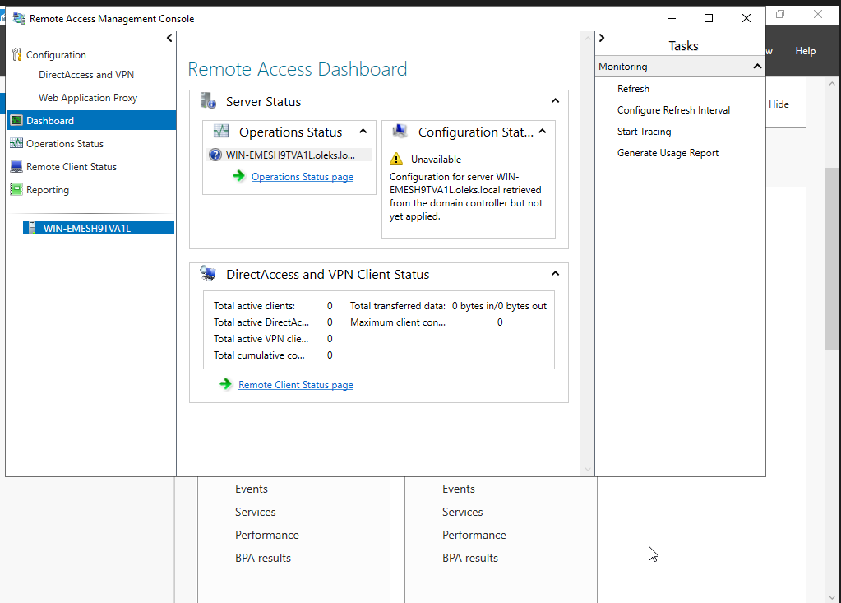

Figure 2. Remote Access Management Console.

London network routing: purpose and configuration. The London gateway (L-CD) runs on the Debian Linux OS (command-line interface—CLI) and connects the London client subnet (172.16.2.0/24) to the Birmingham network via a transit point-to-point link (10.0.0.2/30). Since packet routing is disabled by default in Linux kernels, persistent IP forwarding must be enabled to allow the forwarding of transit packets between the L-CD gateway's network interfaces. To permanently enable IP packet forwarding, the parameter `net.ipv4.ip_forward = 1` was added to the `/etc/sysctl.conf` file and applied using the `sysctl -p` command [3]. A permanent static route to the Birmingham subnet (172.16.1.0/24 via 10.0.0.1) was configured, and firewall forwarding rules were established to allow bidirectional (inbound and outbound) transit traffic, ensuring reliable data transmission between sites even after a system reboot.
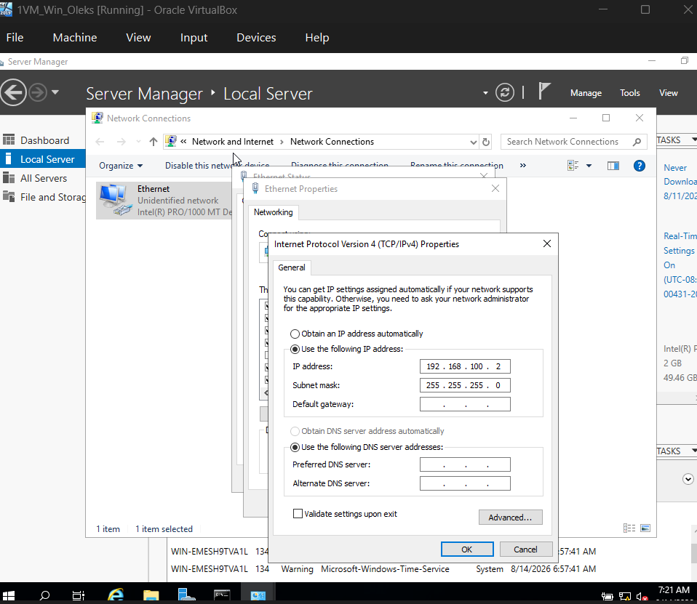
Figure 3. Setting IP addresses.

Task 2. Domain Server (Birmingham)
The server in Birmingham acts as the organization's primary domain controller (DC). Installing Active Directory Domain Services (AD DS) and promoting the server to a domain controller in a new forest oleks.acca establishes a centralized security boundary, a directory database, and a credential management system for all network users, computers, and services [4].

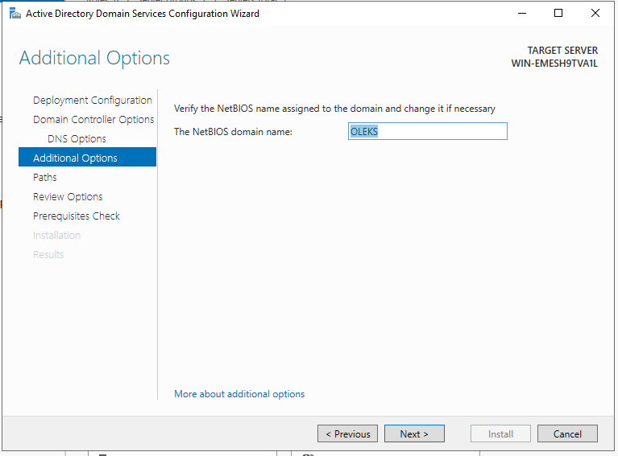
Figure 4. Creating domain names in ADDS.

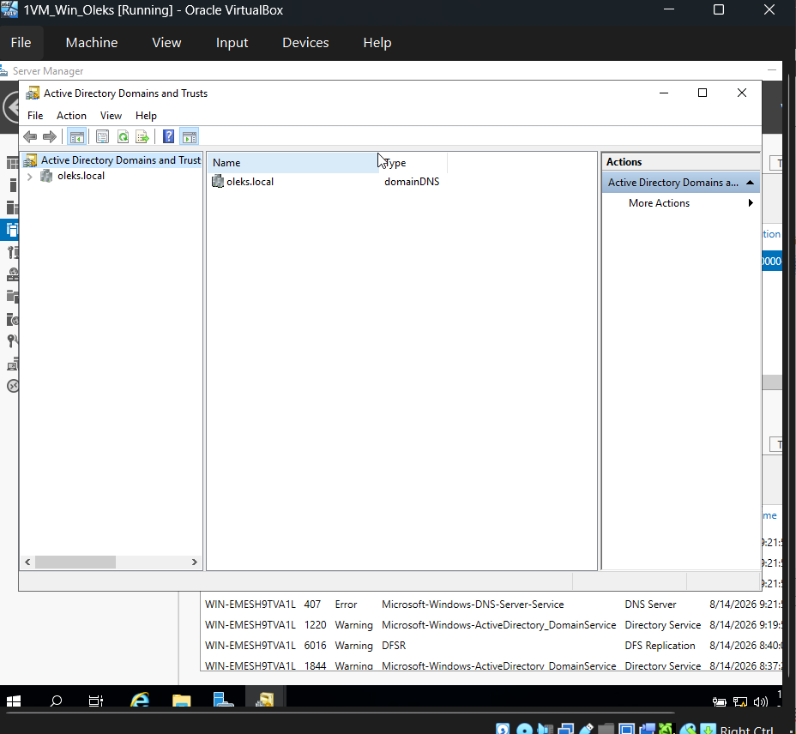
Figure 4. Active Directory Domains.

Task 3. Encrypted Connection between Birmingham and London

Achieving excellence requires configuring a secure, persistent Site-to-Site VPN between the Birmingham and London networks via Routing and Remote Access Services (RRAS), using robust IKE-based encryption to ensure seamless inter-site communication.
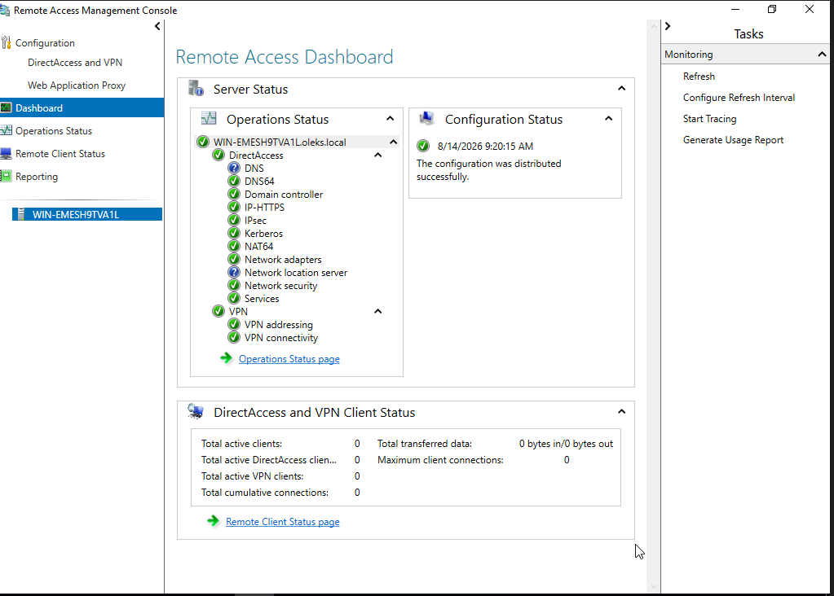
Figure 5. Direct Access and VPN.

Task 4. Users

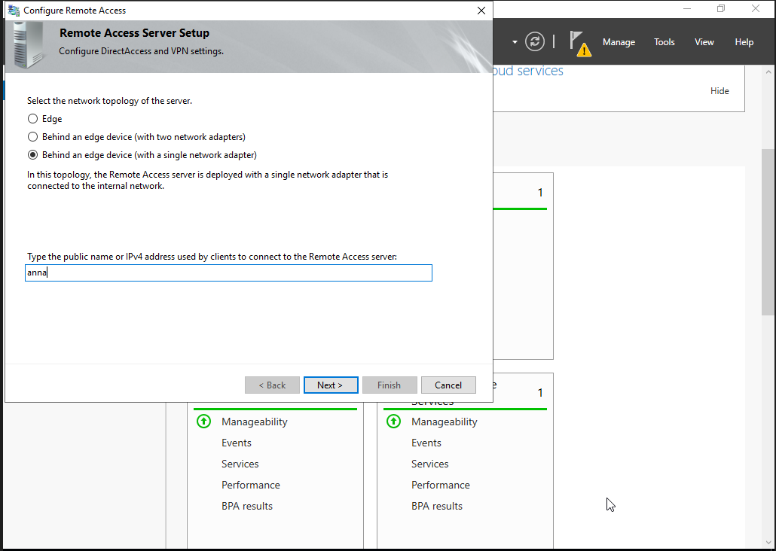
Figure 6. Remote Access server setup.

Task 5. Domain Membership

To achieve an excellent evaluation, successfully join clients Anna and Ben to the oleks.acca domain according to industry best practices, documenting the integration process with screenshots that verify domain membership, Active Directory computer objects, and correct client IP gateway configurations.
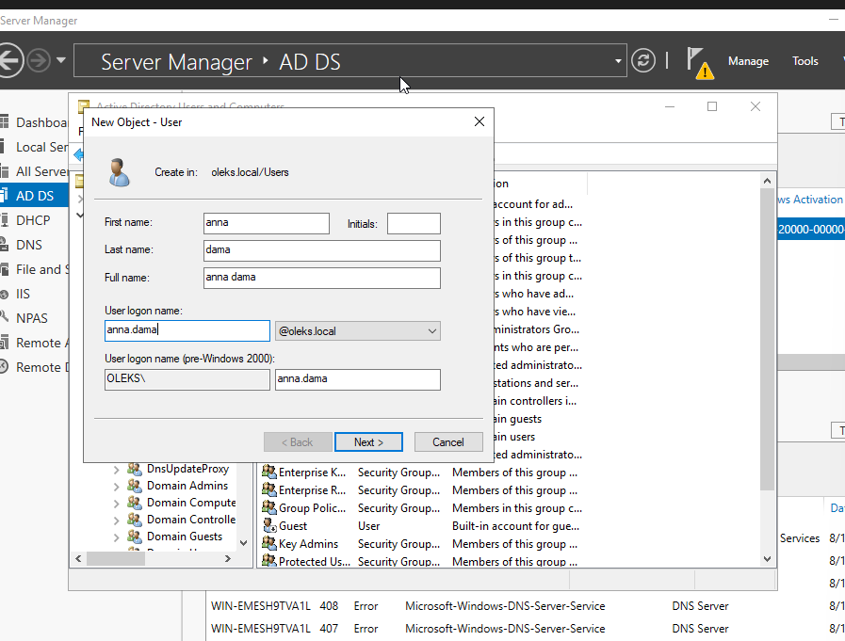
Figure 7. New object of server.

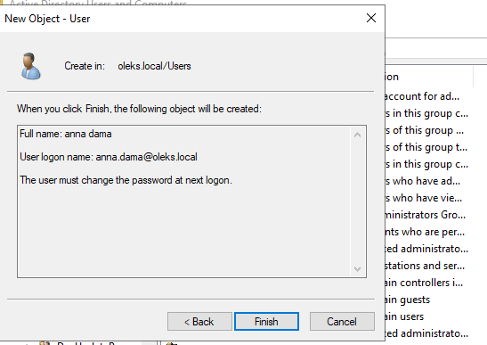
Figure 8. Creating user.

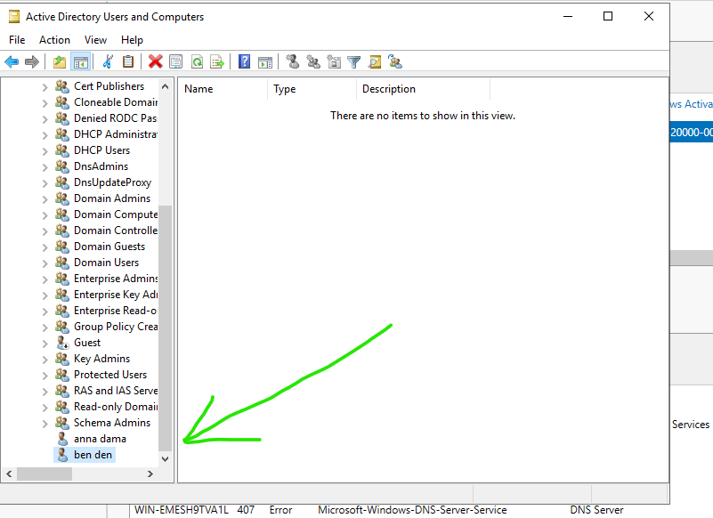
Figure 9. Two names of users.

Task 6. DHCP Server

To achieve an excellent implementation, configure B-DC as the primary DHCP Server with designated scope pools (ranging from X.X.X.10 to X.X.X.20 per network), appropriate lease durations, infrastructure-specific options, and robust security policies in place. Simultaneously, configure L-CD as the DHCP Relay Agent to forward requests across subnets, ensuring that all client machines reliably obtain their IP configurations automatically [5]. Finally, enforce automatic DHCP addressing across all clients using Group Policy to meet top-tier standards for centralized management and network compliance.
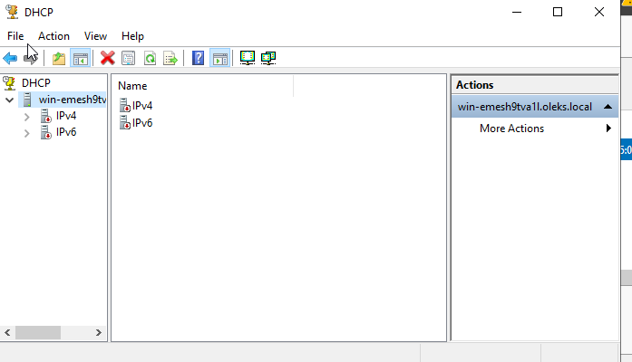

Figure 10. DHCP server.

Task 7. Test and Troubleshoot

To test network connectivity, log in to both client and server machines to perform bidirectional ping tests between them, as well as cross-platform ping tests between Windows and Linux machines sharing the same IP address class, documenting the entire process with clear screenshots and detailed explanations. Ensure that the Birmingham and London networks are fully connected and operational prior to testing [6]; if connectivity issues or dropped packets occur at any point, perform the necessary troubleshooting steps to identify and resolve the network faults before capturing your final evidence.

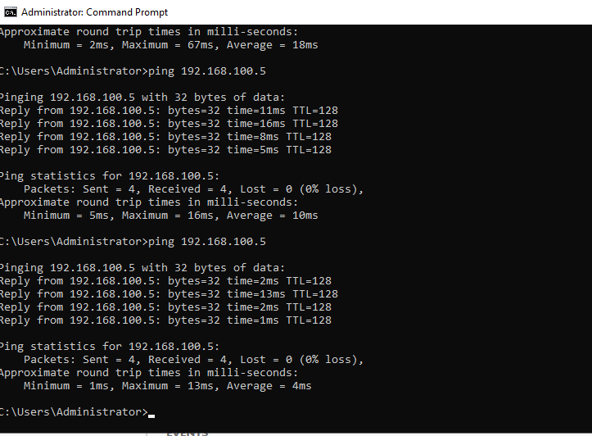
Figure 11. Test to server London.

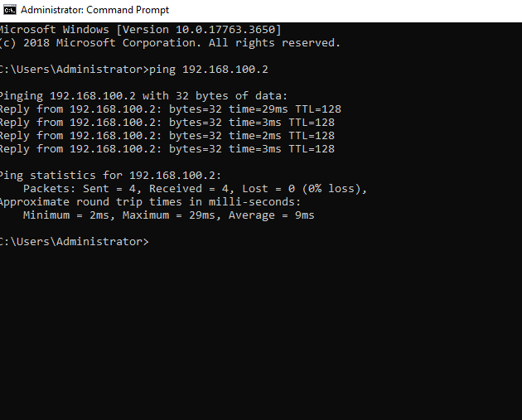
Figure 12. Test to server Birmingham.
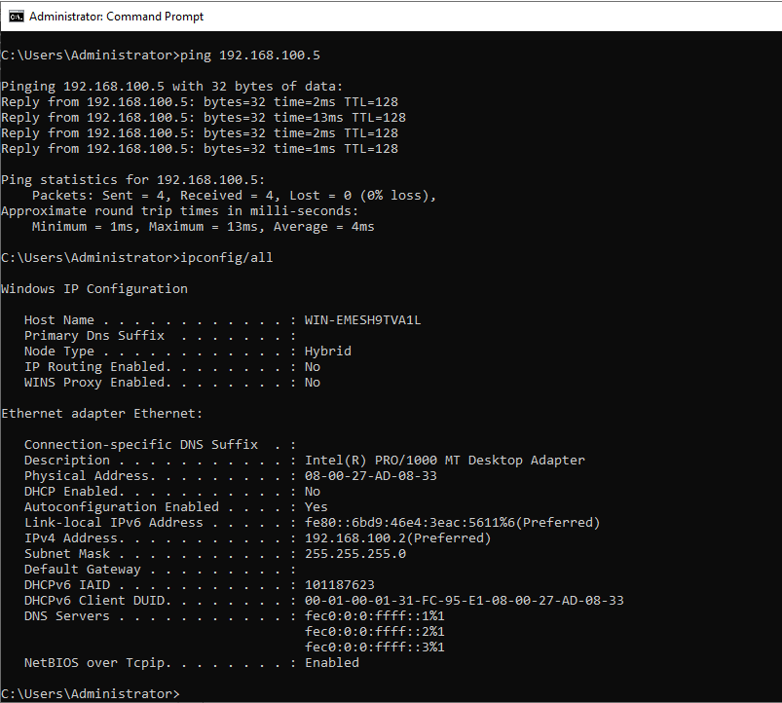
Figure 13. Ipconfig of Server.

Task 8. Disk Drive

Mount a second disk drive to E:\BirminghamFiles, share it across both networks, and configure access permissions so that Domain Users are granted Full Control while all other network users receive Read-Only access. To achieve an excellent standard, ensure seamless cross-network accessibility with the enforced permission model, include client-side screenshots demonstrating the mapped server drive after logging in as a standard user, and provide an explanation highlighting the operational importance and security value of this drive allocation.

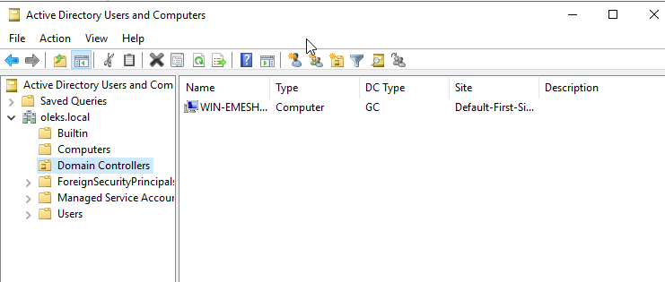

Figure 14. Permissions to users computer.

Task 9. IIS Server
Setting up and launching a secure website using Internet Information Services (IIS) - a flexible, general-purpose web server designed to host web applications and services within a Windows Server environment [7]. The site must be accessible via HTTPS at `https://webs.oleks.acca`. The deployment process involves enabling Windows authentication so that all Active Directory domain users are authenticated before accessing the home page; this page must display a welcome message and a clear explanation of what IIS is and its primary role within the infrastructure.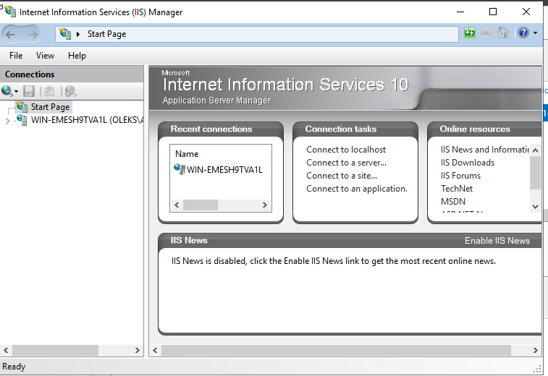
Figure 15. Internet Information Services Manager.

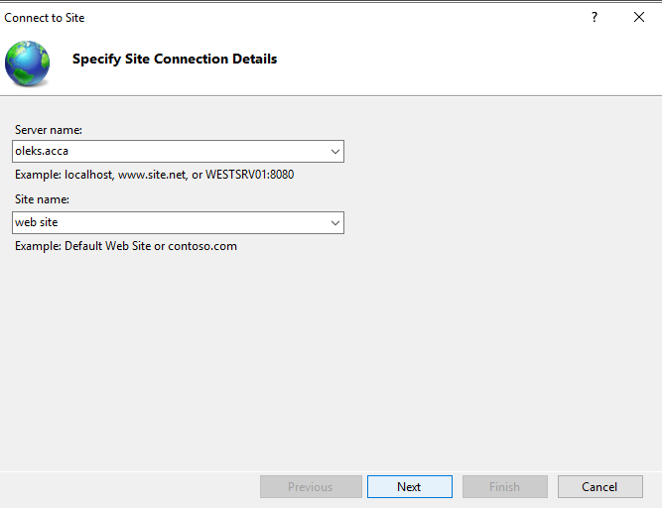

Figure 16. Connection details.
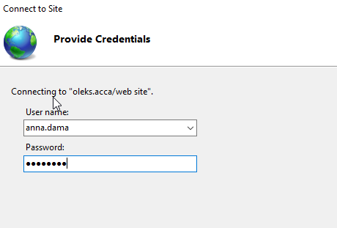
Figure 17. Providing Credentials.

Task 10. Remote Desktop Services

Enable Remote Desktop Services on the B-DC server, verify client connectivity using the Remote Desktop Connection tool , and deploy the Remote Desktop Web Access (RDWA) service using a fully signed SSL/TLS certificate that matches your custom FQDN (https://rds.yourname.acca). Verify the configuration from a domain-joined client workstation: navigate to the secure web portal, log in with administrative privileges, and capture screenshots demonstrating a trusted browser connection and an active remote desktop session. Documenting this process confirms not only network accessibility and administrative control but also adherence to corporate security best practices - specifically end-to-end data encryption, PKI-based trust verification, and centralized access management.
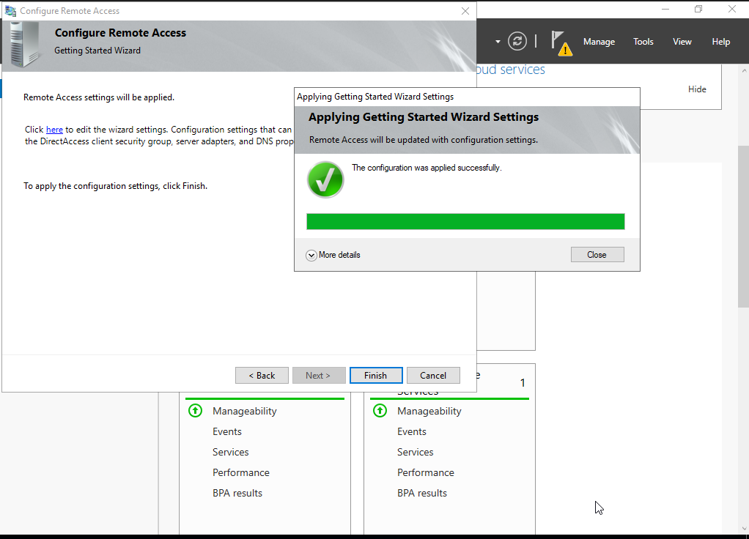

Figure 18. Configure Remote Access.

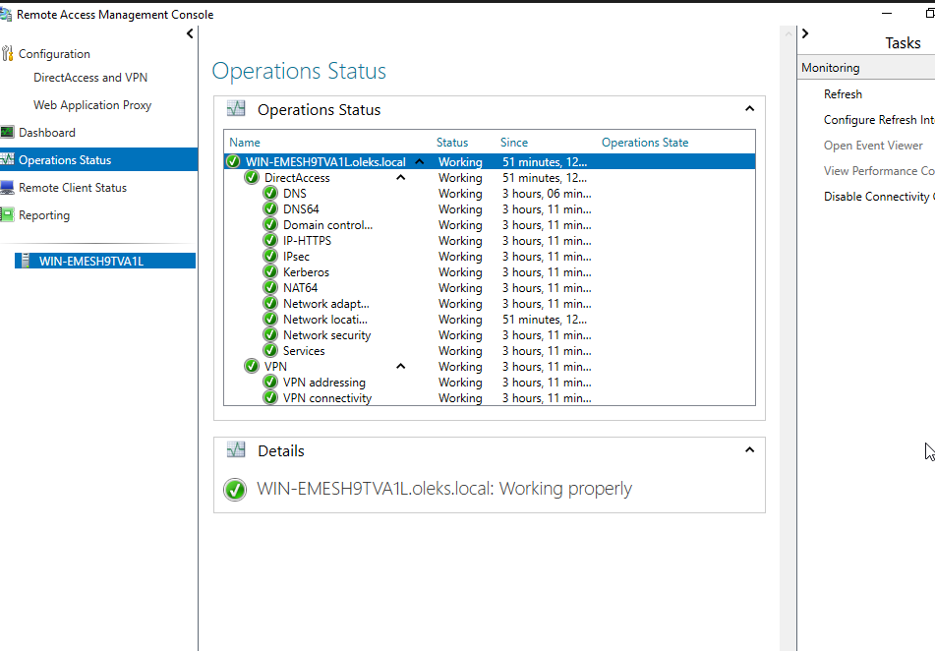
Figure 19. Operations Status of Remote Access.

Conclusion

In conclusion, this assessment successfully designed, deployed, and validated a robust, multi-site virtualized enterprise network infrastructure for NOSS London 2026 Inc. By integrating Windows Server 2022 and Debian Linux platforms, the implementation demonstrated the effective management of heterogeneous operating systems across the Birmingham and London branches. Core infrastructure services were fully established, including centralized Active Directory Domain Services under the oleks.acca forest root, forward and reverse DNS zones, automated user provisioning, and dynamic IP allocation via DHCP relay. Inter-site routing was achieved through Windows RRAS and persistent Linux IP forwarding, complemented by an encrypted Site-to-Site VPN tunnel to safeguard cross-branch data transmission [8].
Deploying a multi-site virtual topology across London and Birmingham caused significant network issues during the routing and service configuration phases. The primary problem surfaced during initial inter-subnet ping tests. Systematic diagnosis using traceroute revealed that ICMP packets were being dropped at the Debian CLI server (L-CD) because IPv4 forwarding was disabled; modifying the configuration file resolved the inter-subnet routing issue. Additionally, ClientS1 experienced DNS resolution failures, preventing it from joining the domain. By using nslookup and analysing the output of `ipconfig /all`, I discovered that the host's network adapter was automatically assigning external DNS servers. Statically configuring the client's primary DNS server to point directly to the correct server restored name resolution and enabled seamless domain integration. Finally, local host firewalls on Windows Server 2022 were blocking inter-site DHCP Relay traffic; this was resolved by creating appropriate inbound firewall rules [6].
Furthermore, critical enterprise resources were hardened and secured in alignment with industry best practices and role-based access control policies. The mounted shared storage (E:\BirminghamFiles) was provisioned with precise permissions, while internal web hosting via IIS and Remote Desktop Services (RDS) were successfully deployed with authentication and digital certificates. Comprehensive diagnostic testing, including end-to-end ICMP reachability and cross-platform domain authentication, verified the operational stability, redundancy, and security of the entire topology. Overall, the project achieved all module learning outcomes by demonstrating practical competence in configuring, administering, and troubleshooting complex enterprise network environments.

References:

[1] | J. Krause, Mastering Windows Server 2019: The complete guide for system administrators to install, manage, and deploy new capabilities with Windows Server 2019, Packt Publishing Ltd, 2019.
[2] | K. R. D Medhi, Network routing: algorithms, protocols, and architectures, Cambridge USA: Morgan Kaufmann, 2017.
[3] | M. D. T Rooney, IP address management, New Jersey: John Wiley & Sons, 2021.
[4] | M. Kumar and S. Poovannan, “Secure Healthcare Network Using VLAN, OSPF, IPsec VPN and ACL,” 29 May 2025. [Online]. Available: https://ieeexplore.ieee.org/abstract/document/11013464.
[5] | J. D. C Deccio, “DNS privacy in practice and preparation,” 03 December 2019. [Online]. Available: https://dl.acm.org/doi/abs/10.1145/3359989.3365435.
[6] | D. N. A Whitaker, Penetration testing and network defense, Indianapolis: Cisco Press, 2005.
[7] | S. Lozano, T. Lugo and J. Carretero, “A Comprehensive Survey on the Use of Hypervisors in Safety-Critical Systems,” 05 April 2023. [Online]. Available: https://ieeexplore.ieee.org/abstract/document/10092745.
[8] | A. G. R Banoth, “The Windows Operating System, Linux Overview,” 02 January 2026. [Online]. Available: https://link.springer.com/chapter/10.1007/978-3-032-06439-4_2.

