

Smart and connected devices ||
Internet of Things – Smart Cities Applications
Smart Campus solutions
Module Code: ACDA6005
Module Lecturer: Prof John Rees
Student Name: Mohamad Wael Baghdadi
Student Number: 1708309
Course: BSc Software Engineering
Due Date: 13/12/2019

Table of Contents
Table of Contents 1
List of Figures 2
1. Introduction 0
2. Smart Cities 0
2.1 The benefits of smart cities 0
3. Smart Campus 1
4. The Internet of Things 2
4.1 Current applications and devices 2
4.2 The industries affected by IoT 2
5. Security 3
5.1 CIA security principles 3
5.2 Security threats and attacks 3
5.3 Security in IoT 4
6. Design and Implementation 4
7. Conclusion 4
8. References: 0
7. Appendixes 3
7.1 Design and implementation: 3
7.1.1 Control System and Security 4
7.1.2 Temperature Control System: 5
7.1.3 Motion sensor: 6
7.1.4 Fire system: 7
7.1.5 Smoke sensor with Carbon gas detector: 8
7.1.6 Humidity system 9
7.1.7 Car Park Management system 10
7.1.8 Another implementation method for smart campus: 11

List of Figures
Figure 1: Percentage of EU population living in urban areas, 0
Figure 2: The Benefits of Gaining SMART City Status[19] 1
Figure 3: The connection between the server switch then to cloud. 3
Figure 4: The connecting from cloud to main Campus gateway then to other devices. 3
Figure 5: Accessing devices. 4
Figure 6: How temperature sensor works. 5
Figure 7: The implementation of temperature sensor with the code. 5
Figure 8: Motion sensor devices. 6
Figure 9: The implementation of motions sensor for light and security with the code. 6
Figure 10: Fire system. 7
Figure 11: the implementation of the fire system. 7
Figure 12: Carbon gas system. 8
Figure 13: The implementation of the Smoke sensor with Carbon gas detector 8
Figure 14: Humidify system. 9
Figure 15: The implementation of the Humidity system. 9
Figure 16: The implementation of the car park management system. 10
Figure 17: Another implementation method for smart campus. 11

Introduction
The world’s population is increasing on a daily basis and cities are urbanizing rapidly. Currently, around 50 percent of the population in the word lives in cities and this number will increase to be around 70 percent by 2050 [1]. Therefore, the form of these cities in the future and what will make them easily liveable in for all humans need to be considered. Furthermore, we can see the extent to which technology is growing and how fast our world has been changed by using it and, therefore, we should expand and link this technology to our cities to make them ‘smart’. In this report, the author has defined what smart cities are and discussed their history and what their benefit might be in the future, then what the definition of the Internet of Things (IoT), with its history, was in this field and how it affects the industry currently. In addition, because the smart campus is part of a smart city, the author has included a brief discussion of what the former is and why it is important. in the last part of this report, there is an explanation and description of a smart campus simulation who is made using Cisco Packet Tracer, showing the future of the smart campus and how the IoT devices will interact and communicate with each other by controlling and managing these devices.

Smart Cities
According to the author's research, there are many different definitions of smart cities but, in fact, there is no one exact definition as the smart city label is considered to be a fuzzy concept. It has also been used in many different concepts and the different definitions amongst them will be dependent on the level of resources, the development and aspirations of its citizens and even the differences between countries. The focus has been on the significance of new information and communication technologies (ICT) regarding the modernistic infrastructures within cities and, in that time, the concept was to focus more on the importance of the new ICT at the same time that the smart city concept was introduced [2] and its possible impact, in relation to modern infrastructures, on the community [1][3].
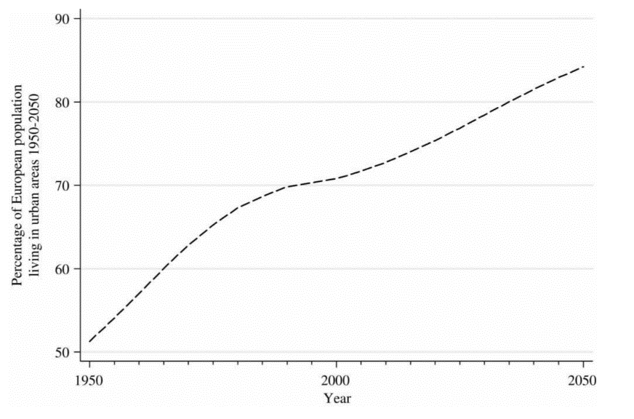
Fundamentally, it can be said that the definition of a smart city is an urban area that uses smart physical devices to collect data around the city, including devices in streets, parking areas and from citizens, and then analyses this data and processes it to monitor, manage and control the traffic and transportation systems, crime detection [4], water supply networks, utilities, power plants, schools, libraries, hospitals, information systems [4][5] and other services to improve the quality of life in an efficient way, providing a wide range of benefits to everyone around the city [6]. According to the McKinsey Global Institute (MGI), the smart city applications can enhance and improve performance in some key quality of life indicators, such as education or health and safety, by 10 to 30 percent [7].
Figure 1: Percentage of EU population living in urban areas,
1950-2050 (forecast) [2]
Currently, we can observe how the popularity of smart city programs and projects has increased in such countries as India, China, the United Arab Emirates (UAE), South Korea and in other small places, such as Mauritius [8][9][10][11][12].

2.1 The benefits of smart cities
The growth of smart city technology can produce efficient and effective cities, which is important given the huge increase in population. Therefore, smart cities that leverage connected technology across their processes provide a wide range of benefits, for example:
- Improved transportation:
This technology can optimize traffic flow by using smart traffic signals, which leads to relieving congestion at peak times. In addition, by using smart transportation technology in cities, it can help to reduce energy use by using smart streetlights for cars on the motorway, or even for humans on the streets, and, by using intelligent parking systems, congestion around the city can be reduced and extra profit can be capitalised on [13].
Automation and environmental impact:
By turning most of the resources around the city ‘smart’ by using the IoT technology automation, significant amounts of money will be saved from electricity and water and even in companies and industries [14].
Improved infrastructure:
A smart sensor can transmit data that shows the negative changes in structure, to recognize if there are any cracks or tilts in the building or structure and to notify the maintenance department, which can save significant sums of money for the government and citizens [13].
A sustainable ecosystem:
By reducing the environmental footprint, with smart cities relying on smart technology and using smart devices, emissions will be reduced, making the cities cleaner. Standards of living and happiness will greatly increase, leading to a better quality of life and new economic development opportunities with economic prosperity [14].
Quality of life:
Everyone worldwide is seeking to improve their life quality and, by improving the whole community, quality of life will be improved. More efficient transport services, digitized government services, smart parking applications, and even charging points or street furniture and public Wi-Fi for all around the city, which might be small or simple but which meet the people’s needs, make big differences, with positive impacts on people’s lives [15]. A major example of a smart city, and how it affects quality of life, is Barcelona [16].
Many other benefits have been included under the smart city concept, such as efficient public utilities, safer communities, more effective, data-driven decision-making, new economic development opportunities, economic prosperity and increased workforce engagement [17][18].
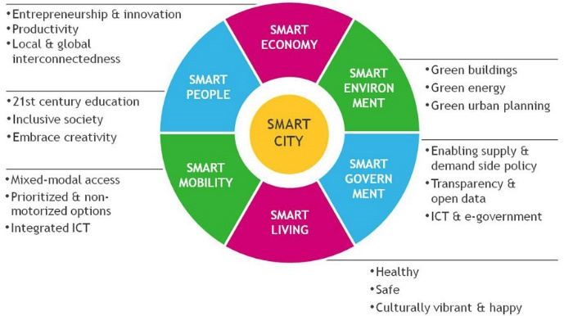
Figure 2: The Benefits of Gaining SMART City Status[19]

Smart Campus
Education is a very important part of life and we need to care more about the educational environment and build it in an intelligent way that that will positively affect the students’ mentality and lives and will lead to ease of gaining more skills and experience. Therefore, in this section, we need to identify exactly what a smart campus is and why it is important for students in their education.
It is considered that a smart campus is the merger of smart cities and smart homes, and concept of the smart campus is to enable new services or experiences to provide the best operational efficiency by linking devices, applications and people. These services or experiences might include smart parking, wayfinding, information on waiting times in the canteen or fitness equipment availability inside the campus and even the recording or transfer of remote live lectures. This entails the availability of the IoT networks, which include sensors, access technologies and gateways to set up the smart infrastructure on the Internet Protocol (IP) network, such as the building lighting, outdoor lighting, security surveillance and physical access systems, controlling the power system, such as the cooling and heating, smart parking facilities, and much more, that can benefit the students. When all the devices, applications and people share the same technology infrastructure it leads to information and data interacting with each other, which provides more experiences and efficiencies, making the campus stand for innovation in creating new services and efficiencies [20][21][22].
Benefits of smart campus:
- Provides Better Student and Visitor Experiences
- Provide more quality of indoor environments like comfort, noise levels, lighting, natural ventilation and other
- Raise sustainability
- Lowers Operational Costs and time
- Occupancy detection and tracking
- Protect the environment
- Automate maintenance
- Smart learning by the effective of the library management
- Enhanced reliability
- Power management system[23][24][24][25].
Also, the smart campus can do much more things such as measuring Efficiency, Automated Control, Peak Usage, Consumption, Savings, Humidity, Water, Occupancy, Revenue, Advanced Analytics, Energy Prices, Total Cost, Reporting, Carbon Emissions, Operating Hours, Tenant Satisfaction, Cash Flow, Renewables, Utility Rates, Demand, Supply, Electric, Billing, Smart Grid, Vacancy Rates, Solar, LEED, temperature, Wind, kWh, Engineering, Energy Storage, Marketing and Leasing, Load Shedding, Worker Productivity, Budget Projections, Natural Gas, Benchmarking and others [26].

The Internet of Things
The most common definition of the IoT is a system of interrelated computing devices that can connect and communicate to the internet, such as lights, plugs, refrigerators, phones, laptops, speakers or any other devices or objects that can be provided with unique identifiers. These objects should have the ability to collect, exchange and transfer data over the network without interference or interaction from human-to-computer or human-to-human [27][28].
The IoT concept goes back a long way, but the first person to use the term was Kevin Ashton (Co-Founder of the Massachusetts Institute of Technology) in late 1999 [29], while he was presenting radio-frequency identification (RFID) technology and how this technology could manage the communication between computers or chips to another machine using wireless networks [30][31].

4.1 Current applications and devices
In this the section, the author defines a few examples of current IoT applications that are used in the real world [32]:
Smart home: This is considered the most popular application for its availability among users and includes devices such as the Amazon Echo, which can provide the user with the weather, order an Uber taxi etc.
Smart cities: This application solves many problems that can face the people in their lives, such as reducing energy waste, noise, pollution and traffic congestion, as in Barcelona, which provides many devices to solve parking issues and help the environment.
Connected car: This relates to the provision and equipping of more applications and functionalities between the internet and users that can use the wireless network at work or home, for example, AT&T, with a total number of connected cars reaching 9.5 million.
Wearables: Devices such as Fitbit and Jawbone can provide information and data for users who want to monitor their workouts, for instance, by tracking the user’s steps or calories burned and monitoring sleep quality and syncing the data to a smartphone or to a personal computer (PC).

4.2 The industries affected by IoT
The future of the IoT in industry will be affected in one way or another, no matter how large its impact among companies, and its impact will not only affect small industries, but will affect the largest companies in the world, and governments, citizens, consumers and ecosystems. including the manufacturing, agriculture, retail, banking, hospitality, healthcare, utilities and logistics sectors.
Currently, we can see hundreds of huge companies starting to link to the IoT, like Microsoft (MSFT), Google, Cisco, Amazon, IBM, GE, BlackRock (BLK) and many other companies.

Security
The Confidentiality – Integrity – Availability (CIA) concept arose in the United States (US) as a method to ensure that documents were safe from being changed or accessed by someone who was unauthorized to access them, especially confidential information [33].

5.1 CIA security principles
There are some principles or components that security relies upon that are considered as the basis of Data Protection legislation and industry standards for Information Security (InfoSec) [33][34][35]:
- Confidentiality: This simply means that the data is not available for unauthorized people to see or to access and, if anyone accesses the information, this will be breaking the principle of confidentiality.
- Integrity: This refers to the trustworthiness of the information or data and that it hasn't been changed or tampered with in the organization in an unauthorized manner.
- Availability: This refers to the people who are authorised to access and see the data and that they can access the information or resources whenever they want to use them.
In general, security means the protection of assets against attack, which might be protection from Interruption (as in a lost asset becoming unusable or unavailable), Modification (if anyone can access the asset without permission), Interception (an unauthorized party gaining access to an asset) and Fabrication (which means that the asset has been counterfeited).
What Cisco defines as InfoSec refers to the tools and processes that are designed and deployed to protect and save sensitive and important data from disruption, modification, inspection and destruction [36]. The theory is that access is allowed to certain information for authorized persons and protected from unauthorized persons. Furthermore, InfoSec does not just concern the information contained on computers [37][34].

5.2 Security threats and attacks
Threats: any possible violation of the security in the computer system is considered a threat, which can take advantage of a vulnerability or from flaws in design, implementation or operation to breach security and negatively alter, which leads to loss or erase any information or data inside the system [38][39][40].
Types of threats:
- Security threat: stealing of system data, attack by virus, exploitation of data etc.
- External: like anything, starting from lighting till natural disaster such as earthquake, flood
- Internal: like the power supply or any fault in the hardware
- Physical threat: Physical loss or damage to the system
- Non-physical threat: data corruption, cybersecurity breaches , Loss of information
- Human: vandalism, theft
Attacks: are malicious software programs, like Trojan and Horses and so on, causing loss of data in the system or any other damage[41][42].
Types of attacks:
- Virus: a type of computer program, used to damage and steal data.
- Phishing: A type of fraud used in e-mail and presents itself as a trustworthy entity to steal sensitive information
- Spyware: a type of malicious software, that is installed in the system without any permission of the end-user and used to steal sensitive data like passwords or bank information
- Spam: random emails
- Worms: a type of malicious software program, self-replicating to spread itself from system to another
- DoS attacks: a cyber-attack used to make the network resource or machine unavailable to the internet
- Botnets: is a group of computers connected to each other used to malicious purposes like performing distributed denial-of-service attack (DDoS attack) which the attacker can send spams, steal data or access the system's user [34][41][43].

5.3 Security in IoT
The security methods in IoT take many ways depending on the IoT application and where the application will be and which place. The security can be hacked in any sort of industry in the smart technology field and the severity of effect can vary on the individual system, the information it contains or the data collected, so for example if the hacker attacked the brakes and damage them in a smart connected car, in this situation the user cannot control the car or decrease the speed of the car, or even if the hacker can attack to lock or unlock the smart doors which could potentially allow a burglar to enter the building or home. so it is very important for the IoT to be secure, therefore the most common IoT security measures [44][45][46]:
- Merging the security at the design stage
- API security
- PKI and the certificates of digital
- The security in the network
- Access the network controller
- Security gateways
- Identity management.
- Patch management/continuous software updates.
- Hardware security.
- Educate the consumer
- Integrating teams.

Design and Implementation
In this section, the author has chosen the Smart Campus solutions and he designed and implemented the practical side by using Cisco Packet Tracer [47] to simulate the system in Smart Campus.
So, the author implements four sensors:
- Temperature Control System
- Motion Control system and security
- Fire system
- Smoke sensor with Carbon gas detected
- Humidity system
- Car Park Management system
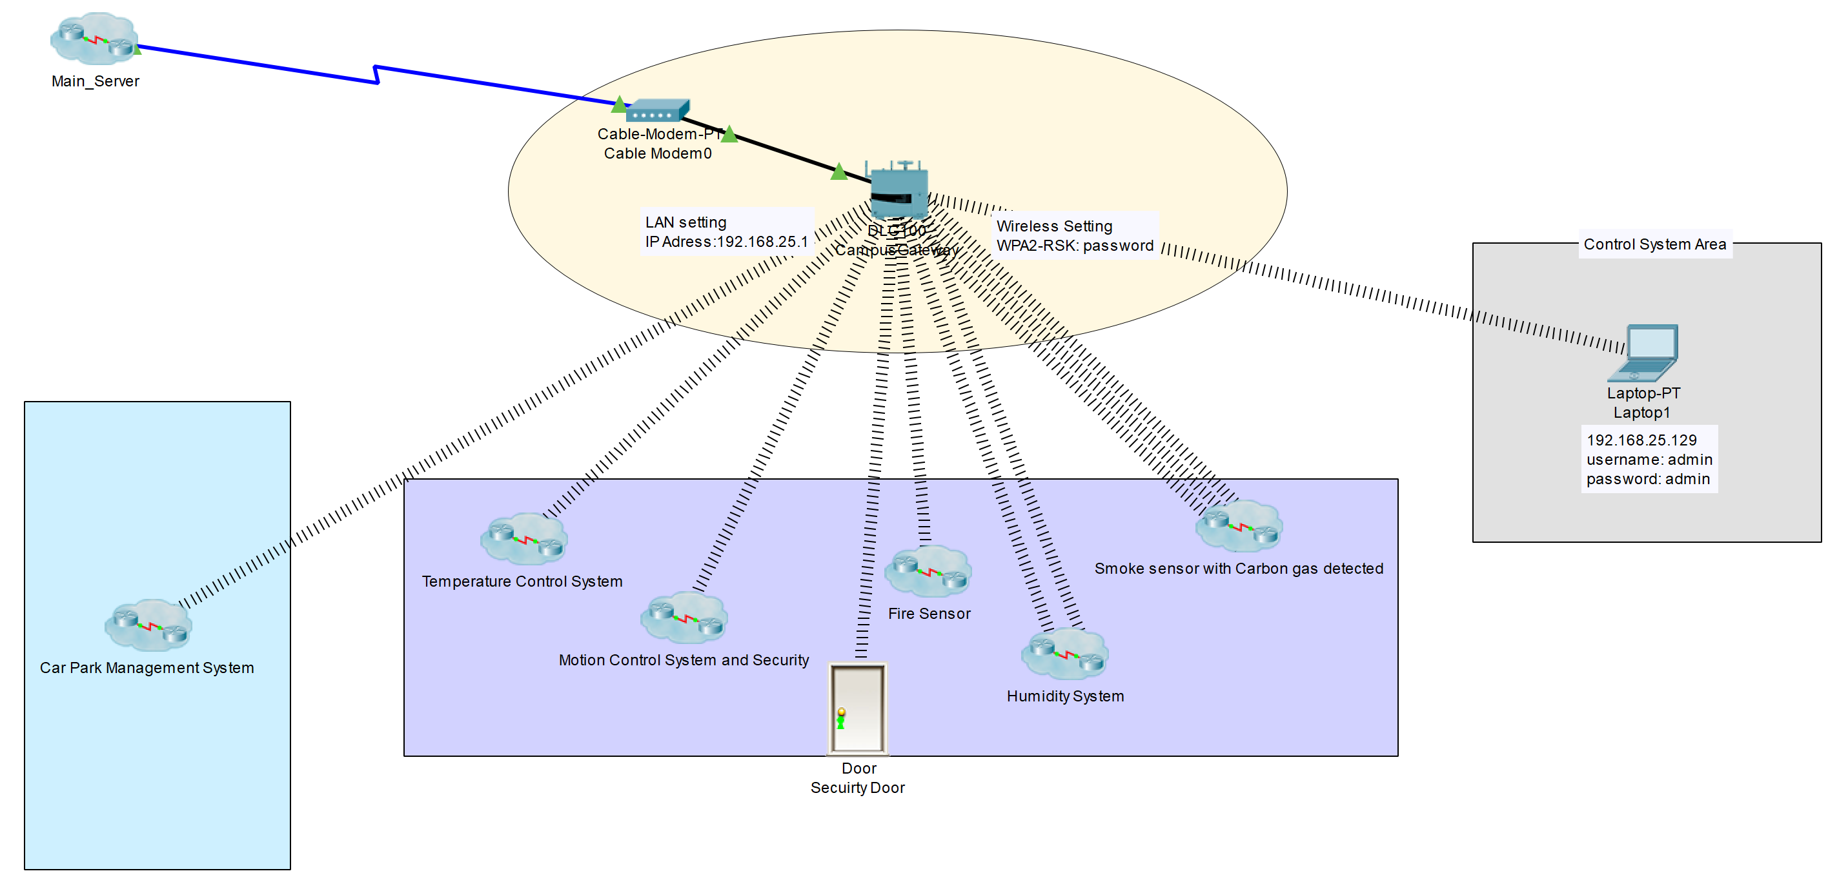
and because of the word count is limited by certain amount, the author has included the whole design and implementation to the appendix section(7.1) with a description of the implementation, how it works, what the benefit of each one of them, the connection between the devices and what security methods that implemented in the design.

Conclusion
According to this research, we can see how technology can changing our world to make it more sustainable and smart, and how powerful and impact this technology in the education field and how can it make the campus more effective for the occupiers by providing smart technology in many different sides in the human life, and describing how important the Internet of Things as well and how the Internet Will Become More of an Ecosystem, and finally describing, in brief, the security definition, principles and how security important in human life.

References:
[1] V. Albino, U. Berardi, and R. M. Dangelico, “Smart cities: Definitions, dimensions, performance, and initiatives,” J. Urban Technol., vol. 22, no. 1, pp. 3–21, 2015.
[2] A. Caragliu, C. del Bo, and P. Nijkamp, “Smart cities in Europe,” J. Urban Technol., vol. 18, no. 2, pp. 65–82, Apr. 2011.
[3] С. Г. Еремеев, “Smart City: управленческие аспекты и компетенции Smart City – менеджера,” Власть, vol. 27, no. 2, p. 57, Apr. 2019.
[4] Fourtané Susan, “Connected Vehicles in Smart Cities: The Future of Transportation,” 2018. [Online]. Available: https://interestingengineering.com/connected-vehicles-in-smart-cities-the-future-of-transportation. [Accessed: 15-Nov-2019].
[5] P. S. Musa, “Smart City Roadmap,” Smart city Roadmap, pp. 1–9, 2016.
[6] D. McLaren and J. Agyeman, Sharing cities: A case for truly smart and sustainable cities. 2015.
[7] J. Woetzel et al., “Smart Cities: Digital Solutions for a More Livable Future,” McKinsey Co., no. June, p. 152, 2018.
[8] T. Nam and T. A. Pardo, “Conceptualizing smart city with dimensions of technology, people, and institutions,” in ACM International Conference Proceeding Series, 2011, pp. 282–291.
[9] A. K. Glasmeier and M. Nebiolo, “Thinking about smart cities: The travels of a policy idea that promises a great deal, but so far has delivered modest results,” Sustain., vol. 8, no. 11, 2016.
[10] A. Datta, “New urban utopias of postcolonial India: ‘Entrepreneurial urbanization’ in Dholera smart city, Gujarat,” Dialogues Hum. Geogr., vol. 5, no. 1, pp. 3–22, 2015.
[11] Z. A.-J. Biourbanism and U. 2017, “Building a conceptual framework for smarting an existing city in Mauritius: The case of Port Louis,” J. Bioubanism, 2018.
[12] R. Kitchin, “Making sense of smart cities: Addressing present shortcomings,” Cambridge Journal of Regions, Economy and Society, vol. 8, no. 1. pp. 131–136, 2015.
[13] A. RUJAN and N. SIMPKINSON, “Thinking about becoming a smart city? 10 benefits of smart cities | Explore Our Thinking | Plante Moran,” Plantemoran.Com/, 2018. [Online]. Available: https://www.plantemoran.com/explore-our-thinking/insight/2018/04/thinking-about-becoming-a-smart-city-10-benefits-of-smart-cities. [Accessed: 22-Nov-2019].
[14] George Martinidis, “10 Economic Benefits of Smart Cities - URENIO Watch,” 2019.
[15] M. N. Kamel Boulos, A. D. Tsouros, and A. Holopainen, “‘Social, innovative and smart cities are happy and resilient’: Insights from the WHO EURO 2014 International healthy cities conference,” Int. J. Health Geogr., vol. 14, no. 1, p. 3, Dec. 2015.
[16] P. Cardullo and R. Kitchin, “Smart urbanism and smart citizenship: The neoliberal logic of ‘citizen-focused’ smart cities in Europe,” Environ. Plan. C Polit. Sp., vol. 37, no. 5, pp. 813–830, Aug. 2019.
[17] H. Schaffers, N. Komninos, M. Pallot, B. Trousse, M. Nilsson, and A. Oliveira, “Smart cities and the future internet: Towards cooperation frameworks for open innovation,” Lect. Notes Comput. Sci. (including Subser. Lect. Notes Artif. Intell. Lect. Notes Bioinformatics), vol. 6656, pp. 431–446, 2011.
[18] N. Komninos, M. Pallot, and H. Schaffers, “Special Issue on Smart Cities and the Future Internet in Europe,” J. Knowl. Econ., vol. 4, no. 2, pp. 119–134, 2013.
[19] “Cognitiv News | Creative, Digital and IT Wakefield.” [Online]. Available: http://www.cognitiv.co.uk/news/all/83/1/. [Accessed: 22-Nov-2019].
[20] M. W. Sari, P. W. Ciptadi, and R. H. Hardyanto, “Study of Smart Campus Development Using Internet of Things Technology,” in IOP Conference Series: Materials Science and Engineering, 2017, vol. 190, no. 1.
[21] “Smart Campus – Merging Smart City and Smart Home in Education for Digital Natives - dotmagazine.” [Online]. Available: https://www.dotmagazine.online/new-work-and-digital-education/ICT4D/smart-campus-merging-smart-city-and-smart-home-in-education-for-digital-natives. [Accessed: 22-Nov-2019].
[22] R. Vasileva, L. Rodrigues, N. Hughes, C. Greenhalgh, M. Goulden, and J. Tennison, “What smart campuses can teach us about smart cities: User experiences and open data,” Inf., vol. 9, no. 10, p. 251, Oct. 2018.
[23] “Smart Campus: Benefits, Trends, and Technology - Part 1 | WRLD3D.” [Online]. Available: https://www.wrld3d.com/blog/smart-campus-trends/. [Accessed: 22-Nov-2019].
[24] A. Abuarqoub et al., “A survey on internet of things enabled smart campus applications,” in ACM International Conference Proceeding Series, 2017, vol. Part F1305.
[25] B. Mattoni et al., “A matrix approach to identify and choose efficient strategies to develop the Smart Campus,” in EEEIC 2016 - International Conference on Environment and Electrical Engineering, 2016.
[26] D. Phin, “The workplace of tomorrow [3],” Business Week, no. 4049. p. 18, 2007.
[27] M. Rouse, “What is internet of things (IoT)_ - Definition from WhatIs,” Tech Target. p. TechTarget, 2016.
[28] Rouse. M, “What is IoT security (Internet of Things security)? - Definition from WhatIs.com,” IoT security (Internet of Things securit, 2015. [Online]. Available: https://whatis.techtarget.com/definition/IoT-OS-Internet-of-Things-operating-system#targetText=IoT operating systems are a,and communicate over a network. [Accessed: 20-Oct-2019].
[29] M. Chui, M. Löffler, and R. Roberts, “The internet of things,” McKinsey Q., no. 2, pp. 70–79, 2010.
[30] A. Good, “The internet of things is revolutionising our lives, but standards are a must,” The Guardian, 2015.
[31] K. Ashton, “That ‘Internet of Things’ Thing: in the real world, things matter more than ideas,” RFiD J., p. 4986, 2009.
[32] A. Meola, “Internet of Things Devices, Applications &amp; Examples - Business Insider,” Business Insider, 2016. [Online]. Available: https://www.businessinsider.com/internet-of-things-devices-applications-examples-2016-8?r=US&IR=T. [Accessed: 16-Nov-2019].
[33] D. Delony, “What is Information Security? - Definition &amp; Best Practices,” Study.com. [Online]. Available: https://study.com/academy/lesson/what-is-information-security-definition-best-practices.html. [Accessed: 22-Nov-2019].
[34] “What does ‘Information Security’ cover here?”
[35] D. J. Saab, “SRA111 - Introduction to Security and Risk Analysis,” 2011.
[36] G. Spafford, “What *is* information security?,” 2004, pp. 342–342.
[37] U. E. Gattiker, The Information Security Dictionary: Defining the Terms That Define Security for E-Business, Internet, Information, and Wireless Technology. Kluwer Academic Publishers, 2004.
[38] M. T. J. Ansari, D. Pandey, and M. Alenezi, “STORE: Security Threat Oriented Requirements Engineering Methodology,” J. King Saud Univ. - Comput. Inf. Sci., 2018.
[39] N. Feng, Y. Chen, H. Feng, D. Li, and M. Li, “To Outsource or Not: The Impact of Information Leakage Risk on Information Security Strategy,” Inf. Manag.
[40] K. Roy Sarkar, “Assessing insider threats to information security using technical, behavioural and organisational measures,” Inf. Secur. Tech. Rep., vol. 15, no. 3, pp. 112–133, Aug. 2010.
[41] “Threats to Information Security - GeeksforGeeks.” [Online]. Available: https://www.geeksforgeeks.org/threats-to-information-security/#:~:targetText=In Information Security threats can,%2C sabotage%2C and information extortion.&targetText=Software attacks means attack by Viruses%2C Worms%2C Trojan Horses etc. [Accessed: 29-Nov-2019].
[42] “Terminology (1),” 2013.
[43] C. Elliott, “Botnets: To what extent are they a threat to information security?,” Inf. Secur. Tech. Rep., vol. 15, no. 3, pp. 79–103, Aug. 2010.
[44] Rouse. M, “What is IoT security (Internet of Things security)? - Definition from WhatIs.com,” IoT security (Internet of Things securit, 2015. [Online]. Available: https://internetofthingsagenda.techtarget.com/definition/IoT-security-Internet-of-Things-security#:~:targetText=IoT security is the technology,internet of things (IoT).&targetText=Allowing devices to connect to,they are not properly protected. [Accessed: 09-Dec-2019].
[45] R. Mahmoud, T. Yousuf, F. Aloul, and I. Zualkernan, “Internet of things (IoT) security: Current status, challenges and prospective measures,” in 2015 10th International Conference for Internet Technology and Secured Transactions, ICITST 2015, 2016, pp. 336–341.
[46] Klein, “IEEE Xploreدانلود رایگان مقاله از.” [Online]. Available: https://ieeexplore.ieee.org/stamp/stamp.jsp?tp=&arnumber=7380718. [Accessed: 09-Dec-2019].
[47] Cisco Academy, “Packet Tracer Simulator | Networking Academy,” Cisco Academy, 2019. [Online]. Available: https://www.netacad.com/courses/packet-tracer. [Accessed: 13-Dec-2019].
[48] Cisco, “Packet Tracer 7.0 - IoT devices configuration - Packet Tracer Network,” The Packet Tracer network, 2016. [Online]. Available: https://www.packettracernetwork.com/internet-of-things/pt7-iot-devices-configuration.html. [Accessed: 21-Nov-2019].
[49] “3.2.4.5 Packet Tracer - Home IoT Implementation | Gateway (Telecommunications) | Internet Of Things.”
[50] I. Shemsi, “Boosting Campus Network Design Using Cisco Packet Tracer,” 2017.
[51] “Packet Tracer Remote IoT Smart Office Assignment Help.”
[52] N. S. Tarkaa, P. I. Iannah, and I. T. Iber, “Design and Simulation of Local Area Network Using Cisco Packet Tracer,” Int. J. Eng. Sci., pp. 2319–1813, 2017.

7. Appendixes

7.1 Design and implementation:
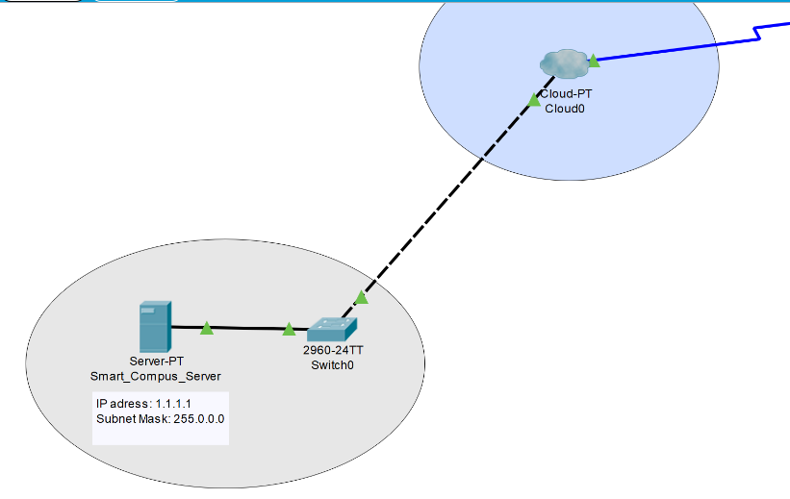
In the practical side, the author has chosen to implement a simulation of smart campus using Cisco Packet Tracer that showing how the sensors interact and communicate with other devices, using some resources to implement his work[48][49][50][51][52]
In (figure 3) the main server has been set in separate cluster, and connected to switch then the switch give the connection to the main modem in the smart campus by the cloud, the modem (Figure 4) sent the connection to the main gateway(CampusGateway), which all the sensor or detectors have been set the SSID to this gateway to link and show the state of this devices, then the author added a laptop and connected to gateway to show and control the devices if necessary.
Figure 3: The connection between the server switch then to cloud.

Figure 4: The connecting from cloud to main Campus gateway then to other devices.

7.1.1 Control System and Security
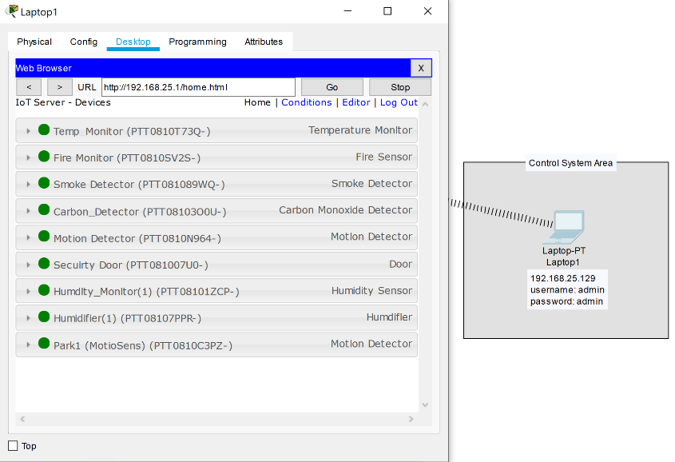
The author has followed few methods to implement the security in this simulation, for example:
To enter the control system, first, the user needs to unlock the door, from the control system.
To access the devices that linked to the CampusGateway the user needs to access the CampusGateway’s IP address through the web browser then inserts the username (admin) and the password (admin).
In (CampusGateway) the authentication set to WPA2-PSK with a password (password) to secure the system.
Figure 5: Accessing devices.
Also, another security has been set to the switch as well by adding a username (admin) and password (admin)

7.1.2 Temperature Control System:
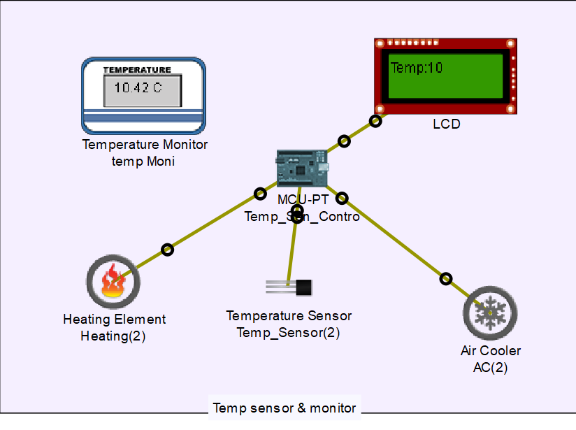
The temperature sensor has been connected to a NodeMCU and set the programming section in the NodeMCU to read the current temperature from the sensor using "analogRead", which that can give us a value between 0 to 1023 mapping between (-100 to 100) Celsius
Then the author added a heating element to increase the temperature, and another Air Cooler element to reduce the temperate by using for both a "digitalWrite".
To show the user the current temperature, an LCD display has been added as well, and it shows the current status of the temperature or if the heating or air cooler switched on or off
Figure 6: How temperature sensor works.
  - How it is work:
The temperature range has been set in the NodeMCU to be between 10C to 20C for example, and while the room temperature between those numbers the heating and cooler will both turned off. if the temperature goes less than 10C the heating will turn on and the LCD will display the message, and if the temperature goes more than 20C the Air Cooler will turn on with a message displayed in LCD.
  - Benefits
By using this sensor we can manage to reduce the energy use and wasting the energy by leaving the heating or the Air cooler working all the time or without control .
  - Connection to NodeMCU:
var heating = D0; // heating element
var airCooler = D1; // Air Cooler element
var LCD = D2; // LCD to display the current stat with temperature
var tempSensor= D3; // The temperature sensor

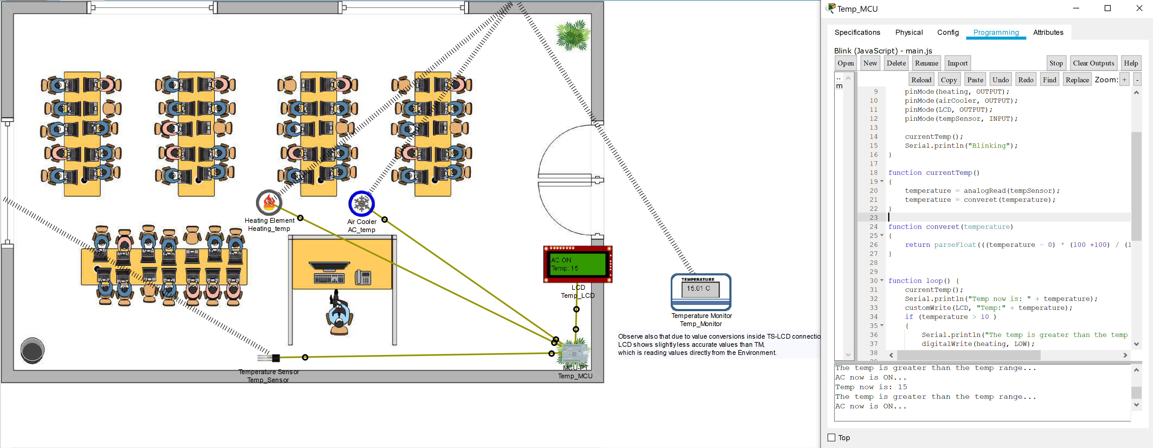
Figure 7: The implementation of temperature sensor with the code.

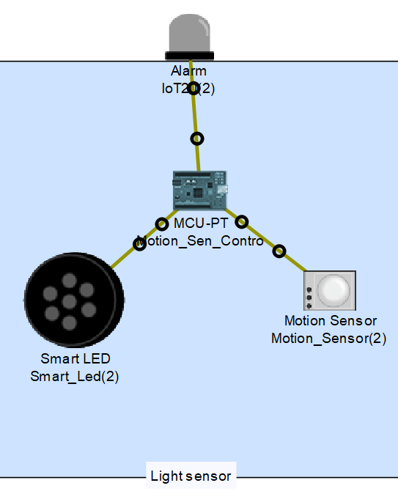
7.1.3 Motion sensor:
The motion sensor is a motion detector, and in this scenario the motion sensor has been connected to the NodeMCU then the lights inside the room connected as well to NodeMCU, so if anyone enter the room the lights will turn on, and if there is no one at all around the room, all the lights will turn off.
For the security, if no one should enter the campus in certain times(like server room or staff room), the controller can set the alarm in that time and if anyone entered, the lights and sound alarms will turn on.
  - Benefits
The benefits of using a motion sensor are not just confined to reduce the energy, it helps in security and congestion traffic by managing the parking area availability.
Figure 8: Motion sensor devices.
  - Connection to NodeMCU:
var heating = D0; // heating element
var airCooler = D1; // Air Cooler element
var LCD = D2; // LCD to display the current stat with temperature
var tempSensor= D3; // The temperature sensor

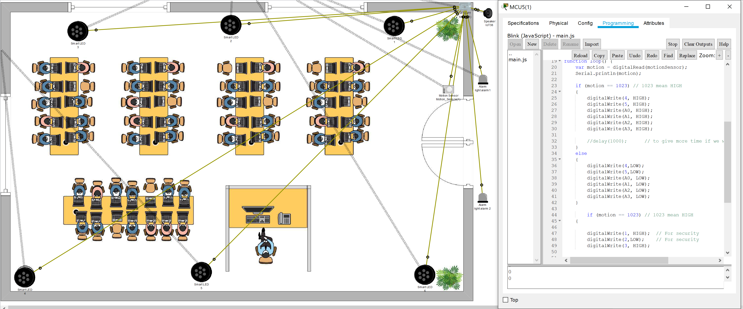
Figure 9: The implementation of motions sensor for light and security with the code.

7.1.4 Fire system:
The fire system basically is about a fire monitor which can monitoring and deducting the fire in certain area, the fire monitor linked to the NodeMCU and if there is any fire the NodeMCU switch on the celling sprinkler to put out the fire, and there is an alarm to alert the people in this area and a LCD to display the status if it is safe or not.
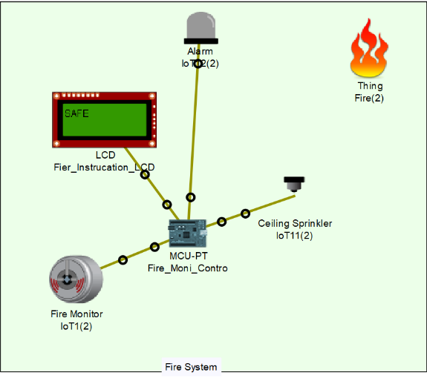
  - Connection to NodeMCU:
Figure 10: Fire system.
var monitorSensor = 0; // Motion Sensor
var LCD = 1; //LCD to display the current stat with temperature
var alarm = 2; //alarm
var sprinkler1 = 3; // Ceiling Sprinkler
var sprinkler2 = 4;
var sprinkler3 = 5;
var sprinkler4 = A0;
var sprinkler5 = A1;
var sprinkler6 = A2;
var sprinkler7 = A3;

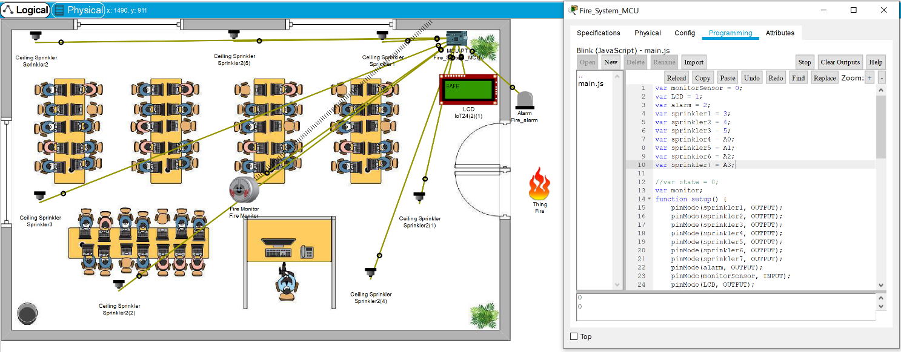
Figure 11: the implementation of the fire system.

7.1.5 Smoke sensor with Carbon gas detector:
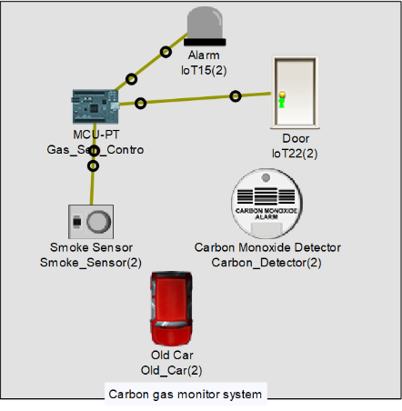
In this cluster, a smoke sensor will detect if there any smoke or the air is not clean enough for the human, and this sensor is linked to the NodeMCU to read the value, there are some windows connected to the NodeMCU with a door, ceiling fan and alarm. if the gas has hit the limit the smoke sensor will read the value and send it to the NodeMCU and then the NodeMCU will switch on the windows, door and ceiling fan to change the air inside this area, once the smoke value has reduced, the other actuators will switch off
Figure 12: Carbon gas system.
also, there is a carbon monoxide detector and a smoke detector device added to the system to show the user the value through his laptop
  - Connection to NodeMCU:
var alarm= 0;
var door = 1;
var wind1 =2;
var wind2 =3;
var wind3 =4;
var wind4 =5;
var smokeSensor = A0;
var cilingFan= A1;

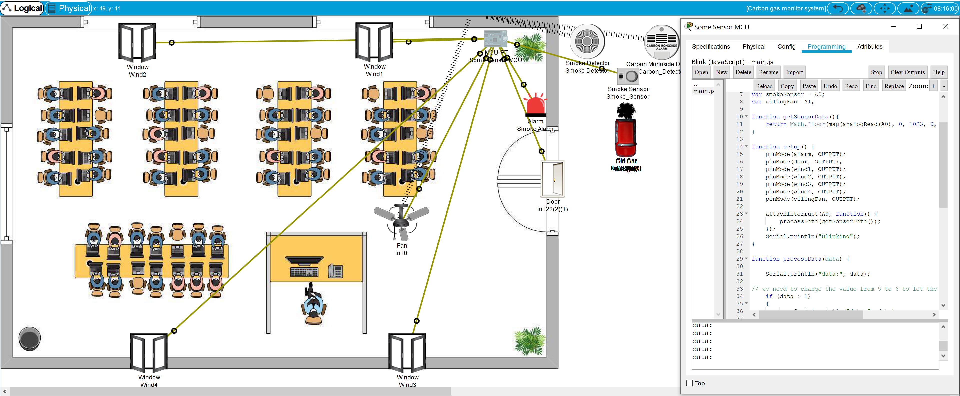
Figure 13: The implementation of the Smoke sensor with Carbon gas detector

7.1.6 Humidity system
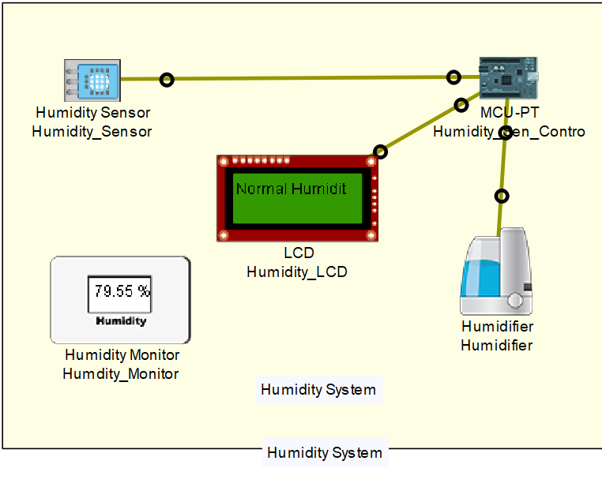
Because the humidity important for the human as well, the author has added a humidity system to the campus, which will adjust the humidity to suit the required humidity needed by the human body
which and lead to increase the Psychological comfort for the student.
So the implementation was by connecting the humidity sensor to the NodeMCU to control the humidity in certain value, and the NodeMCU has linked to humidifier which will switch on when the value inside the sensor hit the limit, also a humidity monitor has been added to the system to show the user the accurate humidity in the are
Figure 14: Humidify system.

  - Connection to NodeMCU:
var humidSensor = A0;
var humidifer = 0;
var LCD = 1;
var humidity;

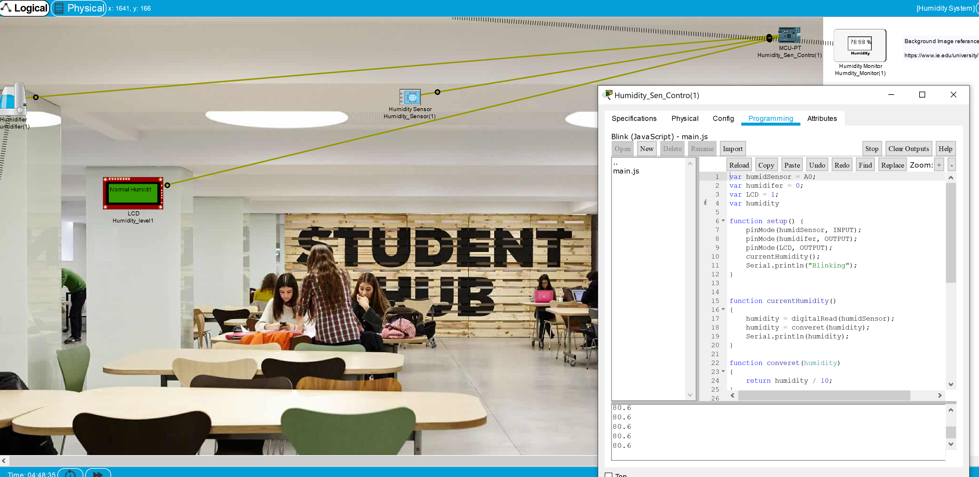
Figure 15: The implementation of the Humidity system.

7.1.7 Car Park Management system
In separate cluster, the author has created a car park management system for the campus, which the user can see the available spaces in the car park and also to reserve a space by turning the red light.
The car park has been implemented by using motion sensor to detect if there is any object in this space, and the motion sensor linked to the NodeMCU to programme it and control, there is an RGB light has been connected to the NodeMCU which it job just to switch the light red when the car has left and red when some car has parked in this place.

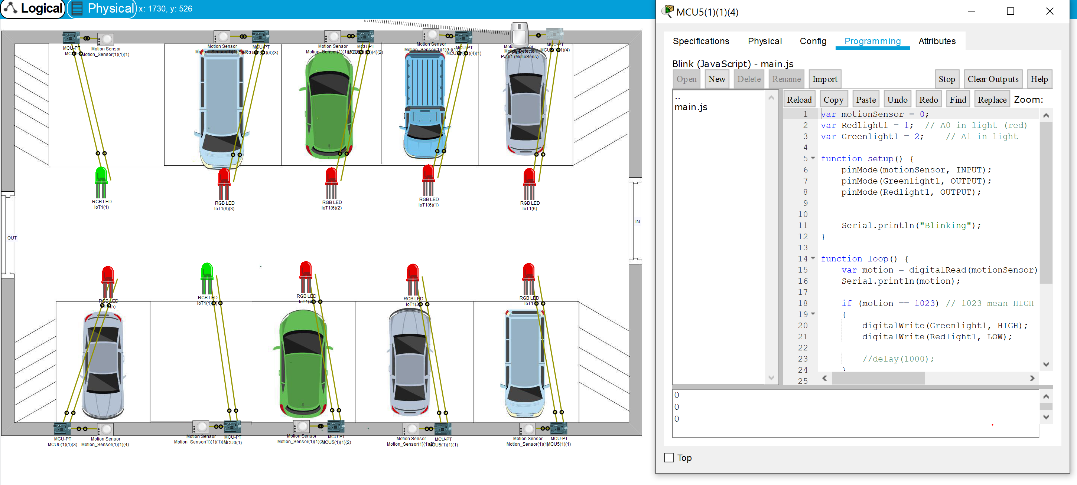
Figure 16: The implementation of the car park management system.

7.1.8 Another implementation method for smart campus:
This part is an example to show the connecting between the sensors straight away to switch then the Server
without using The Campus Gateway
The user can control the temperature from the Laptop by accessing the web browser and entering the IP address for the server
then entering the username and password (admin, admin) to login to the page controller
which the user can control and switch between Cooling, Heating, Auto or set the temperature range.

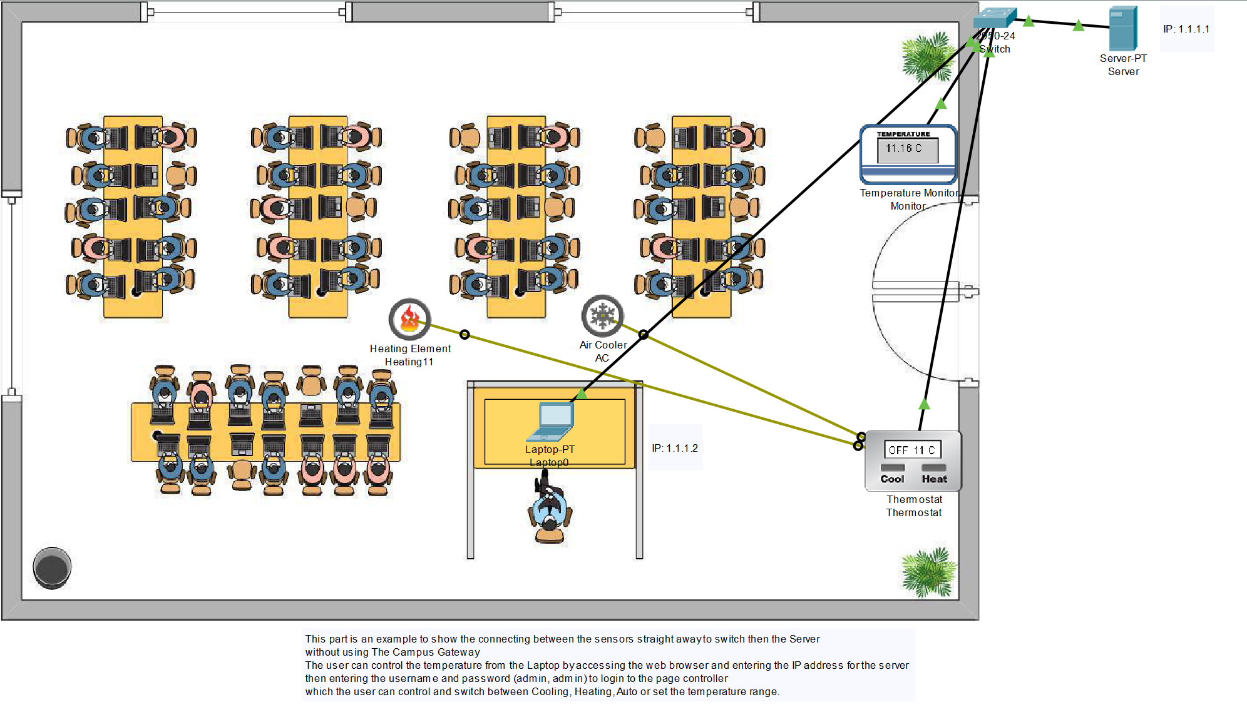
Figure 17: Another implementation method for smart campus.

