UNIVERSITY OF WALES: TRINITY SAINT DAVID

Developing Relationships and Workplace Achievements

BA (Hons) Leadership and Management Skills for the Workplace
Student Name: Corneliu Lupu
Student Number: 1913124
Lecturer Name: Molly Jack

Table of Contents
Introduction 3
Main body 3
Development tools 3
Identification of development needs using ASK concept 6
Application of Maslow’s Hierarchy 7
Action Plan 9
Controlling and evaluation 10
Conclusion 11
Reference List 12

Introduction
The company that has been chosen for this paper is L’Enclume. It was founded by Chef Simon Rogan and his partner Penny Tapsell in 2002 and is known for its modern British food (simonrogan.co.uk, 2021). The restaurant is located at Cartmel, Cumbria in England. Most of the produce used in the restaurant like vegetables, herbs, meat and fruits are purchased from the farm near the restaurant. The restaurant is famous for a twenty-course menu made from wildflowers and herbs. L’Enclume is well known for the natural beauty surrounding the restaurant and for providing an unforgettable experience of the medieval village of Cartmel.
The company provided the following developing techniques for its employees:
- Training and development: The management of L’Enclume provides training and development programs to its employees and encourages growth. The management provides classes for their employees to expand their skills.
- Learning tools: The company held daily lockdown masterclasses due to Covid-19 for cooking by their chefs, wine tastings, more information about local suppliers, cocktail classes and as well as zoom quiz (simonrogan.co.uk, 2021). All these helped in bring all the employees together for a common cause and gave them the opportunity to learn.
- Work environment: L’Enclume provides an enthusiastic and friendly working environment for its employees and encourages their growth. The schedule for the all the employees is compressed of four days per week.
- Hospitality: The management of the company looks after the welfare of its people by carrying out actions like charity fundraising and promoting a sense of togetherness among the employees (simonrogan.co.uk, 2021). L’Enclume has ensured the safety of its employees during the Covid-19 pandemic by providing them with extra sanitizers and regulating the number of staffs working together.
- Communicating tools: The entire team connect with each other through over Teams chats and social media.

Main body

Development tools

The development of an employee is the process in which an employee undergoes different training programs to enhance their skills and obtain new knowledge (Nerstad et al., 2018). An employer needs to support the employee’s development program as the personal growth and development of employees within a workplace is important for the better performance of the employees in their work. An organisation can take initiatives to encourage the growth and development programs for the employees.
- Creating growth plans: Creating growth plans for an employee is the act of planning the way an employee can improve the skills required for doing his or her work (Dachner et al., 2019). The employer can decide the plan according to the qualification and performance of the employee at the workplace. He can also arrange training and development programs for an employee for further improvement of skills and gaining of new knowledge if required. As reported by simonrogan.co.uk (2021), the management also provides classes for their employees to hone their skill. Creating plans to ensure the development of employees is important for the overall growth of the organisation. Without employees, L’Enclume cannot function by depending solely on its owner Simon Rogan. He provides guidance and direction to his subordinates, which helps the employees to work according to a plan, improve their skills and contribute to the success of the company.
However, arranging the growth and development programs for employees can have a certain negative impact on the organisation. Growth and development programs for employees require an investment of time and money, which may increase the overall cost of the organisation.
- Learning tools: As stated by Taştan and Davoudi (2017), the learning tools are the methods that are provided by the employer to his or her employees by using tools in order for the employee to learn a new expertise, acquire knowledge and improve the skills for a better performance. Providing tools to the employees for training and development is essential to adapt skills according to the current market requirement. Lack of acquiring new skills and knowledge can cause a decline in the value and career of an employee. L’Enclume has taken advantage of the lockdown by providing opportunities to help the employees to learn new things and to sharpen their skills.
Although providing tools for learning new skills may be beneficial for the employee performance of an organisation, this also has certain negative impacts. It becomes difficult for the company to retain skilled workers. The talented employees who have developed their skills with the help of development programs may leave the organisation for a better opportunity. This may harm the organisation as the employees might share the expertise they learnt at their previous work with the new company, thereby reducing the exclusiveness of a concept implemented by the old organisation.
- Work culture: The Work culture refers to the attitude and beliefs of the employees and the relationship among them within an organisation along with the objectives and ideologies of the respective organisation. According to Abdullah (2020), work culture is essential for the proper functioning of an organisation, acquiring the best employee performance and the utilisation of the available resources industry. within an organisation. A positive work culture provides a perfect ambience to the employees to concentrate on work and ensures coordination among them. They have a four-day working week for all the employees. All these have helped to increase the productivity of the organisation. The employees love their work and are enthusiastic to gain new knowledge every day. The common shared love for food, drink and customer service has brought the employees together at L’Enclume. The management encourages the share of mutual knowledge and experience among the organisation, which gives everyone at L’Enclume a diverse learning experience. Maintaining a healthy and positive ambience within the organisation has helped L’Enclume to achieve growth and popularity within the hospitality industry.
Lack of a good work culture harms the organisation immensely. It creates poor communication among the employees and between the management and employees (Angouri, 2018). Negative work culture also creates poor management of organisational affairs and leadership and reduces employee performance. All these decrease the productivity and efficiency of the company.
- Health and Welfare: Ensuring the safety and good health of the employees by an organisation is beneficial for the company as the wellness of the employee directly affects productivity and profits (Song and Baicker, 2019). This action has helped the employees in their crisis and strengthened the bond among them. Especially the time during Covid-19 pandemic has been hard for all and the positive gestures by the management of L’Enclume have increased the faith of the employees in the management. L’Enclume has also ensured the safety of its employees during the pandemic `by providing those with extra sanitisers, gloves, face mask and regulating the number of staffs working together (simonrogan.co.uk, 2021). The management has assisted the members who can do their work from home by providing the necessary arrangements. The staffs are provided with clean aprons and uniforms while carrying out their duty.
Lack of employee safety and welfare harms the productivity and reputation of the organisation. Employees are the key to organisational success. Without high performing employees, an organisation cannot function. Employees who are healthy and satisfied with their jobs perform better in their work.
- Communicating tools: Communication is necessary within an organisation to ensure the proper management of all organisation activities. There are various tools such as Teams meeting, social media, notice and others used by an organisation to maintain efficient communication among the company (Genç, 2017). At L’Enclume, the entire team including the management and the employees connect through meaningful interactions over Teams chats and social media. The management invites its employees to share their opinions and personal stories through virtual talks to promote cultural exchange among the team. This has made it easier for people to understand each other, thereby promoting good coordination and teamwork among the employees. Lack of effective communicating tools causes poor communication among the employees which results in their poor performance in work. Mikkola and Valo (2019) stated that poor communication gives rise to arguments as the people fail to understand each other's view. All these together reduce the productivity and growth of the organisation.
- Wage and Salary Administration: This is a procedure, which is used to distribute and plan the compensation programs for employees by a company. The wage and salary administration of L’Enclume helps the employees to acquire a comfortable living and fulfil their basic needs. Employee satisfaction increases in case they are provided with adequate salary every month. This also attracts young talent to apply for the position and contribute their skills in organisational development process. However, this program fails to meet the expectations of some, as they desire for a better salary.

Identification of development needs using ASK concept
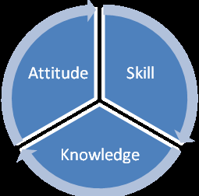
The concept know as ASK is a mechanism that is used to decompose an education discipline into elements to manage them effectively, that consists of the expectations of a professional. The elements that comprise the ASK concept are the following: professional attitude, knowledge, and skills.

Figure 1: ASK Concept
(Source: Sofian et al., 2011)
- Professional Attitude: The employees of L’Énclume fail in their interaction with customers. They are not interactive enough to find out about the customer experience at L’Enclume in order to identify the issues that are taking place and improve their experience in the restaurant.
- Knowledge: Some chefs of L’Énclume lack knowledge of the proper methods that should be used in the preparation of some dishes from the menu, and it affects greatly the final product which is presented to the client.
- Skill: At L’Enclume, the housekeepers lack the skill to pay detail attention to the surrounding to find out any source of discomfort for the customers and take immediate action.
The expectation of employees: An organisation should find out the expectation of an employee to ensure that he or she is satisfied with the job (Maylett and Wride, 2017). L’Enclume needs to fulfil the expectation of its employees like salary and benefits, appreciation for good work and career development to receive a better performance at work and ensure job satisfaction. The expectations include recognition, feedback, efficient leadership and provide a solution for any problem.
Objectives: To set a group of objectives to be followed by all the employees in order to have clear expectations know to both parties.
- To improve the interaction of the employees of L’Enclume with their customers.
- To provide cooking classes so that the chefs can get the correct knowledge to prepare some of the specific dishes.
- To develop the skill of paying attention to even the smallest detail among the housekeepers and provide training in order to achieve this.
Strategies to fulfil needs: L’Enclume may initiate strategies to fulfil the needs of its employees like maintaining safety, provide compensation, a friendly work environment, ensure personal interaction and feedback and provide career development. All this will help the organisation to fulfil the basic needs of its employees and ensure their retention.

Application of Maslow’s Hierarchy
Maslow’s Hierarchy of Needs can be described as the theory that depicts the needs of an individual. It consists of a five-tier pyramid model showing the various needs of human beings from the bottom of the pyramid to the top (Hopper, 2019).
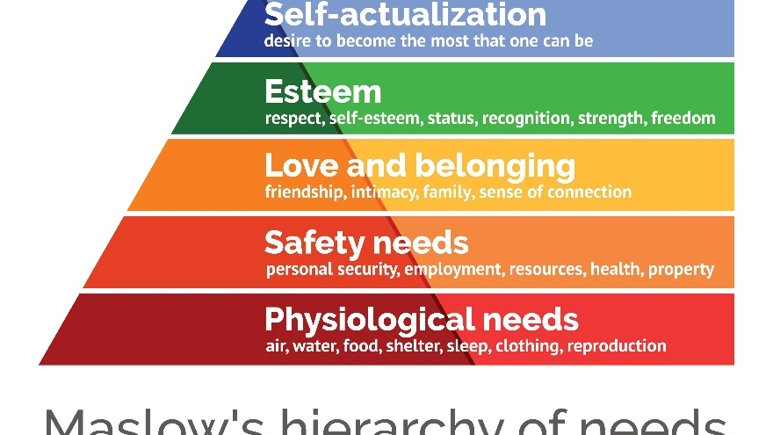
Figure 2: Maslow’s Hierarchy of Needs
(Source: Hopper, 2020)
- Physiological needs: L’Enclume needs to satisfy the physiological needs of the employees by providing salary and compensation to ensure that employees can meet their basic needs for living.
- Safety needs: The management of L’Enclume may fulfil the need for employee security, look after the employee health and welfare and provide secure employment to all the employees.
- Love and belonging needs: L’Enclume can ensure a sense of connection and friendship among all the employees so that they can work in harmony together.
- Esteem: The management can provide respect and recognition to an employee for his or her work.
- Self-actualisation: L’Enclume needs to provide career development opportunity to the employees so that they can have growth in their knowledge and expertise, thereby letting them to achieve their highest qualification.
Matching Model of HRM: The model used to follow human resource management in an organisation is called a matching model of HRM (GADO et al., 2018).
- Selection: L’Enclume needs to select and hire qualified professionals to deliver good performance at work.
- Performance management: The organisation can monitor the performance of the employees closely and provide development if needed. Rewards may be given to those who have performed well. This will increase the motivation of the employees and make them enthusiastic about their job.

Action Plan
Objectives | Tactics | Success criteria | Responsible person | Timeframe
Improve existing knowledge | Advanced hospitality training can be provided to chefs, supervisors and other departmental employees to help them in developing existing skills | Assessment test results | HR manager | 23/06/2021
Enhance detailed oriented skill | Leadership programs and feedback sessions can be arranged to help employees to become detailed oriented. | Feedback from peers and supervisors | HR manager | 25/05/2021
Enhance employee interaction with customers | On the job training can be provided to help employees learn the way to deal with guests and receive feedbacks from them | Feedback from senior managers | HR manager | 27/05/2021
Table 1: Action plan

Controlling and evaluation
The plan can be evaluated with identification of some key performance indicators that are as follows:
- Employee engagement: Employee engagement is essential to understand employee experience, confidence, commitment, and satisfaction towards work. L’Enclume can use this tool to evaluate the quality of an individual to acquire an efficient and talented employee for the organisation.
- Employee satisfaction: Ensuring employee satisfaction is essential for L’enclume to retain talented individuals within the organisation. It is important to consider an employee’s satisfaction regarding the work, workplace, salary, and other facilities to get the best output.
- Net promoter score: This tool may be used by L’Enclume to acquire employee opinion and feedback so that necessary improvements can be done for utmost customer satisfaction. This also shows the effectiveness of the training provided to the employees.

Conclusion
The study has discussed the necessity and benefits of developing individuals in the workplace. The different development vehicles available to an organisation to manage the needs for employee development have been a subject of discussion. The effective use of these vehicles has given a proper way to manage and fulfil the needs. By the use of the ASK concept, the different needs and expectations of an individual at the workplace have been deduced. It has been seen the way relationships at the workplace affect both job satisfaction and the achievements of an individual. Thus, it can be concluded that an organisation needs to develop a healthy and friendly work environment for the growth and development of both the employees as well as the organisation.

References
Abdullah, A., 2020. Relationship the Work Culture and Training Programs Within Performance. International Journal of Progressive Sciences and Technologies, 20(1), pp.92-
Angouri, J., 2018. Culture, discourse, and the workplace. Routledge.
Dachner, A.M., Ellingson, J.E., Noe, R.A. and Saxton, B.M., 2019. The future of employee development. Human Resource Management Review, p.100732.
GADO, A.S.K. and ÜLGEN, B., 2018. HUMAN RESOURCE MODELS: HARD AND SOFT.
Genç, R., 2017. The importance of communication in sustainability & sustainable strategies. Procedia Manufacturing, 8, pp.511-516.
Hopper, E., 2019. Maslow's hierarchy of needs explained. Viitattu, 12, p.2019.
Maylett, T. and Wride, M., 2017. The employee experience: how to attract talent, retain top performers, and drive results. John Wiley & Sons.
Mikkola, L. and Valo, M. eds., 2019. Workplace communication. Routledge.
Nerstad, C.G., Dysvik, A., Kuvaas, B. and Buch, R., 2018. Negative and positive synergies: On employee development practices, motivational climate, and employee outcomes. Human Resource Management, 57(5), pp.1285-1302.
simonrogan.co.uk 2021 Simon Rogan[online] Available At: https://www.simonrogan.co.uk/about [Accessed 21th March]
Song, Z. and Baicker, K., 2019. Effect of a workplace wellness program on employee health and economic outcomes: a randomized clinical trial. Jama, 321(15), pp.1491-1501. 101.
Taştan, S.B. and Davoudi, S.M.M., 2017. The relationship between organisational climate and organisational innovativeness: testing the moderating effect of individual values of power and achievement. International Journal of Business Innovation and Research, 12(4), pp.465-483.
Taştan, S.B. and Davoudi, S.M.M., 2017. The relationship between organisational climate and organisational innovativeness: testing the moderating effect of individual values of power and achievement. International Journal of Business Innovation and Research, 12(4), pp.465-483.

