Worksheet 1

I created my 2 servers which are both on Windows Server 2019 called Server 1 and Server 2.
I have only shown the screenshots for server 1 as the settings are identical on both apart from the names.
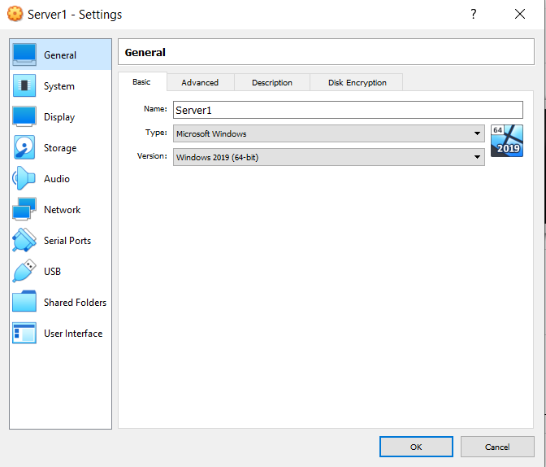

I set the RAM to 3GB instead of 4GB of RAM as my laptop could not handle running 2 VMs at 4GB RAM at the same time.
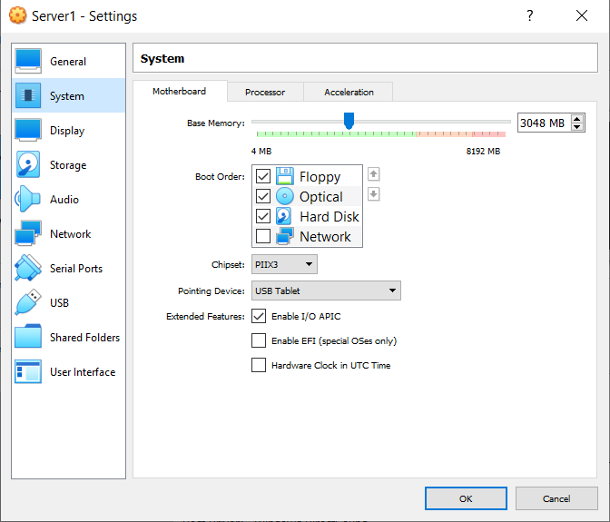

PAE/NX was enabled to improve performance, this setting allows the CPU to access 4GB RAM more adding another 4 bits to memory addresses which helped me a lot as my laptop was struggling before I enabled this setting.
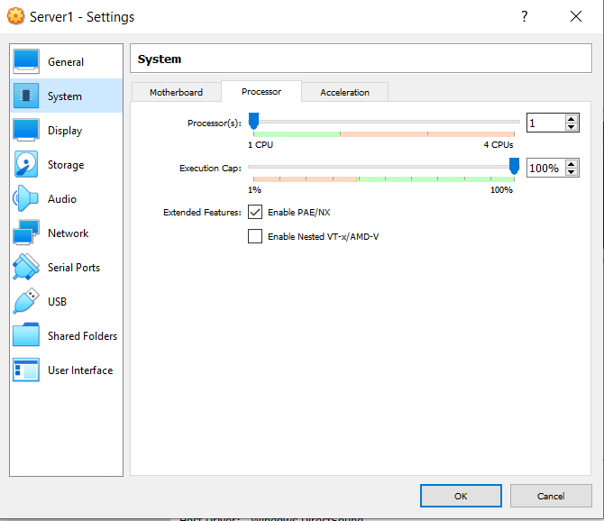

The video memory was also set to the max setting of 128MB to improve how the VMs look which also stops delay.
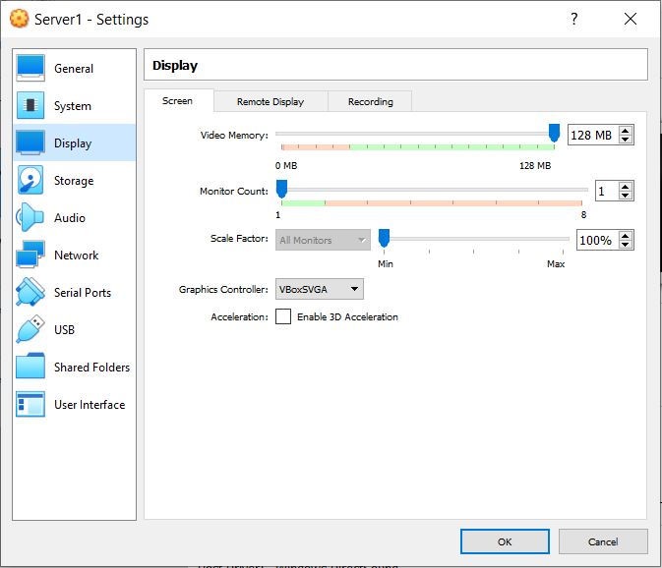

Once I created the servers and optimised I added the ISO so that I could install Windows Server 2019 onto Oracle VM VirtualBox so that I could access it.

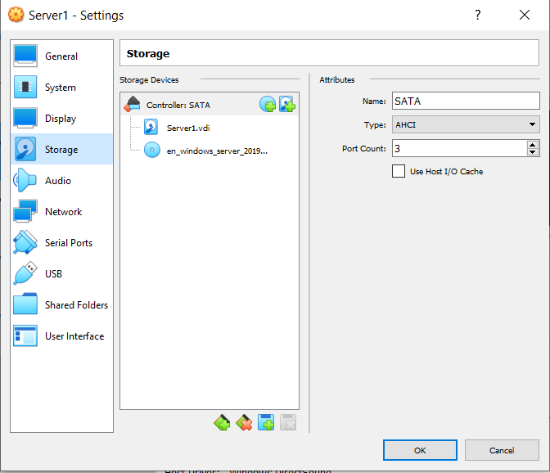

I added 2 network adapters and changed them from attached to NAT to Internal Network so that my different VMs could see each other.
The first adapter is for my the Public network and the second is for the private network, I called these PublicNet and PrivateNet1 for my first server, then on the second server I called it PrivateNet2.
I also had to change the promiscuous mode to allow all as I was having trouble connecting my clients to the domain when it was set to the default deny.
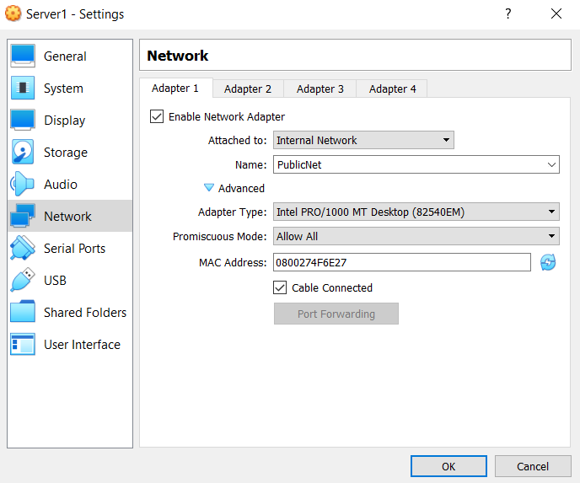
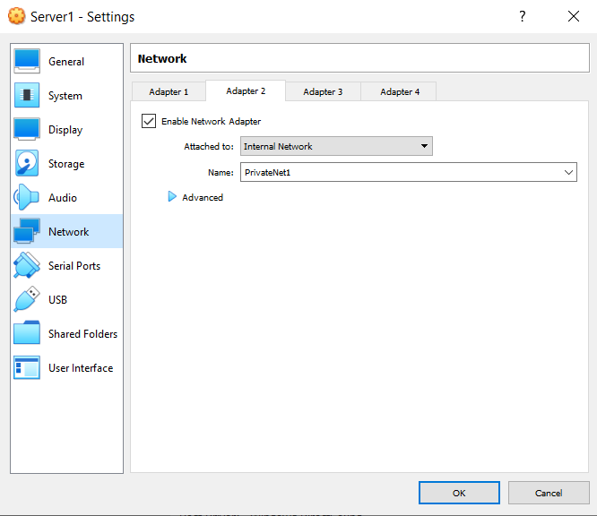
I also created two clients with Windows 10 64-bit called Client 1 and 2.
I have only shown screenshots of client 1 as the settings are the same other than the names.
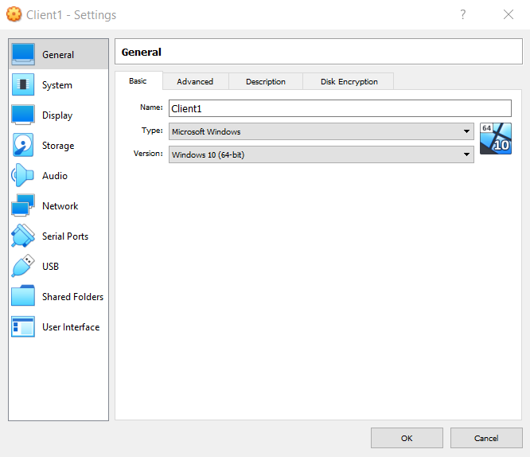

For the same reason mentioned previously, I set the RAM to 3GB.
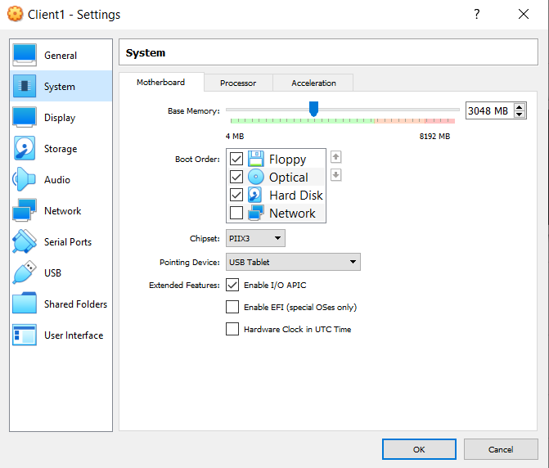

PAE/NX was enabled for better performance.
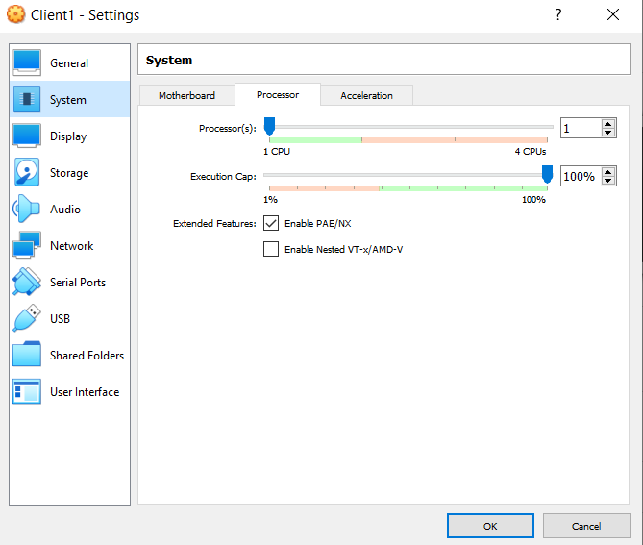

The maximum video memory was used for better performance.
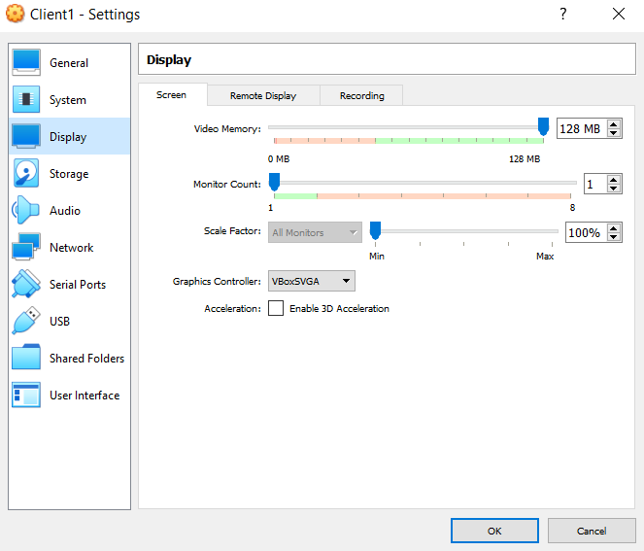

Once I created the client VMs I went into the storage settings and added the ISO so that I could install Windows 10 onto Oracle VM VirtualBox.
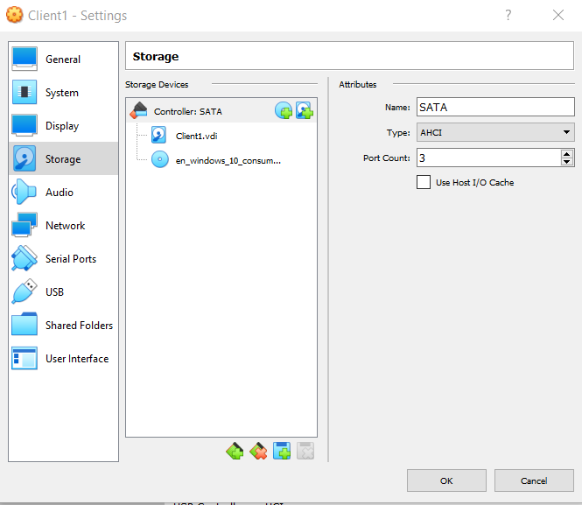

The clients do not need access to the public network so they only have the 1 adapter enabled called PrivateNet1 on client 1 and PrivateNet2 on client 2.
I also had to change the promiscuous mode to allow all as I was having trouble connecting my clients to the domain when it was set to the default deny.
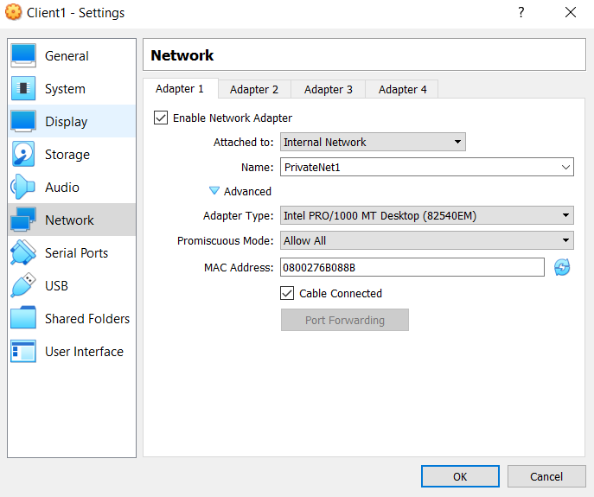

Server 1 Configuration in Windows

I renamed each adapter from the default Ethernet to the appropriate names for my private and public network so that I could easily tell them apart.

Once I renamed them I set the IP addresses and subnet masks on each of my servers.
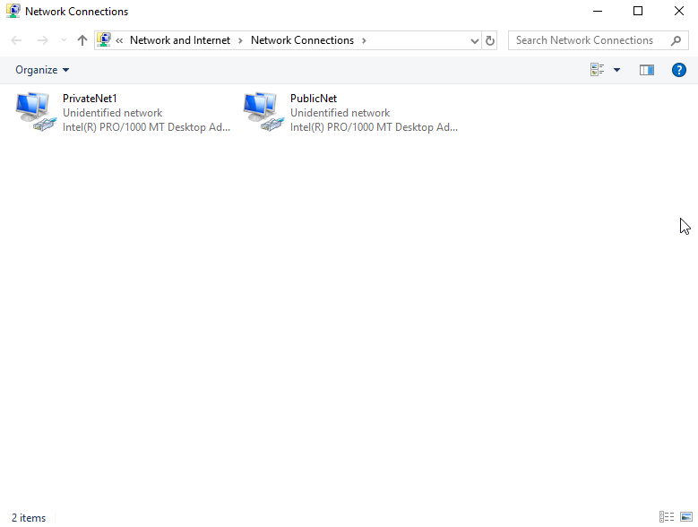

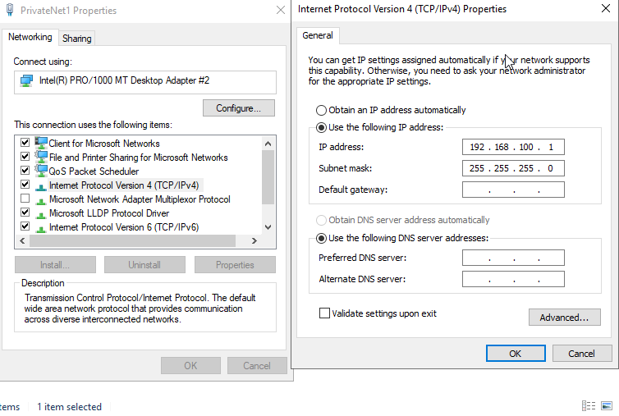

Server 2 configuration in Windows

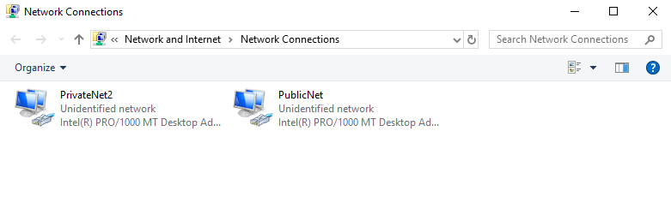

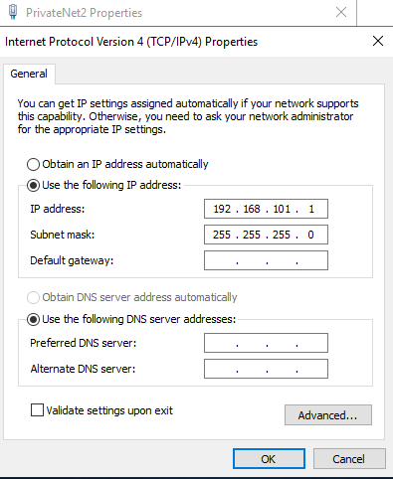
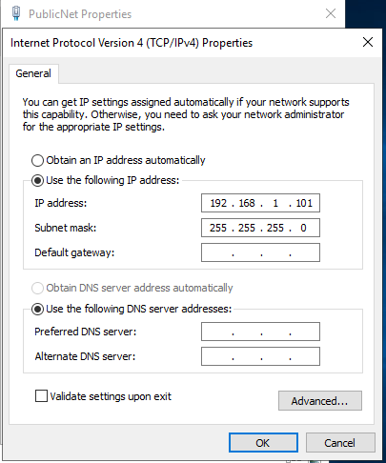
Client 1 configuration in Windows

On the clients, I did the same as on the servers changing the name of the Ethernet adapter from its default to PrivateNet and set the IP address and subnet mask on each device.
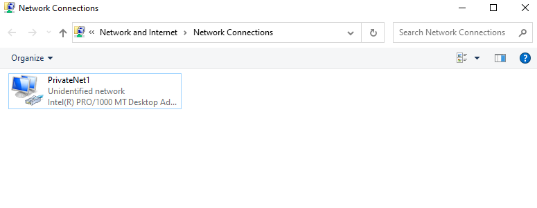
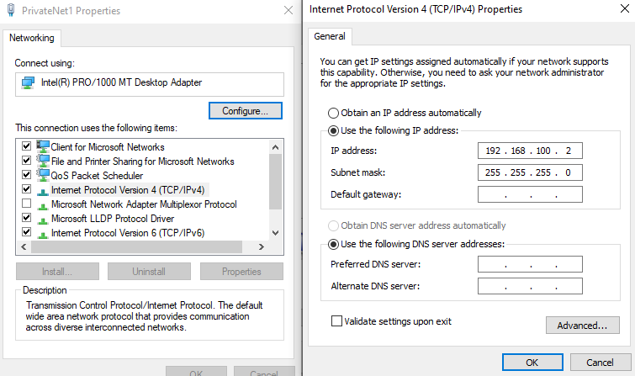
Client 2 configuration in Windows

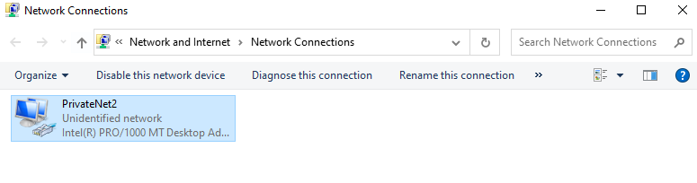

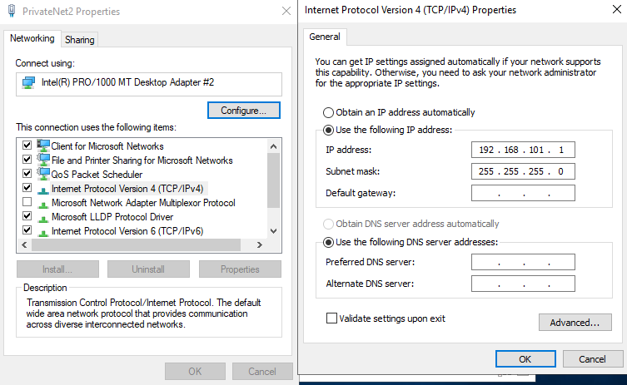

Firewall configuration on all devices

I turned off the Windows Defender Firewalls on all devices so that my VMs could communicate with each other.
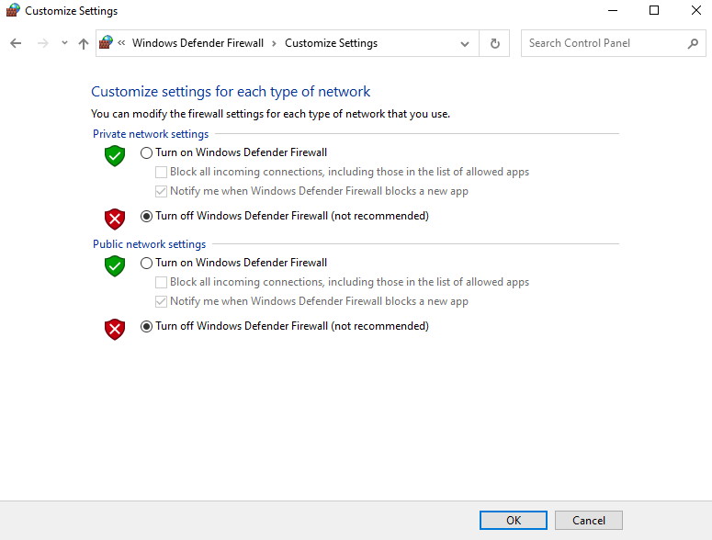

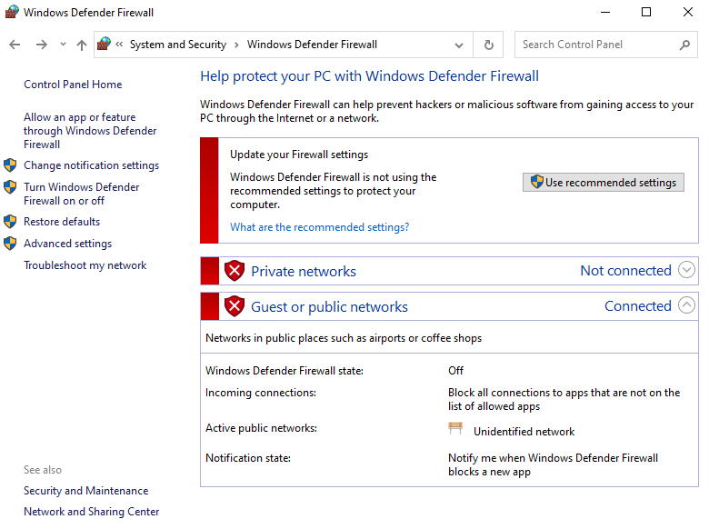

Ping between server 1 and client 1

I pinged my devices so that I could test connectivity, all of my pings were successful first try.
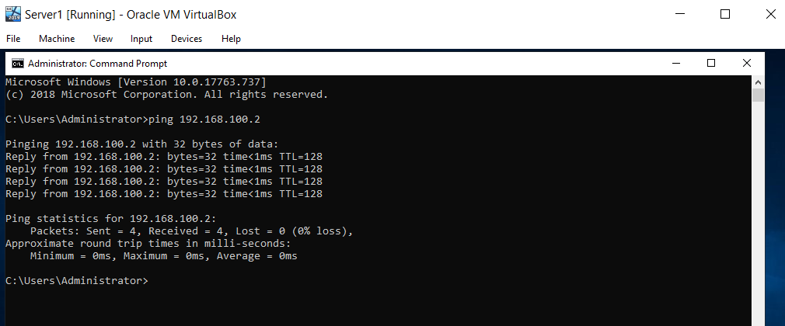

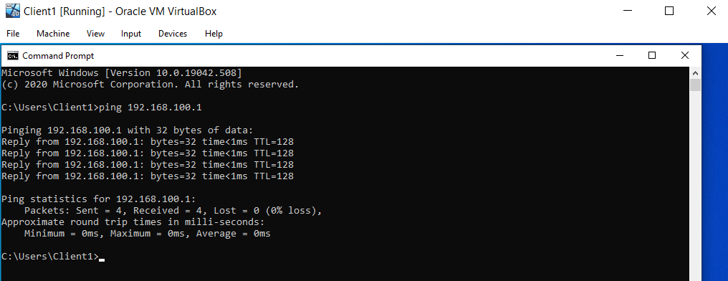

Ping between server 2 and client 2

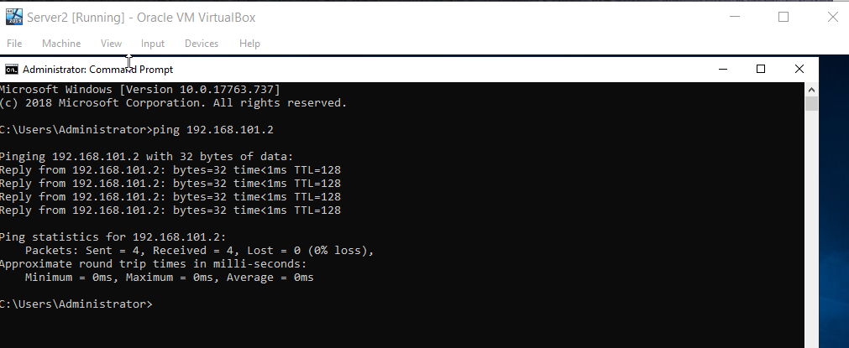

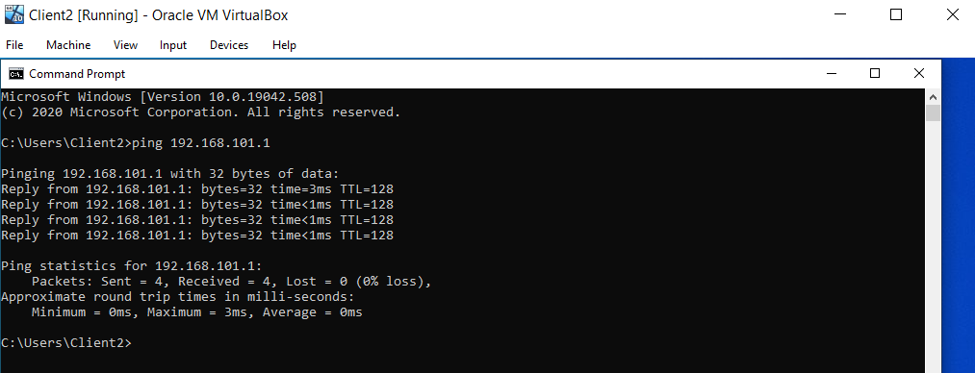

Worksheet 1 questions

- Describe the main differences between Type 1 and Type 2 Hypervisors. Identify benefits and drawbacks of both and provide some example Vendors.
Virtualisation requires the use of a hypervisor to function, it abstracts operating systems and applications from their underlying hardware. The physical hardware that a hypervisor runs on is referred to as a host machine, whereas the VMs the hypervisor creates and supports are collectively called guest machines [1]. A hypervisor enables the host to use multiple VMs which are separate from each other and share abstracted resources among the VMs. Virtualisation with a hypervisor increases a data centre’s efficiency compared to a physical workload hosting.
Hypervisors are split into 2 types, Type 1 and Type 2 hypervisors. Both of these can virtualise common elements such as CPU, memory and networking but based on its location in the stack the hypervisor virtualises these elements differently depending on whether it is a Type 1 or a Type 2 [1].
A Type 1 hypervisor runs directly on the host machines physical hardware which is commonly referred to as a bare-metal hypervisor. Type 1 doesn’t have to load an underlying OS as it has direct access to the underlying hardware such as Operating Systems and drivers. Type 1 hypervisors are regarded as the most efficient and best-performing hypervisors available. Type 1 hypervisors are also highly secure, virtualisation mitigates the risk of attacks on your device as the VM has its own OS so cannot the device it is running off or other VMs that is running on the same hardware.
However, these features come with a much higher initial cost and require greater support. Type 1 hypervisors require some level of external management with interfaces such as Microsoft System Centre Virtual Machine Manager or VMware vCentre to access the full range of abilities hypervisors can offer [1].

A Type 2 hypervisor is typically installed on top of an existing OS, it is called a hosted hypervisors as it relies on the host machines pre-existing Operating System to manage requests to CPU, memory, storage and network resources.
Due to this Type 2 hypervisors are faced with unavoidable latency as all of the hypervisor’s activities and the work of every VM has to pass through the host Operating System. Also, any security flaws or vulnerabilities in the host Operating System could compromise all of the VMs running on it.
This means that Type 2 hypervisors are not usually used for data centre computing because of the issues previously discussed so instead they are used for client or end-user systems where performance and security are less of a concern. Although Type 2 has its drawbacks it does come at a much cheaper cost than Type 1 and it does make for an ideal test platform for something such as testing software before release. They are also typically used by organisations to create virtual desktops for users [1].

Examples of Vendors:
Type 1- VMware vSphere, Microsoft Hyper-V, Oracle VM, Citrix Hypervisor
Type 2- Oracle VM VirtualBox, VMware Workstation Pro

The main differences are that Type 1 hypervisors are very good for large organisations that must deploy hundreds of VMs and Type 2 are better for a smaller scale such as being used for testing or just require a small number of VMs.

- What is the significance of the subnet mask in IPv4 addressing?
A subnet mask is a 32-bit number by setting host bits to all 0s and setting network bits to all 1s, this way the subnet mask separates the IP addresses into the network and host addresses. The subnet mask is used to determine what part of the subnet is a network and what part is the host portion so that when the device want to send traffic it knows what traffic can be sent locally and what needs to go via the default gateway. When a device builds up a packet it will add the DST address into the address field and compare it to the DST address with its own local IP address to determine what needs to go via the default gateway using the subnet mask [2].

- Cloud computing has revolutionised the way that enterprise networks are hosted. Describe the use of cloud computing including its benefits and drawbacks and identify example vendors within the industry.
Cloud computing is a general term for anything that involves delivering hosted services over the internet. These services are divided into three main categories, Infrastructure as a service, Platform as a service and Software as a service. Clouds can be public or private, a public cloud sells services to anyone on the internet and a private cloud is a network or data centre that supplies hosted services to a limited number of people which certain access and permissions. Both of these share the same purpose of providing easily accessible computing resources and IT services via the cloud [3].
Cloud computing works by allowing client devices to access data over the internet from remote servers, databases and computers. An internet connection links the front end such as accessing the client device and browser. The back end consists of databases, servers and computers and its primary function is to store data that is accessed by the front end. The communication between the front and back ends are managed by a central server [3].
Cloud computing has many benefits, one of those is that no hardware is required as everything is hosted in the cloud there is no need for physical storage on site. It is also very convenient for disaster recovery as the data is being held off-site so if a disaster happened to destroy a company’s building then the data would be fine [4].
Another benefit is that it is very easy to implement, cloud hosting allows businesses to use IT systems without a big start-up cost that you would need to buy servers and have the cost of running them. Instead, all of this is already set up and a company just needs to purchase the cloud services and they are up and running [4].
Another benefit is accessibility, as the data is stored on the cloud it is accessible from anywhere as long as you have an internet connection. This allows companies to be more flexible where they work from and makes it much easier to share data with multiple users [4].
Another benefit of cloud computing is the flexibility for growth, there is no need to plan for where to put new servers on-site you can just purchase what you need from the company hosting the cloud services. For example, if a company wanted to get a thousand more licenses for VMs to use they can be purchased and they will be good to go with no setup fees [4].
Lastly, overhead technology costs are kept to a minimum with cloud hosting services enabling companies to use the extra time and resources for improving the infrastructure [4].

Although there are many advantages to cloud computing it also comes with its drawbacks. One disadvantage of cloud computing is that it is essentially handing over the companies data and information to someone else to manage. If a company has its own IT department they are limited to what they are able to do, most things must be resolved by the supplier [4].
Another disadvantage is that although the data stored should be secure a cloud server is not a backed up so if something did happen to the data it could be lost forever unless there were measurements in place such as an onsite backup or by purchasing a redundancy plan with the cloud service providers [4].
Another disadvantage is security and privacy in the cloud. There are concerns with valuable and important data being stored remotely, it is important to choose a reliable service provider as the provider has complete access to the data that you are storing on their cloud services [5].
Another disadvantage is vulnerability to attacks, due to the data being stored on the web it is always going to be prone to attacks which could result in sensitive data being leaked [5].
Another disadvantage is that although the start-up cost is low for cloud services the cost over the years increases and adds up [5].

Examples of vendors in cloud computing:
- Amazon Web Services
- Microsoft Azure
- Google Cloud Platform
- IBM Cloud
- Give an in-detail description about the different terminologies and its purposes (like (not limited to) Ping, Server Management, Firewall, PAE/NX, OOBE etc) you came across during the Task 1 and Task 2. Compare your list of terminologies in the aspect of their operations/functionality with other Network Operating Systems. (For example: If you select Windows Firewall and describe the operations/functionality of Windows Server 2019 Firewall, you have to compare these features with the operations/functionality of other Network Operating Systems like Linux, Mac)

Ping is a computer network administration software utility used to test the reachability of a host on an Internet Protocol Network, it is available for virtually all operating systems that have networking capability including most embedded network administration software. A ping request can be done by simply entering the IP address or domain name of a device [6].

PAE stands for Physical Address Extension. PAE/NX determines whether the PAE and NX capabilities of the host CPU will be exposed to the virtual machine. If enabled and supported by the OS, then even a 32-bit x86 CPU can access more than 4 GB of RAM. This is made possible by adding another 4 bits to memory addresses, so that with 36 bits, up to 64 GB can be addressed. Some OSes, such as Ubuntu Server, require PAE support from the CPU and cannot be run in a virtual machine without it [7].

A firewall is a network security device that monitors incoming and outgoing network traffic and decides whether to allow or block specific traffic based on a defined set of security rules [8].
The two main functions of the firewall are packet filtering and work as an application proxy. In packet filtering, the firewall looks at each data packet as it comes to or leaves the computer network. While it’s examining these packets it uses user-defined rules to determine whether to access or reject the packet. It works as a gatekeeper that determines what can pass through due to system monitoring and the network rules. The other main function is to work as the application proxy, as the packet filtering can’t recognise malware trying to breach the network as it doesn’t understand the entire application but a firewall acting as an application proxy can stop information between inside the network and outside the network because it understands the application being used so it can stop the malware getting through, preventing a breach in the network [9].

Server management is a complex and vital process to the success of a network, without proper server management servers can easily fail which could be detrimental to the network. System administrators must be able to continuously manage physical server hardware. Virtual machines and a variety of application and database servers [10].
Server management is about controlling and having access to servers in order to maintain and perform administrative operations and also involves monitoring its performance in order to optimise and improve it [10].
For good server management, the servers must be kept up to date with the latest software and firmware updates to avoid security risks and to ensure the server is properly optimised. Another key step to good server management is the ability to monitor the server so that if there are any alerts with an issue on any servers it can be quickly identified and resolved. Another feature is optimisation, some server management tools and services can provide optimisation capabilities to improve server efficiency and overall operations. Lastly, ensuring that the server is easily accessible by having a server management tool installed so that IT technicians can easily work on the server to manage, optimise or resolve any problems with the server [10].

Windows Defender Firewall in Windows Server 2019 is a stateful host firewall that helps secure a device by allowing the user to create rules that determine which network traffic is permitted to enter the device from the network and which network traffic the device is allowed to send to the network. As well as this, Windows Firewall supports Internet Protocol security which can be used to require authentication from any device that is attempting to communicate with this device. If the device is not authorised then it will not be able to communicate with the device is it trying to communicate with. IPsec can also be used to make certain network traffic encrypted so that it cannot be read by packet analysers that could be attached to the network by a cyber-attacker [11].
Windows Defender Firewall with Advanced Security MMC snap-in is much more flexible and provides more functionality than the basic consumer-friendly Windows Defender Firewall interface which is found in the Control Panel. Both of these interfaces use the same services but provide different levels of control over these services. The Defender Firewall found in the control panel can protect a single device in a home environment however, it cannot protect a much larger and more complex network typically found in a business environment [11].
Windows Defender Firewall with Advanced Security provides host-based, two-way network traffic filtering for a device, Windows Defender Firewall blocks unauthorised network traffic flowing into or out of a local device. It also works with Network Awareness so that it can apply security settings appropriate to the types of networks that it is connected to [11].

Windows Defender Firewall comes with many benefits, one of these is that it reduces the risk of network security threats by reducing the attack surface of a device by providing an additional layer of defence. By reducing the attack surface of a device it increases manageability and greatly decreases the chances of a successful attack. Another benefit is that it safeguards sensitive data and intellectual property by integrating with IPsec Windows Defender Firewall enforces authentication end to end network communications. This helps to enforce the integrity of the data and helps to protect the confidentially of the data. Another benefit of Windows Defender Firewall is that it is be secureeasily accessible as it is a host-based firewall that is included in the Windows Operating System there is no need for additional hardware or software. It is also free to use some whether it is for personal use or in a business environment it saves the user money having to purchase a firewall from elsewhere [11].
The firewall that runs on Linux examines the network packets arriving at its network interface and then takes appropriate action based on a set of rules. These rules are defined so that they allow only authorised network traffic to go between the two interfaces. Configuring the firewall involves setting up firewall rules that must be configured accurately. A configuration strategy that can be used is to reject all network traffic and only to allow a limited set of network packets to pass through the firewall. This includes connections necessary to enable internal users to do things such as visit websites and receive emails [12].
For the firewall in Linux to be secure, it must not allow any external user to log in a root which is the administrator settings for Linux as this could enable an attacker to cause serious damage to the network if they compromised the firewall. It must also be kept in a physically secure location so that no unauthorised personnel have access to tamper with the firewall making it not secure. It must also not provide dynamic rooting as this allows for route spoofing where attackers use fake routes. Instead, the firewall uses static routing tables to avoid this happening [12].
A common firewall found on Linux is a packet filtering firewall, this is a simple firewall that uses a router that filters packets according to various characteristics including the source and destination IP addresses, the network protocol and the source and destination port numbers. Packet filter firewalls are usually placed at the outer boundary with an untrusted network acting as the first line of defence for the network. These firewalls are fast, flexible and easy to set up however, they cannot prevent attacks that exploit application specific vulnerabilities or functions. They are only able to log a minimal amount of information such as source IP address, destination IP address and traffic type. Another type of attack they are vulnerable to are attacks that exploit flaws in the TCP/IP protocol such as IP address spoofing which alters the address information in network packets to make them appear as a trusted IP address. Although it is better than having no firewall having just a packet filtering firewall is a risk as it has vulnerabilities [12].

Apple now has their own built-in firewall with OS X v10.5.1 and later. This application firewall can be used to control connections on a per-application basis rather than per-port basis. This makes it easier to gain the benefits of firewall protection and helps prevent undesirable apps from taking control of network ports open for legitimate apps [13].
The firewall includes features such as blocking all incoming connections which prevents the device from all sharing services such as file sharing and screen sharing from receiving incoming connections to protect it again certain attacks. With this setting enabled the system services still allows configd which includes DHCP services, racoon which implements IPsec and mDNSResponder which implements Bonjour [13].
Applications that are signed by a valid certificate authority are automatically added to the list of allowed apps rather than the user having to authorise them. Apps included in OS X are signed by Apple and are allowed to receive incoming connections when this setting is enabled. If an app is run this not signed to the firewall list a popup will appear with options to allow or deny connections to the app. If the user chooses to allow then that app will be added to the firewall list and the popup for this app will not appear again. If denied then the firewall will deny connections to this app. The firewall also includes a stealth mode that prevents the device from responding to probing requests from unexpected requests such as ping [13].

References
[1]"What's the difference between Type 1 vs. Type 2 hypervisor?", SearchServerVirtualization. [Online]. Available: https://searchservervirtualization.techtarget.com/feature/Whats-the-difference-between-Type-1-and-Type-2-hypervisors
[2]"What is Subnet Mask? Definition & FAQs | Avi Networks", Avi Networks. [Online]. Available: https://avinetworks.com/glossary/subnet-mask/
[3]"What is Cloud Computing? Everything You Need to Know", SearchCloudComputing. [Online]. Available: https://searchcloudcomputing.techtarget.com/definition/cloud-computing
[4]Stratospherenetworks.com. [Online]. Available: https://www.stratospherenetworks.com/advantages-and-disadvantages-of-cloud.html
[5]"6 Pros and Cons of Cloud Storage for Business - Compare the Cloud", Compare the Cloud. [Online]. Available: https://www.comparethecloud.net/articles/6-pros-and-cons-of-cloud-storage-for-business/
[6]"Ping Definition", Techterms.com. [Online]. Available: https://techterms.com/definition/ping
[7]"Chapter3.Configuring Virtual Machines", Virtualbox.org. [Online]. Available: https://www.virtualbox.org/manual/ch03.html
[8]P. Services, "What Is a Firewall?", Cisco. [Online]. Available: https://www.cisco.com/c/en_uk/products/security/firewalls/what-is-a-firewall.html#:~:text=A%20firewall%20is%20a%20network,security%20for%20over%2025%20years.&text=A%20firewall%20can%20be%20hardware%2C%20software%2C%20or%20both.
[9]Study.com. [Online]. Available: https://study.com/academy/lesson/firewalls-in-network-security-features-functions.html
[10]"What is Server Management? | ServerWatch", ServerWatch. [Online]. Available: https://www.serverwatch.com/servers/server-management/
[11]"Windows Defender Firewall with Advanced Security (Windows 10) - Windows security", Docs.microsoft.com. [Online]. Available: https://docs.microsoft.com/en-us/windows/security/threat-protection/windows-firewall/windows-firewall-with-advanced-security
[12]"What You Need to Know to Set Up a Simple Firewall in Linux - dummies", dummies. [Online]. Available: https://www.dummies.com/computers/operating-systems/linux/what-you-need-to-know-to-set-up-a-simple-firewall-in-linux/
[13]"About the application firewall", Apple Support. [Online]. Available: https://support.apple.com/en-us/HT201642

