

Applied Leadership and Management in the Workplace
Module Assignment Submission

Student Name: | Trinity Schleswick
Student Number: | 2319304
Module No: | BMSK5014
Module Title: | Project management

Statement of Confirmation of Authenticity
By the act of making this submission, the student declares that this is the work of the student named above. The work has not, in whole or in part, been knowingly presented elsewhere for assessment, or where assessment has been built on a previous assessment, this has been identified. Where materials have been used from other sources it has been properly acknowledged. If this statement is untrue, the student acknowledges that an assessment offence has been committed.
Attention is drawn to the plagiarism and unfair practice policies of both the University and of ILM.

Table of contents

Applied Leadership and Management in the Workplace Module Assignment Submission 1
Table of contents 1
Introduction 1
Tools and techniques 1
Waterfall 1
Iterative 1
Vmodel 1
Project stages 1
Buisness case 1
Objective 1
Risk 1
Scope 1
Stakeholders 1
Project organisation. 1
Plan 1
Product Breakdown structure 1
Duration 1
Network and dependencies 1
Critical path analysis 1
Execute 1
Allocated persons/ teams roles and responsibilities 1
Control 1
Monitoring 1
Progress time 1
Budget 1
Quality 1
Change control system 1
Log requests 1
Authorisation 1
Change to plan 1
Risk management 1
Close 1
Sign off 1
Changes and issues agreed 1
Lessons learnt 1
Evaluate project 1
Project manager 1
Skills of a protect manager 1
Evaluation of self against skills 1
Develop Personal Development Plan 1
Conclusion 1
References 1

Introduction
In this report, there will be talks of a project management and the stages of planning an event. The event that will be held is an open day at the hair salon where people of the public and other hair dressers including influencers will be able to come and try out new hair products that are used in the salon and me and my team will be running the event.
Doing this it will attract unknown faces to the business and having influencers there it will promote us as a business. This is an enjoyable way to get the salon known and the products used with a demo for people to see the products for themselves so they can try before they buy.
Through this report there will be Risk analysis, scope, project organisation, work breakdown structure, critical path analysis, monitoring, change control management, evaluation of skills and a personal development plan.

Tools and techniques

Waterfall
The waterfall is a sequential project management methodology that separates into distinct phases. Each phase must be completed before the next phase can be completed ( Laoyan, 2024).
The processes of this model are requirements, design, implementation, verification, deployment, and maintenance.
This method has many strengths which will help you when project managing such as
- Clear
- Structured
- Stable requirements
- Reduced scope creep
But it also has some weaknesses such as
- Lack of flexibility
- Limited client feedback
- High cost of changes
- Longer delivery times

Iterative
Iterative model project management is a cyclical, step-by-step approach where a project is broken into smaller, manageable segments (iterations) that are developed, tested, and refined in cycles to produce an increasingly complete final product. This method emphasises continuous improvement, adaptability, and regular feedback, contrasting with linear approaches by allowing for changes and discoveries throughout the project lifecycle, making it a cornerstone of agile project management ( martins, 2025)
The process of this model is plan, design and implement, test and evaluate, refine and repeat.
The pros of this model are that
- Adaptability
- Early feedback
- Risk reduction
The cons are
- Increased complexity
- Higher cost due to repetitive testing
- Potential scope increase from continuous changes.

Vmodel
The V-model is a process model in software development that depicts a linear project process. It divides the entire project process into phases that are firmly defined from the outset. The v model is shaped as a V and the left side is the verification process and then the right side is the testing phase.
The advantages of this model are
- Simple structure
- Customers aren’t present during the development stage
The disadvantages of this are
- . Not suitable for complexed projects
- Lack of flexibility
All these are good to use when doing project management they have very similar pros but the one that I will be using is the waterfall method as each stage has to be completed to move into the next process which will keep me on track and it is a more straight forward approach.

Project stages
The producer stages are to initiate, plan, execute, control and close (Bridges, 2025).

Buisness case
The Buisness case is that I will be having an open day at hair matters for new customers and existing customers to come to the salon and have demonstrations on how to use products and see them being used on people which will let clients see the true picture when the products is being used and the client not having to buy them and not know if the product will be worth buying.

Objective
The objective of this is to get customers to try and buy products that are more suitable for them, and they can see them work in true time.

Risk
The potential risks have been discovered using a SWOT analysis and using the threats and weaknesses. The potential threats that there can be that people don’t turn up when tickets are given out and then that means other people couldn’t come due to limited tickets. Threats are that customers don’t like the products so that will result in no sales, and we will be out of pocket.
PESTLE
Political risks- trade wars, regulatory changes.
Environmental risks- travel, climate extreme weathers.
Social- attendee behaviour risks.
Technological- the monitor don’t work or electric trips.
Legal- health and safety, first aid.
Economic- low attendance, budget overruns.
All risks must be identified, evaluated, decided on how to address the risk and then monitor the risk.

Scope
The scope of this project will be an open day where people come to the salon, and we talk and demo our products to try and promote them and get higher sales. This will attract new customers and will allow us to be promoted. There will be a buffet for the visitors to enjoy. If the scope is impacted, then there will be a change request.
The things that won’t be included in the scope is that there will be no transport to the salon and people will have to make their own arrangements for transport.

Stakeholders
The stakeholder of this product will be the bank as they will have to provide the money to allow us to do this event. We will have to ring the bank and ask them about the money and let them know how much the event will cost.

Project organisation.
Project organization in project management is the strategic structuring and coordination of roles, responsibilities, resources, and workflows to achieve specific project objectives efficiently and effectively (Khan, 2024)

Plan

Product Breakdown structure
A Product Breakdown Structure (PBS) is a hierarchical decomposition of the total scope of work to be carried out by the project team to carry out the project objectives and create the required deliverables (Brown, 2024). This breakdown provides a systematic and structured way to define, organise and visualise the scope of the project ensuring that everything is clear and tasks are understandable for the staff.

Duration
The event will be held and will be 4 hours long, the planning will be done over 3 weeks. Each stage will have set time scales to be done and the process will be monitored.

Network and dependencies
When planning an event, the network refers to the people, vendors, and systems involved, while dependencies are the crucial tasks or resources that must be completed or secured before others can begin. Key people networks include your team, sponsors, and attendees, while essential vendors provide venues, catering. Dependencies are evident in the need for a venue before marketing can begin, a finalized budget before booking vendors, or a confirmed guest list before sending invites.
Network
- Staff
- Suppliers
- Sponsors
- Attendees

Dependencies
- Venue and date
- Budget
- Goals
- Marketing
- Production

Critical path analysis
A critical path analysis is a project management technique that identifies the longest sequence of dependent tasks needed to complete a project, called the "critical path". It helps project managers determine the earliest and latest possible start and finish times for each task, highlighting activities that cannot be delayed without delaying the entire project (Metroun, 2024)
I have made a CPS with tasks that will need to be done for the event.
Activity | Duration | Can’t be done until/ dependant on
Pol of interest | 3 days | Done first
Brochure | 1 week | Can’t be done until poll of interest is done
Guest invites and tickets | 1 week | Can be done once we have bruchures and poll of interest done
Confirmation list | 2 weeks | Once we get invited back with yes on them
Goodie bags made | 3 weeks | Once we have numbers for confirmation list
Food requests | 2 days | Once we have our numbers from confirmation.

Execute

Allocated persons/ teams roles and responsibilities
Every team member has their roles and responsibilities which will help make the day run smoothly
Work breakdown structure visually organises project deliverable into different levels based on dependencies (Hight, 2024).
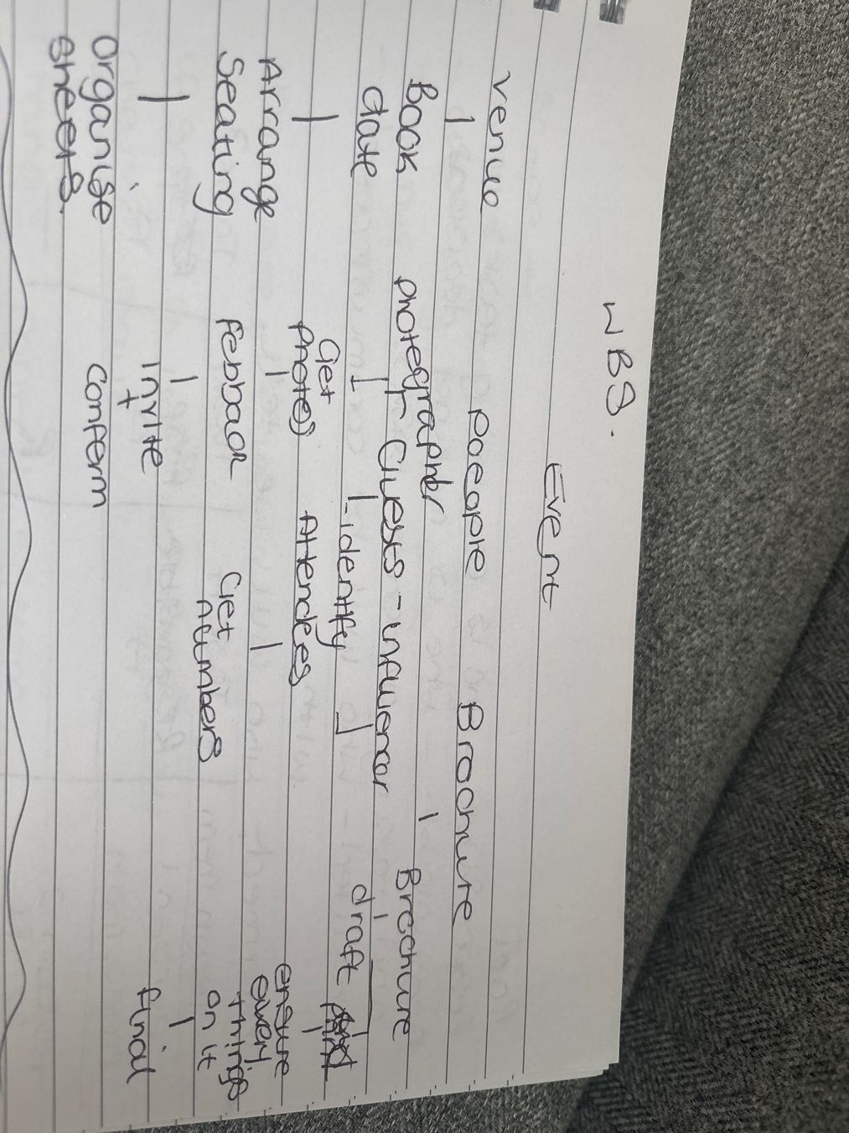
I have made a work breakdown structure with everyone’s roles and responsibilities through the event and what part of the event they are in-charge of. Hayley is in-charge of the venue, Allison is in-charge of the brochure and tickets and I am in-charge of the people.
With the 3 main things to sort out each section what needs to be done so once book the date is done then you can arrange the seating and organise sheets for who sits where.

Control
Having control of the event and everything that goes on around the event is stressful but with control it ensures everything runs smoothly and that everything is correct .

Monitoring
When monitoring we need to ensure that we control the scope creep and keep it from climbing. If there is any changes then all plans will need to be re signed off so that they are in place and done before the event.

Progress time
The whole process time of the start of the event and end of the event will be started and completed in 4 weeks. Everything has a structure and when it needs to be completed by to ensure a smooth transition of each stage.

Budget
Ensuring that we don’t go over budget we need to track spending and total costs and give the event a set price that can’t be increased .

Quality
The quality of the event needs to be up to standards so that everyone is happy for what they are getting and that everything is in place this can be measured by following the plan and doing final checks before the event starts.

Change control system
CCS is a formalised, structured process used by organisations to manage and document modifications to a product, system, or process, ensuring that changes are properly requested, reviewed, approved, implemented, and tracked (Tristancho, 2024)

Log requests
We asked if there was any requests from customers such as what buffet sandwiches that they would prefer and teas and coffees so we had their feedback from them before the day and we can log the request to the producer manager. We also had to request to change the day to we can ensure the day suited everyone.

Authorisation
The requests had to be authorised before we can go ahead with the plan and ensure that everything can be met with the requests.

Change to plan
There was a change in the plans which was a new date of the event so we had to change the flyers and then tickets as they had already been made with the original date on them. This had to go to who was in charge of them to sign it off and then sent to the person in charge of sorting these out.

Risk management
The risks that may affect the event are that there is no ramp for any wheel chair users, we may not have enough seats for everyone. Also risk that people would turn up with no tickets and expect to come in.
I have created a risk analysis matrix which will decide and track the severity and likelihood of the risk.
Risk | Severity | Likelihood | Risk score | Influenced or controlled
Wet floors meaning slipping | High | Medium | Middle | Control by mopping
Not enough chairs at the event | Low | Medium | Low | Control by making sure there is enough chairs
Tripping over wires | Medium | High | Severe | Controlled by putting matts over wires

Close

Sign off
Once the event have been planned and everything is up to standards and there is nothing to add to it and all models have been used to monitor the process. Myself who will be boss of the project will sign it off which will mean that everything is where it should be and everything is up to standards to ensure that everything is going to plan.

Changes and issues agreed
The changes that were agreed on by everyone was that we needed to order a bigger selection for the buffet as people may not like what we choose and some people may be vegan, so we had to ensure that we had that choice in. The issues that we had was that there was not enough room so to resolve the issue we moved stations out of the room, so we had more room to add seating, so everyone had a fair view. The requests will need to be identified on how much it will impact the event and the plan, evaluate the advantages of the request and disadvantage then install the process so that the individual in-charge can accept or deny change.

Lessons learnt
If I had to do anything differently, I would create the plan for the project earlier so that it wasn’t so rushed and I would have a better plan in place. I would have a bigger venue so we could allow more people to attend and have a bigger view for the community.

Evaluate project
The project went well. We had a good turn out, it ran smoothly, everyone had seats. There were no complaints including the buffet food. We managed to demonstrate the products which meant we managed to sell 2 boxes of products. Everyone had their responsibilities and got on with them on their own to make sure that everything ran smoothly. There was areas that could have been done differently but in the future events I will be able to put them in place.

Project manager

Skills of a protect manager
To be a product manager there are a set of skills that will be needed which will help be the best that you can be which are organisation, time management, communication, leadership, risk management and good at problem solving.

Evaluation of self against skills
The skills that I have which would be good for protect management are that I’m a good listener so I’ll be able to listen to peoples suggestions, I’m good with communication skills and I am good at organising.
There are other skills that I could improve such as time management, problem solving and risk management. I will create a PDP to help me improve these skills.

Develop Personal Development Plan
PDP (Personal Development Plan) is a structured, written document that outlines a person's goals for personal, educational, or career growth, acting as a roadmap to achieve these aspirations. It involves a process of self-reflection, identifying development needs, setting specific goals, and planning the methods and timelines for achieving them (Sutton, 2023)
In this personal development plan there will be a list of skills that I need to improve to be a project manager and by doing this I can focus on these skills keeping it in order and giving myself time to improve.

Area. | Goal. | Specific actions I need to do to improve. | When do I plan to achieve it.
Time management | Better at managing my time . | Keep an eye on the clock and don’t get distracted | Do the same task every week and track the timing:
Tone when speaking | To be able to speak with specific tones to suit the conversation. That will stop the problem of being misunderstood. | When having a conversation, I will try and understand what tone is needed whether it was a serious conversation or not. | Ask for feedback on the use of tone in my conversations after 6 months.
Adaptability when in certain conversations | Be better at adapting communication when needed and be able to be confident when doing it. | Prepare on how i would react to certain conversations and use facial expressions if needed. | Use strategies to communicate. Work on my communication methods and then review in 1 month.
Overall communication skills | Be able to do a detailed consultation and ensure i am on the correct page when communicating with clients. | Work on my communication skills and make sure i understand what clients want done. | Review after 2 weeks to see if there's any improvements and then another review in 3 months.

Conclusion
In conclusion, the event went well with following each step of planning and using guides to help us out. By using these methods this will help get to the next stage of the process smoothly with no hassle and making sure everything is up to standards. Having someone in charge and deciding whether the steps are correct will lower the risk of being behind and not being ready. Through this process there was areas that I found I needed to improve on by doing a swot and with that I created a personal development plan so I can improve on my weaknesses and then focus on building up ready for the next event. The process ran smoothly by following step by step plans and having job roles for each staff member. The things I would do differently next time is maybe higher a venue to be able to get more people in to the event and extend the process to see if I can still project manage up to standards with a larger volume of tasks to do.

References

Bridges, J. (2025, January 3). What Is the Project Life Cycle? Project Manager. https://www.projectmanager.com/blog/what-is-the-project-management-life-cycle

Brown, L. (2024, April 19). What is Product Breakdown Structure (PBS)? Invensis Learning Blog. https://www.invensislearning.com/blog/product-breakdown-structure/
Hight, L. (2024, October 1). Work Breakdown Structure (WBS) In Project Management | TeamGantt. Teamgantt.com; TeamGantt. https://www.teamgantt.com/blog/how-to-estimate-projects-accurately-using-a-work-breakdown-structure
Khan, B. (2024, October 24). Project Organization: Definition, Types, & Process. Avaza.com. https://www.avaza.com/project-organization/
Laoyan, S. (2024, April 26). Everything You Need to Know about Waterfall Project Management • Asana. Asana. https://asana.com/resources/waterfall-project-management-methodology
Martins, J. (2025, February 12). Understanding the iterative process, with examples. Asana. https://asana.com/resources/iterative-process
Metroun. (2022, March 8). What Is Critical Path Analysis? Metroun. https://metroun.co.uk/post/what-is-critical-path-analysis/
Sutton, J. (2023, October 3). How to Create a Personal Development Plan: 3 Examples. PositivePsychology.com. https://positivepsychology.com/personal-development-plan/

Tristancho, C. (2024, June 21). What is change control in project management?ProjectManager.com. https://www.projectmanager.com/blog/what-is-change-control-in-project-management

