Complementary Therapies

BMHP5001
Musammat Khaleda Begum
1714938
Lecturer: Mark Gallagher
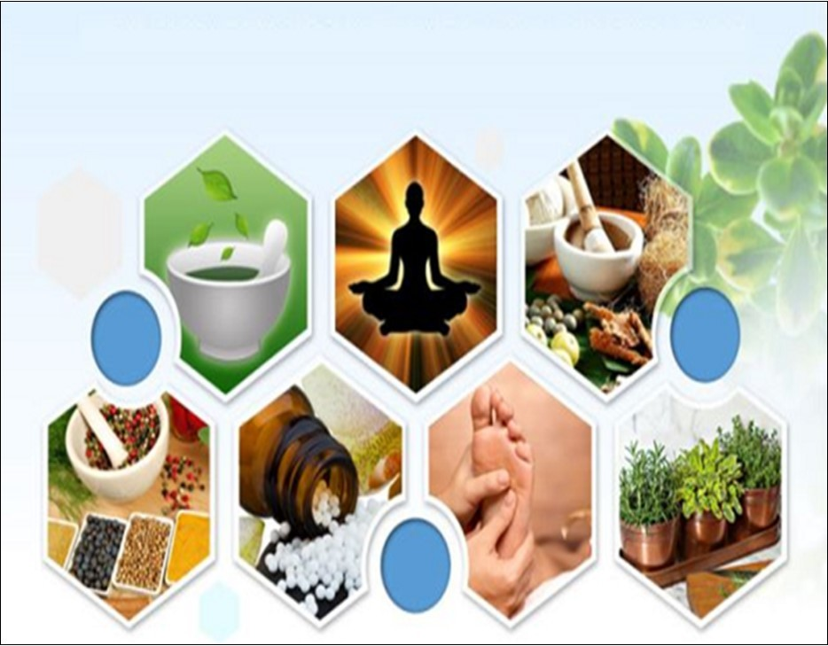

Table of Contents
Introduction 3
Task-1 4
Evaluation of the current systems for regulating complementary alternative therapies 4
Current Systems regarding complementary therapies’ regulation in the UK 4
Some complementary therapies used in the UK 6
Task-2 9
Evaluation of both statutory and voluntary self-regulation system along with membership bodies 9
Statutory self-regulation system for Complementary medicine 9
Voluntary self-regulation system for membership bodies 10
Task-3 12
Recommendations regulatory systems for complementary therapies 12
Ethical guidelines, choices and consent 12
Recommendations for GDPR and confidentiality 13
Conclusion 15
References 16

Introduction
Alternative medicine demands and healthcare service is expanding rapidly across the world. The world needs a more effective solution in healthcare and thus, sometimes, there may arise the needs to go beyond the law and order. The complementary therapies have been using for the last couple of decades. In these cases, complementary therapies make sense in many ways. People need quick healing and medical professionals are taking these advantages for a quick solution. Some therapies have side effect and some work very well with having a side effect. This paper will have a look upon the complementary therapies with a side effect, regulation procedures, effectiveness, standards and how these therapies are using for the betterment of human civilisation. Besides, how complementary therapies are using along with current systems and regulating procedures in the UK.

Task-1

Evaluation of the current systems for regulating complementary alternative therapies
Complementary therapies are used across the world and many consultants prescribed these traditional therapies for healing serious health issues. The usages of these traditional medicines or therapies vary from country to country. Almost 10 per cent of the total population in the UK support these therapies. On the other hand, more than 20 per cent in Canada, 80 per cent in India and 75 per cent in South Arica adopt these therapies as normal medicine. The most widely used these therapies in China, Vietnam and India. These therapies become essential medicine for their daily life (Münstedt and Riepen, 2019). In some countries, traditional practitioners are trained in academic methods and they believe more about these practices but in most cases, they start consulting without taking proper medical or adequate knowledge on that particular matter. And thus, the World Health Organisation(WHO) recommends some guidelines for consultation by using traditional methods. As a result, many governments have taken initiatives to formalise and make discipline for using a traditional method. And countries legalised formal licencing, education, academic research, training and so on.

Current Systems regarding complementary therapies’ regulation in the UK
Practice
As the needs of ancient therapy increasing rapidly around the globe, there is no difference in the UK. Thus, the government should apply strict rules on that matter. If the people who want to become a practitioner of therapy, he must do practice on particular therapy voluntarily (Münstedt and Riepen, 2019). The government should make this rule. Unqualified doctor or practitioner also increases the risk of treatment and make vulnerable the health sector. Many practitioners want to become specialists in multiple therapies. In that case, the government should define how many types of therapies a person can pursue. So, the government should make clear and specific rules in practising these therapies.
Training
As traditional methods of treatments have no formal background and absence of educational institution, every country’s government can arrange training programmes for competences, skilled and safety of health. The practitioner can treat patients how the patients should be treated. This training programme must be carried out by the central government (Avitzur, 2017). The duration of training programmes depends based on how sticky the programmes are. Sometimes practitioners practice as apprentices under the supervision of a specialist and sometimes, taking short courses. Sometimes, practitioners take a higher degree and then they pursue training on a specific type of therapy. This method helps them to boost their career. If the government can give them job-based training, the practitioners do the job willingly and this will become another profession.
Registration and licensing
In many countries practising complementary medicine requires formal registration. By ensuring this, complementary medicine can be used widely. Though the doctors of the UK have no access to complementary medicine, they become specialise on particular therapy in case of their need (Young, 2015). They don’t get any formal certification or any recognition from the government if a practitioner takes training on a particular therapy. The Norway government already announced that they will give certificate those who have professional training and eligible for getting the license. The confidentiality of a person is defined by their academic performance, their training result and previous record. Some countries accept registration application based on the training certificate, academic results and some countries evaluate the practitioners taking an exam in the registration stage. Entry exam or certification exam can help to find more competence practitioners.

Some complementary therapies used in the UK
Alexander technique: It is such a technique that dissuade harmful habit and replace it a better habit. Besides, it helps to change one’s repetitive habits, dissuade strain injury, improve better focus on some performances and make comfortable on specific techniques (Williams and Brucker, 2019). By changing one’s posture and gesture, one can pursue this technique.
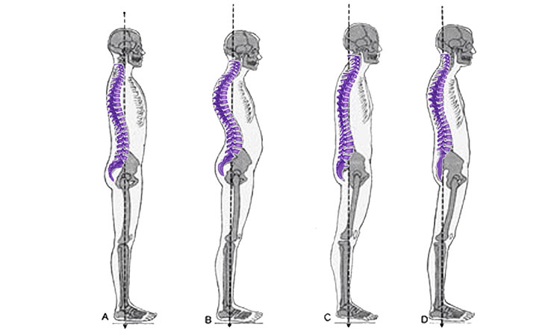
Figure: Alexander techniques
Source: (Williams and Brucker, 2019)
Aromatherapy: It is kind of aroma science, based on ancient techniques. Natural plants’ oil is used to the well-being of physical and mental upgrades (Williams and Brucker, 2019). This holistic healing method is also called oil therapy. Mainly, the people of the ancient Indian subcontinent used it and still many people adopt this therapy as an alternative treatment.

Bach flower remedies (BFRs): This therapy is the combination of water, extractions of flowers and dilutions of flower material (Williams and Brucker, 2019). This is developed by Edward Bach in the decade of 1930s in England as the home therapy.
Bodywork therapies, including massage: This is not a specific therapy or any alternative remedy method. Bodywork is used for improving the performance of gesture and posture. A massage is a form of bodywork therapies where the person who takes massage can get rid of muscle pain and so on.
Counselling stress therapy: Stress is a kind of dysfunctionality of physical or mental health. When the needs of a body can’t meet the demand of mental issue, this is called stress. Headache, acne, body pain, insomnia are the main symptoms of stress. The way of reducing stress is called stress therapy.
Hypnotherapy: It is such type of therapy that helps one to concentrate more and stay focused on a particular matter. Those who have a problem with concentrating on single-tasking, they are highly suggested for this therapy. It improves the productivity of work and helps to stay focused.
Meditation: It is a kind of method for expanding the consciousness and collaborates the body and mind by eliminating the outside stimuli and connecting subconscious mind with visualization. It also helps to stay focused on a particular matter.
Reflexology: This therapy is for relaxation and makes feel better. It enhances the gesture and posture. Besides, this therapy uses in the betterment of body performances, removing stress and pressure (Williams and Brucker, 2019). For taking this therapy, people use their feet along with points.
Shiatsu: It is a form of massaging therapy based on ancient Chinese medicine technique. But this therapy widely used in Japan (Ots, Kalbantner-Wernicke and Wernicke, 2014). It is the combination of soothing, stressing, pressing, kneading without oil. Comfortable or slippery clothes are used when this therapy is performed. The therapist presses the fingers on the body without mixing oils.
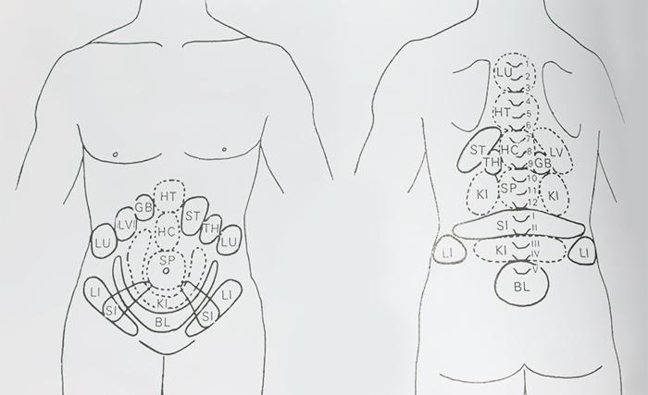
Figure: Shiatsu therapy
Source: (Ots, Kalbantner-Wernicke and Wernicke, 2014)
Healing: It is a kind of therapy which gives the patient for dissuading the illness and mental disorder. This therapy works well in improving the human immune system. This energy therapy uses to recreate and accelerate body performance, spirit and emotion.
Yoga: It is the kind of mental, physical, spiritual exercise which makes a man healthy and stronger. Ancient Indian subcontinental people started firs. Yoga is not a particular technique. It is a combination of various exercises. People do exercise with freehand body movement and other gesture and posture.

Task-2

Evaluation of both statutory and voluntary self-regulation system along with membership bodies

Statutory self-regulation system for Complementary medicine
The World Health Organisation suggested some self-regulatory systems for complementary medicine. These self-regulatory systems help an individual to be an expert or specialist in therapeutic medicine (Ijaz and Boon, 2018). These systems are discussed below.
Integrative systems: In this system, complementary medicine will be recognised as the same as the current medical system. The practitioner will get recognition if he or she takes a course on a particular therapy. Besides, if a practitioner is trained under the direct supervision of that particular professional, then, he or she will be evaluated as a legalise practitioner will be evaluated (WHO 2002). Then, these drugs produce privately or publicly (Ijaz and Boon, 2018). Patients also get insurance benefit through this process. But this country must have the facility to carry out research or academic activities on ancient medicine.
Inclusive systems: When everything is underway, this method suits best for ancient medicine. Here, the government doesn’t permit the public or private healthcare system to use this medicine. But the mass population who can’t bear the brunt of costly treatment, they willingly use this medicine. Healthcare, regulation, codes of ethics, insurance are not supported by the government. Government nether gives permission nor gives punishment if the practitioners make casualties.
Tolerant systems: in this case, National healthcare system is fully run by allopathic treatment but in some cases, the government can’t reject the ancient medicine rather government legalise by applying the law (Ijaz and Boon, 2018). The UK government adopting this system. This government fully run by using allopathic medicine but some normal cases, the practitioners rely on ancient medicine. And the government doesn’t make any response to why they are using these medicine.
Exclusive systems: In the exclusive system, national healthcare is run by fully allopathic medicine. Government announce complementary medicine as an illegal product by laws. We can barely found any country who doesn’t use complementary medicine and make all these medicines as illegal. Every country has at least a few therapies which are widely used and accepted by everyone (Ijaz and Boon, 2018). The UK government is not following this system.

Voluntary self-regulation system for membership bodies
Sometimes, government give waiver in using complementary therapy. Then, the users and the practitioners develop some rules and regulation which are considered as the voluntary self-regulated systems. It depends on the cultural traits, geographical areas, religion and so many things (Hsueh and Prakash, 2018). We can see the American people use therapies less than Indian and Chinese people. Civilisation and modernisation are the reason behind it. Yet there are some systems most widely used in renowned civilisation as voluntary self-regulation. These systems are discussed below.
Education and training: Every people accept competence and experts. If the person is gone through a wide range of training and academic accreditation, he or she must be competent in that particular matter.
Requirements for education and training: The people involved in professional activities, they must be specialised in a particular area. But before taking this professional degree, the person must pursue an academic degree related to the background (Hsueh and Prakash, 2018). Many countries set pre-requirements for being a therapist in a specific field.
Codes of practices: Sometimes, codes of practices are considered as the ethical code of conduct It defines which thing a practitioner can do and which thing a person can’t. Besides, believes systems of people and their expectation bring a variety of codes of ethics.
Standards in producing drugs: The most vital thing in medicine is drug production. If the pharmaceuticals make mistake, the mass people will suffer seriously. So, when the drug companies produce drugs of ancient medicine, they should make standard based on the immunity system of that particular geographical area.

Task-3

Recommendations regulatory systems for complementary therapies
As this complementary system is not fully recognised for many governments, the people must adopt a system where they will not sufferer rather beneficiary. The UK government has taken some initiative for properly regulating the ancient medicine. The most advantage of ancient medicine is cheaper (Hart, 2015). Even, in some cases, it becomes free for the people. Another advantage is less side effect comparatively allopathic medicine. So, this medicine or therapies must carry forward and use widely. Some recommendations in regulating complementary therapies are as follows.
Control over by the government: The government should take control of the production and distribution of these therapies and medicine. Because there has no scientific method for specific therapy (Hart, 2015). It varies from country to country, culture to culture, religion to religion. So, if the government direct control over this industry, the black-marketers can’t take advantage by harming others.
Individual laws: The government should make individual laws for individual therapies. Some cases, it can vary but the government should as far as it can. Otherwise, the government should make presidential charter for light cases.
Set bunch of Standards: As we know that the method of therapy can vary from country to country, culture to culture and so many so, the government should set a bunch of standards which can be applied in various ways upon different people.

Ethical guidelines, choices and consent
The code of conducts, the way of behaviours of a particular method are considered as the ethical guidelines (Winkelmann, 2015). As the complementary therapies are used widely around the world, there needs a specific code of conducts of using complementary therapies.
Guidelines for practitioners
- They must be competent in their chosen therapies. They must be able to satisfy their clients.
- They must pursue training and academic accreditation under the supervision of specialists.
- They must abide by the rules and regulation regarding therapy.
Guidance for the government
The government should make such an environment for the practitioner and the patients of complementary therapies are regarded as the government codes of conduct. As many people believe that this therapy works well for the well-being health without side effect, the government should make easier systems in legal procedures (Winkelmann, 2015). Thus, it will help the practitioner in getting certificates and other legal documents.

Recommendations for GDPR and confidentiality
As the UK government is approaching to legalise the complementary therapies, they must consider the protection and security of the use of those ancient medicines. The elaboration of GDRP is defined as General Data protection and regulation based on integrity (Ng and Azizudin, 2020). As the government is developing a medicine method, they should ensure protocols and other protection. The GDPR and confidentiality consist of six data protection principles which are discussed below.
- Transparency and fairness: The organisation and the person who practise the ancient therapy, must ensure that they will never break laws.
- Purpose limitation: The practitioner should collect data for a specific purpose. And also they should mention the state of purpose.
- Data minimisation: organisations access personal data only for a specific requirement and process these data.
- Accuracy: the organisation must give the data which are accurate and confidential. The individual has the right to give incomplete data.
- Storage limitation: organisation also delete unnecessary data which are no longer be used.
- Integrity and confidentiality: It ensures the whole security system of a protocol. This term explicitly indicates the security and control system.

Conclusion
Policy-makers in various countries have already taken initiatives to form a legal regulative authority on complementary medicine. The practitioners in many countries also come forward to establish academic training and educational systems for specialisation. The World Health Organisation also suggested a code of ethics for those countries who are using traditional medicine. Many countries using traditional medicine as the fundamental treatment method. These countries seriously need the establishment of statutory regulative authority. This paper defines the number of regulative authority taken by the UK government for who are directly or indirectly involved in practising and developing alternative medicine.

References
Avitzur, O., 2017. In Practice: How to Get the Most from your EHR Training — And What Can (and Sometimes Does) Go Wrong. Neurology Today, 11(20), pp.39-40.
Biofeedback and Self-Regulation, 2016. Association for Applied Psychophysiology and Biofeedback Membership Application. 21(1), pp.91-91.
Chevallier, A., 2016. The council for complementary and alternative medicine. Complementary Therapies in Medicine, 4(4), pp.271-273.
Habtom, G., 2018. Perceptions and attitudes of modern and traditional medical practitioners about traditional medical practice in Eritrea. International Journal of Complementary & Alternative Medicine, 11(2).
Hart, J., 2015. Clinicians Approach to Lifestyle Recommendations Is Outdated. Alternative and Complementary Therapies, 21(4), pp.163-165.
Hsueh, L. and Prakash, A., 2018. Incentivizing self-regulation: Federal vs. state-level voluntary programs in US climate change policies. Regulation & Governance, 6(4), pp.445-473.
Ijaz, N. and Boon, H., 2018. Statutory Regulation of Traditional Medicine Practitioners and Practices: The Need for Distinct Policy-Making Guidelines. The Journal of Alternative and Complementary Medicine, 24(4), pp.307-313.
Münstedt, K. and Riepen, T., 2019. Patients’ decisions regarding the treatment of primary dysmenorrhoea. Complementary Therapies in Medicine, 45, pp.1-6.
Ng, J. and Azizudin, A., 2020. Rheumatoid arthritis and osteoarthritis clinical practice guidelines provide few complementary and alternative medicine therapy recommendations: a systematic review. Clinical Rheumatology,
Ots, T., Kalbantner-Wernicke, K. and Wernicke, T., 2014. Samurai-Shiatsu – Mit Shiatsu fit für die Schule. Deutsche Zeitschrift für Akupunktur, 57(4), p.49.
Peltzer, K. and Pengpid, S., 2016. Prevalence and Determinants of Traditional, Complementary and Alternative Medicine Provider Use among Adults from 32 Countries. Chinese Journal of Integrative Medicine, 24(8), pp.584-590.
Williams, G. and Brucker, A., 2019. Surgical Technique Supplement Editorial. Retina, 39, p. S1.
Winkelmann, A., 2015. Consent and consensus-ethical perspectives on obtaining bodies for anatomical dissection. Clinical Anatomy, 29(1), pp.70-77.
Young, R., 2015. Alkalizing Nutritional Therapy in the Prevention and Reversal of any Cancerous Condition. International Journal of Complementary & Alternative Medicine, 2(1).

