
University of Wales Trinity Saint David
School of Engineering

Manufacturing of a Bicycle Sprocket
Materials and Introduction to
Manufacturing M4X01163

Joshua Grant Brimecombe
1701440
1st February 2018

Table of Content
1 Introduction 2
1.1 Aim 2
1.2 Objectives 2
2 Research 3
2.1 Stamped 3
2.1.1 The Process 3
2.2 Milling 3
2.2.1 The Process 3
2.3 Hobbing 4
2.3.1 The Process 4
2.4 Uses of manufacturing processes in industry 4
3 Analysis 5
3.1 Stamped 5
3.1.1 Advantages and Disadvantages 5
3.2 Milling 5
3.2.1 Advantages and Disadvantages 5
3.3 Hobbing 6
3.3.1 Advantages and Disadvantages 6
4 Materials overview 7
4.1.1 Requirements 7
4.2 Research and Analysis 7
4.2.1 Medium Carbon Steel 7
4.2.2 Tool Steel 7
4.2.3 Stainless Steel 7
4.2.4 Aluminium 7
5 Conclusion 8
6 References 9
7 Figure table 10

Introduction

Aim
To find a suitable method for a large batch production for manufacturing the large sprocket of a bike cassette.

Objectives
Research three methods for manufacturing the large sprocket of a bike cassette.
Analyse the advantages and disadvantages of all three methods for manufacture.
Research and analysis for materials that are appropriate for the manufacturing of a bicycle cassette.
Concluding with the best method and material found, to give the best result.

Research
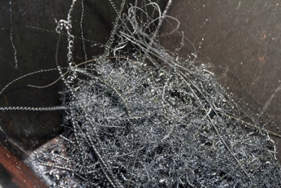
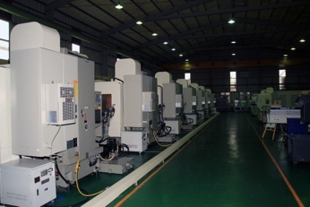
The three-manufacturing processes outlined in this report are methods used to manufacture a large batch of the large sprocket for a Bicycle Cassette. All three methods are wastage processes where material is removed from a blank or a billet. Therefore, these productions can be wasteful and are unstainable so methods of recycling off cuts and waste materials are used. The manufacturing processes develop over time, the three-processes shown below are both new and old methods. Old methods are still used as an alternative, although, it is not as accurate, precise or give a greater quality as some of the newer methods, as it can be a more affordable way of manufacturing cheaper products.
Figure 2 (Overholt, 2015)
Figure 1 (Overholt, 2015)

Stamped

The Process
Stamping is unlike milling or lathing, as they use sharp tools and rotary forces to cut away waste from a solid piece of material. Stamping uses strong stamping presses (machine presses) with dies fitted in them, it relies on pure force being put through the die into the material to form, cut and shape. The press is fed sheet material, some machines are automatically fed, these machines are known as progressive dies (Heju stamping, N/A).
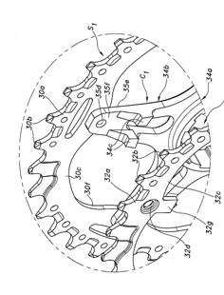
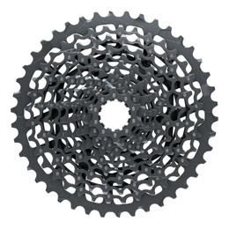
Full pin technology used by Sram (SRAM Co., Full Pin ) takes Steel plates and stamps them into sprockets and then they are assembled and fix with pins made from Stainless Steel, this technology is used in both Sram’s XG 1275 Eagle Cassette (SRAM Co., XG 1275 Eagle Cassette) and XG-1175 FULL PIN Cassette (SRAM Co., XG-1175 FULL PIN Cassette). Shimano uses stamped sprockets mounted on to a machined sprocket carrier (Kamada, 2011).
Figure 3 (Kamada, 2011)
Figure 4 (SRAM Co., Full Pin )

Milling

The Process
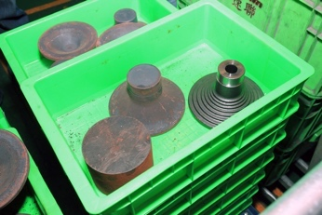
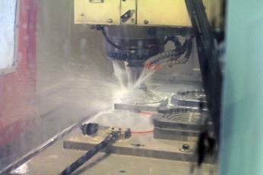
Using a 3 or 4 axis vertical milling machine give a wide and varied range of movement, this allows of more complex designs to be carried out. A rotatory cutting tool, cuts away waste material to reveal a piece of work that has been discovered from a solid billed of raw material. Vertical milling can easily be CNC (Computer numerically controlled), this give great accuracy and precision with in the process.
Figure 6 (Overholt, 2015)
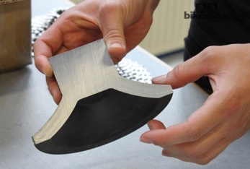
Sram takes a block of Steel billets, it is a common practise to forge the cylindrical billets into a cone, first this means less material is removed, therefore reducing machining time, waste material and wear on tooling. Sram takes this forged cone billet and machines it in domed cassettes which is made from one piece, therefore does not require extra fixings or joining methods reducing process, lowering lead time (Overholt, 2015). Machining cassette allows very precise shift ramps and teeth profiles that are designed to help change gear faster and smoother (SRAM Co., PowerGlide ll).
Figure 5 (Overholt, 2015)
Figure 7 (Patterson, 2012)

Hobbing

The Process
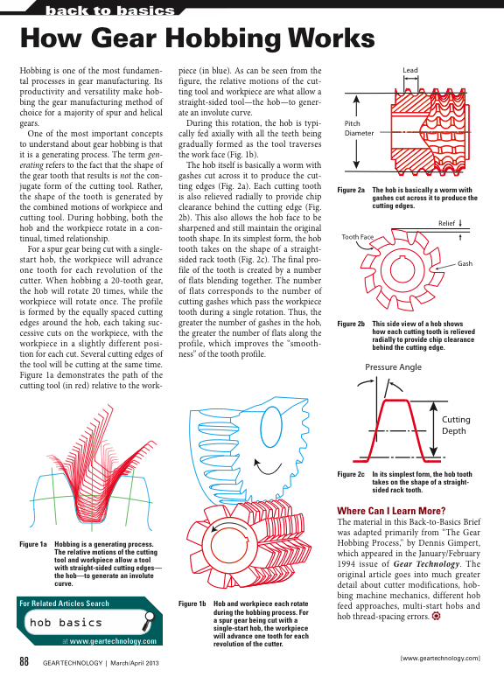
Hobbing is a lathe process which uses a rotating tool called a ‘hob’. The rotating hob is rotated continually in time with the work, to every full rotation of the work, the hob has to rotate once for every tooth on the work (Gear Technology , 2013). This dual rotation means that the teeth end up with a chamfered face with the curve starting from the pitch point, depending on the design of the hob it can also effect other aspects of the gear design and tooth geometry, like the flank and fillet curve (Rex, et al., 1980).
Figure 9 (Gear Technology , 2013)
Figure 8 (Gear Technology , 2013)
This method of gear making is not used in the cycling industry as this method of manufacture works well on thick gears for gearboxes, but not on sprockets as they are thin which means they cannot be held in a lathe easily. The only way to produce this product using this method is to hob a large cylinder into a large gear that then can be sliced up into individual sprockets which can then be either joined or fixed together or left as individual sprockets that can be put on a ridged free hub body with spacers spacing the sprockets out.

Uses of manufacturing processes in industry
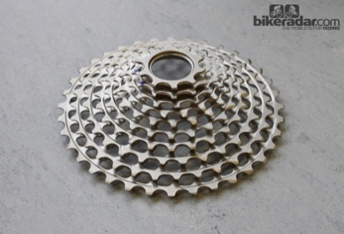
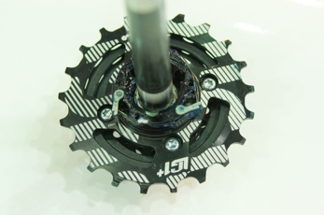
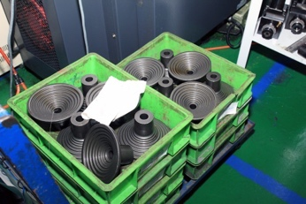
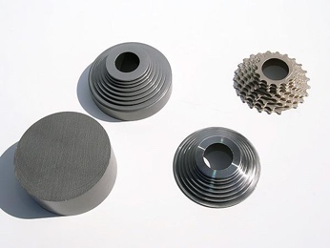
Manufactures take a combination of these process and a mixture of materials and combine them together to get the balance between precision, quality, affordability and durability depending on the budget, market, consumer and purpose. For example, 8 out of the 10 gears on Sram’s ‘red og-1090 powerdome’ is machined out of a single 10lb billet of Steel (Cozy Beehive, 2008). The remaining two smallest spur gears are milled and then stamped. This is a heavy rear cassette as it is not machined from the rear and therefore, is solid Steel but this makes it more affordable as the machining process is quicker. On the contrary, ‘e*thirteen’s LG1+ 7-speed 9- 21 tooth DH (downhill) cassette’, has the six smaller cogs machined from a single billet of Steel, then the largest seventh 21 tooth sprocket is made from Aluminium which has a free-hub mechanism connected straight on to the larges sprocket (Kazimer, 2016). Sram’s XO1 DH 7-speed cassette (SRAM MTB, 2014) is just machined out of a single billet of hardened tool Steel, this cassette uses ‘X-Dome’ technology (SRAM Co., X-Dome) this means that it is machined from a forged cone from both sides. It ends up with no connective structure between each ring as it has to be removed whilst machining the lower sprockets, so each sprocket is suspended off the next, on machined connectors. On a small cassette like this, an extra sprocket is not needed as it can be machined from one piece easily, so an extra ring is added meaning it can be attached to the free hub body. Cassettes that use X-Dome technology only fit on the ‘XD’ Drive body as they have no centre to connect to the hub (SRAM Co., XD Driver Body). Sram’s X-Dome technology is used in the top ranges of most disciplines from their 7 speed DH cassette to their 12 speed XC cassette.
Figure 13 (Cozy Beehive, 2008)
Figure 11 (Kazimer, 2016)
Figure 12 (Overholt, 2015)
Figure 10 (Patterson, 2012)

Analysis
Some manufacturing processes lead themselves more to some tasks than others, as an engineer it is critical to know what process can be or should be used to solve a problem, to do this to the full extent it is essential to know the advantages and disadvantages of each method and analysis for the task in hand.

Stamped

Advantages and Disadvantages
Stamping is not as accurate, precise or give a greater quality as some of the newer methods, but it can be a more affordable way of manufacturing cheaper products and it is much quicker to stamp out vast numbers of individual sprockets. There is a high initial tooling cost therefore, not ideal for one offs or small batches but it suits large batches and mass productions. Efficiency can be produced by stamping out multiple sprockets at a time reducing lead time of a product, this causes for more complex tooling. Due to only being able to manufacture individual sprockets, they require fixing or joining this increase weight of the overall product, and lead time of manufacture. Any design changes, modifications, updates or model changes will require changes in dies and tooling. This means a higher cost in die design and manufacture and an increase in set up time, whereas other processes just require a change in the CAD software or code which is both relatively quick and cheap. Waste from the stamping process can be re forged to form other parts later. The finish given from stamping is dependent on the finish and quality of the die, where the two halves of the dies meet, it can leave a line on the finish product.

Milling

Advantages and Disadvantages
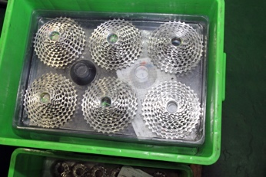
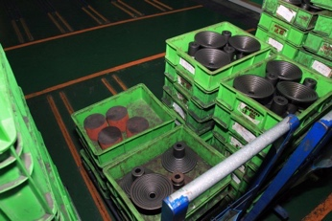
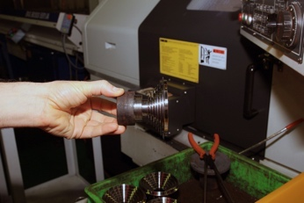
CNC multi axis vertical milling machine have good versatility and adaptability as it is a machine that is capable to do many different jobs and functions; the CNC machine can change its head and tools to be able to do many different roles. They are extremely precise and accurate as there is no human error as these CAM processes are controlled by CAD software. Where the highly detailed designs are held, this method allows complex designs to be carried out efficiently and effectively. This also makes changes, modifications, updates or model changes quick and easy as changes can be changed on the design or in the code and the machines will run the product design in its newest form. This saves money in design and manufacture of dies and tools as well as time in set up. Lead time can be quite long, but time is saved by all the processes being conducted by one machine. Due to it being completely automatic, they are very efficient as the work does not have to be moved from machine to machine, for extra processes to be carried out as the one machine does it all. Therefore, set up time is decreased, decreasing the overall lead time. This process removes waste material from the work piece, the waste material becomes swarf during the milling process, it is important to recycle waste material like swarf to make the process more sustainable. The finish that is given by this process is good to work with straight out of the machine. The surface finish can be slightly ‘swirly’ but this machined look can be appealing as it has a raw aesthetic look. This can be avoided by extra finishing, for example Sram’s mini block cassette is finished with jet technology for extra corrosion resistance and aesthetics (SRAM MTB, 2014), detail such as number of teeth, make and model can be added as decals or machined into the product.
Figure 15 (Overholt, 2015)
Figure 16 (Overholt, 2015)
Figure 14 (Overholt, 2015)

Hobbing

Advantages and Disadvantages
Hobbing has a high initial cost as tooling is expensive and one tool (hob) will only cut one tooth design and tooth number, so for a whole cassette, up-to 12 different hobs would be needed. Although it is quite efficient, as by Hobbing and machining a large single piece of work means it can be cut up into loads of identical sprockets. There is then a variety of different ways that the cassette can be assembled depending on budget and target audience. This process can be partly automated using CNC lathe’s, but it normally requires a human to place the work in the lathe and start the process. There is very little room for change as the teeth are cut with a hob and the only way to change this is to manufacture another hob which comes with a price as it has to be designed then manufactured and only has one job. Lead time is kept low as from one piece of work, many sprockets are made and as each sized sprocket has to be cut using a different hob a production line could have different lathes, using different hobs, running stimulus cutting different size sprockets. After the lathing process, further finishing is needed in the line of material finish such as paint or process like anodising, annealing, tempering and hardening.

Materials overview

Requirements
For a cassette application, the material must be hard wearing and durable whilst having good tensile strength to cope with the stress and strains put on the cassette by the chain, these can be improved further through design and manufacture.

Research and Analysis

Medium Carbon Steel
Medium Carbon Steel has a base material of Iron and is a ferrous metal, it contains Carbon and Magnesium. This would be a good choice as it is durable, has good tensile strength and is easily machined. It can be hardened to get the proprieties required for the cassette.

Tool Steel
Tool Steel is really tough, strong, hard and durable (Ces EduPack, 2015) but is easy to machine as long as it is in a soft condition and has not been hardened as the tools used in the machining process are generally made from hardened Tool Steel. So, to effectively machine hardened Tool Steel you would need to use Diamond or Silicon-Carbide tools, this would increase the machining cost. Heat treating can be conducted afterwards to adjust the properties as you require them. Tool Steel is ferrous and has a base of Iron. For the purpose of a cassette, D grade High-Chromium Tool Steel would be ideal as it is air cooled reducing distortion and the high levels of Chromium give resistance to deep-hardening wear.

Stainless Steel
Stainless Steel is a Steel alloy, which is a combination of Iron, Carbon, Nickel and about 11% of Chromium which stops the metal from corroding (Ces EduPack, 2015). Although the corrosion resistance is hindered when in a salt environment. It can be machined but the process costs more and takes longer due to its toughness, in comparison to other Carbon Steels and alloys.

Aluminium
Aluminium is a softer more malleable non-ferrous metal that is very light and still contains tensile strength properties (Ces EduPack, 2015). It is easily machined and combined with other metals to form alloys which have specific properties. It has a wide range of surface treatments and heat treating which can reduce scratches in the surface as the surface is hardened. Therefore, less dirt and grease can attach and build up reducing weight. This causes the drive train to perform better and for longer, as the chain and cassette can mesh together the way intended putting less stresses and strains on the components as they are designed to work together this way.

Conclusion
In conclusion, this report has demonstrated the uses of manufacturing processes in order to manufacture a large batch of rear cassettes. The report highlights the advantages and disadvantages of each of the processes, as well as giving a quick over view of materials that can be used.
If asked to design and manufacture the largest sprocket of a rear cassette for a large batch production using this research, it would be advised to have to look at the design brief and specification as the manufacture of a product is dependent on its use, user and place in the market. But for optimum performance, this report suggests Milling as it is versatile and adaptable for many different designs and future applications, it is very precise and accurate. Whilst still being efficient and having a low lead time.
This report looks at various materials to machine the cassette from. The report covers and highlights the properties of medium Carbon Steel, Stainless Steel, Aluminium and Tool Steel. For best performance, the report shows Steel is the best option as a material with the combination of the Milling process, as it is both strong and durable material for an optimum cassette, and it is ideal for the Milling process.
Although this report shows all of the appropriate processes and materials that can be used to create a Bicycle Cassette, some of the methods can be seen as being bias as the information is from the manufactures themselves. This giving information that will make a reader interested in the methods. This report shows a mixture of Manufacturers and compared the manufacturing processes as well as looking at patents and the Ces EduPack software.

References
Ces EduPack, 2015. Stainless steel, s.l.: s.n.
CES EduPack, 2015. Tool steel , s.l.: s.n.
Cozy Beehive, 2008. How a Bicycle Cassette is Made. [Online]
Available at: http://cozybeehive.blogspot.co.uk/2008/04/how-bicycle-cassette-is-made.html?m=1
[Accessed 01 02 2018].
Gear Technology , 2013. How Gear Hobbing Works. Gear Technology , 03/04, 2013(03/04), p. 88.
GmbH, S. D., 2011. Multi-Gear Cassette for a Bicycle. US, Patent No. 9260158.
Heju stamping, N/A. What kind of stamping die we do?. [Online]
Available at: http://www.cnstamping.com/progressive-die/
[Accessed 01 02 2018].
Kamada, K., 2011. BICYCLE REAR SPROCKET ASSEMBLY. US, Osaka, Patent No. US7,871,347B2.
Kazimer, M., 2016. e*thirteen's New 7-21 DH Cassette - Taipei Show 2016. [Online]
Available at: https://www.pinkbike.com/news/ethirteens-7-21-tooth-dh-cassette-taipei-show-2016.html
[Accessed 01 02 2018].
Overholt, Z., 2015. Factory tour: Sram's Taiwanese Manufauring. [Online]
Available at: https://www.bikerumor.com/2015/01/23/factory-tour-srams-taiwanese-manufacturing-part-1-rockshox-suspension-sram-drive-train-more/
[Accessed 01 02 2018].
Patterson, J., 2012. SRAM XX1Conponent Development and details. [Online]
Available at: https://www.bikeradar.com/mtb/gear/article/sram-xx1-component-development-and-details-35654/
[Accessed 01 02 2018].
Rex, M., Ellsworth, R. M., therodore, A. & Co., 1980. Diagram of a Theoretical Gear Tooth. [Online]
Available at: http://thediagram.com/12_6/diagramofatheoretical.html
[Accessed 01 02 2018].
SRAM Co., Full Pin . Sram Technologies Full Pin. [Online]
Available at: https://www.sram.com/sram/mountain/technologies/full-pin#sm.00004x48fpnafen2ucq13q51yf6qp
[Accessed 01 02 2018].
SRAM Co., PowerGlide ll. Sram Technologies PowerGlide ll. [Online]
Available at: https://www.sram.com/sram/mountain/technologies/powerglide-ii#sm.00004x48fpnafen2ucq13q51yf6qp
[Accessed 01 02 2018].
SRAM Co., XD Driver Body. Sram Technologies XD Driver Body. [Online]
Available at: https://www.sram.com/sram/mountain/technologies/xd-driver-body#sm.00004x48fpnafen2ucq13q51yf6qp
[Accessed 01 02 2018].
SRAM Co., X-Dome. Sram Technologies X-Dome. [Online]
Available at: https://www.sram.com/sram/mountain/technologies/x_dome#sm.00004x48fpnafen2ucq13q51yf6qp
[Accessed 01 02 2018].
SRAM Co., XG 1275 Eagle Cassette. Sram Mountian Products XG 1275 Eagle Cassette. [Online]
Available at: https://www.sram.com/sram/mountain/products/xg-1275-eagle-cassette#sm.0001s4cun2oznd1fqkk1un2wtckys
[Accessed 01 02 2018].
SRAM Co., XG-1175 FULL PIN Cassette. Sram Mountain Products XG-1175 FULL PIN Cassette. [Online]
Available at: https://www.sram.com/sram/mountain/products/xg-1175-full-pin-cassette#sm.0001s4cun2oznd1fqkk1un2wtckys
[Accessed 01 02 2018].
SRAM MTB, 2014. SRAM XO1 DH Technology, Chicago: Youtube.com.

Figure table
Figure 2 (Overholt, 2015) 3
Figure 1 (Overholt, 2015) 3
Figure 3 (Kamada, 2011) 3
Figure 4 (SRAM Co., Full Pin ) 3
Figure 6 (Overholt, 2015) 3
Figure 5 (Overholt, 2015) 3
Figure 7 (Patterson, 2012) 3
Figure 9 (Gear Technology , 2013) 4
Figure 8 (Gear Technology , 2013) 4
Figure 13 (Cozy Beehive, 2008) 4
Figure 11 (Kazimer, 2016) 4
Figure 12 (Overholt, 2015) 4
Figure 10 (Patterson, 2012) 4
Figure 15 (Overholt, 2015) 5
Figure 16 (Overholt, 2015) 5
Figure 14 (Overholt, 2015) 5

