Academic Skills Assignment 2



MARCH 2018

MODULE NAME: ACADEMIC SKILLS
Project Name: ACADEMIC SKILLS ASSIGNMENT 2
Name: CAI ELLIS
Student Number: 1706655

Table of Contents

1. Executive summary
2. Introduction
2.1 Report Remit
2.2 Background on your project
2.3 Models of reflection
2.4 Masterclass Sessions
2.5 Influence of masterclasses on the project
2.6 Influence of masterclasses on personnal learning & development
2.7 Conclusion
3. References

eXECUTIVE sUMMARY

The purpose of this report is to reflect on the experiences I have had within the academic skills module, basing my reflective process on research informed models. I also discuss the masterclass sessions that were organised by the university, and how the knowledge I received from these entrepreneurs had an effect on my personal development as a student. As an assignment we were placed in groups with other students, we had to collaborate with a charity in order to assist them with a project of their choice. We collaborated with an organisation by the name of The Rising Stars Theatre Company, this charity provided children and young adults with learning difficulties the opportunity to perform within a drama group. The primary objective of the collaboration was to increase the awareness about the charity in the local area, as they felt they needed more recognition for the work they were doing.
From being present at the masterclasses I learned two very important lessons, the first is that confidence is key. Being confident helps you as an individual stand out through all walks of life, whether it is meeting new people or going for a job interview. Upon learning this I decided to develop my own level of confidence and begin implementing these new techniques during the project. These masterclasses also had an effect on the project itself, a recurring factor that came up within masterclasses was that good communication was crucial to success. In the early stages of our project our group communication was not adequate, and it would cause problems within the work and create friction between members. And we took it upon ourselves to improve the situation in order to succeed as we had learnt, by scheduling regular meetings in order to discuss progress with group assignments and also our collaborative effort with The Rising Stars.
In conclusion I have discovered the value and importance of reflection, as it allows me to pinpoint and target specific weaknesses that I may have. Being able to target these weaknesses and then identifying what can be done to ensure that they become strengths is crucial to my learning process and the development of my character, I am extremely pleased with the lessons I have been taught this academic year as they allow me to better myself completely and push my studying to the next level.

Introduction
In this reflective report I will be discussing my experiences in the academic skills module with regards to the masterclass sessions that the university provided. These masterclass sessions had a great impact on my personal development as a student, they also gave me many transferable skills which I have been able to utilise in my learning, as well as through the collaborative project with The Rising Stars Theatre Company. I will also be reflecting on my past work and how I have adapted and overcame the many issues and problems I faced during this academic term.

Report Remit
This report is a reflective piece on the numerous skills I have gained from the Academic Skills module, these skills have been invaluable to me within the new challenge that is higher education. It also discusses the masterclass sessions that the University provided, these sessions gave us with the opportunity to learn from experienced entrepreneurs.

Brief background on your project

For our project we were working in groups in order provide assistance to a charity, we collaborated with an organisation by the name of The Rising Stars Theatre Company (2017). This organisation provides children and young adults with learning difficulties the opportunity to follow their passion of the performing arts, this unique drama group is a small charity based locally in Swansea. Our group had five members, there was Kate (Project Manager), Amy, (Resource Investigator), Rhodri (Finance Coordinator), Jack (Team Worker), and I had the role of Quality Control. Our primary objective upon collaborating with The Rising Stars was to raise awareness for their cause, as they had told us they wanted more recognition for the work they did.

Models of reflection
The Driscoll (1994) model of reflection has three stages as shown in Figure 1, “what ?”, “so what ?”, and lastly “now what ?”. The “what ?” portion of this reflection model refers to returning to the situation, the key aspect is to identify exactly what events transpired. Every detail is important to the reflective process; while reflecting within this section it is important for the users of this model to discuss what they saw and what they did. Not only would this include everything that the user has seen or done, but things that fellow students had also done, as you would discuss your reaction to these actions . This directly relates to the next section “so what ?”, in this section the user analyses the context of the situation. Here they discuss their feelings during the project, relating to things such as how they felt about each decision during the project, be it an individual choice, or a group decision. It also relates to how they currently feel about the project with the benefit of hindsight, where it is easier to recognise how they felt through the experience as a whole. Understanding the context completely is extremely useful as you are able to identify why exactly you felt troubled about certain aspects of the project, and then you are able to adjust for the future in subsequent situations. This brings us to the final stage of the model “Now what ?”, in this stage you are able to take a step back and view the project from a different perspective. Understanding the motive behind every decision, and also the outcome allows you to analyse what could’ve been done differently in order to improve the experience of everyone participating. This particular model was useful upon reflecting the choice of my role within the group, as I selected to be the quality control. Thinking back, I felt out of my depth at times and was unsure with how to handle various aspects of this role. This gave me a different experience to the other members of the group as they were all confident and chose a role that played to their strengths. However, with the benefit of hindsight I believe that selecting this role was beneficial, as it took my outside of my comfort zone and allowed me to learn new skills in regards to referencing and also team work.
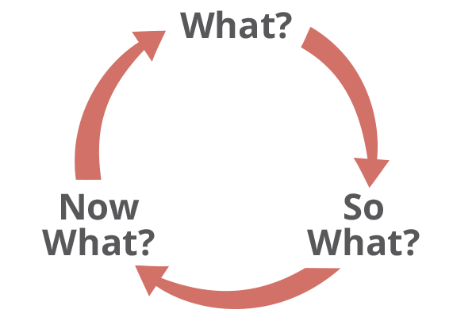

( Figure 1 )

The next model of reflection I will be discussing is Experimental Learning : Experience as a source of learning and development Kolb (1984). As you can see in Figure 2 there are four stages to this model, the first stage is Concrete Experience. Concrete Experience is simply the experience gained from any activity, I gained Concrete Experience of working with kids and young adults with learning disabilities while volunteering with The Rising Stars. The next stage is Reflective Observation, this is analysing the experience you have just had, and how you felt about this experience. This leads to Abstract Conceptualism, which is the lesson you have learned upon reflecting on the experience. Once you have completed this stage you then progress to the final stage of the model which is Active Experimentation, this stage is the implementation of what the individual discovered in previous phases. Personally I discovered that although I enjoyed volunteering with young people with learning difficulties, it is not something that I would like to continue in the future. However, I will always value the new experiences this project has given me, as I would never have had the opportunities to gain these new skills in social interaction without it.
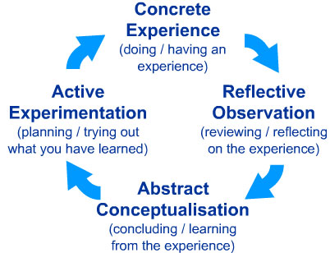

( Figure 2 )

Masterclass Sessions

As a part of our course the university held special masterclass sessions for students, within these sessions many different successful entrepreneurs were able to tell their experiences within the world of business, with the hope of passing down knowledge gained from their position. Three specific masterclasses captured my interest the most, as I was extremely interested in their experiences. These were Stifyn Parri ( Mr Producer ), Mark Power ( Smoke Haus ), and Kate of Gower Brownies. As I will explain further in the report not only did these masterclasses have an impact on my education, but also the choices I plan to make further in life.

Influence of Masterclasses on the Project
A key theme that arose in each masterclass is that great communication skills are vital, and improving these abilities to the best possible can only be beneficial. This was something I felt that I could personally improve upon, which would have an immediate effect as I could practise with the project currently running. I decided to research into different methods which would better my skills, stumbling upon an article in the Harvard Business written by John Baldoni (2009). This review gave five simple and effective tips which would sharpen an individual’s communication skills, the first tip was to understand the basics, which meant to always express yourself coherently. This was something I feel I had room to improve, as often I have the problem of speaking too quickly and miscommunications occur. The next tip was to always think clearly as to what you would like to say, this will help completely flesh out thoughts. After this came the tip to always be prepared, for events such as meetings or interviews. I found this tip to be extremely useful, as preparation was an enormous help with group meetings and also during meetings with The Rising Stars Theatre Company. Preparation came hand in hand with the next tip that is to always engage in discussion, planning what I wanted to say in advance was much more efficient than just listening and taking notes as it allowed me to discover much more. I was able to gather much more information not only about the charity, but also each individuals’ motivations and reasons to contribute which gave me a deeper understanding of the situation. Finally, the last tip that I received was to always focus and listen. I felt that I did not need to improve this skill as I am already a great listener, and am always interested in what others have to say.

Influence of the masterclasses on personal learning & development

As aforementioned there were three specific masterclasses which had a personal effect on me and inspired me in their own way, these were the classes held by Stifyn Parri, Mark Power, and Kate. I found Stifyn’s masterclass extremely interesting, while not always agreeing with things that he was saying I was inspired by what he had to say about confidence, and how far it had gotten him. His masterclass was my personal favourite as it left me contemplating for days on confidence, this tied with the lectures we had on extroverted and introverted personalities made me realise that I needed to make an adjustment and develop myself into a more confident outgoing person. Firstly, I plan to improve to confidence with presenting, public speaking is my first stepping stone into becoming a more outgoing person. To improve this, I plan to join any extracurricular activities which will give me this opportunity, and also take the initiative at every chance possible when a presenting assessment is given. This will slowly eradicate any self-doubt with regards to confidence and being greatly increase my communication and people skills. Both Mark and Kate’s masterclasses taught me a great deal about dedication, they were successful entrepreneurs in their own right and owe a great deal to their own work ethic. These masterclasses taught me that determination was a crucial factor to success, and that there are no rewards worth receiving without hard work. It was with Mark and Kate’s masterclasses that made me realise I would like to run a business of my own, and would have to develop my work ethic and time keeping skills to do so. As of today there is room for a great deal of personal improvement that I need to complete in order to be ready for the challenges of running my own business. I plan to use this course as my stepping stone to being able to achieve that level of work ethic, as each year will challenge me to push myself and improve, while gradually improving my understanding of the business environment as a whole.

Conclusion

Throughout this past academic year I have learnt the value and importance of reflection within my studying, this has allowed me to improve in areas such as communication and confidence. Being able to recognise these faults has given me a great opportunity to be able to build upon my strengths and address my weaknesses, I plan on utilising the skills I have developed in this assignment in my further education to continue improving the quality of my work and my thinking skills.

References

The Rising Stars Theatre Company, (2017). The Rising Stars Theatre Company, for adults with learning difficulties [PowerPoint presentation]

The Rising Stars Theatre Company. 2017. The Rising Stars. [ONLINE] Available at: https://www.facebook.com/groups/36562862521/
DRISCOLL, M. P. (1994). Psychology of learning for instruction. Boston, Allyn and Bacon.

Kolb, D. (1984). Experiential Learning: Experience as the source of learning and development.

Harvard Business Review. 2018. Five Ways to Sharpen Your Communication Skills. [ONLINE] Available at: https://hbr.org/2009/04/five-things-leaders-can-do-to. [Accessed 12 March 2018].

