




























Tesco
Marketing
Plan

Wenxuan Dang (2300603)
Strategic Marketing (BMBM6016)
Lecturer: Gwyneth Jones
Contents
Executive Summary 2
1.0 Introduction 3
2.0 Marketing plan 4
2.1 Situation Analysis 4
2.1.1 Strengths & Opportunities 4
2.1.2 Strengths & Threats 4
2.1.3 Weaknesses & Opportunities 5
2.1.4 Weaknesses & Threats 5
2.2 Objectives 5
2.2.1 SMART 5
2.2.2 Benefits of strategic marketing objectives for Tesco 6
2.3 Strategy 8
2.3.1 Market Penetration 8
2.3.2 Market Development 9
2.3.3 Product Development 9
2.3.4 Diversification 9
2.4 Tactics 10
2.4.1 Product 10
2.4.2 Place 10
2.4.3 Price 11
2.4.4 Promotion 11
2.4.5 People 12
2.4.6 Process 12
2.4.7 Physical Evidence 12
2.5 Actions 13
2.6 Control 13
3.0 Recommendations 15
4.0 Conclusion 16
References 17

Executive Summary
This report uses SMART to detail one of the selected strategic marketing objectives and a detailed marketing plan is constructed using SOSTAC. The strategic part of the plan uses the Ansoff Growth Matrix, the tactical part uses marketing mix decisions, the action part uses a Gantt chart arrangement and finally monitoring and evaluation is carried out in the control part. It is suggested that Tesco has the option of measuring and evaluating the global chocolate market share by using different key indicators.

1.0 Introduction
SOSTAC is a planning model originally developed by PR Smith in the 1990s to help with marketing planning. SOSTAC has six steps which are Situation, Objectives, Strategy, Tactics, Action and Control (Chaffey, 2023). SMART goals are used to help guide goal setting, it is an acronym for Specific, Measurable, Achievable, Realistic, and Timely. Each of these criteria helps the organisation to focus its efforts and increase its chances of achieving its goals (CFI, 2023).

2.0 Marketing plan

2.1 Situation Analysis

2.1.1 Strengths & Opportunities
Strength 1: High customer perception of local foods
Opportunity 1: Win more potential customers by adapting product offerings to cater for changing preferences and needs
Adapt product offerings to win more potential customers by capitalising on high customer perceptions.

Advantage 2: Patents that generate additional revenue
Opportunity 2: Finding new expansion opportunities in international markets
Utilise patents to generate additional revenue in international markets.

2.1.2 Strengths & Threats
Advantage 2: Patents that generate additional revenue
Threat 2: Government changes in tax rates, VAT, duties and surcharges can force up product prices
Additional revenue is generated by licensing patents to other manufacturers to stabilise product prices.

Advantage 3: As well as its staff and distribution network is very hard to come by
Threat 5: The threat of new entrants in the retail sector is very high
Tesco's staff and distribution network are very well established and will not be easily threatened by new entrants.

2.1.3 Weaknesses & Opportunities
Disadvantage 1: Tesco's cost structure affects the company's overall profitability
Opportunity 3: Operating in multiple formats
Adjusting the cost structure by using multiple forms of operation to improve overall profitability.

Disadvantage 2: Its patent organisation is not utilising the full potential of these patents
Opportunity 2: Seek new expansion opportunities in international markets
Sell patents to other countries to earn additional revenue for expansion.

2.1.4 Weaknesses & Threats
Weakness 1: Tesco's cost structure affects the overall profitability of the company
Threat 6: Customers also have strong bargaining power
Focus on customer data and adjust cost structure.

2.2 Objectives

2.2.1 SMART
Specific needs to have a clear desired outcome, as SMART objectives are set to achieve specific goals rather than broad objectives. The goal should be clear so that everyone can agree on it, identifying what is to be achieved and the actions that need to be taken to achieve it. Measurable numbers need to be relevant to the goal, and there needs to be a quantifiable goal so that progress can be tracked and performance can be assessed against the goal. The goal should be measured in some objective way, and there is a need to determine what data will be used to measure the goal and to develop a methodology for collecting the data (Leonard & Watts, 2022). A goal should not be completely out of the realm of possibility; it must be realistic in order to maintain enthusiasm for working towards it. Setting great goals is a good option, but they may need to be broken down into many small steps to ensure a steady and error-free achievement step by step. If the goal is not achievable, then it may be necessary to increase resources to give yourself the opportunity to create success. the "A" and "R" in SMART are closely related. In addition to setting achievable goals, you need to set realistic goals. For example, a goal is achievable in the future, but it will take each team member several weeks of overtime to reach it. While this is an achievable goal, it is not realistic, and by having a clear resource management plan in place ensures that the goal is both (Boogaard, 2023). SMART goals should have a deadline. Not having a time limit can lead to project delays, unclear indicators of success, and suffering from scope creep. Deadline setting means that the success of the effort can be evaluated and the next new goal can begin to be set. And deadlines provide a sense of urgency, so short-term tasks don't drag down long-term goals for no reason (Martins, 2024).

2.2.2 Benefits of strategic marketing objectives for Tesco
As an employee in the strategic marketing department, one of the strategic marketing objectives I have chosen is that the international marketing team will increase our share of the global chocolate market from 27.4% to 28.6% in the next 12 months. If this objective is successfully achieved it will bring significant benefits to Tesco. Firstly, the international marketing arm allows Tesco to expand its customer base, resulting in greater profit margins. Also expanding into other countries will help the company to remain solvent in the event of an economic downturn in a country and the company will have the opportunity to sell products or services that are no longer selling well in its home market. An international marketing department can also provide the opportunity to rebrand or enhance a company's brand and reduce competition for its products or services. In addition, international marketing can also bring new sources of finance to the company, making it more profitable (Coursera, 2024).

Increasing a company's market share not only expands its operations but also improves profitability. An increase in market share also helps the company to develop the cost advantage it needs and also increases the organisation's gross sales. When consumers focus on most of their peers, they make comparisons and eventually find the best brand and buy it, and other consumers also buy that brand's products. Increasing market share can also help a company to expand its customer base. When the majority of consumers recommend a particular brand or product, other consumers will follow suit and make purchases. An increase in market share also helps to improve the company's reputation, and a good reputation helps to boost sales and expand the customer base (CFI, 2023). Similarly, market growth enables organisations to increase revenue and expand their customer base, leading to greater profitability and long-term success. Growing markets offer higher sales and profit potential giving companies more opportunities to make more money. On the other hand, high growth can also attract new entrants to the market. Market growth also has an impact on competition. Growing markets represent more opportunities to increase revenues and profitability without diverting customers away from competitors, and as the market grows the company can compete for more money (Mehta, 2024).

2.3 Strategy
The Ansoff Growth Matrix was developed by H. Igor Ansoff and first published in the Harvard Business Review in 1957 in an article titled "Diversification Strategies." The matrix shows four strategies that companies can use to grow their business. It also helps you analyse the risks associated with each strategy, which increase each time you move into a new quadrant (horizontal or vertical) (Ansoff, 1957).

2.3.1 Market Penetration
The market penetration strategy is the first quadrant and the least risky of the four growth options. It helps the firm to expand its customer base by selling the same products and services to more customers. The main objective of this strategy is to increase the existing market share and market penetration strategy can also be implemented when the market is still growing. The market penetration strategy can be implemented by changing the current marketing mix, such as adjusting pricing strategies, updating promotional campaigns, etc (Joshi, 2023). The strategy of increasing market penetration is ideally suited to organisations operating in a large and growing market where their products have a competitive advantage over their competitors. Although the risk and investment are low, this strategy is not sufficient to support ambitious growth plans. Just beyond a point the market can't expand any further because there is a limit to what a company can sell to the same customers without changing its products (Wright, 2022).

2.3.2 Market Development
Before implementing a marketing strategy, it is important to make sure that you understand the new customer base. There are a number of ways in which this strategy can be achieved, for example, a company can improve product packaging, restructure distribution channels or expand into new countries or cities. Although the risks are somewhat greater than a market penetration growth strategy, this strategy has a higher chance of success if the company is able to increase production without negatively affecting finances or distribution, and if its products are unique enough to stand out in the new marketplace (Rogers, 2023).

2.3.3 Product Development
Product development strategies are designed to create new and improved products for existing markets. This requires the company to have an in-depth understanding of the current market conditions and customer needs. Through these factors, the company can add new products to its portfolio. Organisations usually use investment in research and development to expand their product range, creating new products that can satisfy customers in need thereby increasing sales (Jurevicius, 2024).

2.3.4 Diversification
Diversification is the riskiest of the four strategies for firms because it involves untested products in markets where there is no experience. On the one hand, the challenge of creating a new product is all the potential problems that can occur in the process, and on the other hand, developing a new market with little experience, whose characteristics may be very different from the currently known market. Despite the risks, diversification remains attractive and is used by many companies because the rewards of successfully executing the strategy far outweigh the risks. When used well, companies can achieve higher growth and higher returns than the other three conservative options. In the long run, diversified companies can build resilience. For example, changes in geographic location or regulatory norms in a particular market or shifts in customer preferences may affect a market segment or product line, but have a limited impact on the overall revenues of a diversified company (Peterdy, 2023).

2.4 Tactics

2.4.1 Product
It is important to conduct an extensive study of the life cycle of a product at an early stage of its development. All products have a growth period, a maturity period and a sales decline period. Once a product enters the sales decline period, marketers need to use new methods to make sales increase again. There are a number of issues that need to be considered when developing the right product to ensure that one's product is superior to those of competitors. Therefore, there is a need to understand what the customer wants from the product or how, where and why the customer will use the product (Allen, 2023).

2.4.2 Place
Location refers to the position and distribution of products for sale in places that are accessible to the target audience, which could be high street shops, online shops or post offices. In order to ensure that products are placed in the best locations, it is important to understand customers and their shopping habits. Therefore, when developing a distribution strategy a company needs to make its customers aware of the location of its products, the ways and means of purchasing them and the benefits of selling online to the company (Hanlon, 2023).

2.4.3 Price
Pricing is a very important component that determines profits and product costs. Changing the price of a product not only affects the overall marketing strategy but also affects the sales and demand for the product. As a new entrant in the market, setting the price very high may create some high temptation. However, it's not as recognisable or trustworthy because the brand is just starting out may result in target customers being less willing to pay the price to try it out. These situations will slowly improve over time though. Pricing also helps customers determine their perceptions of products. For example, lower-priced products are perceived to be inferior to higher-priced products in terms of quality and capability compared to higher-priced products (Mailchimp, 2023).

2.4.4 Promotion
Promotion can be used to increase sales and brand awareness through advertising, sales promotion, sales organisation and public relations. Firms can use all of these promotional methods when promoting their products, or they can choose elements that more effectively target their audience. However, having a detailed understanding of the best time to promote your product, your competitors' strategies, the benefits of using social media to promote your product, ways to send marketing messages to your audience, and the marketing channels that are suitable for promoting your product to your target audience can only help in developing a successful product promotion strategy. The promotional strategy used by a company also depends on its budget, communication and how it wishes to convey its message and the target market (Focus7, 2018).

2.4.5 People
Another key point is "people", although this usually depends on whether the target audience is large enough to demand the product. Those providing marketing and selling the product need to consider these issues with the consumer. In order to ensure that a high quality marketing service can be provided, organisations need to put in place well-trained staff. For example, customer service assistants, writers, designers or sales representatives (Brooks, 2023).

2.4.6 Process
Organisational processes affect the performance generated by the delivery of services. As a business, ensuring ease of doing business means being efficient, helpful and timely. Having good processes in place in a business will not only save time and money but also increase efficiency. There will also be consistency in the standard of service provided to customers, which is beneficial in terms of brand reputation and customer loyalty (McCabe, 2024).

2.4.7 Physical Evidence
Physical evidence refers to everything a customer sees or hears when interacting with a company's business. This includes not only the product, the brand, the product packaging, the shop, but even the mannerisms and the way employees and sales representatives dress. The physical image of a brand can have a big impact on consumers and can lead to increased or decreased sales (Ridge, 2023).

2.5 Actions
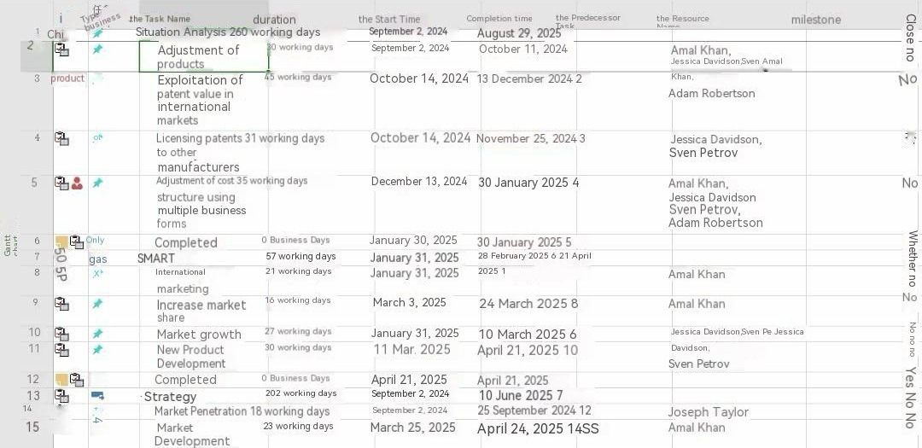
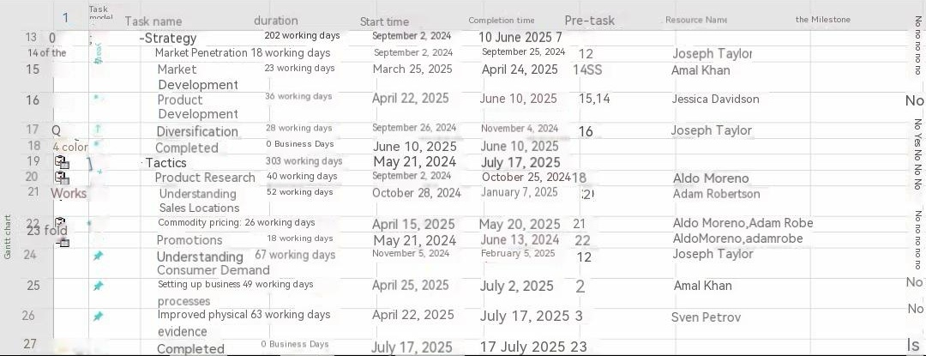

2.6 Control
Key Performance Indicators (KPIs) are quantifiable metrics used to measure the overall long-term performance of a company. KPIs are useful in determining a company's strategic, financial, and operational achievements (Twin, 2024). Once the organisation has identified its KPIs this information should be communicated to employees so that everyone understands the metrics used to measure the performance of the business. KPI performance is continually monitored and evaluated against our chosen strategic marketing objectives, using performance data to measure trends in the global chocolate market share on a monthly basis to determine its development. Any performance gaps are addressed by evaluating and analysing the data collected to identify areas for improvement, corrective action or process improvement (Undru, 2024). By using ThoughtSpot's monitoring feature, we can be notified when a KPI meets a specific threshold condition, or we can set up KPI notifications on an hourly, daily, weekly, or monthly basis.

3.0 Recommendation
Tesco can choose to measure and evaluate the global chocolate market share by using different key metrics such as ROI, market share, customer lifetime value, cost per acquisition, cost per lead, click-through rate and so on. Once all these data are available, the ones that best fit this strategic marketing objective are selected for in-depth monitoring and evaluation to get the final results.

4.0 Conclusion
Using SOSTAC and SMART a detailed plan was developed to achieve the strategic marketing objective chosen by the staff. This objective was analysed in SMART to obtain results that Tesco could benefit from, including profits generated by the international marketing department, increased market share, emergence of new consumers, market growth and new product development. The Ansoff Growth Matrix analyses the risks associated with each of the four strategies, the marketing mix illustrates the methodology for achieving the objective, and then a Gantt chart is used to organise the responsibilities of the employees within the timeframe. Finally, KPIs are used to monitor and evaluate the results. It is suggested that Tesco may choose to measure and evaluate the global chocolate market share by using different KPIs.

References
- Chaffey, D. (2023) Sostac Marketing Planning Model Guide. [online] Smart Insights. Available at: https://www.smartinsights.com/digital-marketing-strategy/sostac-model/ (Accessed: 09 May 2024)
- CFI (2023) Smart goals. [online] Corporate Finance Institute. Available at: https://corporatefinanceinstitute.com/resources/management/smart-goal/ (Accessed: 09 May 2024)
- Leonard, K. and Watts, R. (2022) The Ultimate Guide to S.M.A.R.T. goals. [online] Forbes. Available at: https://www.forbes.com/advisor/business/smart-goals/ (Accessed: 04 May 2024)
- Boogaard, K. (2023) How to write smart goals (with examples). [online] Work Life by Atlassian. Available at: https://www.atlassian.com/blog/productivity/how-to-write-smart-goals (Accessed: 04 May 2024)
- Martins, J. (2024) Set-and achieve-smart-er goals [2024]. [online] Asana. Available at: https://asana.com/resources/smart-goals (Accessed: 04 May 2024)
- Coursera (2024) International Marketing: Career Guide (2024). [online] Coursera. Available at: https://www.coursera.org/articles/international-marketing (Accessed: 04 May 2024)
- CFI (2023) Market share. [online] Corporate Finance Institute. Available at: https://corporatefinanceinstitute.com/resources/economics/market-share/#:~:text=Impact%20of%20Market%20Share%201%201.%20Economies%20of,industry%20...%206%206.%20Increased%20bargaining%20power%20 (Accessed: 04 May 2024)
- Mehta, K. (2024) Market growth - what is it, formula, examples, how to calculate? [online] WallStreetMojo. Available at: https://www.wallstreetmojo.com/market-growth/ (Accessed: 05 May 2024)
- Ansoff, H. (1957) 'Strategies for Diversification,' Harvard Business Review, Volume 35, Issue 5, October 1957. (Accessed: 06 May 2024)
- Joshi, S. (2023) Ansoff Matrix: Growth Strategies, Challenges & Benefits. [online] G2. Available at: https://www.g2.com/articles/ansoff-matrix (Accessed: 06 May 2024)
- Wright, T. (2022) The Ansoff Matrix: 4 growth strategies explained (with examples). [online] Strategy Software for Planning & Execution. Available at: https://www.cascade.app/blog/the-ansoff-matrix-helps-organizations-grow (Accessed: 06 May 2024)
- Rogers, P. (2023) The Ansoff Matrix: Comprehensive Overview with examples. [online] LogRocket Blog. Available at: https://blog.logrocket.com/product-management/the-ansoff-matrix-comprehensive-overview-examples/ (Accessed: 06 May 2024)
- Jurevicius, O. (2024) Ansoff matrix explained - SM insight. [online] Strategic Management Insight. Available at: https://strategicmanagementinsight.com/tools/ansoff-matrix/ (Accessed: 06 May 2024)
- Peterdy, K. (2023) Ansoff matrix. [online] Corporate Finance Institute. Available at: https://corporatefinanceinstitute.com/resources/management/ansoff-matrix/ (Accessed: 06 May 2024)
- Allen, A. (2023) Understanding the 7PS of the marketing mix. [online] Oxford College of Marketing Blog. Available at: https://blog.oxfordcollegeofmarketing.com/2020/10/08/understanding-the-7ps-of-the-marketing-mix/ (Accessed: 07 May 2024)
- Hanlon, A. (2023) How to use the 7PS marketing mix strategy model? [online] Smart Insights. Available at: https://www.smartinsights.com/marketing-planning/marketing-models/how-to-use-the-7ps-marketing-mix/ (Accessed: 07 May 2024)
- Mailchimp (2023) Marketing mix and the 7 PS of Marketing. [online] Mailchimp. Available at: https://mailchimp.com/marketing-glossary/marketing-mix-7ps/ (Accessed: 07 May 2024)
- Focus7 (2018) Marketing mix process - understanding the 7PS of a marketing mix. [online] Focus7. Available at: https://focus7international.com/2018/05/29/understanding-the-7ps-of-a-marketing-mix/ (Accessed: 07 May 2024)
- Brooks, A. (2023) The marketing mix: Building a strategy with the 7ps. [online] Venture Harbour. Available at: https://www.ventureharbour.com/marketing-mix/ (Accessed: 07 May 2024)
- McCabe, A. (2024) The 7PS of the marketing mix: Streamline your strategy. [online] Hurree’s Marketing Blog. Available at: https://blog.hurree.co/marketing-mix-7ps (Accessed: 07 May 2024)
- Ridge, B.V. (2023) Understanding the 7P marketing mix: A comprehensive guide to enhancing your marketing strategy. [online] MEDIUM Multimedia Agencia de Marketing Digital. Available at: https://www.mediummultimedia.com/en/marketing-usa/what-is-the-7p-marketing-mix/ (Accessed: 07 May 2024)
- Twin, A. (2024) Kpis: What are key performance indicators? types and examples. [online] Investopedia. Available at: https://www.investopedia.com/terms/k/kpi.asp (Accessed: 08 May 2024)
- Undru, A. (2024) What is a key performance indicator (KPI)? A detailed guide. [online] ThoughtSpot. Available at: https://www.thoughtspot.com/data-trends/kpi/what-is-a-kpi (Accessed: 08 May 2024)

