Introduction

As recognised by May et al., “Implementing and evaluating complex interventions, new technologies, and business processes in healthcare is complex and demanding” (2015, para.1). There are though, a number of frameworks and theories that can support the management of such interventions, for example, Normalisation Process Theory (NPT). NPT focusses on the work that people, or groups, do to accomplish the embedding and integration of interventions into business as usual. As such, it outlines the importance of these people/groups in the role of stakeholders.

Ingabire, Gitahi and Mwangi (2021) concluded in their study that there was significant correlation between the successful implementation of a strategic plan and the effective involvement of stakeholders. In order though for us to involve stakeholders, we must first identify them.

Stakeholder Identification

There are a number of definitions of a stakeholder within the literature, and as Smith notes, the term encompasses a wide range of people/groups, but ultimately “they are recognised because the organisation would like their support or neutrality on an issue for which the organisation seeks strategic and sometimes operational outcomes” (2017, p.35). PMBOK gives a broad definition, stating that stakeholders “can be individuals, groups, or organizations that may affect, be affected by, or perceive themselves to be affected by a decision, activity, or outcome of a portfolio, program, or project” (2021, p.STD31). To this end, there is a wide range of stakeholders from multiple disciplines and agencies, both external to the organisation, and internal, that will be required in order to successfully implement Betsi Cadwaladr University Health Board’s (BCUHB) digital strategy, ‘Our Digital Future’ (ODF).

Numerous stakeholders are identified throughout ODF, however, they are not outlined as a collective, either within the main body, or its appendices. It is important to note that stakeholder identification is a continuous process whereby new individuals may be identified as the strategy is implemented, and similarly, some may cease involvement, so displaying them collectively in a document such as ODF could be limiting and appear exclusive.

Following is a table outlining the range of stakeholders I have identified as being integral to the implementation of ODF. This list was compiled through ‘brainstorming’ using the ‘9 Cs’ (NHS England and NHS Improvement, 2021) as loose classifications (this is an English, industry based tool so its categories do not map over exactly), and also a sweep of the Strategy itself. It should be noted, that ordinarily, this initial list would be opened up to a wider project group, and then also built upon through various engagement events, so it is potentially not exhaustive:

9 Cs | Stakeholder/Group | Internal / External
Commissioners | -Welsh Government  -Board / Senior leadership  -Chief Digital Officer | -External  -Internal  -External
Customers | -Clinical staff (multiple teams)  -Corporate staff (multiple teams)  -Community providers (pharmacy, optician, dentist) | -Internal  -Internal  -External
Collaborators | -Data, Digital and Technology Team  -Research and Development Team  -Digital Health Care Wales  -Higher education providers  -Small Business Research Initiative | -Internal  -Internal  -External  -External  -External
Contributors | -System Developers  -Suppliers | -External  -External
Channels | -Local Authority  -Health care partners (e.g. Macmillan)  -Voluntary sector | -External  -External
Commentators | -NHS Executive | -External
Consumers | -Patients  -Carers | -External  -External
Champions | -Digital champions  -System champions | -Internal  -Internal
Competitors | Not included within this implementation
Table 1: ODF Stakeholders

Stakeholder Analysis and Engagement

Smith (2017) recognised that, in order to achieve the best possible strategic outcomes within allocated resources, stakeholder engagement cannot simultaneously target all stakeholders on all issues, and instead we must concentrate on the key issues and stakeholders. In order to do this I would prioritise stakeholders in terms of who has the most interest, influence and/or involvement, using a mapping tool such as the one illustrated in figure 1.
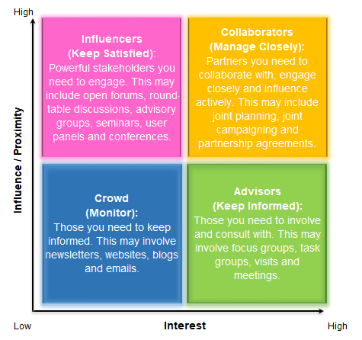

Figure 1: Stakeholder map (adapted from Vain, 2021)

It is important to be mindful that level of interest, influence and/or involvement is likely to change over the course of implementation, as is the range of disciplines involved, therefore, I would need to revisit the map periodically/at significant points throughout the life of the strategy.

I would use the methods outlined within figure 1 as far as possible to engage with the various stakeholders. As can be seen, these are group-based/collective methods, which I feel make best use of resource, can be used across disciplines, and have also been shown to be more effective in producing workable solutions than from individuals alone (Hsieh, Fifić, and Yang, 2020; Paulus and Nijstad, 2003; Tindale and Winget, 2019). However, I consider that appropriate tailoring of engagement methods, according to local knowledge such as shift patterns/office hours/availability ‘hot spots’ and so on, as well as preferences, are important in making engagement effective. Additionally, local awareness of stakeholders who may have unfavourable viewpoints regarding any element/s of the strategy will be vital, in which cases, individual engagement methods may be most appropriate. Regardless of my chosen methods, I would be mindful about managing expectations regarding the how, how frequently, and when communications/engagement may occur, so as to gain/maintain trust.

There was much reference to digital exclusion within ODF and it is indeed a factor that I would be aware of with regards communications with some of the non-professional, external stakeholder groups, such as patients and carers, in particular. In these cases, initial engagement could be via staff members, leaflets, hardcopy newsletters, or newspaper adverts. Subsequently, I would make it a priority to keep a stakeholder register in order to record contact details and preferences, as well as any notes regarding their priorities, motivations, and any barriers to strategy/specific project support.

A Personal Reflection

Unfortunately, I have not had direct involvement with the implementation of ODF. Indirectly, I do practice the points aimed at staff within the ‘How can you support the delivery of this Strategy’ section, however, this is coincidental. I have though, in a previous role (in a different health organisation), been involved with a technology implementation project at a departmental level, which is obviously on a different scale, but I feel my experiences are somewhat transferrable.
I used Gibbs’ model (1988) loosely as a frame for my reflection.

Description and Feelings
I facilitated the engagement of stakeholders for the local implementation of an electronic patient record system. Generally, I felt positive about the project, though was aware that many of one stakeholder group in particular (the staff user group) were more hesitant, and in some cases negative, about the implementation, which I knew I would need to rectify in order to achieve ‘buy-in’. I felt comfortable about the engagement process, happy that I knew the individuals involved, though aware of the implications of not managing the engagement effectively on successful implementation.

With respect to communication I used a pyramid approach as illustrated in figure 2 below:
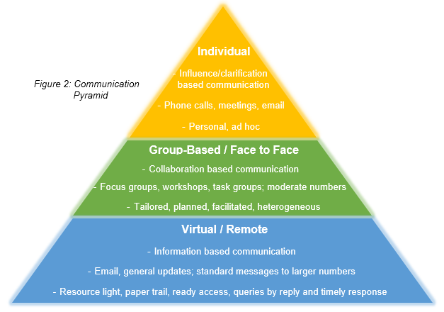

Stakeholder groups were split into sub-groups to facilitate engagement sessions. I allocated stakeholders to groups according to availability ‘hot-spots’, mixing geographic teams and roles. Individual session were booked on an ad-hoc basis.

Evaluation, Analysis and Action
The fact that I knew the stakeholders, and the general requirements of their disciplines, was a positive and meant that I could map the individuals, tailor engagement sessions, and tailor my approach to answering queries and addressing clarifications. It also meant that I was accessible to them.

Although, through planning, I managed to minimise issues relating to dominance and negativity within the groups, it wasn’t eradicated completely. On reflection, it may have been better to utilise some of the staff I knew would be champions in facilitation/group management roles in the sessions.

With respect to communication, the majority of the positives are outlined in figure 2. An additional positive within the group sessions came via my employment of the ‘park-it’ method for issues that deviated from the course I wished to take. This allowed me to validate the idea/concern for the stakeholder, but I was also able to maintain control of the group dynamic and then address issues outside of the group, as required.

On reflection, in response to feedback since, the group emails did not suit all stakeholders who found it more challenging to raise concerns/queries by reply, thus I would consider the introduction of drop-in style sessions in future. These may also be beneficial to stakeholders who are less confident in groups.

Group Consensus

Cabrerizo et al. (2014) see group consensus as a questioning process whereby group members modify their choices, with an aim of attaining the general consent of the group to an opinion, not necessarily full agreement. In fact, they state that complete agreement is unlikely in a group of intelligent, creative individuals. Deliberated consensus, via the active identification and evaluation of alternatives, and perhaps what the NPT perspective would term as ‘cognitive participation’ (May et al., 2015), is what we strive for through stakeholder engagement, to support in identifying clear solutions, actions, and getting ‘buy-in’. However, the dynamics of stakeholder groups should be monitored to ensure that any consensus reached is true, and that all individuals are actively engaged and formulate their position under their own volition, rather than due to perceived pressures.

Janis (1971) popularised the term ‘groupthink’ to explain the effect where members may set aside their own opinions, and critical reasoning, to prioritise group harmony, often in line with the opinions of more dominant group members (with respect to personality and/or authority). When ‘groupthink’ exists, the identification and evaluation of alternatives is either reduced or avoided altogether (Macleod, 2011). There are measures we can take though to minimise the risk of ‘groupthink’ and/or dominance within the group. From my own previous experiences, I concur with Stroebe and Diehl (1994) in that trained facilitators can provide important non-directive leadership within engagement sessions. Also, pre-planning both group/sub-group allocation, which can promote group heterogeneity as well as giving the opportunity to place known dominant personalities strategically, and activities, which can include ‘devil’s advocate’ sessions, or private reflection/individual generation of ideas in addition to group work, is helpful. Where issues are foreseen, I feel there is also merit in Osborn’s (1963, cited in Paulus, 1998) suggestion to separate idea generation and evaluation/decision making phases of group interaction.

Conclusion

