Assignment Submission Form
Wales Academy for Professional Practice and Applied Research

Please complete this form and send with your Submission to wappar@uwtsd.ac.uk

Wales Academy for Professional Practice and Applied Research office COPY

Student Number: ____2125389__________________________________________

Student’s Name: _____Paul Pritchard__________________________________________

Tutor Name: Dr Roisin Mullins_____________________________________________

Assignment Title: _Qualitative Research Methods ________________________________________

Module Code: ___BMPF7102_______________________________________________

Submission Date: __06/09/23___________________________________________

Your work will not be marked unless it is accompanied by this statement.
I confirm that this is my original work and that I have adhered to the University’s policy on plagiarism.
Student’s Name: __Paul Pritchard___________________Signature_P.Pritchard__________________

Wales Academy for Professional Practice and Applied Research Staff only

Received by:_____________________Date submitted:____________________

Student Receipt
Student Number: ______2125389________________________________________

Student’s Name: ______Paul Pritchard_________________________________________

Tutor Name: __________Dr.Roisin Mullins_______________________________________

Assignment Title: ___Quantitative Research Methods

Module Code: BMPF7102__________________________________________________

Submission Date: _06/09/23____________________________________________

Wales Academy for Professional Practice and Applied Research Staff only

Received by:_____________________Date submitted:____________________

Key Words: Train Conductors, Safety Critical Staff, Human Factors, Platform Train Interface, Railway Industry

- Introduction:
This assignment will focus on violations and errors made by safety critical staff on the Transport for Wales (TFW) infrastructure, the focus will be on Train conductors (TC) specifically. The role of a TC is vital in keeping passengers safe when boarding and alighting across the Wales and boarder’s platform train interface, it is imperative to identify why errors are made by safety critical staff. Investigating incidents are important in developing strategies and implementing mitigations to prevent these accidents from occurring again or reducing the likelihood as much as humanly possible with technology. (Kyriakidis, Pak & Majumdar, 2015).
Understanding why these errors occur allows TFW to investigate and helps prevent these mistakes from happening again in the future. There are millions of train passengers that use TFW stations to board and alight trains every year, so it is imperative to maintain safety standards on the platform train interface to prevent future injuries or even death. In the last 3 years on TFW platforms, there have been 115 operational incidents which has the potential to be extremely dangerous to the passengers. In the UK in the past 3 years, there have been 13 deaths on the Platform train interface, which could have been prevented if safety critical staff had followed the correct procedures (RSSB,2022). This demonstrates that investigating errors made by safety critical staff on the railway network is important to reduce injuries or death on the platform train interface.
Many errors made on the operational railway platform are mainly contributed to a lack of concentration and distraction. Customers on the platform can cause major distraction to train staff, however there are many strategies which can be used to divert passengers away from safety critical staff, so errors do not occur. As mentioned, lack of concentration is one of the most common reasons safety critical staff make mistakes, the data which is being analysed in this study is using a holistic approach with qualitative and semi-structured interviews to determine why some of these errors occur.
Transport for Wales can also use the data gathered to identify the locations which may provide clues to why such mistakes are occurring. The data can provide information which can be analysed in great depth, to determine if there is a correlation between the errors caused or indeed a significant trend that can be prevented in training. The research question ‘What impacts human performance when completing safety critical duties. The study will focus on the time of errors made, peak or off-peak times and which human factors influence poor performance. This information will form the data which is required to identify if there is a correlation with the variables and the errors made by TC. These variables will be investigated and analysed with each error made by a TC over the past 3 years on the Transport for Wales network.

- Literature review:
The knowledge and understanding concerning human factors are well documented within the aviation sector, this industry leads the way in training its staff and studies on the topic to better understand how human factors influence accidents. In comparison with the railway sector there is very little. Nevertheless, in the past ten years there has been more studies conducted within the railway sector than in previous years, which is promising in understanding human factors performance for safety critical staff. By increasing awareness of the impact human factors has on performance within the railway industry, will only improve safety standards across the network.
Air travel is considered the safest mode of transport, (Mosey, 2014). With flying being the safest way to travel, this may be due to the extensive training pilots receive because of the literature that has already been made available to the aviation industry. In comparison to aviation, the railway sector is more Likely to incur fatalities, therefore there must be more focus placed on training and studies on how human factors performance impacts incidents on the railway platform train interface.
Human factors can play a major role in railway accidents compared to failure of technology on the railway infrastructure, (Walker, 2013) states “Often disasters arise because people act in apparently rational ways”. Furthermore, despite this claim there has been a lack of comprehensive data and analyses in literature concerning the impact of Human factors on the railway industry (Felmann, Hammerl & Schwartz, 2008). The current literature demonstrates that safety culture of safety critical staff, makes up more than 20% of accidents, with nearly 75% of incidents involving the train drivers. The railway industry is lagging behind other sectors such as the aviation sector which has an abundance of publications concerning human factors for pilots. (Gawlak, 2022).
Moreover, many studies are based on former studies from other domains, which are not suited and can be difficult to employ reliably to railway-specific operations. Moreover, in Europe, the consideration of human factors does not have a long tradition. Even though a large proportion of accidents are due to human error. (Hammerl, & Vanderhaegen 2009).
Human errors are regarded as one of the main causes for railway accidents these days. In spite of this fact, the consideration of human error probabilities in quantified risk analyses has been very rudimentary up to now.
One such study which attempted to focused on measuring human factors performance, titled ‘Development and Assessment of Taxonomy for Performance-Shaping Factors for Railway Operations’ (Kyriakidis et al, 2012). The paper proposed a new system referred to as human performance railway operational index (HuPeROI). The paper also attempted to identify the human error probability for operations but also provide mitigations to reduce degraded performance.
The study produced a performance shaping factors taxonomy for the railway industry, due to the lack of literature on this specific topic, which is the opposite to the aviation industry (Kyriakidis et al 2012) devised a new taxonomy which is explained below.
This new taxonomy is based on the duties of the railway operators in order to provide researchers, as well as operators and safety specialists in the field of HFs, with a simple and comprehensive tool. It defines the R-PSFs in detail and provides an example for each R-PSF to avoid potential misunderstandings. The R-PSFs taxonomy contributes to the existing taxonomies, as it: (i) is based on railway operators’ duties, (ii) clearly and precisely defines the R-PSFs – including providing examples for each R-PSF, (iii) identifies the dependencies amongst R-PSFs, (iv) “assesses” individual R-PSFs contribution on human performance and (v) aims to be transferable. (Kyriakidis et al 2012, p. 2)
(Appendix A)

In validating the taxonomy, the study used real data from 179 accidents and incidents and railway reports were analysed. The methodology of this paper used Pearson chi-square test of independence to determine any relationships with the data.

Typically, accidents which occur on the railway are linked to a train moving along a track, where the train may derail or collide with an oncoming train/vehicle. This type of accident is due to human performance factors or a technical fault. There are studies which focus on this specific area within the railway sector, these types of incidents have been reduced drastically due to implementation of safety working practices and largely due to technology.
However, when incidents occur on the platform train interface, it is difficult to engineer these incidents out. Dispatching trains on the platform is still completed by human interaction with little input from technology. The train conductor and dispatcher will still use their decision making to determine if the train is safe to proceed, this allows the possibility of human error taking place within a safety critical stage.
Another article (Bhuiyan, Ibtihal & Nokshi 2023) presented a framework to identify the most significant human performance factors, known as Performance Shaping Factors (PSFs), which influence the performance of railway operators. The paper analysed a vast amount of incidents on the railway infrastructure which included 479 railway operational incidents and accidents over the past 15 years worldwide. Based upon the Pareto principle, 12 R-PSFs account for more than 90% of the accidents and incidents, regardless of the severity of the event. The purpose of the investigation was to identify what human performance indicators impact performance the most frequent from incidents on the railway infrastructure, the study identified several key indicators that impact performance. The findings can be used to emphasis the key indicators in training to help prevent further mistakes in the future.
Another journal titled ‘Involvement of Human and Organizational Factors in Railway Accidents’ (Bhuiyan, Ibtihal & Nokshi 2023) completed research study on errors/violation by categorizing the accidents into four sections (Collision, derailment, locomotive failure and signal passed at danger). These four categories were then applied to the Human Factors Analysis and Clarification System (HFCAS) framework. The framework used, identifies direct and hidden factors that lead to an accident.
The study found that from 2010-2019, the total derailment was 1422 and trains running into an obstruction was 203. The study found that 38.46% of cases were attributed to human failure. Furthermore, the study states that a considerable fraction of accidents are caused by human errors. However, the study also looks at the operator’s rules and procedure makers. This could be the reason the errors occurred, due to the poor standard of procedures that are in place. The methods used include a framework to determine the rationale of accidents which enabled the study to identify why the accidents occurred using the categories used.
Accidents caused by human error identified that technology has improved in preventing train accidents however, there has been little development in R-SPF (Railway performance shaping factors). (Felmann, Hammerl & Schwartz, 2008). Many operational incidents which occur on the platform are due to human performance factors, typically caused by poor decision making, concentration levels or poor communication. One study focused on age vs experience.
The current trends which have been identified from the current literature concerning human factors performance on the railway industry clearly demonstrates there is more work to be carried out to fully understand how to prevent human factors in causing errors on the railway system. The studies and articles discussed in this literature review, have identified a framework to use to identify what caused errors in various incidents. These frameworks can be of used in determining what factors contributed to the incidents and how to mitigate against these errors occurring in the future. It is clear from the that human factors have a substantial impact on the errors made by safety critical staff. Furthermore, the studies and articles used in this literature review have a lack of interviews, feedback and experience which can impact the results.

- Research methods:
This paper has investigated what variables impact human performance, when completing safety critical tasks on the platform train interface. In attempting to identify what impacts human performance, numerical data would need to be analysed from the secondary data gathered. It was important to identify, if there was a correlation with the time, locations and when the incidents occurred, this was important as this could provide some insights into why the incidents occurred initially. The methodology used was a qualitative approach.
The data gathered was secondary data, which was produced by the TFW safety operations team. Any errors or mistakes made by safety critical staff are registered and investigated by the lead investigation team, to determine the root course of the incident. The system used to generate results to determine was SSPS & Excel. In using the approach of quantitative research allowed the tests to measure the data gathered. Furthermore, there are limitations in using just qualitative data. Further investigation such as interviews with the subjects, would be beneficial to gather more evidence concerning the errors made. A mixed method would be suitable to gain further understanding. The secondary data does not go into great depth when investigating the rationale of the incident.
This papers stance is positivist, to identify the hypothesis, a form of science is required by using the numerical data. Using the data can determine if there is a common trend with the time of errors. It is clear from the literature, that human factors play a significant role in the incidents on the railway infrastructure. The epistemology, ontology, methods, and methodologies within each journal reviewed also follow a scientific approach in identifying how and what human factors influence accidents compared to a subjectivism/interpretivism approach. A positivist approach was primarily used throughout the studies examined in the literature review, due to Ontological approaches; a positivist approach treats reality as objective. Many of the studies followed a scientific approach, which enables the researcher to measure what has been tested, this is how a positivist researcher investigates their findings using statistical methods. There is a claim that a mixed methods approach can be favourable. Using methods such as statistical data, questionnaires, and semi-structured interviews to obtain results, can create a research outcome stronger than either method on their own merits. Using both domains combined, allows the study to explore more complex elements and relations of the human and social World. (Malina, Nørreklit, & Selto, 2011). However, there are some authors who believe both qualitative and quantitative approaches are incompatible (Lincoln & Guba, 1985). However (Patton, 1990) believes that an experienced and skilled researcher can successfully combine both approaches to fill the gap in limitations of research.
It must be said, a post-positivism approach would be useful, incorporating qualitative approach would further enhance the data, by using interviews to gain some objectiveness from the subjects. This would form a more holistic design to understand why the subjects made the error. A structured interview or a self-completion questionnaire, would allow the investigation to fully understand the rationale of the error and implement mitigation if required. (Bryman, 2016). This design is formed of non-probability sampling, the subjects are readily available at their specific locations, the subjects must also provide an extensive report of the incident. This form of information can also be used to understand the incident further.
- Data Analysis:
The data was generated from a secondary source from Transport for Wales, all errors and violations are recorded on an excel spreadsheet to determine several variables concerning the incident (Appendix B). It is also a requirement from Rail Safety Standards Board (RSSB) to obtain all information concerning the incident. The information, which is recorded include the following, Location, Time/date, Weather conditions, Staff involved, Dispatch method, Summary cause, human factor and detailed cause.
To determine the hypothesis, two inferential statistical tests were carried out, Pearsons and an independent T-test. Correlation in the broadest meaning is an association between variables. Pearsons’s correlation tests if there is an association between the variables tested. The data which was tested by using Pearsons’s correlation was between two variables, one being the time of day and how often an incident occurred. Another test which was used was the independent T-Test, this test generated how often an incident occurred at peak times and off-peak times. The independent T test is appropriate for two different groups which was required for this test. There were also descriptive tests used to read the data, bar charts, pie charts and clustered column chart were used to show the results clearly. Each chart was able to provide percentages including mean, mode and median.
Pearson’s correlation coefficient is a inferential statistic, this allows the secondary data to test statistical hypotheses. This allows the test to determine if there is a significant relationship between two variables. However, Spearman’s correlation could have also been used as part of this data testing, but Pearson’s correlation coefficient test linear relationship compare to Spearman’s strength monotonic. (Myers & Sirois, 2004)

- Results:

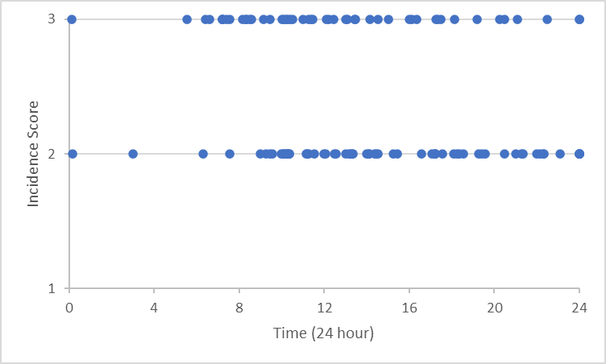
Figure 1:

This table which was generated by Pearson’s coefficient revealed a significant negative correlation (p=0.016) between incidence score and time of day, albeit a low relationship of (r=-0.224).
This equates to 5% of the variance in the data which can be explained by the relationship between the two variables (r²). As seen in figure 1, there is a higher distribution of lower incidence scores during the later hours of the day, meaning the incidence score is reduced over the during of the day.
Figure 2; Independent T-test
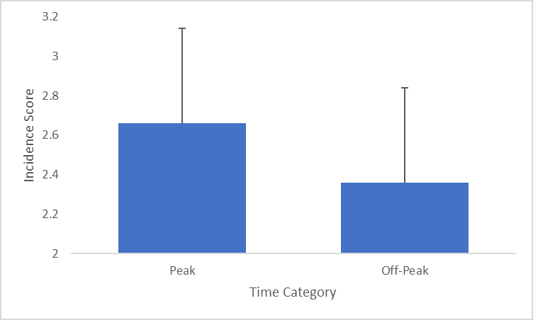

An Independent T-Test revealed a significantly higher incidence score during peak times compared to off-peak times (t₁₁₃=2.841, p=0.005). Data expressed as mean ± standard deviation. This was interesting, as peak times are less hours compared to off-peak hours. Peak hours accumulate to 7 hours and Off-peak hours accumulate to 17 hours. This result suggest, that errors are more frequent during the peak times, this could be largely due to more passengers on the platform train interface and fatigue setting in from safety critical staff. More data is required here, to determine how many trains are dispatched on the platform in peak and off-peak times. This will allow percentages against both peaks, as more interaction with the platform train interface could be a factor in the results shown above.

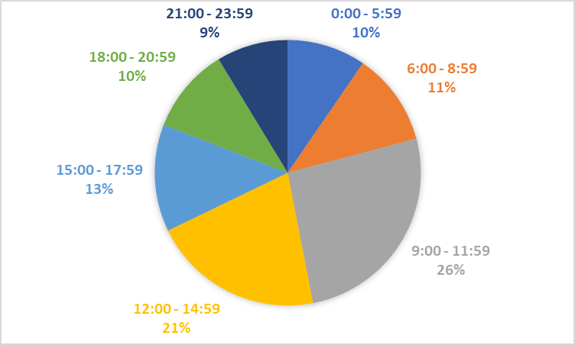
Figure 3; Distribution of incidence percentage over time.

This pie chart shows the mode times an error will occur from the data provided, the most common time for an incident to occur is between 09:00-11:59. The second most common frequency is between 12:00-14:59, this is an interesting finding. This could relate to fatigue however, further data is required on what time the subjects started their shift to determine how many hours they have been working. There could be a link concerning train conductors who book on before a certain time are more likely to have an incident, which has been a consequence of their human performance.

Figure 4; Shows the incident distribution across months.
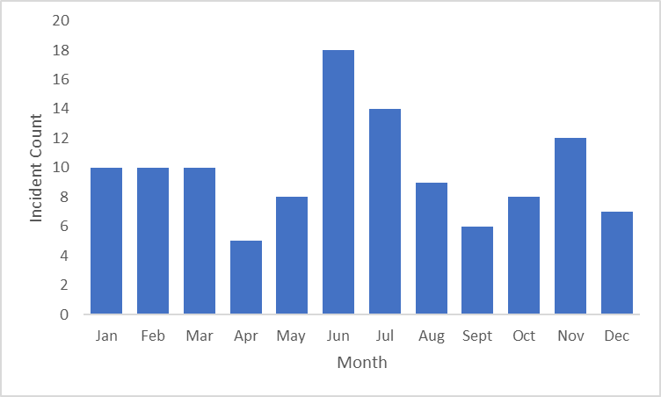
This bar chart shows the incident distribution across the 12 months of the year from 2018-2023, the mode was June, with 18 incidents compared to the lowest being April. The mean average was 9.5 incidents per month and the median was 10. A possible rationale for the mode could be the increase in passengers in June.

Figure 5. Shows which human factor contributes to incidents on the platform train interface.

The bar chart shows a significant difference between the 5 human factors that have contributed to an incident on the platform train interface from moderate to serious error. The mode is concentration with 70.4 incidents which was contributed due to a lack of concentration from safety critical staff. The lowest is checking, the range between the concentration and checking is 68.7. It is clear from these results that concentration plays a significant role in errors made by safety critical staff.

Figure 6: The table shows the number of errors made across the Wales and Boarders network.

Cardiff Central, has the mode with 23 incidents occurring. The Second most frequent station is Cardiff Queen Street with 12. These results are not surprising due to the volume of platforms which are located in Cardiff Central (9 platforms). However, in comparison to Crewe station only 1 incident was required even though Crewe station has 12 platforms. More data is required to determine why this might be the case. There are many reasons why this could be the case, one being in experienced staff.

- Discussion:

The outcome of the descriptive and inferential statistics is similar compared to the other studies identified in the literature review. Human factors play a significant role in a high percentage of incidents, the human factors which are most frequent to cause accidents include concentration, distraction, and preparation. In many studies, concentration had the highest rationale for errors made by safety critical staff. However, other studies also looked at other roles on the railway industry such as train drivers, signallers, and shunters.
In comparison to a Train Conductor, the results were similar compared to other roles on the railway. The data was consistent with a loss of concentration being the most common theme when investigating why errors had taken place. The other studies investigated in the literature review, focused primarily on the human factors.
The data suggests that the most common time a mistake may take place on the platform train interface is between 09:00hrs to 11:59am. There could be many reasons why this is the case. During that particular time of the day, it represents peak and off-peak times. This suggest there are more passengers on the platform, which could impact the safety critical staff when making decisions. Furthermore, many subjects may have started their shift I the early hours, which could explain the loss of concentration due to fatigue. Further studies need to be completed to identify when the subjects began their shift, this would classify how many hours had been completed by the subject, prior to the incident.
There was a significant finding from the tests, which identified that errors made at peak times were serious compared to errors made at off peak times. This information demonstrates that when the platform is busier, there can be a reduction in human performance which includes a loss of concentration and distraction. This new information is supported by studies, that demonstrated that concentration is the most frequent human factor when it influences an error on the railway infrastructure. It would be beneficial to provide mitigations against the loss of concentration during these vulnerable times in the day, to reduce the risk of accidents on the platform train interface. Further studies and discussions would need to be completed, to identify what mitigations can be implemented. One mitigation to reduce the risk would be to increase safety critical staff on the platform, this could reduce the risk of distraction and a loss of concentration by Train conductors when dispatching the train at the most important stage of the process.
The reliability of the data is clear and consistent, a lot of data was provided with each error. However, there are some limitations to the investigation cause. There is some evidence of an investigation in terms of factual data, for example the time, date, operational incident and subject. However, the root cause of the incident is very limited, to provide the data with more information concerning the incident would give the data more depth and understanding. An extensive interview with the subject may bring more information to the investigation, this may provide further insight into the human factors. Furthermore, the investigator is subjective with their decision making, the investigator will determine if the incident is serious, moderate or low. A standardisation approach would make the data more reliable and valid. More research is required to identify other possible reasons errors are being made, for example, a test could be completed on whether age vs experience has any relationship. This type of test could provide interesting discussions, are trainee conductors are passed out too early?
Covid must be taken into considerations, as the footfall between March 2020 to March 2021 was significantly reduced, this would have a significant reduction in errors across the network, further data on the 12 months between March 2020-March 2021 would need investigating to identify the errors made in these 12 months.

- Conclusion:
It is clear to see from the results and literature review, further investigation is required to fully understand the impact of human performance when completing safety critical staff. Compared to other sectors such as the aviation industry, there are many models and frameworks the railway industry can adopt to suit our needs. One model which has been embedded by the aviation industry, is the Swiss cheese model (Reason, J 1990). The Swiss Cheese Model has various barriers to errors being made. There are weaknesses in the barriers which can be penetrated, however even if the barriers have been compromised, all the holes need to line up for the defence to be broken. Due to the railway having many safety system layers, it is very rare for trains to collide. However, on the platform train interface this is not the case. There are no technology systems in place. The only system in place during the dispatch procedure, is human behaviour.
Further recommendations include the implementation of training on human factors. Train crew need to embed strategies to maintain concentration whilst operating high risk tasks on the platform.
This paper demonstrates from the research design using statistical analysis, that errors made by safety critical staff on the platform train interface are most frequent between the hours of 09:00 and 11:59. This information can be used to make safety critical staff aware of the critical times when error are more likely to occur.
Train conductors can implement risk triggered commentary during these times, to help prevent errors occurring. The results also showed that concentration is the most common reason why incidents have occurred.
From the findings identified from the descriptive and inferential statistical tests, it demonstrates that concentration is the most significant human factor that impacts human performance when errors occur on the platform train interface. Furthermore, the data also demonstrate that between the hours of 09:00am and 11:59 are the most vulnerable for safety critical staff in making errors on the platform. Over the past 5 years, the data shows that June is the most frequent month for errors to occur. It is evident from the results that the busy stations are the most vulnerable for train conductors in making errors on the platform which could cause serious injuries or death.

References:
Bhuiyan, Ibtihal, S. A., & Nokshi, K. N. (2023). Involvement of Human and Organizational Factors in Railway Accidents: Application of the Human Factors Analysis and Classification System and Bayesian Network. Transportation Research Record, 2677(8), 496–508. https://doi.org/10.1177/03611981231156932

Evans, A. W. Fatal Train Accidents on Europe’s Railways: 1980–2009. Accident Analysis and Prevention, Vol. 43, 2011, pp. 391–401. 8.

Evans, A. W. Fatal Train Accidents on Europe’s Railways: 1980–2013.Imperial College London, 2014

Feldmann, F., Hammerl, M. and Schwartz, S. 2008, Questioning human error probabilities for railways. 3rd IET International Conference on System Safety, Birmingham.

Gawlak Katarzyna. (2023). Analysis and assessment of the human factor as a cause of occurrence of selected railway accidents and incidents. Open Engineering (Warsaw), 13(1), 15–53. https://doi.org/10.1515/eng-2022-0398

HUMAN FACTORS IN THE RAILWAY SYSTEM SAFETY ANALYSIS PROCESS: 3RD INTERNATIONAL RAIL HUMAN FACTORS CONFERENCE Malte Hammerl1,2, Frédéric Vanderhaegen1 1 Université de Valenciennes et du Hainaut-Cambrésis Laboratoire LAMIH, Group Human-Machine-Systems Le Mont Houy 59313 Valenciennes CEDEX 9, France

Joshi. (2015). Social Research Methods (4th Edition) by Alan Bryman [Review of Social Research Methods (4th Edition) by Alan Bryman]. Abhigyan, 32(4), 77–. Foundation for Organisational Research & Education

Kyriakidis, Pak, K. T., & Majumdar, A. (2015). Railway Accidents Caused by Human Error: Historic Analysis of UK Railways, 1945 to 2012. Transportation Research Record, 2476(1), 126–

Kyriakidis, Majumdar, A., & Ochieng, W. Y. (2015). Data based framework to identify the most significant performance shaping factors in railway operations. Safety Science, 78, 60–76. https://doi.org/10.1016/j.ssci.2015.04.010
Kyriakidis, Miltos and Majumdar, Arnab and Grote, Gudela and Ochieng, Washington, Development and Assessment of Taxonomy for Performance-Shaping Factors for Railway Operations (July 31, 2011). Transportation Research Record: Journal of the Transportation Research Board, No. 2289, Transportation Research Board of the National Academies, Washington, D.C., 2012, 145-153,

Malina, Nørreklit, H. S. ., & Selto, F. H. (2011). Lessons learned: advantages and disadvantages of mixed method research. Qualitative Research in Accounting and Management, 8(1), 59–71. https://doi.org/10.1108/11766091111124702
mbur, Hubbard, P., Cooke, J., & Barnard, S. (2020). Feasibility of a kneeling train to improve platform–train interface for passenger boarding and alighting. IET Intelligent Transport Systems, 14(10), 1163–1170. https://doi.org/10.1049/iet-its.2019.0634

Myers, L., and Sirois, M. J. (2004). Spearman correlation coefficients, differences between[J]. Encycl. Stat. Sci. 12. doi:10.1002/0471667196.ess5050.pub2

Poirier, Adelé, S., & Burkhardt, J.-M. (2021). Individual accidents at the interface between platform, train and tracks (PT2I) in the subway: a literature review. Cognition, Technology & Work, 23(2), 203–224. https://doi.org/10.1007/s10111-020-00624-1

QUESTIONING HUMAN ERROR PROBABILITIES IN RAILWAYS F. Feldmann*, M. Hammerl*, S. Schwartz*

Qin, Cao, Z., Sun, Y., Kou, L., Zhao, X., Wu, Y., Liu, Q., Wang, M., & Jia, L. (2023). Research on Active Safety Methodologies for Intelligent Railway Systems. Engineering (Beijing, China). https://doi.org/10.1016/j.eng.2022.06.025

Appendices:
Appendix A:


