Benjamin East
Dissertation Proposal

Key Words

- Sound+Artwork Relationship
- Hipgnosis
- Artists Who Create Their Own Album Art

Images




Artists/Thinkers

- Storm Thorgerson
- Bladee
Album artwork is something that has intrigued and inspired me for as long as I can remember. I have always felt that it is almost as important as the contents of the album itself, traditionally being some sort of first impression, a snapshot of the sound that chooses to reveal or conceal as much or little information as the designer pleases. Being a collector of records myself, an album’s artwork can decide whether or not I will make the purchase at all, as I have bought records that I don’t particularly care for with regards to the musical contents but have really loved the imagery and typography. I have developed this appreciation over my 20 years and feel that the art, photography and design direction of records and CDs has played an integral part in my choosing to become a graphic designer and has therefore had massive influence on my life as a whole.

The importance of whether Albums need to ‘sound like their artwork’ has intrigued me since I started collecting and has often wondered if it really matters at all. The most immediate example of an album’s artwork not fitting its sound immediately is Deafheaven’s ‘Sunbather’ LP (2013). This is an experimental Black Metal album with some of the harshest vocals imaginable yet features a calming coral, pink and orange gradient with elegant stylized serif typography. It has sparked much debate within the online music community, as some believe the cover fits the spacey ‘shoegaze’ style, as the blurred aesthetic is somewhat reminiscent of earlier examples of albums in this vein, such as ‘Loveless’ by My Bloody Valentine (1991), but feels cleaner and even more minimal in approach. Black Metal album covers with similar vocals to those found on Sunbather typically feature far darker, horror based imagery and typography with the intent of being almost frightening to the viewer and would certainly make some albums quite inaccessible to people outside the genre’s fan base itself. One of my favourite album covers within the genre of Black Metal would be Darkthrone’s ‘A Blaze In The Northern Sky’ (1993), which shows a chilling, minimal image of a person in traditional corpse paint with the band’s almost incomprehensible logo and also the album title in a serif typeface not dissimilar to the type found on Sunbather. This comparison is quite interesting to me as it could be interpreted that Sunbather’s art direction is something of a marketing tool to attract fans of other genres such as Pop and Electronic due to its approachable aesthetic, despite sharing similar qualities to A Blaze In The Northern Sky.

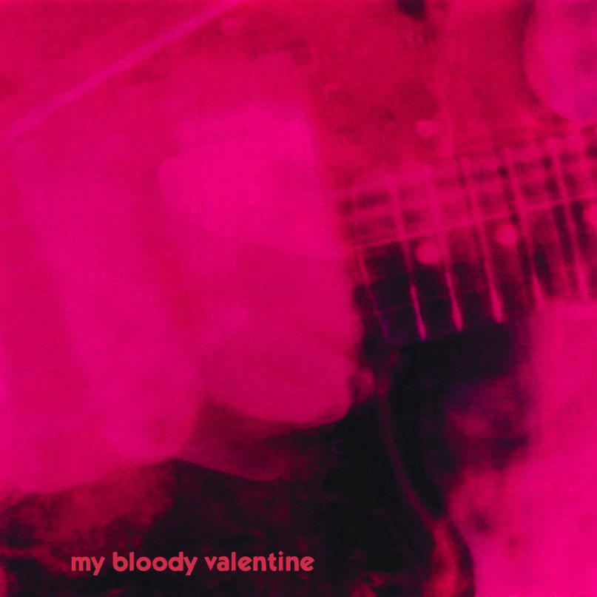


A Blaze in The Northern Sky by Darkthrone (1993)
Loveless by
My Bloody Valentine
(1991)
Sunbather by Deafheaven (2013)

I wish to further explore the relationship between sound and album artwork, with emphasis on whether an album’s cover should reflect the musical contents or not through my dissertation. In order to achieve this I will use ‘Cover Story, a History of Album Artwork’ Chilton M. (2017) for further context regarding the history of album art and how it has changed and been repurposed over time. I think that this sort of discussion creates need for the questioning of whether album art is as important as it once was. I have noticed through this source that artwork used to be quite strict, more informative and less conceptual and watching the evolution of the album cover to be quite fascinating. I hope to be able to use this and similar sources to maybe further the discussion in my dissertation.

With regards to the actual designers behind album artworks, in my opinion there is not a more prolific agency/designer than Storm Thorgerson and his Hipgnosis collective. I constantly return to the vast supply of fantastic and iconic work that they produced and more often than not, to Thorgerson’s works in particular as a source of inspiration and enjoyment. One of my favourite aspects of Hipgnosis is the way that they set out to change the way album covers were perceived, strived to create work that was equally striking and thought provoking, yet also a visual representation of the sounds and feel of the record itself. They brought the precision of the advertising world with them and were able to pioneer the new era of post-psychedelic fantastical artworks in ways equally as daring as their predecessors yet far more marketable and commercial, whilst retaining their artistic and stylistic integrities.

Only Revolutions album by Biffy Clyro
Artwork by Storm Thorgerson
(2008)

Despite working on some of the most easily recognisable pieces of album artwork off all time for artists such as Pink Floyd and The Cranberries, my absolute favourite of his pieces would actually be one of the last album sleeves he designed before his passing. This being Biffy Clyro’s Only Revolutions (2008), one of my favourite albums of all time. This piece of photography is somewhat simple at first glance but unfolds as you delve deeper into it, which is not unlike Biffy Clyro’s music itself, being abrasive and borderline insane yet disguised as a pop rock album, in this instance. The image depicts an adult man and woman holding two massive wind-battling flags, one red and one being blue. I feel that straight away this is extremely significant as it shows two heavily contrasting bright colours, maybe suggesting conflict between the two people as the colours typically represent polar opposites, which do not attract. I feel this is interesting to consider as the flags certainly look as if they are blowing apart, however, they could also just have been used to represent the sexes of the man and woman. This would also suggest some form of bottled up conflict between the two subjects as the woman is holding a sort of rolling pin and the man a large knife behind their backs, not toward each other. I feel that the flags are probably the most significant feature of this piece as they are covering the two people’s mouths and being put into the sky. I’m sure this is meant to show the two’s true thoughts and feelings for each other and how they wouldn’t necessarily say these things out loud, yet are very much conflicted in their respective minds. This is again prevalent in the album’s lyrics and overall feel, one of a love lost including several songs of heartbreak.

He said of this piece; “…perhaps Biffy thought that real change could only be effected by drastic means, namely revolution, and flags play a strong revolutionary role, enormous flags even more so…” (Storm Thorgerson, 2008)

I feel that this is an important quote that can be used to understand Thorgerson’s thought process and what he kept in mind when aiming to achieve this piece, how he connected with it and how closely he worked with the artists themselves.

I own a copy of ‘Vinyl/Album/Cover/Art – The Complete Hipgnosis Catalogue’ by Aubrey Powell, which I will certainly refer back to throughout my dissertation regardless of the question, due to the depth of work and limitless inspiration. I think that Hipgnosis really thought further than just album covers. The way they worked closely with the musicians to create an experience rather than just a single piece of information is something that I admire greatly as a consumer and designer and is something that I hope I will get the chance to consider in my career.

Another aspect of album cover art that I find quite intriguing is when an artist creates their own artwork for their musical projects. I feel that this can lead to deeply meaningful and personal outcomes, where the project feels far more complete and realized when compared to the work being outsourced to a large design corporation, as I feel that the message of the music can be lost if the ideas are not thoroughly discussed, as they certainly were in Storm Thorgerson’s case and many other designers with true passion for their work. The most famous examples of this being the likes of Joni Mitchell, Wayne Coyne of The Flaming Lips and my personal favourite, Daniel Johnston- namely his universally recognisable ‘Hi, How Are You’ piece from 1983.

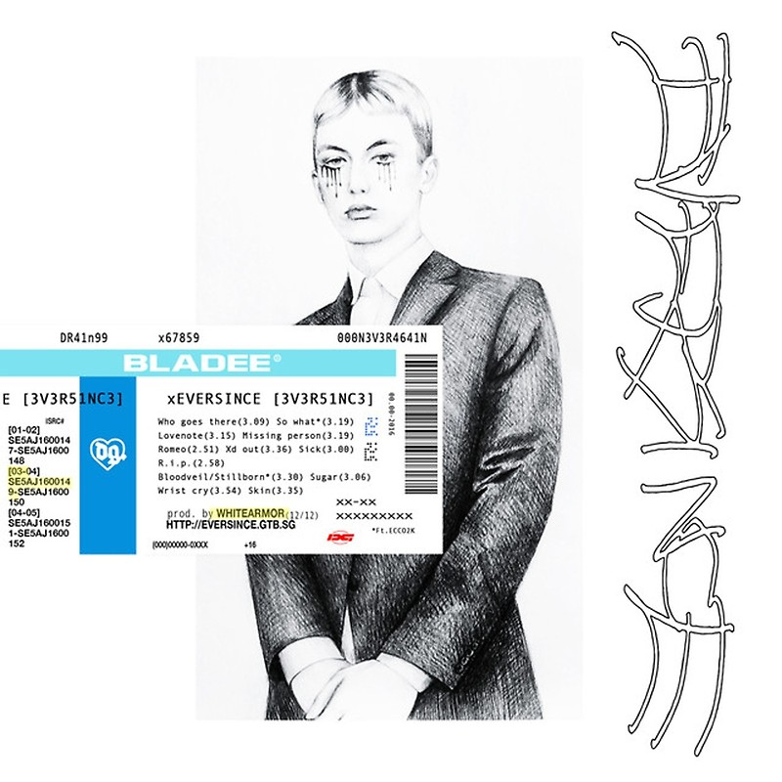


Untitled by Bladee (2016)
Bladee’s Eversince (2015)

‘Bladee’ is another artist that I have come across in recent years as a more modern example of a musician who doubles as graphic designer for his own musical ventures, merchandising and media presence. He is a Swedish musician who makes synth and sample based emotional rap music. His work is almost always a perfect representation of how the album feels and sounds in a visual carnation. He works digitally to manipulate typography and imagery to create intricate and abstract outcomes that borrow heavily from early 2000s graphics. This era is referenced in his music and the music of his counterparts heavily and having a meaningful graphical representation is a fantastic way to further draw some elements of nostalgia. His 2015 LP, Eversince, is both my favourite piece of music and design by him.

I feel that there are so many different aspects to consider and grasp when discussing album artwork and the art direction that accompanies music but I think that perhaps as a graphic designer with a love and appreciation for this craft perhaps I have been looking with rose tinted glasses. Looking at it realistically, there is a strong argument to be had about whether album artwork is, to some extent, diminishing in both importance and relevance in the age of streaming and digital downloads, due to quick turnarounds and immediate distribution made possible by the internet. My research and personal experience has shown me that there are obviously still great album artworks being produced, yet with today’s disposable and screen based culture, I have begun to wonder if future generations will grow up around physical albums with memorable and iconic pieces of art. I have felt for some time that album art is not being made for the purposes of print and physical distribution as much as it is being optimized for screen first and foremost, which is interesting to me as a designer as the limitations of designing in 1500x1500px versus 12” mean that there is a greater challenge for the designer or artist to capture the viewer’s imagination or attention in a split second while swiping on a phone rather than taking their time flicking through a rack of records or CDs.

“One attitude we can all strive for is simply appreciating the work that goes into each record design – take time to study sleeves at your local record store; seek out the artist's portfolio and process; discuss the connections between the songs and the visual representation. Just don't keep scrolling – you might miss something.”

Maine, S. (2015). Why does album artwork exist in the digital age? [Online] Creative Bloq.

I wish to explore the need for album artwork further in my dissertation next year. My key words and chosen artists/thinkers have led me to think deeply and for a long time about whether the album art industry has become a disposable and forgotten trade that has become obsolete. It is the opinion of consumers and seasoned veteran designers alike that there are no truly iconic album covers anymore. Personally I think that this is a somewhat defeatist viewpoint as every album cover means something to the viewer subjectively speaking. Perhaps some of the newer works simply need time to achieve this so called ‘iconic’ status. Despite my initial feelings towards this stance, I have come to understand the difficulties designers face by sometimes being without the option to create designs for print and only to make art for web use.

The question I would like to answer in my next year will be ‘Is Album Artwork Becoming Obsolete?’ which I will further explore using the sources I have utilised here as well as using surveys and articles related to the matter. I look forward to furthering my research about this as I am passionate and interested in seeing how this might affect the way I may have to approach similar tasks in my career as a designer.

Bibliography

‘Vinyl/Album/Cover/Art – The Complete Hipgnosis Catalogue’ by Aubrey Powell

Maine, S. (2015). Why does album artwork exist in the digital age? [Online] Creative Bloq.

Chilton, M. (2018). Cover Story: A History Of Album Artwork. [online] uDiscoverMusic. Available at: https://www.udiscovermusic.com/in-depth-features/history-album-artwork/ [Accessed 6 May 2018].

Flora, J. (n.d.). Vintage album covers | Jim Flora. [online] Jim Flora. Available at: https://www.jimflora.com/galleries/flora-classic-album-covers/ [Accessed 1 May 2018].

