

MARKETING AND MANAGMENT
LCMB70001

COURSE: MBA GENERAL MANAGEMENT
MODULE CODE: LCMB7001
ASSIGNMENT TITLE: 1
STUDENT NAME: SHUHAIB AKKALATH
STUDENT NO: 2131583
LECTURER: TUSHARA BALENDRAN
Executive Summary
In the journey of becoming a global brand marketer, management has an essential role. Marketing management deals with the activity of controlling marketing aspects, defining and setting organizational goals, implementing marketing strategies, and conducting brand audits. The perspective of the consumer touch points and the forecast of consumer mapping for the selected company are evaluated in the report with significant information evaluation.

Table of Contents
Introduction 3
Company overview 3
Definition of communication 4
Explanation of communication model 5
Definition of integrated marketing communication 7
Promotional strategies that Vodafone can use to raise brand awareness 9
Definition of branding and brand equity 10
Discussion on the customer journey and customer touch points 11
Explanation of a customer journey map for organization 13
Total Engagement Model 14
Conclusion 14
References 16

Introduction
The big brands or big companies recognized in today’s world do not become big brands overnight. Behind the success story of every big brand, there is a lot of hard work, fear of failing, wrong decision, inappropriate strategies, uncertainties, risk, and many other things that today's world cannot see. Effective marketing strategies influence pricing by developing a competitive pricing strategy that gets a higher conversion rate. In this conte,xt marketing management considers important factors like price-quality relationship, consumer expectation, competition, political factors, and negotiation that influence pricing strategy. This study aims to determine innovative marketing strategies for Vodafone in terms of raising brand awareness as well as providing a wider vieofut their customer journey, and communication channel. In addition, this study highlights strategies that Vodafone considers to fulfill the expectations of current and future shareholders.

Company Overview
Vodafone group plc is a publicly listed multinational company that is engaged in the business of telecommunication. The company was founded by Ernest Harriston and Gerry When by 30 years age in 19ago 16 September. The company's registered office and global headquarters are situated in Berkshire, UK.
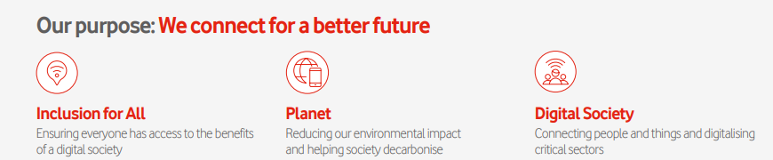
Figure 1: Purpose of Vodafone Group Plc
(Source: Vodafone.com, 2022)
The mission statement of Vodafone Group plc is “Connect people for a better future”. The company further demonstrates its mission statement by setting a goal of building a sustainable digital society by providing advanced technology and communication services that improve people's lives. Over the last 30 years, the company has brought several changes in its management and its approach to reaching consumers. In the 1990s Vodafone interacted with consumers through retail stores and most of the business depended on manual processes. The management of the company is aware of digitalization by keeping these things in mind, the company has developed multi-channel models. Further emphasizing the digital process in 2010 company combined its multi-channel model with omnichannel (Vodafone.com, 2022).
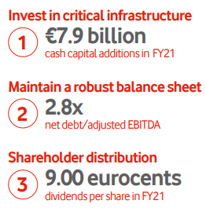
Figure 2: Capital allocation framework of Vodafone
(Source: Vodafone.com, 2022)
The recent annual report shows that companies heavily invest in AI and as a result, it helps to resolve 63% of consumer queries. In the financial year, 2021 Vodafone reported revenue of €m43, 809, net profit of €m536, and cash flow of €m5, 790. The company gave a total return of 6720% return to its shareholders and in the past year, the company gave a return of 2.74%.

Definition of communication
The communication process is important to be involved in an organization in terms of having transmission of messages through different channels. In global organizations, people come from different religions and due to cultural differences, it becomes difficult to communicate with team members and higher authorities effectively. Based on the study by (Radovic Markovic and Salamzadeh, 2018), ineffective communication hampers organisational overall productivity and decreases the quality of products, and services, and hinders the company to achieve the desired goal. In this context building up effective communication, the medium is important as it helps to interact with team members as well as consumers and helps the company to achieve desired results. Effective communication provides essential and necessary information regarding formulating business plans, and policies (Kharouf et al., 2020). Apart from that in business organizations, communication helps to raise awareness about work culture, motivates employees, promotes the brand, creates interest, increases efficiency, and develops better coordination. Hence, it can be derived that the ultimate success of a business depends on its communication.
The telecommunications industry plays a vital role in successfully running any business operation. In about words of (Gurvitš-Suits and Lvova, 2021), telecommunication allows employers and employees to connect at any time from any place. As a telecommunication company, the most important role of Vodafone is to provide reliable and convenient communication service that improves brand awareness and reputation and increases overall productivity. To cater to more consumers, Vodafone has now developed its digital service platforms as well as investing heavily in AI to resolve consumer issues. Currently, the major focus of the company is premium TV in Europe, and financial services in Africa and the company also focuses on unified communication, cloud application, and digital security. In this context, the company partnered with Microsoft, IBM, Google, Accenture, Cisco, and Amazon to provide better and unique services to its consumers (Vodafone.com, 2022).

Explanation of communication model

Figure 3: Shannon-Weaver's communication model
(Source: Siddik and Azamti, 2019)
The communication model of Shannon-Weaver's has been recognized as the most efficient of all communication models. Shannon-Weaver separates its communication model into 6 categories such as sender, encoder, channel, noise, decoder, and receiver (Communicationtheory.org, 2022). This specific model highlights how one message can be mixed up or misinterpreted during transferring a message from sender to receiver. The major aim behind implementing or discovering Shannon-Weaver's communication model is to determine important aspects that impact the communication process.
- Sender: The first step of these specific communication models starts with the sender or “information sources”. Senders are the person who wants to send some message or information to other persons and this process can take place in different ways such as orally, written, with body language, and music.
- Encoder: After a sender, the next step of Shannon-Weaver's communication model is an encoder. An encoder is a machine that converts ideas, information, or messages into signals and sends them from sender to receiver (Lindén and Wedebrand, 2018). Here, Shannon described an encoder means a telephone or computer that breaks down our message in binary digits or radio waves and then transfers it to the receiver.
- Channel: Next important step of Shannon-Weaver's communication model is a channel. As per the views of Gamage, (2022), Shannon refers to the channel as infrastructure which through the sender sends its information, and messages, and the receiver receives it. For example, if any person sends mail to another person with the help of the internet, then the internet is the medium or channel.
- Noise: Shannon defines in its communication model that Noise is the barrier that interrupts messages during transfer to the receiver and it can create misunderstanding between sender and receiver. Shannon highlights in its model that noise has two types one is internal noise and the second one is external noise. Based on the study of Akyurt, (2018), internal noise is created when the sender makes a mistake regarding the encoding message or the receiver makes a mistake regarding the decoding message. For example, misspelling words and misinterpreting sentences while reading an email. External noise such as network issues, sound problems, or other things.
- Decoder: Decoder is the opposite of encoding as here messages break down into binary digits during transformation through telephone or computer (Lindén and Wedebrand, 2018). In the same way, decoding here also needs a device that decodes a message from a binary digit into an understandable format.
- Receiver: Receiver is the step of Shannon-Weaver's communication model where the receiver finally receives a message from the sender. Examples of receivers can be the other end of the telephone and people who read mail.
- Feedback: Feedback is the final step of Shannon-Weaver's communication model where the receiver responds to the sender

- message in terms of a close communication loop (Akyurt, 2018). The response of the receiver clarifies to the sender that the receiver got a message and read it.
Some of the examples of Shannon-Weaver's communication model include telephone conversation and listening to the radio. The major advantage of these specific models includes it explains noise in detail, highlight areas that need to be improved for effective communication, breaks down communication in an understandable way, and messages can transfer in any situation. The major disadvantage of these models includes it does not prefer one too many communications and does not consider the social scientific look, and their complexity.

Definition of integrated marketing communication
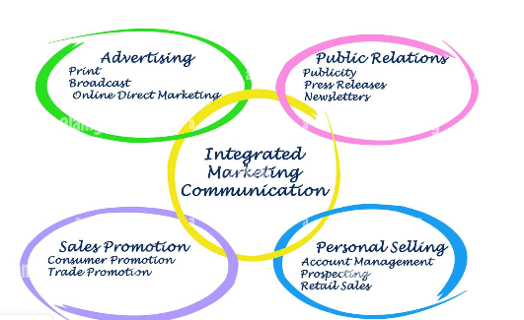
Figure 4: Integrated marketing communication
(Source: Alamy.com, 2022)
Integrated marketing communication or IMC consists of four important pillars that include advertising, public relation, sales promotion, and personal selling. All these are the methods that businesses use as a marketing communication tool to reach millions of consumers and increase awareness of their branding. IMC has 4 major objectives such as create brand awareness, generate product interest, increase desire for products and implement action as a form of sale (Duralia, 2018).
- Advertising: According to the Advertising Association of the UK, advertising is the process of building up communication with end users who want to use products and services. In the study of Ali, et al., (2020), bigger brands use different types of advertising like print, broadcasting, and online direct marketing to influence consumers, and make them aware of the company's new product or services. The major advantage of advertising in Vodafone includes new products or services, expanded market, increase sales, increase goodwill, fighting with competitioeliminatingate middlemen, and educating consumers. On the other hand, the disadvantages of advertising include it enhances the cost of the company, confusing buyers erodes underlining value,s, and influences, buyers, to the wrong products.
- Public relations: Public relations in IMC is defined as the process of building up and maintaining a strong relationship between an orgorganizationd and public communities. Public relations in Vodafone include three important factors such as publicity, newsletter, and press release. All these techniques are used to build product awareness, educate consumers, reinforce the brand and identify consumer problems. In this context consumers, investors, suppliers, and employees both play an important role in developing products and it also helps to increase sales and brand value.
- Sales promotion: Sales promotion is another effective way that is used by Vodafone to market their products and services as well as aware consumers of their brands. In the words of Tairova et al., (2020), sales promotion includes two important factors, one is a consumer promotion and another one is a trade promotion.
- Personal selling: Personal selling is also the part of IMC that consists of three important factors such as account management, prospecting, and retail sales. A company can hire a salesperson whose role is to convince customers to buy products (Oluwafemi and Adebiyi, 2018). In terms of introducing new products or services, personal selling is important in Vodafone as it describes products or services in a detailed way that reduces the complexity of products.
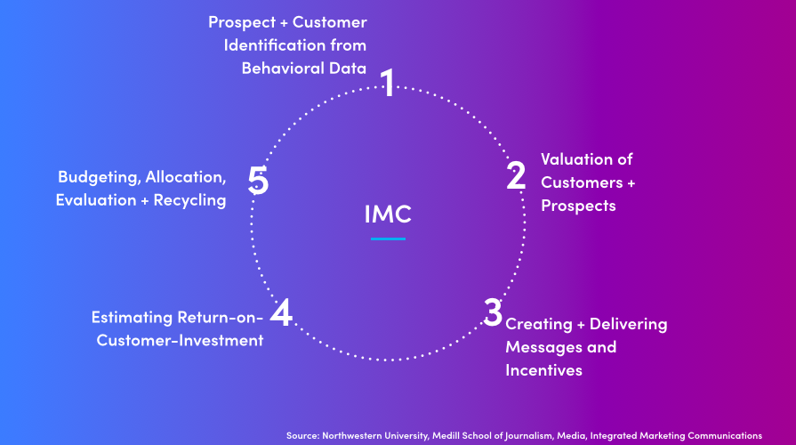
Figure 5: Stage of IMC
(Source: Khikhadze, 2020)
The above figure represents, 5 steps of integrated marketing communication that involve identifying consumers from consumer behavior, determining the financial value of consumers, forecasting the ROCI (return on consumer investment), delivering messages, and making a budget (Khikhadze, 2020). All these steps provide edges for Vodafone to take lead in the competition and increase sales along with profit.

Promotional strategies that Vodafone can use to raise brand awareness
- Invite influencers: The 21st century is the era of digitalization and modernization where companies used digital technologies to raise brand awareness. In the current scenario, people are more engaged in social media and digital platforms and it influences their consumer behavior. In this context, Vodafone can raise its brand awareness by inviting influencers. Influencers have their community and audience, as a result, it helps Vodafone to target a new audience.
- Partnership with phone brands: As a telecommunication service provider the most important aspect of a company is to provide a unique and convenient experience to its consumer in terms of communication and the internet. In this context, Vodafone can build a strategic partnership with different phone brands where the company offers free sim with one-year internment access which can enhance the brand awareness of Vodafone.
- Email marketing: Data shows that 85% of people in the UK actively send or receive messages through email. Vodafone can utilize this opportunity to use email marketing in terms of maximizing its effort for brand promotion. It is a better way to build communication and relationships with consumers and it makes mail users aware of the different offers from the company.
- Online marketing: Data showed that 84.3% of people in the UK actively engaged with different social media platforms such as Instagram, Facebook, and YouTube. Promoting Vodafone services through these social media channels with the help of ad campaigns benefited the company to increase brand awareness.
- Event marketing: due to digital and modern technologies people lost their patience and now everyone wants everything instantly. Event marketing can work well as a tool to increase brand awareness of Vodafone. In events, companies can offer high-speed internet such as 5G at a lower price as well as offer different streaming channel subscriptions with one recharge.
- Relationship marketing: Vodafone offers high internet services as well as advanced technology services to its existing consumers and for this purpose, the company needs to develop strategic partnerships with other technology companies like Microsoft, Accenture, Cisco, and many more. Enhanced consumer experience and created more value for them as a free marketing tool that raises the brand awareness of Vodafone.

Definition of branding and brand equity
Brand equity is defined as a premium value that a business generates by selling its product and services to consumers. Brands create that premium value by producing high-quality products or providing unique services to their consumers. Based on the research process by Shariq, (2020), creating a strong brand image provides many benefits to a company such as it gives international and national recognition to the company, increasing awareness, and creating a strong and loyal consumer base. The value and importance of brand equity can be understood in a more meaningful way by analysis of Keller's brand equity model discussed below;
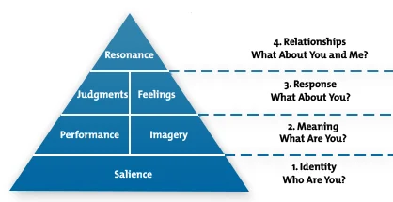
Figure 6: Keller's brand equity model
(Source: Stukalina and Pavlyuk, 2021)
As observed from the above figure, Keller's brand equity model separates into four steps such as identity, meaning, response, and relationship as all these steps involve four important questions. Keller believes that by considering the above represent four steps any company can create its brand equity.
- Brand identity: The first and foremost important step in Keller's model is to create brand awareness. In this context, companies need to make sure that brands stand out and that consumers can recognize them as well as be aware of them (Świtała et al., 2018). These steps can be implemented by Vodafone as per identification of the targeted consumer, understanding the consumer viewpoint about the brand, and exploring different market segments.
- Brand meaning: In brand meaning, companies identify where company brands stand out and why consumers consider company brands rather than competitor brands. Companies consider two important aspects here: one is performance and another is imagery. Keller stated in its model that performance consists of five varieties such as product reliability, durability, style, design, price as well as product features, and quality. Imagery in Vodafone refers to how brands meet consumer needs and what experienced consumers gain by using a brand.
- Brand response: The third step of Keller's model is a brand response which consists of four important factors such as quality, credibility, consideration, and superiority. Based on the words of Stukalina and Pavlyuk, (2021), Keller's model critically influences consumer behaviors in terms of choosing brands and they also have an important role in different products from competitors. In the operational process of Vodafone, it is addressed that consumer response to brands can be derived through experience.
- Brand resonance: This stage is the hardest part of Keller's model and for that reason, it belongs to the top of the pyramid of Keller's model. This stage involves four important factors such as creating a loyal consumer base; creating curiosity about the brand, actively images consumers with brands, and making consumers feel special.
The advantage of Keller's model includes it helps companies to focus on investment decisions, adjust marketing investment levels, create a loyal consumer base, increase brand value, create goodwill, and emotionally connect consumers with brands. Based on the determination made by Stukalina and Pavlyuk, (2021), the brand equity model feels consumers safe, secure warmth, excitement along with self-respect. The disadvantage of Keller's model includes it requires heavy investment, especially in terms of promotion. Additionally, identifying consumer behavior in this fastest-changing economy is very difficult, and increases competition for brands to develop different marketing strategies also increased the overall cost of business.

Discussion on the customer journey and customer touch points
Overall consideration related to consumer journey is based on a set of interactions of the consumers while they have a prospect with a brand in bringing products or services. The prospects of the consumer journey are implacable to visualize the experience of brand interaction within the consumer's viewpoints (Zhou et al, 2019). The consideration related to the fact and the implication of the consumer journey map is useful for Vodafone Group Plc to understand the consumer's needs and deliver better-expected services and products. The experience-based business and the implication of effective monitoring can be considered by mapping the consumer journey. On the other hand, the beneficial value of the customer journey is to lay the foundation for successful business operation for Vodafone, and meaningful interaction established can be considered with it as well.
The definition of consumer touch points is the indirect or direct connection of the consumer with a specific brand. The overall consumer touch points can be outside of the brand's control. Measuring the effectiveness of the consumer touch point in every stage is crucial to formulating an impact rating. Vodafone Group Plc can oblige with the data and monitor it closely as it progresses to identify noticeable aspects by the consumers.
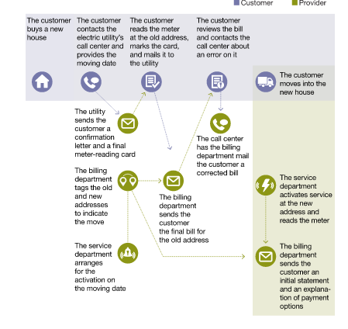
Figure 7: Consumer journey map
(Source: mckinsey.com, 2022)
The essentials of consumer touch points to the consumer's journey have the potential to alter brand loyalty with the specific brand on a significant basis (Koussaifi et al. 2020). The consideration of consumer touch points needs to be identified by Vodafone Group Plc to improve the consumer experience in a conceptualized way. Beneficial values of consumer touch point determination are to consider the consumer's experience and use the data to improve the service quality, to obtain more consumer retention. The cataloging process of the different consumer touch points is used by Vodafone Group Plc to determine the satisfaction level by using the provided services and products.

Explanation of a customer journey map for the organization
Customer Journey Map | Awareness | Discover | Purchase | Uses | Broader perspectives
Website | Pop-ups in internet | services from Vodafone Group Plc and comparing with other companies | Purchasing in terms of discount or cheap price | Utilisation of services | Referring to friends and family.
Store | Walk- in | Different services at different prices. | Purchases based on offer | The implication of service | Repeating purchase of service
Call center | Receiving promotional calls | Consideration of the given offer | Purchases depending on benefits | Utilization service at discounted price | Considering the offer with the expectation
Facebook | Promotional add | Comparison with other offers | Decision-based on comparison | Implying the services as per expectation | Forwarding to other friends
Web Form | Organic search result | Comparison with other companies | Purchase based on anticipation | Consideration of reliability | Indirect promotion to friends
Word of mouth | Referral from friend | Differentiating from other offers | Consideration based on credibility | Using the services | Referring to more friends
Email | Online email campaign | Evaluation of services based on effectiveness | Based on discount | The implication of the expectation | Further purchase
Post | Social media post from a friend | Comparison with other companies to validate the discount | Purchase | Consideration of repeating the service | Forwarding friends

Table 1: Consumer Journey Map
(Source: Created by author)

Total Engagement Model
Determination of customer journey is addressed to be important in terms of knowing the right engagement pattern. Relationships can be effectively justified along with the engagement model determination. In the words of Hapsari et al., (2020), it is addressed that the total engagement model is addressed to be a plan that describes collaboration between customers and vendors during the time of operational prospect. In the operational aspect of Vodafone, it is addressed that there are three different aspects involved including Customer, organization, and employees.
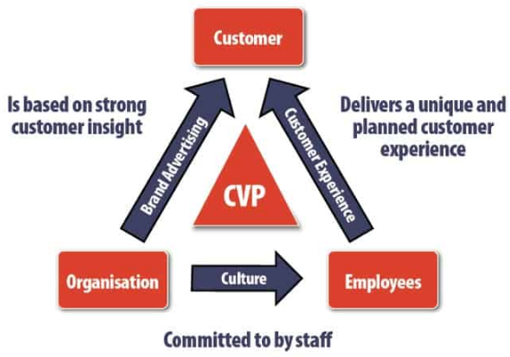
Figure 8: Total Engagement Model
(Source: Gupta and Han, 2021)
Based on the figure above, it is addressed that the use of the total engagement model is effective as the procedure ensures effective promises to maintain quality in brand production. The study by Potdar et al., (2018), it is addressed that cultural determination is effectively required in between organizational and employee relationships in terms of work. A proper reward-based approach is necessary to be set equally for employees working in Vodafone in terms of increasing the motivational aspect.

Recommendations
Vodafone requires some strategic modifications in its management to survive amidst the tough competition in the market. And these changes must begin right from the organizational level because then only the employees can perform better which shall ultimately lead to a great customer experience and enhancing brand identity. The prime suggestion for Vodafone is to ensure that its services of voice and data are of premium quality as the brand must be delivering what it is meant for (Rizomyliotis et al., 2020). Apart from it, telecom operators such as Vodafone must have a such organizational structure that provides room for innovation by supporting its employees in every possible way and even investing funds in it.
One easy way to grab the attention of customers and increase sales is to provide better services at better prices than others in the market. Marketing has a vital role to play and therefore managing its marketing strategies appropriately is quite an essential part that Vodafone can emphasize. Marketing its services and keeping people updated on offers and newly added services is helpful to expand the business and can all be done by communicating with the customers who are already established as well as the potential ones. Hence, for an organization, it is very essential to remain connected with its targeted populace and for those effective communications need to be in place. Also, email marketing and social media marketing are important ways of marketing these days so the organization must put extra effort into advertising through these mediums and increase its brand awareness.

Conclusion
Marketing is addressed to be an important concept for an organization in terms of having reach to the customers. On the other hand, the management of an organization needs to be specific in terms of working efficiently along with appropriate structure and style. In the study, it is addressed that the use of the Vodafone company is chosen in terms of determining its operational efficiency in a competitive market. Based on the study, it can be concluded that communication patterns are very important for an organization in terms of sharing information efficiently. On the other hand, the use of a specific model can be involved in an organization in terms of having an effective pathway to satisfy consumers efficiently. In the organizational process of Vodafone, it is addressed that an effective integrated communication process is used in the marketing context. the company is addressed to be one of the leading businesses. Therefore, awareness is necessary to be derived effectively in terms of addressing an efficient service approach. In Vodafone, the use of an effective model and framework can be addressed that helps in providing appropriate competition to the competitors present in similar industries.

References
Akyurt, N., (2018). Determination of the communication skills of university students by sociodemographic features. In SHS Web of Conferences (Vol. 48, p. 01056). EDP Sciences.
Alamy.com, (2022). Integrated marketing communication. Available on: 12th August 2020, by https://www.alamy.com/stock-photo/integrated-marketing-communication.html
Ali, A.A.H., Nazarov, A.D. and Kondratenko, I.S., (2020), May. The Role of Advertising in the Organization of Digital Marketing Concept. In 2nd International Scientific and Practical Conference “Modern Management Trends and the Digital Economy: From Regional Development to Global Economic Growth” (MTDE 2020) (pp. 31-41). Atlantis Press.
Communicationtheory.org, (2022). Shannon and Weaver Model of Communication. Available on: 12th August 2020, by https://www.communicationtheory.org/shannon-and-weaver-model-of-communication/
Duralia, O., (2018). Integrated marketing communication and its impact on consumer behavior. Studies in Business and Economics, 13(2), pp.92-102.
Gamage, A.N., (2022). Importance of Effective Communication to Minimize Disputes in Construction Projects. Sch J Eng Tech, 7, pp.128-140.
Gupta, P. and Han, C., (2021). Aggregated Customer Engagement Model. arXiv preprint arXiv:2108.07872.
Gurvitš-Suits, N.A. and Lvova, A.L., 2021. Importance of Integrating SDGs Into Business Process by Telecommunication Operators: Opinion of Estonian Customers. European Integration Studies, (15), pp.221-230.
Hapsari, R., Hussein, A.S. and Handrito, R.P., (2020). Being fair to customers: A strategy in enhancing customer engagement and loyalty in the Indonesia Mobile Telecommunication Industry. Services Marketing Quarterly, 41(1), pp.49-67.
Kharouf, H., Biscaia, R., Garcia-Perez, A. and Hickman, E., (2020). Understanding online event experience: The importance of communication, engagement, and interaction. Journal of Business Research, 121, pp.735-746.
Khikhadze, L., (2020). Advantages of integrated marketing communications and synergic effect in global business development. In World economy and international economic relations (Vol. 3, pp. 26-28).
Koussaifi, H., Hart, D.J., and Lillystone, S., (2020). Customer complaint journey mapping: a qualitative approach. British Food Journal, 122(12), pp.3711-3726.
Lindén, E. and Wedebrand, M., (2018). Disrupting Leadership: A study of how digitalization can be disrupting communication channels and the effect it could have on organizational effectiveness.
mckinsey.com. (2022). " From touchpoints to journeys: Seeing the world as customers do " Available at: https://www.mckinsey.com/business-functions/growth-marketing-and-sales/our-insights/from-touchpoints-to-journeys-seeing-the-world-as-customers-do, [Accessed on: 12.08.22]
Oluwafemi, O.J. and Adebiyi, S.O., (2018). Customer loyalty and integrated marketing communications among subscribers of telecommunication firms in Lagos Metropolis, Nigeria. Journal of Competitiveness, 10(3), p.101.
Potdar, V., Joshi, S., Harish, R., Baskerville, R. and Wongthongtham, P., (2018). A process model for identifying online customer engagement patterns on Facebook brand pages. Information Technology & People.
Radovic Markovic, M. and Salamzadeh, A., (2018). The importance of communication in business management. In Radovic Markovic, M., & Salamzadeh, A.(2018). The Importance of Communication in Business Management, The 7th International Scientific Conference on Employment, Education and Entrepreneurship, Belgrade, Serbia.
Rizomyliotis, I., Poulis, A., Apostolos, G., Konstantoulaki, K., & Kostopoulos, I. (2020). Applying fcm to predict the behavior of loyal customers in the mobile telecommunications industry. Journal of Strategic Marketing, 28(1), 1-15.
Shariq, M., (2018). Brand equity dimensions-a literature review. International Research Journal of Management and Commerce, 5(3), p.312.
Siddik, S.M. and Azamti, B.N.A., (2019). Application of Shannon Weaver's Communication Model in Reducing Anxiety in the Elderly in the Perempuan Public Health Center Working Area, West Lombok District. Jurnal Ilmiah Keperawatan Indonesia [JIKI], 2(2), pp.1-15.
Stukalina, Y. and Pavlyuk, D., (2021). Using customer-based brand equity model in the higher education context: simulating the current university’s brand. Business, Management and Economics Engineering, 19(2), pp.272-288.
Świtała, M., Gamrot, W., Reformat, B. and Bilińska-Reformat, K., (2018). The influence of brand awareness and brand image on brand equity–an empirical study of logistics service providers. Journal of Economics & Management, 33, pp.96-119.
Tairova, M.S.M., Giyazova, N.B. and Dustova, A.K., (2020). Goal and objectives of integrated marketing communications. Economics, 2, pp.5-7.
Vodafone.com, (2022). Vodafone Group Plc Annual Report 2021. Available on: 12th August 2020, by https://investors.vodafone.com/sites/vodafone-ir/files/2021-05/vodafone-annual-report-2021.pdf
Zhou, Y., Mishra, S., Gligorijevic, J., Bhatia, T. and Bhamidipati, N., (2019), July. Understanding consumer journey using attention-based recurrent neural networks. In Proceedings of the 25th ACM SIGKDD international conference on knowledge discovery & data mining (pp. 3102-3111).

