Leadership and Decision-Making in

Complex Environments

Chisom Evbota - 1807678

Table of Contents

Task 1 – Interview Questions 3
Reference List 4
Task 2 5
Blog Post – Leading in an Uncertain, Volatile Business Environment 5
Reference List 7
Task 3 – Reflection on Class Discussions 10
Reference List 12
Task 4 – My Own Network and Means of Achieving My Goals Within the Network Setting13
13
Reference List 16
Task 5 – Discussions on the Future of Work with Peers 18
Reference list 20
Task 6 22
Slide 2 23
Slide 3 24
Slide 4 25
Reference list 25
Task 7 - The Leadership Model to Solve the Leadership Dilemma 26
Reference list 28
Appendix…………………………………………………………………………...….…...…30

Task 1 – Interview Questions
The dynamism of the current marketplace has instituted the need for agility to ensure businesses can easily adapt to the changing business landscape. A key element that comes up in modern corporate discourse is strategic innovation that presents organisations with the capacity to revolutionise industries – even established ones-to entrench a sustainable competitive advantage (Grant, 2016). That said, an industry expert would present the best perspective on contemporary organisational leadership, and as such, this section will document an interview with Olaf Bongwald, the chief executive officer (CEO) of Valmet Automotive, a producer of modern, cutting-edge automotive products, for major automotive brands including Daimler. A breakdown of the interview, including the questions and responses, is detailed in the appendix section.

Interview Questions with a Corporate Leader
Question 1: Scholars and industry experts have pointed to several trends that are sure to shape the world of work. Some of the core ones reviewed include new behaviours, technology, millennials, mobility, and globalisation (Morgan, 2014 and Oswald et al., 2019). What do you think are the most critical trends, and how can a business equip itself not to be left behind?
Question 2: The issue of inclusion and equality in the workplace continues to polarise society into the majority and the minority who feel oppressed by the majority (Shore et al., 2010 and Alexandra et al., 2021). What do you feel is the way forward regarding inclusion at the workplace?
Question 3: The automotive industry stands out as one that will be most affected by a global shift towards sustainability (Günther, Kannegiesser and Autenrieb, 2015 and Kalaitzi et al., 2019). What is your take on the electrification of the automotive industry, and what are the key success factors in a net-zero emission world?
Question 4: As we wrap up, please outline your greatest leadership dilemma as an executive in the automotive industry (Weller et al., 2018).

Reference List

Alexandra, V., Ehrhart, K.H. and Randel, A.E., (2021). Cultural Intelligence, Perceived Inclusion, and Cultural Diversity in Workgroups. personality and individual differences, 168, pp. 110285.
Grant, R., 2016. Contemporary Strategy Analysis: Text and Cases Edition. 9th ed. John Wiley& Sons.
Günther, H.-O. ., Kannegiesser, M. and Autenrieb, N. (2015). The role of electric vehicles for supply chain sustainability in the automotive industry. Journal of Cleaner Production, 90(2), pp.220–233.
Kalaitzi, D., Matopoulos, A. and Clegg, B., 2019. Managing resource dependencies in electric vehicle supply chains: a multi-tier case study. Supply chain management, 24(2), pp. 256-270.
Morgan J (2014). The future of work, Wiley, New Jersey.
Oswald, F., Behrend, T.S. and Thompson, L.F., 2019. Workforce readiness and the future of work. New York, NY: Routledge.
Shore, L.M., Randel, A.E., Chung, B.G., Dean, M.A., Holcombe Ehrhart, K. and Singh, G. (2010). Inclusion and Diversity in Work Groups: A Review and Model for Future Research. Journal of Management, 37(4), pp.1262–1289.
Weller, S.C., Vickers, B., Bernard, H.R., Blackburn, A.M., Borgatti, S., Gravlee, C.C. and Johnson, J.C., 2018. Open-ended interview questions and saturation. PloS one; PLoS One, 13(6), pp. e0198606.

Task 2


Hurley, 2021

Blog Post – Leading in an Uncertain, Volatile Business Environment
The leader selected for the interview is currently responsible for overseeing a large car manufacturing establishment, employing over 300 staff members (including managers as well). Due to the interview subject's extensive experience in leadership, the individual was deemed qualified to critically discuss the different development paths of leadership in the last 20-30 years and infer the key leadership lessons for the future. Generally, a sense of business stability is no longer a viable future of the environment, as both leaders and followers operate in a volatile business environment (Darcy, Kleiner, 1991, Nalore‐Winter and Kleiner, 1993). The interviewee specifically mentioned the COVID-19 pandemic as one of the guiding examples to illustrate that even within a matter of weeks (if not days), leaders and followers encounter novel challenges with no clear-cut solution to problems (Kirchner, Ipsen and Hansen, 2021).
In other words, there is a constant "devaluation of best practices" (as said by the interviewee), all pointing to the imperative for practising leaders to exercise a great level of situational awareness and behavioural flexibility to offer the necessary degree of support for followers, and at the same time, sustain operations (Prange, 2016, Snowden and Boone, 2007). Since car manufacturing units continued to operate as expected, leaders were pressured to act as key figures and set direction in a turbulent business environment (Tverdola, 2018).

The uncertain future of work and the potential risk of marginalisation of vulnerable workers in the age of automation are other sources of leadership dilemmas (Prat, 2007). Car industry manufacturers near-autonomous production lines serve as prima facie evidence behind technology's displacement effect and unemployment's rapid rise (even if temporary). The phenomenon can be particularly damaging for low-skilled and unskilled workers with minimal upskilling opportunities and means of achieving relevant qualifications to improve employability (Kim, Kim and Lee, 2017). While it might be slightly premature to draw conclusions on technological unemployment in the wake of the pandemic, there are several warning examples and proof that many manual jobs can be replaced at a much faster pace than initially expected (Coombs, 2020). For example, many organisations are now considering the implementation of fully automated order-picking systems. These systems can operate 24/7, and on the longer-term horizon (not accounting for the immense up-front cost of technology acquisition), there is a clear commercial rationale behind using robotic technologies (Michalos et al., 2010). On the other side of the argument, millions of jobs can be lost within a relatively short amount of time, further reinforcing the unequal distribution of wealth and the stratification of society) (Vámos, 2009). the solution is yet to be attained, and with the current pace of automation, the world will soon experience immense tensions and conflicts, many of which could even culminate "in adverse global tensions" and a very uncertain future ahead for leaders. The growing pressure of ethics on leaders to approximate a good balance between organisational priorities (e.g., returns on investment) and societal value creation is also part of the contemporary dilemma (Waldman, Siegel and Javidan, 2006). Putting it differently, the fundamental dilemma for leaders in the 21st century is to commit to decisions today that do not in any way compromise the well-being of future generations (Friedman, 2020 and Morgan, 2014).

The interview subject also mentioned ethical leadership as "perhaps one of the most pressing issues in the 21st century" to ensure that solutions enacted for the future problem do not in any way contradict long-term interests (and the same logic would apply in a reverse fashion). More precisely, the leader added that cultivating an innovative and collaborative work climate is a prerequisite to fair and equitable leadership behaviour in the future ahead, existing at a delicate point of balance between different stakeholder groups (Oke, Munshi and Walumba, 2009). In the immediate context of the car manufacturing industry, such endeavours include a shift and effective move towards emission-free mobility, part of a new long-term organisational vision. To realise these goals, collective efforts are going to be indispensable to together address dilemmas and concerns existing at the confluence of social and business value creation in the 21st century (Lautermann, 2013). The synthesis of the interview findings with the broader literature on contemporary leadership dilemmas shows several commonalities in the ideas expressed from the case organisation and the macro forces shaping organisations' existence and the adequacy of the leadership styles adopted in a VUCA world.

Reference List
Coombs, C. (2020). Will COVID-19 be the tipping point for the Intelligent Automation of work? A review of the debate and implications for research. International Journal of Information Management, 2(3), pp.102–128.
Darcy, T. and Kleiner, B.H. (1991). Leadership for Change in a Turbulent Environment. Leadership & Organization Development Journal, 12(5), pp.12–16.
Friedman, H.H. (2020). Organisational Agility, Visionary Leadership in the Age of VUCA. SSRN Electronic Journal, 1(2).
Hurley (2021). Net zero: Environmental leadership or pointless virtue signalling? [online] www.linkedin.com. Available at: https://www.linkedin.com/pulse/net-zero-environmental-leadership-pointless-virtue-peter-j-hurley/ (Accessed: 22 October 2021).
Kim, Y.J., Kim, K. and Lee, S. (2017). The rise of technological unemployment and its implications on the future macroeconomic landscape. Futures, 87(4), pp.1–9.
Kirchner, K., Ipsen, C. and Hansen, J.P. (2021). COVID-19 leadership challenges in knowledge work. Knowledge Management Research & Practice, 2(3), pp.1–8.
Lautermann, C. (2013). The ambiguities of (social) value creation: towards an extended understanding of entrepreneurial value creation for society. Social Enterprise Journal, 9(2), pp.184–202.
Michalos, G., Makris, S., Papakostas, N., Mourtzis, D. and Chryssolouris, G. (2010). Automotive assembly technologies review: challenges and outlook for a flexible and adaptive approach. CIRP Journal of Manufacturing Science and Technology, 2(2), pp.81–91.
Morgan J (2014). The future of work, Wiley, New Jersey.
Nalore‐Winter, C.R. and Kleiner, B.H. (1993). Effective leadership in a turbulent environment. Work Study, 42(2), pp.16–19.u
Oke, A., Munshi, N. and Walumba, F.O. (2009). The Influence of Leadership on Innovation Processes and Activities. Organizational Dynamics, 38(1), pp.64–72.
Prange, C. (2016). Engaging with complex environments: why agility involves more than running hard. International Journal of Complexity in Leadership and Management, 3(3), pp.182–200.
Prat, J. (2007). The impact of disembodied technological progress on unemployment. Review of Economic Dynamics, 10(1), pp.106–125.
Snowden, D. and Boone, M. (2007). A Leader's Framework for Decision Making. [online] Harvard Business Review. Available at: https://hbr.org/2007/11/a-leaders-framework-for-decision-making (Accessed: 20 October 2021).
Tverdola, N. (2018). Leadership and Leadership Development Tools in a Vuca World. Management of the Personnel and Intellectual Resources in Russia, 7(6), pp.14–18.
Vámos, T. (2009). Social, Organizational, and Individual Impacts of Automation. Springer Handbook of Automation, 3(2), pp.71–92.
Waldman, D.A., Siegel, D.S. and Javidan, M. (2006). Components of CEO Transformational Leadership and Corporate Social Responsibility. Journal of Management Studies, [online] 43(8), pp.1703–1725. Available at: https://onlinelibrary.wiley.com/doi/10.1111/j.1467-6486.2006.00642.x.

Task 3 – Reflection on Class Discussions
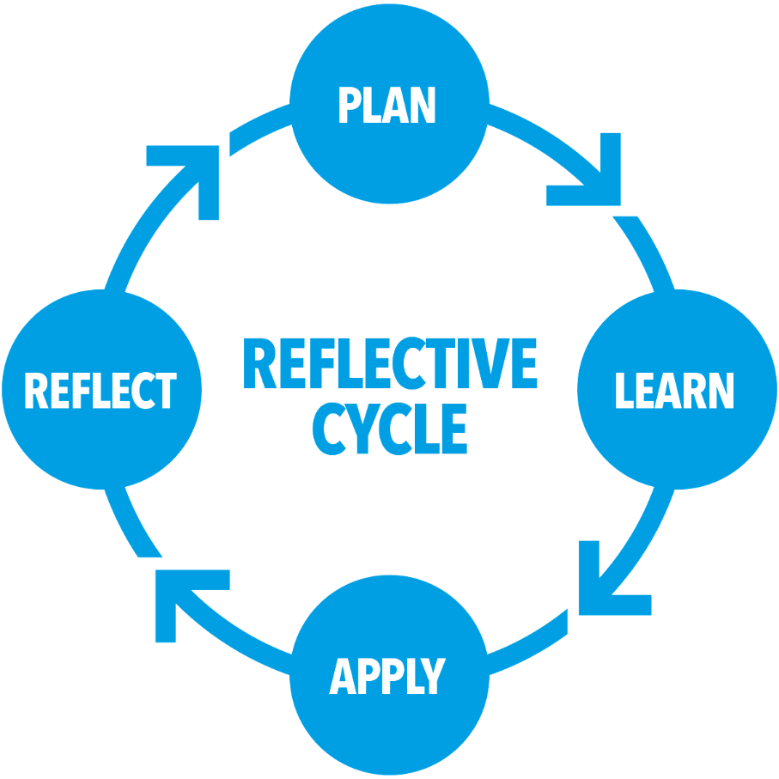

One of the most edifying aspects of the module included intensive dialogues with other learners (i.e. peers) on their own, self-constructed ideas of leadership, which is the by-product of the sensemaking process (Weick, 1995; Decker, 1998 and Basbøll, 2010). Personally, it was intriguing to assess and access those aspects of leadership that were the product of cultural differences (Chhokar et al., 2012). Students from other parts of the world maintained quite different conceptualisations of effective leadership since values, beliefs, and assumptions are culturally infused (Offermann and Hellmann, 1997; Anand et al., 2018). Henceforth, the exemplary leadership style and the accompanying leadership dilemma is not part of a single conceptualisation. Initially, I had a sense of being overwhelmed with the differences, as I mistakenly assumed that my position on leadership challenges would be at least somewhat identical to that of my peers.

Candidly, I experienced a loss of self-confidence, although the supportive discussions with Upon discussing talent sourcing strategies and recruitment raised the concern of leaders and hiring managers automatically linking work competencies to the education obtained, potentially at the very expense of holistically considering candidate profiles (Hora, 2019 and Balcar, 2016). Some other students shared my position, whilst others argued that even if there is validity in my point, they advised that it would be a mistake to discount educational attainments and therefore the viable solution would be to factor a range of different candidate profiles when making hiring decisions.

Social networks and the communication of ideas exist at the intersection of actors and technology and thus, any phenomena can be explained by transactions and exchanges occurring within these networks (Mulcahy and Perillo, 2011). In other words, any social idea and the accompanying perspectives are the products of non-human and human interaction, which constitutes one of the basic foundations of modern sociology and insightful leadership research, all that create a network of human, non-human and technical members (Latour, 2005). In more direct terms, if leaders want to effect change either in the work environment or elsewhere, it is paramount to alter the network itself, develop new connections, and fortify those correspondences that are deemed necessary in terms of achieving the pre-set change objectives (Latour, 2005). In addition, the theory helped to articulate a core idea to support the identified leadership challenge and the necessity of looking at the issue from a much broader perspective to appreciate the complex interactions taking place in the socio-technological environment (Latour, 2007; Bruni and Teli, 2007). Namely, to understand reality, a purely humanistic/social view is unlikely to be sufficient to guarantee that leadership outcomes serve both current and future demands. This insight is particularly astute to discussions on technological unemployment and the accompanying stakeholder-sensitive leadership behaviour (Fenwick, 2010).

Reference List
Anand, S., Vidyarthi, P. and Rolnicki, S., (2018). Leader-member exchange and organizational citizenship behaviors: Contextual effects of leader power distance and group task interdependence. The Leadership quarterly, 29(4), pp. 489-500.
Balcar, J., (2016). Is it better to invest in hard or soft skills? The economic and labour relations review : ELRR, 27(4), pp. 453-470.
Basbøll, T., (2010). Softly constrained imagination: Plagiarism and misprision in the theory of organizational sensemaking. Culture and organization, 16(2), pp. 163-178.
Bruni, A. and Teli, M., (2007). Reassembling the Social—An Introduction to Actor Network Theory. London, Los Angeles, New Delhi and Singapore: Sage Publications.
Chhokar, J.S., Brodbeck, F.C., House, R.J. and And, L. (2012). Culture and leadership across the world : the GLOBE book of in-depth studies of 25 societies. New York: Routledge.
Decker, C.A., 1998. Sensemaking in organizations, by K. E. Weick. (1995). Thousand Oaks, CA: Sage. 321 pp., $44.00 cloth, $19.95 paper. San Francisco: Wiley Subscription Services, Inc., A Wiley Company.
Fenwick, T. (2010). un(Doing) standards in education with actor-network theory. Journal of Education Policy, 25(2), 117–133. doi:10.1080/02680930903314277
Hora, M.T., (2019). Hiring as cultural gatekeeping into occupational communities: implications for higher education and student employability. Higher education, 79(2), pp. 307-324.
Latour, B., (2005). Reassembling the social : an introduction to actor-network-theory. Oxford: Oxford University Press.
Latour, B., (2007). Reassembling the social : an introduction to actor-network-theory. Oxford: Oxford University Press.
Mulcahy, D. and Perillo, S., (2011). Thinking management and leadership within colleges and schools somewhat differently : a practice-based, actor-network theory perspective. Educational management, administration & leadership, 39(1), pp. 122-145.
Offermann, L. R., and Hellmann, P. S. (1997). Culture’s consequences for leadership behavior: National values in action. Journal of Cross-Cultural Psychology,28(3), 342– 351
Weick, K.E. (1995). Sensemaking in organizations. Thousand Oaks: Sage Publications

Task 4 – My Own Network and Means of Achieving My Goals Within the Network Setting

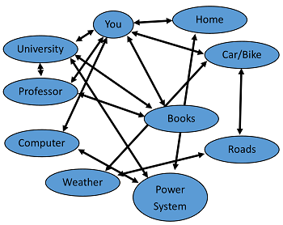
Adapted From Latour (2007)

Another outcome of the module with many practical implications includes my ability to understand the influence of my own network on my personal developmental goals and achieve desired changes (e.g. career objectives and research topics) (Callon, 1999). As per the actor-network theory, one proven way is to effect change in my personal circumstances. In this regard, the network is the first point of analysis to understand those factors that may need be altered (Michael, 2017). The figure on the next page illustrates my network, and the ensuing discussion reveals weaknesses, strengths, and options to strengthen my network across boundaries.

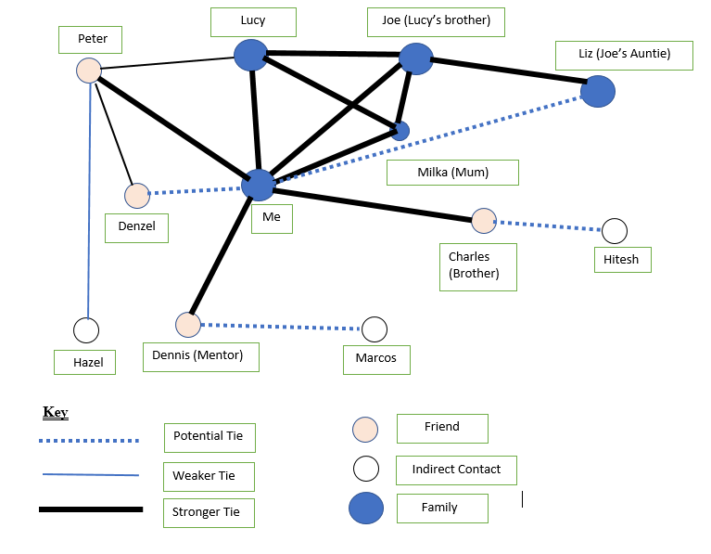
Figure 1 – My Personal Network Diagram
In the network diagram above, I have outlined the relationships between actants. At first sight, I can clearly deduce that my network incorporates many potentially supportive individuals (new acquaintances from the DBA course), although my relationship with mediators (e.g. mentors and other acquaintances) may need to be strengthened. According to Latour (2007) (the mastermind behind ANT), any social phenomenon is the consequence of the connections between actors, so instead of exclusively focusing on the (vaguely defined) social dimension, it is recommended to analyse networks. I found Law's (1992) commentary on the ANT as highly edifying and revealing the influence of patterned networks (of heterogeneous materials) surrounding anyone with an imprinting effect on one's identity. Henceforth, in order to conceptualise my own identity, it is vital to constantly refer back to my network and assess ways of altering relationships, including human and non-human actors (including technology). Hodder's (2014) elaboration of the entanglement of humans and things (i.e. technology) enlightened the centrality of ANT theory. In retrospect, it would be beneficial to expand the visualisation of my network to illustrate the co-dependency between personal choices and the (technological) environment in which these decisions transpire. Professional networking and the use of different networks may be immensely helpful in achieving my DBA research objectives and to ensure that I constantly seek new ways of advancing my career and professional growth.

The ANT is also a suitable methodological framework (or process) for outlining a research problem and to pre-emptively cogitating the links between human and non-human actants. The process consists of four key elements, which include problematisation, interessment, enrolment and mobilisation (Callon, 1999). Emission issues in the car manufacturing industry have long been a pressing problem, and although there appears to be a narrative around reforming the industry and switching to zero-emission engine solutions, progress has been somewhat slow (Rydin, 2012). Through the ANT framework, I can better conceptualise the research problem and eventually find an optimal solution. First, by charting the different competing interests, the driving and the restraining forces of change can be precisely identified to highlight the necessary changes to be induced into the network (Cameron, Green and Ebrary, 2012). Second, in the interessment phase (Latour, 2007), change agents commence negotiations with other actants in the network to demonstrate how a quest towards greener mobility is in the long-term interest of the majority of stakeholders. In the third phase (enrolment), actants accept new roles and eventually start contributing to the new vision (Latour 2007). Needless to say, in the said negotiations, it is vital to account for technological and non-technological actants (e.g. user acceptance and the long-term viability of zero-emission engine technologies).

Reference List
Callon, M. (1999). Actor-Network Theory—The Market Test. The Sociological Review, 47(1), pp.181–195.
Cameron, E., Green, M. and Ebrary, I. (2012). Making sense of change management : a complete guide to the models, tools, and techniques of organizational change. London: Kogan Page.
Hodder, I. (2014). The Entanglements of Humans and Things: A Long-Term View. New Literary History, 45(1), pp.19–36.
Latour, B. (2007). Reassembling the social : an introduction to actor-network-theory. Oxford: Oxford University Press.
Law, J. (1992) 'Notes on the Theory of the Actor Network: Ordering, Strategy and Heterogeneity ', Available at: https://www.lancaster.ac.uk/fass/resources/sociology-online-papers/papers/law-notes-on-ant.pdf (Accessed: 17 October 2021).
Michael, M. (2017). Actor-Network Theory: Trials, Trails and Translations. United States: Sage Publications Ltd.
Rydin, Y. (2012). Using Actor–Network Theory to understand planning practice: Exploring relationships between actants in regulating low-carbon commercial development. Planning Theory, 12(1), pp.23–45.

Task 5 – Discussions on the Future of Work with Peers

Gibbs (1988)
Description and Feeling
Being a naturally conflict-averse person, this task appeared at first sight intimidating, and candidly, I was a little apprehensive to openly share my ideas, despite my particular interest in the chosen topic (high level machine learning and the use of AI (Artificial Intelligence) (Wright and Schultz, 2018). Upon members introduced their own ideas, I think members gained more confidence in articulating diverse opinions. In this section, I broadly follow Gibbs’ (1988) reflective cycle.
Evaluation and Analysis
The management interview which I conducted under tasks 1 and 2 also drew upon the challenges of opportunities of the entrenchment of technology in the modern workplace. Some course members stated that there is a radical shift approaching the idea of management, with a resulting impact leading to the dehumanisation of work experience (Todolí-Signes, 2021 and (Gulcu, 2020). I partly agree with this statement, but I would also maintain that irrespective of the pace of technological advancement, there are likely to be several, remaining decision-making scenarios were technology and robots might fall short of human decisions. The discussion board also agreed that in order for societies at large to benefit from technology if critical, non-routine decisions are retained as a managerial duty, particularly those affecting humans and perhaps vulnerable external stakeholders to the organisation. One that I mentioned the role of ethics and the deployment of soft interpersonal skills.
Conclusion and Action
At some hypothetical point in the future, technology and AI may indeed reach a point of maturity where decisions are even more sophisticated (Vorobeychik and Kantarcioglu, 2018). Nevertheless, it would be a leadership shortcoming to delegate all critical decisions to algorithms. To support my position, I cited the cases of big-tech firms (e.g. Facebook) and the influence thereof on societies (Hussain et al., 2021). There are severe accusations that Facebook's feed algorithm inadvertently promoted and disseminated fake news, leading to the misinformation of a larger share of society (Landon-Murray, Mujkic and Nussbaum, 2019). Whilst AI is indeed becoming more and more capable, the discussion forum members agreed that some human oversight is necessary as AI systems do not have an 'intrinsic' value system to evaluate whether a specific action is either socially beneficial or not (Echeverría and Tabarés, 2016). That is, some managerial intervention will always be needed. Instead of thinking about how robots can replace manual workers, it may be more beneficial to concentrate on actionable means to maximise the technology-human collaboration to produce the best possible societal outcome both in the short term- and the long-term.

The debate then also covered the future conceptualisation of management and leadership in a technology-infused environment (Martı́nez-Miranda and Aldea, 2005). Personally, my belief is that leaders under all conditions shall maintain resilience, and with an ever-shortening time spent in 'normal' phases, crisis leadership becomes part of every professionals' life in a complex network of different stakeholders (O'Reilly et al., 2015). During the discussion, I also found it exceptionally edifying to learn about different interview subjects to compare and contrast leadership approaches across different industry settings. For example, Mr. Eddie's compassionate and caring leadership style (Tomkins and Simpson, 2015) pointed to the leadership imperative to place equitable attention to the people and task orientation of leadership. On the one hand, there remains the objective for leaders to maximise organisational performance and to create shareholder value. On the other hand, leadership output is the function of follower and leader synergies (Kean et al., 2011), and irrespective of the vision and its match with external demands of the organisation, leadership remains fundamentally about inculcating and sustaining motivation among followers. In the future, I will need to be more considerate of different viewpoints, and instead of assuming my idea is the only viable route to leadership, I have to demonstrate more openness to other suggestions, too.

Reference list
Echeverría, J. and Tabarés, R. (2016). Artificial Intelligence, Cybercities and Technosocieties. Minds and Machines, 27(3), pp.473–493.
Gibbs, G. (1988). Learning by doing: a guide to teaching and learning methods. Oxford: Oxford Further Education Unit.
Gulcu, T.Z. (2020). What If Robots Surpass Man Morally? Dehumanising Humans, Humanising Robots in Ian McEwan" s Machines Like Me. International Journal of Languages, Literature and Linguistics, 6(4), pp.177–182.
Hussain, A., Tahir, A., Hussain, Z., Sheikh, Z., Gogate, M., Dashtipour, K., Ali, A. and Sheikh, A. (2021). Artificial Intelligence–Enabled Analysis of Public Attitudes on Facebook and Twitter Toward COVID-19 Vaccines in the United Kingdom and the United States: Observational Study. Journal of Medical Internet Research, 23(4), p.e26627.
Kean, S., Haycock, E., Baggeley, S. and Carson, M. (2011). Followers and the co-construction of leadership. Journal of Nursing Management, 19(4), pp.507–516.
Landon-Murray, M., Mujkic, E. and Nussbaum, B. (2019). Disinformation in Contemporary U.S. Foreign Policy: Impacts and Ethics in an Era of Fake News, Social Media, and Artificial Intelligence. Public Integrity, 21(5), pp.1–11.
Martı́nez-MirandaJ. and Aldea, A. (2005). Emotions in human and artificial intelligence. Computers in Human Behavior, 21(2), pp.323–341.
O'Reilly, D., Leitch, C.M., Harrison, R.T. and Lamprou, E. (2015). Leadership, authority and crisis: Reflections and future directions. Leadership, 11(4), pp.489–499.
Todolí-Signes, A. (2021). Making algorithms safe for workers: occupational risks associated with work managed by artificial intelligence. Transfer: European Review of Labour and Research, 1(2), p.102425892110350.
Tomkins, L. and Simpson, P. (2015). Caring Leadership: A Heideggerian Perspective. Organisation Studies, 36(8), pp.1013–1031.
Vorobeychik, Y. and Kantarcioglu, M. (2018). Adversarial Machine Learning. Synthesis Lectures on Artificial Intelligence and Machine Learning, 12(3), pp.1–169.
Wright, S.A. and Schultz, A.E. (2018). The rising tide of artificial intelligence and business automation: Developing an ethical framework. Business Horizons, 61(6), pp.823–832.

Task 6

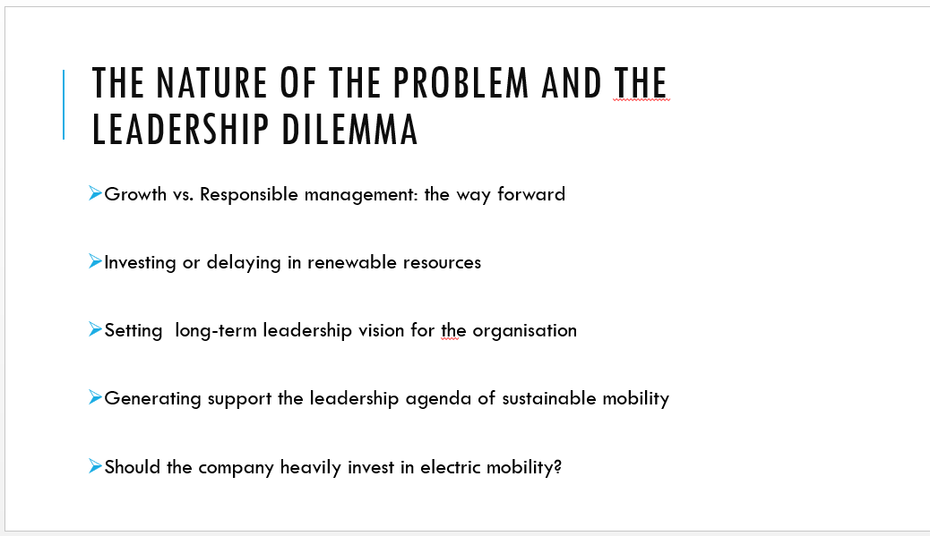
There is no question on the inevitability of reforming the car industry, and the interview with the leader (Mr. Olaf) has also confirmed pending challenges. In sum, the leadership dilemma involves the need to balance corporate growth with broader stakeholder demands for cleaner mobility. That is, leaders in polluting industries must set a compelling vision to mobilise resources and to generate a sufficient degree of commitment from followers to support the vision, otherwise, leadership efforts are unlikely to culminate in measurable success (Davies, 2007). More specifically, the company is at a critical decision point to determine its future strategic direction. The presentation applies two course concepts to outline the perimeters of the dilemma at hand and to advise the management team on systematically proceeding until a solution is attained. The following two slides apply design thinking and the soft systems methodology to the concept of sustainable mobility and explicate how these decision frameworks may aid leadership in a complex, multi-dimensional work environment.
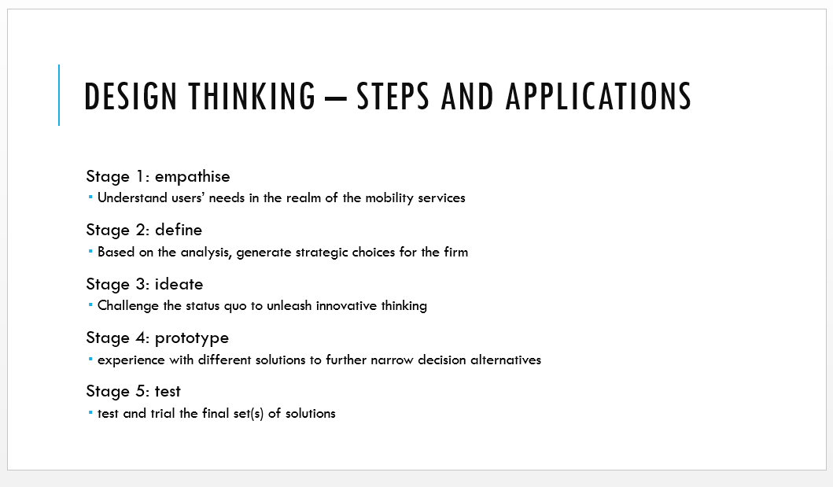
Design thinking is an iterative, structured decision-making tool for leaders (Luchs, Swan and Griffin, 2016). The principal benefit of this decision-making tool is that the model looks at the different aspects of the problem, thus increasing the probability of finding a solution that is most likely to satisfy different needs. On the slide, the five discreet stages of design thinking are described, although further application of the concept to the interview setting reveals more practical aspects of the tool. The company is already in the empathise phase. There is already a solid recognition of the problem, and creative decision-making has already commenced whilst the solution is far from being fully defined (Monahan, 2018). In order to improve the process of decision-making, it is paramount to instil creative and innovative thinking and to test different ideas (e.g. the dilemma between plug-in electric and fully electric vehicles). Assuming the management and the team of developers follow these stages, the company will have approximated a final list of solutions with a long-term impact on stakeholders and company profitability. Irrespective of the actual solution, it is paramount to attain a close balance between organisational and broader stakeholder needs.

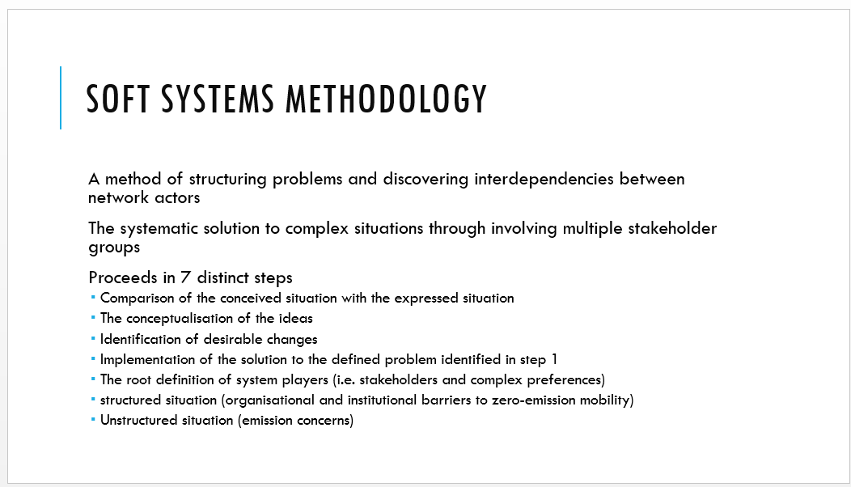
The Soft Systems Methodology (SSM) was elected for two key reasons (Wilson, 2015). First in a business environment with several sources of uncertainty, the SSM is perhaps the best situated to solve a complex problem in a multi-stakeholder environment. Second to this, the model integrates the real world and the system world (i.e. the linkages between different factors and stakeholders) (Ebrahimi, 2020). The slide shows the 7-steps, but perhaps it is essential to spend more words on the formulation of basic definitions (i.e. the actors and the stakeholder with the highest degree of influence on attaining the solution), as well as the actual process of transformation (i.e. transitioning to greener mobility). The SSM once combined with design thinking decouples highly complex systems into manageable segments to inform tactical decisions of the firm and leaders to maximise decision output.

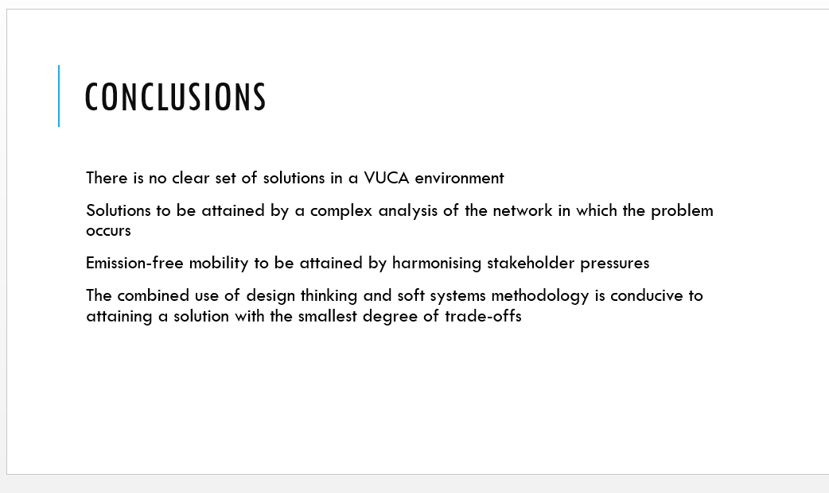

Finally, there are some conclusions to be made from the analysis. Both design thinking and the SSM are foundational frameworks for complex decisions. The enlistment of the different stakeholder priorities and industry dynamics all have to be factored into the decision-making sequence to solve the leadership dilemma.

Reference list
Davies, B. (2007). Developing sustainable leadership. Management in Education, 21(3), pp.4–9.
Ebrahimi, M. (2020). Applications of soft systems methodology for organizational change. USA: Hershey.
Luchs, M., Swan, S. and Griffin, A. (2016). Design thinking : new product development essentials from the PDMA. Hoboken, New Jersey: Wiley.
Monahan, K.A. (2018). How behavioral economics influences management decision-making : a new paradigm. London, United Kingdom: Academic Press, An Imprint Of Elsevier.
Wilson, B. (2015). Soft systems thinking, methodology and the management of change. Translated by K. Haperen. London: Palgrave.

Task 7 - The Leadership Model to Solve the Leadership Dilemma
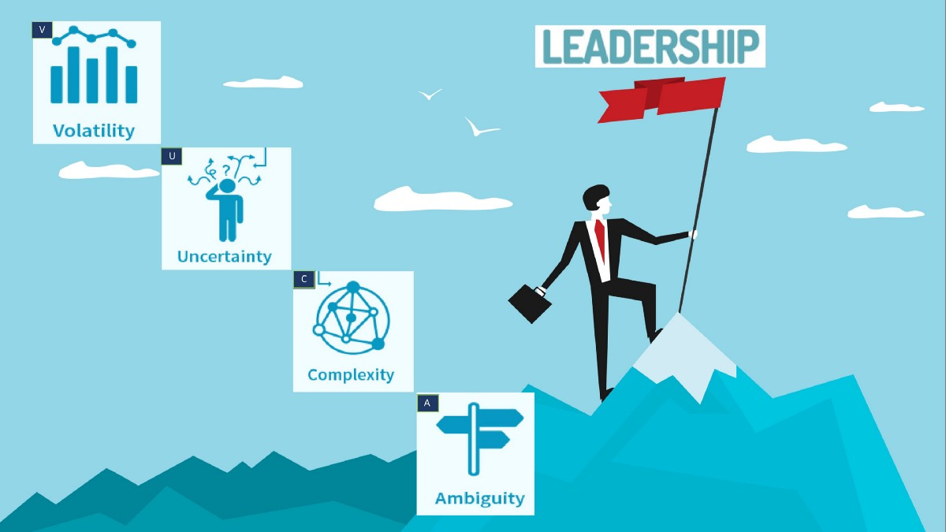
Kalaria (2020)

Leading and managing in the 21st entails many unforeseen and unprecedented challenges. Leadership research in the early 20th century and subsequent empirical studies either published before or at the dawn of globalisation have all served professionals' foundational understanding of the central construct of leadership (Darcy and Kleiner, 1991). A key (not always explicitly noted) limitation of leadership theories is that irrespective of the robustness of leadership models, there appears to be deficient attention delegated to the dynamic environment (DeRue, 2011). Adaptive and contingency leadership theories emphasise the instrumentality of a flexible approach to leadership based on the situation and follower readiness (Heifetz et al., 2009: Bagwell, 2020), whilst transformational/authentic leadership places mutually beneficial, intrinsic relationships at the foundation of leadership success (Bass and Riggio, 2006). However, it is uncertain from these models how adaptive leadership can be realised, practised and developed, against a background of diverse stakeholder pressures (Obolensky, 2016). From another point of view, leadership theories seem somewhat fragmented – uniting different (cross-disciplinary) aspects of the challenges and dilemmas of leadership is thus a timely endeavour.

The leadership dilemma deciphered from the leader interview is the competing priorities for stability and flexibility (Joiner, 2019). Firms, irrespective of the industries served, must nurture internal capabilities of agility and change to manage and influence interactions between different agents. Simultaneously, leaders are no longer the only actors to effect change; rather, the goal is to develop resilience at all levels of the organisation to facilitate sustainable and ethical business decisions (Burnard and Bhamra, 2011). The latter part is best evinced by the extensive body of literature on servant leadership (Houben, 2013), further implying the impeding role for strategic leaders to support followers in navigating the VUCA environment.

With the shortening strategic planning horizon, those leaders capable of amplifying the first sights of disruptions will prosper; accordingly, proactivity is going to be a key leadership trait in leading organisations in a VUCA environment. More specifically, the duty of leaders is to access complex systems, decipher the relationship between different actants, and frame the network towards solutions. Engagement with literature on network theories also underpins the inevitability for leaders to exercise sensemaking and to successfully align followers with a flexible vision (Weick, 1995). Based on the review of academic research and industry publications, I propose a multi-dimensional leadership framework to solve the introduced ethical dilemma and to enable leaders to maintain concurrent focus on different, equally important leadership imperatives in the 21st century.

Figure 2 – The New Proposed Model of Leadership (Created)

Reference list
Bagwell, J. (2020). Leading Through a Pandemic: Adaptive Leadership and Purposeful Action. Journal of School Administration Research and Development, 5(S1), pp.30–34.
Bass, B.M. and Riggio, R.E. (2006). Transformational Leadership. 2nd ed. New York. ; Hove: Routledge.
Burnard, K. and Bhamra, R. (2011). Organisational resilience: development of a conceptual framework for organisational responses. International Journal of Production Research, [online] 49(18), pp.5581–5599. Available at: https://research-portal.uws.ac.uk/en/publications/organisational-resilience-development-of-a-conceptual-framework-f.
Darcy, T. and Kleiner, B.H. (1991). Leadership for Change in a Turbulent Environment. Leadership & Organization Development Journal, 12(5), pp.12–16.
DeRue, D.S. (2011). Adaptive leadership theory: Leading and following as a complex adaptive process. Research in Organisational Behavior, 31(2), pp.125–150.
Heifetz, R. and Grashow, A. and Linsky, M. and (2009). The practise of adaptive leadership. Boston, Mass: Harvard Business Press.
Houben, S. (2013). A Systematic Literature Review of Servant Leadership Theory in Organizational Contexts. CFA Digest, 43(4).
Joiner, B. (2019). Leadership Agility for Organizational Agility. Journal of Creating Value, 2(2), p.231-241.
Kalaria, C. (2020). LEADERSHIP — THE VUCA PERSPECTIVE. [online] Medium. Available at: https://medium.com/@chiragkalaria/leadership-the-vuca-perspective-9a07aa05193b (Accessed: 22 October 2021).
Kalaria, C. (2020). LEADERSHIP — THE VUCA PERSPECTIVE. [online] Medium. Available at: https://medium.com/@chiragkalaria/leadership-the-vuca-perspective-9a07aa05193b (Accessed 22 October 2021).
Obolensky, N. (2016). Complex adaptive leadership: embracing paradox and uncertainty. United States: Routledge.
Weick, K.E. (1995). Sensemaking in organisations. Thousand Oaks: Sage Publications.

Appendices

Appendix A

Interview and Transcripts
Interview with a Corporate Leader
Thank you, Mr Olaf, for granting us the audience. We look forward to picking on critical elements that are sure to shape markets in the coming years, especially the manufacturing industry, and how these changes will affect your role as an executive in the industry. If possible, provide a way forward from your perspective.
Interviewer: Scholars and industry experts have pointed to several trends that are sure to shape the world of work. Some of the core ones reviewed include new behaviours, technology, millennials, mobility, and globalisation (Morgan, 2014 and Oswald et al., 2019). What do you think are the most critical trends, and how can a business equip itself not to be left behind?
Mr Olaf: First, I will thank you for the opportunity to present my insights concerning the industry, and especially shifts in the marketplace. I am glad to offer my view on the various issues, and I am very excited to be here. Shifts in the marketplace have been a part of society for ages; there was the industrial revolution whereby those who embraced the tenets of mass production thrived. We are still experiencing reverberations from the information age, in which the shift from the traditional industry to an economy anchored on information technology was entrenched. In the space of a little over a decade, digital technologies have become a mainstay of human civilisation, and due to the influence of these technologies, manufacturing has come full circle, and Industry 4.0 is the current buzzword. That is occurring as manufacturers integrate new technologies, including the Internet of Things (IoT), cloud computing, artificial intelligence (AI), and machine learning, into their production processes (IBM, 2021). Such is the dynamism of the marketplace, which means it is almost impossible to accurately determine how the world will be in a decade from now. The only safety net can be to entrench the agility needed in its value chains to enable it to adapt swiftly to the changing marketplace. That said, effectively harnessing technology to improve operations and internationalising operations stand out as the main approach for remaining competitive in the next decade.
Interviewer: The issue of inclusion and equality in the workplace continues to polarise society into the majority and the minority who feel oppressed by the majority (Shore et al., 2010 and Alexandra et al., 2021). What do you feel is the way forward regarding inclusion at the workplace?
Mr Olaf: Admittedly, as a race, we humans have achieved so much over the past century, and the strides have reverberated around the world, resulting in the phrase – global village. The advances have allowed many to live decent lives, and have a shot at a decent life, a thing that had hitherto been only a dream. That said, many who remain disenfranchised and to whom it would appear that advances experience by others worldwide have not been felt. On this basis, a movement such as the #BlackLivesMatter has emerged to fight for the plight of Black minorities in America. Considering the uptake that the movement received in other parts of the world is indicative of how entrenched the trend is, which puts minority groups at a disadvantage in society. Unfortunately, these practices are not only a preserve of the police conduct, and neighbourhoods – it extends to boardrooms. At Valmet, in full realisation of the scale of the problem, has embarked on an organisational strategy aimed at ensuring inclusion at the workplace. The effects of the initiatives have been a 20 per cent increase in the number of women at the company and becoming one of the most racially diverse automotive manufacturers based on the size of operations. Admittedly, we are only one organisation, but the initiatives of one are in no way muffled regarding instituting change within an industry. That said, more to be done in fostering inclusion at the workplace, even on aspects such as age.
Interviewer: The automotive industry stands out as one that will be most affected by a global shift towards sustainability (Günther, Kannegiesser and Autenrieb, 2015 and Kalaitzi et al., 2019). What is your take on the electrification of the automotive industry, and what are the key success factors in a net-zero emission world?
Mr Olaf: I would say that the writing has been on the wall concerning the need for automotive manufacturers to adopt sustainable modes of propulsion as a way of enabling the move to a net zero-emissions transportation. That said, in a similar way to other industries in the past that have found themselves in a revolution for which they have to adapt or face extinction, the automotive industry has dragged its feet on the issue, and only a handful of manufacturers have pursued the issue of sustainability with real intent. The enactment of the CO₂ emission performance standards for cars and vans by the European Commission has instituted precedence in that auto-manufacturers now have to act or face huge fines for failing to comply with standards. Interestingly, despite prior knowledge of the approaching enforcement, most companies in the automotive industry were seemingly caught unprepared as the EU instituted fleet-wide CO₂ emissions targets of 95g CO₂/km and 147g CO₂/km for cars and vans, respectively. Crucially, these standards are in place, and they will only get stricter with time; thus, it is high time auto-manufacturers committed to zero-emission fleets in the next decade or two. In doing so, the first initiative should be to increase the number of plug-in-hybrids (PHEVs) in their fleets, and that is a speciality field for Valmet, as we are now working with brands such as Daimler in developing their PHEVs. There is also a case for considering alternate fuels for use on the PHEVs that emit fewer grams of CO₂/km than conventional fuels. That should form the foundation for a full fleet of electric vehicles (EVs) by 2035, which will be crucial if they survive in the industry.
Interviewer: As we wrap up, please outline your greatest leadership dilemma as an executive in the automotive industry (Weller et al., 2018).
Mr Olaf: At present, we stand out as a key driver of the PHEVs technology in the automotive industry, and we are only now beginning to reap the benefits of years of extensive research and development, for which there were minimal rewards. Despite their efficiency and cleaner propulsion system compared to the conventional internal combustion engine, PHEVs still do not offer zero-emission transportation that is desirable under the sustainable model that organisations such as the European Commission are pushing. As a result, they might soon be abandoned in favour of full EVs, and therein lies the dilemma. As a company, I want to ensure that Valmet remains profitable by capitalising on the years of experience that the company has in developing PHEVs to offer its expertise to the growing industry. That said, I am also mindful that we cannot rest on our laurels, and we need to move swiftly to develop EV technology which will inevitably experience a surge in demand at the turn of the decade.
Interviewer: That was an insightful interaction with you, sir, and your invaluable ideas on leadership in dynamic and complex environments are essential in entrenching a comprehension of the marketplace going forward. Thank you so much for your time, till another time.

Appendix B
Discussion Thread on Leadership Dilemma



