Opportunities for women within the aerospace industry in 21st-century organisations.

Implementation Plan

12.01.2024
University of Wales Trinity Saint David

Summary

Mechanical engineering, once perceived through a lens of manual labour and physicality, has evolved into a domain that values cognitive skills, technological proficiency, and inventive thinking. And while women worldwide have meaningfully contributed to the aerospace industry, from groundbreaking research to daring flights, the number of females in this industry is still not proportional to the number of male colleagues. Women worldwide meet challenges such as a lack of acceptance and discomfort in technical roles. The action plan proposed addresses three main objectives: educational changes to support girls early on, fostering interest in the aerospace industry among females, and improving workplace conditions to accommodate the unique needs of women.

In generating interest in the aerospace industry, this paper suggests enhancing the representation of women in instructor roles, providing mentorship, and addressing specific challenges women face in the industry. These steps aim not only to rectify gender imbalances but also to address the global shortage of qualified workers in the aerospace industry.

Table of Contents

Summary 1
1. Implementation Plan 4
1.1 Rationale 5
Figure 1. NASA Gender and Ethnic Demographic Composition between 2012 and 2021. 6
2. Aims and Objectives 6
2.1 Action Plan 7
2.1.1 Time Plan 8
2.1.2 Risk Management and Strategies 11
3. Recommendations 12
4. Conclusion 12
Bibliography 13

Table of Figures

Figure 1 - NASA Gender and Ethnic Demographic Composition between 2012 and 2021………………….6
Figure 2 - Time Plan, own work………………………………………….………………………….….9
Figure 3 - Risk Management and Strategies, own work………………………………………….……...11

Implementation Plan

In 1958, the National Aeronautics and Space Administration, or NASA, was founded to explore the vast expanse of space. Driven by the intense space race competition, NASA quickly became an iconic symbol of human innovation (Garber, 2009).

The Mercury and Gemini missions paved the way for the legendary Apollo program, culminating in Neil Armstrong's historic Moon landing in 1969. As the 21st century unfolded, NASA embraced robotic exploration, sending probes to unravel the secrets of distant planets and moons. With its mesmerising images, the Hubble Space Telescope brought the wonders of the cosmos to Earth (Dick, 2009). The organisation's focus expanded to include Earth-centric missions, studying climate and environmental changes. The Artemis program, NASA's current venture, aims to return humans to the Moon and set the stage for eventual Mars exploration (NASA, 2023).

NASA is an enormous organisation with more than 18,000 employees and many more contractors, so understanding how the external environment and internal culture contribute to the future of work can be difficult. The backdrop environment and culture are still growing; they are constantly changing and will continue to evolve. Understanding this is critical to remain competitive in the future (competition from Russia ROSCOSMOS, SpaceX) (NASA Office of Inspector General, 2023).

According to NASA (2023), an organisation's paramount asset is its people. Discerning a diverse, multigenerational workforce's expectations, preferences, and behaviours is critical to formulating innovative talent strategies that surpass current practices. This understanding is ingrained in the essence of NASA—an organisation defined by continuous development, ongoing discovery, and perpetual growth.

NASA routinely expresses its commitment to attracting and retaining a highly-skilled, technical, and diverse workforce to accomplish its mission. This commitment was highlighted by NASA's recent pledge to send the first person of colour and the first woman to the Moon as part of the Artemis campaign Artemis Plan, 2023).

NASA's core values are safety, integrity, teamwork, excellence, and inclusion. Inclusion was added in July 2020 by the agency as one of its five core values. NASA emphasises the importance of inclusion, as it believes diversity alone is insufficient to create a safe and inclusive environment for all its members. Whereas diversity refers to differences within a group, inclusion speaks to how those members are treated and how they feel. This represents a forward step, where diversity was merely the introduction, and inclusion is now considered the essence of how they treat people (NASA, 2023).

1.1 Rationale

Substantial evidence indicates an underrepresentation of women in certain professional domains, particularly those demanding expertise in STEM fields (IATA, 2018). Within Europe, a mere 30% of women possessing STEM qualifications find employment in related fields, and women constitute a mere 15% of the workforce in STEM occupations (PARE, 2018). Various prior investigations propose that the primary factors contributing to this trend encompass (1) diminished confidence, potentially exacerbated by a shortage of prior exposure to engineering courses; (2) insufficient encouragement from social circles, including friends, family, and educators; and (3) inadequate awareness regarding the burgeoning prospects within STEM careers (Deloitte, 2016). Despite female students performing equally or even outperforming their male counterparts in academic settings, the prevailing masculine culture within educational environments tends to foster an unsupportive atmosphere for females (Science, 2017).

This gendered dynamic is reflected in the underrepresentation of women in engineering professions, exemplified by statistics from the UK Women’s Engineering Society (2022), indicating that a mere 16.5 percent of engineers in the United Kingdom and a global average of 15 per cent are women (Inclusion and Diversity, 2023). This gender disparity is further evident within NASA, where women constitute only around one-third of the workforce. Additionally, their presence diminishes significantly in senior executive leadership positions (28 per cent) and senior scientific roles (16 per cent), as reported in NASA's Equal Employment Opportunity Strategic Plan for FY 2017-19.
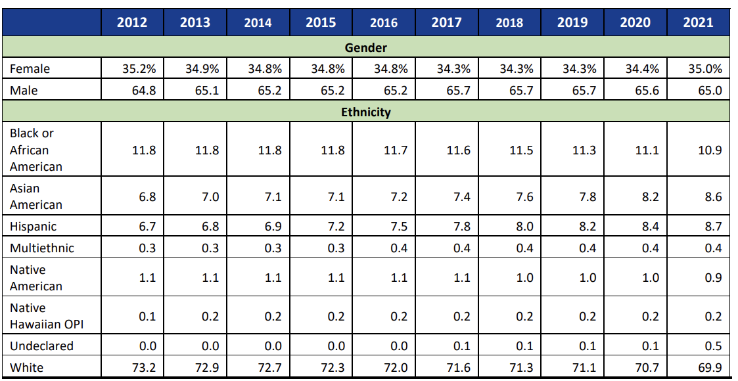
Figure 1. NASA Gender and Ethnic Demographic Composition between 2012 and 2021.
Source: NASA OIG analysis (2022). Amounts are rounded, and total employee percentages may not equal 100.

2. Aims and Objectives

NASA’s audit conducted in 2023 underscored the limited progress made by NASA in enhancing the representation of women and minorities within its workforce and leadership roles (NASA, 2022). Demographic data revealed a negligible overall change in NASA's workforce composition over the past decade, with marginal increases of 1 or 2 per cent observed for select demographic groups (NASA Office of Inspector General, 2023). The actions proposed in this report aim to redress these disparities. These tasks are based on the Kaizen method, which involves introducing changes in small steps. This approach enhances operational efficiency, reduces waste, and increases overall productivity by encouraging minor, manageable improvements over time (Knechtges, 2014: Maurer, 2014)

The initial goal seeks to implement educational changes that provide early support for girls. The second objective focuses on boosting females' interest in the aerospace industry, while the third addresses employment improvements by fostering a workplace that recognises and accommodates the unique needs and differences of women compared to men.

2.1 Action Plan

Changes in the Educational Context

The motivational impact of self-confidence on attitudes toward science is evident, with recent studies indicating that young women exhibit lower confidence than men in tasks related to chemistry and mathematics (Sunny, 2017). The formation of positive STEM experiences and the development of 'STEM identities' commence at a very early age, even before children enter formal education, as stereotypes take shape during this early stage. Therefore, schools should implement the following actions:
- Addressing gender stereotypes in education involves incorporating appropriate role models and peer influence and optimising classroom activities and content, such as hands-on and project-based learning.
- Ensuring primary school children have access to stories and cartoons that depict girls driving cars and flying aeroplanes will allow them to engage with female drivers and promote female representation in these fields.
- Organising visits at universities and industry that enable children to envision their futures by showcasing female role models and real-life examples of success stories within the aerospace industry.

Generating interest in the aerospace industry

Despite positive efforts by aviation and aerospace employers to encourage women to take on technical roles, there is a low number of women in these roles. This situation is linked to issues like a lack of acceptance by male flight instructors, discomfort in cockpits, and the absence of female role models (Puritty, 2017). The absence of women instructors intensifies feelings of anxiety and undermines confidence, resulting in a sense of isolation and a perception of not being understood (Seetles, 2007). In order to address these issues, the suggestion is to
- Enhancing the representation of women in instructor roles is essential for aviation training. Training conducted by both genders ensures a positive impact on future pilots, fostering teamwork in the cockpit with experience working alongside both women and men.
- Women mentors offer valuable support to individuals entering aviation or early in their careers, helping navigate challenges specific to women, such as balancing the desire to start a family with professional aspirations—issues not necessarily applicable to men.
- Females in instruction roles might also positively address issues with a lack of acceptance, isolation, and feeling of not being understood.

Improvement of employment

The aerospace industry wants to bring in and keep more women for its future growth. This is not just to fix the gender imbalance but also because there is a global shortage of qualified workers (McKendrick, 2023). This shortage pressures companies to hire as many qualified employees as possible. It is in the organisation's interest to create a workplace that will support the development but also create the general desire to work in a given place. NASA should consider the following issues concerning this problem:
- It was reported that cockpits typically are not ergonomically comfortable to many females (Archer, 2020). Cockpit ergonomics should consider the shape of the female body.
- Close the Gender Pay Gap by tightening the law regarding these differences in pay.
- Raising awareness of career opportunities. This involves ensuring gender equality in all aspects of job recruitment, including announcements, interviews, benefits, and addressing potential gender differences.
- Training for leaders to increase their awareness of the importance of diversity and equal rights. Leaders are usually closest to all employees and greatly influence the work organisation culture, impacting the entire organisation (Schein, 2010).

2.1.1 Time Plan

To address the following action plan, it is recommended to implement the following steps:

Performance Goal | Action | Performance Measure | Who is responsible | Target Date
Strategic Objective: Changes in the educational context
Storytelling Initiatives | Initiate a campaign to ensure primary school children can access gender-inclusive stories and cartoons. | Track website or platform engagement metrics for the content.  Conduct surveys to understand changes in children's perceptions of gender roles. | Government and schools | 01.01.2025
Industry Visits and Role Models | Establish programs for university and industry visits showcasing female role models in aerospace. | Track the percentage increase in female enrollment in STEM courses.  Collect feedback from students regarding the impact of role models on their career aspirations.  Track the long-term career choices of students involved in the initiatives. | Government and schools | 01.01.2025 + long-term feedback collection
Strategic Objective: Generating interest in the aerospace industry
Females instructors | Evaluate the current representation of women in aviation training | Collect data on the current percentage of women in aviation training instructor roles.  Conduct surveys to gauge trainees' perceptions regarding diversity and inclusion in training. | Organisation | 01.05.2024
Females instructors | Introduce training programs that emphasise collaboration between male and female instructors. | Monitor the percentage of female instructors participating in collaborative training programs.  Collect feedback from trainees on the impact of diverse instructor teams on their learning experience. | Organisation | 01.05.2025
 | Observing and evaluating training | Monitor changes in trainees' reported experiences of acceptance and understanding.  Evaluate the impact of mentorship programs on reducing feelings of isolation among individuals entering aviation. | Organisation | 01.05.2025
Strategic Objective: Improvement of employment
Ergonomic Evaluation of Cockpits | Conduct an ergonomic assessment of cockpits to address female comfort and manoeuvrability issues. | Implement changes based on the assessment and track improvements in reported comfort.  Monitor the ease of manoeuvrability for female pilots and gather feedback on any difficulties encountered. | Organisation | 01.01.2030
Closing the Gender Pay Gap | Advocate for legal measures to close the gender pay gap, addressing disparities in pay (US law). | Track changes in pay structures and identify the reduction in gender pay gaps—Analyse legal compliance and penalties to ensure adherence to tightened laws. | Government and organisation | 01.01.2026
Gender-Equal Job Recruitment Practices | Ensure gender equality in all aspects of job recruitment, from announcements to benefits. | Monitoring the gender balance in recruitment processes and assess any disparities.  Implement surveys to evaluate job applicants' perceptions of gender equality in recruitment. | Organisation | 01.12.2024

Figure 2: Time Plan, own work.
Sources: Sunny, 2017: Puritty, 2017: Seetles, 2007: McKendrick, 2023: Archer, 2020: Schein, 2010.

2.1.2 Risk Management and Strategies

To address the challenges associated with the above strategies, it is recommended to implement the following steps:
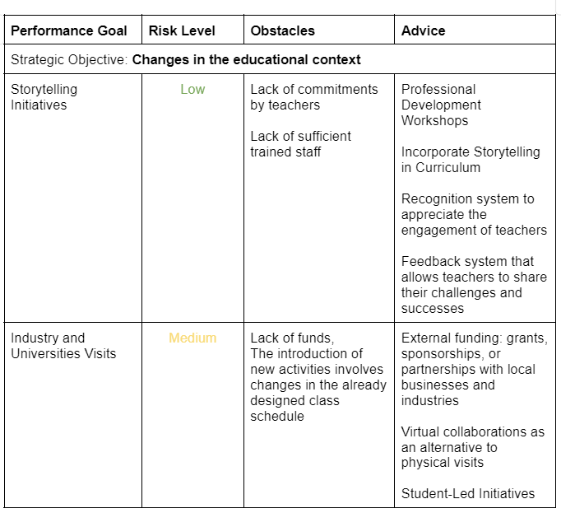
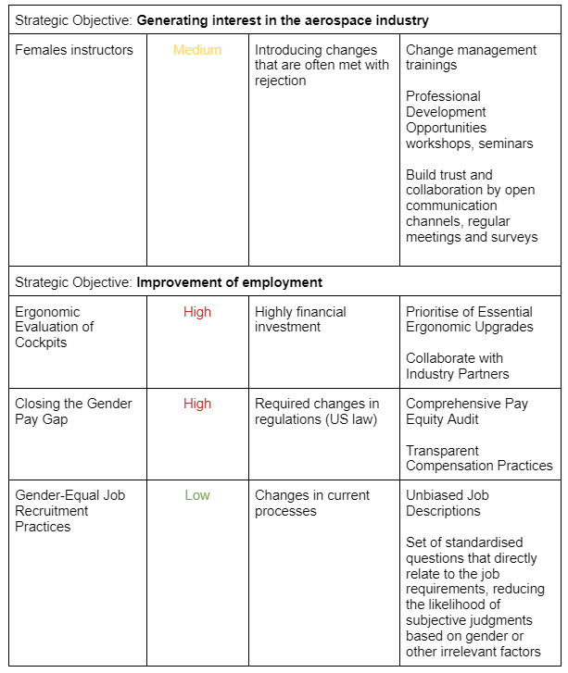
Figure 3: Risk Management and Strategies, own work.
Sources: Todnem, (2005): Opengart, (2016): Blas (2014): GOV UK (2023): Kaiser (2018)

3. Recommendations

To promote gender diversity in STEM and address the challenges women face in the aerospace industry, it is recommended to focus on initiatives at different levels. Teacher training programs should emphasise avoiding gender bias, while collaboration with STEM education organisations can ensure gender-neutral materials. Generating interest in aerospace can be achieved through mentorship programs, workshops, and seminars featuring successful women. Improving employment conditions involves redesigning cockpit ergonomics, closing the gender pay gap, and raising awareness of career opportunities.

4. Conclusion
The results of this study indicate that despite numerous initiatives for diversity at NASA, the agency has shown minimal advancement in enhancing the representation of women and minorities in its workforce and leadership roles (NASA, 2022). Despite establishing a Diversity and Inclusion Strategic Implementation Plan over a decade ago, the overall percentages of women and minorities in NASA's workforce have not seen improvement. The outlined recommendations address specific challenges faced by women at NASA, offering straightforward strategies that do not necessitate substantial financial investments (excluding the cockpit transformation).

The author supports the proposition with actions that enable the removal of barriers and impediments which result in the underrepresentation of women in STEM fields. Implementing women-led aviation training aims to draw in more female participants, bolstering their self-confidence. Furthermore, tailoring the cockpit to accommodate the female body shape seeks to remove existing barriers, opening doors for numerous women currently deterred from pursuing careers as pilots. Establishing an equitable job recruiting process and ensuring fair compensation not only enhances morale within the organisation but also positively shapes the perception of the entire society toward the organisation.

Bibliography
Archer, S., Brewer, H., Fain, S., & Smith, S. (2020), ‘Gender Differences and Cockpit Design’, [Online] Available: https://commons.erau.edu/student-works/159, Accessed 2024, January, 3rd

Artemis Plan (2020), ‘NASA’s Lunar Exploration Program Overview’, [Online] Available: https://www.nasa.gov/specials/artemis/, Accessed 2024, January, 3rd

Blas, N. (2014), ‘Digital storytelling at school: what kind of educational benefits?’, Arts and Technology, 7:1, pp.38-34, [Online] Available: https://www.inderscienceonline.com/doi/abs/10.1504/IJART.2014.058942, Accessed 2024, January, 3rd

Deloitte (2016), ‘Women in STEM – Technology, career pathways and gender gap’, [Online] Available: https://www2.deloitte.com/uk/en/pages/growth/articles/technology-career-pathways-gender-pay-gap.html, Accessed 2024, January, 3rd

Dick, S. (2009), NASA’s First 50 Years. Historical Perspectives, United States: National Aeronautics and Space Administration

Garber, J. (2009), A Guide to the NASA History Program, Monographs in Aerospace Industry, 3th Edition, United States: National Aeronautics and Space Administration

GOV UK (2023), 'Gender pay gap reporting: guidance for employers', [Online] Available: www.gov.uk, Accessed 2024, January, 3rd

Inclusion and Diversity (2023), ‘The European Women on Boards Directive what it means and why it matters’, [Online] Available: www.iod.com, Accessed 2024, January, 3rd

International Air Transport Association (2018), ‘International Women’s Day 2018 – Aviation has further to go, IATA Economics’ chart of the week’, [Online] Available: https://www.iata.org/en/publications/economics, Accessed 2024, January, 3rd

Kaiser, C. (2018), 'Why The Gender Pay Gap Gets Worse—Not Better—For Senior Engineers', [Online] Available: www.wellfound.com, Accessed 2024, January, 3rd

Knechtges, P. (2014), ‘Application of Kaizen Methodology to Foster Departmental Engagement in Quality Improvement’, Journal of the American College of Radiology, 11:2, pp. 1126-1130

Maurer, R. (2014), One Small Step to Change Your Life: The Kaizen Way, New York: Workman Publishing

McKendrick, J. (2023), ‘We Can’t Find Enough Skilled Workers: Can Automation Fill The Gaps?’, Forbes, [Online] Available: https://www.forbes.com/sites/joemckendrick/2023/09/27/we-cant-find-enough-skilled-workers-can-automation-fill-the-gaps/, Accessed 2024, January, 3rd

NASA (2022), ‘Model Equal Employment Opportunity Programs Status Report: FY 2022’, [Online] Available: https://www.nasa.gov/wp-content/uploads/2018/08/odeo-fy-2022-md-715-report-final-tagged.pdf, Accessed 2024, January, 3rd

NASA (2023), ‘Diversity & Inclusion’, [Online] Available: https://www.nasa.gov/odeo/diversity-and-inclusion/, Accessed 2024, January, 3rd

NASA (2023), ‘Explore NASA’s History’, [Online] Available: https://www.nasa.gov/history/explore-nasas-history/, Accessed 2024, January, 3rd

NASA Office of Inspector General (2023), 'NASA’s Efforts to Increase Diversity in Its Workforce', [Online] Available: www.oig.nasa.gov, Accessed 2024, January, 3rd

NASA Office of Inspector General (2023), 'NASA’s Efforts to Increase Diversity in Its Workforce', [Online] Available: www.oig.nasa.gov, Accessed 2024, January, 3rd

Opengart, R. & Ison, D. (2016), ‘A Strategy for Alleviating Aviation Shortages Through the Recruitment of Women’, International Journal of Aviation Management, 4:10, [Online] Available: https://www.researchgate.net/publication/308948455_A_Strategy_for_Alleviating_Aviation_Shortages_Through_the_Recruitment_of_Women, Accessed 2024, January, 3rd

PARE (2018), ‘Perspectives for Aeronautical Research in Europe – 2018 Report’, [Online] Available: https://cordis.europa.eu/project/id/769220/results, Accessed 2024, January, 3rd

Puritty, Ch. (2017), ‘Without inclusion, diversity initiatives may not be enough’, Science, 357:6356, pp. 1101-1102

Schein, E. H. (2010), Organizational Culture and Leadership, 4th Edition, San Francisco: Jossey-Bass

Science (2017), ‘Without inclusion, diversity initiatives may not be enough’, [Online] Available: https://www.science.org/doi/10.1126/science.aai9054, Accessed 2024, January, 3rd

Settles, I.H., Cortina, L.M., Stewart, A.J., & Malley, J. (2007), ‘Voice matters: Buffering the impact of a negative climate for women in science’, Psychology of Women Quarterly, 31, pp. 270-281

Sunny, C. E. (2017), ‘Stereotype threat and gender differences in chemistry’, Instructional Science, 45:2, pp. 157-175

Todnem, R. (2005), ‘Organisational change management: A critical review’, Reframing Leadership and Organizational Practice, 5:4, [Online] Available: https://www.tandfonline.com/doi/abs/10.1080/14697010500359250, Accessed 2024, January, 3rd

UK Research and Innovation (2022), 'Empowering women in the aviation and aerospace industry, [Online] Available: www.ukri.org, Accessed 2024, January, 3rd

Table of Figures
Figure 1 - ‘NASA Gender and Ethnic Demographic Composition between 2012 and 2021’ [Online] Available: https://www.nasa.gov/wp-content/uploads/2018/08/odeo-fy-2022-md-715-report-final-tagged.pdf, Accessed 2024, January, 3rd

Figure 2 - Time Plan, own work

Figure 3 - Risk Management and Strategies, own work

