

Predicting Urban Waterlogging Risk Based on Machine Learning Binary Classification Models: A Case Study of Wuhan
by
Shuyao Jiang

Supervisor: Tim Bashford

Project submitted as part of the requirements for the award of MSc Software Engineering and Artificial Intelligence

November 2023

DECLARATION

I, Shuyao Jiang declare that I am the sole author of this Project; that all references cited have been consulted; that I have conducted all work of which this is a record, and that the finished work lies within the prescribed word limits.

This work has not previously been accepted as part of any other degree submission.

Signed : Shuyao Jiang

Date : 12th September 2023

FORM OF CONSENT

I Shuyao Jiang hereby consent that my Project, submitted in candidature for the M.Sc. Software Engineering and Artificial Intelligence degree, if successful, may be made available for inter-library loan or photocopying (subject to the law of copyright), and that the title and abstract may be made available to outside organisations.

Signed : Shuyao Jiang

Date : 12th September 2023

Predicting Urban Waterlogging Risk Based on Machine Learning Binary Classification Models: A Case Study of Wuhan

Abstract
Urban waterlogging is one of the main urban disasters faced by various countries around the world. Urban waterlogging can inundate residential zone, commercial area, and the industrial land. At the same time, it will also cause huge damage to the city's infrastructure such as energy supply settings and roads. According to the World Bank's estimate, by 2050, the global annual losses caused by urban waterlogging will exceed 1 trillion dollars. The factors which cause the urban flooding including lower terrain, short-term heavy rainfall, reduction of the urban lake area, decreased vegetation coverage, and the impact of extreme weather such as typhoons and hurricanes. Today, with the continuous expansion of urban scale, the continuous increase of urban population, and the economic activities, these social factors have also highlighted a significant impact on the problem of urban waterlogging. It is particularly important to effectively predict the occurrence of urban waterlogging and the impact of different factors on urban waterlogging. In this study, the Wuhan City(the capital of Hubei province in China)was used as the example. The main research work and conclusions are as follows:
- Collecting and organizing relevant data on waterlogging in Wuhan city. Using methods such as literature review and online collection to collect and organize data on LUCC(land use/land cover change), economy and social development in Wuhan from 2007 to 2021 as independent variables. Referring to the research results from another researchers, and analyzing the impact of each variable on the waterlogging. Preprocess the data by using Z-score standardization. It was found that there is multicollinearity exiting in the variables which used in this study by means of the experimental result. This study cannot find the extent of a single variable which affects urban waterlogging.
- To predict the risk of actual situation in Wuhan, a naive Bayesian binary classification model and a neural network binary model are constructed to predict whether waterlogging will occur in Wuhan from June to August. The index(such as LUCC , rainfall, temperature, GDP, and the population, etc.) is used as independent variables, and the event whether urban waterlogging has occurred is used as dependent variable. The dependent variable is made by binary result table. The dataset is composed of multiple independent variables and dependent variable. (Number 1 represents the occurrence of urban waterlogging, and the number 0 indicates that urban waterlogging does not occur). A naive Bayesian binary classification prediction model is established. Seventy percent of the data is selected as the training set to train the model, and thirty percent of the data is selected as the testing set to test the model. Comparing the predicted results with the actual situation can verify the accuracy of the model in whether the actual situation has occurred.
- Comparing the predicted results of the two models, and exploring the advantages of the models. This study also explore the disadvantages of the models ,accuracy of the results,etc. Comparing the conclusions of another researchers and summarizing the reliability of this research method.

Keywords: urban waterlogging, Wuhan, Z-score standardization, multicollinearity, naive Bayesian, binary classification model, neural network

- Introduction
  - Background research
Urban waterlogging refers to the situation where happened short-term heavy rainfall or sustained rainfall causes the water accumulation within a city to be much higher than the city's flood discharge capacity. Due to insufficient flood discharge capacity in the city, a large amount of water accumulates inside the city, causing great harm to urban infrastructure and people's livelihoods. Especially in developing countries, with the increase of population, the continuous expansion of urban scale, and the continuous alteration of land use, the risk of urban waterlogging increases rapidly. At the same time, with the continuous changes in global climate, global temperatures continue to rise, and extreme weather conditions occur frequently, leading to an increasing likelihood of urban waterlogging in every countries.

The Intergovernmental Panel on Climate Change (IPCC) believes that the scenario of high-frequency and overpowering rainstorm will occur frequently in the future (more than 66% probability); The number of people affected by urban waterlogging disasters is expected to be double from 1970 to 2030. Meanwhile, longer periods of drought will pose a more serious threat to human social stability and economic development. The global average surface temperature increased by 0.85 ℃ between 1880 and 2012, and it is expected that the average surface temperature will continue to rise by 0.3-0.7 ℃ until 2035. If no actions are taken, the direct damage of the urban waterlogging caused by climate change may increase to 20 times in the end of this century.

China is a country which most severely affected by urban waterlogging disasters in the world. The urban waterlogging disasters which occur in every summer have become one of the most prominent problems that hinder the development of cities in China. When the urban waterlogging happen, streets are flooded and traffic is obstructed. Sometimes, transportation, water supply, electricity, and communication are disrupted or even paralyzed. According to the "Statistical Bulletin on Water and Drought Disasters in China" published by the Ministry of Water Resources of China over the years, from 2006 to 2017, more than 157 cities were flooded or experienced internal waterlogging every year in China. With the continuous expansion of China's urban economy and population, the social and economic losses caused by urban waterlogging are becoming increasingly evident. For example, in 2017, when the disaster was relatively mild, the number of people affected by urban waterlogging still reached 2.1872 million, with a direct economic loss about 16.568 billion yuan. The object in this study, Wuhan, one of the mega cities in China. In the past thirty years, there have been four major waterlogging disasters(in 1997, 2016, 2017, and 2021). It has brought huge losses to economic development and people's property.

Even today, more and more experts and scholars have been studying the causes and prevention of urban waterlogging. According to research, the occurrence of urban waterlogging is not only related to environmental factors such as rainfall and temperature, but also closely related to human activities. Mainly manifested in the following three aspects: (1) Construction of urban drainage systems. (2) Changes in urban terrain and landforms. (3) Changes in anti-seepage area. The urban drainage system collects rainwater and accumulated water from the ground, thereby lowering the groundwater level, preventing soil waterlogging, waterlogging, and secondary salinization of the soil, while also allowing timely drainage of accumulated water. At the same time, reducing the accumulation of water in low lying residential buildings, unnecessary economic losses caused by soaking and damaging vehicles due to poor drainage, and reducing the losses suffered by people before natural disasters. Urban landforms include the lake area, vegetation area, etc. During the flood season, the lakes accommodate the runoff of the riverbed, thereby reducing the flood peak. Vegetation coverage reduces soil erosion and downstream sedimentation caused by floods(Vegetation coverage changes soil properties and reduces soil erosion; vegetation has a blocking and intercepting effect on floods, and a protective effect on slope banks). With the development of cities, the anti-seepage area within the city will also change. The construction of roads, buildings, subways, and underground garages will reduce the flood resistance capacity of the city.

  - Study significance
The 21st century will be a century of rapid urban development. with the growth rate of urban population will far exceed that of rural areas. The construction of urban residential areas will have a huge impact on the urban surface and water environment. Especially in terms of urban waterlogging, cities often face the problem of the increased peak surface runoff caused by rapid urban development and poor drainage. This in turn leads to extensive urban waterlogging.The problem of urban waterlogging can have varying degrees of impact on urban life, public and private property, and various urban facilities. Even more , it can cause huge personnel and economic losses. For a long time, the strategy for urban waterlogging prevention and control has been the terminal control method, which utilizes the dredging, renovation, expansion, and rectification of waterlogging facilities to quickly remove excess rainwater from the city and discharge it to the edge areas of the city to reduce the impact of urban waterlogging. This type of method has been effective for a considerable period of time and can solve the problem of urban waterlogging on site, meeting the requirements. However, the urbanization process and unreasonable urban land development in the past two centuries have led to an increase in urban hardened area, a decrease in urban surface rainwater interception function, and subsequently, an increasing peak urban rainwater runoff and urban surface runoff. Therefore, the terminal method cannot and cannot always keep up with the development and changes of cities. A unified planning and integration of various control methods are needed to solve the problems of urban waterlogging.

1.3 Review of Research Progress
1.3.1 Study on the Impact of Urbanization on Urban Flooding
The land use transformation that occurs during the urbanization process can lead to changes in urban hydrological processes, specifically, the increase in impermeable surfaces in cities impacts their hydrological processes. The significant increase in impermeable surfaces in cities has altered urban hydrological parameters, mainly manifested as reduced rainwater infiltration, decreased vegetation interception, and accelerated surface runoff aggregation, leading to increased surface runoff. Wang et al. utilized hourly rainfall-runoff data from 1971 to 2012, combined with Geographic Information Systems (GIS) and traditional hydrological methods, to analyze the impact of urbanization on hydrological processes using Zhengzhou city as a case study. The study found that the urban heat island effect in different areas of the city intensifies with the increase in urbanization rate. The peak flow increases by 10% to 30% with the change in constructed volume. The runoff coefficient increases by 20% to 35% with the increase in the built-up area. Zhang et al. used the advanced Weather Research and Forecasting (WRF) model to analyze the impact of urbanization on summer rainfall events in the Pearl River Delta region. The study found that urbanization leads to changes in the surface energy balance, with an increase in sensible heat flux and a decrease in latent heat flux. The reduction in latent heat flux suppresses the availability of moisture, leading to a decrease in the maximum convective available potential energy. As a result, the total summer rainfall in the Pearl River Delta region decreases. In contrast, the increase in sensible heat flux enhances the urban surface temperature and boundary layer circulation, bringing more water vapor mixing into the urban atmospheric region, which increases the frequency and intensity of extreme rainfall events. Zhang et al. used the WRF model and statistical models to quantify the contribution of urbanization to rainfall and flooding. The results indicate that urbanization not only exacerbates urban flooding disasters but also increases the total rainfall during storms. Feng et al.[] explored the sensitivity of urban flooding to the rate of urbanization by simulating flood flows under different urbanization conditions and at different flood stages. The study found that the urbanization process increased the surface runoff rate and river flow rate, and shortened the arrival time of the peak runoff and flow rates. The affected area is not only related to the overall percentage of impermeable surface area but also to the spatial distribution of the impermeable surfaces. When the average percentage of impermeable surfaces is similar, a spatially disordered distribution of land use types exacerbates urban flooding disasters more than a uniform distribution. Therefore, quantifying the impact of land use changes on urban flooding is of pressing importance. However, most past studies have been based on current or past data, with few assessing the effects of future land use dynamics on urban flooding.

Predicting future land use changes is a prerequisite for assessing the impact of future land use changes on urban flooding. The land use change system is a complex system that involves multiple facets. Traditional prediction models are mainly quantitative prediction models, predicting the changes in quantity of different land use types. These include the grey prediction model, the Markov chain model, and the System Dynamics (SD) model. The grey prediction model, due to its ability to predict complex systems and random processes, low sample data requirements, and short-term prediction capabilities, has been widely used in land use change forecasts. For example, Jiang Yunlu et al. used the grey prediction model to predict land use changes in the Kunlun Mountain region for 2025 and 2030, finding that the construction land and cultivated land in the Kunlun Mountain region continue to increase. However, its long-term prediction is less accurate, and it's challenging to apply error compensation techniques, making it difficult to use for long-term land use change predictions. The Markov chain model is a probabilistic model used to describe systems with a few discrete states that change over time. Due to its simplicity and ease of implementation, it has been adopted by many studies. For instance, Tao Chunchen et al. predicted the construction land change trend in the China-Vietnam border region for 2030 based on the Markov chain model. However, its assumptions regarding the initial state of land use are strict, making it difficult to achieve in practical applications. The SD model predicts the long-term evolution of a complex system through feedback and interactions between different subsystems[]. It can effectively reflect the interaction between the structure, function, and dynamic behavior of complex systems. As a result, the SD model has been widely used in predicting future land use change studies. For instance, Cao Qiwen et al. utilized the SD model to simulate future land use changes in China, while Hu Zongnan et al. used the SD model to perform multi-scenario simulations for future land use changes in Yangzhou city. However, quantitative prediction models can only predict changes in the quantity of different land use types and cannot predict future land use changes spatially, making them unsuitable for studies on spatial changes in land use.

1.3.2 Progress in Urban Flood Risk Prediction Research
Rapid advancements have been made in the risk prediction models of urban hydrological processes. The primary methods related to these predictions include Historical Disaster Mathematical Statistics (HDMS) , Index Analysis Method (IAM) , Multi-Criteria Decision Analysis (MCDA) , Scenario Simulation Analysis (SSA) , and Simplified Models. The Historical Disaster Mathematical Statistics method evaluates urban flood risks using recorded historical data of urban flooding disasters. The risk of urban flooding is the cumulative result of hazards and vulnerabilities. The main process involves: generating a statistical analysis model of urban flood risk using historical data, and calculating urban flood risk in conjunction with official historical disaster data. Due to its simplicity and the ability to calculate urban flood risks with just basic historical data, it is widely used. Benito et al. used various historical literature sources and statistical methods to assess the risk of extreme floods in European regions. Sado-Inamura et al. utilized the HDMS method to evaluate the changes in urban flood risk in Tokyo over the past few decades. Research has found that flood risks in low-lying urban areas have decreased. Investing in adaptive measures to mitigate urban flooding can effectively enhance the flood resistance capability of vulnerable regions. However, this method has its shortcomings, such as the difficulty in obtaining historical data, and past urban flooding disasters might not necessarily represent future urban flooding disasters.

The IAM (Index Analysis Method) is based on establishing an evaluation index system according to the constituent elements of urban flood risks, and then quantifying urban flood risks for each indicator. Due to its relatively simple calculation principles, it is widely used for urban flood risk assessment in large-scale research areas. Dou et al. selected 7 urban flooding disaster indicators to assess the urban flooding risk in the Guanzhong urban area of large cities in Northwest China. The results show that there is a significant difference in the spatial distribution of urban flood risk. The areas with extremely high flood risks are mainly concentrated along the Wei River and its tributaries and in the central part of the Guanzhong Plain. Land use and population distribution are related to flood disasters. Wang et al.[] selected 11 flood risk indicators and constructed a flood risk assessment model based on the random forest algorithm. They assessed the flood risk in the Dongjiang River Basin and found that the future flood risk in this region will significantly increase. However, Integrated Assessment Models (IAM) have high data quantity and accuracy requirements for each indicator, which can be challenging to achieve in practice.

Multi-criteria decision analysis (MCDA) is a flexible method for urban flood risk assessment []. The key aspect of MCDA is the allocation of weights to urban flood risk indicators. Subjective weight evaluation methods include Analytic Hierarchy Process (AHP), Pairwise Comparison Analysis, and Fuzzy Comprehensive Evaluation, among others. Subjective weight analysis relies mainly on expert experience and knowledge for scoring []. This method can be susceptible to expert bias and knowledge limitations, leading to uncertainty and subjectivity in the assigned weights. Additionally, this approach may not be sufficiently responsive to the rapid changes in both natural and social environments.

Scenario simulation analysis methods primarily include hydrological and hydraulic models, with the Storm Water Management Model (SWMM) being a representative hydrological model that integrates rainfall-runoff processes. It has been widely used in urban watershed runoff management planning and design work []. This model utilizes the Infiltration Excess and Soil Conservation Service (SCS) methods for runoff calculation, and it employs nonlinear reservoir routing for overland flow, with options for constant flow, kinematic wave, or dynamic wave calculations for pipe flow. This model is often employed to determine the scale of urban drainage systems and simulate areas prone to channel flooding, among other applications [].

A simplified model refers to a model that has undergone simplification to reduce its complexity. In the context of complex system theories with intricate structures and dimensions, simplified models find widespread applications. Simplified models for urban hydrological processes primarily focus on establishing relationships between characteristic conditions and risks, making them highly operational []. Therefore, simplified models used for the rapid assessment of urban hydrological risks serve as important complements to hydrological and hydraulic models. Currently, there is ongoing research in the development of simplified models for hydrological processes, particularly related to water balance.

Machine Learning (ML) methods are a type of simplified model that can automatically capture urban flooding characteristics based on intelligent models, providing a novel and reliable urban flood risk assessment approach []. Similar to MCDA, ML is flexible and requires relatively simple spatial data, offering good time efficiency and generalization capabilities []. Furthermore, ML requires fewer high-resolution data compared to SSA []. Therefore, ML is widely applied in urban flood risk assessment []. For instance, Tehrany et al. assessed flood susceptibility in Kelantan, Malaysia, using decision tree classification, and their modeling results achieved high accuracy []. Srivastav et al. constructed a hydrological model based on Artificial Neural Networks (ANN) to analyze the hydrological conditions in the Kolar River Basin in India, particularly focusing on uncertainty analysis [].

1.4 Research Purpose
Based on the reasons mentioned above, it is necessary to improve the accuracy of urban flooding prediction in Wuhan. The objectives of this study are threefold:
- Construct an appropriate machine learning algorithm model and analyze its accuracy.
- Investigate the interrelationships among independent variables and explore the extent to which each independent variable influences the occurrence of urban flooding.
- Establish parameter values and measure the performance of the algorithm to demonstrate its predictive capability.

1.5 Research Content and Methodology
1.5.1 Study Area
(1) Area Overview
Wuhan City is the central city in the central part of China and is a key industrial, educational, and transportation hub nationwide. It is situated in the eastern part of the Jianghan Plain in the middle reaches of the Yangtze River, where the Yangtze River and its largest tributary, the Han River, converge. The total area of Wuhan is 8,569.15 square kilometers. As of the end of 2022, it had a resident population of 13.739 million people and a regional GDP of 1,886.643 billion yuan. Wuhan has a subtropical monsoon climate and is located at a geographical position between east longitude 113°41' to 115°05' and north latitude 29°58' to 31°22'. In terms of planar rectangular coordinates, its maximum east-west distance is about 134 kilometers, and its maximum north-south distance is approximately 155 kilometers.

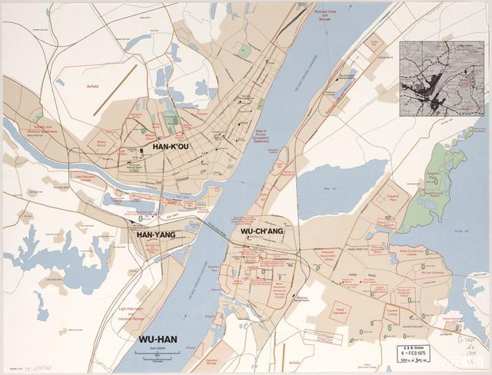
Figure 1. The map of Wuhan
（2）Social and Economic Overview
In 2022, Wuhan City achieved a Gross Domestic Product (GDP) of 1,886.643 billion yuan, calculated at comparable prices, representing a 4.0% increase compared to the previous year. Here is a breakdown of the GDP by sectors; The value added in the primary sector was 47.579 billion yuan, with a growth rate of 3.2%; The value added in the secondary sector was 671.665 billion yuan, with a growth rate of 7.3%; The value added in the tertiary sector was 1,167.399 billion yuan, with a growth rate of 2.3%. The economic structure shifted from 2.5∶34.7∶62.8 in 2021 to 2.5∶35.6∶61.9 in 2022. When calculated per resident population, the per capita GDP in the city was 137,772 yuan, representing a 0.5% decrease compared to the previous year. Wuhan City has a permanent resident population of 13.739 million people and is strategically located at the intersection of the Yangtze River's golden waterway and the major artery of the Beijing-Guangzhou Railway. It has historically been known as the "Gateway to Nine Provinces" and is China's largest inland transportation hub, encompassing water, land, and air routes.
（3）Natural Conditions
Wuhan City is rich in freshwater resources and has the largest water area among major cities in China. The total water area in Wuhan City covers 2,217.6 square kilometers, accounting for 26.1% of the city's land area. There are 277 reservoirs of various sizes, including 3 large reservoirs and 6 medium-sized reservoirs, with a total capacity of 925 million cubic meters. There are 85,100 ponds and weirs with a storage capacity of 330 million cubic meters. As of 2017, Wuhan had a total of 166 lakes, with a water surface area of 803.17 square kilometers, ranking first among Chinese cities. The city's wetland resources also rank among the top three globally for inland cities. The total wetland area in Wuhan is 3,358.35 square kilometers, accounting for 39.54% of the city's total land area. This includes 1,561.86 square kilometers of natural wetlands and 1,796.49 square kilometers of artificial wetlands.

Wuhan's topography is characterized by an east-high-west-low and south-high-north-low configuration, with the Yangtze River and the Han River cutting through the city in a Y-shaped pattern, dividing it into three sections. In the southern part of Wuhan's urban area, there are hilly areas running roughly from east to west, and the surroundings feature a network of densely distributed branching gullies. Throughout the region, there are nearly a hundred lakes scattered about, creating a complex terrain characterized by a well-developed water system and a harmonious blend of mountains and waters. The highest point in the area is approximately 150 meters above sea level, while the lowest land elevation is around 18 meters.

Wuhan experiences a North Subtropical Monsoon Climate, characterized by abundant rainfall, ample sunshine, scorching summers, and cold winters. The average annual temperature generally ranges from 15.8°C to 17.5°C. In the course of a year, January has the lowest average temperature, around 0.4°C, while July and August have the highest average temperatures, reaching approximately 28.7°C. The summer season is remarkably long, lasting up to 135 days, with high temperatures and concentrated rainfall occurring during this period.

1.5.2 research content
Wuhan is a highly developed city in China with a strong economic output, abundant human resources, and intensive production factors. Over the past 40 years, Wuhan has experienced rapid urbanization, which is expected to continue in the coming decades. Urban development is likely to exacerbate the issue of urban flooding. Furthermore, global climate change is expected to increase the frequency and intensity of extreme precipitation events []. However, previous research on urban flood risk in Wuhan has mainly focused on individual regions or watershed scales []. To date, there has been limited research on predicting urban flood risk based on historical climate change and urbanization [], and assessing the impact of future climate change and urban development on urban flood risk. This study aims to address this research gap by proposing a dynamic assessment framework for urban flood risk, which is based on a Bayesian classification model that responds to climate change and urbanization. The framework revolves around three main aspects:
（1）Analysis of Factors Affecting Urban Flooding: By reviewing a large body of literature and research findings, we have selected data that may have an impact on urban flooding as our research dataset. We have also consulted historical records to collect information on the years and months in which urban flooding occurred in Wuhan. We will conduct a statistical analysis of the variables using historical disaster data and mathematical methods to investigate their relationships and influence on urban flooding.
（2）Historical Data Collection, Classification, and Standardization: We have collected historical data by accessing official websites such as the China Statistical Information Network and the Wuhan Statistics Bureau. These data sources were used to find numerical values for the independent variables identified in (1). For certain indicators that required non-public data that could not be obtained, we acknowledge that this may have an impact on the model. The collected data have been standardized using the Z-Score standardization method to ensure consistency and comparability in our analysis.
（3）Construction and Validation of the Prediction Model: Building upon the research of previous scholars, we have employed the Naive Bayes algorithm and neural networks to construct prediction models. We have rigorously verified the accuracy of these models. Experimental results have indicated that there is multicollinearity among the variables, and the model constructed using the Naive Bayes algorithm aligns more closely with the experimental results.
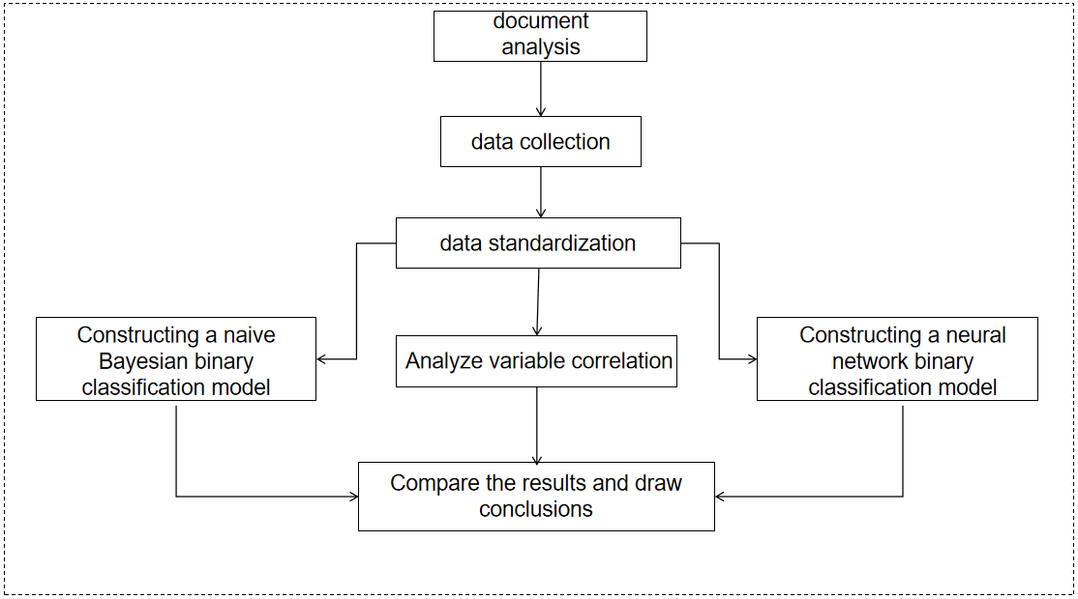
Figure 2. Research flowchart

- Data Sources and Selection Criteria
  - Selection of Climate Indicators
Wuhan falls within a subtropical monsoon climate zone, characterized by significant summer rainfall, and short-duration, heavy rainfall events are the main drivers of urban flooding. As global climate change intensifies and temperatures continue to rise, research indicates that precipitation variability is increasing in tandem with global warming. The changes in precipitation variability are not uniformly distributed worldwide, with the most pronounced increases occurring in climate regions characterized by a wet climate, a phenomenon often referred to as "wet-get-more variable." For every 1°C increase in global temperatures, global average precipitation variability is expected to increase by approximately 5%, which is about twice the rate of average precipitation change. This has important implications for regions like Wuhan, where heavy and concentrated rainfall events can lead to urban flooding. Understanding the relationship between climate change, increased precipitation variability, and urban flooding is crucial for assessing and mitigating flood risks in the city.

Climate change has indeed altered global hydrological cycles, resulting in changes in rainfall patterns, including alterations in the frequency and intensity of extreme rainfall events. Increased frequency and intensity of extreme rainfall can exacerbate urban flooding, making climate change a subject of significant concern. Currently, there are various methods for defining extreme climate indicators, but the 27 extreme climate indicators defined by ETCCDMI (http://etccdi.pacificclimate.org/indices.shtml) have received widespread use. These indicators primarily focus on describing extreme events and include 11 precipitation indicators and 16 temperature indicators. These indicators are based on daily precipitation, daily maximum and minimum temperatures calculations. In this study, based on the climatic characteristics of the Wuhan region, three extreme precipitation indicators have been selected from the aforementioned precipitation indicators to assess their relevance to urban flooding risk.
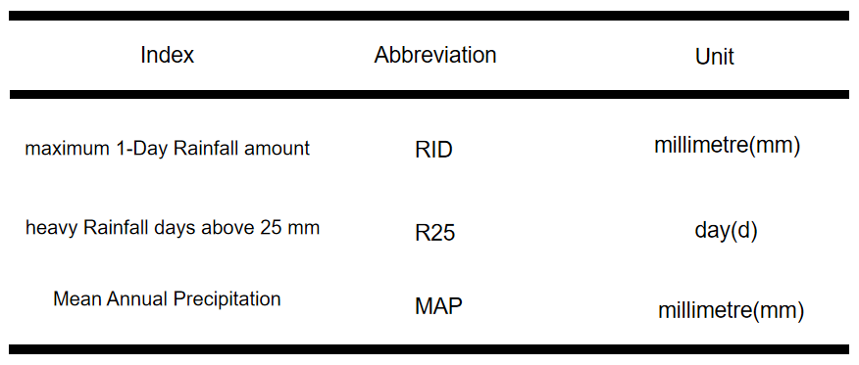
Table 1. Selection of extreme rainfall indicators

Maximum One-Day Rainfall (R1D) represents the intensity of extreme rainfall, with larger R1D values indicating greater intensity of extreme rainfall. The number of days with heavy rainfall (R25) represents the frequency of extreme rainfall, where higher R25 values indicate a greater frequency of extreme rainfall events. Annual Mean Precipitation (MAP) is an indicator used to assess the abundance of precipitation in a region, with higher MAP values indicating greater annual rainfall. Through analysis, it has been demonstrated that the primary cause of urban flooding is when the intensity of heavy rainfall over a period exceeds the drainage capacity of the city's drainage systems. Therefore, selecting R1D as a measure of rainfall is more appropriate for addressing this practical issue. Additionally, changes in urban drainage infrastructure should be considered as one of the measurement factors. With global temperatures on the rise, extreme weather events induced by temperature are becoming more frequent. Due to the climate conditions in Wuhan, temperature variations in the summer are not significant. Therefore, using monthly average temperatures as an indicator to study the climate's impact on urban flooding is suitable.

  - The Impact of Social Factors on Urban Flooding
2.2.1 Land Use Factors
A substantial body of research indicates that Land Use and Land Cover Change (LUCC) resulting from human activities is a significant indicator of changes in surface environments. It has a profound impact on global environmental changes and sustainable development. Changes in urban land use and land cover influence surface evapotranspiration, vegetation interception, soil infiltration, surface roughness, watershed area, and alter the processes of runoff generation and drainage. As China's urbanization process continues to progress rapidly, urban land use patterns are expected to undergo significant changes in the foreseeable future. These changes will increasingly affect urban runoff patterns. Therefore, conducting research on the impact of urban land use changes on urban runoff is essential.

Land Use/Land Cover Change (LUCC) is one of the primary drivers of global change and a central focus of research. LUCC research employs various methods, including mathematical and statistical techniques, remote sensing technology, geographic information systems (GIS), modeling approaches, and methods from landscape ecology. Among these methods, remote sensing is widely acknowledged as one of the most advanced means of acquiring land use information. It offers several advantages, including real-time monitoring, objectivity, and extensive coverage. Remote sensing technology provides the capability to observe and analyze land use and land cover changes on a large scale and in a timely manner, making it a valuable tool for LUCC research.

Land use refers to the process of transforming the natural ecosystems of land into artificial ecosystems, influenced by a combination of natural, economic, and social factors. Social modes of production often play a determining role in land use. It encompasses the ways in which humans utilize land's natural attributes and its usage conditions, encompassing the purposes and intentions behind human land utilization. Land use, in essence, is a form of human activity. Therefore, concepts such as agricultural land, commercial land, transportation land, residential land, and more all fall under the umbrella of land use. Land use factors constitute a complex set of elements, including land use factors, population factors, climate factors, and economic factors. The interactions between these factors can influence the development of each element, with population factors being particularly critical as they often drive changes in other factors. Increased demand for agricultural products, for example, is often a consequence of population growth, indirectly altering the minimum land requirements for cultivation. Economic factors exert significant influence on population and land use factors. Increased investment in agricultural construction due to economic development can lead to reductions in arable land and expansion of construction land. Therefore, it is expected that economic factors will substantially impact land use changes.

Climate factors are primarily associated with long-term changes in precipitation and temperature in arable land, grassland, and farmland. Temperature changes have different effects on the growth and regenerative capacity of arable land, forests, and grasslands. Similarly, appropriate increases in precipitation can meet the water requirements of vegetation, resulting in changes in arable land, forests, and grasslands. Changes in land use (such as land conversion) are closely related to land use factors. Land use factors encompass nine types of land use: construction land, arable land, grassland, forest, shrubland, impervious land area, water bodies, wasteland, and transportation land. Changes in each land use type are influenced by a combination of socio-economic and climatic conditions, as well as constraints imposed by interactions between various land use types. Construction land and transportation land are considered sensitive data and cannot be accessed during the research process. Therefore, seven factors are considered as indicators for assessing urban land use: arable land, grassland, forest, shrubland, impervious land area, water bodies, and wasteland. (Note: Glaciers, a land use type in LUCC indicators, do not exist in Wuhan due to its subtropical monsoon climate.)
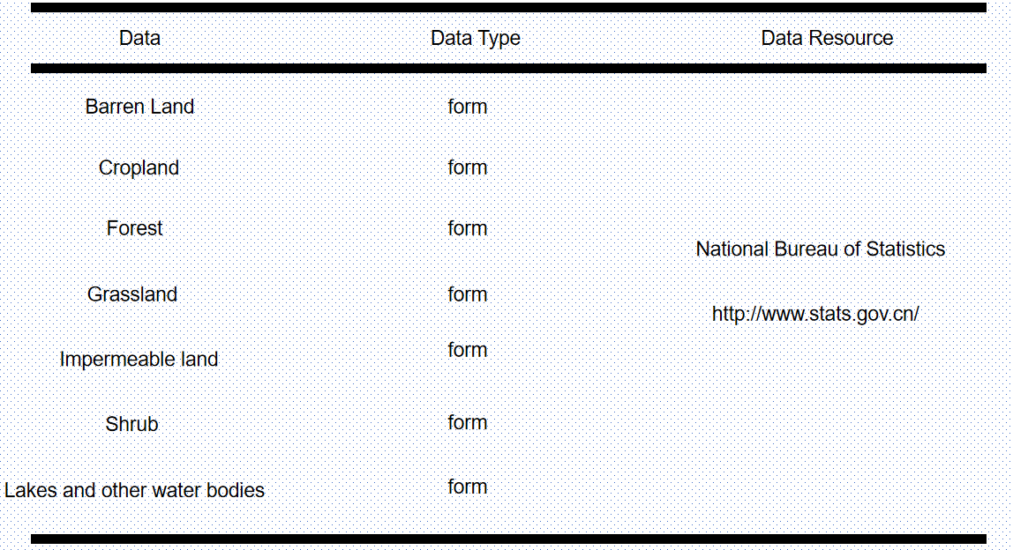
Table 2. LUCC indicators and data sources

2.2.2 GDP Factor
Gross Domestic Product (GDP) is the ultimate result of all productive activities carried out by resident units within a certain period in a country or region. GDP serves as a core indicator in national economic accounting and is an important measure of the economic conditions and development level of a country or region. It objectively reflects the extent of human activities in that area and the degree of social development. Additionally, GDP is an objective representation of changes in urban scale.

2.2.3 Population Factors
Human activities have a significant impact on urban landscapes, and population size is the fundamental determinant of future urban development. The number of people moving into or out of a city has a crucial impact on energy consumption, housing demand, water usage, and land use. Studying changes in population numbers is essential for understanding the impact on flooding disasters in Wuhan city.

2.2.4 The length of drainage pipelines
The primary cause of urban flooding is when short-term heavy precipitation exceeds the drainage capacity of the city's drainage system. The urban drainage capacity heavily relies on the construction of drainage pipelines. Studying the construction of drainage pipelines is crucial for building predictive models. Based on data released by the Wuhan Statistics Bureau, we have chosen the length of drainage pipelines as an indicator to measure the construction of the city's drainage system.

2.2.5 Sponge city area
Sponge city is essentially a "low-impact rainwater development system," so the core idea of a sponge city is low-impact design and development. Specifically, in the process of urban planning and construction, existing waterways and ponds within the city are utilized to coordinate the systematic use of natural rainfall, surface water, and groundwater. Facilities such as permeable pavement, green roofs, and grassed swales are used to facilitate rainwater infiltration and address urban flooding issues. Precipitation is stored in storage facilities such as retention ponds and rainwater tanks, or replenishes groundwater through infiltration wells, giving the city certain sponge-like characteristics. These characteristics include the hydraulic properties of a sponge, such as water absorption, water storage, and water supply, as well as the material properties of a sponge, including its good compressibility and resilience.

China issued the "Guiding Opinions of the State Council General Office on Promoting Sponge City Construction" on October 11, 2015. The purpose of this initiative is to accelerate the development of sponge cities, restore urban water ecosystems, conserve water resources, and enhance urban flood control capabilities. Using the area of sponge city development as a measure of factors affecting urban flooding is of significant importance. According to data released by the Wuhan Statistics Bureau, the area of sponge city development in Wuhan has steadily increased since 2018.
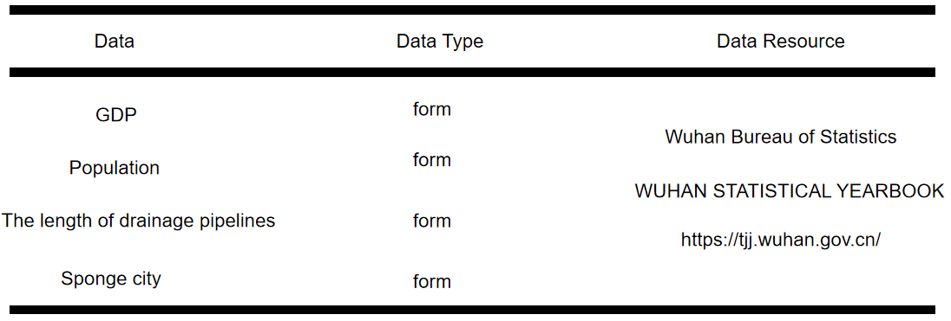
Table 3. Social development indicators and data sources

3. Data standardization and analysis

3.1 Data Description
Compiling the collected data into a dataset. Due to the fact that urban waterlogging in Wuhan occurs from June to August, the official did not disclose the historical situation of urban waterlogging in Wuhan. The data on urban waterlogging in Wuhan was obtained through online search and inquiry surveys. The situation of urban waterlogging in Wuhan from 2007 to 2021 was represented by a matrix, with a value of 1 indicating that there was urban waterlogging in that month and a value of 0 indicating that there was no urban waterlogging in that month.

Table 4 . resulting matrix(the value 1 means urban waterlogging happened in this month, 0 means no urban waterlogging happened)
Year | June | July | August
2007 | 0 | 0 | 0
2008 | 0 | 0 | 1
2009 | 0 | 0 | 0
2010 | 0 | 0 | 0
2011 | 1 | 1 | 0
2012 | 0 | 1 | 0
2013 | 1 | 0 | 0
2014 | 0 | 0 | 0
2015 | 0 | 1 | 0
2016 | 0 | 1 | 0
2017 | 0 | 0 | 1
2018 | 0 | 0 | 0
2019 | 0 | 0 | 0
2020 | 0 | 1 | 0
2021 | 0 | 0 | 0

- . Land use data: Land use data comes from the National Bureau of Statistics and is obtained by the Chinese Academy of Sciences through remote sensing technology.The land use data is the public data.

Table 5. LUCC(land use/land cover change) standardize Data
Barren | Cropland | Forest | Grassland | Impervious | Shrub | Water
0.005541841 | 71.04762834 | 6.29350555 | 0.049404252 | 8.275164996 | 0.000220414 | 14.3285346
0.003935967 | 70.04819722 | 6.373557862 | 0.048648547 | 8.80369708 | 0.000220414 | 14.72174291
0.00300183 | 69.30553806 | 6.321309218 | 0.045657212 | 9.410140309 | 0.000199422 | 14.91415395
0.003033318 | 69.15586637 | 6.030247116 | 0.046307958 | 10.01415898 | 0.000199422 | 14.75018683
0.00305431 | 68.51715871 | 6.012173157 | 0.038215611 | 10.49270954 | 0.000199422 | 14.93648924
0.0028234 | 68.11257284 | 6.101944682 | 0.032253934 | 10.88516214 | 0.000199422 | 14.86504358
0.002256621 | 66.2122672 | 7.231147245 | 0.021925958 | 11.4273494 | 0.000146943 | 15.10490663
0.00207819 | 65.88974885 | 7.431115337 | 0.022083396 | 11.60939048 | 0.000146943 | 15.0454368
0.002508523 | 65.30165248 | 7.643059264 | 0.021086285 | 11.97827976 | 0.000136447 | 15.05327724
0.002707945 | 65.12151116 | 7.735622701 | 0.017507179 | 12.38900574 | 0.000104959 | 14.73354031
0.003316708 | 64.73117873 | 7.922281979 | 0.015397501 | 12.74402993 | 0.000104959 | 14.58369019
0.00420886 | 64.83871983 | 7.924790502 | 0.013896586 | 13.14514165 | 9.44632E-05 | 14.0731481
0.004345307 | 64.88386275 | 7.833056241 | 0.013214352 | 13.35888038 | 7.34714E-05 | 13.9065675
0.004324315 | 64.8747418 | 7.545499773 | 0.014526341 | 13.73654424 | 5.24796E-05 | 13.82431105
0.004555224 | 64.6342984 | 7.600076914 | 0.00969822 | 13.91844595 | 6.29755E-05 | 13.83286231

(2).Climate data:Climate data which include the rainfall and the temperature was collected from the website of the Wuhan Bureau of Statistics.
Table 6 . Climate standardization data (rainfall)
rainfall_Jun | rainfall_Jul | rainfall_Aug
126.6 | 176.5 | 62.3
148.1 | 148.1 | 240.7
306.7 | 95.9 | 38.8
152.7 | 389.7 | 83.6
433.9 | 89.4 | 133.8
192.1 | 245.6 | 131.7
256.6 | 316.2 | 136
65.4 | 151.7 | 145.1
199 | 290 | 74.8
360.2 | 676.1 | 163.8
148.6 | 52.3 | 168.7
64 | 116.2 | 94.7
335.6 | 62.1 | 14.4
419.1 | 554.9 | 121
92.5 | 124 | 244.1

Table 7 . Climate standardization data (temperature)
temperature_Jun | temperature_Jul | temperature_Aug
29.5 | 29.5 | 29.8
26.4 | 29.3 | 28.4
28.1 | 30.3 | 29.1
25.2 | 28.5 | 28.6
25.1 | 28.9 | 27.1
26.6 | 30.3 | 28
26.1 | 30.6 | 30.6
25.7 | 27.7 | 26.1
25.4 | 27.2 | 27.7
24.9 | 29.1 | 29.2
25.2 | 30.6 | 28.6
26.6 | 30.3 | 29.4
26.1 | 29.3 | 30.4
26.5 | 26.4 | 30
27.4 | 29.2 | 28

- . The data of the social development:The data of the social development includes GDP,population,the length of drainage pipeline,and newly added sponge city area,which collected from the WUHAN STATISTICAL YEARBOOK
Table 8. The data of the social development
GDP | population | Pipeline length | Newly sponge city
3960.08 | 828.21 | 6126 | 0
4011.1 | 833.24 | 6321 | 0
4560.62 | 910 | 6592 | 0
5515.76 | 836.73 | 7543 | 0
6756.2 | 1002 | 7909 | 0
8003.82 | 1012 | 8173.15 | 0
9051.27 | 1022 | 9010 | 0
10069.48 | 1033.8 | 9102 | 0
10905.6 | 1060.77 | 9202 | 0
11912.61 | 1076.62 | 9316 | 0
13410.34 | 1089.29 | 9350 | 0
14847.29 | 1108.1 | 8240 | 42.2
16223.21 | 1121.2 | 10849 | 50
15616.06 | 1244.77 | 11422 | 56.9
17716.76 | 1364.89 | 13011 | 51.82

3.2 Z-score standardization
In a multi indicator evaluation system, due to the different properties of each evaluation indicators, it usually has different dimensions and orders of magnitude. When there is a significant difference in levels among various indicators, if the original indicator values are directly used for analysis, the role of indicators which are higher numerical values in comprehensive analysis will be highlighted, and the role of indicators which are lower numerical levels will be relatively weakened. Therefore, in order to ensure the reliability of the results, it is necessary to standardize the original indicator data. Normalization of data refers to scaling data proportionally to fit within a small specific range. In the processing of certain comparison and evaluation indicators, it is often used to remove the unit limit of the data and convert it into dimensionless pure values, so that indicators of different units or magnitudes can be compared and weighted. The most typical one is the normalization processing of data, which means that the data is uniformly mapped onto the [0,1] interval. Taking standardized data from June each year as an example:
Table 9. Standardized data for June
Barren | Cropland | Forest | Grassland | Impervious | Shrub | Water | rainfall_Jun | temperature_Jun | GDP | population | Pipeline length | Newly sponge city
2.1960998 | 1.9250143 | -1.0418583 | 1.569441 | -1.8451879 | 1.3283612 | -0.55732006 | -0.7780391 | 2.626754 | -1.3740637 | -1.444478 | -1.4573152 | -0.5985289
0.51327944 | 1.4672233 | -0.93397963 | 1.5157322 | -1.5408096 | 1.3283612 | 0.32021618 | -0.5990806 | 0.06608138 | -1.3627758 | -1.4095522 | -1.3514798 | -0.5985289
-0.46561742 | 1.127048 | -1.0043904 | 1.3031349 | -1.1915627 | 0.9627184 | 0.74962705 | 0.7210498 | 1.4703217 | -1.2411972 | -0.87656444 | -1.2043955 | -0.5985289
-0.43262064 | 1.0584937 | -1.396626 | 1.3493841 | -0.8437117 | 0.9627184 | 0.38369623 | -0.5607919 | -0.9251456 | -1.0298774 | -1.3853192 | -0.6882438 | -0.5985289
-0.41062278 | 0.76593304 | -1.4209826 | 0.7742522 | -0.5681178 | 0.9627184 | 0.79947287 | 1.7798176 | -1.0077482 | -0.75543636 | -0.23775679 | -0.48959872 | -0.5985289
-0.652597 | 0.5806123 | -1.3000066 | 0.3505493 | -0.3421064 | 0.9627184 | 0.64002573 | -0.23284012 | 0.23128667 | -0.47940683 | -0.16832118 | -0.34623235 | -0.5985289
-1.2465339 | -0.28982213 | 0.22170939 | -0.3834709 | -0.029864416 | 0.04862925 | 1.1753367 | 0.30403513 | -0.18172498 | -0.24766386 | -0.09888557 | 0.107964896 | -0.5985289
-1.4335145 | -0.43755102 | 0.4911865 | -0.37228158 | 0.07497197 | 0.04862925 | 1.0426152 | -1.2874461 | -0.512134 | -0.022389844 | -0.016951216 | 0.15789755 | -0.5985289
-0.9825617 | -0.7069283 | 0.77680284 | -0.44314733 | 0.28741333 | -0.13419218 | 1.0601122 | -0.175407 | -0.75994194 | 0.16259728 | 0.17031641 | 0.21217217 | -0.5985289
-0.77358425 | -0.7894403 | 0.90154177 | -0.6975183 | 0.52394766 | -0.682656 | 0.34654596 | 1.166365 | -1.1729536 | 0.38539332 | 0.2803717 | 0.27404526 | -0.5985289
-0.13565202 | -0.96823305 | 1.1530837 | -0.8474553 | 0.728404 | -0.682656 | 0.012121065 | -0.5949188 | -0.9251456 | 0.7167584 | 0.36834693 | 0.29249862 | -0.5985289
0.79924816 | -0.9189726 | 1.1564643 | -0.95412695 | 0.95940167 | -0.8648329 | -1.1272742 | -1.2990993 | 0.23128667 | 1.0346763 | 0.49895483 | -0.3099497 | 1.2871411
0.94223326 | -0.8982948 | 1.0328435 | -1.0026141 | 1.0824924 | -1.2306149 | -1.4990366 | 0.96160316 | -0.18172498 | 1.3390917 | 0.5899153 | 1.1060752 | 1.6356771
0.9202354 | -0.9024744 | 0.64533144 | -0.9093696 | 1.299987 | -1.5963969 | -1.6826106 | 1.6566278 | 0.14868402 | 1.2047627 | 1.4479316 | 1.4170688 | 1.9439976
1.1622083 | -1.012608 | 0.71888006 | -1.2525094 | 1.4047426 | -1.4135059 | -1.663528 | -1.0618755 | 0.89210474 | 1.6695321 | 2.2819922 | 2.2794926 | 1.7170022

3.3 Variable correlation research
Variable correlation refers to the relationship or dependency between two or more variables. In statistics and data analysis, we usually use correlation to measure the degree of correlation between variables, in order to better understand how they change together or affect each other.

The following are the definitions and types of common variable correlations:

(1). Positive Correlation: When two variables increase or decrease simultaneously, there is a positive correlation between them. A positive correlation indicates that an increase in one variable is accompanied by an increase in another variable, while a decrease in one variable is also accompanied by a decrease in another variable. The correlation coefficient of positive correlation is usually between “0” and “1”, which “1” represents a completely positive correlation.

(2). Negative Correlation: When one variable increases and another variable decreases, there is a negative correlation between them. Negative correlation indicates that an increase in one variable is accompanied by a decrease in another variable, and vice versa. The correlation coefficient of negative correlation is usually between -1 and 0, and the “-1” indicates complete negative correlation.

- . Zero Correlation: If there is no significant relationship between two variables, they are considered uncorrelated. A correlation coefficient close to 0 indicates no correlation.

Table 10 . Data correlation matrix in June (from 2007 to 2021)
 | Barren | Cropland | Forest | Grassland | Impervious | Shrub | Water | rainfall_Jun | temperature_Jun | GDP | population | Pipeline length | Newly sponge city | June
Barren | 1 | 0.143 | 0.031 | 0.039 | 0.019 | -0.175 | -0.826 | -0.114 | 0.647 | 0.190 | 0.131 | 0.088 | 0.576 | -0.325
Cropland | 0.143 | 1 | -0.919 | 0.984 | -0.965 | 0.929 | 0.359 | -0.051 | 0.450 | -0.930 | -0.857 | -0.833 | -0.559 | 0.093
Forest | 0.031 | -0.919 | 1 | -0.910 | 0.842 | -0.890 | -0.412 | -0.089 | -0.269 | 0.859 | 0.716 | 0.686 | 0.520 | -0.235
Grassland | 0.039 | 0.984 | -0.910 | 1 | -0.970 | 0.940 | 0.439 | -0.028 | 0.340 | -0.956 | -0.896 | -0.862 | -0.617 | 0.077
Impervious | 0.019 | -0.965 | 0.842 | -0.970 | 1 | -0.963 | -0.536 | 0.101 | -0.366 | 0.980 | 0.928 | 0.904 | 0.719 | -0.117
Shrub | -0.175 | 0.929 | -0.890 | 0.940 | -0.963 | 1 | 0.649 | -0.120 | 0.225 | -0.975 | -0.902 | -0.889 | -0.781 | 0.198
Water | -0.826 | 0.359 | -0.412 | 0.439 | -0.536 | 0.649 | 1 | 0.005 | -0.336 | -0.659 | -0.578 | -0.551 | -0.907 | 0.387
rainfall_Jun | -0.114 | -0.051 | -0.089 | -0.028 | 0.101 | -0.120 | 0.005 | 1 | -0.241 | 0.030 | 0.113 | 0.133 | 0.097 | 0.409
temperature_Jun | 0.647 | 0.450 | -0.269 | 0.340 | -0.366 | 0.225 | -0.336 | -0.241 | 1 | -0.229 | -0.147 | -0.235 | 0.165 | -0.233
GDP | 0.190 | -0.930 | 0.859 | -0.956 | 0.980 | -0.975 | -0.659 | 0.030 | -0.229 | 1 | 0.931 | 0.905 | 0.791 | -0.197
population | 0.131 | -0.857 | 0.716 | -0.896 | 0.928 | -0.902 | -0.578 | 0.113 | -0.147 | 0.931 | 1 | 0.944 | 0.748 | -0.066
Pipeline length | 0.088 | -0.833 | 0.686 | -0.862 | 0.904 | -0.889 | -0.551 | 0.133 | -0.235 | 0.905 | 0.944 | 1 | 0.718 | -0.075
Newly sponge city | 0.576 | -0.559 | 0.520 | -0.617 | 0.719 | -0.781 | -0.907 | 0.097 | 0.165 | 0.791 | 0.748 | 0.718 | 1 | -0.235
June | -0.325 | 0.093 | -0.235 | 0.077 | -0.117 | 0.198 | 0.387 | 0.409 | -0.233 | -0.197 | -0.066 | -0.075 | -0.235 | 1
Through the study of correlation matrices, it was found that there is a positive correlation between the occurrence of urban waterlogging and the occurrence of cropland, grassland, scrub, water, rainfall. Explaining that the area of crop land, grassland, shrubs, water bodies in the city, and maximum precipitation are positively correlated with whether urban waterlogging occurs in Wuhan. The values of these variables become larger, the likelihood of urban waterlogging become greater. The maximum precipitation represents extreme precipitation, which has been consistent with the research conclusions of another scholars, indicating that the maximum precipitation is indeed positively correlated with urban waterlogging. However, the area of crop land, grassland, shrub, and urban water bodies is contrary to the research results of other scholars. The variables forest, inherent, temperature, pipeline length, and newly sponge city are negatively correlated with urban waterlogging. Indicates a negative correlation between forest area, impervious surface area, temperature, length of drainage pipelines, and newly added sponge city area . The negative correlation between impervious surface area and urban waterlogging has been consistently observed by another researchers. The other variables are opposite to the results of another studies. Indicates that there is a correlation between each variable. This experiment cannot explain the impact of a single variable on urban waterlogging.
3.4 The values of VIF
From the correlation matrix, it can be seen that the correlation coefficients between some variables are above 0.5, and some even reach 0.9, indicating a high correlation between variables. At the same time, the presence of multicollinearity between variables is also tested by calculating their VIF values.

VIF (Variance Impact Factor) is a statistical indicator used to measure the degree of multicollinearity between independent variables in multiple linear regression models. Multicollinearity refers to the high correlation or linear relationship between independent variables, which can lead to instability and inaccuracy in regression models. The VIF value is used to determine whether an independent variable can be linearly predicted by other independent variables. Usually, the higher the VIF value, the stronger the collinearity between independent variables and the less suitable it is for multiple linear regression analysis.
- If the VIF value is close to 1, it indicates that there is no multicollinearity between the independent variables and they are independent in the regression model.
- If the VIF value is greater than 1 but not significantly larger, usually less than 5, it indicates a certain degree of collinearity, but may still be acceptable.
- If the VIF value is very large, usually greater than 5 or 10, it indicates a serious collinearity between the independent variables, which may cause the regression model to be unstable and requires careful handling.

For example, the result of the VIF about the June:
Table 11. VIF value of June
Variable | VIF
Barren | 1327925.5547117505
Cropland | 7086702796806.445
Forest | 818538645469.0105
Grassland | 294702485.97629
Impervious | 4481193659075.12
Shrub | 18303.193474674485
Water | 298399842794.1359
rainfall_Jun | 25.964960247785367
temperature_Jun | 36.105297091899175
GDP | 4715.663476765362
population | 105.7033480716645
Pipeline length | 303.4038375603988
Newly sponge city | 53.570059966121256

3.5 Conclusion
From the VIF values, it can be seen that the VIF values of the variables are very high, all exceeding 10, indicating that the multicollinearity between variables is very severe, so it is not suitable to establish a regression model for the data.

4. Model construction

4.1 Naive Bayesian binary classification prediction model
The data is composed of multiple independent variables and a binary classification result (1 represents flood occurrence, 0 represents no flood occurrence). A naive Bayesian binary classification prediction model is established for the data. Seventy percent of the data is selected as the training set to train the model, and thirty percent of the data is selected as the testing set to test the model, obtaining a classification result of 0 or 1. Comparing the predicted classification results with the original data can verify the accuracy of the model in determining whether the urban waterlogging event has occurred.

4.1.1 Naive Bayes classifier
Bayesian classification is a statistical classification method. This method is based on probability as a framework. For classification tasks, Bayesian classifiers consider how to choose the optimal model to minimize misclassification losses based on all the relevant probability values required by the algorithm are known or can be obtained. Usually, Bayesian classifiers predict the probability that a given instance belongs to a specific class, and classify it by comparing the probabilities of different classes.

4.1.2 Bayesian theorem
Naive Bayes is a machine learning algorithm commonly used for classification and probability estimation. Naive Bayesian classifiers are based on Bayesian theorem and are used to predict which category a data point belongs to. In probability theory and statistics, Bayesian theorem describes the probability of a random event based on the premise that prior knowledge may be associated with the event, and has been widely used in statistical inference. For example, if experience shows that the probability of human cancer is related to age, then using Bayesian theorem with the age of the patient can more accurately calculate the probability of cancer. Assuming A and B are random events of interest to us.is the marginal probability of A and B.p(A) and p(B) are the marginal probability of A and B.p(A|B) and p(B|A) are conditional probability.Bayesian theorem is mathematically represented by the following equation:
Formula 1. Bayesian theorem

The exploration of Bayesian reasoning in this field is of great theoretical and practical significance. It not only provides direction for humans to explore and understand probability information, but also provides guidance for effective learning and decision-making based on probability theory.

4.1.3 Basic classification methods
In binary classification problems, there are one or more features (attributes) used to describe each data point, and there are two possible categories (labels). Naive Bayesian models use features for classification. Assuming that the input space of the algorithm is a set of n-dimensional vectors, and the output space is a set of class labels. The input of the model is an n-dimensional feature vector , and the output is a class label. Using X to represent random vectors in the input space , and Y to represent random variables in the output space .The training dataset is:
Formula 2.training dataset

Generated by the joint probability distribution of random vectors and , which are independent and identically distributed. A prior probability represents the probability of each category appearing in the dataset, usually estimated from training data. By learning the training dataset, the classifier trains the prior probability distribution of class labels. By learning from the training dataset, the prior probability distribution of the class label trained by the classifier is:
Formula 3. prior probability distribution

Conditional independence assumption: The naive Bayesian model assumes that features are conditionally independent, which means that each feature is independent of another features for a given category. Although this assumption is usually not valid in reality, it simplifies the calculation of the model.

Conditional probability: Conditional probability represents the probability distribution of each feature in a given category. The naive Bayesian model estimates these conditional probabilities based on training data.
The conditional probability distribution is:
Formula 4. conditional probability distribution

Among them, represents the value of the i-th feature of the n-dimensional feature vector x.The assumption of feature conditional independence based on conditional probability distribution indicates that the features used for classification are independent under certain conditions. This assumption makes the calculation of conditional probability simple and direct:
Formula 5. conditional probability deformation

After learning the prior probability of class labels and the conditional probability distribution of input and output through training the dataset, a naive Bayesian classifier uses these probabilities to establish a classification model for class label prediction of the test set samples. A posterior probability represents the probability that a data point belongs to each category under a given feature. According to Bayesian theorem, a posterior probability can be calculated. For the given input x, calculate the posterior probability distribution, and output the class label with the highest posterior probability as the class label of x. The posterior probability is calculated as follows:
Formula 6. posterior probability

Therefore, the prediction of class labels can be expressed as:
Formula 7. prediction of class labels

Due to the fact that the denominator in the above formula is the same for all class labels, therefore:
Formula 8. prediction of class labels deformation

By comparing the posterior probabilities of each category, the model selects the category with the highest posterior probability as the prediction result. This is called the maximum posterior probability decision rule.

4.2 Neural network binary classification model
Establishing a neural network binary classification prediction model for the data, and selecting seventy percent of the data as the training set to train the model. Selecting thirty percent of the data as the test set to test the model, and obtaining a classification result of 0 or 1. Comparing the predicted classification results with the original data can verify the accuracy of the model in determining whether the urban waterlogging event has occurred.

Artificial Neural Network (ANN) abstracts human brain neurons from the perspective of information processing, establishes a simple model, and forms different networks according to different connection methods. A neural network is an operational model composed of a large number of nodes (or neurons) connected to each other. Each node represents a specific output function, called an Activation Function. The connection between each two nodes represents a weighted value for the signal passing through the connection, called a weight, which is equivalent to the memory of an artificial neural network. The output of the network varies depending on the connection method, weight value, and excitation function of the network. The network itself is usually an approximation of a certain algorithm or function in nature, and can also be an expression of a logical strategy. Compared to traditional linear logistic regression algorithms, artificial neural networks have good fault tolerance, good generalization ability, and are suitable for fitting complex nonlinear relationships. They have a wide range of applications and are currently a research hotspot in many engineering fields. The neural network binary classification prediction model is a deep learning model used to solve binary classification problems, which divides input data points into two different categories or category labels. Nowadays, many problems are binary classification problems, and many of them are classification problems implemented using artificial neural networks.

4.2.1 Neural Network Classifier
(1) Neural cells: Neural cells are the basic units that make up the nervous system, called biological neurons, abbreviated as neurons. Neurons are mainly composed of three parts: ① cell bodies; ② Axons; ③ Dendritic process. The structure of biological neurons is shown in the figure.
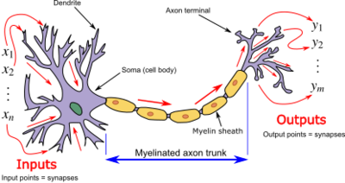
Figure 3. Neuron diagram
- Artificial neurons: Artificial neural networks are artificial networks composed of a large number of processing units that are widely interconnected, used to simulate the structure and function of the brain nervous system. And these processing units are called artificial neurons. The structure of artificial neurons is shown in the figure
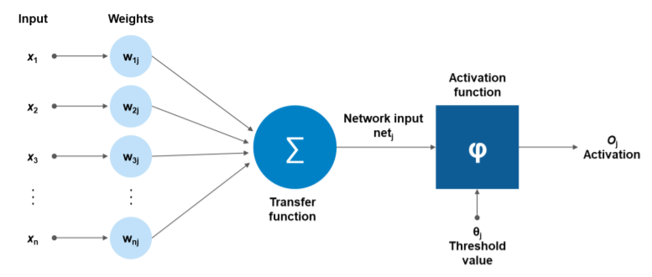
Figure 4. Schematic diagram of artificial neurons

Neural networks simulate the brain from two aspects:
Ⅰ.The knowledge obtained by neural networks is learned from the external environment;
II. The connection strength of internal neurons, i.e. synaptic weights. Used to store acquired knowledge.
The neural network system is composed of a topological structure formed by a large number of connected neurons that can handle the transmission of information between different parts of the human brain. Depending on the large number of neurons and their connections, the human brain is able to receive stimuli from input information, which is non-linear mapped and processed by distributed parallel processing neurons connected to each other, thus achieving complex information processing and inference tasks.

For a certain processing unit (neuron), assuming that the information from other processing units (neurons) is , their interaction strength with this processing unit, i.e. the connection weight value is , =0,1,2,..., n-1, and the internal threshold of the processing unit is . The output of the processing unit is:
Formula 9. output formula

In the formula, is the input of the i-th element, and is the interconnection weight between the i-th processing unit and this processing unit, that is, the neuron connection weight. is called the activation function or action function, which determines the output of nodes (neurons), and represents the threshold of hidden layer neural nodes.

- Artificial neural network: An artificial neural network is composed of multiple neural structures, each layer of neurons having inputs and outputs, and each layer is composed of multiple neurons. The output of the i-1 layer network neuron is the input of the i-layer neuron, and the input data is controlled by the activation function on the neuron to control the size of the output value. The output value is a nonlinear value obtained by activating the function, and the need to activate the element is determined based on the limit value. Generally, multi-layer artificial neural networks are composed of input layer, output layer, and hidden layer. As shown in the figure.
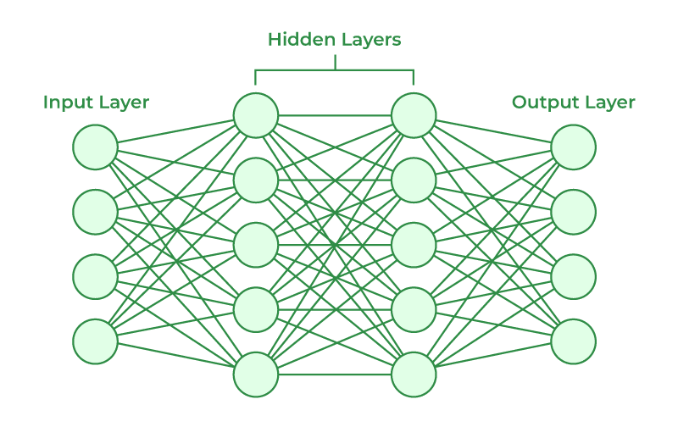
Figure 5. Schematic diagram of neural network

The input layer receives input signals as inputs to the input layer;

The output layer (refers to the layer where signals are transmitted, accumulated, and activated by neurons in a neural network to form an output signal for output;

Hidden layer: Hidden layer, also known as hidden layer, is a network layer composed of a large number of neurons arranged side by side between the input layer and the output layer. Usually, an artificial neural network can have multiple hidden layers.

- Loss function: First, assign random values to all weight vectors and bias , and use these randomly generated weight parameter values to predict the data samples in training. The predicted value of the sample is , and the true value is y. Now, we define a loss function with the goal of making the predicted value as close to the true value as possible. The loss function is to make the loss value of the neural network as small as possible. The basic formula is:
Formula 10. Loss function

The best way to make the model work is to change the parameters and in the neural network to minimize the value of the loss function. During the training phase, the weight vector and bias of the neural network are modified through algorithms to minimize the loss function. When the loss function converges to a certain threshold or is equal to zero, stop training and obtain the weight vector and bias . So far, all parameters in the structure of the artificial neural network model (input layer, output layer, number of nodes in the hidden layer, weight vector , bias ) are known. It is only necessary to input the vectorized data from the input layer of the artificial neural network, calculate it in the direction of data flow in the network, until the data is transmitted to the output layer and output (one forward propagation), Complete one prediction and obtain the classification results.
- The Feed Forward algorithm: The Feed Forward algorithm is repeatedly used in the training and prediction stages of neural networks and is the most common algorithm in neural networks. The calculation method is simple, and only needs to calculate the input data based on the data flow direction of the neural network model, and ultimately obtain the output result. Assuming is the connection between the i-th neuron in the l-th layer network and the j-th neuron in the i+1 layer network, then according to the basic formula of neurons:
=
Formula 11. Basic formula for neurons
Quantify the parameters of the neural network, expressed as:
，，
=
Formula 12. Neuron formula matrix form

Therefore, the forward propagation algorithm of a single-layer neural network can be expressed using a matrix as:
Formula 13. the forward propagation algorithm
Where is the output matrix of the -th layer network, and is the activation function.

- Weights and biases: Each connection in the neural network has a weight used to adjust the impact of the input. Each neuron also has a bias term used to adjust the threshold of the activation function. These weights and biases are learned during the training process.

- Back propagation and optimization: In order to make the model's predictions closer to the real labels, it is necessary to adjust the weights and biases through back propagation algorithms. Optimization algorithms (such as gradient descent) are used to minimize the loss function and find the weights and biases that minimize the loss. The mathematical definition of Back Propagation Algorithms is based on some mathematical rules in calculus. Assuming the parameters of the neural network model are , the essence of the back propagation algorithm is to obtain the partial derivatives of each parameter in the network model through the chain derivative rule.
The four most basic equations in the back propagation algorithm are as follows:
BP1’s output layer error:
Formula 14
BP2’s -th layer Error:
Formula 15
The partial derivative of the BP3 loss function regarding bias:
Formula 16
Partial derivative of BP4 loss function with respect to weight:
Formula 17
Among them, the error of the -th neuron in the -th layer is defined as the deviation of to . is the gradient at, which is the activation function of , is the weight, and is the bias. The back propagation algorithm process is summarized based on four basic equations, as shown in the figure:
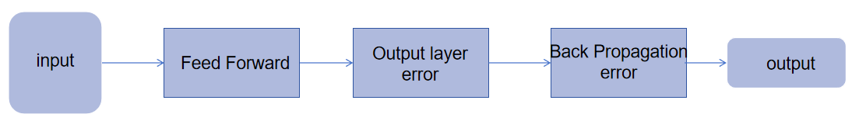
Figure 6. Neural Network Model Flowchart

- Threshold and classification decisions: Typically, the output of a model is a value between 0 and 1, representing the probability of belonging to a positive category. In order to make classification decisions, a threshold (usually 0.5) can be set. If the output value is greater than the threshold, it is classified as a positive category, otherwise it is classified as a negative category.

- Training and Evaluation: Neural network models typically require training on training data with known labels. Once the training is completed, test data can be used to evaluate the performance of the model, typically using indicators such as accuracy, precision, recall, F1 score, etc.

4.3 Research Methods

4.3.1 Mathematical Statistics of Historical Disasters
This study uses the historical disaster mathematical statistics method, which studies the factors that may cause disasters to occur, the relationship between the occurrence of disasters, and the regularity of the interrelationships between various related factors. It is mainly a scientific method that uses statistical calculations such as sample mean, standard deviation, standard error, coefficient of variation rate, mean square, test inference, correlation, regression, cluster analysis, discriminant analysis, principal component analysis, orthogonal experiment, fuzzy mathematics, and grey system theory to conduct relevant research on the data obtained from experiments, measurements, and surveys to obtain the required results. It requires randomness and the data must be truthful and reliable, which is the basis for quantitative analysis.

5. Experimental results

5.1 Results of naive Bayesian binary classification model
Taking the input/output results of Wuhan in June（from 2007 to 2021） as an example, the July data is divided into the training set for the independent variable (X_train) (yellow area in the table), the training set for the dependent variable (y_train) (red area in the table), the testing set for the independent variable (X_test) (green part in the table), and the testing set for the dependent variable (y_test) (blue part in the table). Each part of the data is as follows:
Table 12. Selection of data for training and testing sets in June
Barren | Cropland | Forest | Grassland | Impervious | Shrub | Water | rainfall_Jun | temperature_Jun | GDP | population | Pipeline length | Newly sponge city | June
2.1960998 | 1.9250143 | -1.0418583 | 1.569441 | -1.8451879 | 1.3283612 | -0.55732006 | -0.7780391 | 2.626754 | -1.3740637 | -1.444478 | -1.4573152 | -0.5985289 | 0
0.51327944 | 1.4672233 | -0.93397963 | 1.5157322 | -1.5408096 | 1.3283612 | 0.32021618 | -0.5990806 | 0.06608138 | -1.3627758 | -1.4095522 | -1.3514798 | -0.5985289 | 0
-0.46561742 | 1.127048 | -1.0043904 | 1.3031349 | -1.1915627 | 0.9627184 | 0.74962705 | 0.7210498 | 1.4703217 | -1.2411972 | -0.87656444 | -1.2043955 | -0.5985289 | 0
-0.43262064 | 1.0584937 | -1.396626 | 1.3493841 | -0.8437117 | 0.9627184 | 0.38369623 | -0.5607919 | -0.9251456 | -1.0298774 | -1.3853192 | -0.6882438 | -0.5985289 | 0
-0.41062278 | 0.76593304 | -1.4209826 | 0.7742522 | -0.5681178 | 0.9627184 | 0.79947287 | 1.7798176 | -1.0077482 | -0.75543636 | -0.23775679 | -0.48959872 | -0.5985289 | 1
-0.652597 | 0.5806123 | -1.3000066 | 0.3505493 | -0.3421064 | 0.9627184 | 0.64002573 | -0.23284012 | 0.23128667 | -0.47940683 | -0.16832118 | -0.34623235 | -0.5985289 | 0
-1.2465339 | -0.28982213 | 0.22170939 | -0.3834709 | -0.029864416 | 0.04862925 | 1.1753367 | 0.30403513 | -0.18172498 | -0.24766386 | -0.09888557 | 0.107964896 | -0.5985289 | 1
-1.4335145 | -0.43755102 | 0.4911865 | -0.37228158 | 0.07497197 | 0.04862925 | 1.0426152 | -1.2874461 | -0.512134 | -0.022389844 | -0.016951216 | 0.15789755 | -0.5985289 | 0
-0.9825617 | -0.7069283 | 0.77680284 | -0.44314733 | 0.28741333 | -0.13419218 | 1.0601122 | -0.175407 | -0.75994194 | 0.16259728 | 0.17031641 | 0.21217217 | -0.5985289 | 0
-0.77358425 | -0.7894403 | 0.90154177 | -0.6975183 | 0.52394766 | -0.682656 | 0.34654596 | 1.166365 | -1.1729536 | 0.38539332 | 0.2803717 | 0.27404526 | -0.5985289 | 0
-0.13565202 | -0.96823305 | 1.1530837 | -0.8474553 | 0.728404 | -0.682656 | 0.012121065 | -0.5949188 | -0.9251456 | 0.7167584 | 0.36834693 | 0.29249862 | -0.5985289 | 0
0.79924816 | -0.9189726 | 1.1564643 | -0.95412695 | 0.95940167 | -0.8648329 | -1.1272742 | -1.2990993 | 0.23128667 | 1.0346763 | 0.49895483 | -0.3099497 | 1.2871411 | 0
0.94223326 | -0.8982948 | 1.0328435 | -1.0026141 | 1.0824924 | -1.2306149 | -1.4990366 | 0.96160316 | -0.18172498 | 1.3390917 | 0.5899153 | 1.1060752 | 1.6356771 | 0
0.9202354 | -0.9024744 | 0.64533144 | -0.9093696 | 1.299987 | -1.5963969 | -1.6826106 | 1.6566278 | 0.14868402 | 1.2047627 | 1.4479316 | 1.4170688 | 1.9439976 | 0
1.1622083 | -1.012608 | 0.71888006 | -1.2525094 | 1.4047426 | -1.4135059 | -1.663528 | -1.0618755 | 0.89210474 | 1.6695321 | 2.2819922 | 2.2794926 | 1.7170022 | 0

Establishing a naive Bayesian binary classification prediction model for the data, after training, and evaluating the y_ Test and y_ Train to predict and obtain a prediction classification result of 0 or 1. Comparing the prediction classification result with the original data to obtain the accuracy of the model. Giving the result as follows:

Table13 . Bayesian binary classification prediction model results for June data
dataset | waterlogging | prediction results | Prediction accuracy
Training set | 0 | 0 | 91%
Training set | 0 | 0 | 91%
Training set | 0 | 0 | 91%
Training set | 0 | 0 | 91%
Training set | 1 | 1 | 91%
Training set | 0 | 1 | 91%
Training set | 1 | 1 | 91%
Training set | 0 | 0 | 91%
Training set | 0 | 0 | 91%
Training set | 0 | 0 | 91%
Training set | 0 | 0 | 91%
Test set | 0 | 0 | 100%
Test set | 0 | 0 | 100%
Test set | 0 | 0 | 100%
Test set | 0 | 0 | 100%

The process of dividing the dataset for July and August is not presented in the main text, and the results are presented in the form of a table with analysis.

Table14 . Bayesian binary classification prediction model results for July data
dataset | waterlogging | prediction results | Prediction accuracy
Training set | 0 | 0 | 72.7%
Training set | 0 | 0 | 72.7%
Training set | 0 | 0 | 72.7%
Training set | 0 | 0 | 72.7%
Training set | 1 | 0 | 72.7%
Training set | 1 | 1 | 72.7%
Training set | 0 | 1 | 72.7%
Training set | 0 | 1 | 72.7%
Training set | 1 | 1 | 72.7%
Training set | 1 | 1 | 72.7%
Training set | 0 | 0 | 72.7%
Test set | 0 | 0 | 75%
Test set | 0 | 0 | 75%
Test set | 1 | 0 | 75%
Test set | 0 | 0 | 75%
According to the prediction results, it can be seen that in the training set data, there are three incorrect Bayesian prediction results, and in the test set data, there is one correct Bayesian prediction result. The prediction accuracy of Bayesian binary classification prediction on the training set is 72.7%, the prediction accuracy on the test set is 75%, and the comprehensive prediction accuracy is 73.85%, achieving good prediction results.

Table14 . Bayesian binary classification prediction model results for August data
dataset | waterlogging | prediction results | Prediction accuracy
Training set | 0 | 0 | 100%
Training set | 1 | 1 | 100%
Training set | 0 | 0 | 100%
Training set | 0 | 0 | 100%
Training set | 0 | 0 | 100%
Training set | 0 | 0 | 100%
Training set | 0 | 0 | 100%
Training set | 0 | 0 | 100%
Training set | 0 | 0 | 100%
Training set | 0 | 0 | 100%
Training set | 1 | 1 | 100%
Test set | 0 | 0 | 100%
Test set | 0 | 0 | 100%
Test set | 0 | 0 | 100%
Test set | 0 | 0 | 100%
According to the prediction results, it can be seen that the Bayesian prediction results are correct in both the training and testing sets. The Bayesian binary classification prediction has a prediction accuracy of 100% in both the training and testing sets, and a comprehensive prediction accuracy of 100%, achieving great prediction results.

5.2 Prediction results of neural network binary classification model
In the neural network model, data is divided into three input datasets, namely June as the input dataset, July as the input dataset, and August as the input dataset. The partitioning method of the dataset is consistent with the partitioning method in the naive Bayesian model, and is not shown in the main text. In the process of selecting the number of iterations for training, the first step is to set the number of iterations to 10, resulting in poor prediction accuracy and under fitting linearity. After multiple experiments and attempts, the final iteration training count was set to 100. The results and conclusions from June to August are as follows：

Table 15. Neural network binary classification prediction model results for June data
dataset | waterlogging | prediction results | Prediction accuracy
Training set | 0 | 0 | 100%
Training set | 0 | 0 | 100%
Training set | 0 | 0 | 100%
Training set | 0 | 0 | 100%
Training set | 1 | 1 | 100%
Training set | 0 | 0 | 100%
Training set | 1 | 1 | 100%
Training set | 0 | 0 | 100%
Training set | 0 | 0 | 100%
Training set | 0 | 0 | 100%
Training set | 0 | 0 | 100%
Test set | 0 | 0 | 100%
Test set | 0 | 0 | 100%
Test set | 0 | 0 | 100%
Test set | 0 | 0 | 100%
According to the prediction results, it can be seen that the neural network model's prediction results are all correct in both the training set data and the prediction set data. The prediction accuracy on both the training and testing sets is 100%, and the comprehensive prediction accuracy is 100%, achieving great prediction results.

Table 16. Neural network binary classification prediction model results for July data
dataset | waterlogging | prediction results | Prediction accuracy
Training set | 0 | 0 | 100%
Training set | 0 | 0 | 100%
Training set | 0 | 0 | 100%
Training set | 0 | 0 | 100%
Training set | 1 | 1 | 100%
Training set | 1 | 1 | 100%
Training set | 0 | 0 | 100%
Training set | 0 | 0 | 100%
Training set | 1 | 1 | 100%
Training set | 1 | 1 | 100%
Training set | 0 | 0 | 100%
Test set | 0 | 0 | 75%
Test set | 0 | 0 | 75%
Test set | 1 | 1 | 75%
Test set | 0 | 1 | 75%

According to the prediction results, it can be seen that in the training set data, the prediction results of the neural network model are all correct, while in the test set data, one of the prediction results of the neural network model is incorrect. The prediction accuracy on the training and testing sets is 100% and 75%, respectively, with a comprehensive prediction accuracy of 87.5%, achieving great prediction results.

Table 17. Neural network binary classification prediction model results for August data
dataset | waterlogging | prediction results | Prediction accuracy
Training set | 0 | 0 | 100%
Training set | 1 | 1 | 100%
Training set | 0 | 0 | 100%
Training set | 0 | 0 | 100%
Training set | 0 | 0 | 100%
Training set | 0 | 0 | 100%
Training set | 0 | 0 | 100%
Training set | 0 | 0 | 100%
Training set | 0 | 0 | 100%
Training set | 0 | 0 | 100%
Training set | 1 | 1 | 100%
Test set | 0 | 1 | 0%
Test set | 0 | 1 | 0%
Test set | 0 | 1 | 0%
Test set | 0 | 1 | 0%
According to the prediction results, it can be seen that in the training set data, the neural network model prediction results are all correct, while in the test set data, the neural network model prediction results are not accurate. The prediction accuracy on the training and testing sets is 100% and 0%, respectively, with a comprehensive prediction accuracy of 50%, indicating poor prediction performance.

5.3 Explanation of experimental results validation

5.3.1 Binary confusion matrix
To provide a more accurate explanation of the experimental results, we introduce a confusion matrix, which is a tool used to evaluate the performance of classifiers. It is a matrix of n rows and n columns, where n is the number of categories. Each cell represents the cross count of a real category and a predicted category. The confusion matrix is a situation analysis table used in machine learning to summarize the prediction results of classification models. It summarizes the records in the dataset in the form of a matrix according to two criteria: the true category and the category judgment predicted by the classification model. The rows of the matrix represent the true values, and the columns of the matrix represent the predicted values. Let's take binary classification as an example and take a look at the matrix representation, as follows:
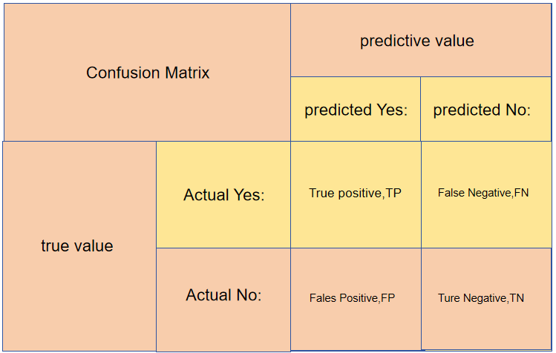
Figure 7. Schematic diagram of confusion matrix

The parameters are as follows:
（1）TP (True Positive): Predict a positive class as a positive class number, with a true value of 0 and a predicted value of 0.
（2）FN (False Negative): Predicts a positive class as a negative class number, with a true value of 0 and a predicted value of 1.
（3）FP (False Positive): Predict negative classes as positive class numbers, true to 1, predicted to 0.
（4）TN (True Negative): Predict negative classes as negative class numbers, with a true value of 1 and a predicted value of 1.

5.3.2 Confusion matrix results in the experiment
Taking the neural network binary model as an example:
- . Results of data for June
The prediction accuracy of the training set (11 samples) for June data is 100%

Figure 8. training set Confusion matrix in June
The prediction accuracy of the test set (4 samples) for June data is 100%

Figure 9. test set Confusion matrix in June

(2). Results of data for July
The prediction accuracy of the training set (11 samples) for July data is 100%

Figure 10. training set Confusion matrix in July
The prediction accuracy of the test set (4 samples) for July data is 75%

Figure 11. test set Confusion matrix in July

(3). Results of data for August
The prediction accuracy of the training set (11 samples) for August data is 100%

Figure 12. training set Confusion matrix in August

The prediction accuracy of the test set (4 samples) for August data is 0%

Figure 13. test set Confusion matrix in August

5.4 Secondary indicators
In order to analyze the experimental results better, the confusion matrix has extended the following four indicators on the basic statistical results, calling them secondary indicators. This experiment used four secondary indicators, and we named them accuracy, recall, precision, and F1-score.
- . Accuracy: The proportion of all correctly judged results in the classification model to the total observed values is called accuracy, and the formula is:
Formula 18. Accuracy rate
Although accuracy can determine the overall accuracy, it cannot be used as a good indicator to measure results in cases of imbalanced samples. For example, in a total sample, where positive samples account for 90% and negative samples account for 10%, the sample is severely imbalanced. For this situation, we only need to predict all the samples as positive samples to obtain a high accuracy of 90%, but in reality, we did not classify very carefully, just casually without a brain. This indicates that the problem of imbalanced samples leads to significant issues in obtaining high accuracy results. If the sample is imbalanced, the accuracy will fail.

- . Recall: recall rate is also known as sensitivity. Among all results where the true value is positive, the proportion of the model prediction is correct. (Corresponding missed detection: The lower the indicator, the more missed detection) The formula is as follows:
Formula 19. Recall rate

- .Precision: The proportion of model predictions in all results which model observations are positive (Corresponding false alarm: The lower the indicator, the higher the false alarm rate), the formula is:

Formula 20. Precision rate

- .F1-score: F1-score is an indicator used in statistics to measure the accuracy of binary (or multi task binary) models. It takes into account both the accuracy and recall of the classification model. The F1-score can be seen as a weighted average of model accuracy and recall. Its maximum value is 1, and its minimum value is 0. The larger the value, the better the model. If there are 100 samples, including 1 positive sample and 99 negative samples, and the model's prediction only outputs 0, then the accuracy rate is 99%. It is obviously incorrect to use accuracy to measure the quality of the model. The formula is:
Formula 21. F1-score

The results regarding accuracy, precision, recall, and F1 score are as follows:

Table 18. The Results of Naive Bayesian Secondary Indicator
Month | Index | Event | Training set | Test set
June | accuracy | None | 0.91 | 1.0
June | recall | 0 | 0.89 | 1.00
June | recall | 1 | 1.00
June | precision | 0 | 1.00 | 1.00
June | precision | 1 | 0.67
June | F1-score | 0 | 0.94 | 1.00
June | F1-score | 1 | 0.80
July | accuracy | None | 0.73 | 0.75
July | recall | 0 | 0.71 | 1.00
July | recall | 1 | 0.75 | 0.00
July | precision | 0 | 0.83 | 0.75
July | precision | 1 | 0.66 | 0.00
July | F1-score | 0 | 0.77 | 0.86
July | F1-score | 1 | 0.67 | 0.00
August | accuracy | None | 1.0 | 1.0
August | recall | 0 | 1.00 | 1.00
August | recall | 1 | 1.00
August | precision | 0 | 1.00 | 1.00
August | precision | 1 | 1.00
August | F1-score | 0 | 1.00 | 1.00
August | F1-score | 1 | 1.00

Table 19. The Results of Neural Network Secondary Indicator
Month | Index | Event | Training set | Test set
June | accuracy | None | 0.91 | 1.0
June | recall | 0 | 1.00 | 1.00
June | recall | 1 | 0.50
June | precision | 0 | 0.90 | 1.00
June | precision | 1 | 1.00
June | F1-score | 0 | 0.95 | 1.00
June | F1-score | 1 | 0.67
July | accuracy | None | 1.00 | 0.75
July | recall | 0 | 1.00 | 0.67
July | recall | 1 | 1.00 | 1.00
July | precision | 0 | 1.00 | 1.00
July | precision | 1 | 1.00 | 0.50
July | F1-score | 0 | 1.00 | 0.80
July | F1-score | 1 | 1.00 | 0.67
August | accuracy | None | 1.0 | 1.0
August | recall | 0 | 1.00 | 0.00
August | recall | 1 | 1.00 | 0.00
August | precision | 0 | 1.00 | 0.00
August | precision | 1 | 1.00 | 0.00
August | F1-score | 0 | 1.00 | 0.00
August | F1-score | 1 | 1.00 | 0.00

5.5 Experimental Conclusion
In this experiment, the neural network binary classification model had an accuracy rate of 0 in predicting the test set in August. The experimental results showed significant errors. In this experiment, the naive Bayesian binary classification model has a good representation and is more suitable for the experimental results. The reasons for the poor generalization ability of neural network models may include:
- .Insufficient data volume: If the dataset is too less, if the segmentation of the dataset is uneven, or if the distribution of the training and testing sets is uneven, and the model can correctly capture the internal distribution patterns of the data, this may cause the internal variance of the training set to be greater than that of the validation set, resulting in greater errors in the training set. At this point, you need to re segment or expand the dataset to make its distribution the same.
(2) .Excessive number of iterations for training: The fundamental reason is still due to insufficient data volume. Because the data from August cannot be well fitted in actual experiments due to data reasons, the number of iterations for training was adjusted to 500. The experimental results may cause overfitting phenomenon.
6. Summary and Outlook
Today, the global climate is constantly changing due to the influence of human activities, with global temperatures constantly rising and the probability of extreme weather occurring increasing. For every developed countries and developing countries, as the size of each cities continue to expand, the migration population is increasing. The scale of cities and changes in urban terrain and landforms also constantly affect people's lives. The problem of urban waterlogging is becoming increasingly apparent. Urban waterlogging damages urban infrastructure, affects social and economic development, and threatens people's life safety. Even though the research and construction of urban waterlogging risk management and control systems are constantly advancing, research on dynamic assessment of urban waterlogging risks in response to climate change and urbanization is still very limited. It is crucial to scientifically evaluate the impact of climate change and urbanization on urban waterlogging. In order to develop effective urban waterlogging risk management strategies. Therefore, based on existing problems and the research of another scholars, a prediction method based on machine learning binary classification model has been proposed.

6.1 Conclusion
(1) In the process of studying urban waterlogging, variables such as LUCC, GDP, and population are not mutually independent. These factors are interrelated and collectively affect the occurrence of urban waterlogging. However, it is certain that extreme precipitation will increase the occurrence of urban waterlogging, and an increase in impervious surface area will also increase the probability of urban waterlogging.
(2) In the case of a small amount of data, the naive Bayesian binary classification model is superior to the neural network binary classification model, and both algorithms do not need to consider the interrelationships between variables. However, there is currently no conclusion on the issue of urban waterlogging that can directly affect the occurrence of urban waterlogging, except extreme precipitation and the drainage capacity of urban drainage systems. Further research and exploration are needed on the issue of urban waterlogging.
(3) For machine learning algorithms, the size of the dataset has a strong impact on the algorithm. Too little training data can lead to poor approximation. Overconstrained models are insufficient to fit smaller training datasets, while models lacking constraints may overfit training data, both of which result in poor performance. Too little test data will lead to high variance estimation of model performance.

6.2 Innovation
This study uses a binary classification model to predict the occurrence of urban waterlogging, and its innovation lies in transforming complex weather data, land use type data, etc. into easily understandable model outputs. Through machine learning algorithms, this model can predict urban waterlogging and provide effective support for urban disaster prevention.

6.3 Problems and Disadvantages
(1). The size of dataset is too small: The data used in this study was from 2007 to 2021. The official data before 2007 was not fully disclosed, resulting in a decrease in the model's generalization ability and model accuracy in this experiment, which affected the accuracy of the experiment. This results in significant deviations in some experimental results.
(2). Lack of influencing factors: According to literature review, the factors that affect urban waterlogging include changes in urban building area and changes in urban transportation land occupation. Because of these two factors, some of the information belongs to classified information. The research on the impact of urban waterlogging is not comprehensive enough due to the fact that construction land is not publicly available.
(3). Insufficient research tools: Due to the influence of experimental environment and conditions, the model used in this study can only roughly predict whether urban waterlogging occurs. Many researchers use GIS and other technologies to integrate geographic information such as urban terrain and altitude into the experiment. By drawing the waterlogging prone points of multiple cities, the impact of urban waterlogging can be explained, and the causes of the problems can be analyzed. This experiment mainly uses the mathematical statistics method of historical disasters, combined with official data, to make a simple prediction of urban waterlogging.
(4) Experimental result issue: The fundamental reason is that the size of dataset is too small. The neural network binary classification model failed to predict the occurrence of waterlogging in August due to overfitting caused by insufficient data volume.、

References

