Assessment Form

Module: Preparing for Professional Policing
Student Name: Cassy Rumberlow
Module Tutor (s): Kelly Andrews
Question | 1  Situation | 2  Task | 3.  Action | 4.  Result |  | Total Mark
1 | 3/5 | 1/5 | 8/15 | 2/5 |  | 14/30
2 | 4/5 | 1/5 | 10/15 | 2/5 |  | 17/30
3 | 3/5 | 1/5 | 8/15 | 2/5 |  | 14/30
 |  |  |  |  |  | Total Mark 45/90
Key
No Reference | Minimum | Satisfactory | Exceptional
0 | 0-4 | 5-10 | 11-15

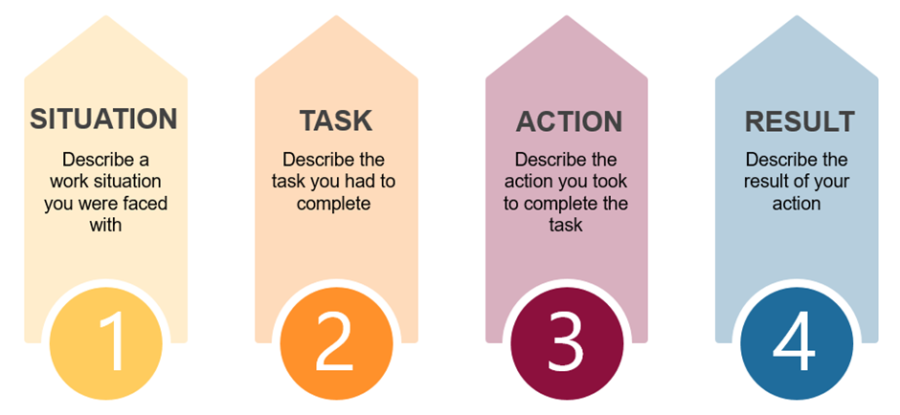

Question | Comments
1 | Q2  Work example: Key holder for MS- There was a time where I forgot to lock one of the doors in the building.  I realised, I took ownership, so I called the manager.  We resolved it by returning and securing the door.  Needed a prompted. For more detail around what would happen if she had not done this- needed more detail.  Needed to explain in more detail why it was challenging.  Need to use STAR in more detail.
2 | Q5.  Work example  Time where the fire alarm had set off in the building – can’t use the lift and there were several elderly people in the building.  Key decision was to use the stairs.  Use I not We.  There was a need for the evacuation car because of a person in a wheelchair.  That needed to be done in a short space of time – didn’t know where the fire was.  Not doing this could have led to anything.  Needed a prompt for more detail –  USE STAR in more detail start each sentence with each element so you don’t miss sections.
3 | Q9:  Work related example:  Two young boys who had trespassed in the building – I needed to adapt my way of working because instead of calling another manager – I took my own action to resolve the issue myself-  I took them down the right way, took them out of the building.  Explained what they could have done if this had not happened.  Provide more detail around the decisions that you made- why did you do these things.  Did go into more detail after a prompt.  Did link back to the question being asked which was good.  .

.

.

