Communication & Network Simulation
Research and Evaluation of BPSK Modulation & Wireless Sensor Network Design and Evaluation

George P. Searle
School of Applied Computing
University of Wales Trinity Saint David
Swansea, Wales

Abstract—Simulation is an important step before implementing any communication or network system in the real-world. Digital modulation is a fundamental concept in communication systems and has a direct effect on communication performance. This makes waveform-level simulations an important step when designing communication hardware. Network simulation is also more important than ever with the growing popularity of Wireless Sensor Networks (WSN), Smart and Internet of Things (IoT) devices. This report will research and evaluate the BPSK modulation technique, as well as evaluate the performance of a WSN based smart factory network.
Keywords-communication systems; network simulation; modulation; BPSK; Simulink; WSN; smart factory; NetSim

introduction
Modulation is a fundamental concept to all wireless communication systems, where by a periodic waveform has its properties varied to enable it to carry information [1]–[3]. The goal and function of digital modulation is to fit as much data as possible (in the form of binary ‘1s’ and ‘0s’) into as little spectrum as possible to allow successful wireless data transfer over a channel [1], [2].
Communication systems are closely linked to computer network systems. This is because it is the role of the physical layer of the Open Systems Interconnection (OSI) model to generate electrical, microwave and optical signals which signify the bits in a frame [4]. There are three functions of the physical layer, encoding, signalling and physical components [4]–[6]. Digital modulation would occur at the physical layer as part of the encoding and signalling process [7], [8]. For physical layer techniques to function the media access control (MAC) sublayer of the data link layer and the data link protocols control the format of frames for different media, and establish the specifications for physical layer implementations [9], [10]. This means that during a network simulation the media and how a communication system is implemented will play an important factor.
Simulation is the mimicking of a system or real-world process over a period of time [11], [12]. The advantages of using a computer-based simulation is that it allows a user to design and evaluate different system designs without having to physically build them [12]. This makes simulation a more affordable, cost effective and flexible method compared to building a test-bed [13]. Simulation is well suited to analysing large complex problems which would not be possible to solve with a mathematical method [14]. Another advantage of simulation is the ability for systems and problems to be studied at different levels of detail, from individual components to a full system [12]. This allows for detailed analysis of interactions between variables and performance evaluation [11]. Simulation is also good as a teaching aim to demonstrate concepts [12]. Disadvantages of simulation include the initial steep learning curve to operate the software, which may require training from an expert [11], [13]. Simulation software is expensive and time consuming to develop. The software is often then expensive to buy and time consuming to run, providing results that are often hard to interpret [11]. High performance hardware is needed due to the computational intensive processing of simulation [12]. There is no standardised approach meaning the credibility and validation of simulation is a factor that must be considered. This is because not every single variable from the real-world can be implemented. The software must also be error free and based on verified models [15]–[17]. User error can also affect how a simulation performs (e.g. choosing inappropriate initial conditions and shortening run times) [17].
The Binary Phase-Shift Keying (BPSK) modulation scheme will be examined in section II, including fundamentals, advantages and disadvantages, as well as implementations. In section III a simulation of BPSK is demonstrated in Simulink. A wireless sensor network (WSN) for application in a smart factory is then presented and evaluated in section IV. Finally, the report concludes with a discussion and conclusion.

bpsk modulation scheme

BPSK Fundamentals
Binary Phase-Shift Keying (BPSK) also known as binary antipodal signalling, is a basic modulation technique that transfers one bit of data per symbol [1], [18], [19]. A symbol is the number of sine carrier signal state changes per second (per periodic waveform per sub-carrier) [1], [3], [20]. This can be a change in amplitude, frequency or phase [21]. There are two phases of the carrier signal in BPSK, separated by a 180º phase change [22], [23].
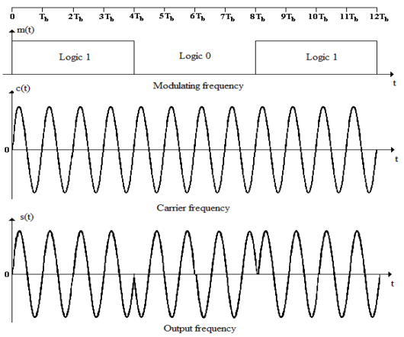
Fig. 1. BPSK modulation [22]
Binary ‘1s’ are carried in one phase and ‘0s’ carried in the other phase (the modulated signal is inverted by 180º) [2], [24], as seen in fig. 1. Both phases have the same frequency and amplitude [25].
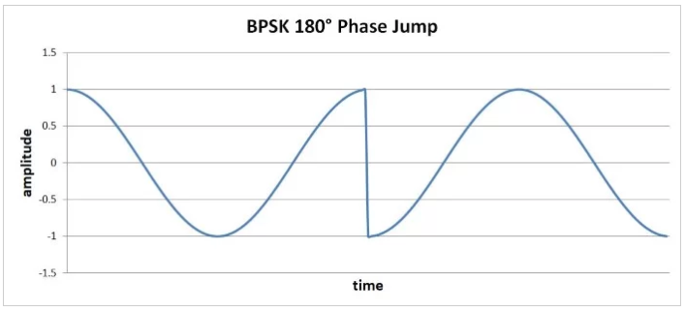
Fig. 2. BPSK with phase jump [24]
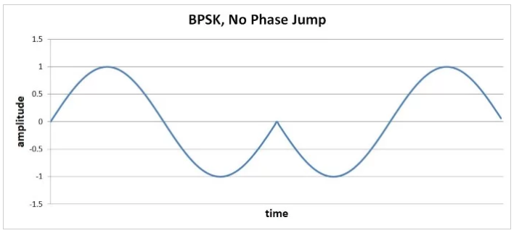
Fig. 3. BPSK with no phase jump [24]
To avoid phase jumps in BPSK (as seen in fig. 2) also called high-slope changes the digital bit duration (period) equals one or more complete carrier cycles. The carrier waveform and digital transition between ‘1’ and ‘0’ are also synchronised. This means that a phase transition will occur when the carrier signal’s amplitude is zero (or very close), as seen in fig. 3. Phase jumps are undesirable as amplifiers have a limited ability to produce such changes in voltage. High-slope changes will also create unwanted higher-frequency energy that could disrupt other radio frequency (RF) signals [24], [26].

Advantages & Disadvantages
There are a few advantages to using BPSK over other modulation techniques. BPSK is a simple system to design and very power efficient [2], [23], [27]. BPSK also has the lowest bit error rate (BER) when subjected to various signal-to-noise-ratios (SNR) compared to Differential Binary Phase-Shift Keying (DBPSK), Quadrature Phase-Shift Keying (QPSK) and Quadrature Amplitude Modulation (QAM) [28]–[32]. This means BPSK has high immunity to noise [29].
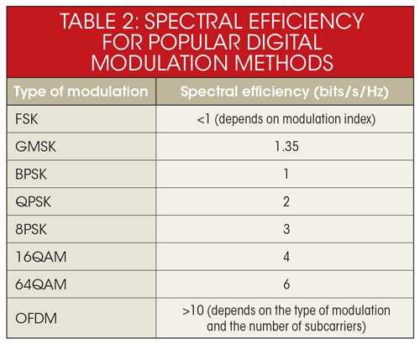
Fig. 4. Spectral efficiency for popular digital modulation techniques [1]
The disadvantages of BPSK include low bandwidth efficiency compared to other modulation techniques [1], [24], [33]. This is because BPSK carries one bit per symbol, which means it only has a spectral efficiency of one bit per second per Hz (bit/s/Hz) [1], [3], [20], as seen in fig. 4. Spectral efficiency is a measure of how fast data can be transmitted in a given bandwidth [1]. Another disadvantage of BPSK is ambiguity of the output signal [2], [18], [34], [35]. This is because it is impossible to tell whether demodulated data has or as not been inverted [31]. This can cause a problem as phase information may be lost if the exact carrier frequency is not known [36].

Application & Implementations
BPSK is widely used in wireless local area networks (LANs), Radio-frequency identification (RFID) and Bluetooth communication applications [36]. This is due to the robustness of BPSK modulation because of its high noise immunity [36]. However, it should be noted that BPSK is best suited for use in low speed communication systems due to its low spectral efficiency [2]. BPSK is often used in Mobile sink assisted Wireless Sensor Networks (MWSNs) for modulation in Static Sensor Nodes (SSN), due to the technique’s superior power efficiency [27]. BPSK is also used in cable modem and deep space telemetry applications [37]. Other proposed implementations of BPSK include use in Ultra-Wide Band (UWB) communication and ground penetrating radar (GPR) [23], [38].

bpsk simulink simulation
Simulink is a software simulation and model-based design plug-in for MATLAB [39]. It can be used to simulate at the MAC sublayer and physical layer of the OSI model [40].
A simple BPSK modulator and demodulator was designed in Simulink with a Guassian noise channel, as seen in fig. 6-8 given in Appendix A. To test the bit error rate (BER) performance of BPSK, the signal-to-noise-ratio (SNR) was gradually decreased and the BER observed, as seen in table 1.
Table 1. Effect of SNR on BER
Signal-to-noise-ratio (SNR) | Bit error rate (BER)
1 | 0
-4 | 0
-9 | 0.01
-14 | 0.05
-19 | 0.16
-24 | 0.24
-29 | 0.40
-34 | 0.41
-39 | 0.47
-44 | 0.50

At an SNR (dB) of 1, no errors were observed, as seen in fig. 9 given in Appendix A. When the SNR was lowered to -4 a visible error can be seen in fig. 10-11 given in Appendix A, despite the BER remaining at 0. This may be due to the error being minimal that the Error Rate Calculation block (in Simulink) did not register it. The error has occurred due to the level of noise causing an increase in amplitude. The sine wave has crossed 0 amplitude which causes the conditioning circuit of the demodulator to register the wave as a zero.
As the SNR is lowered the demodulated signal further degrades, as seen in fig. 12 given in Appendix A. At an SNR of -29 the BER is 0.40 as it is severely degraded, as seen in fig. 13 given in Appendix A. When the SNR was -44 the BER was 0.50, as seen in fig. 14-15 given in Appendix A. At this point the demodulation completely fails as phase changes can no longer be detected accurately, as seen in fig. 15 given in Appendix A.

Fig. 5. A scatter plot showing the effect of SNR on BER
Fig. 5 shows a scatter plot of SNR verses BER and visually highlights that as SNR decreases the BER increases, which will result in degraded performance.
The author’s results agree with the researched literature that BPSK has high resistance to noise [29], [36]. BER performance of BPSK has been compared to other modulation techniques [28]–[32]. However, the author’s results do not match existing research test results. This can be explained by several factors. The author used a carrier signal frequency of 100Hz and designed a simplistic model from scratch, which is likely not an industry correct design. The author also tested BPSK to failure and used negative SNR values which presented high BER percentages (in relation to existing tests). If existing research conducted BER performance to failure a similar trend to that found by the author would likely be discovered.

wireless sensor network design & evaluation

Design
Fig. 16-17 given in Appendix B show the author’s smart factory Wireless Sensor Network (WSN) design, implemented in Tetcos NetSim Standard edition; a network layer simulation software [41]. The WSN is implemented using the Internet Protocol version 6 (IPv6) Low-power Wireless Personal Area Network (6LowPAN) standard [42]. 6LowPAN integrates IPv6 into low-power wireless IEEE 802.15.4 devices [42]–[44]. The 6LowPAN standard was developed to further low-power Wireless Embedded Internet devices by providing an open standard that optimises related protocols [44].
The smart factory is 200m long by 100m wide. The WSN features two occupancy sensors to control the heating system and four motion sensors to control four industrial warehouse lights. An RFID reader and secure door control access into the factory. There are also two integrated smoke and heat sensors to control a fire alarm system. The sensors and systems are connected to a main control and monitoring server. This allows for a simple consolidated system which can be monitored to various degrees (based on security policy) from the warehouse manager’s and reception computer, as well as by health and safety officers’ smart devices. The RFID and access door connect to a secure registration server, a separate server from the control server. This keeps personal information separate from the control server for security purposes. The interactions between control server and registration server are also controlled by policies. The control and monitoring server will only have a limited view of access data and logs and cannot modify the registration server. The manager’s user account will have the ability to modify sensor and system parameters, as well as access to the registration server to add new records etc. The sensors, servers, systems and devices are connected to the main backbone network with a gateway router. This allows for remote monitoring by ‘Warehouse Secure’, a security contractor.
The backbone network, servers and desktop computers are located on the top (north) side of the factory. This is where the offices are located and keeps network equipment away from any factory machinery. This will minimise electrical interference. It is assumed that the factory is a small-scale manufacturing plant. It is also assumed that there is additional network redundancy in place. However, the simple design has been chosen to minimise latency and delay in the WSN. This is because low delay is an important factor in WSNs [45]–[47]. Systems such as the fire, heating and lighting are cabled from the control server to the reacting systems, instead of adding additional wireless devices. This was a design choice to provide better reliability and low delay to important systems.

Simulation Methodology
The smart factory WSN will be simulated in two different scenarios for a duration of 10 minutes each. The first scenario will be a best case synthetic simulation with no pathloss. The second scenario will introduce PathLoss, Fading and Shadowing (using the ‘INDOOR_FACTORY’ pathloss model with a standard deviation of 6) to the environment to demonstrate a more realistic simulation. The pathloss exponent is 2.1, Rayleigh fading model with 1 fading figure and Lognormal shadowing model. The noise is applied to the environment to impact on the IEEE 802.15.4 WSN devices and IEEE 802.11 wireless links.
The simulation features three different application data types. Constant Bit Rate (CBR) is used as the data type for communication between the RFID reader and door, as well as data sent from the control server to the lights, heating thermostat and fire alarm system. CBR was chosen as the data type as these systems are likely to receive regular status updates. The inter arrival time is set to constant at 20,000 microseconds. Sensor application is used as the data type for communication from all sensor nodes to the control server. The inter arrival time is set to constant at 1,000,000 microseconds. This is because sensor nodes will only send data when required to remain energy efficient and are often in a low power state. Database is used as the data type for communication from the control server to monitoring users (e.g. manager and health and safety officers). This seems like an appropriate data type for real-time logs to be transmitted. The inter arrival time is set to constant at 1,000,000 microseconds. This value could be lower but has been chosen to prevent the network from being flooded by unnecessary traffic. The monitoring of sensor statuses is also not super time critical and one second updates should be fine.
Advanced Encryption Standard (AES) has been used on communication between the RFID reader and door, as well as the fire alarm system and all monitoring applications. This hardens security against snooping and modification of sensitive data.

Results

Delay
Low delay is an important consideration in WSN design. For example, it would not be acceptable for there to be a noticeable delay between a light motion sensor detecting movement and the light switching on.
Fig. 18 given in Appendix B shows the effect that pathloss has on delay between a sensor and the reacting system. The graph highlights that there is no clear link between pathloss and increased delay. This is because Light 1 and 3, and the Fire alarm system show increased delay with pathloss. While Light 2 and 4, the Door and Heating systems show reduced delay with pathloss. These findings contradict established concepts and results [48]–[51], thus put the author’s results validity into question. One explanation for the author’s mixed results are poor WS node placement (as not all sensors are the IEEE 802.15.4 standard’s recommended 8m distance from each other [41]). WSN pathloss modelling simulations are also known to be hard to simulate accurately and often lead to unreliable results [50], [51], [52]. The delay of less than 60 milliseconds in every scenario is good performance. This is because all systems will be perceived to be performing instantaneously [53]. Such a good delay benchmark also allows room for overhead caused by any server processing (which is not demonstrated in the simulation).
Fig. 19 given in Appendix B shows the effect of pathloss on delay of the real-time monitoring between control/monitoring server and various users. Similar unpredictable results can be seen. The delay is significantly less (less than 0.07 sec) than what was seen in fig. 16. This is because the monitoring system is mainly facilitated through the wired network, with only the health and safety officers connecting to an IEEE 802.11 access point (AP). The delay of less than 7 milliseconds for every monitoring scenario is excellent performance for a real-time monitoring system according to Burger [53].

Packet Loss
Packet loss is undesirable in a network as it will cause degraded performance, packet retransmissions and increase delay [54].
Fig. 20 given in Appendix B shows the total number of packets transmitted in each simulation with and without pathloss. The simulation without pathloss has a higher number of transmitted data and control packets, 453393 compared to 451493 data packets and 733198 compared to 731405 control packets. The difference in transmitted data packets is 1900 and 1793 for control. The difference in transmitted packets could possibly be linked to the greater number of packet collisions and less backoff time of wireless sensor nodes in the simulation without pathloss.
Fig. 21 given in Appendix B shows the total number of packets errored in each simulation. The simulation with pathloss has 1240 errored data packets compared to 1214 without and 91 errored control packets compared to 69. This is an anticipated result as with greater noise and interference more errored packets are to be expected.
Fig. 22 given in Appendix B shows the total number of collided packets in each simulation. The simulation without pathloss has 2757 collided data packets compared to 1843 without (a difference of 914) and 12596 collided control packets compared to 12580. This is a surprise to the author as it would be expected that pathloss would contribute to greater collisions. A possible explanation is a combination of factors. WSNs can form a multi-hop self-organised wireless network [55]. This means that a node can transmit data to another node which can then forward that data to other nodes, to the 6LowPAN gateway (that connects the sensor nodes to the backbone network). Fig. 23 given in Appendix B shows that sensor nodes 7, 11 and 12 are forwarding packets in the simulation without pathloss. Fig. 24 given in Appendix B shows that nodes 7, 11 and 12 have not forwarded any packets in the pathloss simulation. This possibly means that when noise and interference are introduced into the simulation neighbouring nodes lose the visibility of nodes 7, 11 and 12 and send packets directly to the 6LowPAN gateway instead. Considering the already identified poor placement and lack of nodes in the simulation; collisions may occur when packets are forwarded to other nodes. This is because the receiving node may transmit itself at the same time to the gateway. This is a conflict as a node is transmitting and receiving in one time slot [49]. Congestion due to a short active period is also likely another contributing factor [56], [57]. The WSN is poorly optimised and the loss of visibility to neighbouring nodes may have in fact reduced collisions.
It is worth noting that there are two types of packet loss in IEEE 802.15.4. These are inhibition loss and collision loss. The NetSim software seems to categorise both types under the label of packets collided. Inhibition loss is due to channel access failure, when packets are discarded if they exceed the ‘macMaxCSMABackoffs’ metric [58]. It is possible that inhibition losses contribute to WSN packet losses in both simulations.

Throughput
Throughput is the amount of data that can be transmitted from one place to another in a given amount of time and is an important metric for evaluating network performance [59].
Fig. 25 given in Appendix B shows moving averages of throughput of the WSN in each simulation. The simulation without pathloss has a consistently higher throughput of roughly 0.023Mbps compared to 0.020Mbps with pathloss from 100000ms (1 minute 40 seconds) to 600000ms (10 minutes). Without pathloss also peaks higher at 0.071Mbps compared to 0.0615Mbps. This immediate peak and dip is possibly caused by all sensor nodes immediately transmitting as soon as the simulation starts. As throughput is interference-limited the nodes quickly back off and wait their turn to transmit. IEEE 802.15.4 uses Carrier Sense Multiple Access with Collison Avoidance (CSMA/CA) to control access to the media; only one node can transmit at a time to reduce interference [49], [58], [60]. In the pathloss simulation interference is introduced into the environment, so it is normal to see a reduced throughput.
The average throughput achieved of 20Kbps is well below the IEEE 802.15.4 standard’s 250Kbps data rate [41]. This highlights a problem with the WSN and is likely a result of a lack of and poor placement of sensor nodes.

Other Observations
In IEEE 802.15.4 backoff time is a random time interval that a node waits before sending a clear channel assessment (CCA) [61]. After the backoff period ends the CCA mechanism performs Energy Detection (ED) and/or Carrier Sense (CD). If the energy intensity of the channel is deemed low enough the media is considered free and a packet is transmitted [58].
Fig. 26 given in Appendix B shows the average backoff times of each sensor node in the WSN. On average the simulation with pathloss has a greater backoff time. This is caused by CCAs failing more than the simulation without pathloss causing the node to continue to backoff [61]. Increased CCA failure may be due to noise interfering with the assessment and packet retransmissions causing the media to be engaged. Increased backoff time is likely to increase delay and lower throughput.
Fig. 27-28 given in Appendix B show the application metrics generated by NetSim for the simulation without and with pathloss. Both tables highlight that all eight WS nodes are functional (application IDs 9, 10, 11, 12, 13, 14, 19 and 20). This is because there are a high number of packets that have been received by the destined applications (packets received column). This verifies that nodes are in range of the 6LowPAN gateway and are successfully sending data.
Fig. 29-30 given in Appendix B show the network metrics generated by NetSim for the simulation without and with pathloss. Links 14, 16, 17 and 18 have a high number of errored data packets. This indicates a possible bottleneck in the backbone network as links 14, 16, 17 and 18 are all located near the control server. The bottleneck is likely caused because all data is sent to and from the control server. This highlights a design flaw that can now be corrected in revisions of the simulation in the future.
Fig. 29-30 can also be used to calculate the percentage of lost packets in the WSN without and with pathloss. Without pathloss loses 32% of packets $(2699+12390)÷(11106+35443)=0.32$. With pathloss loses 34% of packets $\left(2+13+1790+12378\right)÷\left(8402+33718\right)=0.34$. These results provide evidence that more data has been lost in the WSN when pathloss was introduced to the simulation. The high percentage loss in general is likely caused by poorly positioned nodes.

discussion
The author’s smart factory WSN design provides a functioning basic solution to a small manufacturing plant. The network features low delay. However, numerous problems have been discovered because of the simulation. The WSN has too few nodes to operate efficiently, with nearly every node exceeding the recommended 8m distance from one another [41]. The poorly designed WSN is most likely responsible for the performance issues discovered. This includes the poor throughput and packet losses of the WSN. A bottleneck was also discovered in the backbone network which would likely hamper future growth.
NetSim WS nodes have a limitation that the modulation technique is fixed, only offset quadrature phase-shift keying (O-QPSK) is supported. This made it impossible to test BPSK in a WSN simulation, as a result the research and Simulink simulation of BPSK cannot be verified. However, O-QPSK performed well with no errored packets without pathloss and less than 0.0004% packet errors with pathloss (15 errored packets as seen in fig. 30 given in Appendix B). This is a significant statistic as BPSK’s superior BER performance and high noise immunity [28]–[32] may not be required in the author’s smart factory. However, the trade-off of greater spectral efficiency over increased power consumption should be considered before using other modulation techniques such as QPSK and QAM.

conclusion
In conclusion, the BPSK modulation technique has been researched and simulated in Simulink to highlight its high noise immunity. The author also designed and simulated a smart factory network featuring a WSN. The results from the simulation with and without pathloss were mixed. Delay was unpredictable in both simulations, however, was still low. Packet loss provided more complex and hard to explain results. Throughput was lower for the simulation with pathloss. The simulation also identified many problems with the WSN. Such problem identification highlights the importance of simulation. This is because the problems can now be investigated further and corrected at no cost before the system is implemented in the real world. BPSK is a modulation suited to WSN due to its robustness, high noise immunity and power efficiency. However, other modulation techniques with higher spectral efficiency should be considered.
Future recommendations include the resolution of identified problems and an investigation into the QPSK and QAM modulation techniques.

references
[1] L. Frenzel, “Understanding Modern Digital Modulation Techniques,” Electronic Design, 2012. [Online]. Available: http://www.electronicdesign.com/communications/understanding-modern-digital-modulation-techniques. [Accessed: 31-Mar-2018].
[2] A. Khan, A. K. Singh, D. K. Gupta, and D. K. Vimal, “Communication System Using BPSK Modulation,” Int. J. Sci. Eng. Res., vol. 4, no. 5, 2013.
[3] Q. Chen, F. Schmidt-Eisenlohr, D. Jiang, M. Torrent-Moreno, L. Delgrossi, and H. Hartenstein, “Overhaul of ieee 802.11 modeling and simulation in ns-2,” in Proceedings of the 10th ACM Symposium on Modeling, analysis, and simulation of wireless and mobile systems - MSWiM ’07, 2007, p. 159.
[4] Cisco Networking Academy, “Network Fundamentals - Chapter 8: OSI Physical Layer.”
[5] D. Cabric and R. W. Brodersen, “Physical Layer Design Issues Unique to Cognitive Radio Systems,” in 2005 IEEE 16th International Symposium on Personal, Indoor and Mobile Radio Communications, vol. 2, pp. 759–763.
[6] Microsoft Support, “The OSI Model’s Seven Layers Defined and Functions Explained,” support.microsoft.com, 2017. [Online]. Available: https://support.microsoft.com/en-gb/help/103884/the-osi-model-s-seven-layers-defined-and-functions-explained. [Accessed: 06-Apr-2018].
[7] Electrical Notes, “NFC Physical Layer: Modulation & RF Signal,” www.electronics-notes.com. [Online]. Available: https://www.electronics-notes.com/articles/connectivity/nfc-near-field-communication/physical-layer-rf-signal-modulation.php. [Accessed: 06-Apr-2018].
[8] University of Glasgow, “Physical Layer Networked Systems 3 Lecture 5,” csperkins.org, 2008. [Online]. Available: https://csperkins.org/teaching/2008-2009/networked-systems/lecture05.pdf. [Accessed: 06-Apr-2018].
[9] Spengergasse, “CCNA Exploration Network Fundamentals: Chapter 7 Datalink Layer.”
[10] J. Unger, “Deploying License-Free Wireless Wide-Area Networks,” Cisco Press, 2003. [Online]. Available: http://www.ciscopress.com/articles/article.asp?p=31731&seqNum=5. [Accessed: 06-Apr-2018].
[11] C. Banks and N. Nicol, “Chapter 1 Introduction to Simulation.” Western Michigan University.
[12] D. C. Craig, “Extensible Hierarchical Object-Oriented Logic Simulation with an Adaptable Graphical User Interface,” Department of Computer Science Memorial University of Newfoundland, 1996.
[13] L. Breslau et al., “Advances in Network Simulation,” IEEE Res. Featur., 2000.
[14] Wisdom Jobs, “Advantages and disadvantages of simulation,” Quantitative Techniques For Management. [Online]. Available: https://www.wisdomjobs.com/e-university/quantitative-techniques-for-management-tutorial-297/advantages-and-disadvantages-of-simulation-10185.html. [Accessed: 06-Apr-2018].
[15] D. Duzevik, “Advantages and Disadvantages of Simulation,” Concentric, 2017. [Online]. Available: https://concentricmarket.com/blog/advantages-and-disadvantages-of-simulation/. [Accessed: 06-Apr-2018].
[16] S. Rampfl, F. Wohlfart, and D. Raumer, “Network Simulation and its Limitations,” in IITM Network Architectures and Services, 2013.
[17] C. Campbell, “Drawbacks with Computer Simulation.” School of Applied Computing, University of Wales Trinity Saint David, 2018.
[18] D. Tse and P. Viswanath, Fundamentals of Wireless Communication, Draft. Cambridge: Cambridge University Press, 2004.
[19] G. Smithson, “Introduction to digital modulation schemes,” in IEE Colloquium on Design of Digital Cellular Handsets, 1998, vol. 1998, pp. 2–2.
[20] B. A. Fette, “8.3.5 The Wi-Fi PHY (802.11b),” in RF & Wireless Technologies, Newnes/Elsevier, 2008, p. 827.
[21] L. Frenzel, “What’s The Difference Between Bit Rate And Baud Rate?,” Electronic Design, 2012. [Online]. Available: http://www.electronicdesign.com/communications/what-s-difference-between-bit-rate-and-baud-rate. [Accessed: 31-Mar-2018].
[22] S. O. Popescu, A. S. Gontean, and G. Budura, “Simulation and implementation of a BPSK modulator on FPGA,” in 2011 6th IEEE International Symposium on Applied Computational Intelligence and Informatics (SACI), 2011, pp. 459–463.
[23] S. Kahveci and M. E. Rajaby, “UWB Communication Using BPSK Modulation,” in 2017 10th International Conference on Electrical and Electronics Engineering (ELECO), 2017.
[24] All About Circuits, “Digital Phase Modulation: BPSK, QPSK, DQPSK,” in Practical Guide to Radio-Frequency Analysis and Design, www.allaboutcircuits.com.
[25] Y. Tang and X. Lv, “Research on the modulation and demodulation of BPSK and BDPSK simulator based on Matlab,” in 2011 International Conference on Electrical and Control Engineering, 2011, pp. 1239–1241.
[26] A. Tan and C. E. Saavedra, “A Binary Phase Shift Keying Demodulator using Pulse Detection,” in 2004 1 st International Conference on Electrical and Electronics Engineering, 2004.
[27] K. Lin, H. Si, L. Kang, X. Li, Y. Zhang, and W. Wang, “Virtual Adaptive Modulation Trunk Link in Mobile Sink assisted Wireless Sensor Networks,” in 2014 IEEE 11th International Conference on Mobile Ad Hoc and Sensor Systems, 2014, pp. 624–629.
[28] L. N. Gahalod and S. Gupta, “Performance Analysis of BPSK and QPSK Based on Bit Error Rate,” People’s J. Sci. Technol., vol. 2, no. 1, pp. 73–77, 2012.
[29] A. Ul Haque, M. Saeed, and F. Ahmed Siddiqui, “Comparative Study of BPSK and QPSK for Wireless Networks over NS2,” Int. J. Comput. Appl., vol. 4119, pp. 975–8887, 2012.
[30] M. A. Khan, S. Pal, and A. Jose, “BER Performance of BPSK, QPSK & 16 QAM with and without using OFDM over AWGN, Rayleigh and Rician Fading Channel,” Int. J. Adv. Res. Comput. Commun. Eng., vol. 4, no. 7, 2015.
[31] J. A. Desai, S. N. Kulkarni, K. Ber, and M. Simulink, “Effect of Noise on BER of BPSK, QPSK, DPSK, and QAM Modulation Techniques,” Int. J. Res. Sci. Innov. Issue VII, vol. III, pp. 2321–2705, 2016.
[32] H. Singh and M. Arora, “Comparison of Bit Error Rate Performance of different Modulation Techniques over Turbulent FSO Link,” Int. J. Comput. Appl., vol. 109, no. 12, pp. 975–8887, 2015.
[33] RF Wireless World, “Advantages of BPSK | Disadvantages of BPSK,” www.rfwireless-world.com, 2012. [Online]. Available: http://www.rfwireless-world.com/Terminology/Advantages-and-Disadvantages-of-BPSK.html. [Accessed: 01-Apr-2018].
[34] J. S. Chitode, “3.2.7 Drawbacks of BPSK : Ambiguity in Output Signal,” in Digital Communication, Technical Publications, 2010, p. 664.
[35] P. J. Edmonson, P. M. Smith, and C. K. Campbell, “SAW-based carrier recovery without phase ambiguity for 915 MHz BPSK\nwireless digital communications,” IEEE 1992 Ultrason. Symp. Proc., pp. 241–244, 1992.
[36] Y.-T. Toh Ali Niknejad and E. Borivoje Nikolic, “BPSK Demodulation for RF Applications,” 2017.
[37] S. Jain and S. Yadav, “A Survey Paper on Digital Modulation Techniques,” Int. J. Comput. Sci. Eng., vol. 3, no. 12, pp. 107–111, 2015.
[38] A. Kumar Nayak, S. Bhardwaj, R. Pawar, and S. Wadar, “Implementation of BPSK Modulation for Ground Penetrating Radar Application,” Int. J. Ind. Electron. Electr. Eng., no. 26, pp. 2347–6982, 2014.
[39] The MathWorks, “Simulink,” uk.mathworks.com. [Online]. Available: https://uk.mathworks.com/products/simulink.html. [Accessed: 03-Apr-2018].
[40] C. Wu, “Building a Packet Data Radio Network in Simulink,” MathWorks, 2017. [Online]. Available: https://uk.mathworks.com/company/newsletters/articles/building-a-packet-data-radio-network-in-simulink.html. [Accessed: 03-Apr-2018].
[41] Tetcos, “NetSim User Manual.”
[42] X. Ma and W. Luo, “The Analysis of 6LowPAN Technology,” in 2008 IEEE Pacific-Asia Workshop on Computational Intelligence and Industrial Application, 2008, pp. 963–966.
[43] D.-L. Yang, F. Liu, and Y.-D. Liang, “A Survey of the Internet of Things,” in Proceedings of the 1st International Conference on E-Business Intelligence (ICEBI2010), 2010, pp. 358–366.
[44] Z. Shelby and C. Bormann, 6LoWPAN: The Wireless Embedded Internet, 1st ed. Chichester: John Wiley and Sons, Ltd, 2009.
[45] J. Wang, W. Dong, Z. Cao, and Y. Liu, “On the Delay Performance Analysis in A Large-Scale Wireless Sensor Network.”
[46] S. Kaur and R. N. Mir, “Quality of Service in WSN-A Review,” Int. J. Comput. Appl., vol. 113, no. 18, pp. 975–8887, 2015.
[47] A. Cortes Cabezas, R. Gamboa Medina, N. M. Pena, and M. A. Labrador, “Low Energy and Low Latency in Wireless Sensor Networks,” in 2009 IEEE International Conference on Communications, 2009, pp. 1–5.
[48] H. Chen, “End-to-end Delay Analysis and Measurements in Wireless Sensor Networks,” 2012.
[49] V. Zibakalam and M. H. Kahaei, “Increasing Throughput and Reducing Delay in Wireless Sensor Networks Using Interference Alignment,” Int. J. Commun. Netw. Syst. Sci., vol. 5, pp. 90–97, 2012.
[50] S. Lu, J. May, and R. J. Haines, “Effects of Correlated Shadowing Modeling on Performance Evaluation of Wireless Sensor Networks,” in 2015 IEEE 82nd Vehicular Technology Conference (VTC2015-Fall), 2015, pp. 1–5.
[51] L. Nassef, “On the effects of fading and mobility in on-demand routing protocols,” Egypt. Informatics J., vol. 11, no. 2, pp. 67–74, Dec. 2010.
[52] S. Kurt and B. Tavli, “Path-Loss Modeling for Wireless Sensor Networks: A review of models and comparative evaluations.,” IEEE Antennas Propag. Mag., vol. 59, no. 1, pp. 18–37, 2017.
[53] T. Burger, “How Fast Is Realtime? Human Perception and Technology,” PubNub, 2015. [Online]. Available: https://www.pubnub.com/blog/2015-02-09-how-fast-is-realtime-human-perception-and-technology/. [Accessed: 05-Apr-2018].
[54] IsItUp Network Monitor, “What is packet loss and how does it affect your network,” www.isitupnetworkmonitor.com. [Online]. Available: http://www.isitupnetworkmonitor.com/faqs/PacketLossFAQ.html. [Accessed: 05-Apr-2018].
[55] A. Payandeh and N. Mozayyani, “Detection Collision Attacks In Wireless Sensor Network Usingrule-Based Packet Flow Rate,” SaeedSedighianKashi/ Int. J. Eng. Res. Appl., vol. 3, no. 4, pp. 261–268, 2013.
[56] T. Yousuf, A. Zabi, and M. Pallavi, “An Approach for Controlling Faults in Wireless Sensor Networks Using Clustering,” Int. J. Eng. Trends Technol., vol. 12, no. 6, pp. 286–292, 2014.
[57] L. Cheng et al., “Taming collisions for delay reduction in low-duty-cycle wireless sensor networks,” in IEEE INFOCOM 2016 - The 35th Annual IEEE International Conference on Computer Communications, 2016, pp. 1–9.
[58] W. Yuan, J.-P. M. G. Linnartz, and I. G. M. M. Niemegeers, “Adaptive CCA for IEEE 802.15.4 Wireless Sensor Networks to Mitigate Interference,” in 2010 IEEE Wireless Communication and Networking Conference, 2010, pp. 1–5.
[59] M. Rouse, “throughput,” TechTarget, 2015. [Online]. Available: https://searchnetworking.techtarget.com/definition/throughput. [Accessed: 05-Apr-2018].
[60] H.-N. Dai, “Throughput and delay in wireless sensor networks using directional antennas,” Proc. 5th Int. Conf. Intell. Sensors, Sens. Networks Inf. Process., pp. 421–426, 2009.
[61] P. K. Sahoo, S. R. Pattanaik, and S. L. Wu, “A reliable data transmission model for IEEE 802.15.4e enabled wireless sensor network under wifi interference,” Sensors (Switzerland), vol. 17, no. 6, Jun. 2017.

appendix

appendix a

bpsk simulink implementation figures
See pages 13-17 for Figures 6-15.

appendix b

netsim results figures
See pages 18-30 for Figures 16-30.

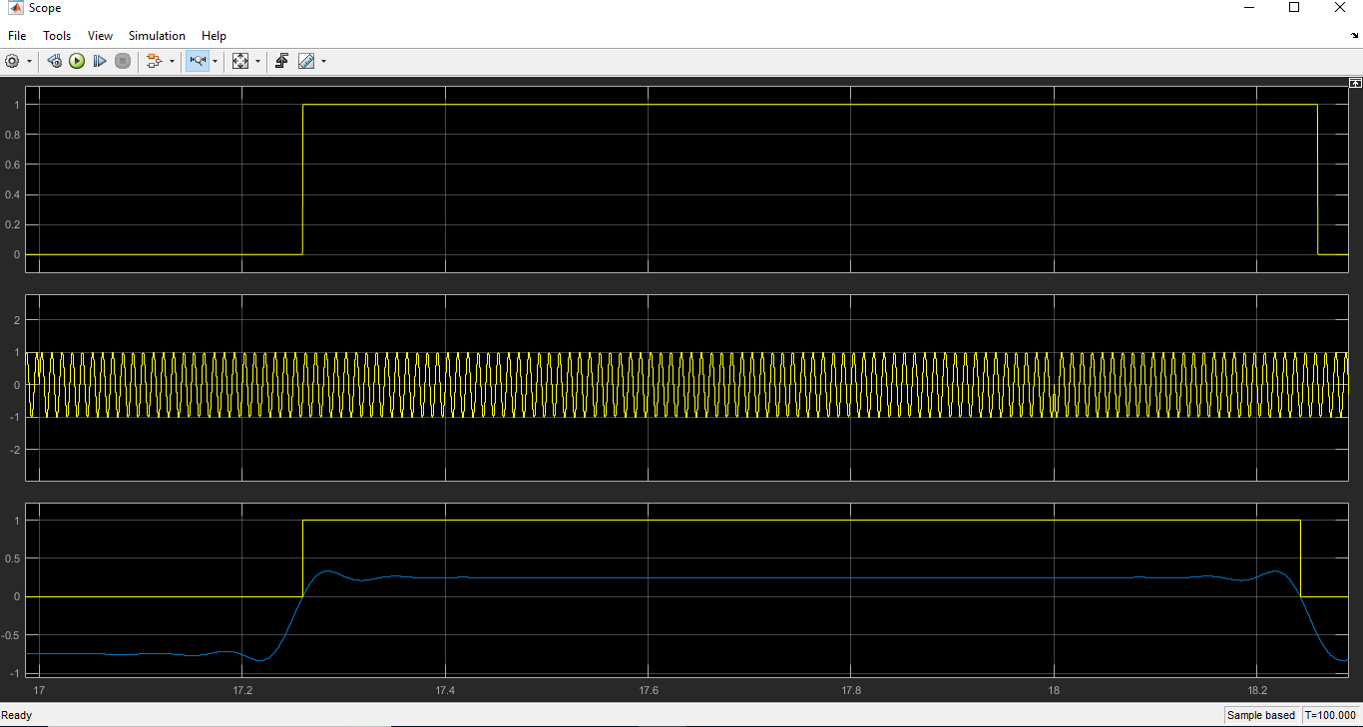
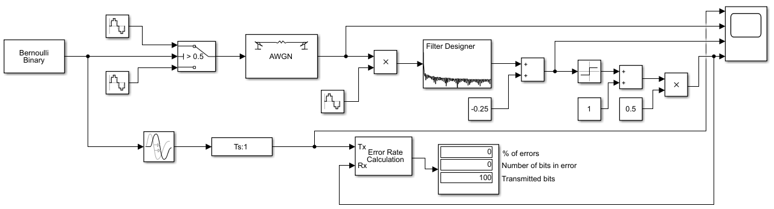
Fig. 7. BPSK phase changes
Fig. 6. BPSK modulation and demodulation implementation in Simulink

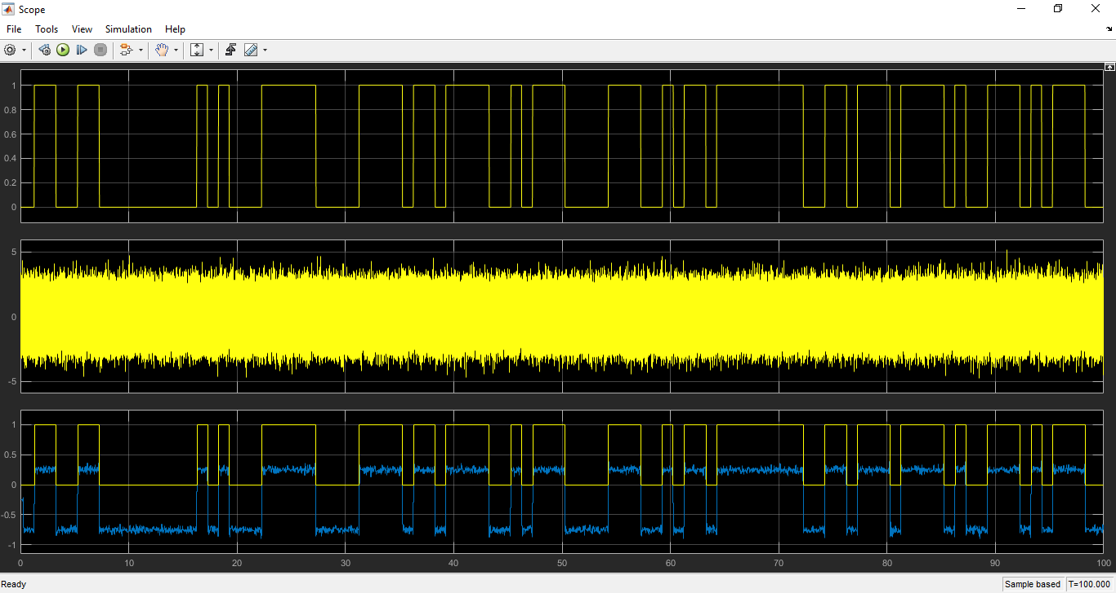
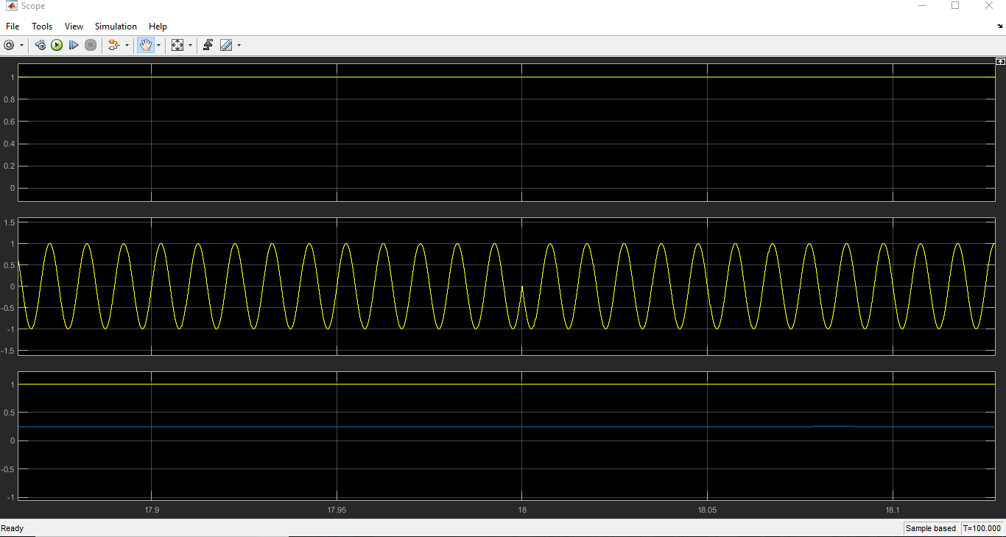
Fig. 9. Oscilloscope view of binary signal (top), BPSK modulated signal with noise (middle) and demodulated signal (bottom) with the signal after it has been compared to a sine carrier, lowpass filter applied and amplitude shifted down by 0.25 (blue) when the SNR is 1
Fig. 8. Zoomed in view of BPSK phase change
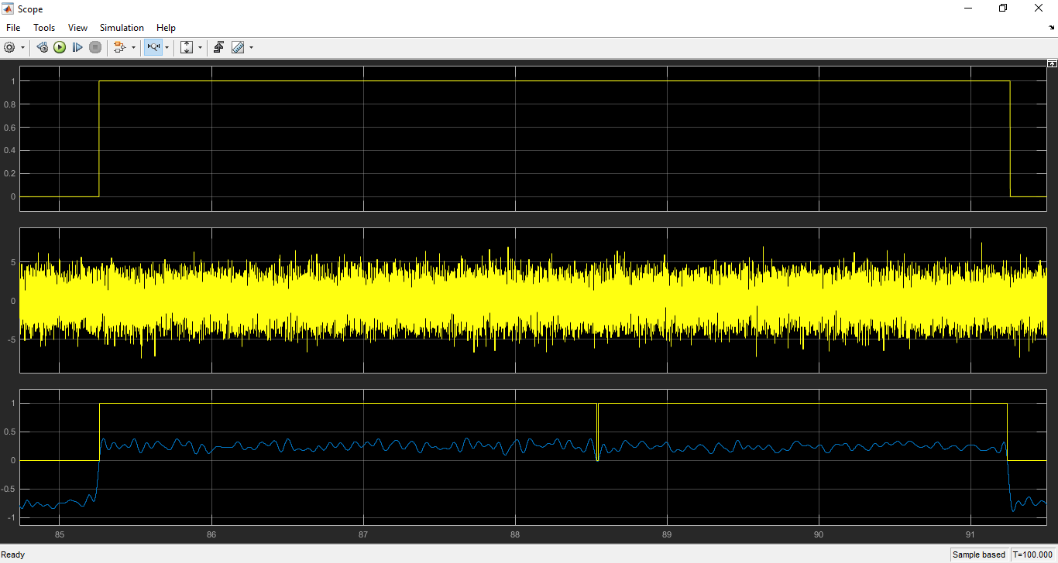
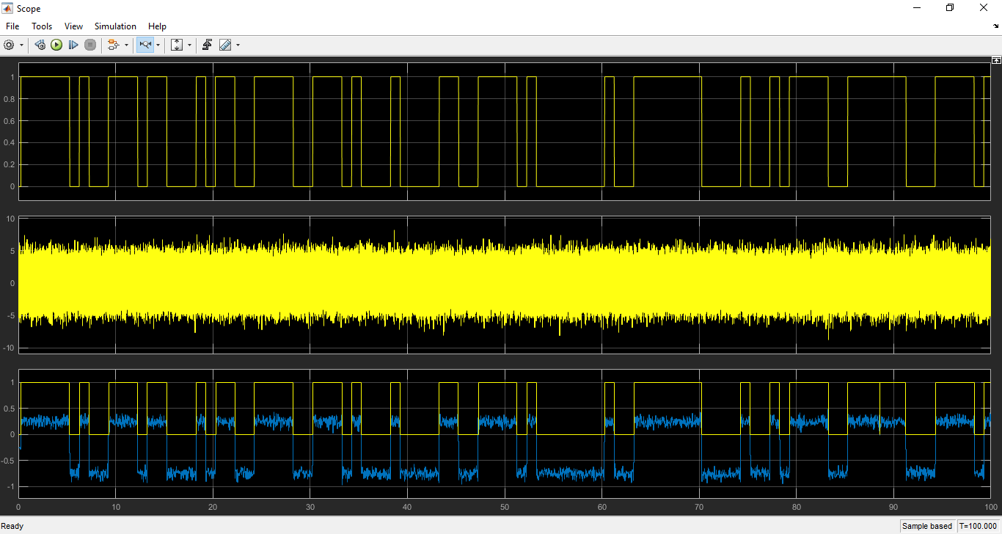
Fig. 11. Zoomed in oscilloscope view of binary signal (top), BPSK modulated signal with noise (middle) and demodulated signal (bottom) with the signal after it has been compared to a sine carrier, lowpass filter applied and amplitude shifted down by 0.25 (blue) when the SNR is -4
Fig. 10. Oscilloscope view of binary signal (top), BPSK modulated signal with noise (middle) and demodulated signal (bottom) with the signal after it has been compared to a sine carrier, lowpass filter applied and amplitude shifted down by 0.25 (blue) when the SNR is -4
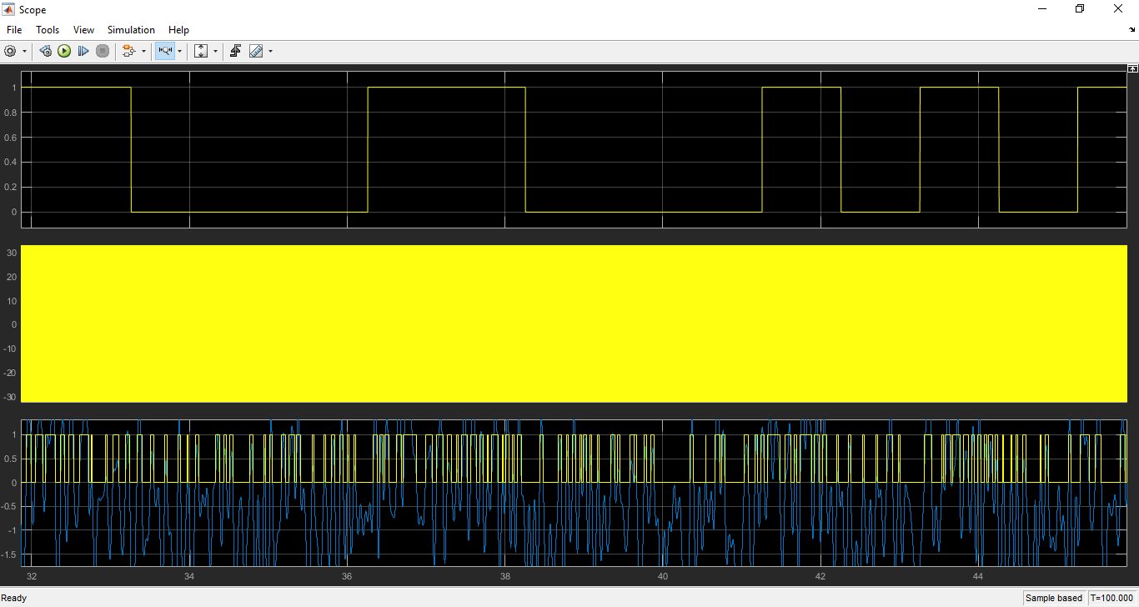
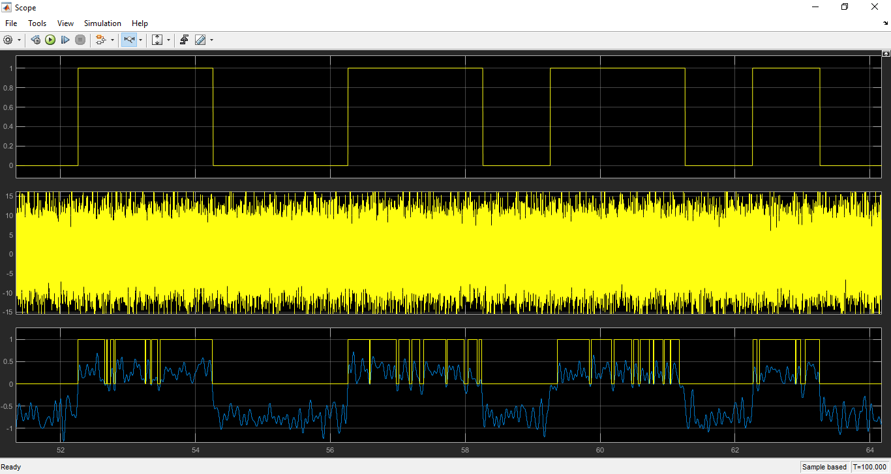
Fig. 13. Zoomed in oscilloscope view of binary signal (top), BPSK modulated signal with noise (middle) and demodulated signal (bottom) with the signal after it has been compared to a sine carrier, lowpass filter applied and amplitude shifted down by 0.25 (blue) when the SNR is -29
Fig. 12. Zoomed in oscilloscope view of binary signal (top), BPSK modulated signal with noise (middle) and demodulated signal (bottom) with the signal after it has been compared to a sine carrier, lowpass filter applied and amplitude shifted down by 0.25 (blue) when the SNR is -14
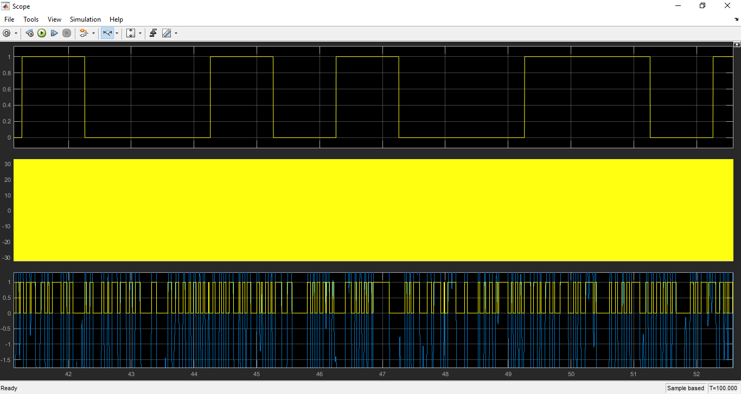
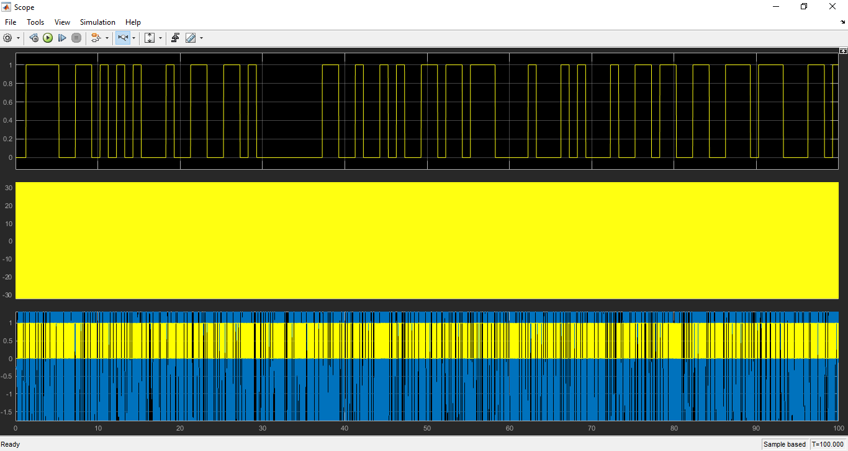
Fig. 15. Zoomed in oscilloscope view of binary signal (top), BPSK modulated signal with noise (middle) and demodulated signal (bottom) with the signal after it has been compared to a sine carrier, lowpass filter applied and amplitude shifted down by 0.25 (blue) when the SNR is -44
Fig. 14. Oscilloscope view of binary signal (top), BPSK modulated signal with noise (middle) and demodulated signal (bottom) with the signal after it has been compared to a sine carrier, lowpass filter applied and amplitude shifted down by 0.25 (blue) when the SNR is -44

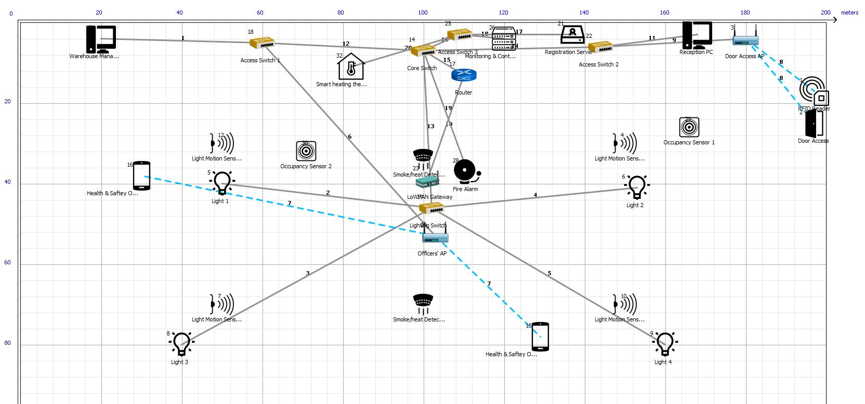
Fig. 16. The simulated Smart Factory network design

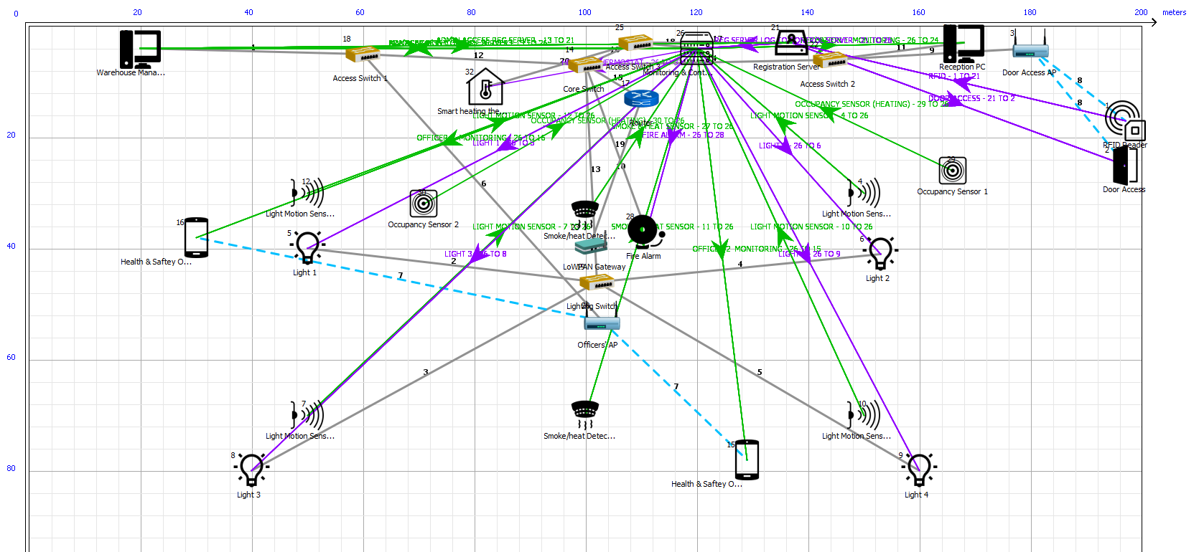
Fig. 17. The simulated Smart Factory network design with application data flow arrows

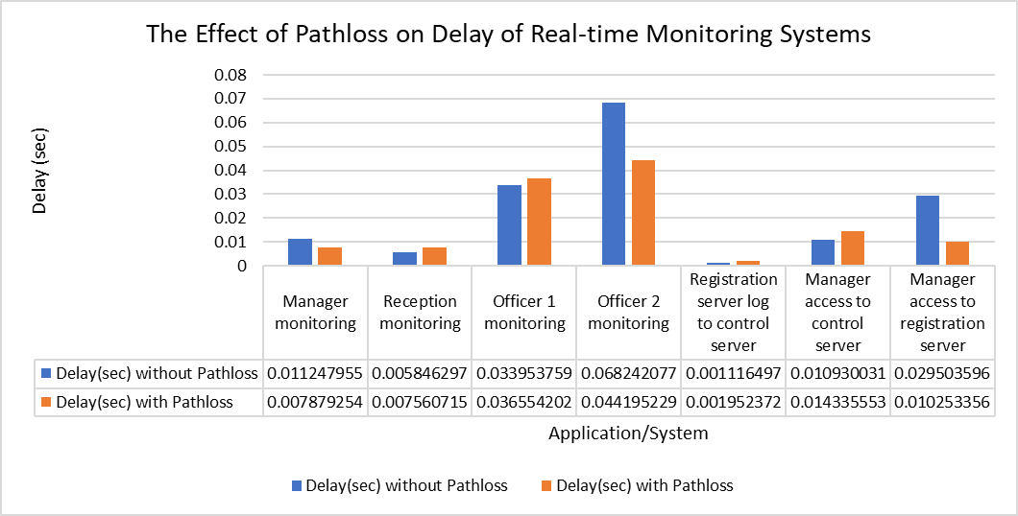
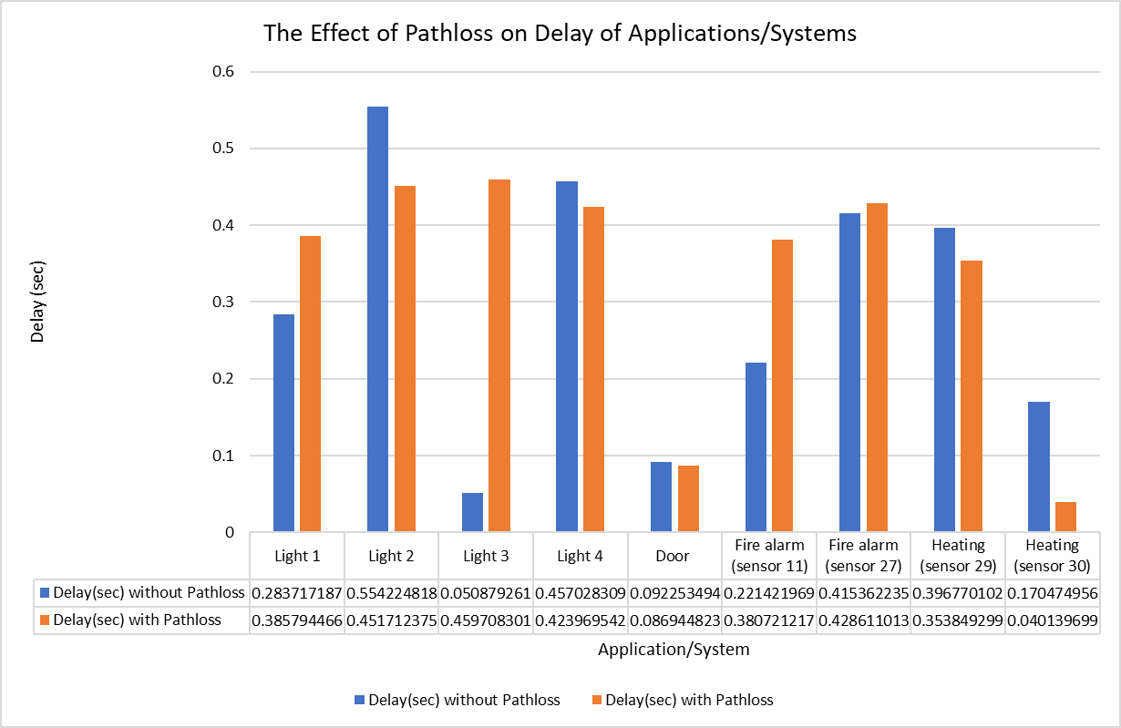
Fig. 19. A graph showing the delay between control/monitoring server and various users without and with pathloss
Fig. 18. A bar graph showing the total delay between sensor and relating system without and with pathloss
Fig. 21. A graph showing the total number of errored packets without and with pathloss

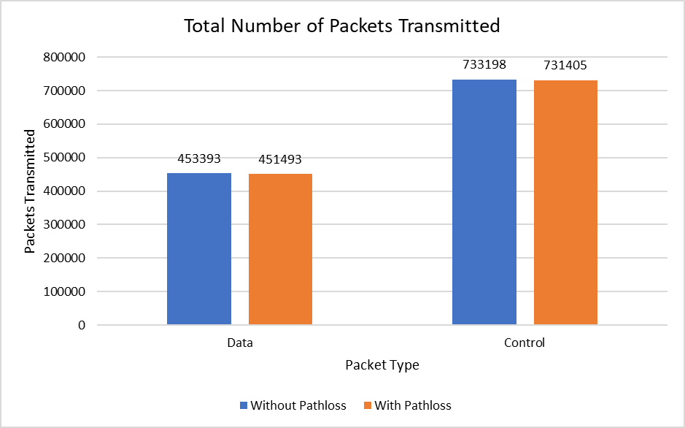
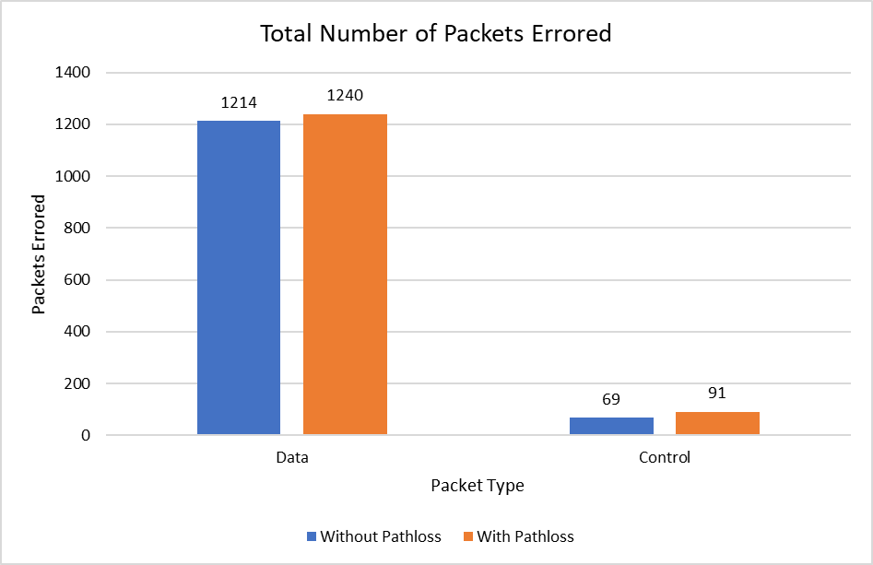
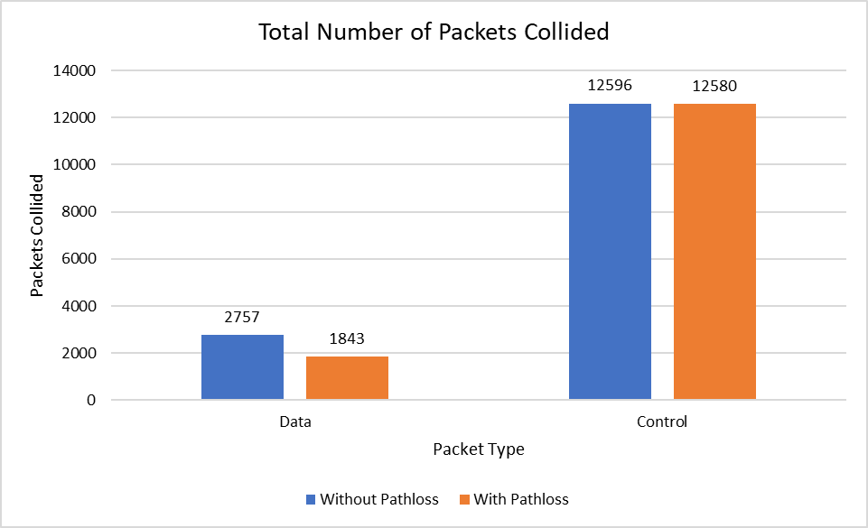
Fig. 20. A graph showing the total number of packets transmitted in the 10-minute simulations
Fig.22. A graph showing the total number of packet collided without and with pathloss
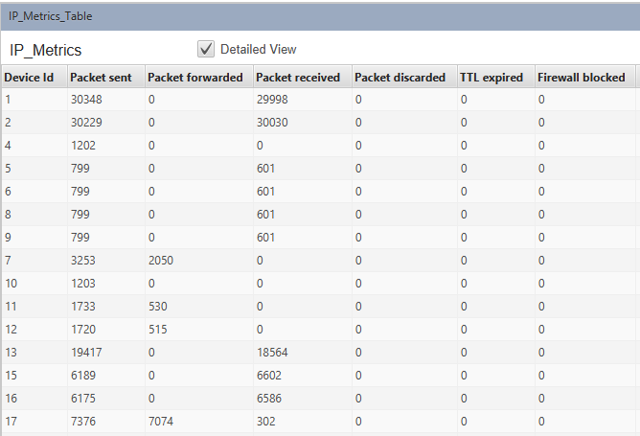

Fig. 23. A screenshot of Internet protocol (IP) metrics from the simulation without pathloss
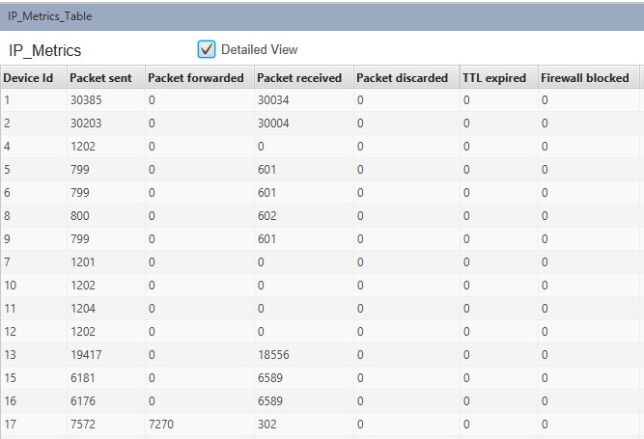

Fig. 24. A screenshot of Internet protocol (IP) metrics from the simulation with pathloss

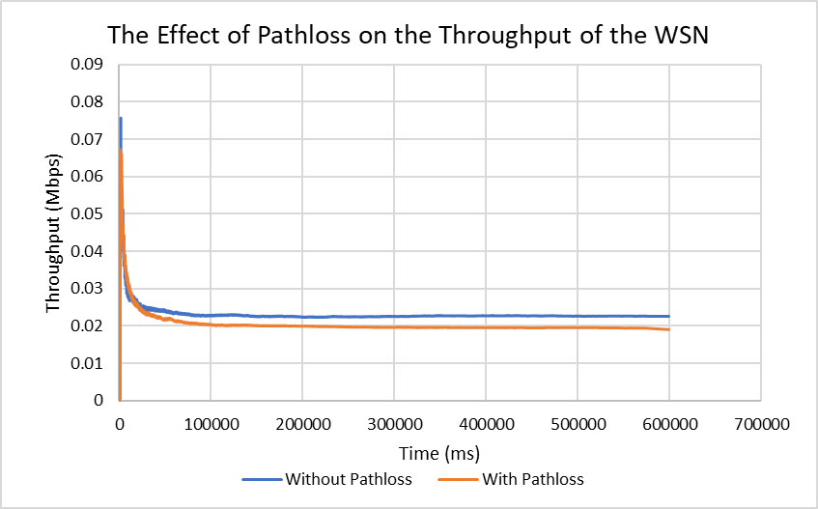
Fig. 25. A graph showing moving averages of throughput from the Smart Factory’s WSN

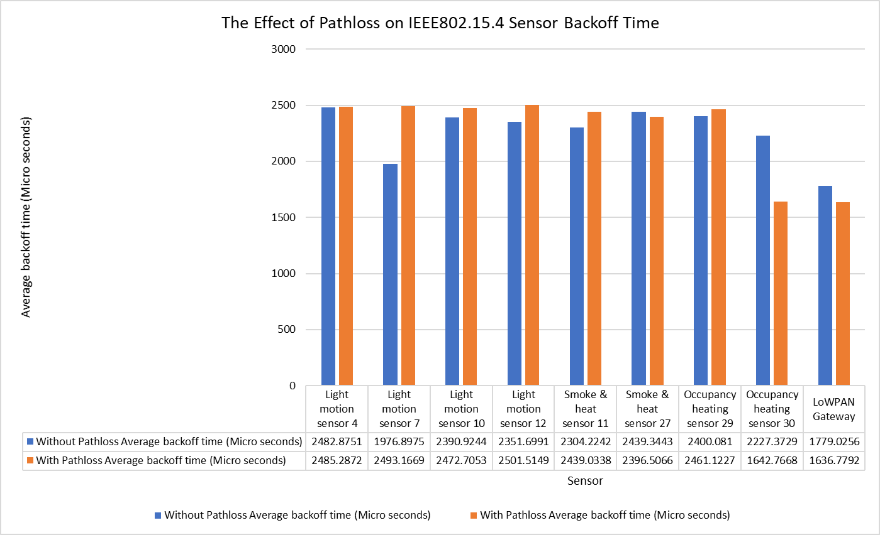
Fig. 26. A graph showing IEEE 802.15.4 sensor average backoff times
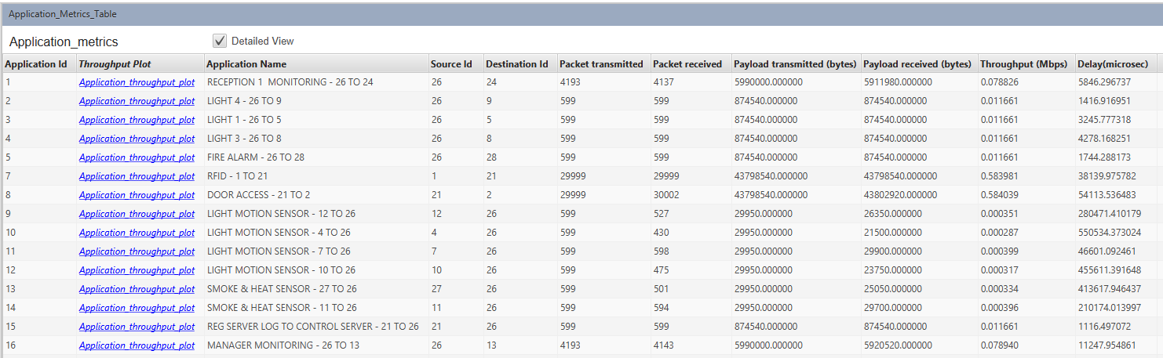
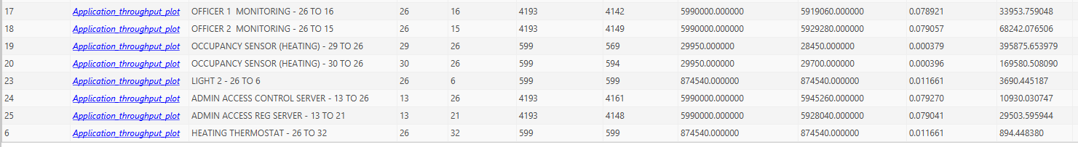
Fig. 27. A screenshot of the Application metrics from the simulation without pathloss
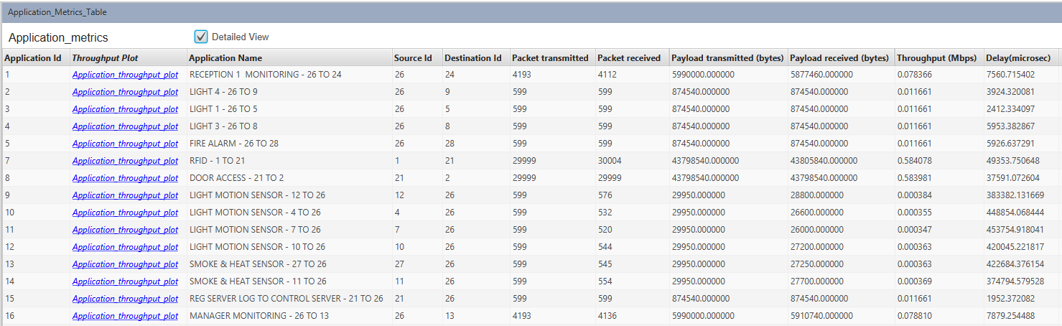
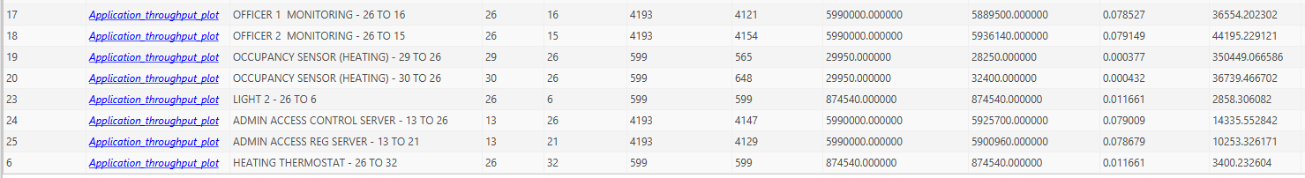
Fig. 28. A screenshot of the Application metrics from the simulation with pathloss

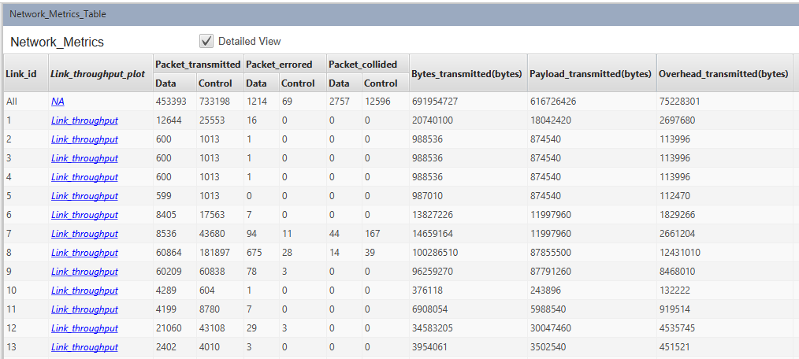
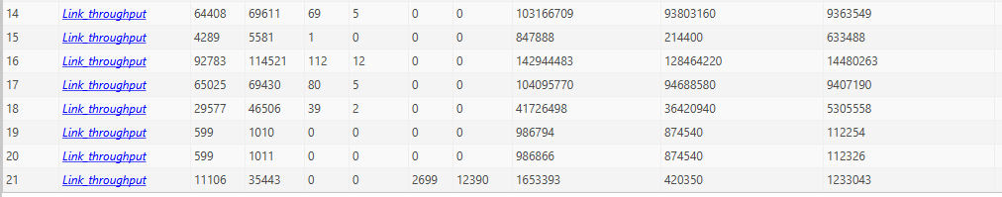
Fig. 29. A screenshot of the Network metrics from the simulation without pathloss

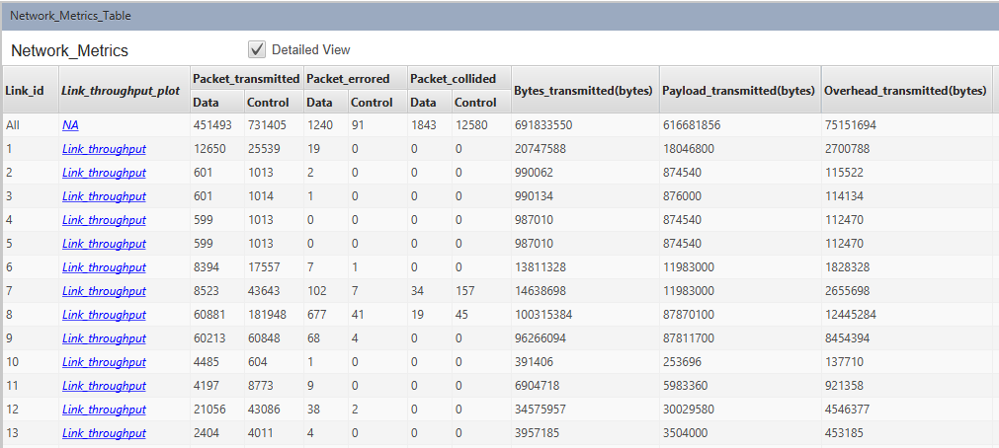
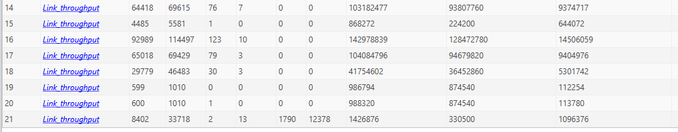
Fig. 30. A screenshot of the Network metrics from the simulation with pathloss

marking criteria and Student FEEDBACK

This section details the assessment criteria. The extent to which these are demonstrated by you determines your mark. The marks available for each criterion are shown. Lecturers will use the space provided to comment on the achievement of the task(s), including those areas in which you have performed well and areas that would benefit from development/improvement.

Common Assessment Criteria Applied (Assignment 1) | Marks available | Marks  awarded
1. Research-informed Literature
Extent of research and/or own reading, selection of credible sources, application of appropriate referencing conventions.
Outstanding knowledge of research informed literature. High level of referencing skills consistently applied. (Grade mark: 96.67%) | 15 | 14.5
2. Knowledge and Understanding of Subject
Extent of knowledge and understanding of concepts and underlying principles associated with the discipline.
High detailed knowledge & understanding of the main theories and concept. Excellently discussed and critiqued the literature and the key concepts that build the premise of your report. (Grade mark: 96.67%) | 15 | 14.5
3. Analysis
Analysis, evaluation and synthesis; logic, argument and judgement; analytical reflection; organisation of ideas and evidence
Very high quality analysis developed. For the level of this assignment the discussions were analysed and critiqued excellently. See report feedback for further comments to take on board for future work. (Grade mark: 96.67%) | 30 | 29
4. Practical Application and Deployment
Deployment of methods, materials, tools and techniques; application of concepts; formulation of innovative and creative solutions to solve problems.
Although the offsite is not shown in netsim model it is discussed in the report. A thorough report has been produced with a strong implementation. The observations have been given sound reasoning and validation. (Grade mark: 85.71%) | 35 | 30
5. Skills for Professional Practice
Attributes in professional practice: individual and collaborative working; deployment of appropriate media; presentation and organisation.
Can communicate professionally and confident in a suitable format.  (Grade mark: 100.00%) | 5 | 5

Assignment Mark (Assessment marks are subject to ratification at the Exam Board. These comments and marks are to give feedback on module work and are for guidance only until they are confirmed. ) | Late Submission Penalties (tick if appropriate) |  | 93%
 | Up to four weeks late |  | 93%
 | First Attempt? |  | 93%

