
Skills for the Workplace
Module Assignment Submission
Student Name: | Anamaria Bock
Student Number: | 2114314
Module No: | BMSK4005
Module Title: | Professional Career Development

Statement of Confirmation of Authenticity
By the act of making this submission, the student declares that this is the work of the student named above. The work has not, in whole or in part, been knowingly presented elsewhere for assessment, or where assessment has been built on a previous assessment, this has been identified. Where materials have been used from other sources it has been properly acknowledged. If this statement is untrue, the student acknowledges that an assessment offence has been committed.
Attention is drawn to the plagiarism and unfair practice policies of both the University and of ILM.

Table of Contents
Introduction 3
Section 1: Know how to identify development needs 4
1.1 Identify learning styles for self and another 4
1.2 Use a simple technique for identifying development needs for self & another 5
1.3 Barriers – suggesting strategies for overcoming them. 8
Section 2: Know how to develop self & others to achieve organisational objectives 8
2.1 Development options 8
2.2 Identify support mechanisms for the development of self & another 9
2.3 Prepare development plans for yourself and another person 9
2.4 Method used to monitor the development of self & another. 11
Reflection on the recruitment process 11
3.1 Description 12
3.2 Feelings 12
3.3 Evaluation 12
3.4 Analysis 12
3.5 Conclusion 13
3.6 Action plan 13
References 14
Appendix A 15
Appendix B 15
Appendix C 16

Introduction
The purpose of this assignment is to identify the learning styles for self and others, explanation on learning styles, development needs , barriers , strategies to overcome them , finding solutions for development and the reflection on recruitment process with an example based on Gibbs Reflective Cycle.

Section 1: Know how to identify development needs

Every person has different development needs. It is very important to know how to identify this needs.
A simple way of doing it is using the Johari Window, see heading 1.2.

Identify learning styles for self and another

Learning how to learn, this is what learning styles mean. Each person is having a particular way of learning, it can be by listening or reading or seeing an action being developed.
“Definitions of learning
- A change in behaviour as a result of experience or practice.
- The acquisition of knowledge.
- Knowledge gained through study.
- To gain knowledge of, or skill in, something through study, teaching, instruction or experience.
- The process of gaining knowledge. A process by which behaviour is changed, shaped or controlled.
- The individual process of constructing understanding based on experience from a wide range of sources.” (Pritchard,2013)
Learning is very important because we develop new skills, we improve our knowledges and also, we keep ourselves up to date.
I have done the Honey and Mumford’s Learning Style Questionnaire to identify my learning style and the score shows I’m a pragmatist; I value the information that I’ve been given only if I can see how this relates to practical tasks. So, the “plan” stage is what more suits me, being a pragmatist. (see Appendix A )- pragmatists are keen to apply whatever they learn and will always work out how they can apply it in a real situation an plan how to put it into practice.They will value the information that they are given only if they can see how this relates to practical tasks that they need to do .
After completing the Vark questionnaire it results that I personally find it more helpful to learn by hearing the information, writing it and interacting with the person who transmits it so I can understand better by asking questions.
The Dantec questionnaire shows that I am a dynamic learner who needs to know what can be done with things, learn by trial and error and self discovery.
My colleague done the Honey and Mumford questionnaire as well and it results that he is an activist, his best way of learning is by having a go, he is keen to take risks in the real environment.Activists learn best from “having a go”and trying something out without necessarily preparing.They will be enthusiastic about role play exercises and keen to take risks in real environment.
My colleague is learning easier if he can see how the things are done and experiment, it’s showing on the Vark questionnaire result.

1.2 Use a simple technique for identifying development needs for self & another
To identify the development needs we have to do a Gap analysis, so first we have to know our current skills and then to think about the desired ones, fill up the gap in between this with smart objectives to achieve the goal. So for example I have all the skills needed to be a manager but I’m not qualified , so all the employers are looking for a qualified manager for this important position in the company. Now the gap is the degree that can give me the right knowledges and certificate to be the right person for this position. So this is the reason why I have started this course , Level 4 Leadership and Management , to fill up the gap and achieve the desired goal.

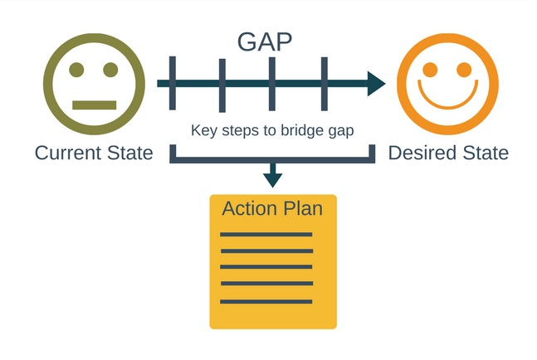
Now we can use the Swot analysis as a better way to find the connections between strengths and opportunities as Max McKeown wrote in his book.
Having this tables now, we can clearly see the strengths and opportunities so let’s try to make a connection to see if we have any qualities that can recommend us to achieve the desired goal/position. As for table 1 , I wrote some of my strengths , so I do consider that a manager should be a very good customer service professional ,patient and creative.
For table 2 , for my colleague , the same, he is strong , organised and motivated, skills that a manager should have ,so next step will be to work on the weak points as much as we can, so we can develop ourselves easier.
SWOT Person 1

STRENGTHS  Patience  Good customer service  Creativity | WEAKNESSES  Sensitivity to stress
OPPORTUNITIES  The management position | THREATS  Other colleagues
SWOT Person 2

STRENGTHS  Strong  Organised  Motivated | WEAKNESSES  Laziness  Doesn’t speak good english
OPPORTUNITIES  Management position | THREATS  Other colleagues

Johari Window (Luft and Ingham , 1955)
The Johari window is used to make people understand better themselves and others. The best you can do is to increase the arena, which is the part known by you and known by the others, this way you can reduce the stress of having to hide unpleasant things.

me | Known to self | Unknown to self
Known to others | I am punctual  I am honest  I am short | Sometimes too strict  I am not confident enough
Unknown to others | I have a thyroid problem  I might have anxiety | I might win the lottery

A colleague | Known to self | Unknown to self
Known to others | He is fast  He is serious  He is friendly | He is too quiet sometimes  People can notice when he is lying
Unknown to others | He had all his blood changed  He misses his family | He might live 100 years

1.3 Barriers – suggesting strategies for overcoming them.

me | barrier | remedy
internal | Knowledge level | Start studying
external | My family | Get some time for myself to study
My colleague | barrier | remedy
internal | English level | start learning
external | His family speaking urdu all day | They should speak English at work
The barriers cand be internal or external. First, we must identify them and then to find a way to overcome them.

Section 2: Know how to develop self & others to achieve organisational objectives

2.1 Development options
For my own development needs I have already started to overcome the barrier by enrolling to University of Wales Trinity Saint David, Certhe skills for the workplace, Level 4 Leadership and Management.
To overcome the external barrier, which is my family, the only thing I can do is to self isolate in a bedroom when I read or go out somewhere quiet.
As for my colleague I suggest him to start frequenting some English accredited courses in Bridgend college or even try to do some courses online, there are plenty. Regarding the external barrier, working in the same place with his family and speaking the native language it makes it even harder for him to learn English. My suggestion is , as the rest of the family speaks English, to try to give him a hand and speak English with him al least when they are in work.

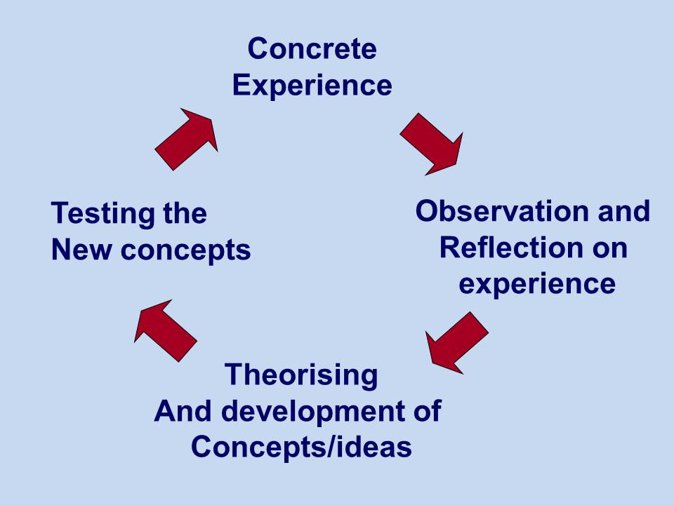
There is also the Kolb learning cycle which is really helpful for learning as it says that after having a concrete experience, for example I have started the course, then you can observe and reflect on it, so I enjoy it a lot, then theorising , and I want to learn more and graduate, and finally testing the new concept.

2.2 Identify support mechanisms for the development of self & another
We are currently living the times when technology can give us the right answer to our questions and concerns, rather we need a book, or the doctors advice , you can do anything online. So why not just take advantage of what is surrounding us and recreate ourselves, cross all the barriers and do more for our own development .
For me ,at this moment ,the biggest support I get is from my family, as I have my mother in law taking care of my baby when I am in work, most of the times 10 hours a day, and also my husband when he is having some time off he spends it all with the baby, and on the other hand I have support for learning from the University, the tutors are always there to answer any questions we have, they try hardly to make it possible for all of us.
For my colleague , the best support he can get to achieve his goal can be found only in school, or , as I said previously ,an online course can help as well as he is working many hours a week. He can receive support from his family if they start speaking English to him,and also if he wants to be active in a course in class he can speak to the employer and for sure he will be more than happy to give him some time off to improve his English.

2.3 Prepare development plans for yourself and another person

Part 1: Personal Analysis
See SWOT Analysis in 1.2

Part 2: Setting Goals

What do I want to learn? | What do I have to do? | What support and resources will I need? | How will I measure success? | Target Date for Review
To be a good manager | Study | Support from the university which I already have  University fees | Success for me is to be the manager of a big company | August 2024
My colleague wants to learn English | Online course or college | Dictionary  Books  Course fees | Success for him is to speak fluent English | December 2022

Part 3: Personal Objectives

Short Term Goals (next 12 months)
To graduate Certhe skills for the workplace, level 4 Leadership and Management (for me)
To learn English (for my colleague)
Medium Term Goals (2-3 years)
To graduate Level 2 for the same course (for me)
To speak fluent English (for him)

Long Term Goals (3-5 years)
To be the manager of a big company (for me)
To find better job opportunities (for him)

2.4 Method used to monitor the development of self & another.

The best way of monitoring our own progress is by making a Personal Development Plan (PDP) , looking back at the plan and reflect on it . Also, another god way of monitoring the development of self and others is by having a feedback from the others, for example when I first started this course I didn’t had any idea about Gap analysis ,but after I have learned it in class ,I was ready to apply it in work and it worked, the manager told me straight that I’ve had a very good solution to solve a situation.

Reflection on the recruitment process
The recruitment process is the way of choosing the right candidates with the most suitable skills for the right job. It should be efficient, keep it low in cost, effective, to identify the right candidates and also fair, that means the decision must be made on the candidates merit.
The recruitment process should be :
Efficient – cost effective
Effective – to identify the right candidate
Fair – decisions should be made on merit
“Recruiting the right people is one of the most important activities organisations can undertake. Getting it right can mean fast, healthy growth and the fulfilment of business goals; getting it wrong can mean heavy costs, sinking morale and stunted growth. “ (Newell Brown,2011)
So, I have decided to choose the Gibbs reflective model, as I find it as the most appropriate way of analysing and evaluating a recruitment process.
‘It is not sufficient simply to have an experience in order to learn. Without reflecting upon this experience, it may quickly be forgotten, or its learning potential lost. It is from the feelings and thoughts emerging from this reflection that generalisations or concepts can be generated, and it is generalisations that allow new situations to be tackled effectively.’ (Gibbs 1988) 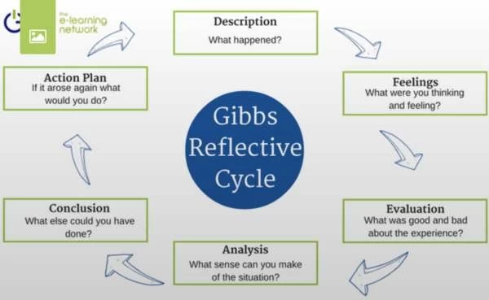

3.1 Description
I have applied for a job, found on indeed, as a cinema host in Odeon cinema in Bridgend !I have sent s cover letter ( see in appendix C) with the cv.
As I was desperate to find a job as soon as possible I have applied for many jobs without thinking exactly if I am suitable for the job or no, not even my CV (see appendix C) was not personalised to the jobs description but I wanted to give it a try, in my mind I was asking myself: what can be so difficult in welcoming people at the entrance and directing them to the right room? As I have 10 years of customer service, I thought it will be “piece of cake” and easy money. I got the invite for the interview and I was ready to go. I always do an exercise before any interview, I look in the mirror and tell myself that I am confident and I can do this but apparently this time it didn’t work at all as I thought it will. I am an anxious person and that makes me overactive when I am nervous but once I get there and I speak to the person who is interviewing I somehow manage to calm down and be myself again.

3.2 Feelings
I spent many hours trying to find something nice to dress, but not too formal and not too casual, so when I finally left home, I just started being nervous thinking about what is going to happen, what questions is he/she going to ask, am I prepared for this? As I am a very open person , you can literally see on my face every stage I’m going through , from nervous to enthusiastic to excited and sad and all that happened when I was waiting for my turn, as there were 3 more candidates. I was staring at them trying to figure out if they are more prepared than me, but how can you see this on someone’s face?

3.3 Evaluation
And when it was finally my turn, things didn’t go as planned. But I probably didn’t had a plan at all. The manager was asking me things like “when did you read a book last?”, “what book was it?” , “what’s your favourite movie?” “when have been last to a cinema?” . I was shocked , like my mind was completely empty, I couldn’t remember anything, like I haven’t seen a movie in my entire life or didn’t even know how a book looks like! He probably saw the panic on my face, and somehow I managed to spell something, even if it was not the smartest answer that he heard that day. So I fail the interview.

3.4 Analysis
Reflecting on it, I realised that I should have read better and understand the job description “Are you a film fanatic looking to kick start your career and be our next leading star? Being a cinema host is the most important role within our cinemas and is the key part of our guests having the ultimate experience every time they come” (indeed) Even after the interview I actually couldn’t understand what was the relevance of the questions in the actual job. Being a cinema host , in my mind was greeting the customers, make them feel good and comfortable , making sure they have everything they need , all the information , trying to make this day a bit better for them and this way making sure they were happy to have this experience and will happily come back.

3.5 Conclusion
This was the first time I failed in an interview but I was not sad, it just made me realise that failing is a part of the process sometimes, you always learn something out of any experience and it’s never called a failure it is a lesson ,if you actually know how to take the good part of it and learn from it, just to make sure you are not going to repeat the same mistake again then it is a lesson.

3.6 Action plan
If I ever choose to apply for a similar job in the future I will make sure that I will read the job description twice, and also make a job analysis “identifying what tasks the job will involve. This is useful for you so that you know whether you might like the job, and useful to employers, who can use it to identify the kinds of qualities they are looking for” (Morgan,2017) than I will do some research on the company , this will make me feel better organised and more confident during the interview.I can also try to not get in such a situation to be desperate to find a job because it would probably not be the right thing to do.

If I would have been the person who was doing the interviews I would, certainly insist more on the customer service experience and personal skills which, in my opinion are more important that the last movie the candidate saw or how much popcorn is a person allowed to eat when they’re watching a movie, or what is the legal distance between the seats.
In conclusion, it was an experience and even if I have failed, I learned how to pay more attention at a job description, to read between the lines sometimes it’s good, I learned to be more confident and I am trying as much as I can to control my emotions and let them outside the room, before going in for an interview.

References
Cathy Dantec, Learning Styles
Gibbs G. (1988) Learning by doing: A guide to teaching and learning methods, FEU.
Honey P and Mumford A (1992) The manual of learning styles, Peter Honey Publications
Kolb D.A. (1984) Experiential learning,experience as the source of learning and development , Englewood Cliffs,N.J Prentice Hall
Luft J and Ingham H (1955) The Johari Window
Max Mckeown (2012) The Strategy Book, Pearson Education
Neil Fleming (1987) VARK questionnaire
Newell Brown, Jane(2011) The complete guide to recruitment, Kogan Page.
Morgan P (2017) The business students guide to study and employability, Sage Publications Ltd
Pritchard A (2013) Ways of learning: learning theories and learning style, A David Fulton book

Appendix A

For the Honey and Mumford learning styles questionnaire, it shows that I am a Pragmatist , always try to apply what I am learning in real situations and plan how to put it into practice.

Appendix B
Anamaria Bock
Email address - bock12ana@yahoo.com
Phone number - 07568715204
Personal profile
With over 10 years experience, I am an enthusiastic customer service professional, being always interested in finding out what people really want.
I am hardworking in delivering the highest level of service, making sure they will always come back.

Key skills

- Excellent communication skills
- Team working
- Empathy
- Willingness to improve
- Patience
- Adaptability
- Attentiveness
- Creativity
- Organised
- Hardworking
Career history
Assistant manager
Kaspas – 2020 – Present
Helping the manager with everything he needs , being able to replace him on his days off , organising staff , handling money , dealing with customer complaints , receiving deliveries , stock rotation .
Production operative
Sony – August 2019 – August 2020
Verifying the hair removal devices to make sure they are fine to be packed , scanning and packing laser hair removals .
Manager
Andrea Mattia Alfresco Ltd – June 2015 – August 2018
Stock rotation , organising staff , dealing with customer complaints , handling money , placing orders , receiving deliveries .
Education and training

- University of Wales Trinity Saint David – CerThe Skills for the Workplace – Level 4 Leadership and Management – on going
- College – Romania
Hobbies – long walks in nature

Appendix C

Dear Mr Thomas
I am writing to express my interest in the cinema host role at Odeon. I believe that I am the perfect match for the job specification as I have 10 years experience in customer service, and I strongly believe that I would make a great addition to your company.
The skills that recommend me are punctuality, great team work , leadership , hardworking , open to new , willingness to improve and patience.
Please see attached my cv.
Looking forward to meeting you soon.
Kind regards,
Anamaria Bock

