Emma Martin
P151454
BA Glass: Architectural Arts
M4X01559
Curator Task
Word count: 1276
Blood, Passivity and Death
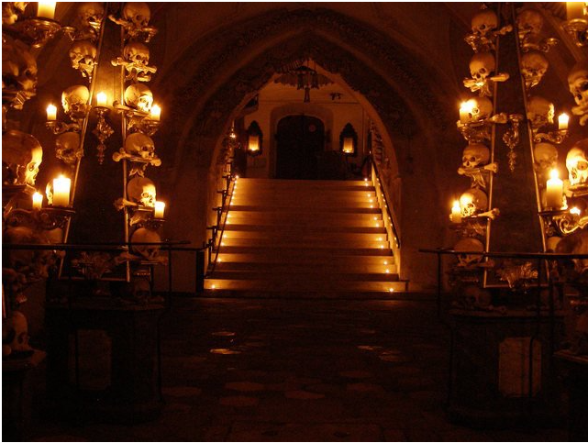
This exhibition explores artists who use pain or blood in their work. Society has become disconnected from reality. We watch bloodshed happening across the world but no longer react. The civil war in Syria barely features on the news despite the 465000+ death toll (Aljazeera, 2018). We are passive, detached, numb; yet horrified at people hurting themselves for art. The artists in the exhibition are Abramović, Pane and Taccardi. Abramović says, ‘The function of the artist in a disturbed society is to give awareness of the universe, to ask the right questions, and to elevate the mind,’ (Economist, 2010) however, pain in this context makes people uncomfortable. Art should challenge its audience, ‘Pane plays with masochism, letting her blood be witness to our culture’s sedated relationship to witnessing everyday violence’ (Alvarez, 2015). This exhibition will confront people with what unsettles them, creating an awareness of their surroundings. It will be held in the ossuary in Sedlec, Prague (Figure 1).
Figure 1 – Sedlec ossuary, Czech Republic (Anon., 2018)
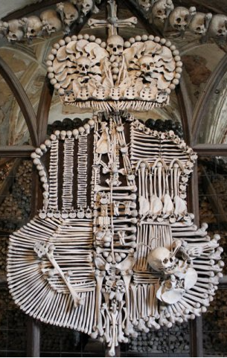
This macabre setting compels people to think of their own mortality, housing 40,000-70,000 human skeletons. These have been artistically arranged into chandeliers, a coat of arms (Figure 2) and pillars. Artists spilling their own blood here will challenge our perception of blood and death.
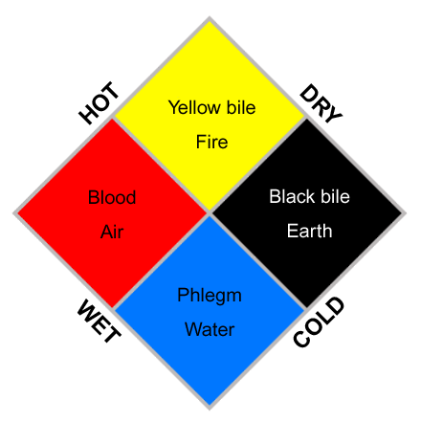
Blood has an important role. ‘From earliest times blood had been treasured as the liquid of life’ (Porter, 2002, p. 59). It has sacred properties in religions, such as Catholicism where Communion wine becomes the blood of Christ. From ancient Greeks balancing humours (Figure 3), to Galen’s theory of plethora, bloodletting was a common practise to cure most ailments. They wanted to ‘remove evil humours’ (Starr, 1999, p. xii). There has never been any evidence of bloodletting helping, yet in 1920s America, doctors still bled patients (Starr, 1999, p. 16). The importance of blood was realised early on; though science has disproved many theories, beliefs prevail.
Figure 2 – Schwarzenberg coat of arms – Sedlec ossuary (Anon., 2018)
Blood is still seen as having otherworldly properties. A study into self-harm says, ‘…the women believed that their blood had become evil and had tactile hallucinations involving the sensation of the blood flowing in their blood vessels’ (Himber, 1994, p. 625). Self-harmers attribute bloodletting with relieving suffering. It releases a build-up of emotional pain but they are simultaneously sickened by their actions. ‘A vortex of summons and repulsion places the one haunted by it (the abject) literally beside himself’ (Kristeva, 1982, p. 1). These people are compelled to hurt themselves and are distressed by this behaviour, yet cannot stop. They know bloodletting could bring death and are tormented by this.
Figure 3 – Properties of the four humours (Anon., 2013)
Blood is the medium by which we live and die. The two aspects are intertwined, which scares people; once blood stops pumping, death awaits. It is an uncomfortable memento mori. In Stoker’s Dracula blood represents sustenance and rejuvenation for the undead vampires. Harker is abhorred by what the female vampires represent but admits he has ‘burning desire that they would kiss me with those red lips’ (Stoker, 1998, p. 37). The female vampires are the controlling actors; Harker the passive observer. This duality is what Kristeva alludes to in relation to abjection, ‘a composite of judgment and affect, of condemnation and yearning, of signs and drives’ (Kristeva, 1982, pp. 9-10), in this case the female vampires. We typically associate men with violence, Stoker proves that anyone is capable of aggression. Women can also exhibit control of their bodies through art.
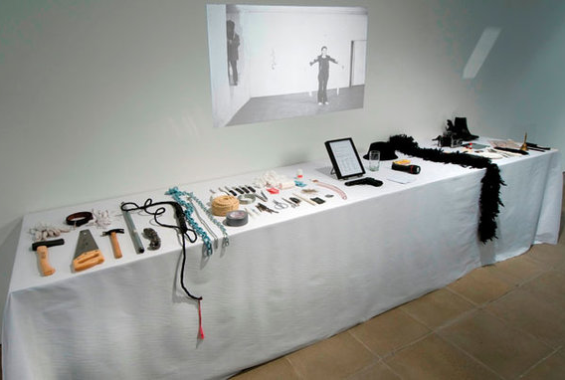
Abramović is a performance artist whose body is the canvas. Her work challenges people with their darkest desires and apathy towards violence. For Rhythm 0 (Abramović, 1974) she stood for 6 hours in front of an audience with 72 objects on a table (Figure 4). These items, representing pleasure, pain and death, ranged from feathers and a plaster to scissors and a gun. The audience split into those who hurt and those who protected. As the performance progressed people became more sadistic (Figure 5).
Figure 4 – Recreation of the table used in Rhythm 0 (Админ, 2018)
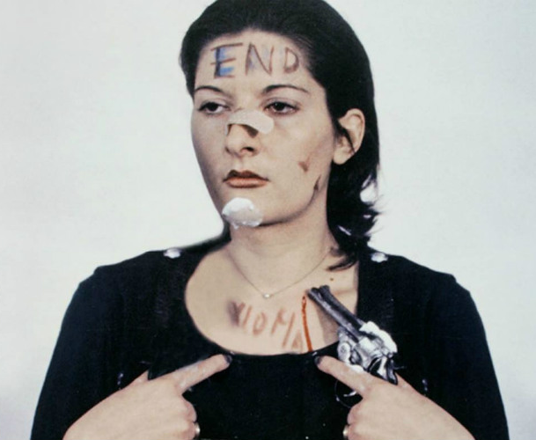
Figure 5 – Abramović pictured near the end of Rhythm 0 (Hunt, 2016)

After 6 hours she moved, the participants, terrified, ran away screaming (Renzi, 2013, p. 130). As Arbus says ‘the shock of immersion in experiences that cannot be beautified, the encounter with what is taboo, perverse, evil,’ (Sontag, 1979, p. 43) is what is happening here. People were fine observing; joining in whilst Abramović was an object, but upon her ‘transformation into a living object’ (Renzi, 2013, p. 133), they were confronted by their disgusting behaviour. It shows our propensity for group violence and disconnection from the feelings of others. Abramović was dehumanized by some and protected by those who empathized. Abramović’s experiences growing up shaped her ability to tolerate pain. ‘I was punished frequently, for the slightest infraction, and the punishments were almost always physical... I had bruises all over’ (Abramović, 2017, p. 7). These experiences allow her to experiment with pain in her performances, yet she has a fear of her own blood (Abramović, 2017, p. 10). In her performance, Art Must Be Beautiful (Abramović, 1975) Abramović combs her hair continuously with a metal comb drawing blood. She continues to abuse herself in adulthood through her art whilst using it to evoke a response, to stop indifference towards violence.
Violence, pain and gender are central to Pane’s work. Her body, a vehicle to destroy and recreate. By hurting herself she is attempting:
‘To destroy the passive status of femininity that has to endure pain and violence inflicted on it and the attempt to re-create "autonome Zeichen der Frau" (autonomous signs of women), which develop out of the self-inflicted pain (Pane, 1973).
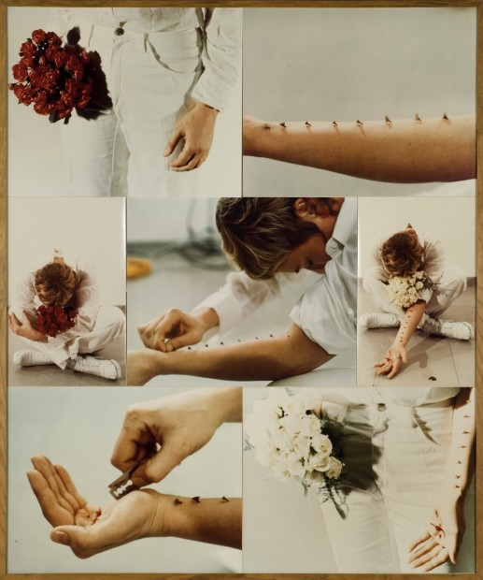
She wants to take back control of her body. For Pane vision and bodily pain are connected. Through her performances she wants us to engage with our surroundings, feel pain, however the audience rarely gets to see this. Unlike Abramović most of her performances are solitary, when there is an audience it is carefully selected. Pane’s work mostly consists of images of her performances. In her piece Azione Sentimentale (Figure 6) she inserts 8 thorns into her arm then cuts her hand, bleeding whilst poetry is read. Pane is not seeking to shock the audience but immerse them in the experience, to question their own vulnerability. ‘ For to be oneself in pain is to be more acutely aware of having a body… to see from the outside the wound in another person is to become more intensely aware of human embodiedness’ (Scarry, 1987, p. 199). By seeing pain, we become mindful of our own fragility. The visual display is heightened by the poetry. Music can have the same effect.
Figure 6 – Azione Sentimentale (Pane, 1973)
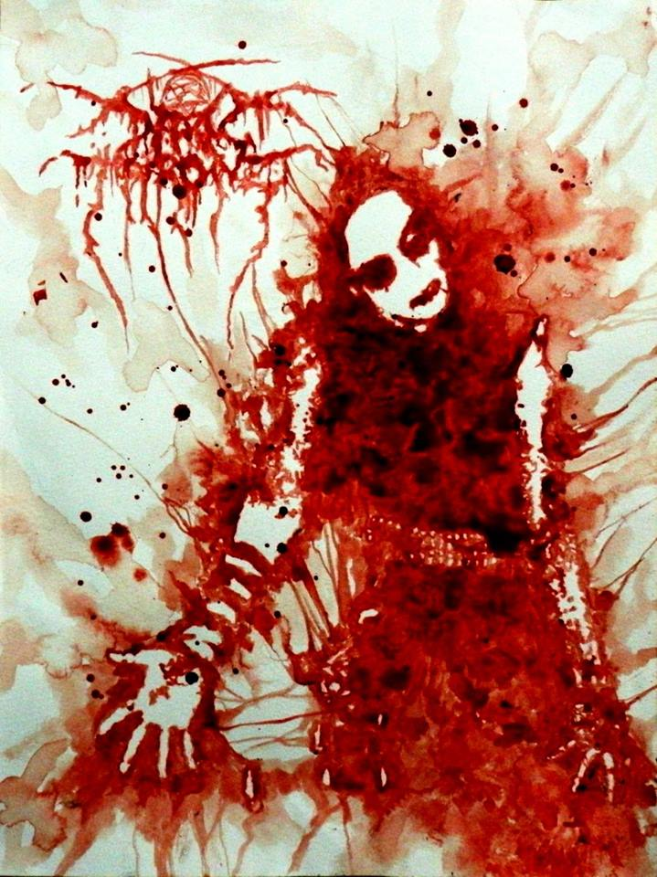
Taccardi paints using his own blood to music. He cuts his wrist deeply, using it as palette and medium. The ritualistic way he works is interesting. He dresses in white robes in a room with crucifixes in the background. The video highlighting the razorblade cutting his wrist is disturbing yet fascinating, accompanied by self-composed music, it is anything but ritualistic. Taccardi says he is not doing it to shock, ‘I see art as some sort of a ritual, a chat between spirits and my mortal flesh... the manifestation of spirits through artist bodies’ (Taccardi, 2017). This results in blood pictures of demons and dream creatures (Figure 7). He wants to create an open wound between our unconscious and reality. ‘Self-cutting is accompanied by higher blood levels of endogenous opioids’ (Winchel & Stanley, 1991, pp. 306-317). This is what Taccardi is seeking and it can be a cleansing process. He needs this high to create his work as in this moment the mind can have most clarity. Abramović and Pane are suffering to highlight issues important to them whereas Taccardi gets pleasure out of his work. Painting in blood amidst the plague victims is fitting of his style. ‘Death would thus be the chief curator of our imaginary museum;’ (Kristeva, 1982, p. 17) and witness to flowing crimson treasure.
Figure 7 – Darkthrone (Taccardi, 2017)

Bibliography
Abramović, 1974. Rhythm 0. Morra: s.n.
Abramović, 1975. Art must be Beautiful; Artist must be Beautiful. Copenhagen: s.n.
Abramović, 2017. Walk Through Walls: A Memoir. London: Penguin Group.
Abramović, 2018. Marina Abramović. [Online]
Available at: http://www.marinaabramovic.com/home.html
[Accessed 9 April 2018].
Abramović, M., 2015. An art made of trust, vulnerability and connection. [Online]
Available at: https://www.ted.com/talks/marina_abramovic_an_art_made_of_trust_vulnerability_and_connection/up-next
[Accessed 20 March 2018].
Aljazeera, 2018. Syria's civil war explained from the beginning. [Online]
Available at: https://www.aljazeera.com/news/2016/05/syria-civil-war-explained-160505084119966.html
[Accessed 4th April 2018].
Alvarez, A., 2015. All the times artists used blood for radical work. [Online]
Available at: http://www.dazeddigital.com/artsandculture/article/27205/1/a-history-of-the-relationship-between-blood-and-art
[Accessed 4 April 2018].
Anon., 2010. Freud’s theory and Vampire Movies. [Online]
Available at: https://fangbangerz.wordpress.com/freuds-theory-and-vampire-movies/
[Accessed 20 February 2018].
Anon., 2013. The Four Humours. [Online]
Available at: http://knowyourmeme.com/memes/the-four-humors
[Accessed 25 April 2018].
Anon., 2018. Sedlec Ossuary. [Online]
Available at: http://sedlecossuary.com/
[Accessed 27 March 2018].
Anon., n.d. Erfinder der Plastination. Schöpfer der Körperwelten.. [Online]
Available at: http://www.vonhagens-plastination.com/dr-gunther-von-hagens-2
[Accessed 28 February 2018].
artstory, 2018. Movements, Styles, and Tendencies Body Art. [Online]
Available at: http://www.theartstory.org/movement-body-art.htm
[Accessed 9 April 2018].
Berger, P. & Luckmann, T., 1979. The Social Construction of Reality. Harmondsworth: Penguin Books Ltd.
Bright, C., 2018. Blood in Dracula: Symbolism, Imagery & Significance. [Online]
Available at: https://study.com/academy/lesson/blood-in-dracula-symbolism-imagery-significance.html
[Accessed 20 February 2018].
Carter, A., 1995. The Bloody Chamber. London: Vintage.
Domus, 2018. Gina Pane: è per amore vostro. [Online]
Available at: https://www.domusweb.it/it/arte/2012/04/02/gina-pane-e-per-amore-vostro.html
[Accessed 6 May 2018].
Economist, T., 2010. The artist was here. [Online]
Available at: https://www.economist.com/node/17036088
[Accessed 19 March 2018].
Fink, B., 1995. The Lacanian Subject: Between Language and Jouissance. Princeton: Princeton University Press.
Galleria-Elefante, 2018. Gina Pane: Ensemble. [Online]
Available at: http://www.galleriaelefante.com/wordpress/gina-pane-ensemble/
[Accessed 6 May 2018].
Giin, n.d. [Online]
Available at: giin.bigcartel.com
[Accessed 9 April 2018].
Greene, G. & Kahn, C., 1985. Making a Difference: Feminist Literary Criticism. london: Methuen & Co. Ltd.
Himber, J., 1994. Blood rituals: Self-cutting in female psychitric inpatients. Psychotherapy: Theory, Research, Practice, Training, Volume 31(4), pp. 620-632.
Hunt, 2016. Research Task -Marina Abramovic – Rhythm 0 ‘Testing the Body’. [Online]
Available at: https://alrobertphotography.wordpress.com/2016/02/01/testing-the-body/
[Accessed 2018 April 2018].
Huxley, A., 1997. The Doors of Perception Heaven and Hell. London: Flamingo.
Kirby, S., 2013. A brief History of blood. [Online]
Available at: http://www.postmedia.com/
[Accessed 20 March 2018].
Kristeva, J., 1982. Powers of horror. New York: Columbia University Press.
Morris, P., 1993. Literature and Feminism. Oxford: Blackwell Publishers Inc.
Nietzsche, F., 1986. Human, All Too Human. 3rd ed. Nebraska: University of Nebraska Press.
Noyes-Platt, S., 2014. Feminism and Performance: Joan Jonas and Gina Pane. [Online]
Available at: http://www.artandpoliticsnow.com/2014/04/feminism-and-performance-joan-jonas-and-gina-pane/
[Accessed 28 March 2018].
Pane, 1973. Azione Sentimentale. [Art] (Museum of Modern Art).
Pane, G., 1973. Bemerkungen zu meiner. Aktion Autoportrait, Volume 9, p. 11.
Pastore, N., 1967. Condillac's Phenomenological Rejection of Locke and Berkeley. Philosophy and Phenomenological Research, 27(3), pp. 429-431.
Pierre, J., 2015. Dracula on the Couch: The Psychiatry of Vampires. [Online]
Available at: https://www.psychologytoday.com/us/blog/psych-unseen/201510/dracula-the-couch-the-psychiatry-vampires
[Accessed 28 February 2018].
Porter, R., 2002. Blood and Guts. 1st ed. London: Penguin Group.
Quinn, M., 2018. Artworks. [Online]
Available at: http://marcquinn.com/artworks/self
[Accessed 20 february 2018].
Renzi, K., 2013. Safety in Objects: Discourses of Violence and Value--The Rokeby Venus and Rhythm 0. Substance: A Review Of Theory & Literary Criticism, 42(1), pp. 120-145.
Saltoun, R., 2018. Richard Saltoun Gallery. [Online]
Available at: http://www.artnet.com/artists/gina-pane/azione-sentimentale-sentimental-action-a-cQC4v79uzRBZ5E3H2BDOSw2
[Accessed 28 April 2018].
Scarry, E., 1987. The Body in Pain: The Making and Unmaking of the Worlds. 2 ed. New York: Oxford University Press.
Schnnemann, C., n.d. [Online]
Available at: http://www.caroleeschneemann.com/works.html
[Accessed 12 February 2018].
Sontag, S., 1979. On Photography. London: Penguin Group.
Spooner, C., 2006. Contemporary Gothic. London: Reaktion Books Ltd.
Starr, D., 1999. Blood. London: Little, Brown and Co..
Stoker, B., 1998. Dracula. 2nd ed. Oxford: Oxford University Press.
Taccardi, M., 2017. Maxime Taccardi: Blood Paintings. [Online]
Available at: http://popcornhorror.com/maxime-taccardi-blood-paintings/
[Accessed 20 February 2018].
Taccardi, M., 2018. Maxime Taccardi (Artworks). [Online]
Available at: https://www.facebook.com/MaximeTaccardiArtworks/
[Accessed 28 April 2018].
Tofique, R., 2012. 7 Horrifying Uses of the Human Body to Create Art. [Online]
Available at: http://www.cracked.com/article_20116_7-horrifying-uses-human-body-to-create-art.html
[Accessed 20 February 2018].
Tong, R., 1989. Feminist Thought. London: Routledge.
Trio, B., n.d. Whitby Brunswick Centre. [Online]
Available at: http://brunswickcentre.wixsite.com/brunswick-centre
[Accessed 28 February 2018].
Winchel, R. & Stanley, M., 1991. Self-injurious Behavior: A Review of the Biology and Behavior of Self-mutilation. American Journal of Psychiatrity, Volume 148, pp. 306-317.
Wojcik, N., 2016. Blood and pain: Extreme performance artist Marina Abramovic turns 70. [Online]
Available at: http://www.dw.com/en/blood-and-pain-extreme-performance-artist-marina-abramovic-turns-70/a-36583787
[Accessed 20 February 2018].
Zimmermann, A., 2002. "Sorry for Having to Make You Suffer": Body, Spectator, and the Gaze in the Performances of Yves Klein, Gina Pane, and Orlan.. Discourse, 24(3), pp. 27-46.
Админ, 2018. Югослав уран бүтээлч Марина Абрамовичийн алдарт "Хэмнэл-0" үзүүлэнгийн тухай.... [Online]
Available at: http://seen.mn/p/151567
[Accessed 2018 April 2018].

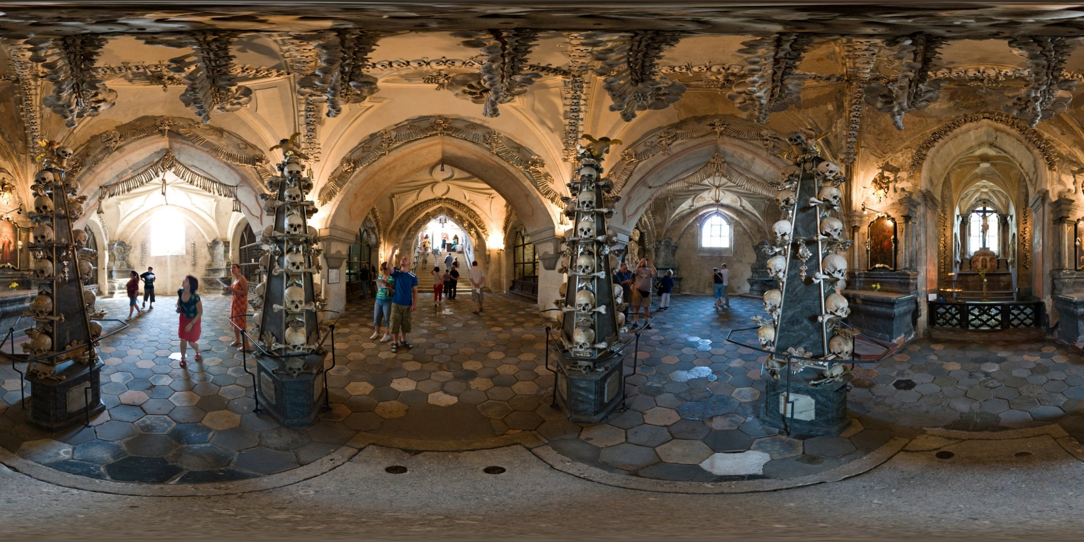
Appendices

Appendix 1 - 360° image of Sedlec Ossuary

Aspect A Aspect B Aspect C Aspect D

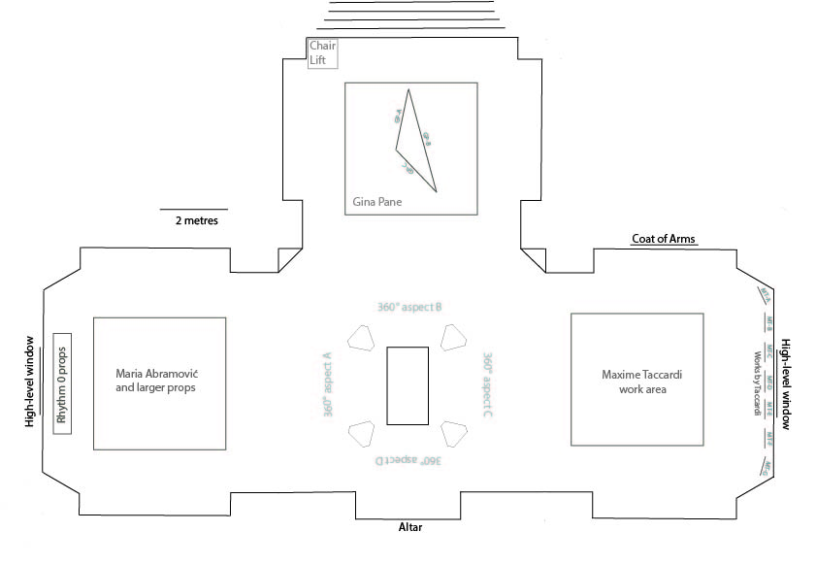
Appendix 2 – Floor plan of Sedlec Ossuary showing locations of artists and work
Appendix 3 – Installation key
GP-A - Azione Sentimentale [Sentimental Action], 1973. 16 black and white photographs. 80 × 120 cm overall (Saltoun, 2018)

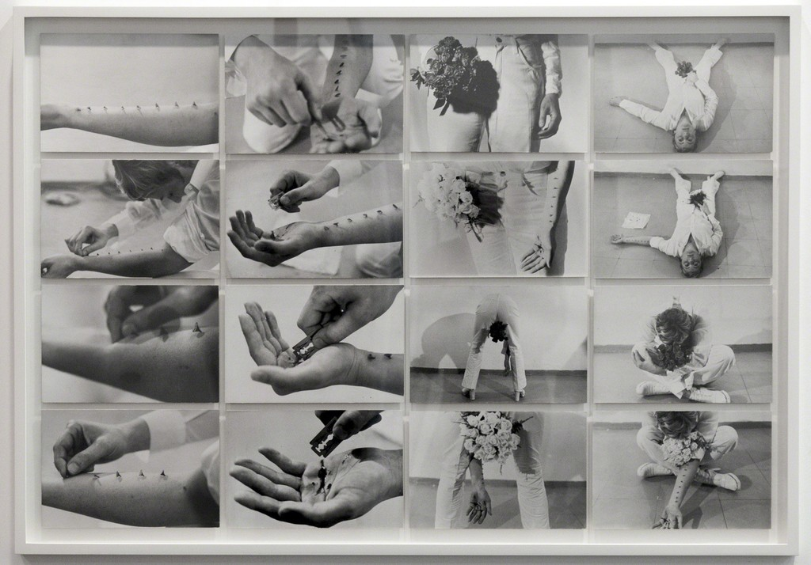
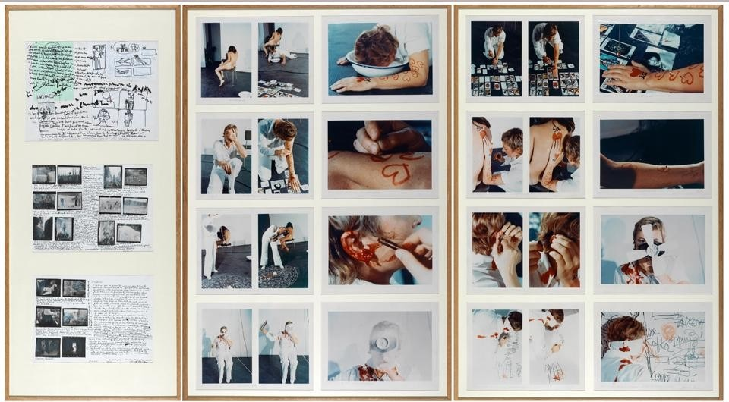
GP-B - 3 Works: Action mélancolique 2 x 2 x 2, 1974. Collages of paper, felt, ink, graphite and black and white photographs and colour
Largest 124 x 87 cm (Domus, 2018)

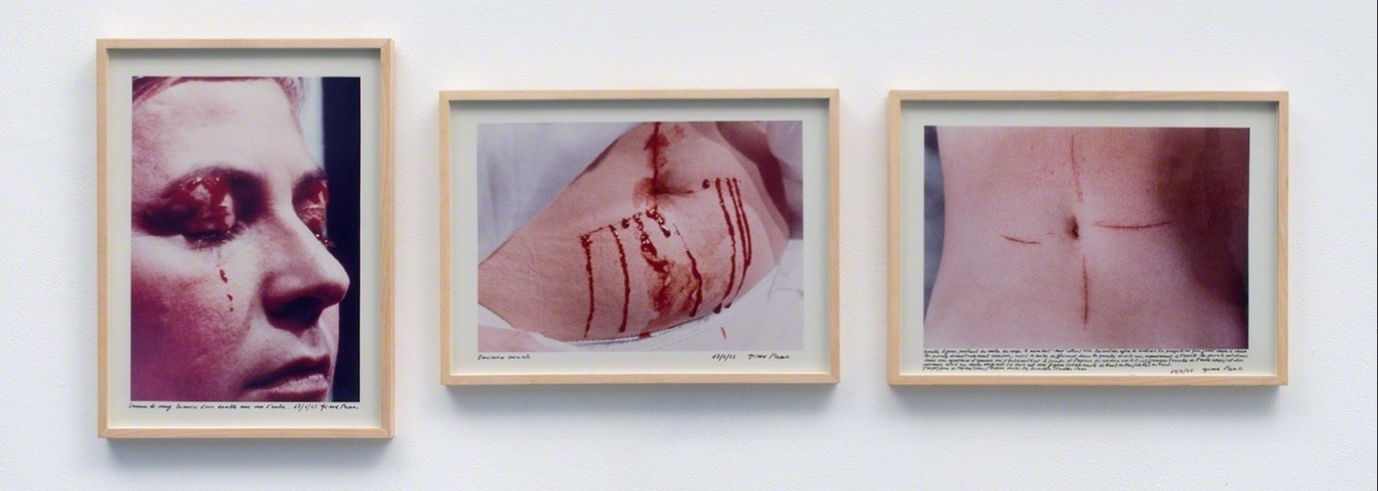
GP-C - Psyché, 1974. Colour photos, 29.3 x 40.2 cm each (Galleria-Elefante, 2018)

Display order for Taccardi works
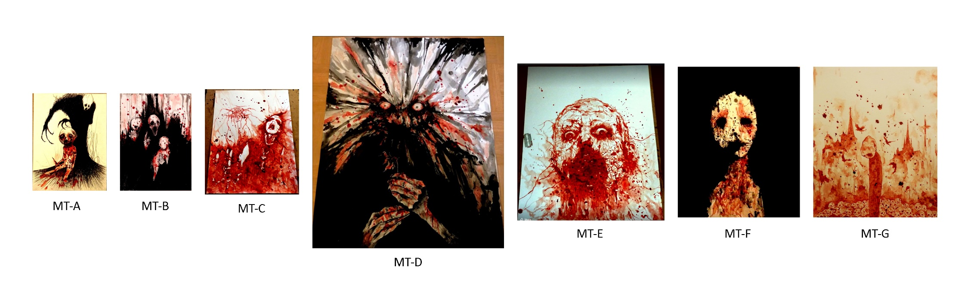

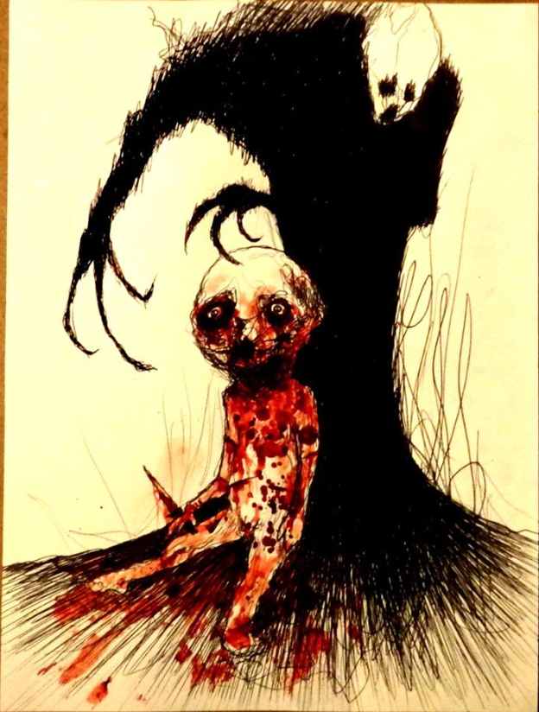
MT-A – Too Late, 2015. Blood, ink, paper. 21 x 29.7 cm (Taccardi, 2018)

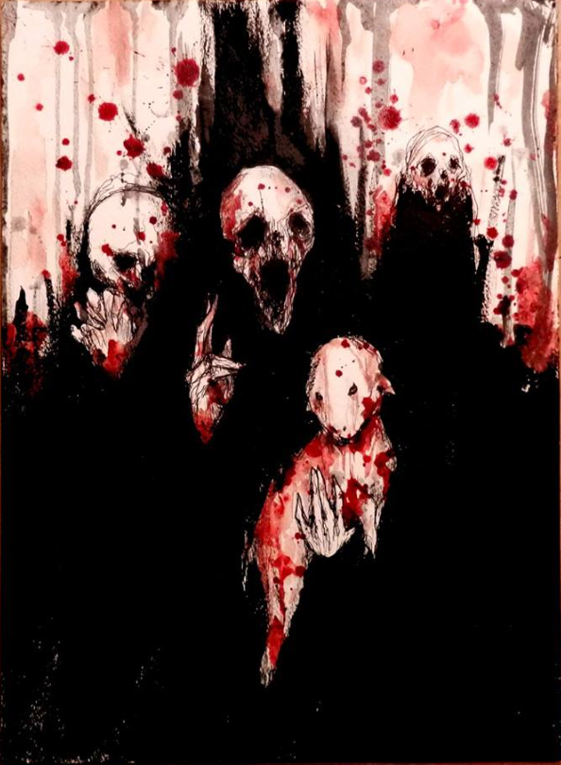
MT-B – Sacrifice the Lamb II, 2017. Blood, acrylic. 21 x 29.7 cm (Taccardi, 2018)

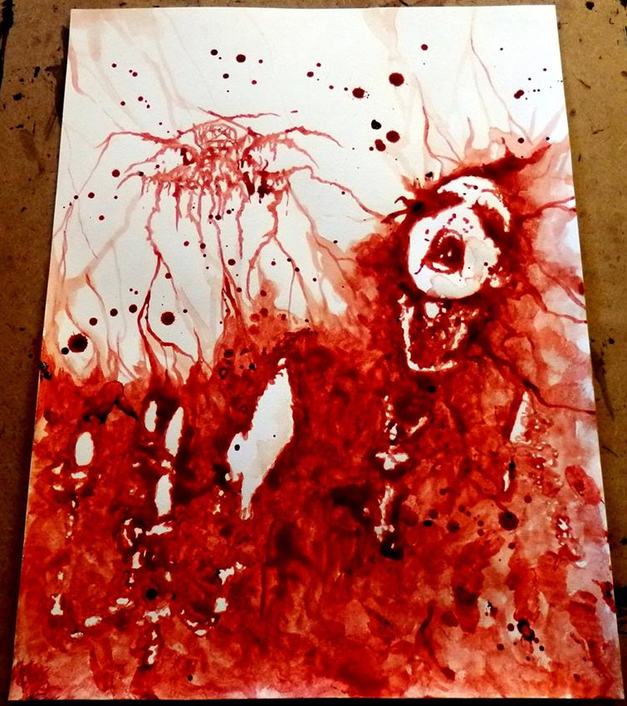
MT-C – Transilvanian Hunger, 2015. Blood, paper. 24 x 32 cm (Taccardi, 2018)
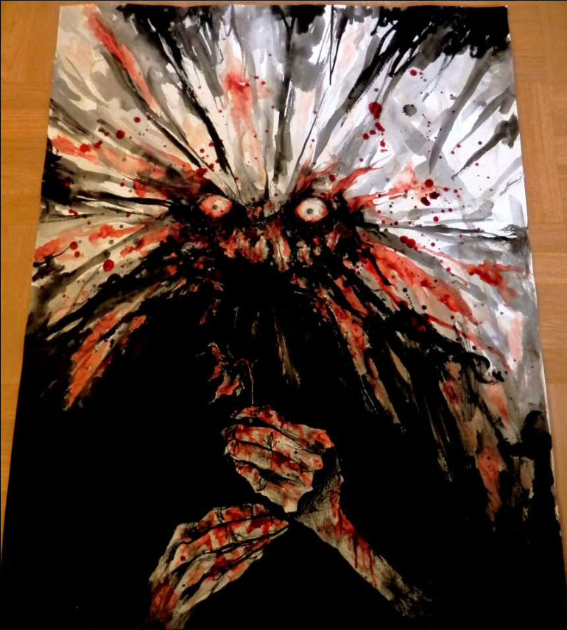
MT-D – Hate, 2014. Blood, black paint. 50 x 65 cm (Taccardi, 2018)

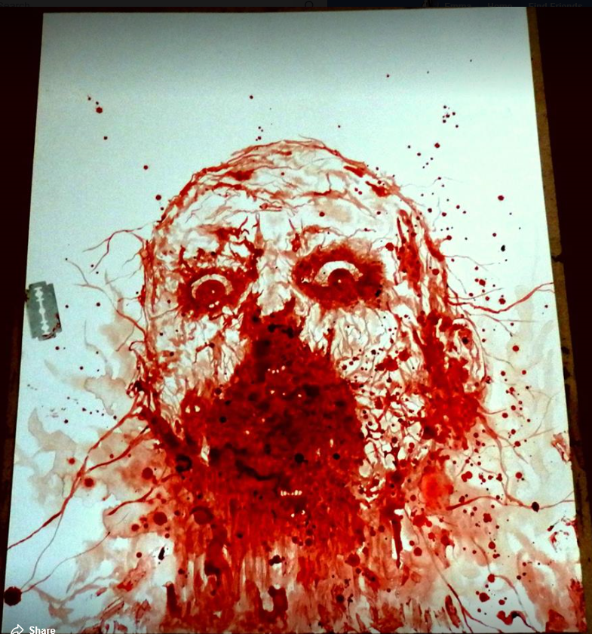
MT-E – Self Portrait, 2015. Blood, canvas. 40 x 48 cm (Taccardi, 2018)

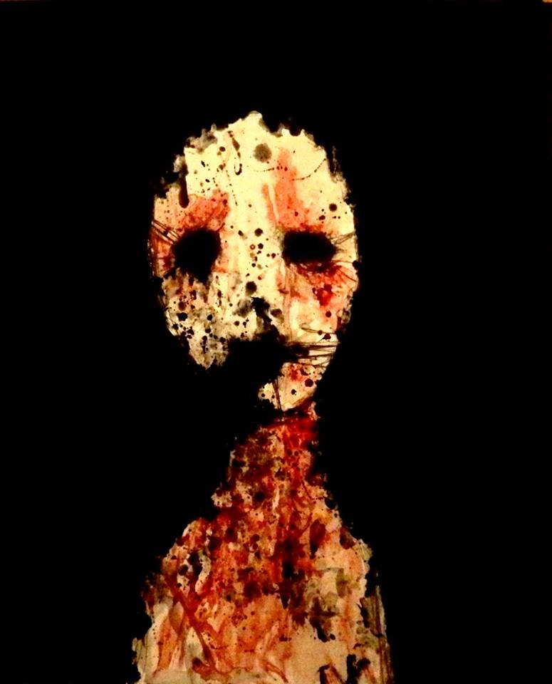
MT-F – I Can’t Blink Anymore, 2015. Acrylic, blood, canvas. 38 x 46 cm (Taccardi, 2018)

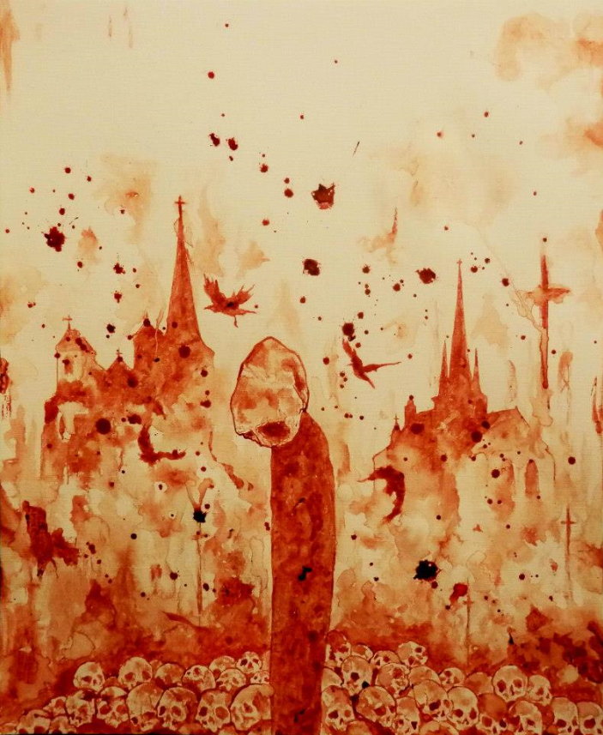
MT-G – Desolation, 2013. Blood, paper. 38 x 46 cm (Taccardi, 2018)

