Appendices

Appendix one - Good practice report from the electives experience
Appendix two - Ethics form
Appendix three – Example consent form
Appendix four – Example cover letter
Appendix five - Questionnaires
Appendix six - Interviews with teachers
Appendix seven - Interviews with children
Appendix eight - Notes from the electives experience

Appendix One 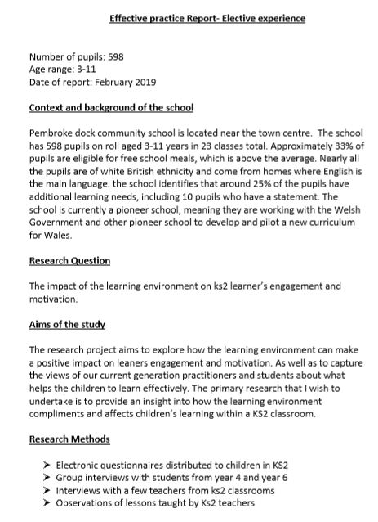
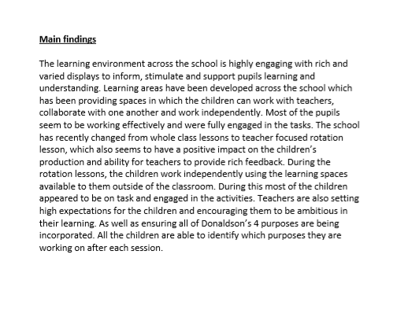

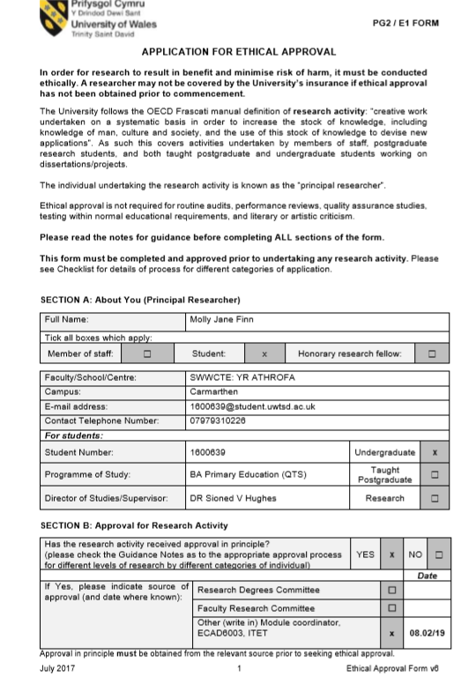
Appendix Two
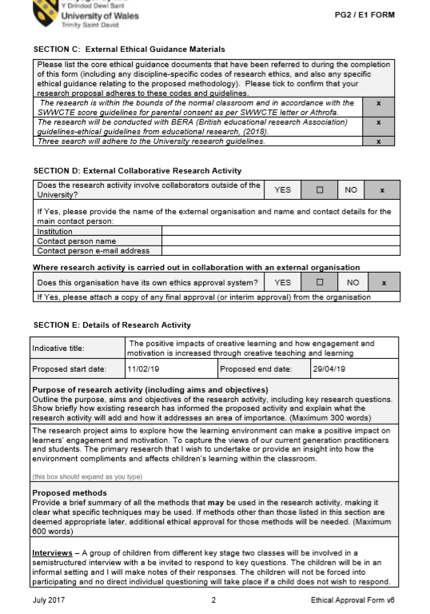
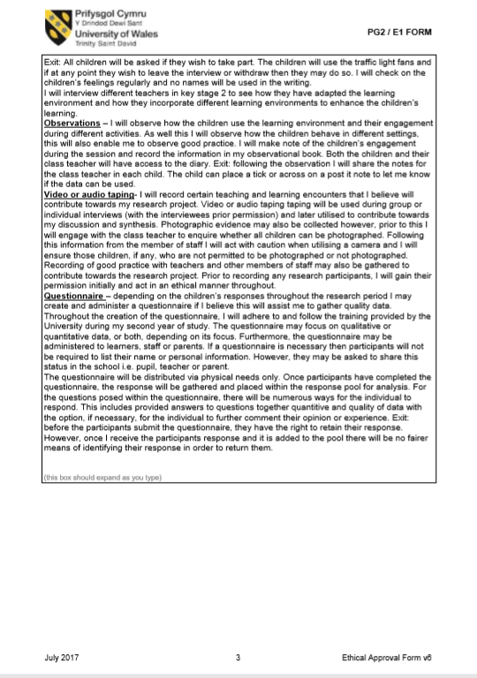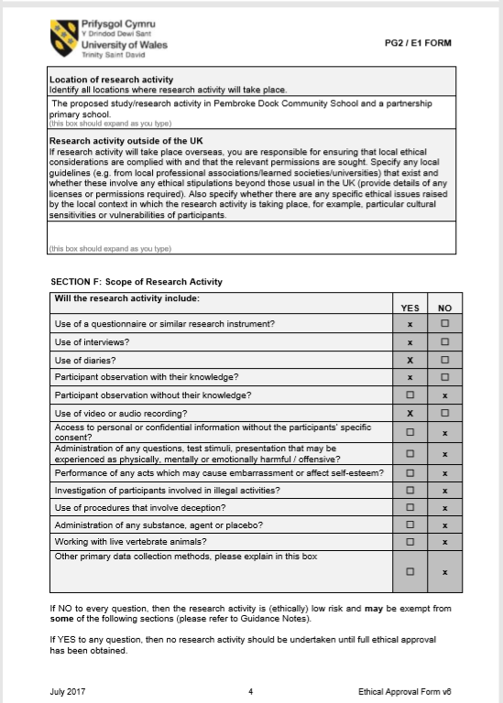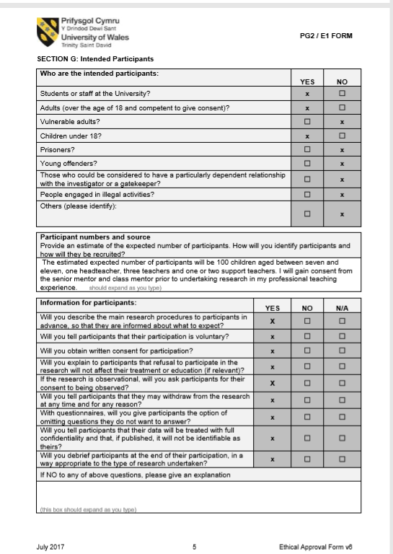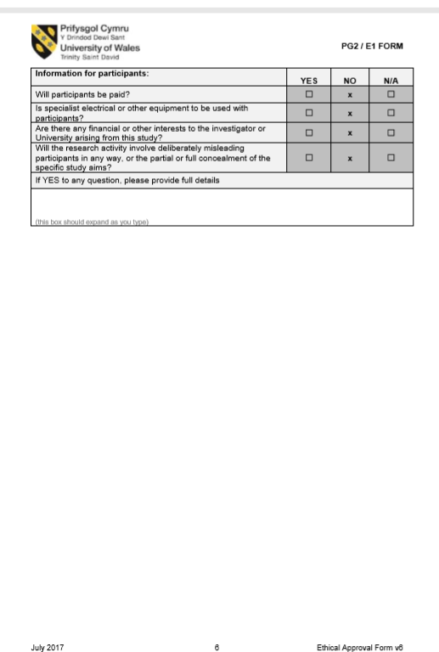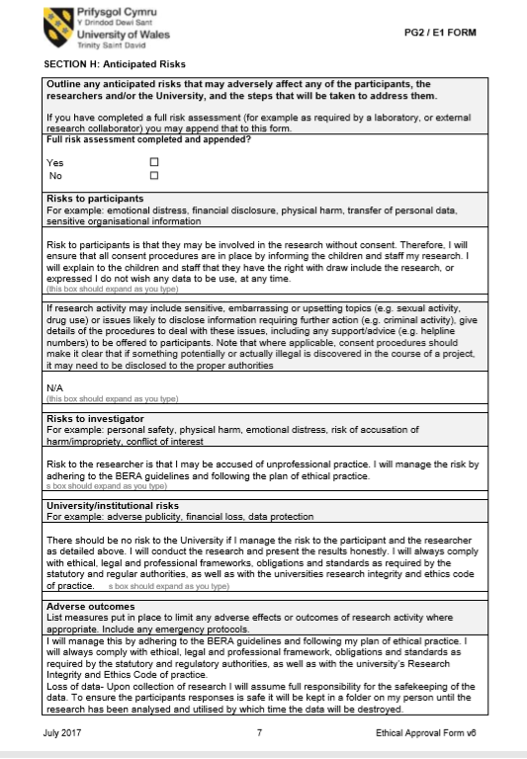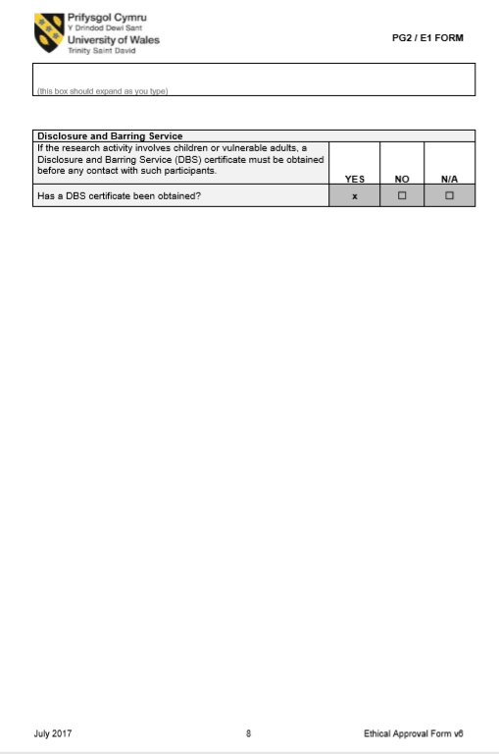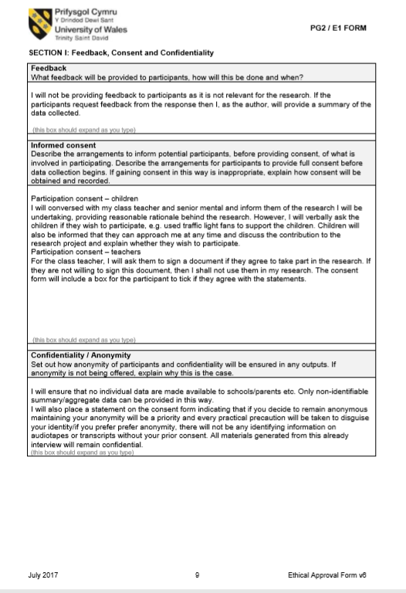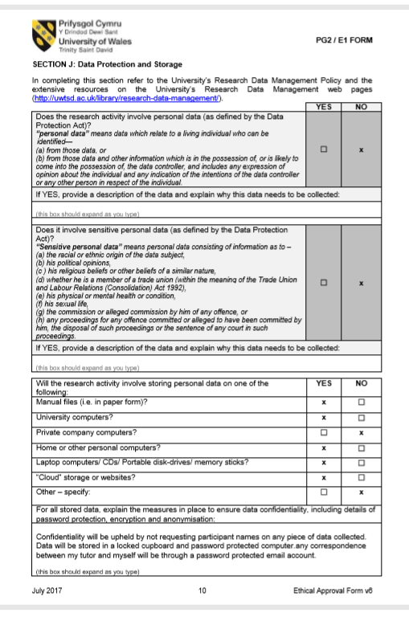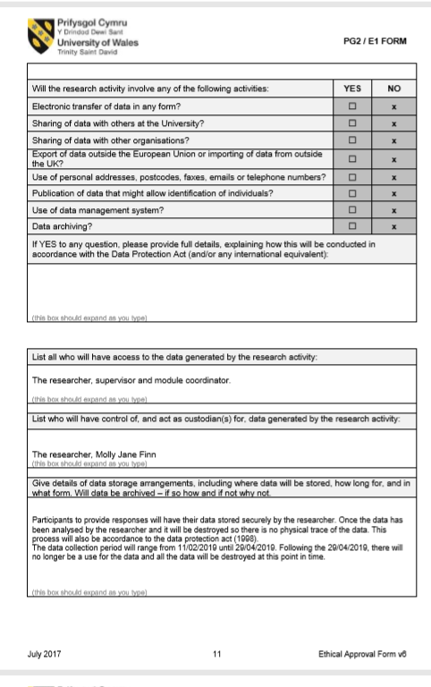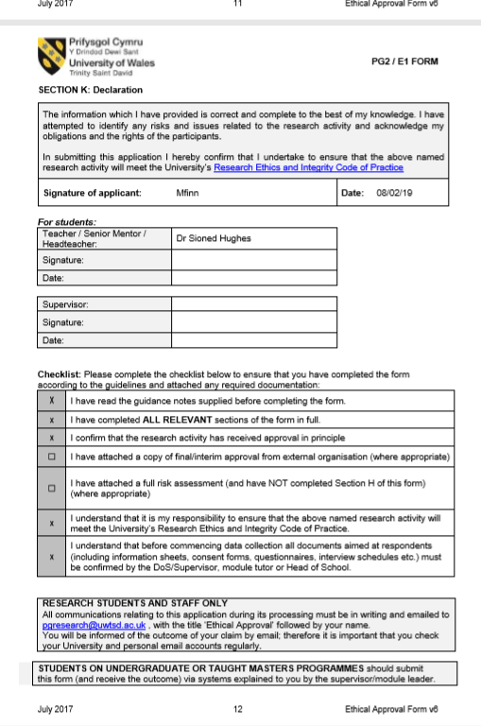Appendix Three
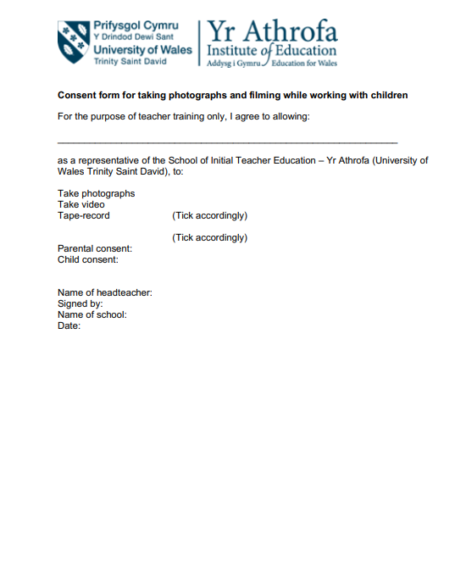

Appendix Four
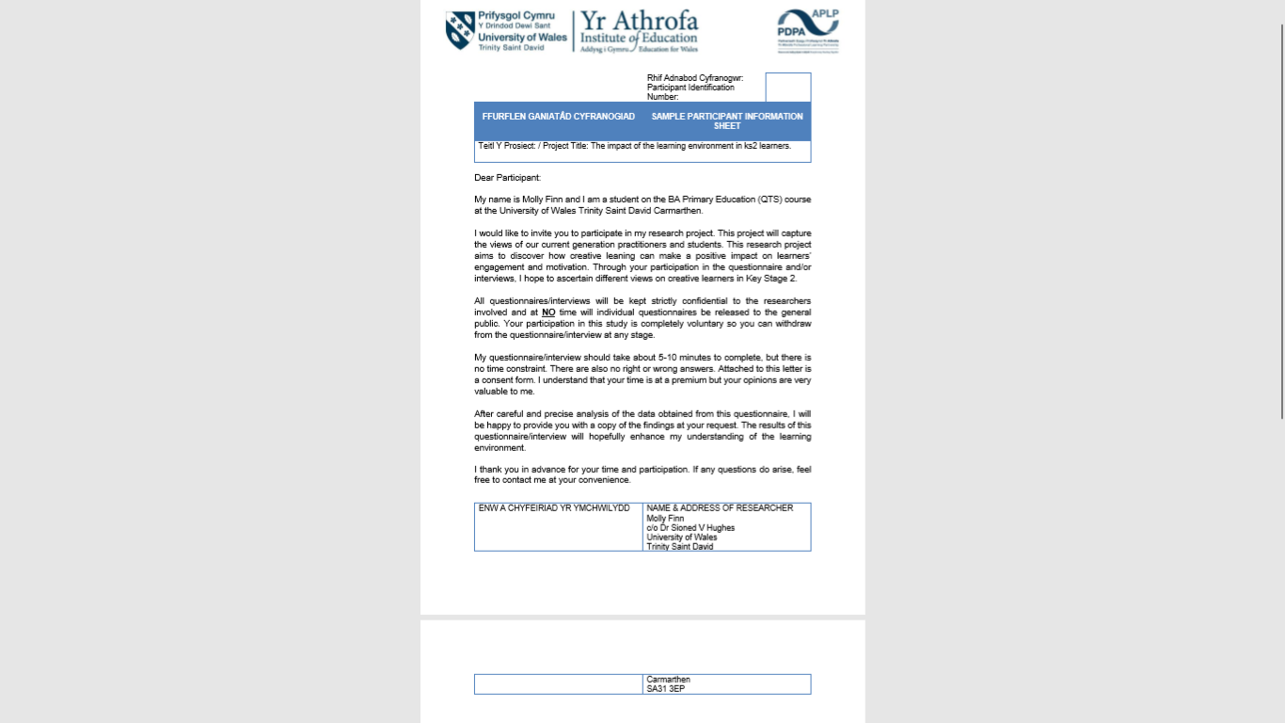
Appendix Five
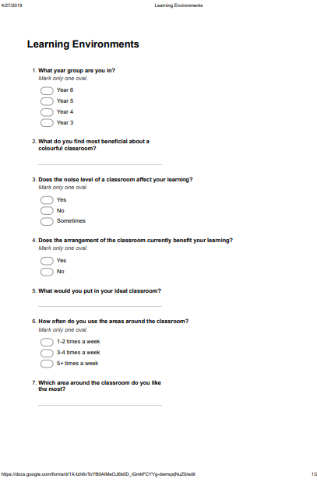
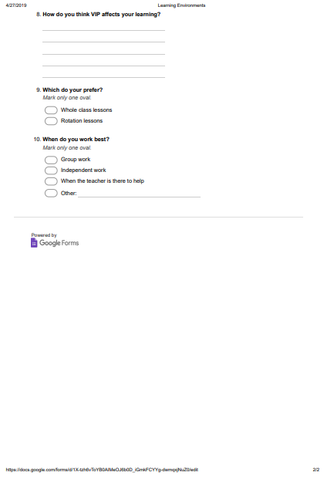
Appendix Six

Interview- teacher 1
- How do you motivate the children?
I would make the planning fun and engaging for the children, the more interesting the activity the higher the possibility for the children to be engaged.
- When do you think the children are working at their full capacity? For example: teacher focused groups, collaborative learning, independent learning
This would depend on the child; I think the children work the hardest during the teacher focused tasks because I am there to keep them on task and engaged.
- What do you have in your classroom to help the children if they get stuck?
I have resources in the classroom for example, access to the thesaurus and dictionaries, times tables and displays in the class.
- How would you ensure that the children are happy and ready to learn in the classroom?
I have a well-being chart; the children place themselves in the morning where they are. If a child is not happy for a reason, we informally talk to the children to help solve the problem so they are then able to get focused on the sessions.

Interview- teacher 2
- How do you motivate the children?
I involve the children as much as I can in the teaching of a new area, this keeps the children listening and thinking for themselves as well as motivating the children to contribute to the session.
- When do you think the children are working at their full capacity? For example: teacher focused groups, collaborative learning, independent learning
My children enjoy the lessons when they are working collaboratively and are engaged in the activities, however not all the children are working at their full capacity at all times.
- What do you have in your classroom to help the children if they get stuck?
I have a buddy system in the class, the children have learning partners. The children sit with their partners and can help out each other when they are stuck on a particular problem.
- How would you ensure that the children are happy and ready to learn in the classroom?
I look out for the children who are not being themselves, because it is later on in the year I know when a child is not as focused or happy as they usually are. I then have a chat with the child to work out what is wrong and how to overcome this.

Interview- teacher 3

  - How do you motivate the children?
I get involved in the lessons and get really enthusiastic, the more enthusiastic I am the more motivated the children are as they get excited about the topic we are learning.
  - When do you think the children are working at their full capacity? For example: teacher focused groups, collaborative learning, independent learning
I feel that this is very dependent on the strength and weaknesses of the children, some children work really well independently and are learning at their full capacity. However, some children need me to be there to help them and keep them on task.
  - What do you have in your classroom to help the children if they get stuck?
I have resources in my classroom, the children know where everything in the class and use it to help them. For example, there is Numicons in the draw for them to use in maths, I also have extending vocabulary on the walls they can use to develop their writing.

  - How would you ensure that the children are happy and ready to learn in the classroom?
I have a well-being chart, the children place themselves in the morning where they are. If a child is not happy for a reason we informally talk to the children to help solve the problem so they are then able to get focused on the sessions.

Appendix Seven

Children’s interviews –group 1, year 6
- What helps you when you are stuck?
“Wagolls really help me to know what I need to write” (What a good one looks like)
“When we are allowed to magpie ideas, helps my imagination”
- What do you like the most about your lessons?
“I like when the lessons are fun and interesting, otherwise I get bored and don’t want to do anything”
“I like when we do treasure hunts around the school, because it gets us out of the class for a bit”
- When are you working at your highest capacity?
“During maths because I am good at maths”
“When the teacher is there to help me with my work”
- What else could the teachers do to help?
“Make more wagolls, I like wagolls”
“I like it when there is help for me on the displays, to give me ideas on what to write”
- Which area do you like the most?
“I like the digi-den because I enjoy maths and we get to sit on bean bags”
“Smaller groups because then there is less people to distract me”

Children’s interviews –group 1, year 4
- What helps you when you are stuck?
“I like when we have a brain brake, going outside helps clear my head”
“The words on the walls help me to make my writing better”
“Working together to work something out”
- What do you like the most about your lessons?
“I like it when they are fun”
“I like it when we can go outside in the sun”
“I like drawing but I’m not very good at it”
- When are you working at your highest capacity?
“When I’m on my own I can focus more”
“When we work in small groups there is not as much noise”
“Working with someone else so they can help me”
- Which area around the school do you work best?
“I like going to the library because there is comfy sofas to do my work on”
“I like it when we work independently because we are allowed to go where we want”
“I like the challenges because I can dance and play outside with the footballs”

Appendix Eight

Day one –

Early years were using VR headsets to visually see an image and then using their knowledge paint the image that they can see. This is good for the children to see a 3D image to fully investigate the textures on the animals.
Early years were also using play dough to make animals placing different materials in the play dough for texture.

Year 1+2 were using real money to add up to two pound, the task was to see how many different ways they could make the money. Children take control, of their own learning and choose which level they think they could tackle.

Year 3+4 were independent learning, the children looked like they knew what they were doing however the wing looked very confusing coming into the wing.

Year 6 had just finished playing a game of quidditch, year 5 on residential trip.

Day two –

Observation of Parkour lesson, children use their problem solving skills when tackling the obstacles in different ways.
- The children were very engaged in the activity
- The children were developing their key motor skills for PE early on.
- The children explained that the activities are not scary, and they are not scared of the heights.
- Some of the children saw it as a creative activity, they explained that it is fun and away from the classroom
- Some children explained that you get out of the task what you put in. And will only succeed in the task if you put full effort into the activity.
- The learning is very hands on and involves the children running and ushering the space provided.

Observation of P4C lesson, starting with a question the children discuss and debate their views on the topic.
- Activity involves the classroom being flexible, where the tables are pushed to the side and chairs in a circle to help include everyone in the task.
- The children were made aware of the skills they would be working on and also made aware of the skills that are in year 7 for the children to extend their skills.
- Unfortunately, the behaviour of the class wasn’t as good as the parkour lesson which is interesting as with the parkour the children are outside of the classroom in a different environment.
- The children enjoy the lesson as they feel more comfortable working on the floor
- Easier to get involved in the activity when in a circle.
- The children enjoy activities that involve the children and keep them engaged in the task.

Year 6 math lesson, the children previously had assessed their own learning so knew which levels they were working at. The children were then sent off to complete a rotation of activities.
- Teacher focus group
- Digi-den (my maths)
- VIP game in pairs
Children discussed that they don’t lie being stuck in the classroom, the VIP means Very Independent Person. The children work outside of the classroom collaboratively or on their own to extend their learning.
- “ I don’t learn unless an adult is with me”
- “I can learn in any environment”
- “I like the reading corner because its comfy and warm.”
- “The birds are creative because it’s another way to show angles”
A child explained that she likes the discovery area, she has made a lava lamp there previously. She would use the discovery are to make maths more interesting because she doesn’t like it.

Year 4, challenges. Following the four purposes the year 3’s use the iPad to scan the QR code to find out the activity. When the children are on this activity they can chose any paper out from the 4 purposes to complete. The children enjoy the activities because they can choose which activity the wish to complete however the children also ways chose the creativity and healthy individual where they can dance and do crafts.

Day three-

Year 6 welsh activity with the rotation
- “30 mins to just mess around”
- “Sometimes I do more than I have to”
- “I enjoy drawing but I’m not good at it”
- “If I was on my own I would have finished by now”

What makes the classroom good?
Do you like coming outside of the classroom?

Day four-

Expert sashes- if the children or the teach feels that the children are comfortable with the task they can help the other children
Horse shoe tables, learning environments
What would be more effective small teacher focus groups or longer engagement for the children.
Skill ladder, the children are fully aware where they are and what they need to do to move up the ladder.
Flipped learning, the children learn the topic at home as homework first and then level themselves ready to come in and apply the knowledge they have learnt.
Children are able to recall all the 4 purposes and make their own eg we should be kid and caring learners.

Year 6- children building a safety zone out of Jenna blocks, each child writes on a block and they build a class one.
- The children were shy when walking up on their own, but had a little more confidence talking when in the comfort of their seats.
- However, when the children had the opportunity to remove a block from the Jenna and knock it down, all the children were engaged and ready to contribute their answers

Towards the beginning of the next lesson the children looked very sleepy and not ready to do work, the LSA paused the lesson and took all the children outside for a run or walk on the courts.

“I prefer the VIP area because it makes me more independent”
“It depends who is there if I do my work”
“It makes me more independent”
“I prefer the digi den its really comfortable and relaxed in the room”

