Marketing plan written for

RITZ-CARLTON MALDIVES

Student Name

ANDREEA SERBAN

Student ID number
2212423

Marketing Essentials BMIH4005

Lecturer

Luciana Suardi

Introduction

The primary goal of this marketing plan is to bring awareness to existing and potential new customers that a new Ritz-Carlton hotel has opened in Maldives at Fari Islands (Ritz-Carlton, 2022). This plan is intended to help management and staff to understand how this new establishment classes within the area, what can be achieved and how can this be done by applying the same Ritz-Carlton values and system which made this a well-recognised brand worldwide. To analyse all micro and macro-environmental aspects involved in this business plan various marketing frameworks such as 4’Ps, SWOT, etc will be used.

Situation Analysis

Ritz-Carlton which has an international presence across “30 countries” and welcomes their guests in one of their “29,158 rooms” (Pravin, 2021) with the finest personalised experience at the same standard of hospitality.). The Maldives location was opened in June 2021 on Fari Island which is a “four-island man-made archipelago in the North Male Atoll based a 45-minute boat ride from Velana International Airport”. (Levius, 2022). There are another 2 resorts in the same archipelago, Patina & Capella.

SWOT analysis for Ritz-Carlton Maldives, Fari Islands
Strengths | Weaknesses
Staff quality | Higher costs involved in providing the experience
Strong Brand | Fluctuating demand
Large client bases
Opportunities | Threats
Growing preference for luxury | Competition from 2 rivals within the same archipelago
Sought for destination | Rising costs of labour and supplies
 | Uncertain economic environment

Ritz-Carlton developed as a brand over the years and they are now well established and recognised worldwide as the “Gold Standard” (Ritz-Carlton, 2022) in hospitality and every stay is personalised. According to Bhasin (2019), families from the elite and upper-middle classes of society have been targeted, as well as business leaders, vacationers, corporations, and business travellers. The company has established a reputation as a high-end organisation that values giving its visitors lasting impressions.

Porter’s Five Forces Analysis of Ritz-Carlton Maldives
Threat of new entrants (Very low) | Bargaining power or buyers (Low) | Bargaining power of suppliers (Medium) | Threat of substitutes  (Very Low) | Industry rivalry  (Medium)
No available plot within the archipelago | Brand loyalty | Number and size of suppliers limited | Strong relationship with customers through Loyalty programme | 2 direct rivals
Capital requirements | Limited alternatives in the area | Remote area |  | Same offering
 |  | Logistics dependable on the weather |  | Brand identity
 |  |  |  | Smaller direct rivals

Pestel Analysis of Ritz-Carlton Maldives
P  Political | E  Economic | S  Social | T  Technological | E  Environmental | L  Legal
Good political stability | Low inflation rate | Cultural changes worldwide could increase travel experiences such as luxury resorts | Access to internet constantly expanded | Impact of changes in weather conditions | Possible data security breaches due to the system in place in Maldives, which is not fully digitalised
Incentives offered by the Government | Economic growth |  | Cost of internet high | Water shortages
 | Current worldwide economic slowdown could case a decline in luxury demand |  |  | Increased fuel prices
 |  |  |  | Climate change could impact making the location too hot

Objectives

This marketing plan is aiming to attract new customers at Ritz Carlton Maldives and increase sales by 10% in the year 2023 (May, 2022). The main objectives are to raise the brand's visibility in the Maldives, making sure that the establishment is available for booking and advertised properly (Landman, 2022), adding value to the services already offered to the customers so they can recommend the hotel brand to family and friends, and also differentiating from the competition by promoting the wow factor that the location itself has, combined with excellent services provided by the hotel (Nilsson, 2022).

Strategy

A product's competitive position in the market can be improved with the use of Bowman Strategy Clock. According to Sridharan (2022), this highlights the elements of market positioning for a company's goods or services based on the two criteria. The first addresses the price, while the second covers the perceived value of the brand, product, and service.
Sridharan (2022) wrote that Focused Differentiation is the attitude that Ritz Carlton Maldives adopts. This seeks to position a service or product at the top pricing points, where clients buy it or use it because they think it has a high level of quality. For their costly items, their targeted audience is prepared to pay more than their rivals. To achieve the higher profit margins, targeted marketing, distribution, segmentation, and promotion techniques are used. The price of their products must remain greater than those of their competitors that serve the same market segment.

Tactics
Product: The Ritz-Carlton Maldives, Fari Islands hotel, located within an integrated development and offering luxury accomodation (Ritz Carlton, 2022).
Place: Fari Island, Maldives. The hotel will use advertising with images and short clips using drones, so the resort and the island can be seen from above as it is a very eye-catching scenery. These will be promoted on various channels such as social media, website, travel agencies, etc. (Ritz Carlton, 2022).
Price: According to Bhasin (2019), because it is known as a high-end hotel chain, Ritz Carlton will have higher prices. It attracts members of the privileged class who are prepared to spend more for luxurious rooms. They place more value on extras and comfort than on money, which is why the brand's high prices have worked.
Promotion: Ritz Carlton will advertise its services through a variety of media platforms such as social media, TV, travel magazines etc. According to MBA Skool Team (2019), it tries to offer goods and services that will satisfy its clients so they would subsequently promote the experience to others, and so on, in order to position itself as a highly premium brand. Ritz Carlton will run striking Maldives Island advertisements in tourist magazines in addition to their official website to attract new clients.

Action

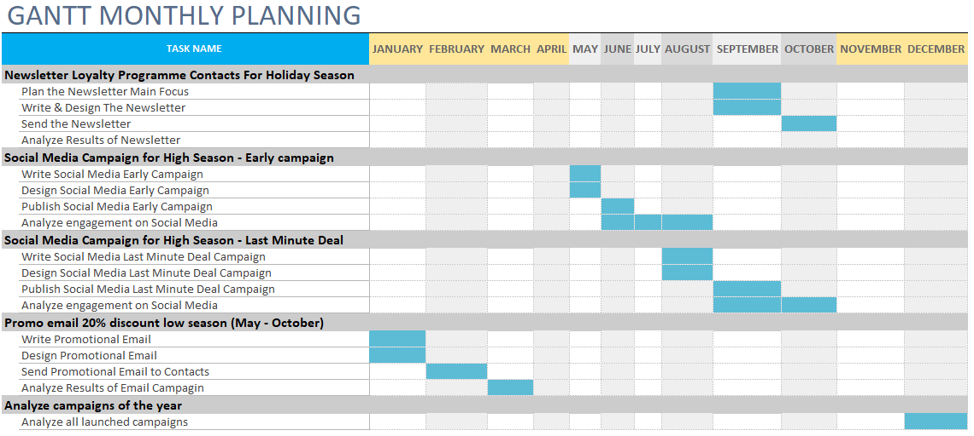

In the Maldives, there are two seasons: a low season between May and October and a high season between November to April, so the marketing activities action plan must be done accordingly:

January – March: a promotional e-mail with 20% discount in the low season will be sent;
May – August: a social media campaign will be promoted for high season;
August – October: a social media campaign with last minute deals for high season will be promoted;
September – October: a loyalty programme newsletter will be sent;
December: the campaigns results will be analysed.

Control

Competition within the location of the hotel is quite tight since all resorts operating within the archipelago promote the same message: luxury accommodation, but the main selling point for Ritz-Carlton Maldives is the service, which comes with an unique approach. At Ritz-Carlton Maldives the guests will have a butler called “Aris Meehas, a historical Maldivian reference to someone assigned to serve royalty” (Levius, 2022). In this way the level of luxury will look like is upgraded to a totally new level, of royalty, something which is not easy achievable elsewhere. The success of this approach will be measured by the guests’ feedback, as Ritz-Carlton delivers quality rather than quantity.

Conclusion
Ritz-Carlton Maldives blends perfectly with the brand image of luxury and bespoke services as Maldives is very well-known to be a top exquisite destination. The brand’s presence on the luxury market should automatically create demand for this new location and the large database of loyal customers who’ve already tried Ritz-Carlton’s services elsewhere should be tempted to book a stay in the foreseeable future. Challenges which come automatically with this remote destination such as limited availability of staff and supplies as well as issues which might occur due to the unpredictable weather should be proactively tackled and well planned ready to be actioned when it happens.

References

Bhasin, H. (2019) Marketing mix of Ritz Carlton Available at: https://www.marketing91.com/marketing-mix-of-ritz-carlton/ (Accessed: 30 November 2022).
Bhasin, H. (2019) SWOT analysis of Ritz Carlton Available at: https://www.marketing91.com/swot-analysis-of-ritz-carlton (Accessed: 29 November 2022).
Investopedia Porter's 5 Forces Explained and How to Use the Model Available at: https://www.investopedia.com/terms/p/porter.asp (Accessed: 29 November 2022).
Kenton, W. () What Is PEST Analysis? Its Applications and Uses in Business Available at: https://www.investopedia.com/terms/p/pest-analysis.asp (Accessed: 1 December 2022).
Landman, P. (2022) Hotel Marketing Plan & Strategies for 2022 & 2023 Available at: https://www.xotels.com/en/hotel-management/hotel-marketing-plan-strategies (Accessed: 30 November 2022).
Levius T. (2022) The Ritz-Carlton Maldives, Fari Islands Available at: https://www.cntraveler.com/hotels/fari-islands/ritz-carlton-maldives-fari-islands (Accessed: 29 November 2022).
May, M. (2022) 12.5 STEPS TO A PERFECT INCENTIVE PROGRAM Available at: https://brightspotincentivesevents.com/wp-content/uploads/2017/09/Incentive-Program-How-to-Guide.pdf (Accessed: 30 November 2022).
MBA Skool Team (2019) Ritz Carlton Marketing Strategy & Marketing Mix (4Ps) Available at: https://www.mbaskool.com/marketing-mix/services/17698-ritz-carlton.html (Accessed: 30 November 2022).
Nilsson, D. (2022) SOSTAC ® Marketing Model – Top Ranked Planning System Available at: https://www.daniel-one.com/blog/sostac-marketing-model-planning-system (Accessed: 30 November 2022).
Pravin, P. (2021) Ritz-Carlton Business Strategy: Maximum Customer Satisfaction Available at: https://thestrategystory.com/2021/06/09/ritz-carlton-business-strategy (Accessed: 29 November 2022).
Ritz Carlton (2022) An ISLAND DESTINATION OFFERING ADVENTURE AND CULTURE Available at: https://www.ritzcarlton.com/en/hotels/maldives-fari-islands/area-activities (Accessed: 30 November 2022).
Ritz-Carlton (2022) Gold Standards Available at: https://www.ritzcarlton.com/en/about/gold-standards (Accessed: 29 November 2022).
Ritz Carlton (2022) Modern waterfront luxury Available at: https://www.ritzcarlton.com/en/hotels/maldives-fari-islands/hotel-overview (Accessed: 30 November 2022).
Ritz-Carlton (2022) Ritz-Carlton Maldives, Fari Islands Available at: https://www.ritzcarlton.com/en/hotels/maldives-fari-islands (Accessed: 29 November 2022).
Sridharan, M. (2022) Bowman’s Strategic Clock – How to position your product? Available at: https://thinkinsights.net/strategy/bowmans-strategic-clock/ (Accessed: 30 November 2022).



