Michael Cunniffe (P148021)
Mcunniffe.148021@student.ac.uk

SEMINAR paper of BSC motorsport engineering Flow Analysis of a cylinder head for motorsport competition and validation by use of a rolling road

General Abstract
In this paper the activity presented is focused on the volumetric flow rate of cylinder heads intake and exhaust ports for competition use. Volumetric flow rate (VFR) is the study of the amount air-fuel mixture that flows through an intake port. The process of burning fuel with a mixture of air in an engine as a means of propulsion is a very well documented craft. It is known as a craft as the easy part is to get the fuel into the cylinder but the more difficult part is supplying the air into the chamber. There are many parameters in the cylinder head that influence an engines performance. One of those methods is empirically discussed in this paper which includes modifying the intake and exhaust port geometry. The study of cylinder head port design airflow the main bulk of the analysis and how its effects performance output, there is just an acknowledgment of fuelling but no in depth research on the topic just brief descriptions where needed. As this study is just involving volume and flow of air in an engine modified for racing, it will be ignoring the swirl and tumble effect as the study is just involving volume and flow of air because swirl and tumble are flow characteristics that improve air fuel mixing for better fuel economy.

Technical Abstract
This paper presents the application of practical experimental procedures with the help of a Superflow-300/600 Flowbench to increase the volume of air to and from the engine and the speed at which that volume travels through the engine. The flow through an engine is equally important to have accurate values for coefficients of discharge (CD). During the testing of the cylinder heads the pressure of air mixture supplied to the intake port remains constant whilst a recording of the VFR is taken during a fixed valve lift between 1.4mm to 11.2mm (because the engine being tested has 10.15mm of valve lift) so a reading can be recorded as is typically done on a flow bench test. The flow velocity (FV) of the air in the intake port, is recorded in increments per valve lift to show how efficient the port design is in getting the air mixture to the combustion chamber and the flow velocity of the exhaust ports will show how quickly the gases are expelled. Modifications to improve the VFR such as to Port and polish the cylinder head after a comparison of the data is examined. The OEM engine and the modified engines output will be calculated in the vehicle to give outputs with real world conditions by use of a Dyno Dynamics rolling road to validate the research in this paper.

Contents Page

1) General Abstract 0
2) Technical Abstract 0
3) Contents Page 1
4) Introduction 2
4.1) 2020 Junior rallying regs 3
4.2) How to collect the data 0
5) Literature Review 1
5.1) Peugeot (TU5J4) cylinder heads 2
5.2) Swirl and Tumble Limitations 3
5.3) Porting and Polishing 4
6) Conclusion 5
7) References 6


Seminar of BSc Motorsport engineering Year 3 2019

Flow Analysis of a cylinder head for motorsport competition and validation by use of a rolling road.
By Michael Cunniffe (P148021)

Introduction
The development of the internal combustion engine (ICE) in the field of motorsport industry processes have become more technical in aspects of performance and efficiency. The cylinder head has been thoroughly researched mainly the intake system, as it is a vital sub system of an engine that can impose a great effect on air-fuel mixture, consumption and exhaust gas formation. How the air is shaped dose not concern the study in this paper because in this case of a race engine, every part of research found for performance engine building ignores flow characteristics such as swirl and tumble but is more focused on volume of air and velocity of air in the intake ports i.e (how fast that air volume travels into the combustion chamber). Don’t be mistaken by volume and the capacity of the overall engine, this volume increase is dedicated to the volume of air in the cylinder head ports whilst retaining the vehicles cubic capacity. To produce more horsepower from an engine you must be able to burn more fuel, one way of burning more fuel is done by increasing air supply to the engine. In order to extract the maximum performance from an NA car it is usually necessary to modify the cylinder heads ports. Without doing this you will never really see big gains. Putting “high lift” long duration camshafts into the ICE “will allow more air in but the head ports” of a production car are already causing the restrictions (D. Vizard .1971). This topic of the paper of increasing an engines power output by analysing the flow of gases in an OEM stock cylinder head with the intent of using techniques such as machine porting and polishing therefore improving the volumetric flow rate of the engine. This topic is has been chosen to be reviewed because the vehicle that the internal combustion engine is from is a Peugeot 106 GTI rally car that is used for motorsport purposes, in this case stage rallying. In Ireland there is new stricter regs for 2020 junior rallying set out by Motorsport Ireland to make junior rallying cheaper and more competitive.

4.1) 2020 Junior rallying regs
- The engine homologation rules state that all engines must retain inlet and exhaust manifolds in there entirety.
- No modifcations to throttle body are permitted, similarly the fitting of an aftermarket high flow manifold or larger throttle body from the same manufacturer.
- Engine must be from the original manufacturer of the chassis.
- forced induction is not permitted with the exception of a 1000cc turbo diesel.
- all 2wd must be equal to or less than NA 1650cc multi-valve

The regulations are open for modifications to the port geometry of the cylinder head which is important for power and torque of racing engine that are going to be taken full advantage of in this paper. There are various methods to enhance the performance of a production spark ignition (SI), naturally aspirated (NA) engine for high performance application. “Modifications to a cylinder head port system will give greater benefit compared to an exhaust system” (1. M. Johar, 2. M. Said, 3. M. Abas, 4. Z. Latiff, 5. M. Ali and 6. N. Ibrahim 2019). The challenge in this study is to maintain the NA engine while increasing the mass of the air circulating through the port. This paper will describe gas motion in terms of air mass flow rate and optimization to enhance the flow rate for racing purposes.

4.2) How to collect the data
- Experimental evidence is involved to explore potential of the production Peugeot TU5J4 cylinder head by means of a Superflow 300/600 flowbench in the university workshop

- Prior to using the flowbench the Valve stem and head for both the intake and the exhaust valves must be measured to calculate the area of the valve of which the air is flowing through.

- The cylinder head has to be set up on the flowbench with the combustion chamber sealed
- The flowbench measures the volumetric flow rate (VFR) of the intake ports and exhaust ports of the production Peugeot TU5J4 cyclinder head

- the volumetric flow rate is measured during each increment from valve opening 1.4mm to full lift, the max lift on the TU5J4 head is 10.2mm but open further to make sure it opens enough.

- The flowbench measure the VFR but it is measured is cubic feet per minute (CFM) for each increment of Valve lift in which needs to be converted to (m³/sec) using this formula: VFR = CFM / 3600 X 1.7
- Once VFR is calculated for each increment of valve lift then the flow velocity (FV) can be calculated for each increment of valve lift using the formula: FV = VFR / Valve area
- Valve area = VFR / (Πr2 valve head – Πr2 valve stem)

- Flow velocity unit = (m/s)

- Calculate the CO-Efficient of discharge which is the ratio between actual discharge to ideal discharge. CD is used to monitor the flow efficiency of a cylinder head based on the valve are as a function of valve lift / valve diameter ratio as stated by (Burgess and Gollan .1997)

- Now repeat these steps for the Ported and polished cylinder head.

- Conduct a thorough comparrison of the VFR, FV and discharge of the production head against the ported and polished head.

- Place the production head on the TU5J4 ICE and run the Peugeot 106 GTI rally car on the Dyno dynamics rolling road

- Place the modified head on the TU5J4 ICE and run the Peugeot 106 GTI rally car on the Dyno dynamics rolling road

- Do a comparison on the engine power outputs between the production and modified head to validate the research on greater capacity air mass flow through intake cylinder heads ports increases power output of an engine for motorsport application.

Literature Review

Obviously an ICE has a block fuel of components such as piton crown shape and materials used that plays a huge factor in the power output of an ICE but not as important as the cylinder head , this is because it is more difficult to get air mass into an NA spark ignition engine on the induction stroke than it is to get burnt gasses out because the burnt gasses get pushed out during the exhaust stroke also with the help of the increased torque from the ignition stroke. This is where the design and geometry of intake ports stand out with its operation of “volume of flow”. This is really the primary source of an engines power as stated (Burgess and Gollan .1997)

Some restrictions engine designers face when building a production car:
- Legislation: Production cars having to meet emissions quota, motorsport Ireland a trying to implement these regs to follow the car industry by trying to promote capacity downsizing in the sport.

- Reliablity: nowadays in the automotive industry engine manufactures face downsizing so they strive to get the same power output from a 1.0l turbocharged car than they did 15 years ago with a 1.6l Na engine which leads to reliability problems in some cases such as engine blocks cracking the the ford 1.0l ecoboost. The same can be said in formula 1 where the cars are making close to 1000bhp

- from a 1.6 V6 turbocharged with and energy recovery system.

- Noise: The introduction of noise restrictions hindered the power output of NA engines from the 2000s because exhaust manifold lengths and systems had to be altered.

- Dimensions: ports shape is more so what manufactures are striving for now to meet emission legislation therefore don’t need expensive large bores.

- Efficiency: Since the combustion cycle takes place in the cylinder head there needs to be a competent applicable casting process because burnt gasses exit from here. (The Aluminium Automotive manual .2011)

5.1) Peugeot (TU5J4) cylinder heads

In this study the engine used in the flow analysis is a Peugeot TU5J4 taken from a 106 GTI. It is a 1.6L 16v 4 cylinder engine therefore the engine has 2 intake and 2 exhaust ports per cylinder and it comes well equipped with multi-point fuel injection, and “downdraft” port design. This is a port shape technique used by many other engine manufacturers such as Honda where the inlet ports are angled downwards into the combustion chamber also known as a “High approach port”. This enables a turning motion in the port as shown in the image on the right. Earlier it was mentioned that production cars don’t need a competitive head design but Peugeot is such a large wealthy company with 74.03billion euro in revenue for 2018 and deep history in World rallying/endurances racing at the highest level. So you’d expect a good product from them. This port is designed so that air goes directly at the path of the valve to the seat to create ‘’swirl’’. In this case the port design was for natural swirl. “The mass flow rate of a stock production engine have the optimum combination between intake port design and intake valve lift”. (1. M. Johar, 2. M. Said, 3. M. Abas, 4. Z. Latiff, 5. M. Ali and 6. N. Ibrahim 2019). But there designed in such a way to meet strict emissions, comfort and drivability criteria for daily usage. Therefore performance in a stock SI production engine is being compromised to meet an overall goal of the vehicle. The Study will look into optimizing the stock production SI engine to understand the performance limitations before using the Peugeot 106 GTI rally car in an event.

Peugeot (TU5J4) engine
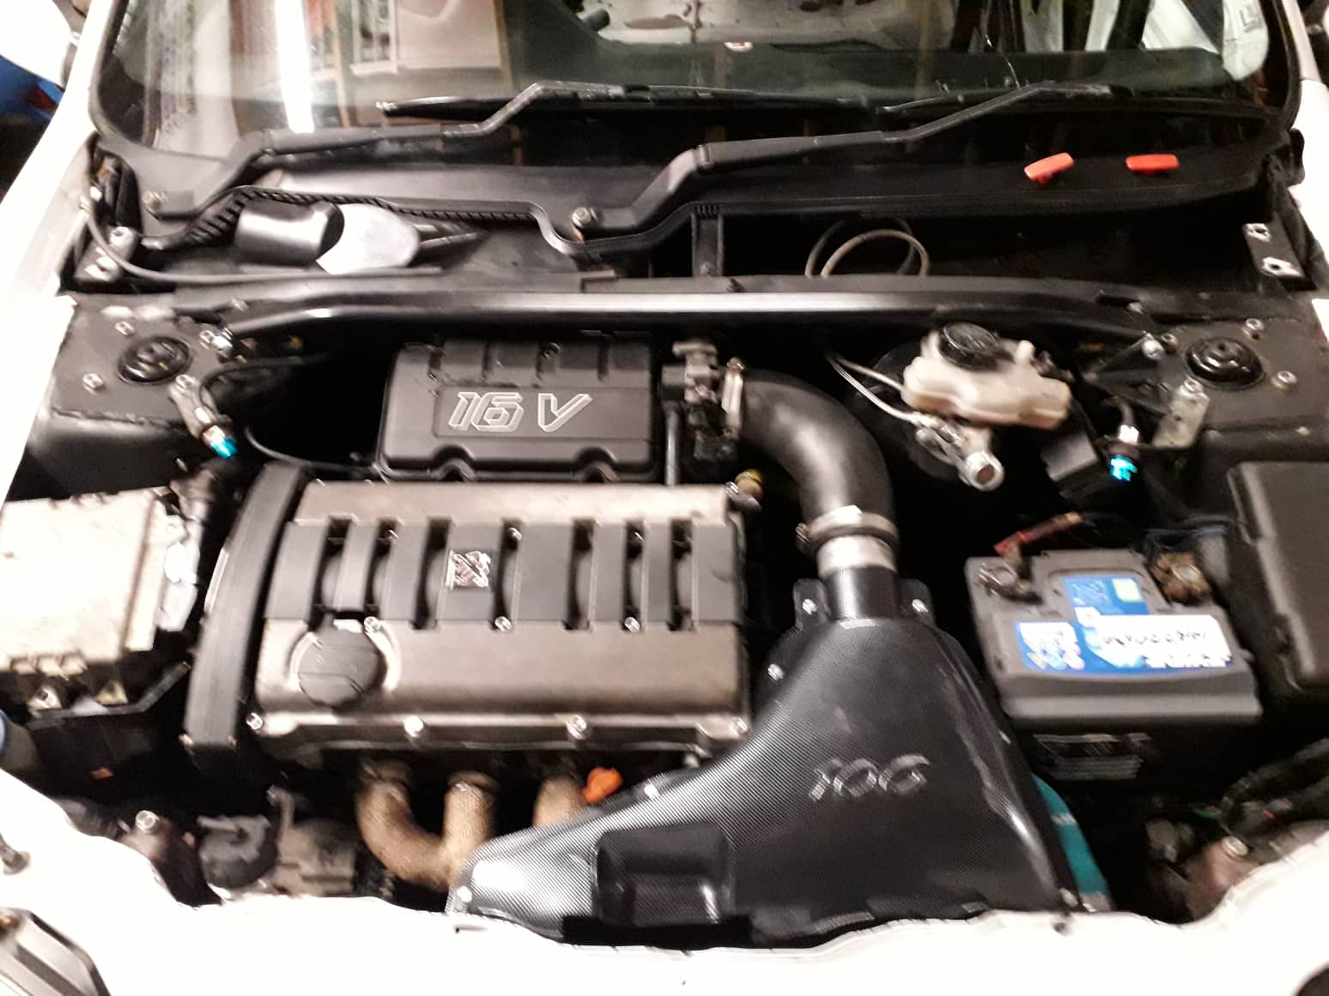

5.2) Swirl and Tumble Limitations

Engine builders according to (Baechtel .2015), (Performance trends. INC) state that generally heads with good motion charachteristics such as swirl and tumble, perform better because they will burn the fuel/air mixture faster. “The swirl meter lets you measure intake mixture motion on your flow bench to track differences between just good heads and great heads”. Even though these flow characteristics could not be measured in the university facilities, they deserved a mention as they involve types of airflow through a cylinder head. These two phenomenon’s are two different types of motions that aid in air-fuel mixture but since this study isn’t about fuel efficiency they are of no use in this paper but could have made the paper a little more appealing (Performance trends. INC). This motion gives rise to faster burn. Heads gain from this faster burn in two ways.
- The engine will require less spark advance. Because the mix is fired closer to top dead centre (TDC), which means that there will be less cylinder pressure to fight the piston as it comes up.

- The burning of the mixture is finished sooner than it reaches TDC which in turn creates more cylinder pressure after the ignition stroke which pushes the piston back down making more power as stated by (Performance trends. INC)

Left: Swirl Right: Tumble
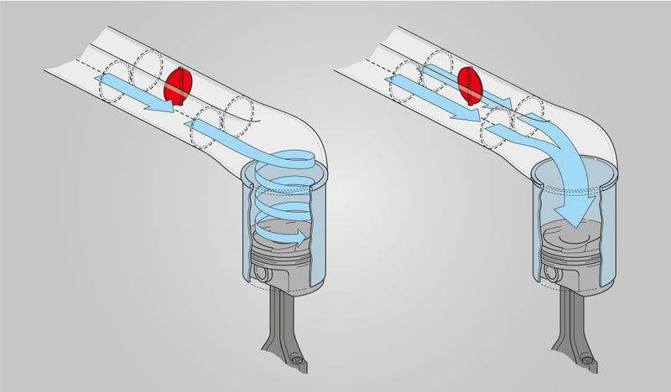

5.3) Porting and Polishing

This is the technique used across the motorsport fraternity for increases the output of an engine by removing excess rough material from the casting process. Porting refers to removing the material to create a greater port geometry which in turn improves the mass airflow of the cylinder head or getting that volume into the combustion chamber. It is done by using a Dremel or with modern techniques by means of a 5-axis CNC machine. Polishing refers to the smoothening out the ports to make sure there is as little friction to slow the velocity of the air. For homologated racing eg (formula ford 1600) or rallying (Peugeot 106 super cup challenge) classes in which certain cars must have the same diameter ports as the homologation papers state but competitors gain a slight advantage by blueprinting there cylinder heads. This is done by ports matching the same diameter as the homologation papers state because there will always be excess material from the casting process. Studies have show that a rough surface creates turbulence in the airflow that promotes air-fuel mixing in the port rather than having a squeaky clean port refined down by 400 grit sandpaper. Studies have shown when testing a production cylinder head vs ported and polished head on a flowbench to calculate the mass air flow and flow velocity of the air, at opening valve lift of 1mm up to 7mm valve lift the air flow recorded is slower on the modified head than the production head. This can be seen on the study of (Intake Port Flow Study on various cylinder head using a flow bench). The reason being for this makes clear understanding as it states the increase in port geometry means that the air has a larger cross sectional area to flow through, that’s why it would be slower than the production car and because the original ports as designed for the capacity of that engine. But the study shows at full open lift the volumetric flow is greater and the velocity.

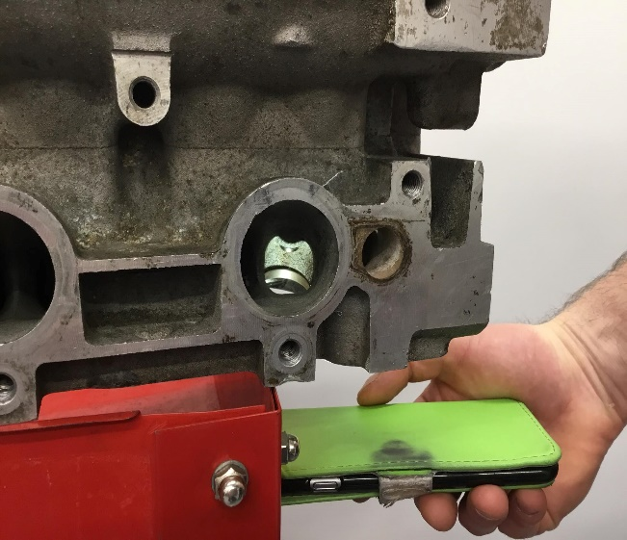
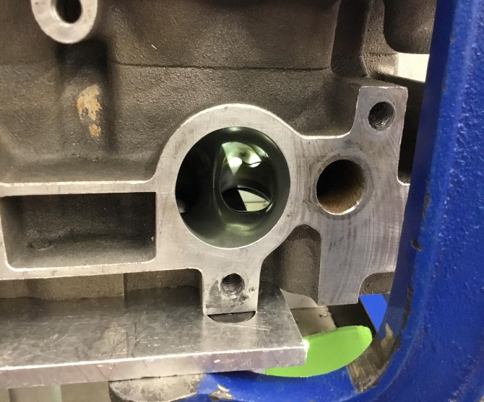
Production Head Ported and polished Head

Conclusion

- The aims of the paper and the instructions supplied for the steps in calculating data of from the TU5J4 engine and have been clearly discussed and in order as can be seen at sub heading 4.2 How to collect the data.

- The analysis will be done in an experimental form by using a Superflow 300/600 flowbench in the university workshops. The data to be collected from the Peugeot TU5J4 engine and the research supplied has a direct correlation on the performance output of an ICE. For example increasing the volumetric flow rate and velocity of the air in the cylinder head greatly improves an engines ability receive oxygen for combustion and to breath better for increased power output.

- Actual evidence of the impacts of VFR have been displayed throughout the paper and in the reference list.

- Evidence of a well known methods or techniques of increasing the flow capacity of an ICE is supplied in sub heading 5.3 Porting and polishing.

Evaluation

Since the paper is a primarily about the flow analysis of a cylinder head, the paper could have been more interesting if swirl and tumble effect the two cylinder heads were compared since they are a characteristic of air flow motion in an intake port into a the combustion chamber.

References
- Practical Engine Airflow : Performance theory and applications, 2015, Pub Pro Series, by John Baechtel.

- R.Sindhu, G.Amba Prasad Rao, K.Madhu Murthy (Effective reduction of NOx emissions from diesel engine using split injections, September 2018, by Department of Mechanical Engineering, NIT Warangal, Telangana, India).

- Superflow Corporation, SF-300/600 Flowbench Operation’s manual, 2004.

- How to build, Modify and Power Tune Cylinder heads, 3rd Ed 1997, Pub Motorbooks International, 1999 by Peter Burgess and David Gollan

- Advanced motorsport engineering, Pub 2011, by Andrew Liversey

- Flow Analysis of Intake Port Geometry of Spark Ignition Engine Using Simulation (Mohammad Abdullah Mohamad Johar , Mohd Farid Muhamad Said, Mohd Azman Abas, Zulkarnain Abdul Latiff, Mas Fawzi Ali and Nik Mohd Izual Nik Ibrahim) Pub January 2019

- Theory and practice of cylinder head modification, Pub 1971, by David Vizard

- The effects of various test parameters on the steady flow test results of a four valve spark ignition engine: a tentative approach toward standardisation (Abolfazi Mohammadebrahim, Mohammed Behshad Shafii, Siamak Hannani): Pub January 2019.

- The Aluminium Automotive Manual, technical information, Published 2002, updated 2015.

- Performance Trends, INC. Producing Quality Computer Tools For Racers and Engine Builders Since 1986. Website. http://Performance Trends.com

- Flow Analysis Through a High Performance SI-Engine Cylinder Head Intake Port (Andrew Welling, Donald Mueller, Paul Lucas), Pub January 2018

- In Cylinder Air Flow Charachteristics Generated by Guide Vane Swirl and Tumble to Improve Air-fuel mixing in Diesel engine using Biodiesel (Idris Saad, S. Bari, S N Hossain), Pub 2013

- Intake Port Flow Study on Various Cylinder Heads using flowbech (Mohd Taufik Bin ABD Kadir) Pub November 2008

- 5.2 Swirl and Tumble limitations, image underneath of swirl and tumble was taken from MS Motorservice Technipedia Website: ms-motorservice.com/en/technipedia/post/swirl-flapstumble-flaps/

