University of Wales Trinity Saint David
Bachelor of Arts- Business Management
Community Engagement

Academic Report
The community engagement approach within Marks and Spencer

Author: Elena Turcanu, Student nr 2127547
Lecturer: Zahra Mohammadnazari

Introduction
Since the dawn of civilization, people have cooperated to solve common issues, and as time has gone on, they have come up with a variety of creative methods for coordinating their efforts. Such mutual collaboration for the good of society took the form of community engagement.
This essay describes what is the social impact of corporations, in particular Mark & Spencer, and how these approach community engagement.
M&S is a global retailer whose history of success starts at a Penny Bazaar in 1884. Its founders Michael Marks and Tom Spencer contributed to British social history in a variety of ways, including how we dress, what we eat, how we shop, and how we work. Marks and Spencer owns a large network of stores (over 1500), around 100 websites, and over 70,000 people who serve these networks. The efficient management of these considerable resources allows the company to show its concern for society and to develop positively their community engagement.
Understanding the fundamentals of community engagement
According to WA Health (2007), community engagement is the process by which the goals, problems, wants, and values of individuals and communities are taken into account when making decisions in the public, private, and non-profit sectors and while planning and providing a solution. Through this cooperation process, it is hoped that better decisions will be made that will benefit the community as a whole and the stakeholders involved.
In the context of the social involvement of the business, McWilliams & Siegel (2001) described community engagement as “actions that appear to further some social good, beyond the interest of the firm and that which is required by law”.
M&S pledges to inspire people to act decisively and combat the most critical social and environmental concerns affecting our planet, our society, and our economy. In addition to their environmental objectives, which are centred on net zero and Plan A, their social strategy prioritises helping individuals, human rights, ethical sourcing, non-profit collaborations, and animal protection.
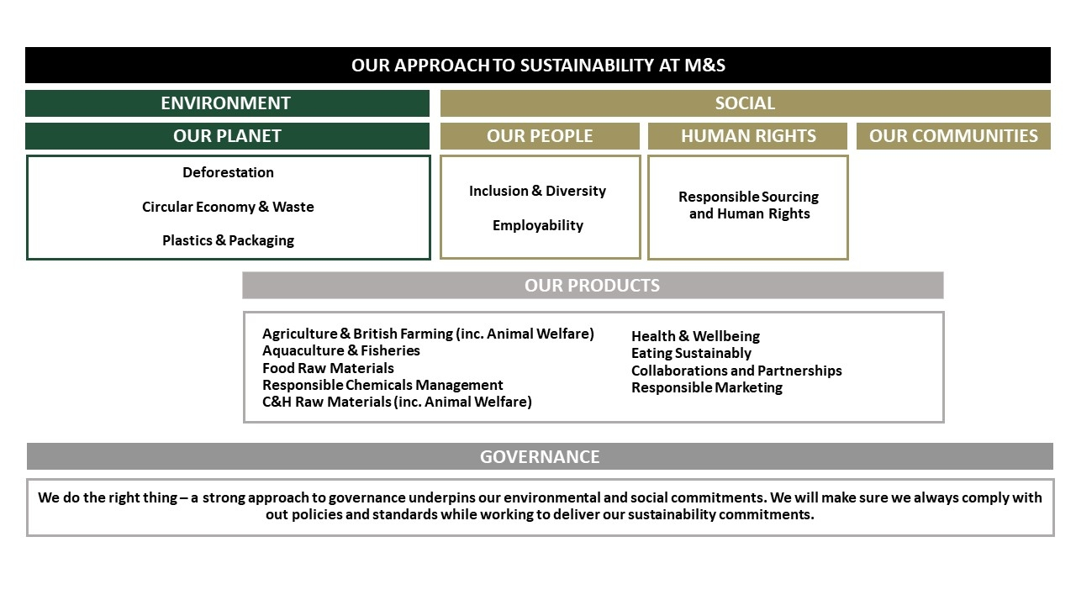
Figure 1. Sustainability at M&S. Source: M&S corporate website
Three main goals of community engagement are as follows:
1. Making judgments offers communities the chance to enhance their decision-making
2. Partnership building, which entails establishing new connections and/or enhancing those already made with or within communities
3. Building community strength-based capacity will enable groups and individuals to better impact their physical, social, economic, and cultural contexts.
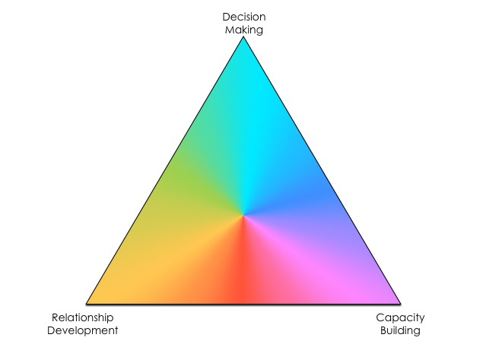
Figure 2. Community Engagement Triangle. Source: the Capire Consulting Group

Its triangular shape emphasises that community engagement might have multiple goals and invites us to consider what we desire to accomplish.
In the context of the sustainable triangle exposed above, we can observe the key activities of Marks and Spencer in relation to society when they operate. They take action locally, nationally, and internationally on problems that are important to their employees and customers. They integrate common goals for their projects by communicating with and engaging with stakeholders throughout the world in order to realise the social, environmental, and commercial benefits that partnerships and collaboration can provide. To address a variety of social challenges, M&S works with several organisations, which include Breast Cancer Now, Macmillan Cancer Support, The Royal British Legion, Great Ormond Street Hospital Charity, Shelter. In collaboration with its partners, M&S were actively involved in fundraising and donations (over £8.4 million) for NHS Charities Together during the Covid-19 pandemic, and in the context of the humanitarian crisis in Ukraine, they contributed with donations in the form of money and goods worth of £1.5 million.
In 2007, M&S launched Plan A for the first time, whose main objective is to reduce carbon emissions to zero by 2040. To achieve this objective of major importance for ecology, especially in the context of global warming, M&S promotes pro-eco and lower-carbon live ideas, principles, and values in society. Because cooperation with stakeholders is essential in achieving net zero, M&S team has created a multi-stakeholder roadmap that includes clients, employees, provider partners, and research institutes to help deliver the emissions reductions needed across their entire product life cycle, from the materials they use to how buyers use their products.
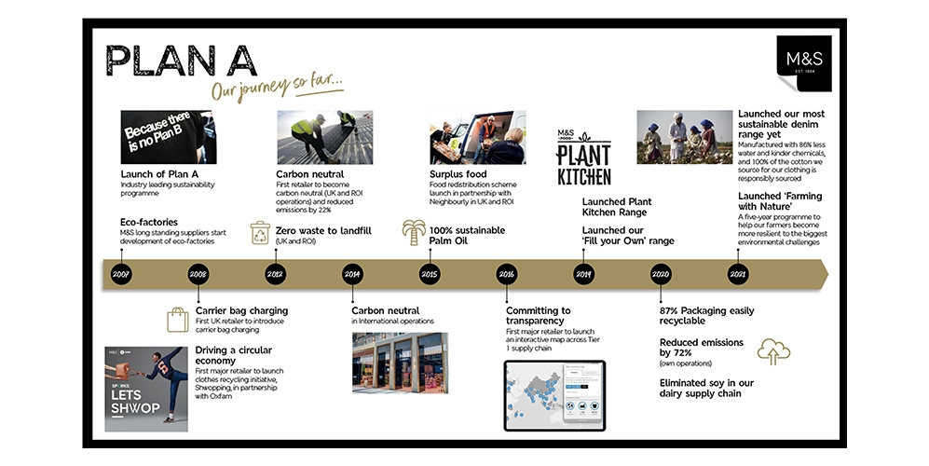
Figure 3. Plan A's current timetable. Source: M&S corporate website
Community engagement can be classified into 2 categories: vertical and horizontal.
Vertical community engagement occurs when organisations, such as public entities, local authorities, education institutions, companies, and health and social assistance, want to involve communities in various aspects of their work, improve society’s access to information, or participate in planning and decision-making processes.
People who participate actively in their local community are said to be engaged horizontally. There are instances when organisations or projects strive to strengthen community ties, even though this frequently occurs as a result of community interactions without the help of any organised initiatives. Building ties among local residents, for instance, is frequently a key element of civic engagement and community development, and enhanced collective identity can have positive effects on both health and educational outcomes.

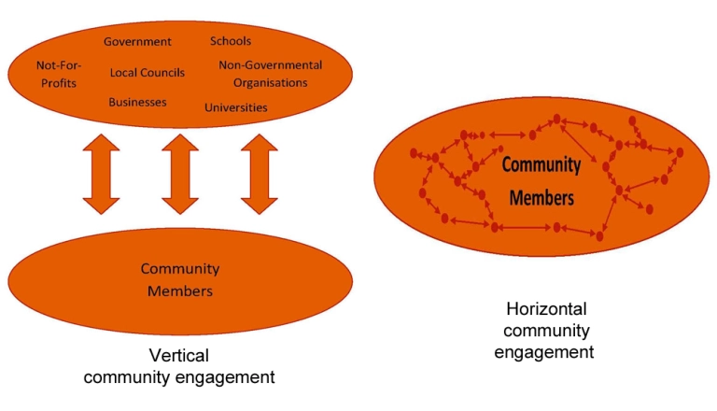
Figure 4. Community engagement classification. Source: Stuart G., Sustaining Community, WorldPress
We can observe in M&S's community engagement strategy both approaches, both vertical and horizontal.
In order to involve the community in this process, M&S encourages employees to get involved in volunteering, offering paid days off to work in one of the charity companies, but also organizing charity weeks, where up to 5,000 employees volunteer in the framework of about 450 non-profit companies. The programs range from reviving neighbourhood communal gardens to hosting tea gatherings for senior residents. By school visits, speeches at schools, and involvement in the larger town centres, employees also contribute positively.
A project of social importance that may be presented as vertical engagement is Food Redistribution. M&S partners with Neighbourly to connect their shops with a community of more than 1,400 neighbourhood organisations that regularly collect contributions of excess food. Fruit and vegetables, food staples, and baked products are all offered; in 2021/22, they provided 14.8 million meals to individuals in need.
Connection among a company's profitability and its corporate social responsibility (csr)
Management experts have stated that it is essential for companies to make constructive contributions to the society in which they do business. The study of CSR has drawn significant scientific interest in recent years, and several publications have produced special issues examining the subject (Bies, Bartunek, Fort, & Zald, 2007; McWilliams, Siegel, & Wright, 2006; Morgeson, Aguinis, Waldman, & Siegel, 2013).
The question of whether there is a business justification for becoming a socially responsible corporate citizen has long dominated debate on CSR. Our judicial and financial systems frequently rely on claims of shareholder primacy, which is why it is necessary to demonstrate that CSR increases business profits. As a result, numerous studies have attempted to examine the connection between a company's social and financial performance. According to Wood (2010), there is a weakly positive correlation between corporate social responsibility (CSR) and a company's income statement.
On the other hand scholars as Caligiuri, Mencin, & Jiang, 2013; Fort & Schipani, 2001; Greenhaus & Powell, 2006; Wilson & Musick, 1997, argued that businesses may influence communities and cultures by influencing the attitudes, ideas, and habits of the employees. It's probable that people's interactions with organisations and their experiences at work will have an impact on and even form their habits and perceptions outside of the workplace.
Additionally, when considered together, the impacts that employers have on the behavior and attitudes of specific employees could be as important as the impacts that their practices have on the community. According to Bishara & Schipani (2010) when most of an organization's employees perceive their job to be stressful and isolating, the direct and indirect repercussions of this pressure on employees in their nonwork lives are likely to be severe ( low participation in family life, health issues, and drug and alcohol addiction).
M&S took certain actions that have assisted them on the path to becoming a more diverse company in order to foster an environment where people can bring their complete selves to work, feel like they belong here, and feel more comfortable as well:
- M&S have sustained the 10,000 Black Interns program, which works to address the lack of representation of Black talent. have Established early career development initiatives with a focus on finding and nurturing varied potential at an early age.
- Another crucial element of their objectives to increase the backgrounds, breadth, and calibre of future leaders is the 30% Club. M&S joined the new "Mission Include" initiative in 2021–2022, making the programme accessible to all underrepresented groups. A record number of candidates for the 2022 programme, 60% of whom are members of ethnic minorities, and 30% of whom have a handicap or other health issue.
- Recognizing in-Store Experience programme aids M&S in promoting internal varied talent, ensuring that employees from disadvantaged minorities gain confidence to investigate these possibilities if it's appropriate for the situation.
M&S community engagement plans and strategies for next 20 years
In context of the global warming we are all confronting, the M&S team established Plan A with the single goal of being a net zero business by 2040, a decade sooner than the Government's UK-wide plan. They've defined intermediate aims for 2025, 2030, and 2035 as well as a detailed plan for how to get there. On their path to net zero, they have created a challenging plan that identifies the ten urgent strategic priorities they will pay attention.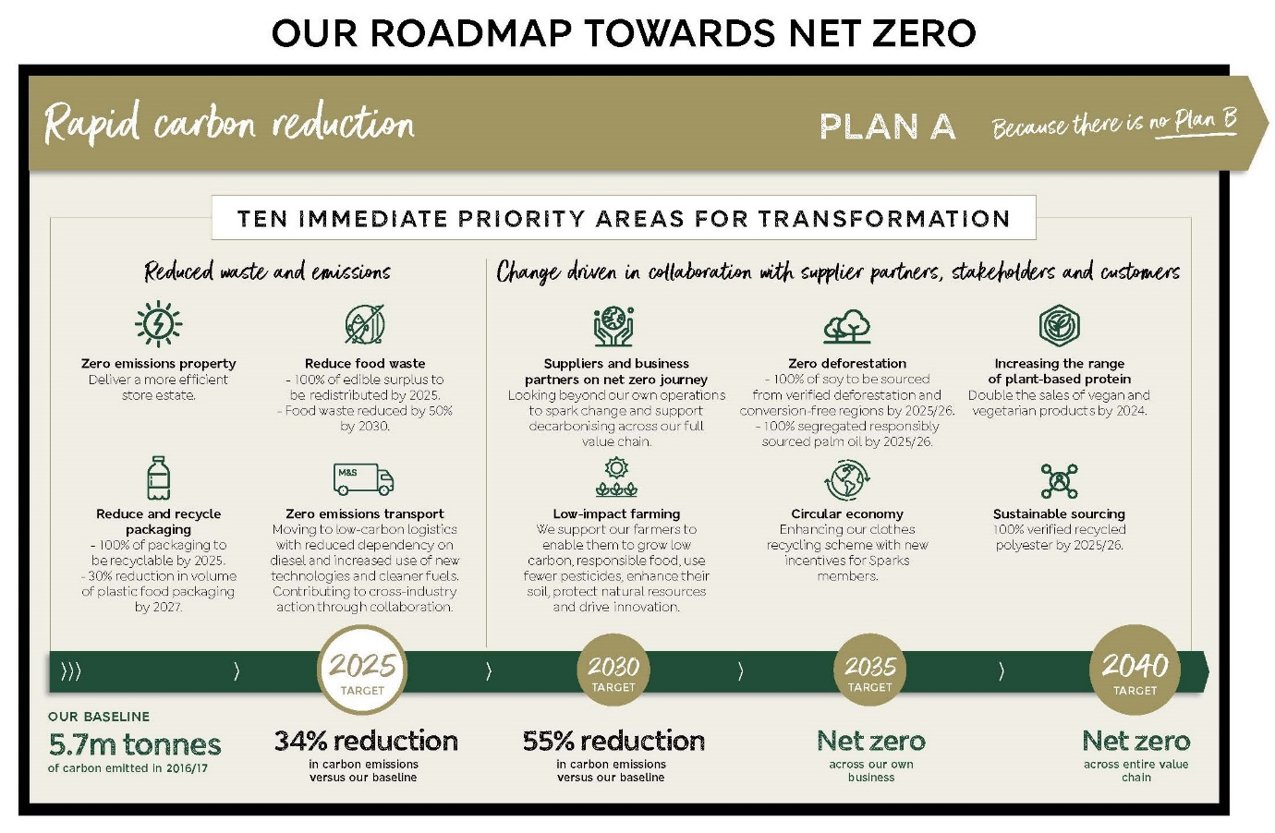
Figure 5. M&S strategy towards NET ZERO. Source: M&S corporate website
Having at its disposal financial resources, human resources (stakeholders), partnership relations (from blacksmiths to factories), M&S has the ability to influence the progress of the global strategy to reduce carbon emissions. In order to contribute to maintaining global warming below the crucial threshold of 1.5 degrees, they have announced a new approaching science-based ambition to cut carbon emissions by 55% versus the updated benchmark, which is 5.7 million tonnes of CO2 equivalent (CO2 e), by 2030.
The "Circular Economy" may be highlighted as one of the 10 critical foundations as part of M&S's net zero by 2040 plan. Company is making efforts to promote circularity and lessen waste in domains as old clothes, food waste, packaging, and shopping bags throughout their entire product life cycle.
In this context, they assumed the following short-term objectives:
- 100% of our packaging to be recyclable by 2025;
- to eliminate 1 billion units of plastic from the food industry by 2027, which equates to a 30% decrease in the volume of plastic food packaging;
- to donate all of their acceptable extra food through charity organizations by 2025 and to cut down on food waste by 50% by 2030.
Their commitment in social area is to have at least 50% women and 15% members of underrepresented racial or ethnic groups in senior management by 2025. Additionally, M&S is committed to ensuring that those with disabilities, as well as those from low socio - economic backgrounds, are included and have the confidence to succeed and advance alongside the company.
Conclusion
Since larger companies and their affiliates are some of the most potent players on the international scene, they have the ability to provide an impact on millions of people's lives worldwide. Additionally, through the way they conduct themselves and do their business, they may be able to gradually change societal norms and values.
In the presented case study, two directions of Mark and Spencer's activity are emphasized: commercially successful and socially, and environmentally responsible. These two areas of activity are carried out in parallel and complement each other! So, being commercially successful, Mark and Spencer creates new jobs, giving people the opportunity to earn money to support their families; by diversifying the range of products and expanding the market, they bring more satisfaction to consumers; promoting and adapting to the zero-waste business ideology creates beneficial premises for the environment and the Globe, encourages society to appreciate and preserve nature, sets a good example for other companies that may be inspired to pay more attention to ecology. Therefore, using the resources it has, Mark and Spencer supports society, helps people to live happier and healthier, and promotes a policy of supporting a clean environment and an eco-planet.

References
- Stuart, G. (2011) Definitions of community engagement. WorldPress. https://sustainingcommunity.wordpress.com/2011/03/21/what-is-community-engagement/
- Stuart, G. (2012)What are vertical and horizontal community engagement?. WorldPress. https://sustainingcommunity.wordpress.com/2012/05/24/vertical-and-horizontal-community-engagement/
- Stuart, G. (2016) An introduction to community engagement. WorldPress. https://sustainingcommunity.wordpress.com/2016/02/25/introduction-community-engagement/
- Capire. (2015). The engagement triangle: Understanding the purpose of your engagement. Carlton: Capire Consulting Group.
- Milliken, Frances J. ; Schipani, Cindy A. ; Bishara, Norman D. ; Prado, Andrea M., (2015) Linking workplace practices to community engagement: the case for encouraging employee voice, Vol.29 (4), p.405-421, Academy of Management perspectives.
- The Editors of Encyclopaedia Britannica. (2022). Marks & Spencer PLC British company. Encyclopaedia Britannica. https://www.britannica.com/topic/Marks-and-Spencer-PLC
- WA Health (2007). WA Health consumer carer and community engagement framework: For health services, hospitals and WA Health following consultation across WA Health. Perth: Western Australia Department of Health.
- M&S Team. (2022). Sustainability. https://corporate.marksandspencer.com/sustainability
- M&S Team. (2022). About us. https://corporate.marksandspencer.com/about-us

