Strategies for resilience and prosperity
Assessment 1
‘Apple Inc.’


Kirsty Thomas
University of Wales Trinity St David
(2014376)

Contents
Executive summery 3
Introduction 4
Report Objectives 4
Company background 4
What is Strategic Management? 5
Competitive Strategy 6
Apple Inc strategies 7
Analysing Apple’s Generic Strategy (Porter’s Model) & Objectives 8
9
9
Analysing Apple Inc. business strategy – Bowman’s clock 9
Evaluation of Bowman’s Strategic Clock & Porters Generic Strategy 10
Analysing Apple inc. business strategy – SWOT & PESTEL 10
Conclusion 13
Reference 14

Executive summery
This report includes a full analysis of the internal and external environment of Apple Inc. which demonstrate aspects of sustainability and resilience. Businesses need a strategy to achieve goals and to become successful using strategic tools to help plan. It is important to identify the company’s Strengths, weaknesses, threats, and future opportunities to be able to improve if needed and to see a vision. External changes can happen uncontrollably, and a business need to be able to adapt to changes to keep being successful. Apple Inc. business level strategy can be affected by internal and external factors.

Introduction

Report Objectives
The objective of this report is to gather information and research on an organisation’s strategic management approach and how they achieve their goals and become successful in their business. The report will research the action a company takes to attain an advantage and how to they achieve their vision. Any business will need to understand the purpose of their company and where the business is heading for the future by strategic choices, strategic management takes a lot of planning and organising. This report will include an analysis of the external and internal environment of an organisation called Apple Inc.

Company background
This report will focus on a worldwide company called ‘Apple Inc.’ founded by Steve Jobs, Ronald Wayne, and Steve Wozniak in 1976. ‘The company make consumer electronics, personal computers, and software’ (Joe, 2014) and is known to be one of the most successful businesses of all time. The three became friends over their love for electronics, they came together to make their first Apple computer. Apple I was the first production for the founders to work on, Apple II was soon in the making when the innovation of computers took off. Apple was able to have a real office by 1970 with several employees, the company doubled in revenue every four months (Faizal,2021).

In 1980 they began to experience some issues with the technology they made which left no option in them to recall Apple II due to choices Steve Jobs made in hope to improve the noise the computer fan made which unfortunately resulted in the Apple II to overheat. They didn’t stop trying to improve their technology, and soon made faster speed technology with an impressive design. Theses made a hit for businesses needing electronics for offices and schools (WorldAtlas, 2022).

Although Steve Jobs left the company and sold his shares due to disagreement with CEO John Sculley, Apple Inc. experienced a drop in sales and struggled due to competitors, in 1997 Steve came back to Apple. Inc (Faizal, 2021).
‘Apple went public on December 12, 1980, at $22 per share. According to EDN Network, Apple’s $4.6 million shares sold out immediately and generated more capital than any other IPO (Initial Public Offering) since the Ford Motor Company in 1956 (Faizal, 2021)’.
The company started to become successful and produced the best electronics worldwide, introducing the Mac OS X in 2001 and the iPod portable audio player, in 2003 iTunes music store was released which became the world’s best music retailer in 2005. In 2006 the MacBook Pro was released with the first iPhone released in 2007, the apple store was realised in 2008.
‘Within a month, 60 million applications were sold through the App store, and it was able to register an average daily revenue of $1 million. Apple also became the third-largest mobile handset supplier in the world thanks to the popularity of the iPhone’ (Faizal, 2021). Steve Jobs died in 2011 and is now replaced by Tim Cook (Faizal, 2021).

What is Strategic Management?
According to Jean & Edward (2013) like all business discipline, strategic management has its roots in the conventional economics model, which presents organisational success as being solely correlated with economics success. Business succeeds when they generate a profit, cover their cost, and increase sales, and fail if they don’t. This hasn’t changed, and it’s unlikely to in the future. A company’s financial performance and health have always been essential to its success and will continue to be so.
A company will need to develop a strategy to set goals and objectives to develop the company into something big and different to any other organisation to become more successful against their competitors. When a strategy is applied this helps an organisation vision where the company is heading, what they need to change and prepare for uncontrollable changes. This allows them to identify strengths and weaknesses within the organisation (Kenton, 2022).
‘Johnson Sholes and Whittington defined strategy as the direction of scope of an organisation over the long term which, which achieve advantage in changing environment through its configuration of resources and competencies with the aim of fulfilling stakeholders’ expectations’ (Johnson, 2004).
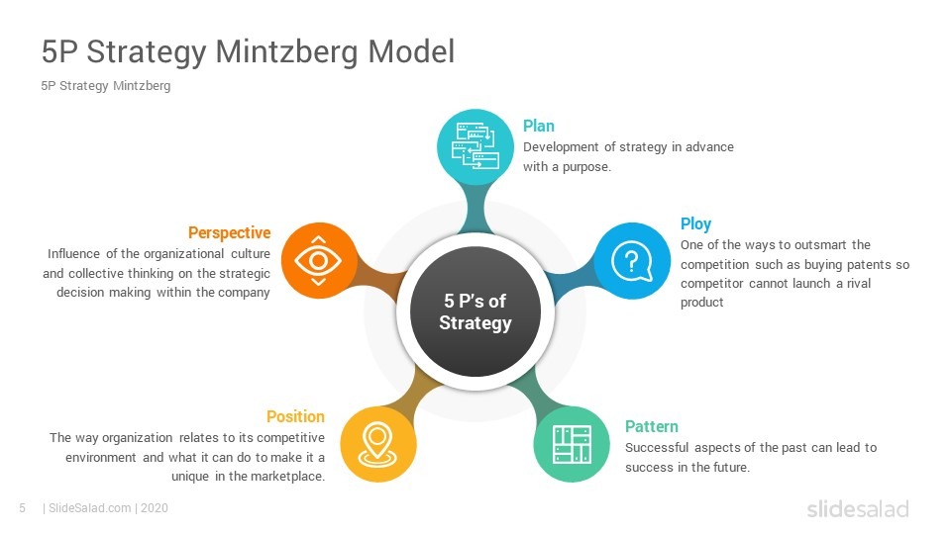
Henry Mintzberg developed the 5ps of strategy to help organisations to develop their own strategy plan (MindTools, 2022). Below is an image for a better understanding of Mintzberg’s 5 P’s.

According to Mintzberg strategies tend to emerge from people solving problems and learning from it along the way. It’s thoughts in how the company sees the world and work together to develop strategies (Fasth, 2016).

Competitive Strategy
Jean and Edward (2013) states that the decisions made when defining the business serve as the foundation of competitive strategy. These are strategic decisions regarding how to satisfy client wants, customer groupings, and main competitors. Data for market segmentation is provided by the breakdown of client wants.
Michael Porter created the ‘Porters Five Forces tool’ to assist businesses in analysing the situations of their rivals and predicting their upcoming actions (MindTools).
A SWOT and PESTLE analysis can be applied to accomplish internal and external factors to set goals within a business (Bush, 2019). Both processes provide the business with a better understanding of the environment they are in or just entering as well as the items or services they intend to bring to the market (Pestle analysis, 2011).

Bowman’s clock is a strategy for marketing that helps a business in deciding their position in the marketplace. Bowman argues that the cost advantage, which helps as a unique quality for the business and highlights the appropriate positioning and the general placement of the goods in the market, it is the factor of competitive advantage (Bhasin, 2019).

Apple includes stakeholders into its goals and policies in an effective manner. Through a policy on obtaining sustainable materials, the corporation responds to stakeholders’ environmental concerns. Regarding meeting the needs of stakeholder groups that are essential to the company, Apple takes a bold and thorough approach. Stakeholder groups encourage Apple to become their best, while Apple impacts them by pursuing their ambitions (Thompson, 2017).

Apple Inc strategies
Product differentiation can be used to describe Apple’s business strategy (Dudovskiy, 2021).
Its expansion is mainly due to business strategy. By combining its design expertise with its technological and software knowledge, the firm has created an ecosystem that a user won’t want to leave.
‘Apple business strategy consists of the following four elements:
- Focus on product design and functionality
- Strengthening Apple’s ecosystem
- Improving consumer service experience
- Reducing the business’s reliance on iPhone sales’ (Greyb, 2022).

Pauline Myer (2019) states that the Strategic choices that the business can utilise to create its competitive advantages in the consumer electronics, information technology, and service industries are defined by Michael E. Porter’s model for generic strategies. Apple Inc. demonstrates that their generic strategy is a crucial part in determining competitive advantage to rivals like Samsung, Google, Amazon, and others.

Igor Ansoff’s matrix of growth methods, outlines options for the technology industry to increase greatly in both existing and new markets and industries. The ability to maintain a position of power in the worldwide market is supported in this situation by Apple’s ambitious development tactics. The firm is doing well despite its relatively high selling price thanks to a strong rate innovation and concentrate on great product design. This great positioning demonstrates Apple’s efficiency in utilising both intensive techniques for commercial growth and its overall competitive advantage approach (Myer, 2019).

Apples strategy is first and foremost project development, continually being ahead of the game and being top of the marketing battle, increasing market shares and continuously being more prosperous financially. Product creation and innovation is a crucial element, from releasing new and more Up to date, phone’s, iPads, and smart watches. Having a solid continuous growth
approach and attitude, allows the business to grow steady and be stable in the marketplace (myler,2019).

Analysing Apple’s Generic Strategy (Porter’s Model) & Objectives
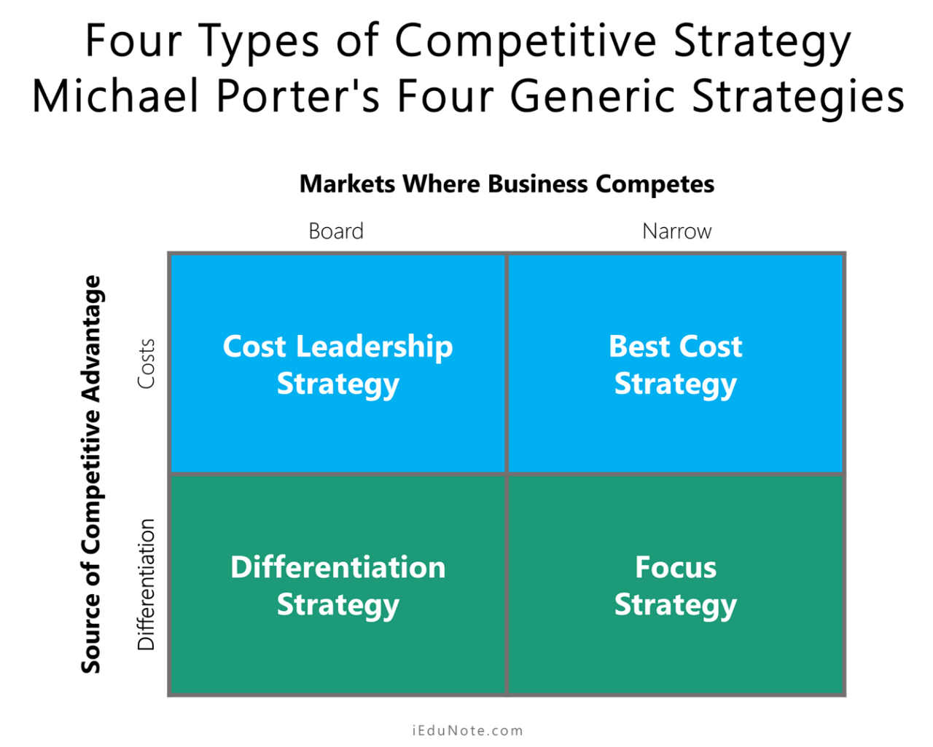
Apple Inc. approach is extensive differentiation. This approach highlights important traits that define the business and its information technology solutions apart from competitors. Apple stands out in the market due to its general approach of wide differentiation. For example, modern product design and usability, along with fancy branding, successfully differentiating the IT sector. According to this general strategy, Apple tries to distinguish itself from rivals not only through low prices but through competitive advantage (Myer, 2019).



Analysing Apple Inc. business strategy – Bowman’s clock
A company strives to outshine its rivals in terms of its financial standing. It also concentrates on offering pricing that are distinctive from those of its rivals. As explained above Apple focuses on customer experiences, model designs and branding which would place Apple inc. in Focused Differentiation on Bowmans strategic clock. Although prices are high, the experience customers will achieve from Apple’s products is like no other on the market. I believe they placed between 4-5 on the Bowmans clock that best suit their future goals and how they continue to bring new upgraded models out with customers placing themselves on Apples waiting list to be able to purchase their products due to products being popular.
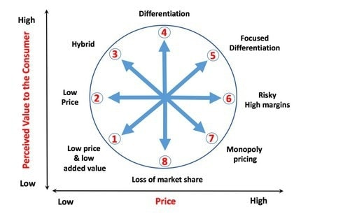

Evaluation of Bowman’s Strategic Clock & Porters Generic Strategy
By using these strategic tools like Bowman’s clock and Porters generic Strategy, Apple inc. can identify where they are as a company, set goals and what areas they need to improve in (UK Essays, 2022). Apple need to take in consideration that businesses such Samsung also bring out similar product to Apple which means it can get competitive. They seem to be very focused on what their products can produce and want to give the customers what they want although it does come at a heavy price. People are willing to buy when they can have exactly what they want through experiences using the product with a modern design.
As a business they need to focus on time and development of their products with continued upgrades to stay at the top, above everyone else at the market, with new ideas and inventions.

Analysing Apple inc. business strategy – SWOT & PESTEL
As explained above SWOT and PESTEL allow a company to accomplish internal and external factors within a business
SWOT analysis:
Strengths  - Customer experience  - Strong brand  - Known worldwide  - Modern design  - Loyal customers  - Customer focus  - Market share  - Advanced technology  - Continued innovation ideas  - Product range | Weakness  - Pricing  - Lack of retail stores  - Compatibility problems (Apple software)  - Lack of strategy for promotion  - Lack of advertising and marketing
Opportunities  - Development  - Eco-friendly  - Expand customer base | Threats  - Competitors  - High tariffs in China  - Technology keeps changing  - COVID-19 in China resulted in Apple making a loss

Political | - Apple is an American company  - China is the manufacturer for Apple as they can produce products for low cost. There is a trade war between US and China (MBA, 2021).
Economical | - China labour cost increased (Wonder share, 2022).  - The potential market for higher-end consumer goods like those offered by Apple may become smaller if middle-class earnings remain in various developed nations, including the US (Pestle analysis, 2015).
Social | - Apple’s products may not appeal as much to socially conscious consumers due to ethical concerns about their manufacturing in China (Pestle analysis, 2015).  - After a year or two, it will be replaced or renewed. However, as consumers hunt for affordable and useful solutions, social status is no longer a powerful driver for updating mobile devices. Apple must expand because they cannot make money from iPhone alone (Wonder Share, 2022).
Technological factors | - Apple Inc. continues to update its features (Assignment Desk UK, 2022).  - Apples systems are less secure due to the increasing capabilities of cybercriminals (Pestle analysis, 2015).
Environmental Factors | - China is trying to reduce greenhouse gas emissions and stop the use of fossil fuels. This may cause higher electricity prices and production expenses for Apple in that nation (Pestle analysis, 2015).
Legal Factors | - Apple pay is the company’s recently new entry to the regulated financial services industry. This might make it subject to more rules and oversight from the government.
PESTEL analysis:

PESTLE analysis helps Apple Inc. in planning and strategic decision-making. It is an audit or external scan of an organization’s environmental impacts. The PESTLE analysis’ results are interpreted with the use of SWOT analysis to recognise the firms’ strengths, weaknesses, opportunities, and threats (Linkedin, 2022).
These tools are useful to use to make business plans and reach goals, but its important to understand changes could happen that cannot be controlled, and businesses should be prepared to adapt and prepare for changes in plans.

Conclusion
Apple Inc. has an interesting background, from starting with little to growing worldwide. They have produced the best electronics over the world, however along the way they did experience some issues with their electronics which left them to recall some of their products back. This didn’t stop Apple Inc. they continued to learn along their journey and continued to produce the best-selling electronics with amazing features which continues to upgrade every 1-2 years. When looking at Apple Inc. strategies it is clear to see they are placed in the differentiation strategy and focused strategy. They give customers hat they want and make sure they get the best experience when using their products. They keep up to date with technology and make sure their products look modern with eye catching designs. Although the prices are high, they still seem to be at the top leaving customers signing to a waiting list to get their hands on the new and improved electronics before anyone else.
The SWOT and PESTEL analysis help companies like Apple Inc. to identify their strengths and weaknesses and to look deeper into their future goals. This allows them to plan and to work on their weaknesses and what can they do to change. There is always room for improvement, but they also need to be able to adapt the business plans due to uncontrollable changes during their journey. It gives an overview of external and internal factors within the company.

