MARINELA COVASNEANU 1920078
Word count 1524

LECTURER NAME: DALE CLARKE

a Comparison of marketing methods of two multinational hotel brands
MARKETING ESSENTIALS BMIH4005

Introduction

The most important part in hotel industry business is the marketing that helps to build a brand, to attract more customers and finally to maintain the loyalty. The main aim of this essay is to compare the methods and strategies of marketing for two of multinational hotel brands: Six Senses and Holiday Inn. This will be done with the help of a Swot analysis for both hotels in order to evaluate the situation they are in (Allen, 1999). Then again to provide direction for the development of the institutions by assessing the strengths and weaknesses to match the opportunities and threats (Anthony, 1998). Additionally, is presented an examination from six different perspectives: political, economic, sociocultural, technological, legal and environmental (PESTLE) and similarities and differences in marketing strategies (Perera, 2017).

Main body

Six Senses was founded in 1995 and became quickly recognized in the hospitality industry. Like suggested in the brand name these hotels are focused on being environmentally friendly and socially responsibly. The people are taken beyond destinations and are being reawaken their senses to reconnect with themselves and the world around them. On the other hand, Holiday Inn founder created the chain in 1952 based on delivering consistently best class services and physical quality levels. According to SWOT analysis (Appendix D), one of the strengths of Six Sense is that it works with local owners to find the perfect land and orientation and uses renewable materials to preserve the natural areas. The organic gardens that provide fresh herbs and vegetable to the hotel kitchens, the meat purchased from the local farmers, fresh milk for breakfast from camels and goats, self-bottled still and sparkling water are added to the long list of strengths of Six Senses hotels (Six Senses, 2023). Additionally, part of the services are bespoke guest experiences and unexpected surprises like barbeques with a personal cooker and butler, romantic royalty dinners, speed boat trips, swim with the dolphins or snorkel with a resident marine biologist. It also provides fun activities for instance organic cooking classes organized in special grill spaces, spa treatments, yoga and Thai courses and tree climbing for the adventurers (The Daily Telegraph, 2015). Using the local suppliers Six Senses hotel help to increase the economics of the destinations. It also brings more workplaces for internal community. In contrast Holiday Inn aims for the big city location alongside the motel properties in order to provide more amenities and newer rooms. Principal strength is to provide business and leisure to their customers with the comfort they are seeking. It has a good advertising that offers them high visibility of the brand, leading to over 100 million or more guest room rented per annum. The aim of the company is to give a welcoming and sociable environment for business travellers with the hotels providing amenities such as free Wi-Fi, onsite business centres, open public areas for meetings and relaxation. Furthermore, to deliver memorable experience Holiday Inn hotels include pools, steam rooms, restaurants with free meal for children under 12 years old and comfortable lounges. Incorporating 1226 hotels with approximative 224.381 rooms, Holiday Inn have been voted leading budget hotel brand in 2022 on World Travel Awards (IHGPLC, 2022). The reason an organization do not achieve the full potential are the weaknesses and threats (Fine and L.G, 2009). Because of the far-flung exotic locations, the access to the resorts is attainable but difficult. This is one of the brand weaknesses followed by the fact that there are just 22 open hotels with 1569 open rooms distributed on 4 continents. More advertising is required therefore more costs and strategies for digital content. An important weakness of Holiday Inn is that the trust had a bad rated review with a lot of customers complaining about poor or average experience (Trust Pilot, 2021), as a result the hotel must work harder to recover and grow the guest satisfaction. Also, in 2017 unknown group of hackers hit 1200 franchisees stealing personal information revealing another weak point and vulnerability in the IT system (BBC, 2017). A similar opportunity for both brands is to aim for more destinations and focus on specific seasonal offers. Six Senses hotels can open new resorts and spas in more countries while Holiday Inn could explore new markets with the help of IHG group financing their expansion (IHGPLC, 2022). Competitors are the biggest threat for any business. Therefore, Six Senses is competing against Maxx Royal, Okada Manila, HMS Host and Golden Tulip while Holiday Inn have Premier Inn, Travelodge, Ibis, Comfort Inn as opponents (Bondarenko et all, 2019).
According to PESTLE analysis approach this are some of different threats that affect both hotels (Perera, 2017). Prices war and the rate of expansion of other guest accommodations challenge to reanalyse their marketing strategies to comply with the demands. The decline of the tourists is affected also by the political threats similar for both hotels. Government changes in tourist traveling can impact negatively the hotel industry (Frue, 2019). Increased cost caused by living crisis after Brexit, Covid19 pandemic or wars in different parts of the world reduces significantly the number of tourists resulting a diminution of profit. Media platforms are now the principal source of advertising but also a great enemy for the brand image caused by the easy circulations of bad customer reviews. A major threat for Six Senses hotels is the weather. Therefore, the marketing department apply the seasonality like strategy. For the guest off season provides heavy offers and visitors that come in shoulder will pay a more competitive rate because of spare capacity. On the other hand, Holiday Inn accommodations are available all year long.
Another marketing mix used for attracting and engaging customers in order to increase the profit is 7P approach. It includes Product, Price, Place, Promotional, People, Product and Physical Evidence (Kamari et all, 2020). Six Senses tag line is “Hospitality starts with ingenuity” (Six Senses, 2023). Its main aim is to satisfy and improve the wellbeing of guests and society simultaneously. Holiday Inn is focused on delivering a hotel for businesspersons, home and abroad at affordable prices offering quality custom services. Hotel industry slowly became less dependent on traditional intermediaries substituting the agents with expanded online agencies (Amaro and Duarte, 2015, Oskram and Zandberg, 2016) for trustworthy research for locations and travel related products for specific hotel (Anguera et all, 2022). Six Senses is based just on online resources, is in the lead with 3.45% social traffic (Similarweb, 2023). Their website is easy to navigate in order to check the holiday packages or to make bookings, while Holiday Inn utilizes the traditional agent-based agency too, due to the locations in main cities of the hotels. People have a major impact on both hotels. First, customers, the main part in hotel business, can impact through positive or negative reviews. Second, employees, must be well trained and motivated because they interact with the guest during their journey, and they become the face of the business. Finally, the suppliers and the service persons which for Six Senses are inhabitants and local suppliers. The ultimate element physical evidence includes the brand design, surroundings, appearance of the employees and advertising. The logo of Six Senses illustrates 6 pillars that represent their values: local and global sensibility, crafted experiences, fun and quirky, emotional hospitality, pioneering wellness and caring for their customers (Six Senses, 20230). Holiday Inn logo is with H widely to be recognizable. According to Bowmans strategy clock (Bowman, 1987) as in Appendix C, Six Senses can be situated in differentiation position having high and accessible prices with unique experience being recognised with “The World`s Award Top Hotel Brand “(Six Senses, 2019) in luxury hospitality. Holiday Inn is offering a lower range of prices for the value of services and adapts to the guest needs can be located on hybrid position. According to a Similarweb research and as shown in Appendix A and b, both hotels are targeting young families and tourists. Similar percentage Six Senses 40,19% males and 50,81% females, age 24-34 biggest figure 34,15% and Holiday Inn 46,52% males, 53,48% females, 27,69% same age range. Belonging to one of the biggest hotel chains in the world, IHG Group, both hotels have almost identical advertising offers but different prices and approaches.

Conclusion

The comparison made in the essay based on marketing analysis of two multinational hotel brand revealed that Six Senses is focused on extra sensorial experience, being situated in the most beautiful and unique places. The resorts are intimate and deliver unexpected surprises challenging the norms. Having a strong brand awareness and reputation and a continued management commitment to grow, Six Senses is considered to have an indefinite life. In contrast Holiday Inn is targeting business and exclusive events to offer a place where the guests can relax and be themselves. Despite being one of the best-known budget hotel family in the world Holiday Inn has the lowest cost provided for their product to create loyalty. Six Senses brand is superior to Holiday Inn being a luxury chain of hotels providing unique and exceptional experiences with a high standard service. Both are big brands with different marketing strategies and approaches.

References

Ahani, A. et al. (2019) ‘Market segmentation and travel choice prediction in Spa hotels through TripAdvisor’s online reviews’, International journal of hospitality management, 80, pp. 52–77. Available at: https://doi.org/10.1016/j.ijhm.2019.01.003.
Anonymous (2015), Win the experience of a lifetime: Worth up to Pounds 50,000 Your chance to enjoy some of the world's most extraordinary locations with this superb prize, provided by Six Senses Hotels Resorts Spas. The Daily Telegraph
Amaro S, Duarte P (2013) Online travel purchasing: A literature review. Journal of Travel and Tourism Marketing 30(8): 755–785.
Anguera-Torrell, O., & Langer, C. (2022). The impact of positioning on click-through-rates in hotel metasearch engines. Journal of Vacation Marketing, 28(2), 228–243. https://doi-org.ezproxy.uwtsd.ac.uk/10.1177/13567667211042640
Batey. (2012). Brand Meaning. Taylor and Francis.
BBC (2017) Holiday Inn hotels hit by card payment system hack, available at: https://www.bbc.co.uk/news/technology-39642172 (accessed 12 .05.2023)
Bondarenko, V. A., Efremenko, I. N., & Larionov, V. A. (2019). Marketing strategy for hotel and tourist complex companies. International Journal of Economics & Business Administration, 7(1), 388-394.
Bowman, C., D. Asch. (1987). Strategic management. Basingstoke. London: Macmillan.
Fine, L.G. (2009) The SWOT analysis: using your strength to overcome weaknesses, using opportunities to overcome threats. Kick It, LLC.
Hamdi, R. (2019, October 2). IHG’s Six Senses Goes a Step Further on Being Green Among Hotel Chains. Retrieved from https://skift.com/2019/10/02/ihgs-six-senses-goes-a-step-further-on-being-green-among-hotel-chains/
IHGPLC, (2022), Annual Report True Hospitality for Good, available at annual-report-2022.pdf (ihgplc.com), accessed on 11.05.2023
Frue, K. (2019), ‘PESTLE Analysis for Hotel Industry’, Available at: https://pestleanalysis.com/pestle-analysis-for-hotel-industry/
Komari, A., Indrasari, L. D., Tripariyanto, A. Y., & Rahayuningsih, S. (2020). Analysis of SWOT marketing strategies and 7P influence on purchasing decision. In Journal of Physics: Conference Series (Vol. 1569, No. 3, p. 032002). IOP Publishing.
Kunst, Alexander, (2022), Holiday Inn brand profile in the UK 2022, available at Holiday Inn brand profile UK 2022 | Statista, accessed on 11.05.2023
Oskam J, Zandberg T (2016) Who will sell your rooms? Hotel distribution scenarios. Journal of Vacation Marketing 22(3): 265–278, accessed on 13.05.2023
Perera, R. (2017). The PESTLE analysis. Nerdynaut
Pingali Venugopal (2010), Marketing Management: A Decision-making Approach. New Delhi, India: Sage Publications Pvt. Ltd. Available at: https://search-ebscohost-com.ezproxy.uwtsd.ac.uk/login.aspx?direct=true&db=nlebk&AN=340360&site=ehost-live (Accessed: 9 May 2023).
Six Senses, (2023), History Six Senses, available at https://www.sixsenses.com/en/about-us/history , accessed on 10.05.2023.
Telegraph Travel Awards 2015/16: Six Senses Hotels named world’s best hotel group. (2016). Telegraph.co.uk.
The business analyst (2023): What is SWOT analysis: Application, Examples and Tips/ https://thebusinessanalystjobdescription.com/what-is-swot-analysis/, accessed on 16.05.2023.
Trust Pilot (2021) Holiday Inn, available at: https://uk.trustpilot.com/review/www.holidayinn.com (accessed 12.05.2023)

Appendices

https://pro.similarweb.com/#/digitalsuite/websiteanalysis/overview/website-performance/*/999/3m?webSource=Total&key=sixsenses.com,moxy-hotels.marriott.com

Appendix A

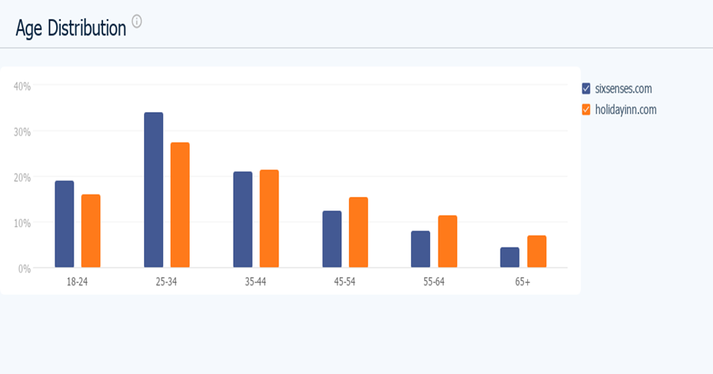

Appendix B

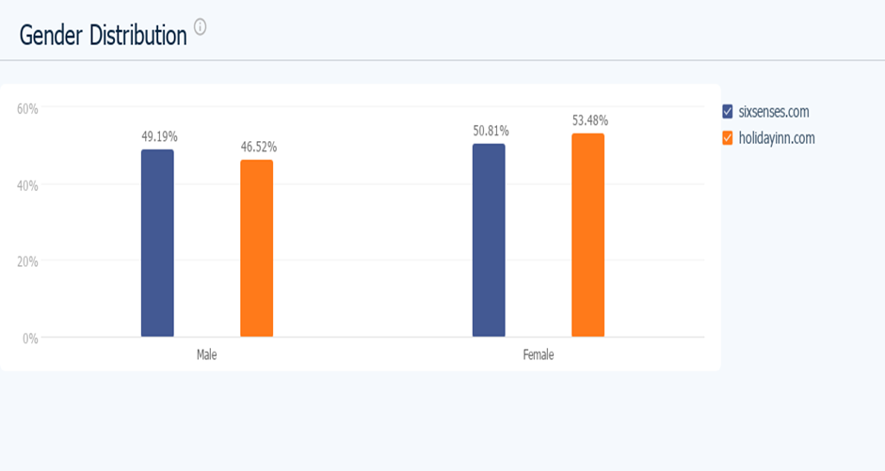

Appendix C

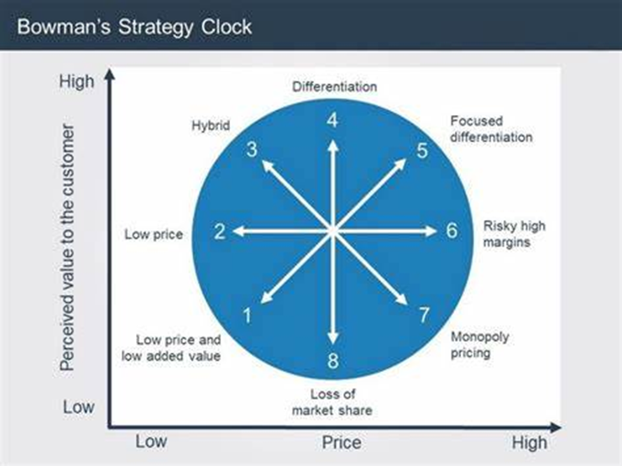

Appendix D



