Mapletree Primary school
Prospectus 2020
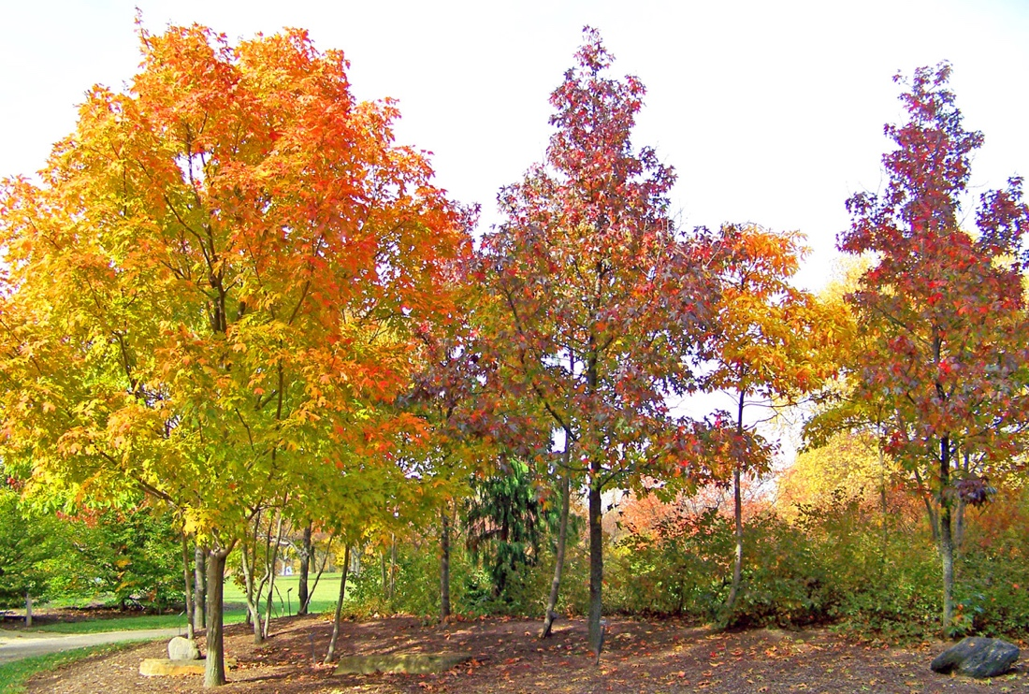

Contact details
Mapletree Primary School
Brynhyfryd
Swansea
Sa1 2qd
Telephone number 01792 524678
Website. Www.mapletreeprimary.co.uk



Introduction
Welcome to Mapletree Primary School which has been open since 1974. There are around 60 pupils in each year group, and the age ranges from 3 to 11 year olds. Our prospectus lays out the relevant information that every parent would need to know about our successful school. It includes our aims, ethos policies and curriculum. Our students enjoy spending time around the attractive grounds within the safety of the school premises.

Staff
Our dedicated team of staff are committed to maintaining a happy and safe school in which every student is encouraged to become confident, enthusiastic and valued members of the school. We have 15 qualified teachers and 15 teaching assistants as well as 8 specialist members of staff that are on site for any students with ALN.
Behaviour policy
Our behaviour policy emphasises that each child takes on the responsibility for their own actions, we do this through teaching Empathy to every child. This has helped tackle issues of bullying in the past as we deal with these serious issues promptly before they get out of hand. The children understand how to be thoughtful and kind individuals to every person they meet.

ECO-School
The children from each year group are also involved in the successful running of our part as an Eco school which is a global programme adopted by many schools here in Wales. It was developed in 1994 and we have been an Eco school since 2001, the students love to be involved in keeping their school and community tidy and recycling is a huge part of that. We link it to our curriculum so that it is a whole school approach and as much as we can achieve as a school the curriculum we make as child centred as possible as well as continuing a subject centred approach we incorporate both here at Mapletree as expressed by Martin Buber. Our school encourages that child's spontaneous creativity which is a natural occurrence and then comes the connection with the class teacher and it is then that the relationship and values start. The teacher provides the force in educating the child along with embracing the child's creativity. Even though the child's creativity is encouraged and supported the teacher is still very much in charge of the learning outcome.

About our school
Breakfast club, this is available for all. Children in each year group. The children can attend from. One day to five days a week, and to take advantage of this children are to be brought to school between 7.50am and 8.15am. There is a variety of options for breakfast from cereal to toast and fruit with fresh juice or water. After breakfast club the children are taken Martin to their classroom for registration.
School times, For the children attending breakfast club this doesn't apply, but for other children that don't attend breakfast club the start time. Is 8:45am and the school day ends at 3:15pm.
Healthy eating, here at Mapletree our school is committed to encouraging healthy eating and we are part of the ‘five a day’ scheme we provide a piece of fruit or vegetable at morning break on a daily basis, this is for all children from nursery to up to key stage 1. For key stage 2 the children are encouraged to bring in a piece of fruit every day and are also encouraged to bring in a bottle of water to drink through the day. We also encourage school lunches to be healthy too and offer a varied range of school meals, and work alongside Swansea council to ensure this is met.
Aims for our students
We understand the importance of education and the way in which we deliver it throughout the school is to always encourage the natural occurrences to happen and to encourage questioning from the children. They love to know how things work and always want to be challenged in finding different ways in which to do things. We also understand that the term education is not a one size fits all approach and therefore grasp each child's level of learning and embrace their achievements. The delivering of our learning and teaching is in line with the current curriculum for schools in Wales. Our highly qualified and dedicated staff team are motivated in giving the students a great foothold in knowledge, opportunity and always encouraging independence and a love for learning for every child. A great emphasis for our school is the continuing and successful partnership between school and home and working together to enable every child to reach their potential. We encourage parents to have an active role in their children's learning, this ranges from assisting with homework tasks and to continue their child's reading skills at home. This will then improve the children's skills and learning between home and school. Our local authority ensures that each child has the right and opportunity to an education. Inclusion of every pupil is important here at Mapletree and we pride ourselves on being an inclusive environment for every child within our mainstream setting. We provide education for all children here at our school and believe with each child their cultural beliefs and diverse character makes them a valued member of our school.
Assessment,
throughout the foundation phase each child is individually assessed through observation of daily activities, and the parents are kept up to date with their child's progress and improvements at the end of year meeting with the class teacher. If there are any concerns from either the teacher or the parent then there is a opportunity to meet up to discuss how to assist the child's learning.
PE and sports, due to there being no set uniform for our school for the days of PE the children can wear a plain white t shirt and coloured/plain shorts and can be brought in a PE bag and kept on the peg until the end of the week.
Important information for parents,

Attendance
This policy is quite common for all schools and their pupils. For our school attendance is important for the child's progress throughout their education. Sometimes it cannot be helped when a child is absent for health reasons or holiday etc. We have an opportunity for the child to work at home with some subjects should they be absent for more than a few days at a time so that the child doesn't fall behind. We do require that the parents let the school know as soon as possible if their child will be absent. For other reasons e.g a holiday then there is a form to complete for the teacher to be aware that the child will be out of school for that time.

School uniform policy
, we don't have one. The only stipulation is that on the day of a school trip or outing that each child of that class wear an orange top/sweater so that the class will be easily noticeable when out in public. We here at Mapletree understand the expense of school uniform to be sometimes rather costly so we try to limit that by letting the children come to school in the clothes they feel most comfortable wearing, which helps create their individuality which is celebrated here. A.S Neill.
Admission form,
this needs to be completed for each child before they attend our school so that their vital information is stored safely and confidential at all times.
Home-school agreement policy.
This is an agreement written up by us at Mapletree to encourage an agreement between us and all parents to be active in their children's learning and communication between home and school is vital in the successful relationship we have with our parents.
Parent consent forms. This would be required for school outings and other outings from the school premises. Also parental consent for the administration of any medication required etc. All the relevant forms once returned are filed in the school office and kept confidential. consent
Parent helpers,
we value the help and various skills that parents may be able to offer, and we appreciate the involvement of parents on a number of occasions whether they are helping in the classroom or with the gardening side of learning, or even being extra numbers of staff on school trips. If you would like to get involved in any of these activities please contact the school office.
Making a complaint, if there is an occasion where a complaint needs to be made we encourage that communication be through the teaching staff or headteacher so that we can sort it out first hand, if the matter cannot be resolved then there is complaints procedure that can be followed and a form to be completed. Please contact the office if required
Photograph consent,
this is pretty self-explanatory from time to time we update our school website and use current images of the pupils and your child may be featured. If the consent hasn't previously been given then we wouldn't use your child's photo, also within the classroom there are images of the children up for various pieces of work so they would need consent firstly from parents.

Our school Ethos



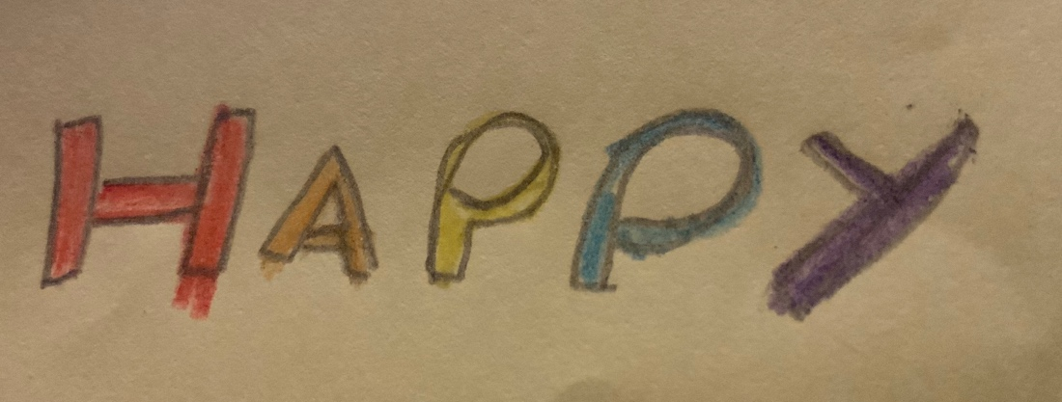
Members who are valued
Artistic and creative
Play and free expression
Our school ethos is evident throughout the school, it is based on the word MAP which stands for members of school who are all valued. We believe in letting every child show their artistic and creative side, and the importance of play and free expression towards every child's learning experience throughout their time here at Mapletree . There are many pieces of work placed around the school that the children have created on their own to emphasise their creative sides. The school corridors are bright and welcoming and full of freedom of expression from each child which is a celebration of their character. As your children reach the end of the school journey with us we wantthem to have enjoyed the learning process to become eager learners. To be confident creative and to have made strong positive relationships. For them to be proud of their achievements to be happy and healthy individuals and eager to continue learning and be ready for secondary school where the adventure of learning will continue. There are various rules around the school that all the children and staff adhere to. We believe for all of us to achieve in school and life is to be helpful, kind, honest and good role models. We adopt a buddy system for all new starters where they are taken under the wing of an older child to be shown around the school premises and to be their buddy the first few days of them starting school. This system does not interrupt with the older students learning time and in fact enhances their social skills as they are taught empathy in a positive way as they reflect on their first time at school and how daunting it can be.

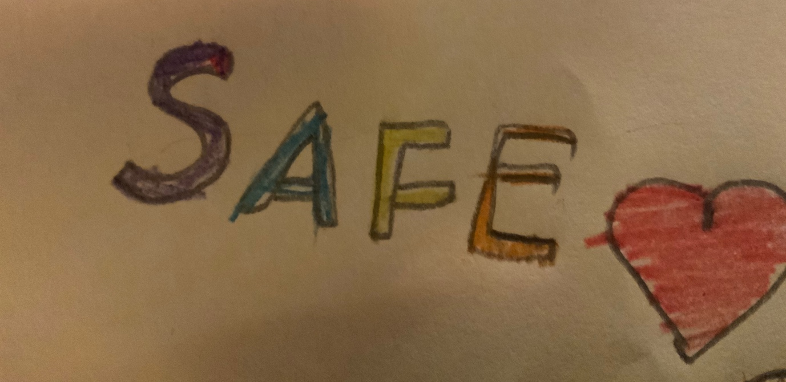

Mapletrees vision
To be creative and artistic and the freedom of expression is very much the vision for our school and our students as is the importance of play especially for our 3 -5-year olds this is based on Aristotle's notion of children being able to grow through physical exercise and especially play. We may not adopt a traditional style of schooling our vision may seem unusual in the sense of the normal institution of a school but that's why our students thrive and enjoy the creativity notion of learning and the freedom of no school uniform to be themselves but at the same time they are still eager to learn and confident individuals, our inspiration for this vision for our school is very much the ethos of A.S.Neill That he adopts for his school.



Our daily structure for children aged 3-7 their learning is different from their older peers it is very much planned around The Foundation Phase curriculum for Wales. This consists of seven learning arrears. Strong emphasis is on learning through play as its essential for the growth in children's cognitive, physical, social and emotional development. Play allows the children to be creative which fulfils our schools' vision. When the children come to learn their letters, we use a phonic approach as recognised by Marcus Fabius Quintilian. With this approach to learning the children will be able to construct words with the letters learned and begin to string sentences together. The other important areas of learning highlighted below.

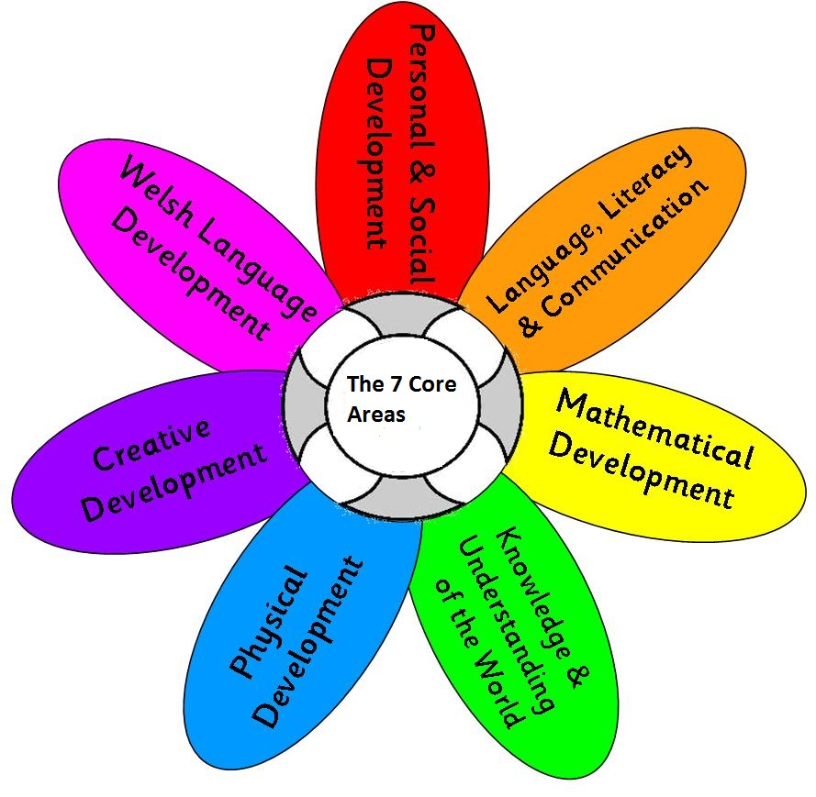

Foundation phase (2010)
These other areas of learning are covered in our varied curriculum through various activities which take place inside the classroom and also outdoors weather permitting. The children also enjoy to learn Welsh and enjoy incorporating the language into their lessons and to conduct sentences of Welsh language to their friends and teachers. They use various range of resources in the classroom to assist with learning Welsh. This is incorporated using the foundation phase curriculum and key stage 2.
As previously mentioned we have an extensive and attractive grounds around the school that the children make full use of when carrying out certain activities outdoors. We take outdoor learning very seriously and believe it to be a very important part of the children's learning experience as we make it an extension of the classroom as taken from a Maria Montessori approach to learning. The children enjoy outdoor learning and love to be creative when they are given the task to create something from natural materials as noted from Rousseau. Getting close to nature enriches a child's learning that we at Mapletree understand is so important to the children's growth, and experiences through observation. Weather permitting, we try and carry out outdoor learning once or twice a week which can become tricky in the winter months so we then try to bring the outdoors in. We are also proud to say that as an Eco school we have various plots around the premises that the children have access to and actually plant things from flowers to herbs to even some fruit and veg. The children are very proud to see the results of the various things they are growing and some parents even continue this at home in a part of their own garden as the children enjoy it so much. Each year group is involved in the creation of growing and planting things it is an important part of the pride we take in our school and to ensure the areas are clean.
Mapletree drop in market
Year 6 children are responsible for the picking of the fruit and veg that have grown and they have been taught entrepreneurship through our key stage 2 curriculum and had to pitch business ideas to the class they worked in teams of four and had some great ideas to sell the fruit and veg to the children in the other groups. This was done through the school grounds and the parents were asked if their child wanted to purchase an item that has been home grown by them to send them in with money on the selling day. This has been so successful since we started in back in 2016 and the children have developed with their numeracy skills by handling money and giving change etc. The funds then go back into the drop in market to continue to grow more items so that the children can continue to enjoy what their garden has to offer. The younger children enjoy the experience of going to the drop in market to buy some fruit or veg as they would have had the input of growing the things that they get to purchase. This then encourages healthy eating which our school promotes as being part of the Healthy Wales scheme and Forest schools.
Estyn
are the education and training inspectorate for Wales. They ensure that all learners within Wales have access to a quality education. They carry out inspections within our school to. Ensure we are delivering a high quality level of learning and to ensure if there is any need of improvement they advise us on what to do and the areas we need to improve on.
Communication
There is a positive relationship between staff and parents, we use a programme called DOJO which is in every class and every year group. It is used on a daily basis to communicate anything from the teacher for e.g reading books coming home or a message regarding an event happening at school. The messages work from parents to the teacher also as messages are private and confidential regarding their child. Each parent can have the DOJO. App on their phone and communicate anytime with the teacher of that class.
School day
The school day always starts with what we call a check in which gives the children an opportunity to share with the class something that they are happy or sad about and it normally starts the day off on a positive note as we are always told about important achievements in the children's lives or family holidays coming up or birthdays. The atmosphere within the school is so encouraging and a happy place to be. For the children they feel valued there input into their own learning is positive. They are given opportunities to choose the lesson for the morning which is always them being creative so they can express their feelings and its their own work, this kind of activity ranges from items found outdoors i.e sticks stones, acorns etc or things in the classroom i.e paint, tissue paper glue etc. They have little input from the teacher on this occasion the teacher acts merely as a facilitator and is there if the children need help. This notion of freedom in the school day is inspiration taken from AS.Neill. When the children are given this choice in the mornings of what they would like to do they are eager to learn in the afternoon and ready for a little structure. The morning activities are always in guidelines with the foundation phase curriculum it just offers choice to the children which they take full advantage of which has a positive affect on their day and the staff too. The structure of our classrooms differ in all year groups the younger children do have in a sense more freedom where the teacher sits at the front but there are various areas for the children to access with all the carpet space to allow freedom of movement and to allow opportunities for the children to create their own learning experience, taken from John Dewey and his idea of a step away from a traditional classroom. The teacher is there to guide that natural behaviour and natural occurrences in the children's learning this is the learning pedagogy approach we use with great response from the children, they enjoy learning this way and given a choice of what area to go to learn in. There will be a table set up by the teacher that allows the children to attempt a problem solving idea and the children are able to work together to solve either a puzzle or putting something together, the teacher observes their social skills and listening skills as they work together to complete the task, another of John Deweys inspirational way of learning pedagogy. The children have fruit and milk as a mid morning snack, they are read a story by the teacher as this takes place. They then have lunch an hour later in the school hall and this includes an outdoor session of play in the yard. Sometimes after lunch there is an opportunity for outdoor leaning in the afternoon if weather permits it. This can range from exploring the surroundings to creating something from outside resources, or even talking about the weather smells and sounds the children can hear while outside. The school day for key stage 2 children is a little different as the children are older and are subject to a very different curriculum they no longer follow the Foundation phase but follow a more advanced curriculum. It comprises of core subjects and non core subjects this is for children in year 3, 4, 5 and 6 the national curriculum for Wales outlines each programme of study that specify what students should be taught in each subject.
Keystage 2 curriculum subjects
. Art and design
. Design and technology
. English
. Geography
. History
. Information and Communication Technology
. Mathematics (Delivered through Inspire Maths)
. Music
. Religious Education
. Personal and Social Education Framework
. Physical Education
. Science
. Welsh Second Language
These subjects are all being taught through our careful planning and various learning styles here at Mapletree but in line with the curriculum. The opportunity for students to develop their thinking skills across the curriculum through the processes of planning, developing and reflecting. Students are able to explore and experiment through using a range of resources which they use to develop and reflect on their creative activities. We understand the importance of technology in these modern times and all children have access to a wide range of resources and software to enhance their ICT skills and confidence building. Personal and social education is also very important so we encourage this through the children promoting their own wellbeing and moral as well as spiritual development. Being able to express themselves and to say how they are feeling is very important for us as a school to ensure every child is happy and healthy so the teacher student relationship is that of trust and friendship whilst always remaining professional. The children feel confident and happy to express any concerns they may feel. The wellbeing side of every student also encompasses eating healthy and getting enough rest and enough play but in equal measure to undertake the tasks of life.

ALN
we have a few students at our school that have some additional learning needs that we meet here at Mapletree. We have trained specialist staff on hand to assist the Qualified teacher in each classroom for all children to be inclusive and able to attend our mainstream setting. It is important that each child's needs are met and we ensure that happens by following the guidelines set by the Welsh government for ALN. The children enjoy being in our school with the specialist support as they are with friends and always included in every lesson. The funding available for our specialist staff is always being monitored to ensure that every child that needs any assistance to achieve is receiving the help that they require. Parents of our children with ALN are very much involved in their schooling and on board with our learning strategies. The communication between parents and school is essential for all children to have a positive outlook educationally and emotionally. Our parent/school partnership is very successful in the efficient running of our school, and especially vital for our students with ALN. All students are at the heart of everything we do here, and it is essential that we are up to date with all legislation around ALN.
Conclusion
We here at Mapletree welcome all the children that wish to attend our school and the parents. It is our vision to ensure all children attending our school are happy healthy individuals. Their learning is at the forefront of everything we do here. The freedom of each child showing their creativity is what we have pride in and get the best outcomes for our students. The dedicated staff have a great input into that positive outcome when our students reach the end of their time here. They are ready for secondary school and thirsty for their own learning to continue, their individual characters shine through the years they attend our school and are happy with the time they have spent with us. Many students actually return to do work experience here as they enjoyed their learning so much. Our curriculum is a well developed tool for our teaching methods here at Mapletree the freedom of choosing what to learn and not being constricted to a school uniform encourages them to be comfortable and safe and To be themselves. The communication between home and school is essential for the successful running of our school, we encourage the use of the dojo app. Our successful running of the school the way we deliver the curriculum is evident in the positive response from the children that attend and their parents. Please feel free to contact the office if you require more information or wish to visit our school before deciding to enrol your child. We here at Mapletree thank you for taking the time to read our prospectus and hope that it answers all of your queries/concerns and hope to see you soon at our successful and happy school.

References
Flanagan, F. (2006) The greatest educators ever. Continuum. London
Bartlett, S. & Burton, D. (2016) Introduction to Education Studies. 4th Ed. London: Sage publications.
Welsh government (2015) Foundation phase framework. Available at: http://Hwb.gov.wales/curriculum-for-wales-2008/foundation-phase/foundation-phase-framework (Accessed 23rd October 2020).
Welsh government (2008) Key stage 2 to 4. Available at: https://Hwb.gov.wales/curriculum-for-wales-2008/key-stages-2-to-4 (Accessed 20th October 2020).
Welsh government (1994)Eco-Schools. Available at: https://www.keepwalestidy.cymru/pages/category/eco-schools (Accessed 23rd October 2020).
Class dojo (2011). Available at: https://www.classdojo.com/en-gb/about/?redirect=true. (Accessed 23rd October 2020).
Neill, A. S. (1921) Summerhill. Available at: http://www.summerhillschool.co.uk (Accessed 20th October 2020).
Britannica (1957) Maria Montessori. Available at: https://www.britannica.com/biography/Maria-Montessori (Accessed 23rd October 2020).

