

Developing Relationships and Workplace Achievements.

BMSW5102
Nishi M Ramsurrun

Jesica Mora Mera 2010296

Contents
Introduction 3
360 Degree Fedeeback 4
540 Degree Feedback 5
Feedback 7
Management by Objectives MBO 8
Individual Pay Report Performance IPRP 8
Professional development plan (PDP) 8
Conclusion 11
Recommendation 11
References 12

Introduction
The objective of this report is to identify the personal development and expectation of individual employees in the organisation, understanding their feedback, how customers think and feel about the services, quality and the products Reiss gives.
Reiss focuses on managers and employees receiving the right training and motivation to archive their goals in the company. Using the 360 degrees feedback we find out what the employee’s strengths, the areas for improvement, the gap between expectation and what the organisation provide and then know how we can help them to improve their new skills. In addition, we will use the 540 degrees feedback to get the customers and suppliers feedback, this will help the company to improve and stay focused on providing the best customer services so that the customers stay loyal to the brand.
Human resources use tools such as Management by objectives (MBO), Professional development plan (PDP) and individual pay related performance (IPRP) to help to improve the company.
Reiss is a company that has been around since 1971 and is a luxury high street company in the UK for almost 50 years with 160 stores globally. They are a fashion retail company that focuses on the best customers service with unique values and focuses on personal style. Human Resources make an effective contribution to the company, and they must process business and financial skills. Human Resources understands that the skills that the employees have brings value to its company and this achieves competitive advantage to the competitors.
Reiss’s Human resources strive to make developments between employer and employee so that they have the maximum affect for customer satisfaction.
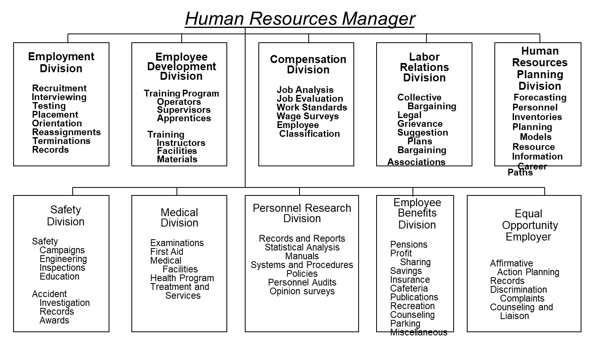

Words of wisdom Human resource management (HRM), the management of work and people towards desired ends, is a fundamental activity in any organization in which human beings are employed. It is not something whose existence needs to be radically justified: Human Resource Management is an inevitable consequence of starting and growing an organization. While there are myriad variations in the ideologies, styles and managerial resources engaged, Human Resource Management happens in some form or other. It is one thing to question the relative performance of models of Human Resources Management. It is quite another thing to question the necessity of the HRM process itself, as if organizations cannot survive or grow without making a reasonable attempt at organizing work and managing people. Boxall et al (2007: 1)

Human resource planning
- Longer term focus
- Tie the need to the business
Staffing
- More socialisation
- More opportunities
Performance appraisal
- Customer service measures
- Awards and celebration

Training and development
- More skills training
- Customer services training

360 Degree Feedback

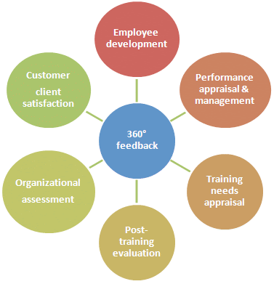

Reiss 360 degrees
The 360 Degrees Feedback will help Reiss to understand the members of staff in the company. This feedback helps to support individual development plans and understand the perspective of others, The managers in Reiss need to listen to very carefully and helps to understand their strengths and weaknesses of the employees. All the feedback is confidential so that they can be open and honest with their comments. All the feedback will be collected from the manager in Reiss and they need to report and shared with the line manager and the employee. This report will help in evaluating the managers and the subordinate’s overall performance in the company.
This will improve the productivity in the organization and the feedback will help the individual improve behaviour. The comments are constructive and supportive to the skills and goals of the employees in the workplace. The software needs to be very simple, and people can just use their phone or on their laptop so that they can give the feedback straight away.

Benefit of 360-degree Feedback.
This will help to Reiss as company to understand the member of staff in the organization. This feedback supports the individual’s development plans and helps to understand the perspective of others. It helps in evaluating the overall performance of an employee. The 360-degree feedback gives a complete view of what the employee has done.
The feedback is very useful to the company and can show the performance that needs to be improved and increases the employees experience at Reiss.
- Performa improvement
- Management Development: Improve leadership
- Carrer Development
- Succession Planning

Disadvantage of 360-degree feedback.
- Favouritism can affect the feedback of certain employees who otherwise must be working well.
- 360-degree feedback mostly gives quality feedback and might overlook the quantitative performance of an employee.
- With unfair feedback some people may lead to an ambiguous of the employee’s performance.

540 Degree Feedback

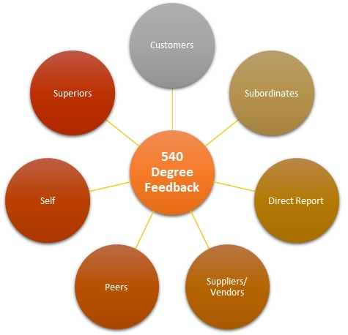

The 540 degrees feedback can help to Reiss to evaluate the performance in the employees. The 540 degree is additional feedback from the clients outside of the organization. The 540 Degree Feedback is an extension to the 360-degree feedback and customer will be involved to give their feedback and opinion. The 540-degree feedback system is used to find their weaknesses as well as their strengths of the targeted person and can be used as motivational techniques to motivate the targeted employee. It involves other relevant stakeholders in the form of customers or clients for the targeted person. This feedback helps to improve the quality of employees in the workplace. The clients can give you feedback on your customer service so the company can upgrade the information of 360 degree. The 540 Degree Feedback can also help in orienting the content of the training modules and training methods so that the employees can achieve higher customer satisfaction leading to greater revenue and help identifying problems which would not have been possible to identify using traditional feedback systems.
Client’s feedback helps to determine if the clients are happy or unhappy with the service and quality from the brand. This feedback will help to improve customer experience and the service efficiency. Reiss collect this feedback and they contributions to develop Customer’s satisfaction. This date provides to help to improve our service and understanding customers and employees and employer.
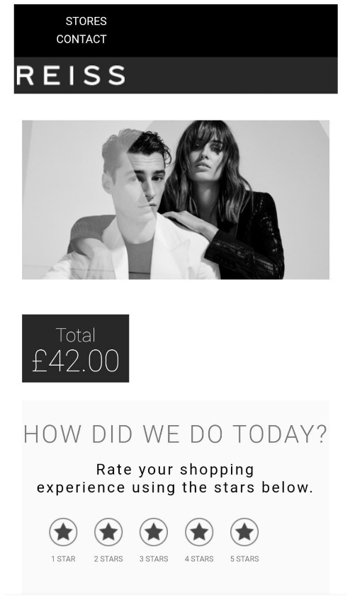

Feedback provided by staff in Reiss
Feedback is constructive opinions to improve the performance of the employees and the company.
Positive Feedback
Positive feedback to the employee is crucial to the way that they carry on excelling in the way that they work and bring positivity to the workplace. This will help them to meet new targets and to help the business
Positive and construction feedback should occur as soon as possible. Be specific with providing any performance feedback clearly and concisely. The feedback can be supported with facts and job-related examples, focus on behaviours not judgments. Do not ignore you feedback this can help you pinpoint where you can do better. Mangers can make a list of all the improvements they could make in the company.
Negative Feedback in Reiss
Reiss use 540-degree feedback the customer can explain the experience in the service. Reiss have two stars of Negative feedback with the customer. This feedback its about receive a bad customer service, poor communication, bad telephone customer services and bad network. Reiss need to work to improve the customer services for not lose a loyal Reiss customer. Human Resources need to work with management to improve the system in Reiss as a company to rich the mission and vision to succeed.

Management by Objectives MBO
Management by Objective is a strategic management model that finds the objectives and goals from the management to the employees. Leadership is important in the company because everyone will work better, and it keeps everyone focused to archive the goals. The organization objective is encouraged to help to concrete goals that both the employee and the organization aim to achieve in the immediate future.
The key to management by Objectives is to evaluate and monitor the progress of employees, each employee needs to feel indispensable to the organization and eventually develop a sense of loyalty to the organization.

Individual Pay Report Performance IPRP
Individual pay report performance is a technique of remuneration that link pay progression with individual performance within the Reiss company.
Reiss’s staff will all be eligible for a bonus pay scheme were depending on sales and targets they will be rewarded. This scheme includes for every £400 of sales there will be a £4 commission to the sales assistant. This commission gives the incentive for the sales assistant to produce as many sales as possible which in favour helps the company to increase its profits and reach the employers targets. Individual pay report performance also increases the employee’s motivation to succeed in their work which in turn brings improvement in their workplace.

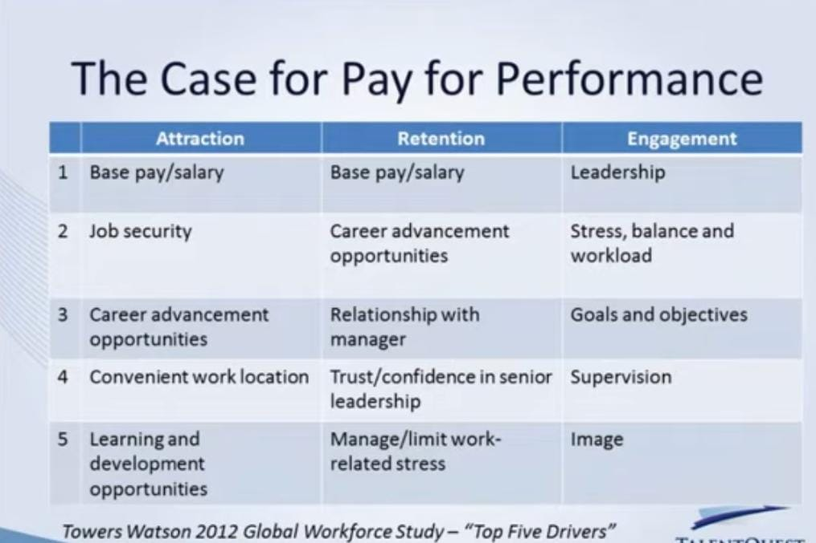

Professional development plan (PDP)
This is to focus to help all individuals build strength and basic skills in leadership, this will help them to develop knowledge to improve skills or build required knowledge. This plan will be providing leadership, effective meetings, facilitation technique, learning skills. Professional Development Plan will help to improve job performance. This training will help to learn new skills and knowledge in the workplace. The line managers need to implement the operational plan and this document summarises the goals the person wants to achieve.
Reiss uses the structure of a SMART goal to make your goals trackable and realistic and cover goals that are short-term, medium-term, and long-term.

SMART goals are:
Specific – states exactly what you need to achieve
Measurable – includes a quality or quantity measure
Achievable – the resources, time, opportunity, and support to succeed are available
Realistic – can be challenging but must be achievable and relevant to your role
Time bound – with a clear end date or timescale

Development  Objective | Priority | Activities to be  Undertaken | Resources | Target Start Date | Target End Date | Criteria for Success
Time management | Very  High | The role of a manager.  Delegating the right way  How to handle difficult customers.  Active listening.  Coaching technical. There are different tools and techniques which the company can use such as POMODORO and Eisenhower technique | Training In the Shop floor  HR | November  2021 | February  2022 | shop floor manager Reflective thinking and reflective writing
Problem solving | Very High | Dealing with customers.  Handling a Difficult Customers.  Retail Sales Academy Reiss.  Selling skills | Online training  In the house | November  2021 | December  2021 | Improve relationship in Customers  Decision making and solutions.
Leadership | Very High | Leadership skills, attitudes, communication skills. Learn further from different leadership skills and characteristics and apply contingency approach | Training In the store  Shop floor Manager, coach | November  2021 | December  2021 | Leading the team
Software  IT Project | Very High | New Software in Covid 19. Teams.  website | Online course  It | November  2021 | February  2022 | Support to the website, products, and services.  Marketing online
Communication  Decision making | Very High  Very  High | Effect Communication skills  Internal Employee training. | Managers  Training In the store Shoop floor Manager | November  2021  November  2021 | March 2022  March 2022 | Developing excellent communication skills.  Knowledge planning decision products and Visual Merchandising and be the leader team in the shop floor.  Plan implementation

Conclusion
To conclude this report understands the role of Human Resources and the techniques that apply in the company. These techniques understand the managers, employees, and customer’s needs. Also recognise how important training and motivation can help to improve to achieve the goals in short and long time in Reiss. The individual pay performance is using to motivated to the staff to play a team work and good communication with the managers and the staff to make the targets every week. Reiss need to have more Development Objectives to the staff. This activities employee will feel they are progress in the company, knowledge and skills performs will be improve. Also, as an employee in REISS I like to have the opportunity to be promoted.

Recommendation
Strong recommend using a Professional development plan to help the employee to support them reach their goals in the company, in the short term and long-term. It’s important to recognise the strengths and weaknesses and identify the need for improvement for the future of the company. When you recognise your own weaknesses then you can be part of the professional development plan to strengthen them weaknesses. This in turn will increase your skills and knowledge in the workplace.
Encourage more training’s programs that provide an opportunity to achieve personal objectives and professional objectives in the company. The training schemes leading to qualifications which can increase the quality of the training. The reviews and feedback need to be more often from the managers to help to understand the view of the employee and make the employee clear of the mission and vision of the company.
Human resources in Reiss needs to be sure that employees have been trained and are motivated in the workplace. When you have the right training then this encourages the staff to be more productive and more motivated to achieve the goals and the targets of the company. However, in the stores It is a lack of motivation, lack of management skills, little Human resources support and training. Recommending the 360 degrees needs to be done more than ones a year to evaluate the member off the staff and managers to developing in the organisation. This evaluation focus’s attention on how good the potential of each person completes the training and the skills they need. This will improve the professional performance and personal well-being and then that covers a 360-degree knowledge. It is important that the managers give the feedback open and honest to the employees. The feedback can be precise and clear to the individual employees.

References

- ARMSTRONG, A. (2011) Armstrong's Handbook of Strategic Human Resource Management. 5th ed. London: Kogan Page.
- Becker, B E and Gerhart, S (1996) The impact of human resource management on organizational performance: progress and prospects, Academy of Management Journal, 39 (4), 779–801
- Blyton, P. and Turnbull, P (eds)(1992) Reassessing Human Resource Management, London, Sage Publications.
- Bournias, F. (1992a) ‘Human Resource Management in France’, in Brewster, C. (ed.) International Guide to Human Resource Management, London, Academic Press.
- Boxall, P F (2007) The goals of HRM, in (eds) P Boxall, J Purcell and P Wright, Oxford Handbook of Human Resource Management, Oxford, Oxford University Press, pp 48–67.
- Haasen, A. (1996) ‘Opel Eisenach GmbH – Creating a High-productivity Workplace’, Organisational Dynamics, Spring 1996.
- https://www.employment-studies.co.uk/system/files/resources/files/mp18.pdf
- https://www.reiss.com/careers/
- Handbook of Human Resource Management, Oxford, Oxford University Press, pp 1–16Brewster, C (1993) Developing a ‘European’ model of human resource management, The International Journal of Human Resource Management, 4 (4), pp 765–84.
- L Dyer, Gestión de recursos humanos: funciones y responsabilidades en evolución, Washington DC, Oficina de Asuntos Nacionales, págs. 1-46 MPunH P OPIMNRXONCCINHDCIOALJC = 3 7 ° C 17:13 01/12/2021
- Legge, K (1998) The morality of HRM, in (eds) C Mabey, D Skinner and T Clark, Experiencing Human Resource Management, Sage, London, pp 14–32.
- Leading HR, Basingstoke, Palgrave Macmillan, 68-89 dd Tyson, S (1985) Is this the very model of a modern personnel manager? Personnel Management, May, Pp 22-25.
- Marginson, P., Armstrong, P., Edwards, P.K. and Purcell, J. (1988) Beyond the workplace: Managing industrial Relations in Multi-Establishment Enterprises, Oxford, Basil Blackwell.
- Simon, H A (1977) The New Science of Management Decision, Englewood Cliffs, NJ, Prentice Hall
- Simon, H A (1979) Rational decision making in business organizations, American Economic Review, 69 (4), pp 493–513
- Truss, C, Gratton, L, Hope-Hailey, V, McGovern, P and Stiles, P (1997) Soft and hard models of human resource management: a re-appraisal, Journal of Management Studies, 34 (1), pp 53-73
- Ulrich, D (1998) A new mandate for human resources, Harvard Business Review, January- February, pp 124–34.
- Ulrich, D (1997) Human Resource Champions: The new agenda for adding value and delivering results, Boston, MA, Harvard Business School Press

