Food & Beverage( BMIH4002)
Teacher Name: Antoinette Milne
Student Name: Dzonatan Aleksandrowicz 2115161

TASK 2

Gourmet fast food the reason I chose this style of restaurant is because its fast affordable and fancy it covers all demographics as well as all age groups it also makes sure to use locally sourced ingredients as well as has specific items on the menu for people with allergies my restaurant will use items similar to a KFC or McDonald but with a more fancier twist with a similar low price my target audience for this restaurant will be everyone young and old both lower and upper class families and budget customers. This restaurant will cover all bases of customers it will include gluten free food peanuts free and milk free as well as egg free the menu will include appetisers such as mozzarella sticks which include a gluten free version as well as a milk free version another appetiser will include bread sticks with special cheese sauce this appetiser will also come in a gluten free and milk free option. There will be 5 main dishes my restaurant will offer this includes whole Kentucky style fried chicken with a side of mash potatoes or fries both with our special sweet hot or gravy sauce this will be priced at £11.00 another main menu option is our special burger with the option of beef chicken and tofu with our special secret sauce. Another main is our gourmet sandwich peppers, fresh mozzarella, grated parmesan, basil, arugula, green goddess dressing, garlic aioli, and salt and pepper a fontina/mozzarella blend, and market sauce. it’s prepared with smoked chicken, American cheese, red onions, and Buffalo sauce. Another main item is our Asian hotdog Wasabi mayonnaise ginger pickles and nori topper with either a beef hotdog or a vegan plant based hot dog. Our tasty pizza is another menu option topped with real or vegan cheese topped with a selection of toppings from our salad bar as well as a selection of meat which include beef brisket tomahawk aged beef chicken and pork. Our 5th and final main dish we other are the vegan gluten free tacos made with plant-based cheese with a selection of black beans real or plant-based meat like chicken or beef topped with our secret chilli sauce. Finally, our dessert menu includes vegan ice cream of ten different flavour out chocolate billionaire donuts homemade churros strawberry shortcake, chocolate cake, red velvet cake. And homemade macarons our drinks options include lemonade coke Pepsi milk shakes and a selection of juices. Our side dishes include green beans fries’ mash.
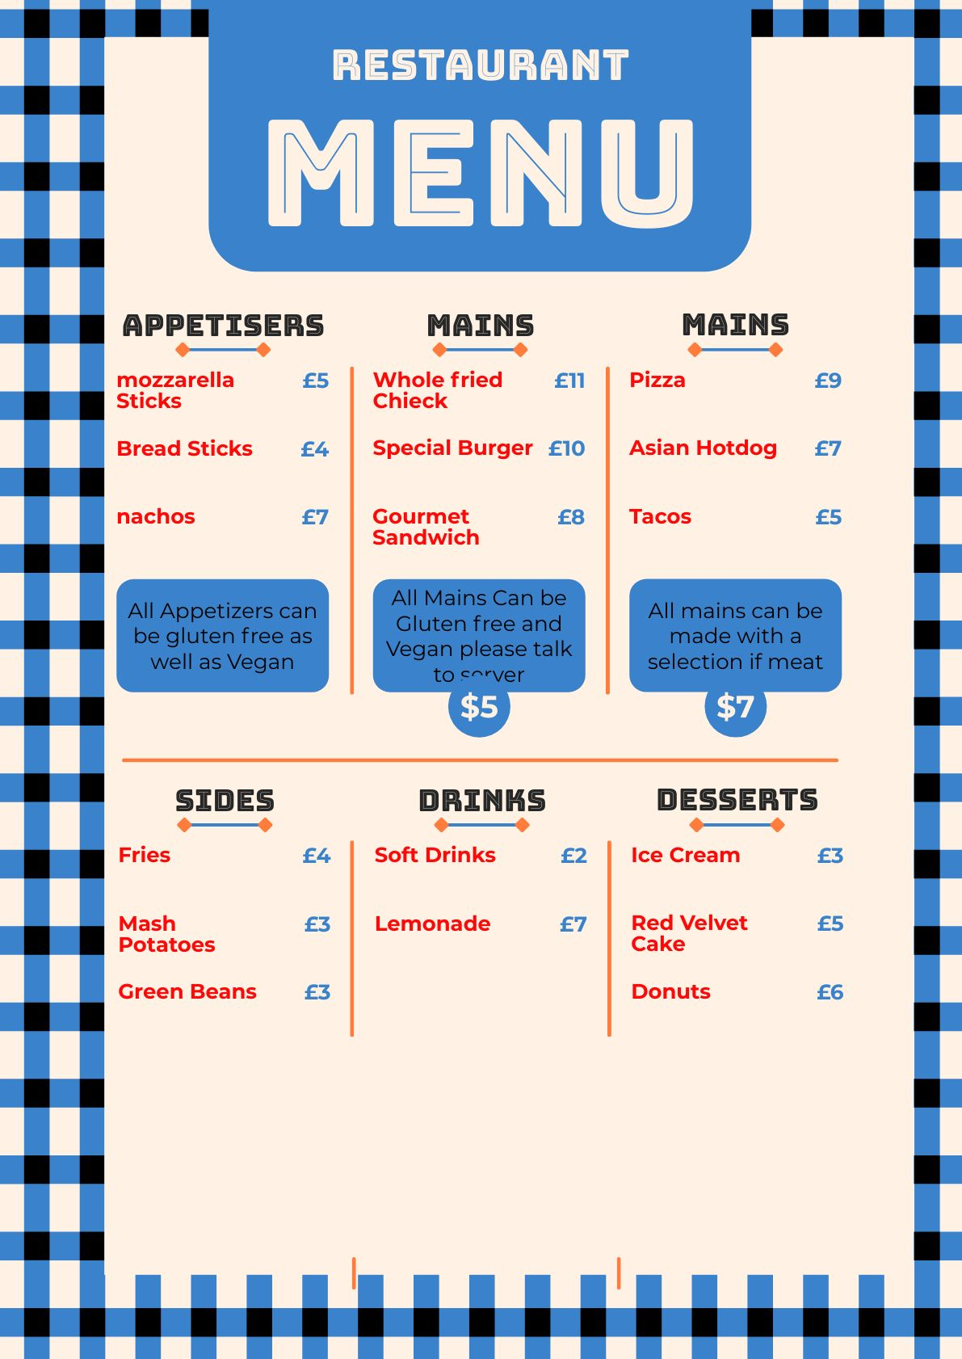
Desert

REFFRENCES

Chris Harding Aug 2011 “Fast food goes gourmet” https://www.theguardian.com/lifeandstyle/wordofmouth/2011/aug/26/fast-food-goes-gourmet

Ruth Carpenter Feb 2016 “Why fast food is going 'Gourmet'” https://www.linkedin.com/pulse/why-fast-food-going-gourmet-ruth-carpenter

Jana Pijak June 2015 “25 Gourmet Fast Food Innovations” https://www.trendhunter.com/slideshow/gourmet-fast-food

Federico Cesconi Sep 2023 “Why Be Gourmet When Fast Food Gets the Job Done?” https://federicocesconi.medium.com/why-be-gourmet-when-fast-food-gets-the-job-done-349a37d5420b

RIDIE PEARSON-JONES Aug 2011 “Michelin Star McDonald's! Food blogger challenges chefs to turn fast food into gourmet dishes - including a Quarter Pounder beef wellington and crispy chicken caviar KFC” https://www.dailymail.co.uk/femail/food/article-9884127/Food-blogger-viral-sensation-getting-chefs-transform-fast-food-gourmet-meals.html

Malika Dalama Sep 2012 “Bubbledogs, a new restaurant serving hotdogs and Champagne, is the latest place to indulge in the culinary trend of upscale fast food.” https://www.bbc.com/travel/article/20120905-londons-gourmet-fast-food-fad

Jason Colthorp sep 2023 “Tasty Tuesday: Growing Savvy Sliders chain serving up gourmet fast food in Michigan, beyond” https://www.clickondetroit.com/features/2023/09/05/tasty-tuesday-growing-savvy-sliders-chain-serving-up-gourmet-fast-food-in-michigan-beyond/

Cairo West Oct 2017 “9 Restaurants that Offer True Gourmet Fast Food” https://cairopulse.net/gourmet-fast-food-places/

Samantha McLeod Nov 2014 “Gluten Free Gourmet Fast Food” https://theprovince.com/life/food/gluten-free-gourmet-fast-food

Grace Dean Jan 2022 “Fast-food chains are finally taking vegan food seriously” https://www.businessinsider.com/fast-food-chains-are-finally-taking-vegan-food-seriously-2022-1?IR=T

