Personal Learning Environment Portfolio
By Alyssia Frampton
Word Count: 1642

Contents:

Task 1-
Objectives |  | 3
Importance of Skill |  | 4
Task 2-
Blog 1: Learning Styles |  | 6
Blog 2: Independent Learning Plan |  | 8
Task 3-
Identity and Participation  References |  | 9  10

Task 1: Objectives
- Aim for achievement whether that is through assessment results or seizing different opportunities and becoming fully involved in the course.
- Take the time to read around the subject, challenging different ideas and forming your own opinions.
- Network with experts, lecturers, and colleagues at every given opportunity.

Task 1: Importance of Skill
Objective one being the most important to me, will help me to reach my highest potential in both intellectual expertise and practice. By stepping out of my comfort zone I hope to gain experience in the working field alongside achieving a 1st in my degree of Business and Management to ensure prep for the working world. The UWTSD Degree Outcomes, 2023, posts data on the number of students obtaining a Good Honours Degree (1st class or 2:1) in business management in 2022/2023.
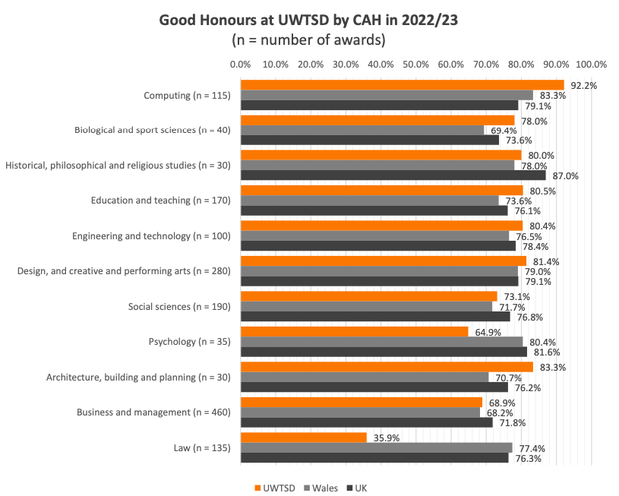(University of Wales Trinity St David, 2023)
The graph shows that out of 460 UWTSD students, 68.9% were awarded a 1st class or 2:1 in Business and Management. A report from Think Student, 2021, recommend that a further 4-5 hours of study should be completed a day (35 hours a week) on top of lectures to ensure that content, context, pre-lecture work and assignments can be to the best quality of understanding. Striving for success is a common goal among higher education students due to the substantial risk taking of finances, new independence, and future job prospects.
Objective two links into objective one in someways, discussing the importance of independent study throughout the course. However, objective two suggests the importance of critical thinking and evaluation that comes with reading around the module subjects. Independent learning means the student will gain more confidence in managing their learning and become more motivated to perform well academically (Meyer, et al., 2008). This leads me to believe that increased reading will help with contextualising theories and develop my own opinions further. The ability to contextualise, critically think and read around subjects is a useful skill for university students as it allows more depth of research and understanding following reflections on lecture work.

Objective three is important to my study at UWTSD because it will help me discover opportunities for after university and look for potential work alongside my studies. An article from Indeed’s Career Guide, 2024, promotes networking in the world of business and encourages the understanding of industry, possible mentorship and brand awareness as useful ways to get involved with business communities and develop an identity. Networking is a key skill for university students as it opens doors for the future, allows you to speak to professionals and build relationships with businesses.

Task 2: Blog 1 (Learning Styles)
14/10/24
As a part of my pre-lecture work, I was tasked with answering three questionnaires in hopes of understanding more about my learning style and application of learning.
My first questionnaire was the Honey and Mumford Learning Styles questionnaire, designed from research by Peter Honey and Alan Mumford in 1986, who discovered there are 4 favoured methods of learning: Activist, Theorist, Pragmatist and Reflector (Rosewell, 2005). My results of the evaluation highlighted 14 results for theorist and 14 results for pragmatist. Theorist suggests I excel in structured and intellectually challenging environments, I enjoy being methodical and can easily analyse information in terms of success, failure and complexity and formulate and understand concepts around different situations. My weaknesses as a theorist are suggested as: “Restricted in lateral thinking and low tolerance for uncertainty, disorder and ambiguity, intolerant for anything subjective or intuitive” (The Institute of Legal Finance and Management). The pragmatist element is also logical, strives to improve beneficial skills and enjoys applying concepts in practice however struggles with ideas that do not have a direct relevance to myself (Bitesize Learning, 2024). I agree with these finding as I thrive in putting ideas and strategies into practice and finding applicability in my university work for example, as well as enjoying being challenged through critical thinking and finding difficulty in subjective ideas compared to factual evidence.
Marcia Carlyn explains The Myers Briggs Type Indicator as:
“...a description of the four personality scales measured by the instrument, a summary of the scoring process and an extensive review of intercorrelation studies, reliability studies, and validity studies conducted with the Indicator. Results of the studies indicate that the Myers-Briggs Type Indicator is an adequately reliable self-report inventory” (Carlyn, 1977).
Based on Carl Jung’s theory from 1921, the scale of personality offers choices against the way you focus, the way in which you process knowledge, decision making tactics and judgement of the world (The Myers-Briggs Company, 2024). My results from the indicator describe my personality to be Introverted, Sensing, Thinking and Judging (ISTJ or Examiner). This means I am a reflective, reasonable, and scheduled person. As a result, my suggested career lines are a bank teller, military officer, business analysist, property manager and loan officer (Hinkle, 2024). I agree with my personality scale to a degree however, I would not consider these options as a future career.
The final learning style quiz was VARK. Created by the Neil Fleming in the late 1970s, the theory approaches the idea that the intake of information varies per individual in 4 categories; Visual learner, Auditory learner, Read Write learner or Kinesthetics learner (Cloke, 2024). My result from the VARK test shows I am a kinesthetics learner, and this is described as bored when sedentary, disengaged with classroom settings and prefers hands on learning (Engage Education, 2023). I disagree with the results from this test as I believe that using a variety of methods during learning or revising makes it more engaging and easier to recall. Equally, ‘hands on experience’ is not always applicable in the classroom. I think it is also worth mentioning that the questions given from this test were flawed in the fact they are more about how you choose to convey information across to other people.

Task 2: Blog 2 (Independent Learning Plan)
14/12/2024
To maximise my learning, I will consider what I can improve on in terms of taking in content and applying it. From taking the 3 learning styles tests, I can see elements of myself in them; I enjoy challenging myself, getting experiences based upon the knowledge I have gained, I am logical in breaking down tasks and I appreciate facts over feelings. Overall, I would agree with the consensus of these tests, however I do appreciate the theories are outdated and would not strictly base all future learning from them, particularly when the human brain and the environments around you are always changing.
To make a more personalised learning plan, I decided to input the following into ChatGPT: “Create an independent learning plan, personalised to me based on the following information. I am a university student studying Business and Management. I am labelled as a kinesthetics learner by the VARK test. Labelled as Introverted, Sensing, Thinking and Judging from the Myers Briggs Type Indicator. And labelled as a strong-preference Theorist and a moderate Pragmatist on the Honey and Mumford Questionnaire. The independent plan must include what type of learning approaches I need to try and include example methods of how to achieve this”. AI suggests the following for each attribute:
Attributes: | Kinesthetics Strategies | Introverted Strategies | Theorist Strategies | Pragmatist Strategies
Methods of Learning: | Solve real-world business issues in group activities.  Use Capsim to simulate management struggles.  Role-play scenarios  Notes on key concepts using sticky notes to prioritize.  Engage in internships and field work. | Use time-block study methods for independent studies.  Maintain a learning journal for reflections on improvements.  Participate in purposeful study groups. | Use mind map methods and diagrams for theories.  Dedicate time for reading around subjects.  Critically analyse applied theories.  Organise content to learn systematically. | Test theories through projects.  Attend skill workshops.  Solve real-world business issues with applying theory.
(OpenAI, 2024).
AI suggests using methods to break down tasks to prioritise learning as well as applying theories in real life situations, particularly in study groups. Looking at the proposed, I agree that these steps will help to consolidate knowledge and help with retaining learning, particularly based on the questionnaire findings in Blog 1. Taking steps to simplify will allow for further exploration of my subjects and forming further interests. While I had never heard of ‘Capsim’ before, I understand now that it is a simulation based product which is not free to use- because of this, I will not use this resource, however, I hope to find similar websites where these resources are available. From this outcome, I will take opportunities where I can apply these methods and try to implement them into my daily learning.

Task 3: Identity and Participation
To achieve my goals and follow my learning plan, it is important for me to build an identity that will make me stand out from other learners. A key area of networking is developing a LinkedIn profile. While I am on LinkedIn, I do not post or engage as often as I should, my new target is two posts a week and to ‘connect’ with four people a week who are in roles I am interested in doing to find more about their daily responsibilities. 16.2% of LinkedIn users are on the app daily (Shepherd, 2024). This is something I hope to progress to in time. Another area of participation I am willing to try is volunteering. While doing my studies I am between the two communities of Carmarthenshire and Pembrokeshire which means I have plenty of opportunities to volunteer for organisations like PAVS and CAVS. This possibility would allow connection with local businesses and charities to expand my network further. Finally, I am currently searching for internships, and I will put myself forward for opportunities and challenges that arise. I hope to learn from the application process and the role itself by applying content theory to real-life scenarios.

References:
Bitesize Learning. (2024). Honey & Mumford’s learning styles, explained. https://www.bitesizelearning.co.uk/resources/honey-mumford-learning-styles
Carlyn, M. (1977). An assessment of the Myers-Briggs type indicator. Journal of personality assessment, 41(5), 461-473
Cloke, H. (2024). The VARK Model: Your Complete Guide to Learning Styles. https://www.growthengineering.co.uk/vark-model/
Engage Education. (2023). Learning Styles: Kinaesthetic Learner Characteristics. https://engage-education.com/blog/learning-styles-kinaesthetic-learner-characteristics/
Hinkle, J. (2024). 7 of the Best Careers for ISTJ Personalities. https://www.indeed.com/career-advice/finding-a-job/best-careers-for-istj-personalities
Indeed Career Guide. (2024). What is networking in business. https://ie.indeed.com/career-advice/career-development/networking-in-business
Meyer, B., Haywood, N., Sachdev, D., & Faraday, S. (2008). What is independent learning and what are the benefits for students. Independent Learning: Literature Review.
OpenAI. (2024). ChatGPT (Dec 14 version) [Large language model]. https://chatgpt.com/c/675c05e3-439c-8005-8823-9522a7a3d7f3
Rosewell, J. (2005). Learning styles. Technology: level, 1.
Shepherd, J. (2024). 41 Essential LinkedIn Statistics You Need to Know in 2024. https://thesocialshepherd.com/blog/linkedin-statistics
The Institute of Legal Finance. Learning Styles Questionnaire. https://www.ilfm.org.uk/cms/document/ILFM_Learning_Styles_Resource_TK_09Oct17_Ver1.0.pdf
The Myers-Briggs Company. (2024). MBTI personality types. https://eu.themyersbriggs.com/en/tools/MBTI/MBTI-personality-Types
Think Student. (2021). How much Independent Study should you do at Uni. https://thinkstudent.co.uk/how-much-independent-study-should-be-done-at-university/
University of Wales Trinity St David. (2023). UWTSD Degree Outcomes Statement 2022/2023. [Graph image].

