DS 1 Template

My Screenshots/Photos
- Please add 4–6 screenshots or photos of your digital life.
- You can use your phone or laptop.
- For each screenshot, write one or two sentences explaining what it shows.

Screenshot/Photo 1
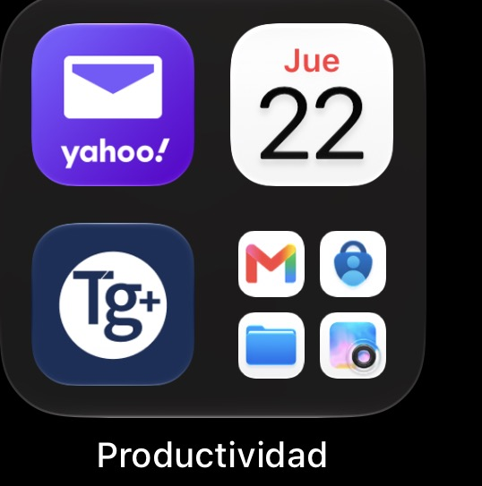
- I always use my Yahoo and Gmail email for review every day if I have a new message. This way, I know If I need to do something really important.
- I use the Time gate app every day, it is important for me because I clock when I start and finish my work, and it’s help the company know that I went to work, as well I booking my holiday’s.

Screenshot/Photo 2
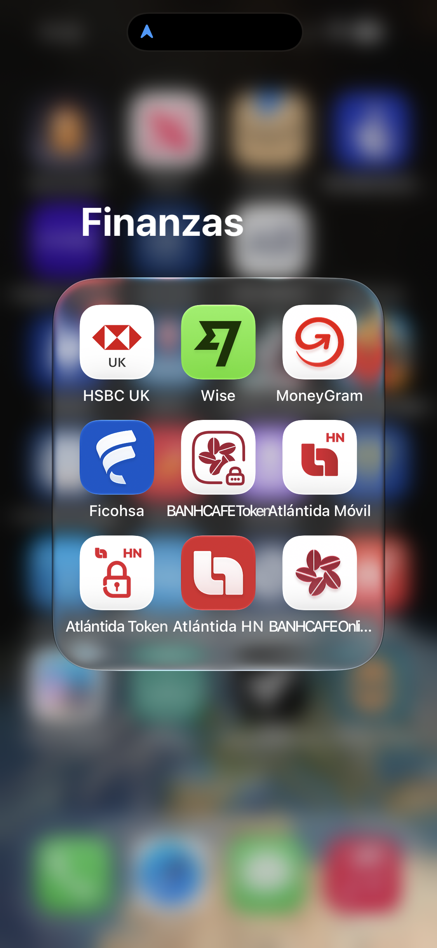
- Some time in my daily life, I use HCBC app to pay online, for example I pay my rent of my house and other bills.
- Another App’s and I use is Money Gram, I feel nervous when I use it because I need to enter the numbers very well and not make any mistake when I send the money.

Screenshot/Photo 3
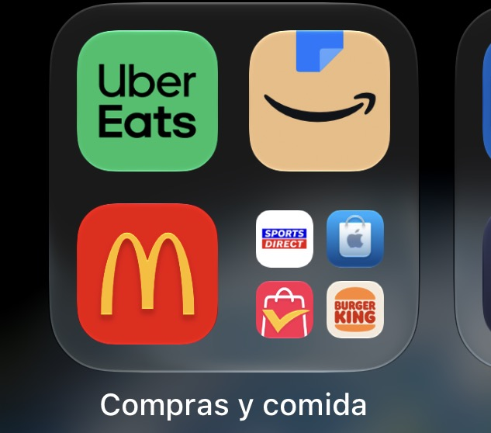
- These App’s are my favourite because when I feel hungry or need something, I use them. I don’t like of waiting for the items, but it is very nice when they arrive at home. It is really easy use the app and I feel confident.

Screenshot/Photo 4
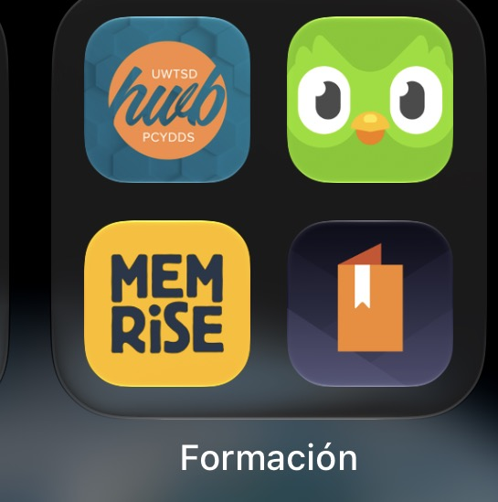
- I spend a lot of time every day on these apps because I use them to improve my English and learn from my mistakes. it’s no easy but every lesson helps me improve my skill.
- The App of my University is new for me, but I try to use it all the time always because there are many options to learn every day and I think it is really important for my future.

Screenshot/Photo 5
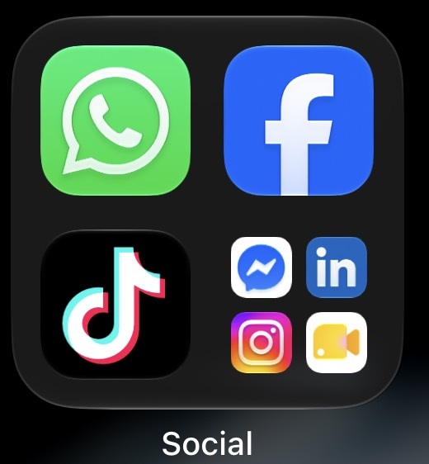
The Social Media Apps are of the most important for me because I stay in contact with my old friends and some peoples of my job, they are really useful because in seconds can I stay and contact with family.
I also do business on Marketplace because I buy cheap car, I repair them, and them I sell for a higher price, I like doing this activity.

Screenshot/Photo 6
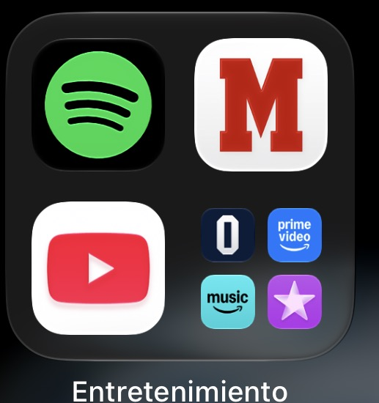
- On my way to work, when I travel by bus, I always listed podcasts because I like to improve my English listening as well I listen to music. Entertained is one way for to relax.

My Short Reflection
- Write 5–8 simple sentences about your digital life.
- You can use the sentence starters below if helpful.
- And every moment of my life I use digital tools to work, pay my bills , learn English and stay and contact with my family and friends.
- I often use these tools digitals because it is part of my daily routine.
- I feel confident when I use social media because I can talk to my family in seconds.
- I sometimes feel nervous about using Money Gram because I must not make mistakes when I enters the numbers.
- I want to improve my Academic skill and my Digital skill and this way have new opportunity’s.
- I hope this module will help me use my apps better.
- Digital skills are important for me because they help me with my job, solve problems in my life and get new option and a better future an U.K.

Sentence starters
- I use digital tools to …
- I feel confident when I …
- I want to improve …
- I often use these tools: …
- I sometimes feel nervous about …
- I hope this module will help me …
- Digital skills are important for me because …
You can write more if you want.
Submission Checklist
Before you submit, please check:
​​​ ☒ I added 4–6 screenshots
☒ I wrote short sentences for each screenshot
☒ I wrote my short reflection
☒ My work is my own
☒ My file opens correctly
​​☒ My file opens correctly

