NAME: LILIANA GURALIUC
STUDENT NUMBER : 1811989
MODULE TITLE: RESEARCH METHODS
PROJECT TITLE: HEATING AND TEMPERATURE CONTROL USING WIRELESS SENSORS
LECTURER: RENUGA JAYAKUMAR

Contents
Introduction 3
Research and development methods 3
Literature review 3
Risk for wireless communication 7
Mitigation 7
Resources and planning 8
Conclusion 9
Gantt chart 10
References 10

Introduction
Wireless sensor network is the infrastructure for communication which consists of collection of receivers, sensor nodes, repeaters. Receivers collect data from the sensor nodes as well as transmit data to data centre. Repeater performs amplification when the distance between sensor nodes as well as receiver is large. Sensor node has microprocessor with one or more sensors, memory, and transceiver as well as power supply. The main function of sensor node is to measure the variables of interest and transmit the measured data over the wireless network to the receivers. WSN consists of few or more number of sensor nodes that are distributed in wide region.
In WSN systems different indoor environmental parameter can be monitored though radio frequency wireless sensor module. The system is helpful for living in safe environment. The application is helpful for the office to provide safe working environment. Office room will get heated due to environmental conditions and the digital system use in the office. Excessive temperature will lead to health issues for the employee. It is effective to adopt temperature monitoring system to control the environment through providing measurement to the decision makers.
ZigBee is one of the effective communication protocols for indoor monitoring application. The work is proposes heating and temperature monitoring system for room in a building with wireless sensors over WSN. In this work, we propose W-wireless S-sensor M-module (WSM) which has sensor as well as Zigbee communication module. Sensor module has different enlargement for different types of sensors to monitor office or room in building using WSN. In this work, we will use temperature sensor to sense the temperature of office in building. With ZigBee communication protocol, user can monitor the temperature information of room through terminals. The proposed wireless sensor system will helpful for the user to control their environment based on sensed temperature.

Research and development methods

Literature review
In the year 1999, experts of HVAC industry realized the benefit of wireless techniques for controlling the indoor climate [1]. Wireless technologies have ability to provide more benefits for the owners of building and also facility managers like cost effective, simple, scalable and flexible system [2, 3]. Wireless sensor network has gained high attention in HVAC industry due to the reduced cost of sensors. Wireless sensor network is helpful for improving the energy efficiency as well as environmental conditions. It is one of the technologies used by A-American S-Society of H-Heating, R-Refrigerating and A-Air Conditioning E-Engineers-ASHRAE. Companies like Millennial Net, Honeywell use the WSN technology for the building to monitor the light, humidity, occupancy, temperature, contaminant density and status of doors and windows etc. More number of HVAC application use wireless sensor network for recently.
Technologies for the application of HVAC
Sensor node is the main component of WSN. The wireless sensor networks the following units such as sensing, processing, transceiver and power [4]. The sensing unit of WSN sense the environment with sensors. The analog signal which is produced by the sensor node will be converted into digital signal with ADC (A-Analogue D-Digital C-Converter). Processing unit receives that digital signal for processing which is known as microcontroller. It has processor and storage unit. Microcontroller processes data that received from the sensor node and also controls the other components functionalities in sensor node. It is also useful for managing the techniques that enable the collaboration of sensor nodes in the WSN. The process unit can also be programed for ensuring that sensors in given region is working as coherent system. [5] The unit transceiver is device which performs the task of transmitter and receiver. The device has the following operational states such as receive, transmit, idle and sleep. The sensor node connects to the network with transceiver. The transmission is done in the form of radio frequency, infrared or optical communication. The power unit in WSN provides power to sense, process data and communicate. The power unit use rechargeable or non-rechargeable batteries for the power supply to sensor nodes. Some of the sensors can able to get energy from vibration, solar sources or difference temperature. Basic units of sensor node are illustrated below:
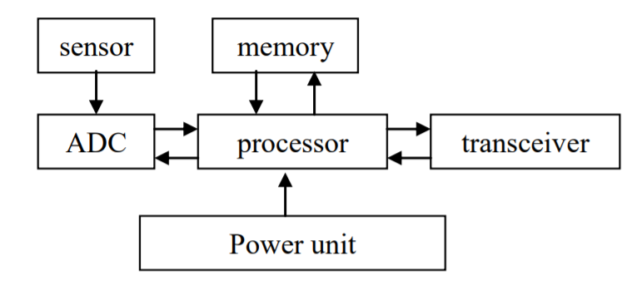
Criteria for selecting the topology in WSN are ease of installation, reliability and consumption of power.
Network topologies for the application of HVAC
Most popular topologies in WSN for the HVAC systems are star/router, star and mesh network. Popular topologies of WSN are illustrated below:
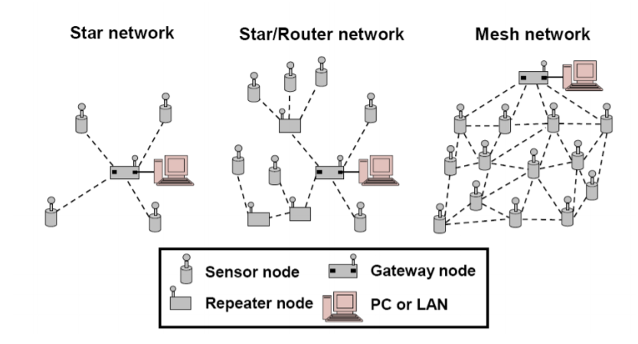
Star
The simplest topology is the star. Each of the node in the network broadcasts to the central receiver or hub. The topology is cost effective. The sensor nodes have one transmitter that do not have the capability of 2-way communication. The network topology adopted in building and in-home security products. The sensors can be fixed with doors or windows and when triggered then data will be communicated to the central location to provide alarm as well as performs some pre-programmed actions such as calling to fire service or police. [6] The network topology can also be used to monitor the temperature of zone-air through wireless sensor with PNNL.
Demerits
[7] Authors concluded that, star topology has limitation according to size of overall network. It covers only less range network. It has lack of expandability issue. All the nodes are connected with the centralized hub through link. There is no redundancy in the network. Failure of link leads the node to unreachable.
Star/router
The upgraded version of star topology is the star/router which enhances the communication. The network has repeater when the senor node is located far away from the receiver. Repeater is used to extend the network range which allows larger range network than star network. The topology can be used for the network with more number of devices. For example, It can be used by PNNL in office building with more number of temperature sensors, 3-line powered repeater as well as 1-repeater [8].
Demerits
Wireless networks with star/router topology needs repeater installation. The initial cost will get increase while increasing the size of the network due to installing repeaters and wireless sensors.
Mesh
Mesh is also one of the popular topology for WSN. In this topology, each node of the network can communicate with each other without any routing via receiving point similar to star topology. The central receiving point is act as one of the node in Mesh network. It collects data that passes through the network. In this architecture, node can able to transmit to another node in the network that need data which reduces the unnecessary data transfer thereby reduces traffic. It offers various advantages rather star and star/router topology. Each node of the network is interconnected with multiple paths which eliminate issues related with link failure, centralized failure, changes in environment. It achieves self-organization and self-healing. The mesh topology [9] can be used for monitoring energy performance of residential heat pump system. The authors concluded that mesh topology provides high robust communication due to establishing redundant paths.
Demerits
The main demerits of this topology are due to the multi-hopping behaviour which increases the load in the network. It will reduce the battery life of each node. Latency can also be increased due to receive, process as well as re-transmit of data at each node [10].
Protocols for communication
Different short range communication protocols and techniques for wireless network are Bluetooth, Zigbee, WI-FI (IEEE 802.11) and so on. [11] Most of the applications of HVAC use Bluetooth and Zigbee communication protocols. The protocol is preferred due to considering the power consumption factor as well as energy efficiency. In WSN, battery life of each node should be minimum 3-5 years [8].
bluetooth
Bluetooth can be adopted for personal area network to connect phones and wireless headsets. The data rate as well as power consumption of the Bluetooth radios are less than Wi-Fi. The battery life of temperature sensor that enabled with Bluetooth is about weeks to months. It does not satisfy the minimum requirement such as 3 to 5 years. The blue tooth network has only limited number of device. The communication protocol can be sufficient only for smallest network like in-building deployments.
Zigbee
The communication protocol is implemented by the ZigBee Alliance in association with above than 200 member companies. It is based on the standard IEEE 802.15.4. It is mainly designed for the low data rate and power consumptions applications. [8] Zigbee approved in the year 2004 which adds security, logical network as well as application software for addressing market needs such as cost effective, low power consumption, secure and reliable wireless solutions. [8, 13] The protocol is one of the effective solution for the applications that dependent on location in building applications.
BACnet
It is one of the popular protocols for wired communication for automation of building as well as control networks. It is required for integrating BACnet and Zigbee for the applications of HVAC.
WSN : Install, operate and maintain
Wiring cost can be eliminated in wireless communication. [14] cost of the WSN is based on the sensor network size and the complexity of each sensor nodes. [15] authors concluded that installation cost of wired network is high rather than wireless network. [8] due to the mass production of low cost sensors in the network lead to reduce the installation cost of WSN. According to the cost factor, WSN is suitable for the applications of HVAC due to its low cost.
Installation
Wireless sensor nodes overcome the constraints about location which exists in the wired network. it gives more flexibility for the system. Wireless senor can be installed in as well as near discharge air diffuser for measuring the temperature of supply air. It can also be placed near the occupants for monitoring the micro climate around the occupants.

Risk for wireless communication
In the indoor environment, WSN may interfere due to the other wireless networks like telephone, microwave ovens, and broadband transmitters and so on. [16] While designing WSN in indoor environment, need to consider the sources that may interfere the radio frequency of WSN.

Mitigation
Site survey and measurement is also required for determining the location of the senor nodes as well as repeaters in building. These are all determined based on building structure, material as well as facilities in the building. [17] Optimal location and density are important factors that will lead reliable system with the low maintenance. Try it & see approach can be used to validate the installation cost. Different model proposed by various authors to offer the solution of sensor location. The authors [18][19][20] proposed multi model approach that predicts signal propagation in buildings as well as help to find the location for sensors. The author [20] introduced optimization algorithm for WSN design and methodology associated tool for supporting system integrator and designers to deploy WSN.
Operation
In WSN, [11] data should be reached at destination with minimal delay as well less error. Reliability depends on various factors such as received and transmitted power and also distance between receiver and transmitter. For the building applications, the factor which impacts the reliability is presence of obstruction. Components like floors, walls, windows have effect the wireless signals while transmission. [14] Some of the materials completely stop the propagation as well as other little resistance for propagation. Reliability is also based on the topology of WSN. Authors concluded that, mesh network topology is more reliable than star and star/router network [11,13]. WSN’s security is based on topology and communication protocols.
Maintenance
Maintenance is the task of monitoring the operations and ensuring the health of WSN. WSN are battery powered, the nodes of the network should be power efficient. Various techniques have been developed for prolonging the battery life.

Resources and planning
Methodology
The proposed wireless temperature system will have sensor to sense the room temperature which is known as sensor node. The system has receiver such as microcontroller to send the signals to the control. The nodes of the system will connected over WSN through ZigBee technology. It is effective solution for HVAC applications.
The proposed system architecture is illustrated below:
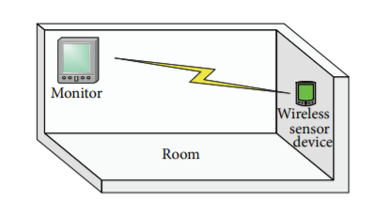

The proposed methodology is illustrated below:
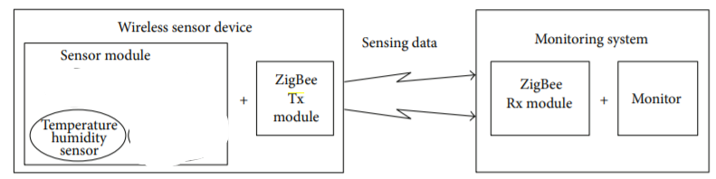
Zigbee communication module is illustrated below:
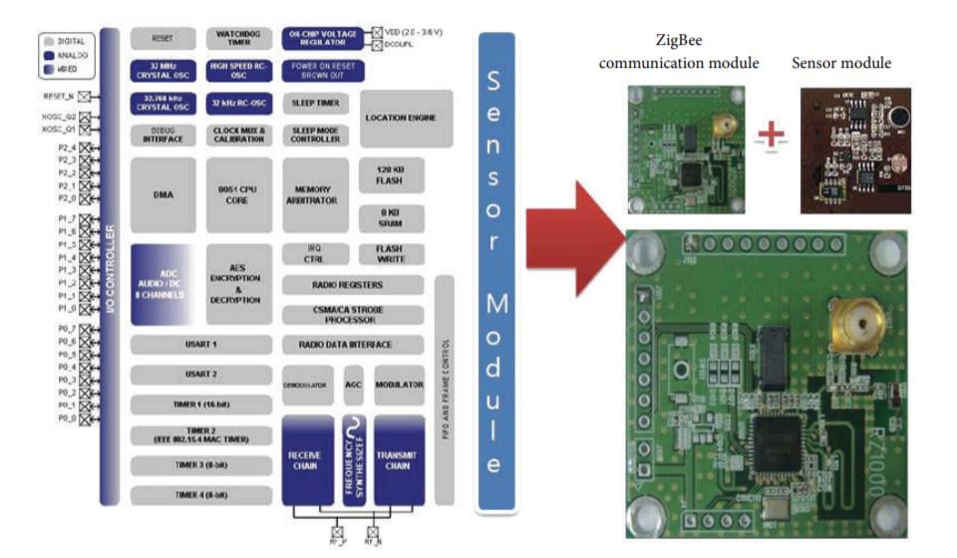

Conclusion
The work is to propose heating and temperature control monitoring using wireless sensors. The wireless sensor network is highly utilized for HVAC application. From the literature survey, It is observed that, wireless sensor network has the components such as sensor node, receiver node and repeater. Sensor node has the following units such as processor, memory, power and ADC. Receiver node is the micro-controller which controls the data transmission over WSN. The microcontroller is pre-programmed to process the received data from sensor node. For the proposed system, ZigBee communicating technology will be preferred due to its energy efficiency, low cost and reliability. Sensor LM35 will be used to sense the room then it will send the sensed data to the ZigBee Micro controller. It will be transmitted to the end terminal. The collected data will be interpreted with data analytics tools.

Gantt chart
Please find the below the Gantt chart for the project with activity and timing.


References
[1]. M, I. and G. D, Future of intelligent buildings is now. HPAC Heat Piping Air Cond, 1999. 71(5): p. 73-79.
[2]. Sullivan, F. Wireless sensors in building automation. 2005; Available from: http://www.frost.com.
[3]. Wang, S., Editorial: Wireless Networks and Their Applications in Building Automation Systems. HVAC&R Research, 2008. 14(4): p. 529-533.
[4]. Akyildiz, I.F., et al., Wireless sensor networks: a survey. Computer networks, 2002. 38(4): p. 393-422
[5]. Roth, K., L. Quartararo, and J. Brodrick, Emerging Technologies-Wireless for Controls: An Update. ASHRAE Journal, 2008. 50(8): p. 76-79.
[6]. Capehart, B.L. and L.C. Capehart, Web based energy information and control systems: case studies and applications. 2005: The Fairmont Press, Inc
[7]. Kintner-Meyer, M. and M.R. Brambley, Pros & cons of wireless. ASHRAE journal, 2002. 44(11): p. 54-56.
[8]. Kintner-Meyer, M., Opportunities of wireless sensors and controls for building operation. Energy engineering, 2005. 102(5): p. 27-48.
[9]. Healy, W.M., Lessons learned in wireless monitoring. ASHRAE journal, 2005. 47(10): p. 54- 62.
[10]. WM, H. and J. WS, Practical challenges in wireless sensor network used in building applications. NIST Technical Note 1604, 2008.
[11]. Wang, S., Editorial: Wireless Networks and Their Applications in Building Automation Systems. HVAC&R Research, 2008. 14(4): p. 529-533.
[12]. Gutierrez, J.A., E.H. Callaway, and R.L. Barrett, Low-rate Wireless Personal Area Networks:--enablling Wireless Sensors with IEEE 802.15. 4TM. 2004: IEEE Standards Association
[13]. Guo, W., W.M. Healy, and M. Zhou. Performance measurement and analysis of low data rate wireless communication under interference sources in buildings. in Systems Man and Cybernetics (SMC), 2010 IEEE International Conference on. 2010. IEEE.
[14]. Wang, Y., J.P. Lynch, and K.H. Law, Validation of an integrated network system for real- time wireless monitoring of civil structures. Ann Arbor, 2005. 1001: p. 48109.
[15]. Romer, K. and F. Mattern, The design space of wireless sensor networks. Wireless Communications, IEEE, 2004. 11(6): p. 54-61.
[16]. Jang, W.-S. and W. Healy, Wireless sensor network performance metrics for building applications. Energy and Buildings, 2010. 42(6): p. 862-868.
[17]. Kintner-Meyer, M., et al. Wireless sensors: technology and cost-savings for commercial buildings. in 2002 ACEEE Summer Study on Energy Efficiency in Buildings. 2002
[18]. Chang, J.-J. and P.-C. Hsiu. Search-oriented deployment strategies for wireless sensor networks. in Object and Component-Oriented Real-Time Distributed Computing, 2007. ISORC'07. 10th IEEE International Symposium on. 2007. IEEE.
[19] Pinto, A., et al. Synthesis of embedded networks for building automation and control. in American Control Conference, 2008. 2008. IEEE.
[20]. Guinard, A., A. McGibney, and D. Pesch. A wireless sensor network design tool to support building energy management. in Proceedings of the First ACM Workshop on Embedded Sensing Systems for Energy-Efficiency in Buildings. 2009. ACM.

